**Grocery Helper**

**How to run?**

**Dependencies: Tomcat 8.0, Maven, servlet and Eclipse.**

**Clone the project into your workspace and import as a maven project.**

**Right click on the project and hover above run as and select run on server**

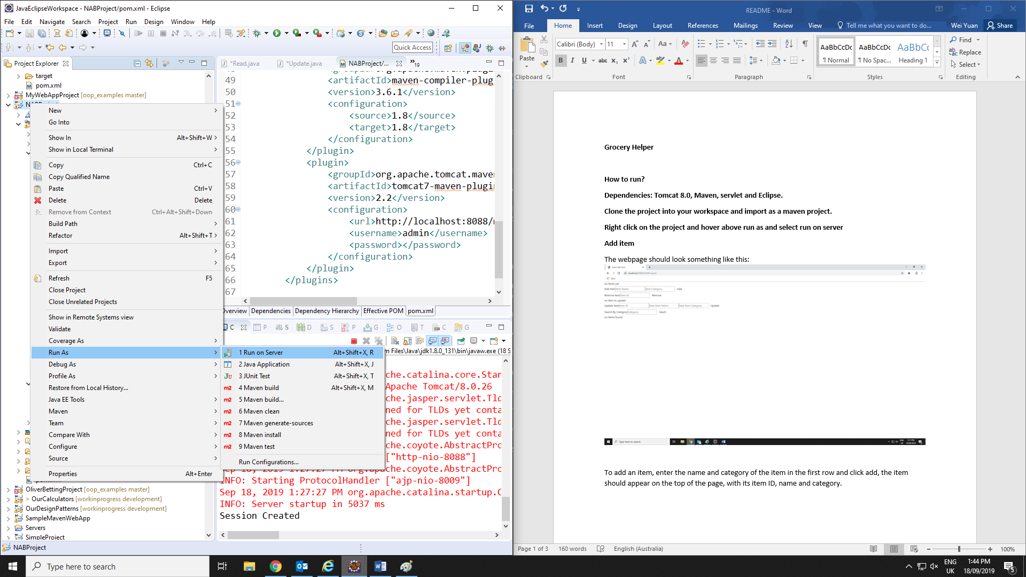

**Functions**

**Add item**

The webpage should look something like this:

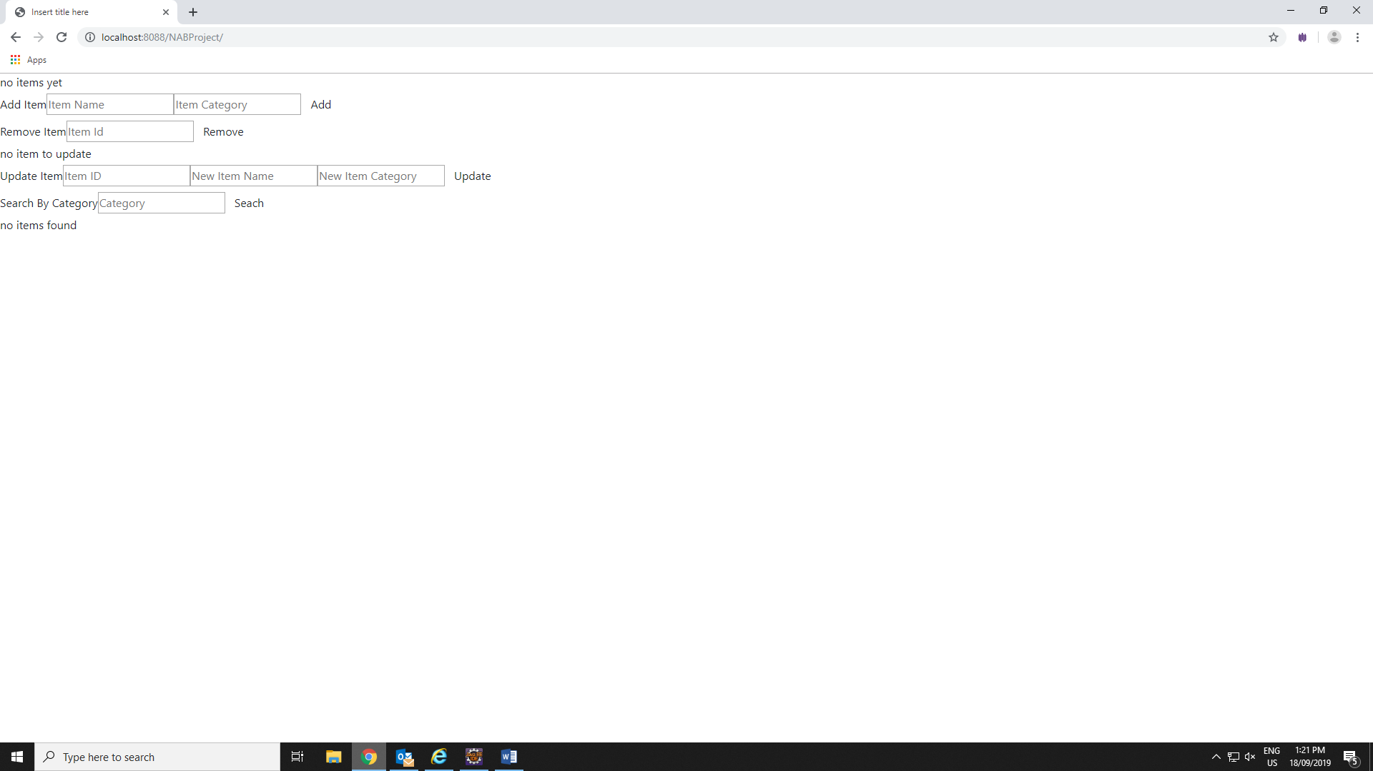

To add an item, enter the name and category of the item in the first row and click add, the item should appear on the top of the page, with its item ID, name and category.

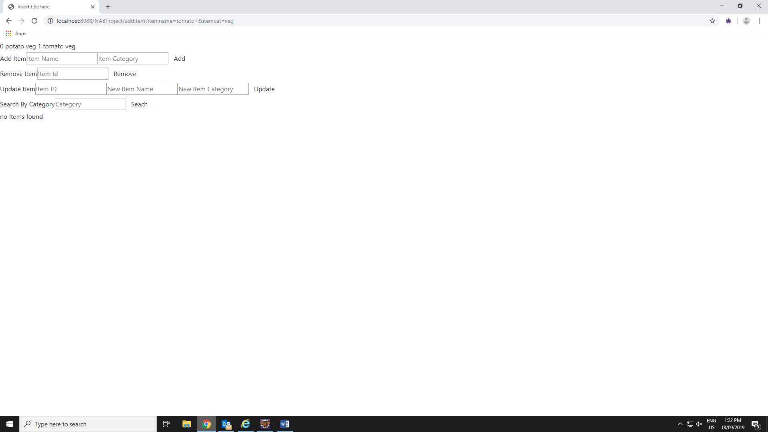

**To remove**

To remove an item, enter the item ID of the item you want to remove and click remove.

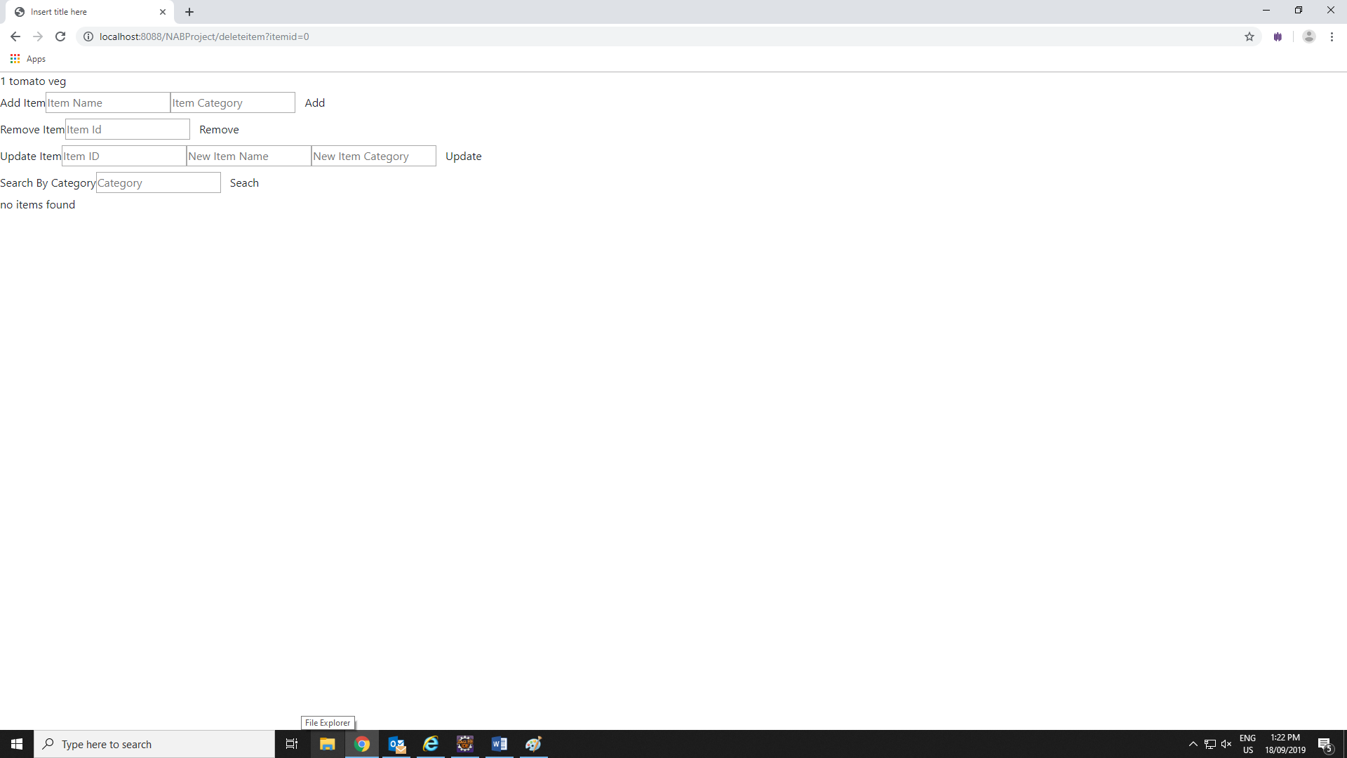

The item will be removed from the list.

**Update**

To update any item, enter the ID to locate the item and in the meantime enter the new name and new category of the item.

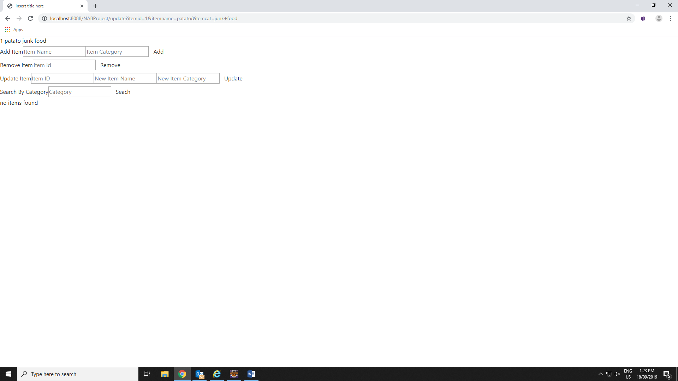

**Search by Category**

Finally, search by Category will give you a list of all the items under that category at the bottom.