1. Timing Analysis of the CAN Protocol — Part I
2. What is the worst-case response time of µ0?

|  |  |  |  |  |
| --- | --- | --- | --- | --- |
| Iteration | LHS(Q0) | B0 | RHS | Stop? |
| 1 | 30 | 30 | 30 | Yes |

B0 = Max(C0,C1,C2) = 30

Q0 = B0 = 30

LHS = RHS , Stop!

worst-case response time = 10 + 30 = 40

(2) What is the worst-case response time of µ1?

|  |  |  |  |  |  |  |  |  |  |
| --- | --- | --- | --- | --- | --- | --- | --- | --- | --- |
| Iteration | LHS (Q1) | B1 | j | Q1 + τ | Tj |  | Cj | RHS | Stop? |
| 1 | 30 | 30 | 0 | 30.1 | 50 | 1 | 10 | 40 | No |
| 2 | 40 | 30 | 0 | 40.1 | 50 | 1 | 10 | 40 | Yes |

Iteration1:

B1 = Max(C1,C2) = 30

Q1 = B1 =30

LHS = 30 < 30+1*10 = 40 = RHS

Iteration2:

LHS = 40 = 30+1*10 = 40 = RHS , Stop!

worst-case response time = 30 + 40 = 70

1. What is the worst-case response time of µ2?

|  |  |  |  |  |  |  |  |  |  |
| --- | --- | --- | --- | --- | --- | --- | --- | --- | --- |
| Iteration | LHS (Q2) | B2 | j | Q2 + τ | Tj |  | Cj | RHS | Stop? |
| 1 | 20 | 20 | 0  1 | 20.1 | 50  200 | 1  1 | 10  30 | 60 | No |
| 2 | 60 | 20 | 0  1 | 60.1 | 50  200 | 2  1 | 10  30 | 70 | No |
| 3 | 70 | 20 | 0  1 | 70.1 | 50  200 | 2  1 | 10  30 | 70 | Yes |

Iteration1:

B2 = C2 = 20

Q2 = B2 = 20

LHS = 20 < 20+1*10+1*30 = 60 = RHS

Iteration2:

LHS = 60 < 20+2*10+1*30 = 70 = RHS

Iteration3:

LHS = 70 = 20+2*10+1*30 = 70 = RHS , Stop!

worst-case response time = 20 + 70 = 90

1. Timing Analysis of the CAN Protocol — Part 2(coding)

worst-case response time結果如下:



Source code的部分: 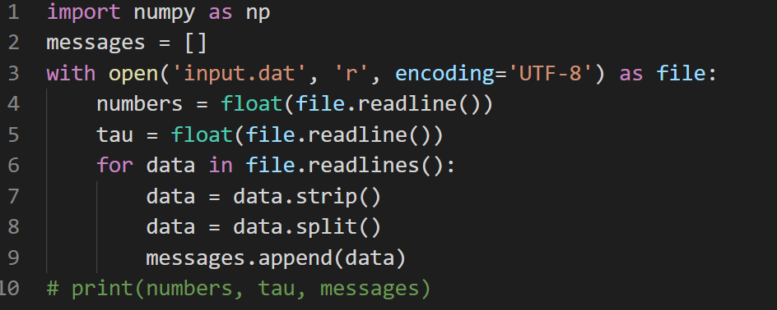

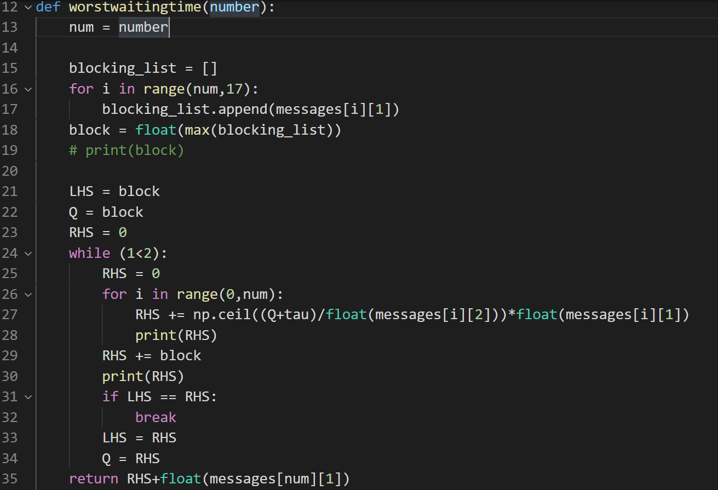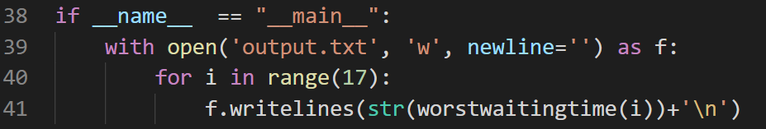

1. Timing Analysis of TDMA-Based Protocols

(1)Please duplicate the schedule pattern

(4,10,1,2,6,7)

(2) Please duplicate the arriving times of frames in the frame arrival pattern

(0,3,5,6,10,13,15,16)

(3) Please duplicate the starting times of time slots in the schedule pattern

(1,2,6,7,11,12,16,17)

(4) Please complete the following table

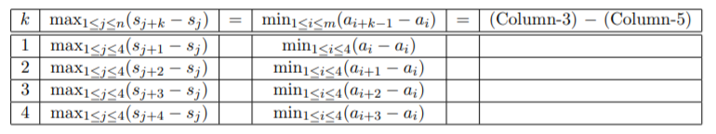

6-2= 4 0 4

7-2= 5 6-5 =1 4

11-2 =9 6-3 =3 6

12-2 =10 6-0 =6 4

(5) ) Please compute the worst-case response time

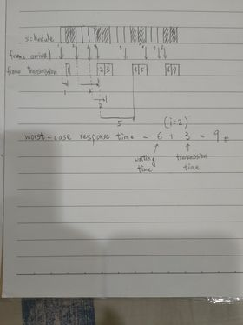

Answer = 9