What distinguishes high-level computer vision from low-level computer vision?
High-level vision focuses on semantic understanding of the scene (e.g., object detection, segmentation, tracking),
while low-level vision focuses on image structure and physical properties (e.g., depth, optical flow).
Which of the following is a high-level computer vision task?
A. Optical flow estimation
B. Depth estimation
C. Object detection
D. Image denoising
Give two examples of high-level computer vision tasks.
Object detection Image segmentation Object tracking
Which of the following topics is NOT the main focus of this course?
A. Object detection
B. Image segmentation
C. Object tracking
D. 3D multi-view geometry
High-level computer vision 研究什么？
semantic understanding
High-level vision 主要任务？
object detection image segmentation object tracking
Low-level vision 关注什么？例如？
image structure / geometry depth optical flow
CV3 在哪三个领域的交集？
real-world applications deep learning CV
What is the goal of computer vision?
mimic the human visual system
What is the difference between semantic segmentation and instance segmentation?
. Semantic segmentation labels each pixel with a class,
while instance segmentation also distinguishes individual object instances.
Why is detection considered a coarse representation?
Because objects are represented using bounding boxes instead of precise pixel masks.
Which representation provides the highest level of spatial detail?
instance segmentation
What is object detection?
Predicting object classes and their bounding box locations.
What is semantic segmentation?
Assigning a class label to each pixel.
What is instance segmentation?
Segmenting each individual object instance separately.
Why do we use the temporal domain in video analysis?
To analyze motion and exploit information across multiple frames.
What is the smoothness assumption?
That consecutive frames change gradually over time.
Name two challenges of video processing.
high computational cost occlusions frame redundancy
Quiz #1: How many parameters define a bounding box? 4 (x0,y0,h,w)
Quiz #2: Is such parametarisation unique? No.
What is the idea of sliding window detection?
Scanning an image with a fixed-size window
and classifying each window.
What are the outputs of a sliding window detector?
confidence score bounding box
What is the main drawback of sliding window detection?
very high computational cost
Sensitive to changes in scale, appearance, and illumination.
One of the traditional approaches to object detection is based on template matching with sliding windows. Outline how it operates
A sliding window scans the image and compares each image patch with a template using a similarity metric. High similarity indicates the presence of the object.
What does SSD compute or mean squared error (MSE)?
The squared difference between template pixels and image patch pixels.
SSD (sum of squared differences) 公式：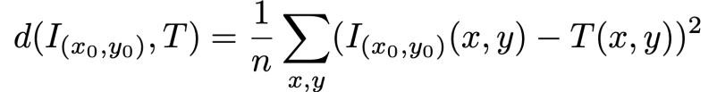 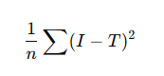
Normalised cross-correlation (NCC): 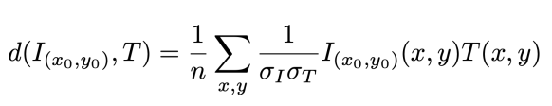
Zero-normalised cross-correlation (ZNCC): 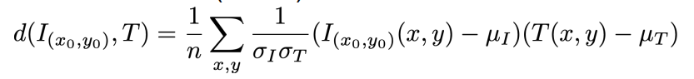
Can I just swap SSD with NCC in my code?
Yes in principle
but computationally more expensive
NCC / ZNCC 需要计算： mean standard deviation
Why is NCC preferred over SSD? Because NCC is less sensitive to illumination changes.
What does ZNCC additionally normalize? mean intensity
Why can template matching produce false detections?
because similar background regions can produce high correlation
What is a major limitation of template matching?
sensitivity to occlusion and appearance changes
Name all disadvantages of template matching.
sensitivity to (Self-) occlusion
sensitivity to appearance changes
cause object position, scale and aspect ratio are unknown
and must be searched with a brute-force sliding window
What are the two outputs of a modern one-stage object detector?
classification (class probabilities)
localization (bounding box)
What is the idea behind feature-based detection?
Use features that are invariant to appearance changes
and train a classifier to detect objects.
Why are features better than template matching?
features are more robust to pose, illumination and appearance changes
Why boosting is useful in feature-based detection?
Because features are not always linearly separable,
multiple weak learners can be combined to form a strong classifier.
Explain how the Viola–Jones detector is trained using AdaBoost.
1 Define a set of Haar-like features.
2 Find the weak classifier with the lowest weighted classification error.
3 Update the weights of the training samples.
4 Repeat steps 2–3 for N iterations.
Finally, the strong classifier is obtained as a linear combination of all weak classifiers.
Why are gradients useful for object detection?
Gradients capture edge and shape information and are less sensitive to illumination changes
What does HOG represent?
A histogram of gradient orientations in local image regions.
Describe the training procedure for an object detector based on Histogram of Oriented Gradients (HOG).
1 Collect positive training images that contain the object of interest.
2 Collect negative training images that do not contain the object.
3 Extract HOG features from both the positive and negative images.
4 Train a classifier (e.g., SVM) on the feature vectors to distinguish between object and background.
What is the role of SVM in HOG-based object detection?
The SVM learns a decision boundary that separates HOG features of the object from background features.
What is the idea of the Deformable Part Model (DPM)?
Objects are modeled as collections of parts.
The object is detected if the parts are detected in a valid spatial configuration.
Why use deformable part models?
Because many objects are not rigid and their parts can move relative to each other.
What is a two-stage object detector?
A two-stage detector first generates object proposals and then classifies and refines the bounding boxes.
What is the purpose of object proposals?
To generate candidate regions that may contain objects.
What is objectness?
Objectness measures how likely an image region contains an object, independent of the object class.
Explain the concept of objectness and object proposals.
Objectness measures the likelihood that an image region contains an object.
It is used to generate object proposals (RoIs) that are later classified.
1️⃣ Objectness判断一个区域 像不像物体（不管类别）2️⃣ Object proposals / RoI
选出 可能有物体的候选框3️⃣ Classifier再判断：
Name two methods for generating object proposals and briefly describe their idea.
Selective Search: segmentation-based proposals
Edge Boxes: edge-based proposals

What is Non-Maximum Suppression?
Non-Maximum Suppression is a method used in object detection to remove redundant bounding boxes by keeping the box with the highest score and suppressing overlapping boxes.
Why is NMS needed?
Because object detectors often produce multiple overlapping bounding boxes for the same object.
What is the purpose of Non-Maximum Suppression?
To remove redundant overlapping bounding boxes and keep the highest scoring detection.
What metric is used to measure overlap?
Intersection over Union (IoU)
When is a box suppressed?
If IoU > threshold and another box has a higher score
Write the formula of IoU 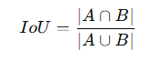
Explain the trade-off when choosing the NMS threshold.
High threshold → fewer boxes suppressed → more false positives → lower precision
Low threshold → more boxes suppressed → risk of removing correct detections → lower recall

Why are handcrafted features limited for real-world object detection?
Handcrafted features cannot generalize well to all real-world variations such as different viewpoints, lighting conditions, scales, and object appearances.
What is the main idea behind deep learning for object detection?
Instead of manually designing features, deep learning learns useful features automatically from data.
What are the two main tasks in object detection?
Object detection consists of classification (what object it is) and localization (where the object is).
What does the regression head predict?
The regression head predicts the bounding box coordinates (x, y, w, h).
What does the classification head output?
The classification head outputs class scores or class probabilities.
Why is bounding box prediction called regression?
Because the model predicts continuous values representing the bounding box coordinates.
How is OverFeat trained?
First, the classification head is trained while freezing the CNN layers.
Then the regression head is trained to predict bounding box coordinates.
Why does OverFeat not train classification and regression jointly?
Because training both tasks jointly can make optimization unstable, as the losses may interfere with each other.
What are the three main components of OverFeat?
OverFeat uses:
- sliding window detection
- classification
- bounding box regression
What does the regression head output?
The regression head predicts bounding box coordinates (x, y, w, h).
What is the role of the CNN in OverFeat?
The CNN extracts feature maps from the input image, which are used for classification and bounding box regression.
Why does sliding window detection produce many bounding boxes?
Because the detector makes predictions at many spatial locations, leading to multiple overlapping detections for the same object.
Why is Non-Maximum Suppression required?
Sliding window detection produces many overlapping bounding boxes.
NMS removes redundant boxes and keeps the highest scoring one.
What is the runtime complexity of the naive NMS algorithm? $O(N^{2})$
because every bounding box is compared with all other boxes.
Why did OverFeat improve detection accuracy compared to traditional methods?
Because it uses feature representations learned by deep convolutional neural networks instead of hand-crafted features.
Why is sliding window detection computationally expensive?
Because the detector must evaluate many positions, scales, and aspect ratios across the image.
What is the runtime complexity of naive sliding window detection? $O(ND)$
where N is the number of windows and D is the cost of detection.
How does pre-filtering sliding windows improve runtime?
A cheap method first filters out unlikely regions, reducing the number of windows that require expensive detection.
What is the complexity after pre-filtering candidate regions? $O(Nd+nD)$
where $d$is the cheap filtering cost and $n$is the number of candidate windows.
When does pre-filtering sliding windows improve runtime? 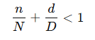
Region-of-Interest (RoI) ratio efficiency of RoI generator
We filter out one third of sliding windows, with $d=D/2$. Is it worth it?
filter out 1/3 windows → remain 2/3 n/N=2/3 d/D=1/2 7/6>1
Not worth it
Why is there a trade-off between $n$and $d$?
A stronger filter reduces the number of candidate windows $n$but increases the filtering cost $d$, while a cheaper filter reduces $d$but allows more windows through.
Why can't we make $d$extremely small and $n$extremely small simultaneously?
Because a very cheap filter cannot accurately remove many windows, while a highly accurate filter usually requires more computation.
What is the main idea behind Selective Search?
It generates object proposals by hierarchically merging segmented image regions.
Write the main steps of the Selective Search algorithm.
Perform oversegmentation to generate superpixels.
Compute similarity between neighboring regions.
Iteratively merge the most similar regions (greedy merging).
Repeat merging to build a hierarchical segmentation.
Generate bounding boxes from the merged regions as object proposals.
What is the main idea behind EdgeBoxes for object proposal generation?
Bounding boxes that enclose many edge contours are more likely to contain objects.
Why are bounding boxes that cut through many edges considered incorrect?
Because they likely split object contours, indicating that the box does not fully contain the object.
What information does EdgeBoxes use to generate object proposals?
Edge detection and contour information.
What is the key idea behind the R-CNN family of detectors?
Using CNN features extracted from candidate object regions to perform classification and localization.
Describe the main steps of the R-CNN object detection pipeline.
Generate region proposals using Selective Search.
Warp each proposal to a fixed size.
Extract CNN features for each region.
Classify the region and refine the bounding box.
Why is the CNN in R-CNN pre-trained on ImageNet?
To learn general visual features from a large dataset before fine-tuning on the object detection task.
What classifier is used in the original R-CNN architecture?
A linear Support Vector Machine (SVM).
Why did R-CNN significantly improve object detection performance?
Because it uses deep CNN features instead of hand-crafted features such as HOG.
How is each region proposal represented in R-CNN?
Each region is represented by a 4096-dimensional feature vector extracted from the CNN.
What role does transfer learning play in R-CNN?
The CNN is pre-trained on ImageNet and then fine-tuned for the object detection task.
Why is R-CNN computationally expensive at inference time?
Because the CNN must be run separately for each region proposal (~2000 times per image).
Why is R-CNN training considered complex?
Because CNN training, SVM training, and bounding box regression are performed in separate stages.
Why is the object proposal stage in R-CNN not optimal?
Because it relies on a fixed algorithm (Selective Search) that is not learned jointly with the detection network.
What is a key limitation of the R-CNN training pipeline?
The model is not trained end-to-end.
Why do we need Spatial Pyramid Pooling?
To allow CNNs to accept images of arbitrary size by converting feature maps into fixed-length representations before the fully connected layers.
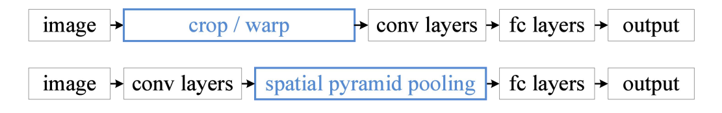
What is the purpose of ROI pooling in object detection?
A: ROI pooling converts an arbitrarily sized region of interest into a fixed-size feature map for the fully connected layers.
How is ROI pooling computed for a given region proposal?
A: The ROI is divided into a fixed number of spatial bins, and max pooling is applied independently in each bin.
Why is ROI pooling needed in Fast R-CNN?
A: Because different region proposals have different sizes, while the fully connected layers require fixed-size inputs.
Is max-based ROI pooling differentiable?
A: yes and no – depends on pooling
Is $S^{*}$differentiable w.r.t $\left(x , y , h , w\right)$? No
What is the purpose of the Spatial Pyramid Pooling (SPP) layer? B
A. To resize the input image to a fixed resolution
B. To convert feature maps of arbitrary spatial size into a fixed-length representation
C. To reduce the number of convolution layers
D. To generate region proposals
In SPP-Net, the spatial pyramid pooling layer is applied on: B
A. The raw input image
B. The convolutional feature maps
C. The output of the fully connected layers
D. The class prediction scores
Which pooling levels are typically used in Spatial Pyramid Pooling? C
A. 1×1 only
B. 1×1 and 2×2
C. 1×1, 2×2, and 4×4
D. 3×3 and 5×5
Why was the SPP layer replaced by ROI pooling in Fast R-CNN?
SPP makes end-to-end training difficult
Spatial Pyramid Pooling allows CNNs to accept inputs of arbitrary sizes without resizing？ True
Fast R-CNN computes convolutional features: B
A. once per region proposal
B. once per image
C. once per class
D. once per convolution layer
What is the role of the ROI pooling layer? C
A. Generate region proposals B. Resize the input image
C. Convert arbitrary-size regions into fixed-size feature maps D. Remove background objects
Why is Fast R-CNN faster than R-CNN?
Because convolutional features are computed once
for the whole image and shared across all region proposals.
What component is added in Faster R-CNN compared to Fast R-CNN??
Region Proposal Network (RPN)
Outline the Faster R-CNN detection pipeline.
→ CNN feature map
→ RPN generates proposals
→ ROI pooling
→ classification + bounding box regression
Dealing with variable-sized output is challenging RNN and • Predict the # of objects:
- Predict one object after another - Regress the number of objects in an image
RPN solution
dense anchors + objectness prediction
What are anchors in Faster R-CNN?
Anchors are predefined bounding boxes of different scales and aspect ratios placed at each location of the feature map.
The Region Proposal Network predicts an objectness score and bounding box offsets for each anchor to generate region proposals.
What is the dimensionality of the proposal encoding if there are n anchors per location?
1 objectness score 4 bounding box coordinates h × w × 5n
How are anchors labeled during RPN training?
Anchors with IoU > 0.7 are labeled as positive (object).
Anchors with IoU < 0.3 are labeled as negative (background).
Anchors with IoU between 0.3 and 0.7 are ignored during training.
How is the Region Proposal Network trained?
During training, a mini-batch of anchors (e.g. 256) is randomly sampled for each image, balanced between positive and negative samples.
The objectness score is trained using a binary cross-entropy classification loss.
Bounding box regression loss is computed only for positive anchors that overlap with ground-truth objects.
How are anchors generated in RPN?
At each location of the feature map, multiple anchors with different scales and aspect ratios are placed.
Typically, 3 scales and 3 aspect ratios are used, resulting in 9 anchors per location.
How does RPN parameterize bounding box regression?
The RPN predicts offsets relative to anchor boxes.
For an anchor $\left(x_{a} , y_{a} , w_{a} , h_{a}\right)$and predicted box $\left(x , y , w , h\right)$, the regression targets are:
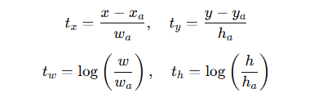
These offsets represent the normalized shift and scale relative to the anchor box.
The regression is trained using Smooth L1 loss.
What losses are used to train Faster R-CNN?
RPN classification loss – predicts whether an anchor contains an object.
RPN bounding box regression loss – refines anchors into proposals.
Fast R-CNN classification loss – predicts the object class for each proposal.
Fast R-CNN bounding box regression loss – refines proposals into final bounding boxes.
What are the advantages of Faster R-CNN?
- Faster detection by replacing Selective Search with an RPN.
- End-to-end training of the entire network.
- Fully convolutional region proposal generation.
- Higher accuracy since proposals are learned instead of hand-crafted.
Define precision and recall in object detection.
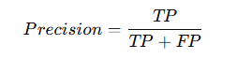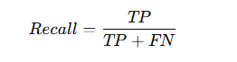
What are TP, FP, and FN in object detection?
- True Positive (TP): correctly detected object
- False Positive (FP): predicted object where none exists
- False Negative (FN): object present but not detected
How is a true positive defined in object detection?
A detection is considered a true positive if the predicted bounding box matches a ground-truth object with sufficient overlap. The overlap is measured using Intersection over Union (IoU).
Example: IOU > 0.5
How are conflicts resolved when multiple predictions match the same ground-truth box?
Each ground-truth object can be matched with at most one prediction.
Predictions are first sorted by confidence score.
What is Average Precision (AP) in object detection?
Average Precision (AP) summarizes the performance of an object detector by computing the area under the Precision–Recall curve.
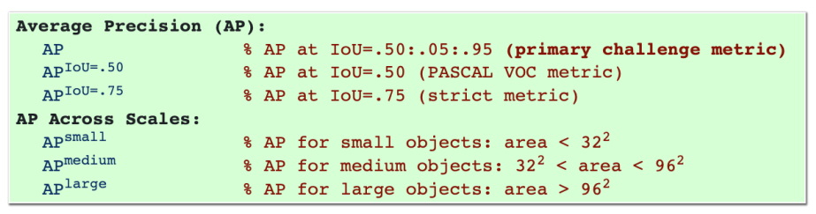
What is mAP?
mAP = mean Average Precision over all classes
真实物体： GT = 3 预测结果按 confidence 排序： Prediction results: [TP, FP, TP, FP] 计算： Precision 和 Recall。
P=[1/1,1/2,2/3,2/4] R=[1/3,1/3,2/3,2/3]
Why are CNNs not scale-invariant?
CNNs use filters of fixed size. When objects appear at different scales in the image, their feature representations change, meaning the network does not produce identical features for scaled versions of the same object.
How do region proposal methods help address scale variance?
Region proposal methods generate candidate object regions and apply RoI pooling to convert features from regions of different sizes into a fixed-size representation. This canonicalization helps the classifier process objects at different scales.
Why are small objects difficult for CNN-based detectors?
Small objects occupy very few pixels in the image. After multiple downsampling operations in CNNs, their features may collapse into very small feature maps, resulting in loss of important information for detection.
What is an image pyramid in object detection?
An image pyramid is a set of images at different scales generated from the same input image. Each scale is processed by a CNN to detect objects of different sizes.
What is the main disadvantage of using image pyramids?
Image pyramids require running the CNN multiple times on different image scales, which significantly increases computational cost.
What is a pyramidal feature hierarchy?
A pyramidal feature hierarchy refers to the multi-scale feature maps naturally produced by CNNs at different layers. Each layer has a different spatial resolution and semantic level, which can be used for detecting objects at different scales.
Why does using features from shallow layers limit detection accuracy?
Shallow layers have high spatial resolution but weak semantic information. As a result, they may not provide sufficient information for accurately classifying objects.
What is a Feature Pyramid Network (FPN)?
A Feature Pyramid Network is a neural network architecture that builds a multi-scale feature pyramid using a top-down pathway and lateral connections. It combines high-level semantic information from deep layers with high-resolution features from shallow layers to improve object detection across different scales.
What are the key operations used to build a Feature Pyramid Network?
Feature Pyramid Networks are built using three main operations: 1×1 convolution to align channel dimensions, upsampling to increase spatial resolution, and element-wise addition to fuse features from different layers.
How is RPN integrated with FPN?
RPN is applied independently on each level of the feature pyramid. Each level is responsible for detecting objects of a specific scale, and the proposals from all levels are merged during inference.
Where are large/small objects detected in FPN?
Large/Small objects are detected at low/higher-resolution feature maps
What is disadvantage of FPN?
increased model complexity.
What is advantage of FPN?
improves recall across all scales (esp. small objects); • more accurate (in terms of AP); • broadly applicable
What is a one-stage object detector?
A one-stage detector directly predicts object classes and bounding boxes from the feature map in a single forward pass without generating region proposals.
Difference between two-stage and one-stage detectors
Two-stage detectors first generate region proposals and then classify them, while one-stage detectors directly predict object locations and classes in a single network pass.
Given S=7, B=2, C=20, what is the YOLO output size?
B(5+C)=2(5+20)=50 7×7×50
What does each YOLO anchor predict?
Each anchor predicts bounding box coordinates $\left(x , y , w , h\right)$, an objectness score, and class probabilities over $C$classes.
Describe the inference pipeline of YOLO
YOLO performs a single forward pass of the CNN to predict bounding boxes, objectness scores, and class probabilities on an $S×S$grid. The predictions are combined into detection scores and redundant boxes are removed using Non-Maximum Suppression.
Why is YOLO faster than Faster R-CNN?
YOLO performs object detection in a single forward pass of the CNN without generating region proposals or applying RoI pooling.
Why is YOLO less robust to scale variation?
Because early YOLO models detect objects from a single feature map with coarse grid resolution. Small objects may be lost after downsampling and cannot be localized accurately.
What is the main idea behind SSD?
SSD (Single Shot multibox Detector) performs object detection using multiple feature maps at different scales, allowing objects of different sizes to be detected efficiently in a single forward pass.
What is disadvantage of SSD?
still lags behind two-stage detectors; • data augmentation is still crucial
a bit more complex
What is advantage of SSD?
more accurate than YOLO; works well even with lower resolution → improved inference speed.
Why do two-stage detectors handle class imbalance better than one-stage detectors?
Two-stage detectors first generate region proposals that filter out most background regions. As a result, the classifier only operates on a smaller set of candidate regions, making the foreground–background class imbalance more manageable.
What is the foreground–background imbalance problem in one-stage detectors?
One-stage detectors perform dense predictions over many anchors, resulting in a large number of background examples and only a few foreground examples. This extreme class imbalance makes training difficult.
What is hard negative mining?
Hard negative mining selects only the most difficult negative examples (with highest loss) during training instead of using all background samples.
What is the cross-entropy loss used in classification?
The cross-entropy loss is defined as $CE(p_{t})=-log⁡(p_{t})$, where $p_{t}$is the predicted probability for the true class.
Why is cross-entropy problematic in dense object detection?
Because dense detectors produce many easy negative examples. Although each easy example has a small loss, their large number dominates the total loss during training.
What is focal loss?
Focal loss modifies the cross-entropy loss by adding a modulating factor $\left(1 − p_{t})^{γ}\right.$, which down-weights well-classified examples and focuses training on hard examples.
Write the focal loss formula: FL(pt​)=−((1−pt​)^γ )log(pt​)
What is RetinaNet?
RetinaNet is a one-stage object detector that combines a ResNet backbone, a Feature Pyramid Network for multi-scale detection, and focal loss to address the class imbalance problem in dense object detection.
What is dataset bias?
Dataset bias occurs when the training data distribution differs from the test data distribution, causing models to perform poorly on unseen variations.
What is equivariance in computer vision?
f(A(x)) = A(f(x)) x = input image
A = transformation f = model Equivariance means that if the input undergoes a transformation, the output transforms in the same way.
What is a Spatial Transformer Network (STN)?
A Spatial Transformer Network is a differentiable module that learns spatial transformations of feature maps to improve the alignment of visual patterns.
What are the parameters θ in a Spatial Transformer Network?
The parameters θ represent the spatial transformation applied to the input feature map, typically an affine transformation matrix.
What is bilinear interpolation in Spatial Transformers?
Bilinear interpolation computes the output pixel value as a weighted average of the four nearest neighboring pixels based on their distances.
Describe how a Spatial Transformer computes an output pixel value.
Compute the sampling coordinate using the affine transformation.
Locate the four neighboring pixels.
Compute interpolation weights based on distance.
Compute the weighted sum of the four pixel values.
Affine transformation： affine transformation matrix
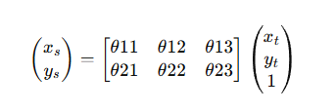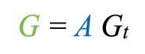
What is a chain of transformations in Spatial Transformers?
A chain of transformations refers to stacking multiple Spatial Transformer modules so that each module predicts a transformation applied sequentially.
What advantage do Spatial Transformers provide for localisation?
Spatial Transformers can learn to localise regions of interest without explicit bounding box supervision by optimizing the classification loss.
What is the advantage of training multiple Spatial Transformers?
Multiple Spatial Transformers allow the network to focus on different parts of an object, improving feature extraction for classification.
Why do we need tracking?
dynamic world model future motion prediction help detection (when appearance fails)
Why is temporal association required in object tracking?
Temporal association is required to determine which detections in consecutive frames correspond to the same physical object.
Describe the two main components of object tracking.
Detect objects independently in each frame.
Associate detections across frames to maintain consistent object identities.
Challenges of object tracking
Fast motions • Changing appearance • Changing object pose • Dynamic backgrounds • Occlusions • Poor image quality
What is tracking by detection?
Tracking by detection is an approach where the object is detected independently in each frame.
What is the main problem of tracking by detection?
The main problem is data association. When objects are detected in each frame, the system must determine which detection corresponds to which object across frames.
What is a motion prior in tracking?
A motion prior is the assumption that objects move smoothly between frames. It allows the tracker to predict the likely location of an object in the next frame and restrict the search area.
What is the main assumption used in background extraction?
The main assumption is that the background remains almost constant across video frames, while moving objects appear as changes in the image sequence.
Why can the background of a video be modeled as a low-rank component?
Since the background is nearly identical across frames, the information is highly redundant. This redundancy leads to a low-rank structure when the video frames are arranged in a matrix.
What is background subtraction?
Background subtraction is a method that detects moving objects by subtracting a background model from the current frame. The remaining regions correspond to foreground objects.
What is the purpose of a binary map in object detection?
A binary map highlights candidate foreground regions by separating moving objects from the background using thresholding.
What is the system state in the Bayesian tracking example?
The system state represents the hidden variable we want to estimate, which in this example is the car position $\left(x , y\right)$in the image.
What are the observations in Bayesian tracking?
The observations are the image frames obtained from the video sequence, which provide visual evidence about the object location.
What does the likelihood represent in Bayesian tracking?
The likelihood represents the probability of observing the image evidence given that the object is at a specific position.
What is the role of the prior in tracking?
The prior represents the predicted location of the object based on the previous frame and a motion model.
How is the posterior obtained in Bayesian tracking?
The posterior is obtained by combining the likelihood from the observations with the prior prediction using Bayes’ rule.
What does $x_{k}$represent in Bayesian tracking?
represents the internal system state at time step $k$, such as the position of the object in the image.
What does $z_{k}$represent in the tracking formulation?
represents the measurement or observation at time step $k$, such as the image or detection results.
What is the difference between $x_{k}$and $z_{k}$in Bayesian tracking?
$x_{k}$represents the hidden system state at time step $k$, such as the true position of the object. $z_{k}$represents the observation or measurement obtained from the image at time step $k$.
Why is recursion used in Bayesian tracking?
Recursion allows the posterior distribution to be updated sequentially from the previous time step without recomputing the entire history of observations.
Bayesian formulation
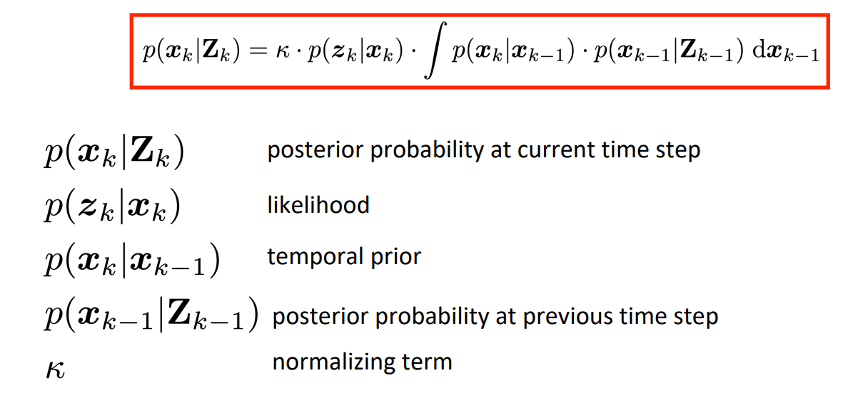
What is the posterior mean estimator?
The posterior mean estimator computes the expected value of the state given the observations, $E(x_{k}∣Z_{k})$.
What is the MAP （maximum a posteriori） estimator?
The MAP estimator selects the state with the highest posterior probability, $arg⁡{max⁡}_{x_{k}}p(x_{k}∣Z_{k})$.
What is the difference between Bayesian tracking and deep network tracking?
Bayesian tracking explicitly models the probability distribution of the state, while deep networks typically learn a function that directly predicts the state estimate.
What is online tracking?
Online tracking estimates the current state using only the observations available up to the current time.
What is offline tracking?
Offline tracking estimates states using all observations, including future frames.
Why can offline tracking be more accurate than online tracking?
Because offline tracking can use future observations to correct earlier state estimates.
Can an online tracking model be used for offline tracking?
Yes. Online models such as recursive Bayesian filters can still be applied sequentially when all observations are available.
What is the input of GOTURN?
The input consists of a template region from the previous frame and a search region from the current frame.
What does GOTURN output?
GOTURN outputs the bounding box coordinates of the target within the search region
How does GOTURN model the temporal prior $p(x_{k}∣x_{k-1})$?
GOTURN models the temporal prior implicitly by cropping the search region in the current frame around the previous target location.
What are the main advantages of GOTURN?
Simple efficient end-to-end
What are the main limitations of GOTURN?
sensitive to the template choice temporal prior is too simple（fails fast motion or occlusion） tracking one object only
What is online adaptation in visual tracking?
Online adaptation refers to updating the appearance model during tracking to adapt to changes in the object's appearance.
What is the key idea of MDNet?
MDNet learns shared feature representations across multiple tracking sequences while using domain-specific classification heads for each sequence.
How is MDNet initialized at test time?
The network is fine-tuned on the first frame of the sequence using the provided ground truth bounding box.
How does MDNet perform tracking in each frame?
MDNet generates candidate bounding boxes around the previous location, evaluates them using a CNN classifier, selects the best candidate as the target, collects new training samples, and updates the classifier if necessary.
What are common challenges in multi-object tracking?
Common challenges include multiple objects of the same type, heavy occlusions, and very similar appearances of individuals.
What are the main steps in tracking-by-detection?
Detect objects in each frame
Associate detections across frames
Build (motion model) for each object.
What roles can deep learning play in object tracking?
Deep learning can improve tracking by enabling accurate object detection for track initialization, learning motion models for predicting future positions, and learning appearance embeddings for matching detections across frames.
What methods can be used to predict the next object position in tracking?
Classic methods use motion models such as Kalman filters with a state transition model, while deep learning approaches learn motion patterns from data using models.
What are typical motion models used in object tracking?
typical motion models include constant position, constant velocity, and constant acceleration models.
What is bipartite matching in multi-object tracking?
Bipartite matching assigns predicted tracks to detections by minimizing a global cost function, typically solved using the Hungarian algorithm.
How is the cost matrix defined in tracking-by-detection?
The cost matrix measures the similarity between predicted boxes and detections, commonly using metrics such as $1-IoU$or appearance feature distance.
What happens when a detection is missing?
A pseudo detection with a fixed cost is added to keep the matrix square, and assignments to the pseudo node are discarded afterward.
Why are pseudo nodes used in bipartite matching for tracking?
Pseudo nodes allow tracks or detections to remain unmatched when no suitable correspondence exists, for example when an object leaves the frame.
What is the idea of the regression-based tracking approach（Tracktor）?
The bounding boxes from the previous frame are used to initialize positions in the current frame, and a regression model refines the boxes to better fit the object.
Tracktor tracking pipeline
Detect objects in frame t−1 Copy boxes to frame t
Refine boxes using regression head Kill tracks with low score
Run detector to initialize new tracks
Tracktor: advantages
reuse well-engineered object detectors Works well even if trained on still images
Why can Tracktor work even when trained only on still images?
Because the bounding box regression head learns how to refine bounding boxes and is independent of object identity or temporal information.
Tracktor: disadvantages
No motion model Confusion in crowded spaces Temporary occlusions
What is a metric space?
A metric space is a set of elements together with a distance function $d(p,q)$that satisfies positivity, symmetry, and the triangle inequality.
How is a metric space learned in metric learning?
A metric space is learned by mapping inputs into a feature representation using a function $f_{θ}$, and then computing distances between features using a metric function.
Why do Siamese networks use shared weights?
Shared weights ensure that both inputs are mapped into the same feature space, allowing meaningful distance comparisons.
What problem occurs if we only minimize distances between positive pairs?
The model may learn a trivial solution where all feature embeddings are identical.
Why does metric learning require negative pairs?
Because minimizing distances between only positive pairs leads to a trivial solution where all embeddings collapse to the same vector.
Why does metric learning require negative pairs?
Because minimizing distances between only positive pairs leads to a trivial solution where all embeddings collapse to the same vector.
Write the hinge loss used in metric learning.
What is the role of the margin m?
The margin enforces a minimum distance between embeddings of negative pairs so that different identities are sufficiently separated.
What is triplet loss?
Triplet loss is a metric learning loss that enforces the distance between an anchor and a positive sample to be smaller than the distance between the anchor and a negative sample by at least a margin.
Describe the steps of using metric learning for tracking.
Train an embedding network using positive and negative pairs (or triplets).
2️⃣ Extract feature embeddings for detections.
3️⃣ Compute distances between embeddings.
4️⃣ Use these distances to match detections across frames.

How can object tracking be formulated as a network flow problem?
Object tracking can be formulated as a graph where nodes represent detections and edges represent temporal correspondences between detections.
Tracking is then solved by finding disjoint paths in the graph, where each path corresponds to a trajectory of an object.
flow = 一条 trajectory（一个人）
edge cost = 两个 detection 属于同一目标的“代价”（越小越可能）
total cost = 所有路径的总不合理程度
Write the optimization objective for tracking with network flows and explain its components.
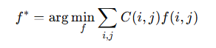 where $f(i,j)∈\{0,1\}$indicates whether an edge between detections $i$and $j$is selected, and $C(i,j)$is the cost representing the likelihood of association.
The goal is to find trajectories that minimize the total association cost.
C_in C_out的含义
in: cost to start a trajectory out: cost to end a trajectory
How can detection confidence be incorporated into network flow tracking?
Node cost Split the node in two. Assign the cost using detection confidence C_det​
Why do we connect all detections to the source and sink in tracking-by-detection?
This allows trajectories to start and end at arbitrary frames, making the model robust to occlusions and missed detections. Without this, trajectories would be forced to span all frames.
Write the flow conservation constraint and explain its meaning.
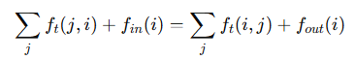 It ensures that for each detection, the incoming flow equals the outgoing flow, guaranteeing consistent trajectories.
Write the MAP formulation and explain its components.
he MAP formulation is:
$$T^{*}=arg⁡\underset{T}{max⁡}P(T∣X)$$Using Bayes rule:
$$=arg⁡max⁡P(X∣T)P(T)$$
The likelihood models detection confidence, while the prior models motion consistency.
How is the trajectory prior modeled?
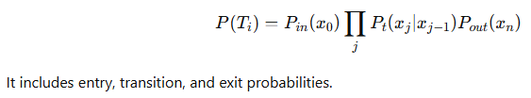
How is the detection cost derived from detection confidence?
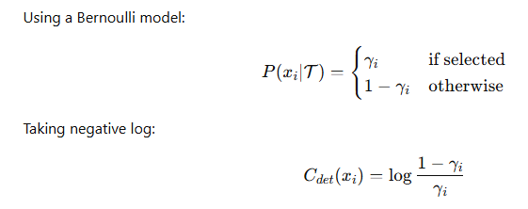
Describe the optimization steps of min-cost flow for tracking.
First, construct the graph from detections and costs. Then initialize an empty flow. Iteratively augment the flow and compute the minimum-cost flow. Finally, return the best flow as the optimal trajectories.
Why do we use min-cost max-flow for tracking?
Because it allows finding the maximum number of trajectories while minimizing the overall cost, leading to a globally optimal solution.
How can we handle long-term occlusions in tracking?
By adding long-range connections between non-consecutive frames, allowing trajectories to continue even when detections are missing.
How are costs typically obtained in tracking?
Costs are learned from data, such as detection confidence and motion models, and then used in a graph optimization framework.
How is tracking formulated as a graph problem?
Detections are represented as nodes and possible associations as edges. Tracking is formulated as partitioning the graph into disjoint trajectories.
Why is MLP not suitable for graph data?
Because it requires an ordered input and is not permutation invariant, while graph data is unordered. 每个 node 独立：h_i → MLP → y_i
Why is CNN not suitable for graph data?
Because CNN assumes a regular grid structure with fixed neighborhoods, while graph data is irregular and has varying connectivity.
What is permutation invariance?
It means that the output of a model does not change when the order of input nodes is permuted.
What is permutation equivariance?
It means that when the input nodes are permuted, the output is permuted in the same way.
What are the key challenges in deep learning on graphs?
Graphs can have arbitrary size, require permutation invariance, and have no fixed structure.
Describe the steps of message passing.
First, nodes aggregate messages from neighbors. Then, they update their own features based on this information.
What are the two steps in message passing?
Node-to-edge updates and edge-to-node updates.
What does $h_{i}^{\left(l\right)}$represent?
The embedding of node $i$after $l$message passing steps.
What is the difference between $h_{i}^{\left(l\right)}$and $h_{\left(i , j\right)}^{\left(l\right)}$?
$h_{i}^{\left(l\right)}$is a node embedding, while $h_{\left(i , j\right)}^{\left(l\right)}$is an edge embedding.
Write the node-to-edge update equation.
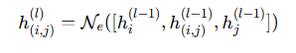
What information is used to update edge embeddings?
The embeddings of the two connected nodes and the previous edge embedding.
Write the edge -to-node update equation?
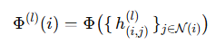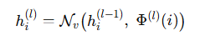
What is the goal of message passing?
To gather contextual information into node and edge embeddings.
Why do we repeat message passing multiple times?
To capture information from more distant nodes.
Describe the pipeline of GNN-based tracking.
The pipeline consists of five steps: detections are first extracted from video frames, then encoded as node features using CNNs. A graph is constructed where nodes represent detections and edges represent possible associations. A GNN performs message passing to propagate contextual information across the graph. Then, edge classification predicts whether two detections belong to the same object. Finally, trajectories are obtained by partitioning the graph.
Feature extraction → graph construction → message passing → edge classification → graph partitioning.
What features are used for nodes and edges?
Node features encode appearance via CNNs, and edge features encode geometric relationships such as position, size, and time difference.
What is the difference between traditional tracking and GNN-based tracking?
Traditional methods define unary and pairwise costs manually, while GNN-based methods learn node and edge features and use message passing for data association.
What is flow conservation in tracking?
Each detection has at most one connection to the past and one to the future.
Why is standard GNN aggregation problematic? How can this issue be addressed?
Because it aggregates all edges, while tracking requires selecting only one valid connection.
By decoupling incoming and outgoing edges.
What is time-aware message passing?
It separates messages from past and future nodes and aggregates them independently before combining them.
How are edges classified?
Using an MLP that outputs a probability via a sigmoid function.
What loss function is used?
Binary cross-entropy loss over all edges.
Why is a weight term used?
To handle class imbalance between active and inactive edges.
What are the advantages of GNN-based tracking? What is a limitation of this method?
It is flexible, learns costs from data, handles occlusions, and incorporates global context.
It does not strictly enforce flow constraints and requires post-processing.
How are predictions evaluated in tracking?
By matching predictions to ground truth per frame using the Hungarian algorithm.
What is an identity switch?
When the same object is assigned different IDs across frames. IDSW
Difference between ID switch and fragmentation?
ID switch changes identity, fragmentation breaks the track.
Why is there no ID switch in case (c)?
Because the assignment is chosen to minimize identity changes.
Is ID switch based on local or global matching?
Global matching.
What does MOTA measure?
Overall tracking accuracy combining FP, FN, and ID switches.
Write the MOTA formula.
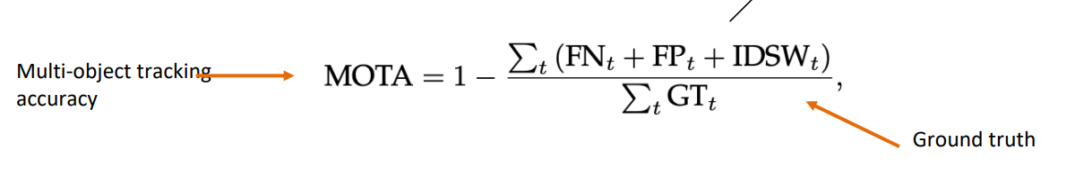
Can MOTA be negative?
Yes ❗（错误 > GT）
F1-Score IDF1（identity F1）
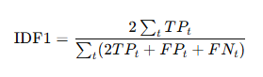
MOTP
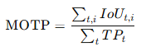
Which is suitable for real-time?
Online
Difference between online and offline tracking?
online → real-time offline → global optimization
Why is offline tracking better for occlusion?
Because it can use future frames to reconnect trajectories.
Define and differentiate semantic segmentation, instance segmentation, and panoptic segmentation. part segmentation
Semantic segmentation assigns a semantic class label to every pixel but does not distinguish between different object instances.
Instance segmentation segments individual object instances and assigns separate masks to each object, typically focusing on countable “things”.
Panoptic segmentation unifies both approaches by assigning every pixel a semantic label and, for object pixels, an instance identity.
Higher granularity, e.g. discriminating between object parts
Why do we use superpixels instead of operating on raw pixels?
Superpixels group pixels into perceptually meaningful regions, reducing the number of primitives from pixels to regions. This improves computational efficiency and preserves important image structures such as boundaries.
Describe the K-means algorithm for image segmentation.
- Initialize K cluster centers randomly.
- Assign each data point to the nearest cluster center using a distance metric.
- Update each cluster center as the mean of the assigned points.
- Repeat steps 2 and 3 until convergence.
Why does K-means fail for certain segmentation tasks?
K-means relies on Euclidean distance and assumes convex cluster shapes.
It cannot capture non-convex structures or connectivity, which may lead to incorrect segmentation.
What is the graph representation used in spectral clustering?
In spectral clustering, data points are represented as nodes in a fully connected undirected graph, where edge weights encode the similarity between points. The adjacency matrix stores these pairwise similarities.
How are edge weights defined?
Edge weights are typically defined using an exponential function of distance, such as
$a_{ij}=exp⁡(-γd(i,j))$, so that closer points have higher similarity.
Define the graph Laplacian and explain its components.
The graph Laplacian is defined as $L=D-A$, where A is the adjacency matrix and D is the degree matrix with $D_{ii}=\sum_{j}{A_{ij}}$. It captures the connectivity structure of the graph.
What is the intuition behind the graph Laplacian?
The graph Laplacian measures how much a node differs from its neighbors.
It encourages smoothness by penalizing large differences between connected nodes.
What does $x^{T}Lx$represent in spectral clustering?
The term $x^{T}Lx$measures the smoothness of x over the graph.
It penalizes differences between strongly connected nodes, encouraging similar values for nodes within the same cluster.
Why do we minimize $x^{T}Lx$? To enforce similar values for strongly connected nodes.
Why do eigenvectors of the Laplacian give clustering information?
Eigenvectors of the Laplacian minimize the energy $x^{T}Lx$, which enforces smoothness over the graph. As a result, strongly connected nodes obtain similar values, allowing clusters to be identified.
Write $x^{T}Lx$
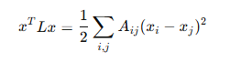
x：你给节点的值
$L$：图的连接结构
$x^{T}Lx$：整体“不一致程度”
What can we say about the eigenvector corresponding to eigenvalue 0?
The eigenvector corresponding to the zero eigenvalue is a constant vector, where all entries are equal. For multiple connected components, each component has a constant value.
Why does the multiplicity of eigenvalue 0 equal the number of connected components?
Because for each connected component, all nodes must have equal values to make $x^{T}Lx=0$.
Each component can take an independent constant, resulting in one eigenvector per component. Thus, the number of zero eigenvalues equals the number of connected components.
Describe the steps of spectral clustering
Compute the first k eigenvectors of the Laplacian matrix.
Form matrix U using these eigenvectors as columns.
Represent each node by its corresponding row in U.
Apply k-means clustering to these representations.
Why is the second smallest eigenvector used for clustering?
Because it provides the smoothest non-constant solution that minimizes differences between connected nodes, leading to a natural partition of the graph.
Why does the standard min-cut often lead to poor clustering results?
Min-cut only minimizes the number of edges between partitions and ignores the size of clusters.
As a result, it tends to isolate small sets of nodes, leading to unbalanced and trivial partitions.
Write the normalized cut objective and explain its terms.
The normalized cut is defined as:
Ncut(A,B) = cut(A,B) (1/assoc(A,V) + 1/assoc(B,V))
where cut(A,B) is the sum of edge weights between A and B, and assoc(A,V) is the total connection weight of nodes in A to all nodes.
This formulation penalizes small clusters and leads to balanced partitions.
Describe the steps of normalized cut / spectral clustering.
Construct a graph where nodes represent data points and edges encode similarities.
Compute the degree matrix D and weight matrix W, and form the Laplacian L = D − W.
Solve the generalized eigenvalue problem (D − W)x = λDx.
Use the eigenvector corresponding to the second smallest eigenvalue.
Partition the graph based on the sign of the eigenvector.
Recursively apply if more clusters are needed.
Energy function
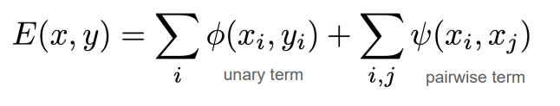
What is the unary potential?
The unary potential encodes local information about a pixel or patch and measures how likely it is to belong to a certain class.
What is the pairwise potential?
The pairwise potential encodes neighborhood information and encourages similar neighboring pixels or patches to take the same label, enforcing smoothness.
How can the CRF（ Conditional Random Fields） energy be minimized?
The energy function is converted into a graph where nodes represent pixels. Unary terms define edges to the source and sink, and pairwise terms define edges between neighboring nodes. The optimal labeling is obtained by computing the minimum s–t cut, which can be solved via the max-flow algorithm.
Why can grid CRFs be solved with graph cuts, but fully connected CRFs cannot?
Grid CRFs have a local neighborhood structure and binary labels, which allows the energy function to be minimized exactly using graph cuts. In contrast, fully connected CRFs involve pairwise interactions between all pairs of pixels, making the graph too complex and preventing efficient exact optimization. Therefore, approximate inference methods such as mean-field are used.
Why not just use CNN alone in Image Segmentation？
CNN predictions can be noisy and lack spatial consistency → CRF enforces smoothness and sharp boundaries
Why do we remove global average pooling (GAP) when extending classification networks to segmentation?
Global average pooling removes spatial information by collapsing the feature map into a single vector, which is suitable for classification but not for segmentation. Segmentation requires per-pixel predictions, so spatial structure must be preserved. Therefore, GAP is removed to maintain spatial information.
What is a 1×1 convolution and how is it interpreted?
A 1×1 convolution applies a linear transformation to each pixel’s feature vector independently. It is equivalent to applying a fully connected layer with shared weights at every spatial location.
What is output stride?
Output stride is the ratio between input resolution and output feature map resolution.
Why does a smaller output stride improve segmentation?
A smaller stride preserves more spatial details, leading to more accurate segmentation boundaries.
Quiz: Why not keep feature resolution high in all network layers?
Keeping high resolution in all layers leads to very high computational and memory costs.
Additionally, it limits the receptive field, reducing the ability to capture global context.
What is the receptive field?
The receptive field is the region in the input image that influences a particular neuron.
Why is a large receptive field important for segmentation?
A large receptive field allows the network to capture global context, which is necessary to correctly segment large objects.
What are the two main problems of increasing feature resolution??
Increasing feature resolution reduces the receptive field and significantly increases computational cost.
What is dilated convolution and what problem does it solve?
Dilated convolution uses spaced kernels to enlarge the receptive field without reducing feature map resolution.
How does increasing dilation affect the receptive field?
Increasing dilation enlarges the receptive field without changing the feature map resolution.
What is the receptive field of a dilated convolution with kernel size K and dilation D?
The receptive field is given by $D(K-1)+1$.
Why do dilated convolutions improve scale invariance?
Dilated convolutions capture features at different spatial scales, enabling the network to handle objects of varying sizes.
Why use multiple dilation rates in the same layer?
Using multiple dilation rates allows extracting both local and global features simultaneously.
What is Atrous Spatial Pyramid Pooling (ASPP)?
ASPP applies parallel dilated convolutions with different dilation rates to capture multi-scale features.
Why do we still reduce feature resolution even if receptive field is not an issue?
Reducing feature resolution makes computation tractable by lowering memory and computational cost.
What is the role of upsampling in segmentation networks?
Upsampling restores the spatial resolution of feature maps to produce dense pixel-wise predictions.
How can we use convolution to increase output resolution?
By using transposed convolution, which applies the transpose of the convolution operation to increase spatial resolution. 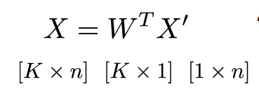
Describe how transposed convolution increases spatial resolution.
Zeros are inserted between input pixels, and a convolution is applied, which expands the feature map.
What are checkerboard artifacts?
Checkerboard artifacts are grid-like patterns in the output caused by uneven spatial coverage during upsampling.
Why is interpolation + convolution preferred over transposed convolution?
Interpolation avoids uneven overlap and checkerboard artifacts, providing more stable upsampling.
What is interpolation in upsampling?
Interpolation is a non-learned upsampling method that estimates new pixel values based on neighboring pixels.
What is resize-convolution?
Resize-convolution is an upsampling method that first applies interpolation and then a standard convolution.
How does the number of transposed convolution layers affect artifacts?
More transposed convolution layers amplify uneven overlap, leading to stronger artifacts.
How does a skip connection work?
They pass feature maps from early encoder layers directly to corresponding decoder layers to preserve spatial details.
Describe the architecture of U-Net.
U-Net consists of an encoder that downsamples the input and a decoder that upsamples it, with skip connections between corresponding layers.
What is unpooling in SegNet?
Unpooling is an upsampling operation that places activations back to their original positions using pooling indices.
How does SegNet recover spatial information?
SegNet recovers spatial information by storing pooling indices in the encoder and using them in the decoder during unpooling.
What is the difference between semantic and instance segmentation?
Semantic segmentation assigns a class label to each pixel, while instance segmentation distinguishes between different objects of the same class.
Describe proposal-based instance segmentation.
Proposal-based methods first generate object proposals (e.g. bounding boxes), then perform segmentation and classification for each proposal.
Describe proposal-free instance segmentation.
Proposal-free methods first perform semantic segmentation and then group pixels into instances.
Describe the architecture of Mask R-CNN.
Mask R-CNN extends Faster R-CNN by adding a mask prediction branch. After extracting RoI features, the network splits into two heads: one for classification and bounding box regression, and another for predicting a pixel-wise segmentation mask for each instance.
Why is RoIAlign needed in Mask R-CNN instead of RoIPool?
RoIAlign is needed because RoIPool introduces quantization errors due to rounding, which leads to misalignment between the extracted features and the original image. This is problematic for pixel-level tasks like segmentation. RoIAlign avoids this by using interpolation, preserving precise spatial alignment.
Describe how RoIAlign works.
RoIAlign divides each RoI into fixed bins and samples multiple points (e.g. four) in each bin. Instead of rounding coordinates, it computes feature values at these points using bilinear interpolation. The values are then aggregated (e.g. by max or average pooling) to produce the final feature representation, preserving precise spatial alignment.
Where does bilinear upsampling fail and why?
Bilinear upsampling is problematic at object boundaries because it averages neighboring pixels, which mixes foreground and background information. This results in blurred edges and loss of fine details.
What is coordinate-based neural representation in mask prediction?
Coordinate-based neural representation models the mask as a continuous function that maps spatial coordinates (x, y) to mask values, instead of predicting values on a discrete grid.
What does PointRend focus?
on boundary points
Describe the training and inference process of PointRend.
During training, PointRend learns a coordinate-based function by focusing on uncertain boundary points. During inference, it applies this learned mapping to refine the mask by predicting values at selected boundary locations, improving segmentation accuracy.
Why can’t we directly apply semantic segmentation methods to instance segmentation?
Semantic segmentation uses a fixed number of kernels corresponding to a fixed number of classes. In instance segmentation, the number of object instances varies across images, so the number of kernels cannot be fixed, making direct application infeasible.
How does SOLOv2 handle the variable number of instances?
SOLOv2 handles the variable number of instances by dynamically predicting a kernel for each instance. These kernels are then applied to the feature map to generate instance-specific masks.
Explain the meaning of $M_{ij}=G_{ij}*F$in SOLOv2.
In SOLOv2, $G_{ij}$represents the dynamically predicted kernel at location (i, j), and $F$is the feature map. The convolution $M_{ij}=G_{ij}*F$generates the mask for the corresponding instance at that location.
Why is D = E in SOLOv2 when using 1×1 convolution?
When using 1×1 convolution, the kernel must have the same number of channels as the feature map. Therefore, D equals E to ensure proper channel-wise convolution.
What are the key advantages of SOLOv2?
SOLOv2 is conceptually simple, as it directly predicts instances on a grid without proposals. It is a natural extension of semantic segmentation and achieves both high speed and accuracy due to its efficient and dynamic kernel-based design.
Why does SOLOv2 produce sharper masks than Mask R-CNN?
Mask R-CNN predicts low-resolution masks (e.g. 28×28) and relies on upsampling, which leads to blurred boundaries and loss of fine details. In contrast, SOLOv2 generates masks directly on higher-resolution feature maps, preserving sharper boundaries and fine structures.
What is panoptic segmentation?
Panoptic segmentation combines semantic and instance segmentation by assigning each pixel both a class label (for stuff) and an instance ID (for countable objects, i.e. things).
Describe the typical early architecture for panoptic segmentation.
Early panoptic segmentation architectures use two separate networks: a semantic segmentation network to predict stuff classes and an instance segmentation network to detect and segment individual objects. The outputs are then combined, giving priority to instance predictions, to produce a unified panoptic result.
What are the main challenges in panoptic segmentation and how are they addressed?
Panoptic segmentation is challenging because semantic and instance segmentation require different pipelines, making it difficult to unify architectures and share parameters efficiently. Two main approaches address this: top-down methods, which use proposal-based pipelines, and bottom-up methods, which group pixels based on learned feature representations.
Describe the pipeline of Panoptic FPN.
Panoptic FPN uses a Feature Pyramid Network backbone to extract features. It applies Mask R-CNN for instance segmentation and a semantic segmentation decoder for stuff, where all thing classes are replaced with a single “other” class. The outputs are merged by applying NMS to instances, resolving conflicts in favor of things, and removing “other” or small stuff regions.
Why are thing classes replaced with a single “other” class in the semantic branch?
Thing classes are replaced with a single “other” class to avoid conflicts with the instance segmentation branch. This allows the semantic branch to focus only on stuff categories, while instance segmentation handles individual objects.
Write the loss function of Panoptic FPN.
L=Linstance​+λLsemantic​ L_instance = L_ classification + L_ box regression + L_ mask prediction
What are the limitations of Panoptic FPN?
Panoptic FPN uses simple heuristic rules to merge instance and semantic predictions, and treats both branches independently. There is no cross-task supervision, meaning the semantic and instance branches do not share gradients, which limits joint optimization.
Why do things and stuff require different feature representations?
Things require instance-aware features to distinguish between different object instances, while stuff requires semantically consistent features so that pixels of the same class have similar representations.
How does Panoptic FCN differ from Panoptic FPN?
Panoptic FCN uses a single fully convolutional network to jointly predict panoptic segmentation in an end-to-end manner, while Panoptic FPN uses separate instance and semantic branches with heuristic merging.
Describe the architecture of PanopticFCN.
PanopticFCN uses a fully convolutional pipeline consisting of a feature encoder to extract shared features and a kernel generator to produce dynamic kernels. These kernels are applied to the feature map to generate masks, allowing unified prediction of both things and stuff.
Single-stage feature - Position head
Object Centers & Stuff Regions 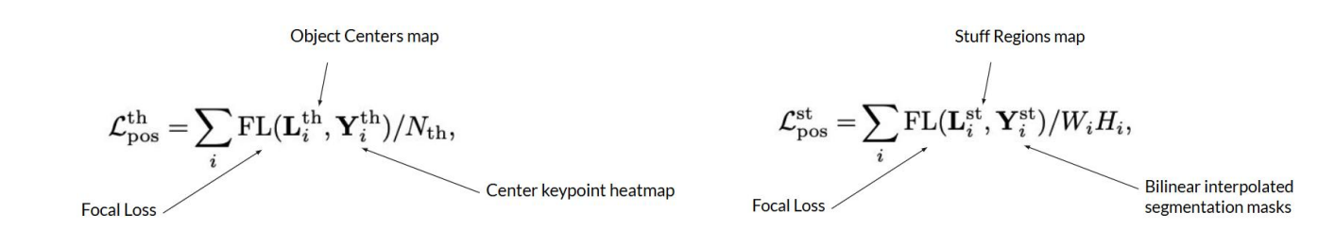
Single-stage feature - Kernel Head
predicts the kernels weights
Describe how masks are generated in PanopticFCN using the kernel head.
The kernel head predicts convolution kernels for each spatial location. Based on the object centers predicted by the position head, the corresponding kernels are selected and applied to high-resolution feature maps. This convolution generates the final instance masks.
Why is the matching between predictions and ground truth unique in PQ evaluation?
The matching is unique because predictions are disjoint. If two predictions both had IoU greater than 0.5 with the same ground truth, their IoU sum would exceed 1, which is impossible. Therefore, at most one prediction can match a ground truth segment.
Write the formula of Panoptic Quality (PQ) and explain how it is computed.
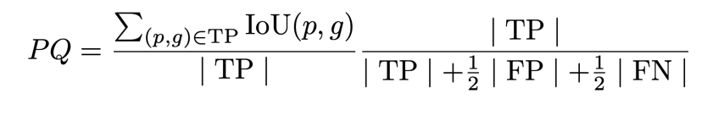
Segmentation Quality (SQ) * RQ = “Recognition Quality”
What is the range of PQ, SQ, and RQ? Why?
PQ, SQ, and RQ all lie in the range [0,1]. SQ is the average IoU, which is bounded between 0 and 1. RQ is a ratio of TP over a larger denominator, so it is also between 0 and 1. Since PQ is the product of SQ and RQ, it is also bounded in [0,1].
What is the effect of missing one object on PQ?
Missing one object increases the false negatives for its true class and introduces a false positive for the incorrectly predicted class. As a result, the PQ decreases for both classes.
Why is it beneficial to predict an “unknown” class instead of misclassifying an object?
Predicting an “unknown” class avoids introducing false positives for other classes. While the true class still incurs a false negative, other classes are not penalized, preventing a double penalty and improving overall PQ.
Explain how void regions are handled in PQ evaluation.
Void regions are ignored during evaluation. Pixels overlapping with void are excluded from IoU computation. Predicted segments that largely overlap with void regions are discarded and do not count as false positives. Predicted void pixels are also ignored and do not affect evaluation.
What is the goal of video object segmentation?
The goal of video object segmentation is to generate accurate pixel-level masks for objects while maintaining temporal consistency across video frames.
What are some challenges in video object segmentation?
include strong viewpoint changes and appearance changes, which make it difficult to consistently segment the same object across frames. •Occlusions Scale changes
Illumination Shape changes
why do we need appearance and motion models?
Appearance models help recognize objects despite visual changes, while motion models predict object positions over time and handle occlusions.
Compare appearance models and motion models in video object segmentation in terms of assumptions, inputs, and outputs.
Appearance models assume constant appearance and take a single frame as input to produce segmentation masks. Motion models assume smooth displacement and brightness constancy, take two frames as input, and output motion in the form of optical flow.
Compare semi-supervised and unsupervised video object segmentation.
In semi-supervised VOS, the input is a video and an object mask in the first frame, and the task is to propagate this mask over time. In unsupervised VOS, only the video is given, and the model must automatically discover and segment objects without any annotations.
Describe the task formulation of semi-supervised video object segmentation.
In semi-supervised VOS, the segmentation mask of the target object is given in the first frame. The task is to propagate this mask over time and produce pixel-accurate segmentation for the entire video while maintaining temporal consistency.
Why is choosing what to track challenging in video object segmentation?
Choosing what to track is challenging because it can be subjective, especially in online settings where only limited temporal information is available. Offline tracking, which considers the entire video, can provide better cues based on object permanence.
How is optical flow used in motion-based video object segmentation?
Optical flow estimates the apparent motion between two consecutive frames. In motion-based VOS, the segmentation mask from the previous frame is propagated to the next frame using the estimated flow to maintain temporal consistency.
Write the SSD formulation used in optical flow and explain its components and purpose.
The SSD formulation is
$E_{SSD}(u,v)=\sum_{(x,y)∈R}{(I(x+u,y+v,t+1)-I(x,y,t)})^{2}$.
It measures the brightness difference between two frames under displacement (u,v). Minimizing this error gives the optical flow.
State the brightness constancy assumption and explain its meaning.
The brightness constancy assumption states that
$I(x+u,y+v,t+1)=I(x,y,t)$,
meaning that the intensity of a moving pixel remains constant between consecutive frames.
What is the spatial coherence assumption in optical flow?
The spatial coherence assumption states that neighbouring pixels typically belong to the same surface and therefore have similar motion, leading to a smooth optical flow field.
What is the temporal persistence assumption in optical flow?
The temporal persistence assumption states that the motion of a surface patch changes gradually over time, ensuring temporal smoothness of the estimated motion.
Derive the optical flow constraint equation from brightness constancy using Taylor approximation.
Using first-order Taylor approximation,
$I(x+u,y+v,t+1)≈I+uI_{x}+vI_{y}+I_{t}$.
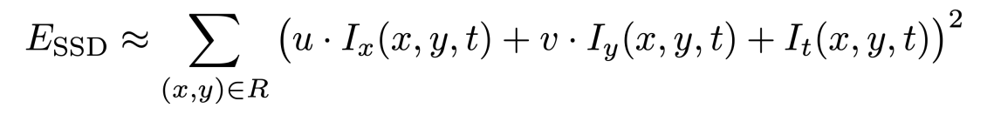
How do we estimate optical flow (u,v) from the linearized SSD formulation?
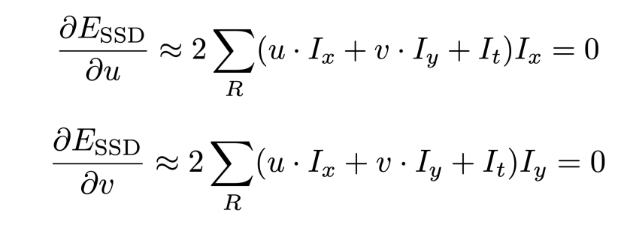
Lucas-Kanade
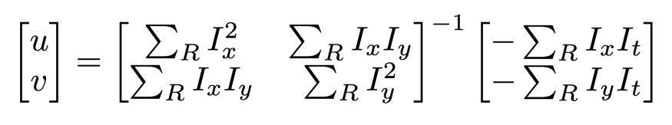
Describe the Lucas-Kanade method for optical flow estimation.
The Lucas-Kanade method assumes constant motion within a local patch. It computes image gradients, forms a linear system over the patch, and solves for the optical flow (u,v) by least squares.
How can motion be used for object segmentation?
Motion segmentation uses optical flow to group pixels with similar motion. Pixels that move together are likely to belong to the same object, allowing segmentation based on motion patterns.
Why does the aperture problem occur in optical flow?
The aperture problem occurs because motion is observed only within a small local window. For one-dimensional structures such as edges, only the motion component orthogonal to the edge can be determined, while motion along the edge is ambiguous.
How is optical flow visualized using color coding?
Optical flow can be visualized using color coding, where the direction of motion is represented by hue and the magnitude of motion is represented by intensity or saturation. This provides a compact and less cluttered visualization compared to arrow-based representations.
Explain the relationship between motion boundaries and object boundaries.?
Motion boundaries indicate changes in motion and therefore suggest object boundaries. Conversely, object boundaries imply motion discontinuities, since different objects can move differently.
What are the limitations of joint segmentation and optical flow methods?
Joint methods are computationally expensive due to iterative optimization and are sensitive to initialization, as errors in the initial optical flow can propagate and affect both motion estimation and segmentation.
Describe the architecture of FlowNet.
FlowNet stacks two input images to form a 6-channel input and processes them with a convolutional neural network. It predicts optical flow in a coarse-to-fine manner using refinement and upsampling, and is trained with an L2 loss on synthetic data.
Why is synthetic data used for training optical flow models?
Synthetic data is used because ground truth optical flow is difficult to obtain in real-world data. In synthetic environments, exact pixel correspondences and motion can be computed, providing accurate supervision for training.
Describe the Siamese architecture in FlowNet.
In FlowNetC, a Siamese architecture is used where two input images are processed by identical CNN branches with shared weights. The extracted features are then compared using a correlation layer to compute similarities, which are used to estimate optical flow.
What does the correlation layer do in FlowNet?
The correlation layer computes pairwise dot-products between feature vectors from two images to measure their similarity. It produces matching scores that help identify corresponding points for optical flow estimation.
Why is it beneficial to jointly estimate optical flow and segmentation?
Joint estimation is beneficial because optical flow provides motion cues that help segment objects, while segmentation provides object boundaries that improve flow estimation. Thus, both tasks can mutually improve each other.
Why is optical flow alone not sufficient for video object segmentation?
Although optical flow can be estimated efficiently, it is not sufficient for video object segmentation because it fails under occlusions, self-occlusions, and illumination changes. These factors make dense tracking unreliable, requiring additional cues such as segmentation or learned models
Appearance-only models Main idea
Train a segmentation model from available annotation (including the first frame); • Apply the model to each frame independently;
Describe the One-shot VOS OSVOS approach for semi-supervised video object segmentation.
OSVOS first pre-trains a segmentation model to learn objectness. It then fine-tunes the model on the first-frame annotation of the target object. During inference, the model segments each frame independently without using temporal information.
Describe the three stages of OSVOS.
OSVOS consists of three stages. First, the network is pre-trained on ImageNet to learn basic visual features. Second, it is trained on a segmentation dataset to learn object segmentation. Finally, it is fine-tuned on the first frame of the test sequence to adapt to the specific object of interest.
What is one-shot video object segmentation?
One-shot video object segmentation refers to learning to segment an object in a video using only a single annotated example, typically the first frame. The model is fine-tuned to learn the appearance of the target object and then processes each frame independently without using temporal information.
What is the drifting problem in video object segmentation and why does it occur?
The drifting problem refers to the gradual degradation of segmentation accuracy over time. It occurs because the appearance of the object changes due to factors such as object deformation and camera pose changes, leading to accumulated errors in the segmentation.
How does OnAVOS use pseudo-labels for online adaptation?
OnAVOS performs online adaptation by selecting high-confidence foreground and background regions from the model’s predictions as pseudo-labels. These are used to update the model during inference, allowing it to adapt to appearance changes and reduce drifting.
What are the advantages and limitations of OnAVOS compared to One-shot VOS?
OnAVOS is more accurate than One-shot VOS because it continuously adapts the model using a dynamic set of pseudo-labels instead of relying only on the first frame. However, pseudo-labels may be inaccurate, leading to error accumulation and reduced performance over time.
Describe how MaskTrack works and how it is trained.
MaskTrack takes the current frame and the mask from the previous frame as input and predicts the refined mask for the current frame. During training, ground-truth masks are perturbed using transformations to simulate previous-frame errors, and the network learns to recover the correct mask. This allows training without real video sequences.
What are the advantages and disadvantages of appearance-based VOS methods?
Appearance-based VOS methods can be trained on static images, are robust to occlusions, and are conceptually simple. However, they lack temporal consistency since each frame is processed independently, and they can be slow at test time due to model adaptation.
How do metric-based approaches perform video object segmentation?
Metric-based approaches learn a pixel-level embedding space where semantically similar pixels are close. For each pixel in a new frame, the method retrieves the most similar pixels from reference frames and assigns labels based on similarity, enabling segmentation without explicit model adaptation.
Describe the training and inference process of pixel-wise retrieval methods.
During training, a pixel-wise embedding space is learned using triplet loss, where pixels of the same class are close and different classes are separated. During inference, pixels from both the annotated reference frame and the test frame are embedded, and labels are assigned to test pixels using nearest neighbour search based on similarity.
What are the advantages of metric-based VOS methods?
Metric-based methods do not require retraining or fine-tuning for each video, as they rely on a general embedding space. Additionally, they can be trained using unsupervised methods such as contrastive learning, reducing the need for labeled data.
Why are convolutions limited in modeling long-range dependencies?
Convolutions operate on local neighborhoods and require deep stacking of layers to capture long-range dependencies, making them inefficient.
Why is attention more flexible than convolution?
Attention allows each element to interact with all others in the same layer, enabling flexible and global receptive fields.
Compare how CNN and attention aggregate information.
CNNs aggregate information locally and expand context layer by layer, whereas attention directly aggregates global information in a single layer.
Write the attention computation and explain each term.
Attention computes similarity scores $w_{ij}^{'}=x_{i}^{T}x_{j}$, normalizes them using softmax 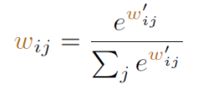, and outputs $y_{i}=\sum_{j}{w_{ij}}x_{j}$, where $w_{ij}$are attention weights.

Why is attention better than CNN for text understanding?
Attention allows modeling long-range dependencies by enabling each word to interact with all others directly, unlike CNNs which rely on local context.
Write the attention formula with Q, K, V and explain each term.
. Attention computes $w_{ij}^{'}=q_{i}^{T}k_{j}$, where $q_{i}=Qx_{i}$, $k_{j}=Kx_{j}$, and outputs $y_{i}=\sum_{j}{w_{ij}}v_{j}$with $v_{j}=Vx_{j}$.
Why do we use Q, K, V instead of raw input?
Q, K, V allow the model to learn task-specific similarity instead of relying on fixed input representations.
Write the scaled dot-product attention formula and explain each term.
Attention is defined as $softmax(QK^{T}/\sqrt{n})V$, where Q, K, and V are query, key, and value matrices.
Why do we divide by √n in attention?
Scaling by √n prevents large dot-product values, which would otherwise cause softmax to produce very peaked distributions and lead to vanishing gradients.
Given Q, K, V dimensions, what is the output dimension? 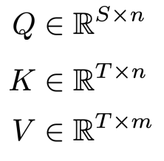
The output dimension is $S×m$. $QK^{T}$ -》 S x T (S×T)(T×m)=S×m
How is self-attention computed from an input matrix $X$?
Given $X∈R^{T×d}$, we compute $Q=XW^{Q}$, $K=XW^{K}$, and $V=XW^{V}$. Then attention is computed as $Attention(Q,K,V)=softmax\left(\frac{QK^{⊤}}{\sqrt{d_{k}}}\right)V$, followed by an output projection.
Write the formulas for computing $Q$, $K$, $V$, and the final output $Y$.
The final output is $Y=Attention(Q,K,V)W^{O}$, where $W^{O}$maps the attention result back to the original feature dimension.
Describe the steps of computing the self-attention output for a token xᵢ.
Compute query, key, value vectors for all tokens.
Compute similarity scores between qᵢ and all kⱼ using dot product.
Scale scores by dividing by √dₖ.
Apply softmax to obtain attention weights αᵢⱼ.
Compute weighted sum of value vectors.
Output the result as the new representation of xᵢ. O(N^2d)
What is multi-head attention?
Multi-head attention applies several attention heads in parallel, where each head attends to the input from a different representation subspace.
Why can multi-head attention model more complex interactions than single-head attention?
Different heads can capture different relationships between tokens, allowing the model to represent more complex interactions than a single attention head.
Describe the normalization step after self-attention in a Transformer.
After self-attention, the output is added to the original input via a residual connection, and the result is normalized using layer normalization.
Why do we need positional encoding in Transformers?
Positional encoding is needed because self-attention is permutation invariant and does not capture the order of tokens. It provides position information to the model.
Write the positional encoding formula and explain its components.
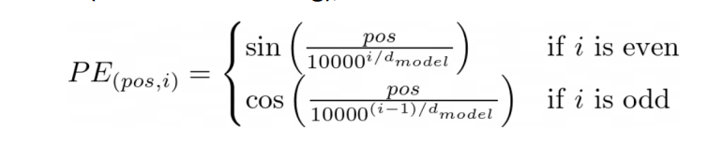 pos is the position and i is the dimension index.
What does permutation-equivariant mean in self-attention?
Permutation-equivariant means that if the input tokens are reordered, the output is reordered in the same way.
Why is positional encoding required in Transformers?
Positional encoding is required because self-attention does not capture token order, as it is based only on pairwise similarities.
What is the main idea of Vision Transformer (ViT)?
ViT splits an image into a sequence of image patches and treats them as input tokens to a Transformer.
This allows the model to apply the Transformer architecture to image classification.
Describe the full pipeline of Vision Transformer (ViT).
The image is split into fixed-size patches.
Each patch is flattened and linearly projected into embeddings.
A learnable [class] token and positional embeddings are added, and the sequence is fed into a Transformer encoder.
The output [class] token is used by an MLP（Multi-Layer Perceptron） head for classification.
Describe the structure of a Transformer encoder block in ViT.
Each block consists of LayerNorm, multi-head self-attention, and a residual connection,
followed by another LayerNorm, an MLP, and a second residual connection.
This structure is repeated multiple times.
Why are residual connections used in the Transformer encoder?
Residual connections help preserve the original input information.
They also improve gradient flow and stabilize training in deep networks.
What does multi-head attention do in the ViT encoder?
It models relationships between all tokens in the sequence.
Multiple heads allow the model to capture different types of dependencies.
Why does ViT require large-scale pretraining?
ViT lacks inductive biases such as locality and translation invariance.
Therefore, it needs large datasets to learn these properties from data.
What are inductive biases in CNNs ViT does not have?
Inductive biases are prior assumptions built into the model.
In CNNs, they include locality, 2D structure, and translation invariance.
Why does self-attention in ViT have quadratic complexity??
This results in a complexity of $O(N^{2})$. Each token attends to all other tokens in the sequence.
How does Swin Transformer reduce the computational complexity compared to ViT?
It restricts self-attention to local windows instead of global tokens.
This reduces the complexity from quadratic to linear.
What is window-based attention in Swin Transformer?
Self-attention is computed only within fixed-size local windows.
Each token interacts only with tokens inside its window.
Why does a naive window-based attention hurt context reasoning?
Because tokens only attend to other tokens within the same window.
This prevents modeling long-range dependencies across windows.
Why do we use shifted windows in Swin Transformer?
To enable interactions between tokens from different windows.
This helps propagate information across the entire image.
Describe the patch merging operation in Swin Transformer.
Four neighboring patches are concatenated to form a 4C-dimensional vector.
Then, a linear layer reduces it to a 2C-dimensional feature.
Why does Swin Transformer not require large-scale pretraining like ViT?
Because it introduces inductive biases such as locality and hierarchical structure.
This allows it to learn effectively from smaller datasets.
Why is Swin Transformer more efficient than ViT?
It uses window-based attention with linear complexity instead of global attention.
It also reduces token numbers through patch merging.
Describe the pipeline of DETR.
A CNN extracts image features, which are fed into a Transformer encoder-decoder.
The Transformer predicts a set of bounding boxes in parallel.
During training, predictions are matched to ground truth using Hungarian matching.
Why does DETR not require non-maximum suppression (NMS)?
Because predictions are uniquely assigned to ground truth objects.
This avoids duplicate detections.
DETR: The loss function
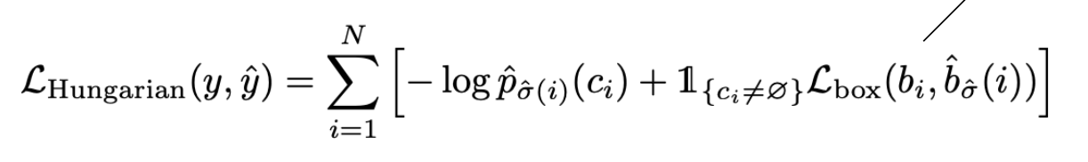
y： ground truth（真实标签集合）$c_{i}$：类别 $b_{i}$：真实 bounding box
y^ ​模型预测（queries 输出）$σ(i)$ = 对应的 prediction index
${\hat{p}}_{σ(i)}预测概率$ bounding box loss
DETR: Bounding Box loss
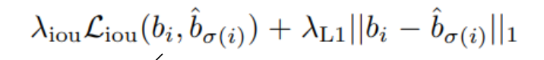 use Generalised IoU
Why do we use Generalized IoU instead of standard IoU?
最小包住 A 和 B 的框（convex hull）
Standard IoU is zero when boxes do not overlap.
GIoU provides gradients even in this case, improving training. 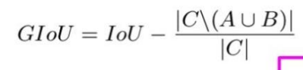

Why is L1 loss alone insufficient for bounding box regression?
L1 loss only measures coordinate differences and ignores spatial overlap.
Thus, predictions with very different IoU can have the same L1 loss.
Therefore, IoU-based loss is added to capture geometric alignment.
How does DETR separate different object instances?
DETR uses object queries, where each query attends to a specific region of the image.
Through self-attention, each query focuses on a different object instance.
Thus, the model learns to separate objects without post-processing like NMS.
Summarize the advantages and disadvantages of DETR.
DETR provides an end-to-end object detection framework without the need for hand-crafted components such as anchors or non-maximum suppression.
It directly predicts a set of objects using Transformer-based architecture.
However, it has high computational and memory requirements due to global self-attention, and it suffers from slow convergence during training.
MaskFormer’s idea
Compute the kernels using learnable queries with a Transformer.
MaskFormer troubles
small objects/segments
How does Mask2Former improve over MaskFormer?
introducing multi-scale features and masked attention
Write the masked attention formula and explain how it works.
Masked attention modifies standard attention by adding a mask to the attention scores.
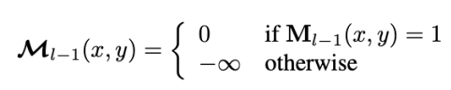
Why is Mask2Former considered a unified model for segmentation tasks?
Mask2Former is a unified model because it uses object queries to predict masks and classes without distinguishing between “things” and “stuff”.
Each query represents a region, allowing the model to handle semantic, instance, and panoptic segmentation within a single framework.
Write the Information Bottleneck objective and explain each term.
The Information Bottleneck objective is $L=I(X;Z)-βI(Z;Y)$. It minimizes the mutual information between input and representation to achieve compression, while maximizing the mutual information between representation and labels to preserve relevant information.
Why minimize $I(X;Z)$and maximize $I(Z;Y)$?
Minimizing $I(X;Z)$removes redundant and irrelevant information from the input. Maximizing $I(Z;Y)$ensures that the representation retains useful information for predicting the target.
Why is $Z=\{\#legs\}$not a good representation?
Although it provides strong compression, it does not preserve enough information to distinguish between classes. Multiple classes share the same number of legs, leading to low mutual information between Z and Y.
Why does a good representation reduce the need for labeled data?
A good representation organizes data in a meaningful way, often making it linearly separable. As a result, only a small amount of labeled data is needed to learn a simple decision boundary for classification.
How can we train models without labels?
We define self-supervised objectives based on the data itself. These proxy tasks provide training signals that allow the model to learn useful representations without requiring manual annotations.
What is a pretext task?
A pretext task is an auxiliary task with automatically generated supervision used to train a model on unlabeled data. It is designed to help the model learn useful representations.
What is shortcut learning and why is it problematic?
Shortcut learning refers to the model exploiting simple patterns in the data to minimize the loss without learning meaningful features. This leads to poor generalization and ineffective representations.
Why is designing pretext tasks challenging?
Designing pretext tasks is challenging because they must be related to the target task while avoiding trivial solutions. If the task is not well designed, the learned representations may not be useful.
Describe the training process of rotation prediction.
An image is sampled from the dataset and rotated by a predefined angle, such as 0°, 90°, 180°, or 270°. The rotation angle serves as the label, and the model is trained to predict this rotation using a classification loss.
Do we minimize all terms in the Information Bottleneck loss?
No. While the overall objective is minimized, it consists of minimizing $I(X;Z)$and maximizing $I(Z;Y)$. These terms represent a trade-off between compression and preserving relevant information.
Why does rotation prediction rely on photographic bias?
Because natural images have a preferred orientation, such as objects being upright. This allows the model to distinguish between correct and incorrect rotations.
What happens if all rotated versions are included?
The orientation bias disappears, making all rotations equally likely. As a result, the task becomes ambiguous and the model cannot learn meaningful representations.
Describe the training process of the jigsaw puzzle task.
An image is divided into patches, which are then shuffled. The model is trained to predict the correct arrangement of the patches using a classification loss.
What is a limitation jigsaw puzzle task?
The model may rely on low-level cues such as patch boundaries instead of learning high-level semantic information.
How many classes are needed for a 9-piece jigsaw puzzle?
A 9-piece jigsaw puzzle has $9!=362880$possible permutations. However, in practice, only a subset of permutations is used to reduce complexity.
Why does colorization help learn useful representations?
Colorization requires semantic understanding of the image, as different objects are associated with specific colors. This forces the model to learn meaningful features.
Why do we use Lab color space?
Lab separates luminance and color information, allowing the model to predict color given lightness. Additionally, distances in Lab space are more perceptually meaningful.
Why cast as classification?
By discretizing the color space and using classification, the model can represent multiple plausible color modes and avoid averaging effects.
Why does contrastive learning work without labels?
It constructs supervision signals using data augmentations, treating augmented views of the same image as positive pairs and other images as negative pairs.
What is contrastive learning?
Contrastive learning is a self-supervised approach that learns representations by bringing similar samples closer and pushing dissimilar samples apart in the feature space.
Explain the contrastive (InfoNCE) loss and each term.
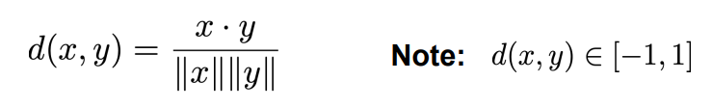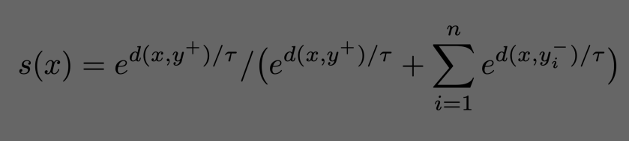
Temperature – a hyperparameter (usually between 0.01 and 1.0).
0<s(x)<1 s(x) → 1 positive similarity 非常大 negatives similarity 非常小 反之
L=−logs(x)
What is SimCLR?
SimCLR is a self-supervised learning framework that learns representations by maximizing agreement between augmented views of the same image using contrastive loss.
Why does SimCLR require a large batch size?
A large batch size provides more negative samples, making the task harder and improving representation learning. It also reduces gradient variance by providing a better approximation of the data distribution.
What is MoCo Momentum contrast?
MoCo is a contrastive learning framework that uses a momentum encoder and a queue to maintain a large and consistent set of negative samples.
Why do we need MoCo instead of SimCLR?
SimCLR requires large batch sizes to obtain many negative samples. MoCo addresses this by using a queue of negative samples and a momentum encoder to ensure consistency without large memory requirements.
Explain the momentum update rule and discuss the effect of m being too high or too low.
The update rule is $θ_{k}←mθ_{k}+(1-m)θ_{q}$
A high m leads to stable but potentially outdated features, while a low m causes fast updates and inconsistency. A balance is required.
Describe the training process of DINO.
An image is augmented into multiple views. The student and teacher networks process these views and produce probability distributions. The student is trained to match the teacher outputs using a cross-entropy loss.
Why does DINO produce meaningful attention maps without labels?
DINO enforces consistency between local and global views, which encourages the model to learn semantic structures, resulting in meaningful attention maps even without labels.
How does DINOv2 improve over DINO?
DINOv2 improves DINO by using curated data, removing redundancy, and training on more diverse samples, leading to better representations without changing the loss.
How does DINOv3 differ from DINOv2?
Compared to DINOv2, DINOv3 introduces Gram Anchoring to improve local consistency, in addition to scaling the model and dataset.
Describe the training pipeline of MAE Masked Feature Prediction.
The encoder processes only visible patches, while the decoder reconstructs the masked patches. The model is trained using a reconstruction loss.
Why are MAEs conceptually similar to contrastive learning?
Both MAE and contrastive learning generate different views of the same image and encourage consistent representations across them.
What is fine-tuning in SSL?
Fine-tuning refers to adapting a pretrained model to a downstream task using labeled data.
Why do we still need labeled data to evaluate SSL models?
Labeled data is required to objectively evaluate the quality of learned representations on downstream tasks.
Fine-tuning on the downstream tasks •Pros •Cons
•Pros Typically leads to best task performance (e.g. accuracy, IoU).
•Cons Our model becomes task-specific; cannot be re-used for other tasks.
What is linear probing? •Pros •Cons
Linear probing evaluates a pretrained model by freezing its parameters and training only a linear classifier on top.
Pros: We can re-use the model for other tasks by training multiple linear projections.
•Cons: Typically worse task accuracy than fine-tunining.
Why can k-NN be used to evaluate representation quality?
It evaluates whether the learned representations cluster similar samples together and separate different classes.
Compare k-NN and linear probing.
k-NN requires no training, while linear probing trains a linear classifier; both evaluate representation quality. Cons: Prediction can be a bit costly
What is meant by “semantic correspondence” in DINO features?
Semantic correspondence refers to the ability to match points across images that belong to the same semantic part (e.g., legs or heads), regardless of appearance differences.
What is meant by “lack of geometrical understanding” in DINO features?
Lack of geometrical understanding means that features fail to capture precise spatial relationships such as position, shape, or structure, even if they capture semantic similarity.
What is part co-segmentation?
Part co-segmentation is the task of segmenting corresponding semantic parts (e.g., limbs or heads) across multiple images.
Why can DINO features be used to segment background (stuff) regions?
DINO features encode both object-level semantics and background context, making features of similar regions (including stuff) clusterable without supervision.
Semantic segmentation Learn a lower-dimensional embedding loss funncvtion？？
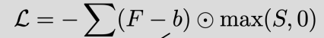
What are the two main self-supervised learning problems in videos?
The two main problems are: (1) segmenting objects in a video using motion cues, and (2) learning to track objects across frames using a video dataset.
What are the roles of networks G and I in motion-based segmentation?
Network G predicts an object mask from image and optical flow, while network I reconstructs the original optical flow from masked inputs.
What is cycle consistency in video representation learning （Contrastive random walk）?
Cycle consistency means that a point tracked forward and then backward through video frames should return to its original position.
Explain how label propagation works using the affinity matrix.
Compute the affinity matrix between frames.
Apply softmax to obtain transition probabilities.
Multiply by the label matrix to propagate labels.
Repeat across frames.
What is Edge Dropout in contrastive random walk?
Edge Dropout randomly removes edges in the affinity graph, reducing available connections during label propagation.
List and explain the main challenges in self-supervised learning.
Key challenges include designing effective proxy tasks, reducing computational cost, and understanding why the learned representations work.
What is semi-supervised learning?
Semi-supervised learning is a paradigm that uses both labeled and unlabeled data for training.
Semi-supervised loss
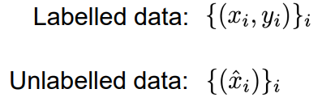
Why do we need the weighting factor $λ$?
The factor $λ$balances the contribution of unlabeled data, preventing unreliable unsupervised signals from dominating training.
What is the smoothness assumption in semi-supervised learning?
The smoothness assumption states that if two data points are close in the feature space, they are likely to share the same label.
What is the low-density assumption in semi-supervised learning?
The low-density assumption states that the decision boundary should lie in regions where the data density is low.
What is the manifold assumption in semi-supervised learning?
The manifold assumption states that data lies on low-dimensional manifolds in high-dimensional space, and points on the same manifold share the same label.
What is the difference between inductive and transductive semi-supervised learning?
Inductive learning aims to learn a general model applicable to new data, while transductive learning focuses on predicting labels only for the given unlabeled dataset.
What is unsupervised pre-processing in semi-supervised learning?
Unsupervised pre-processing is a two-stage approach where features are first learned from unlabeled data, followed by supervised training on labeled data.
What is self-training in semi-supervised learning?
Self-training is a semi-supervised method where a model is trained on labeled data, then used to generate pseudo-labels for unlabeled data, which are added to the training set.
What is Segment Anything (SAM)?
Segment Anything is a prompt-based segmentation model that produces object masks conditioned on user-provided prompts.
Describe the training pipeline of SAM.
The model is first trained with human-assisted annotations, then used to generate predictions refined by annotators, and finally used to automatically label large-scale datasets.
What is SAM3?
SAM3 is a segmentation model that aligns visual masks with natural language phrases, enabling concept-level segmentation.
Why is choosing the confidence threshold difficult in self-training?
A high threshold yields accurate but uninformative samples with little gradient, while a low threshold introduces noisy labels that can degrade model performance.
Why can self-training fail when the initial model is inaccurate?
If the initial model produces inaccurate predictions, these errors are used as pseudo-labels, leading to error accumulation and degraded performance.
Describe the self-training pipeline.
First, a model is trained on labeled data. Then, it predicts pseudo-labels for unlabeled data. The model is retrained on both labeled and pseudo-labeled data, and this process is repeated iteratively.
What is Virtual Adversarial Training?
Virtual Adversarial Training enforces consistency of model predictions under adversarial perturbations of the input.
Why does training on synthetic data often fail on real data?
Models trained on synthetic data may not generalize to real data because of differences in appearance, leading to distribution mismatch.
Explain how synthetic data is used in training.
Synthetic data is generated with automatic annotations and used for training, often combined with real data to improve generalization.
What is unsupervised domain adaptation?
Unsupervised domain adaptation is a learning setting where a model is trained on labeled source data and adapted to unlabeled target data with a different distribution.
Why does a model trained on source data fail on target data?
A model trained on source data learns decision boundaries based on source features, which may not apply to target features if they lie in different regions.
Describe how adversarial learning is used for domain alignment.
A discriminator is trained to classify whether features come from the source or target domain, while the feature extractor is trained adversarially to make both domains indistinguishable.
What is consistency regularisation?
Consistency regularisation enforces that a model produces similar predictions for different transformations of the same input.

