姓名：谭盛晞 学号U202411086 题号：A01

测试代码

#include <stdio.h>

#include <stdlib.h>

//choose A01 谭盛晞 U202411086

#define BEGIN 200

#define END 1000

int isNarcissistic(int x);//return 0 or 1

void displayNarcissistic(int x);//if x is Narcissistic,display it,if not,tell the user

int findNumbers(int x);//find how many numbers x has

int main(void)

{

int integer;

printf("I can help you see whether your number is Narcissistic or not!\n");

printf("please input a positive integer(q or negative numbers to quit)\n");

if( scanf("%d", &integer) != 1 || integer <= 0 ){

printf("wrong input");

}

else {

displayNarcissistic(integer);

}

int i;

printf("here is the narcissistic between 200 and 1000\n");

for(i = BEGIN; i <= END; i++){

displayNarcissistic(i);

}

return 0;

}

int findNumbers(int x){

int divider = 10;

int counter = 0;

while(x){

x /= divider;

++counter;

}

return counter;

}

int isNarcissistic(int x){

int counter = findNumbers(x);

int hold = x;//to hold the value of x

int i,j;

int sumOfCubes = 0;

for (i = 0; i < counter; i++){

j = x % 10;

x /= 10;

sumOfCubes += j \* j \* j;

}//en of for loop

int ret = 0;

if(sumOfCubes == hold){

ret = 1;

}

return ret;

}

void displayNarcissistic(int x){

if(isNarcissistic(x) == 1){

printf("Yes,it is!\n");

printf("%d = ", x);

int counter = findNumbers(x);

int i,j;

//as the last number should not be accompanied by "+" , the number of loop should minus 1

for (i = 0; i < (counter - 1); i++){

j = x % 10;

x /= 10;

printf("%d^3 + ", j);

}//end of for loop

j = x % 10;

printf("%d^3\n", j);

}

else{

printf("It is not a narcissistic number.\n");

}

}

1. 测试任务：测试函数scanf，考察其能否判断异常输入

测试方法：输入正常值和异常值，考察是否报错

测试结果：

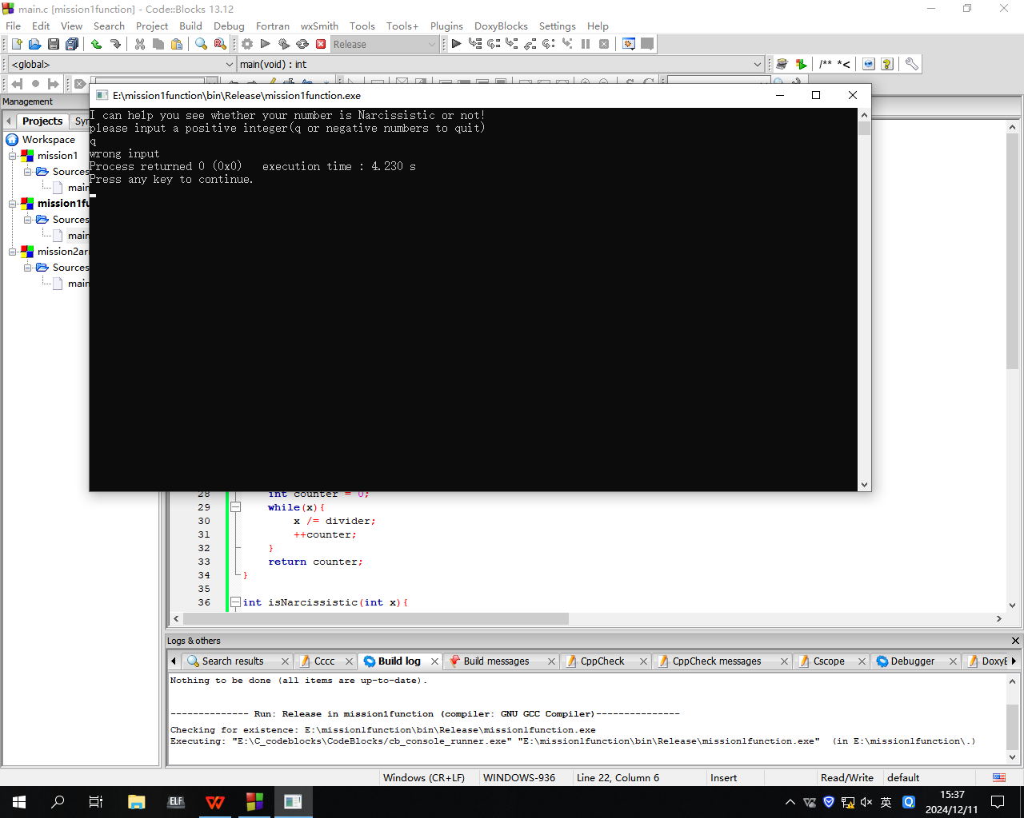

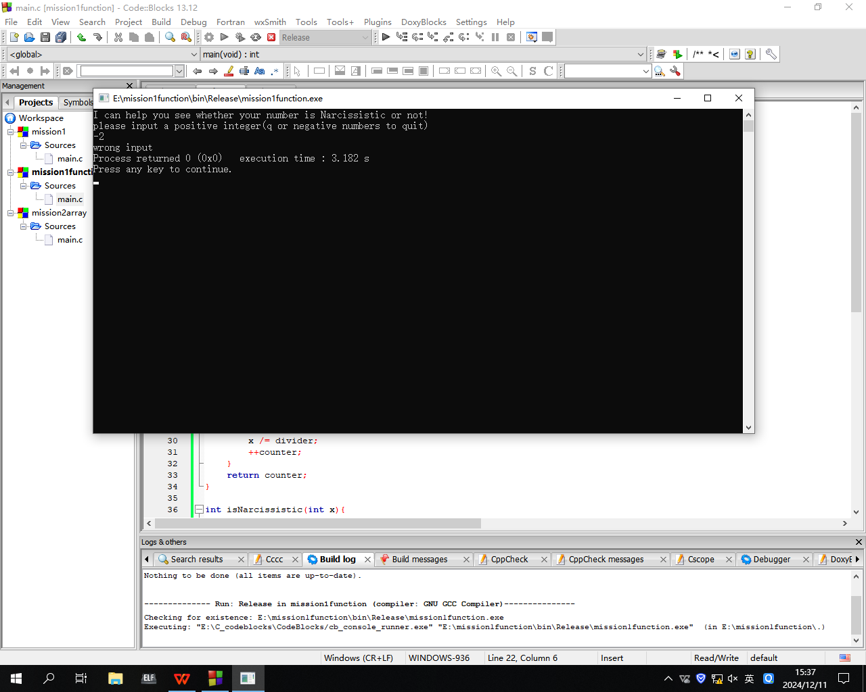

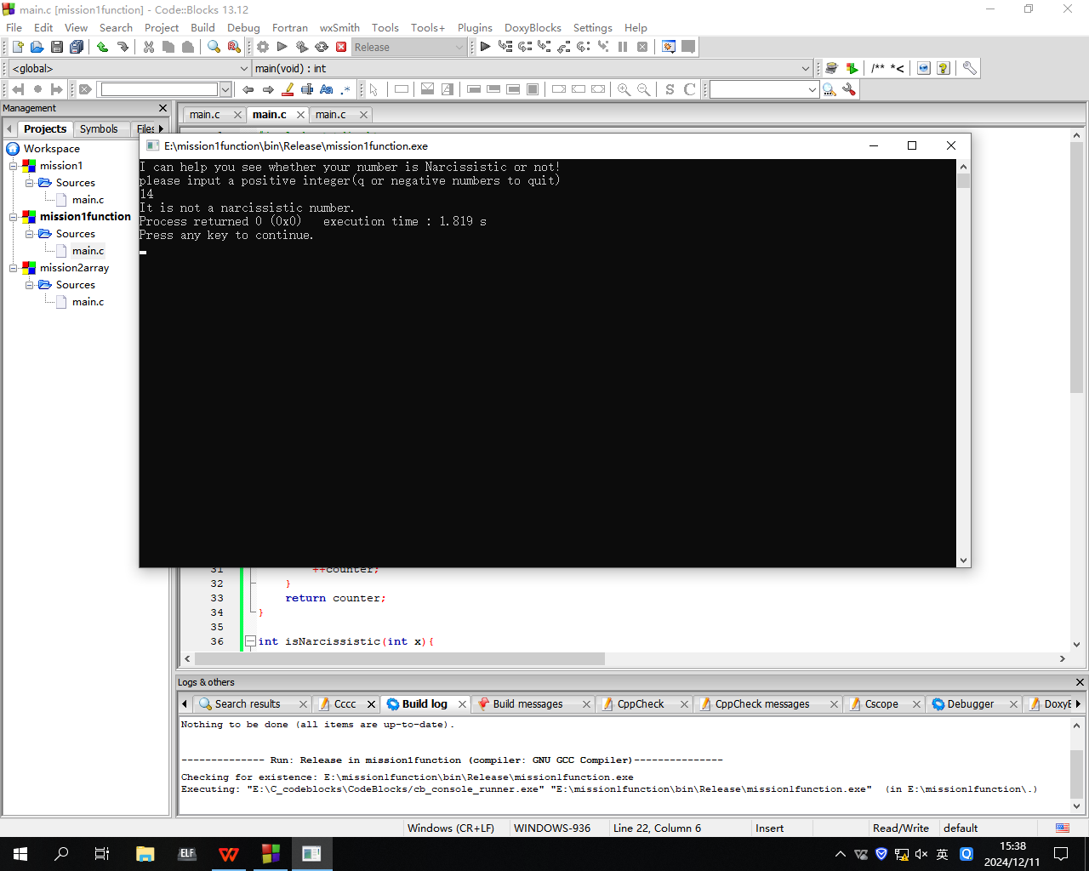

测试结论:合格

2.测试任务：测试函数isNarcissistic和display，考察其能否正确判断水仙花数并反应

测试方法：输入多个数字

测试结果：

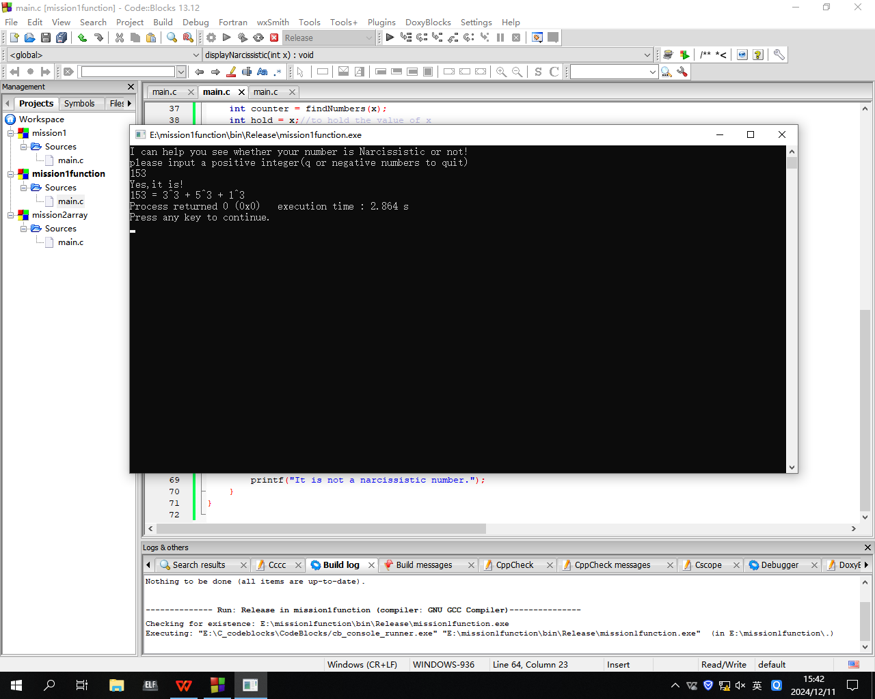

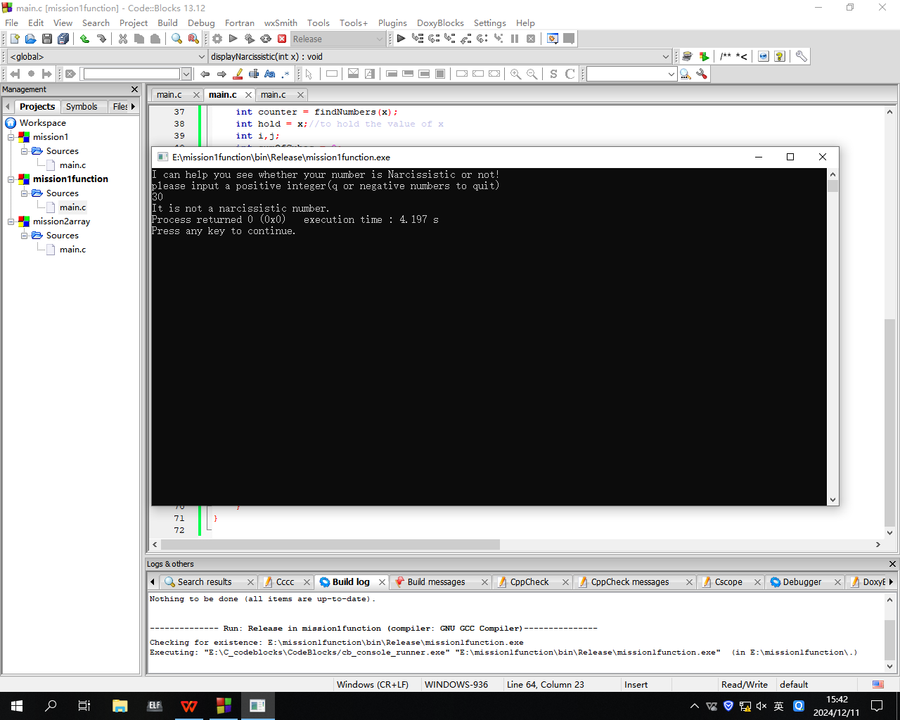

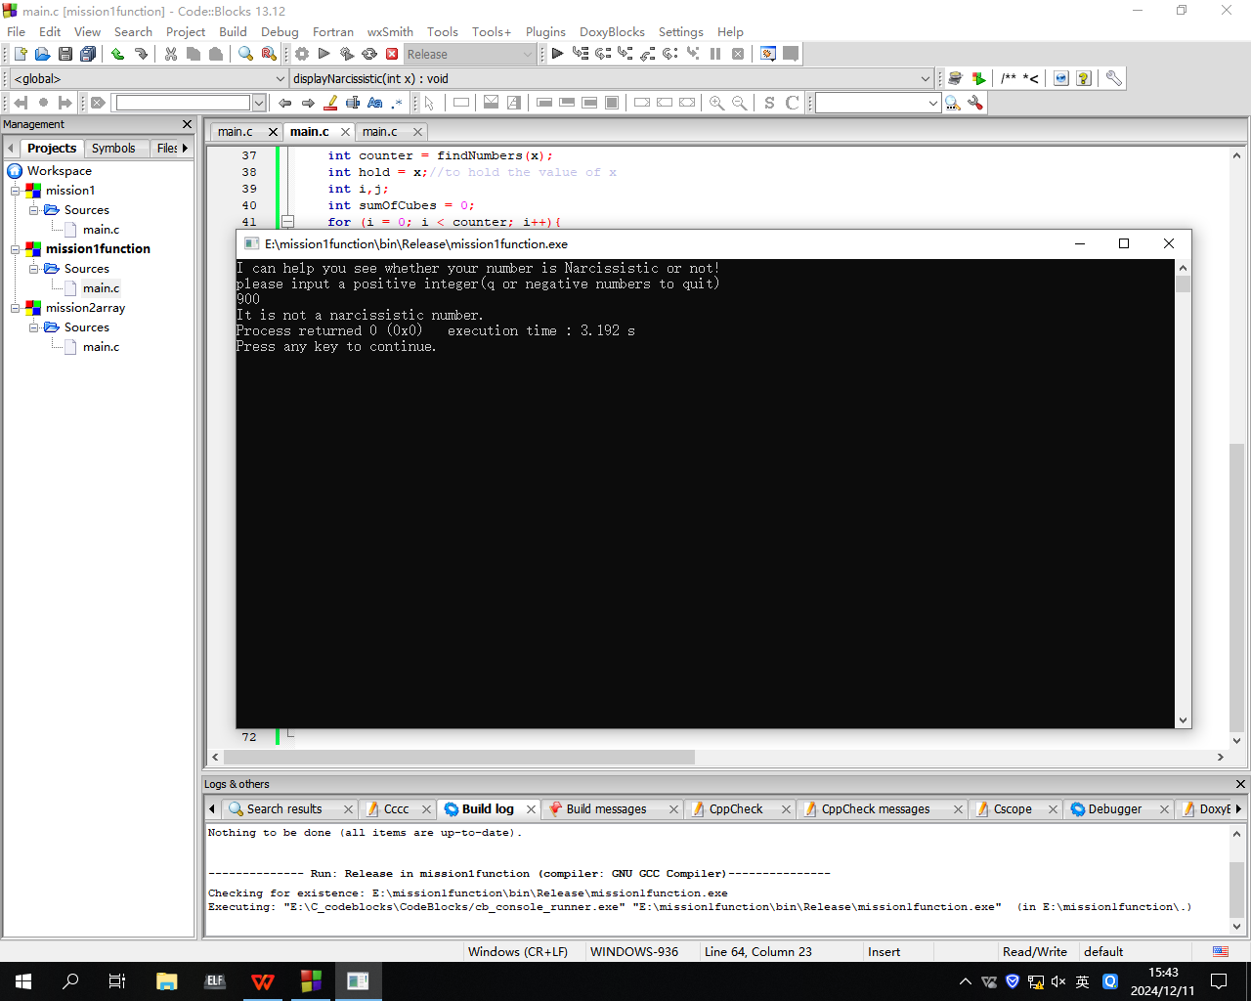

测试结论：合格

3.找到【200，1000】内所有的水仙花数并打印

测试结果：

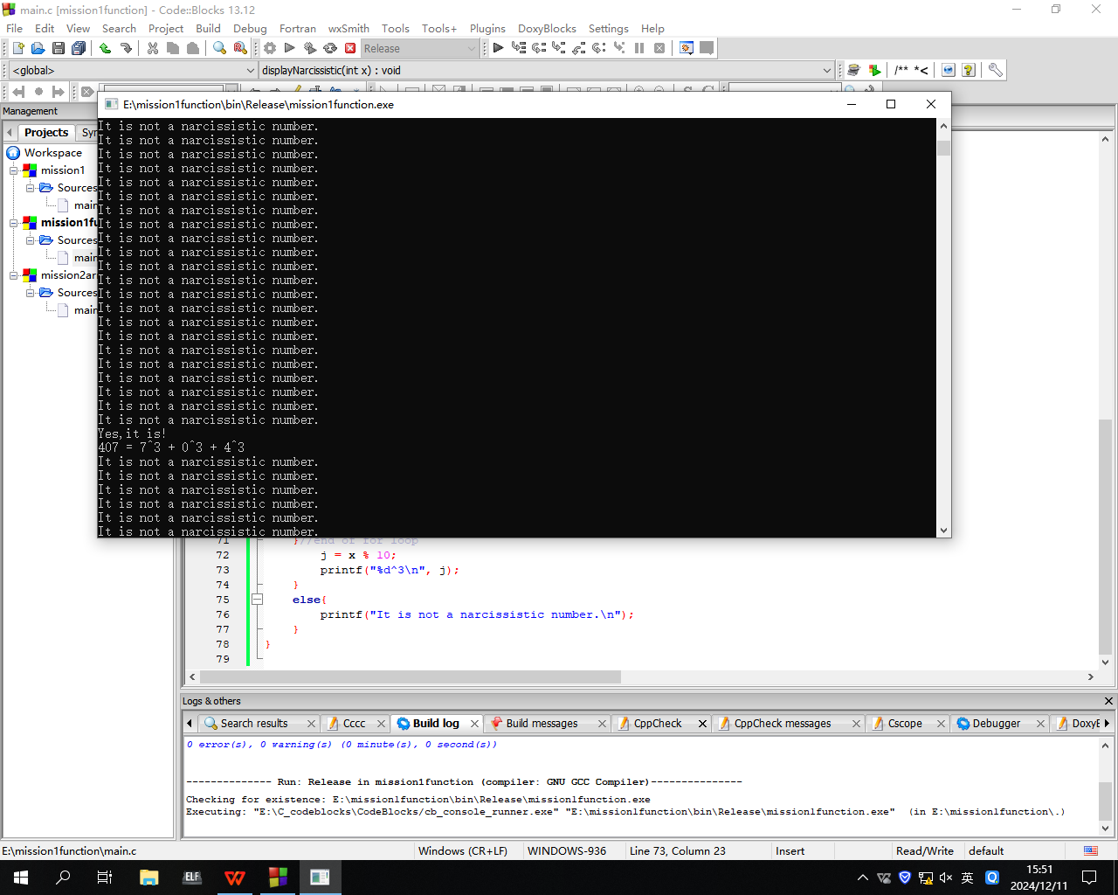

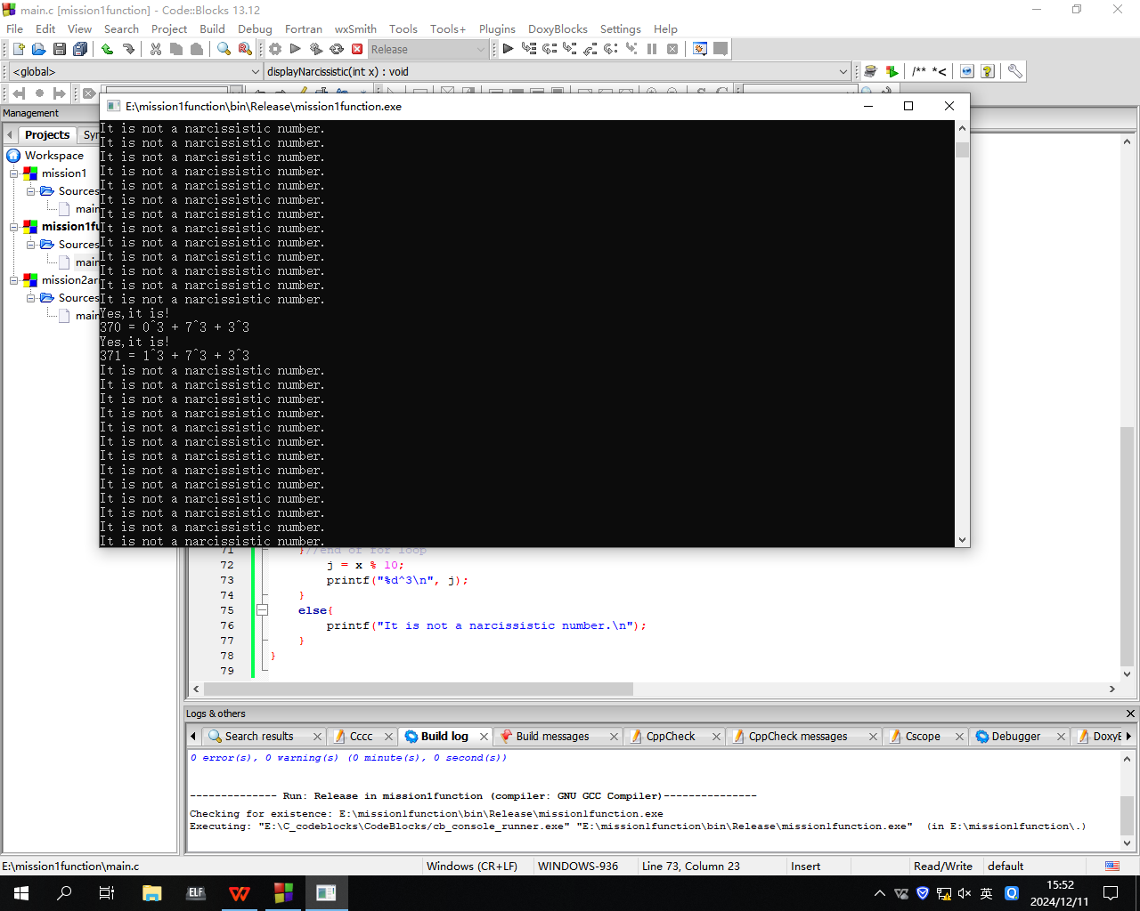

测试结论：共找到三个

测试结论：该题所有要求都完成