姓名：谭盛晞 学号U202411086 题号：B01

测试代码

#include <stdio.h>

#include <stdlib.h>

#define SIZE 20

#define MAX 99

//chooseB01

void setRandonArray(int x[], const int size);

void sortArrayBubble(int x[], const int size);

//as I am unfamiliar with pointers,I used another arrayN as my pointer.

void displayResults(int x[], const int size, int N[]);

int main()

{

int arr[SIZE] ={0};//initialize the array

setRandonArray(arr, SIZE);

sortArrayBubble(arr, SIZE);

int foundNum[1] = {0};

displayResults(arr, SIZE, foundNum);

printf("find %d qualified element groups", foundNum[0]);

return 0;

}

void setRandonArray(int x[], const int size){

srand( time(NULL) );

int i;

for(i = 0; i < size; i++){

x[i] = rand() % MAX + 1;//use % to control x[]

}

}

void sortArrayBubble(int x[], const int size){

int i,j;

int isSwapped,hold;

for(i = 0; i < size; i++){

isSwapped = 0;

for(j = 0; j < (size - i); j++){

if(x[j] > x[j+1]){

hold = x[j];

x[j] = x[j+1];

x[j+1] = hold;

++isSwapped;

}

}//end of inner for loop

if( isSwapped == 0){

break;

}

}//end of outer for loop

for(i = 0; i < size; i++){

printf("%d ",x[i]);//to see the sorted array

}

}

void displayResults(int x[], const int size, int N[]){

int differenceMax = (MAX - 1) / 2;

int i,j,n;

int numOfElement;

int potential[20] = {0};//an array to record potential qualified members

int potentialPosition[20] = {0};//record the index of potential qualified members

for( i = 0; i < differenceMax; i++){

for(j = 0; j < size; j++){

numOfElement = 0;

potential[0] = x[j];

potentialPosition[0] = j;

for(n = 1; n < size - j; n++){

if(x[j] == (x[j+n] - i) ){

++numOfElement;

potential[numOfElement] = x[j+n];

potentialPosition[numOfElement] = j + n;

}

}

if(numOfElement >= 3){

++N[0];

printf("\nfind one:\n");

int c;

for(c = 0; c < numOfElement; c++){

printf("arr[%d] = %d, ", potentialPosition[c], potential[c]);

}

}

}//the inner one to see if x[j] could be the element of this group

}//the outer loop to record the difference from 0 to its max

}

1. 测试任务：测试函数set random array 和 sort array bubble，考察其能否设置随机数列并排序

测试方法：测试多组随机数列

测试结果：

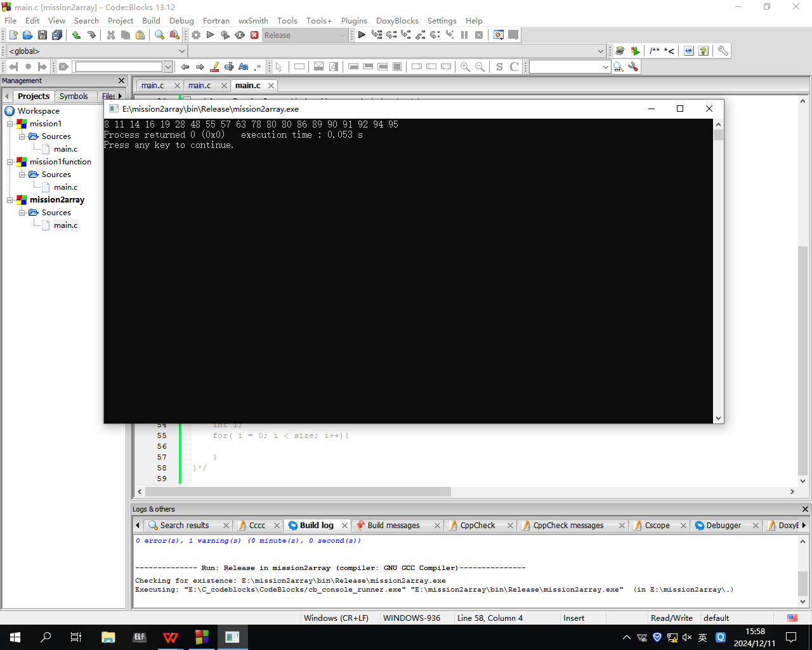

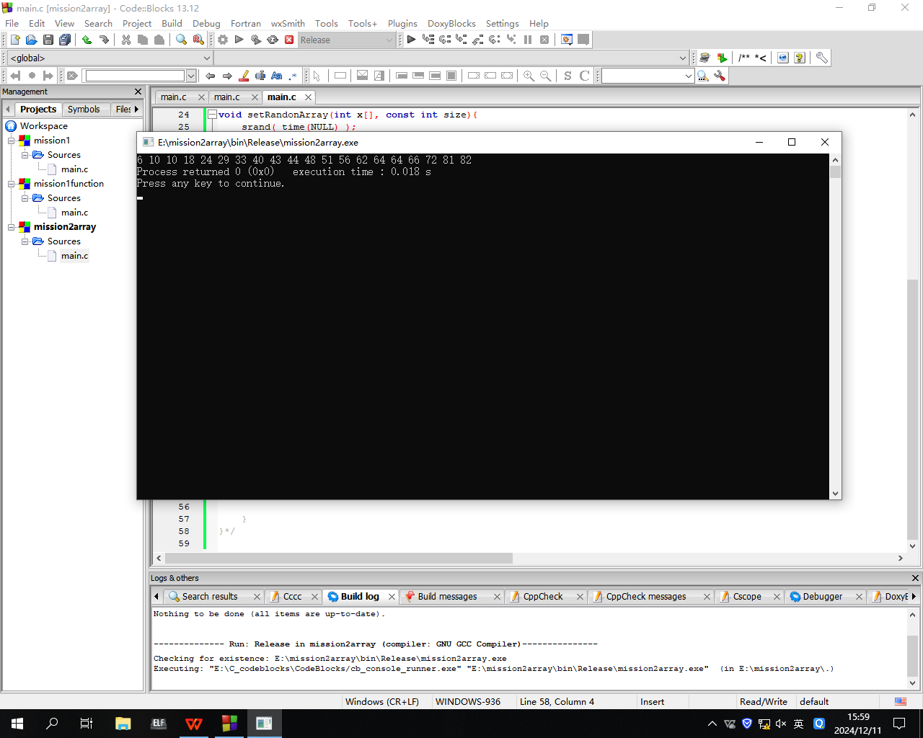

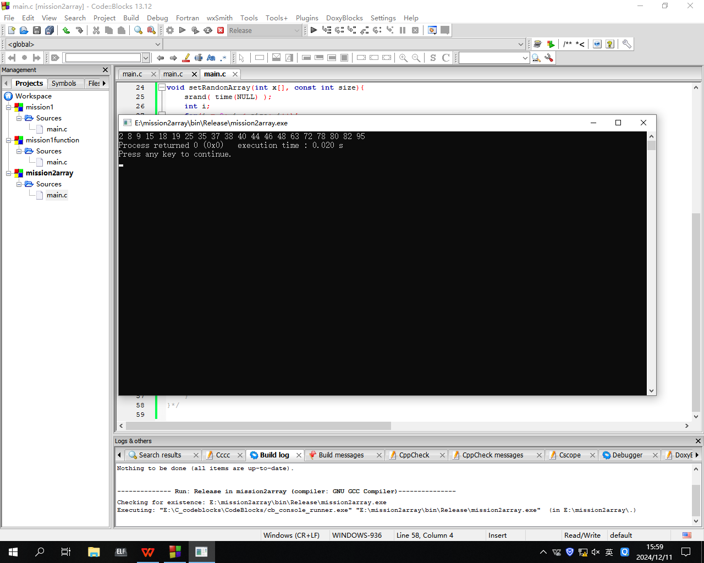

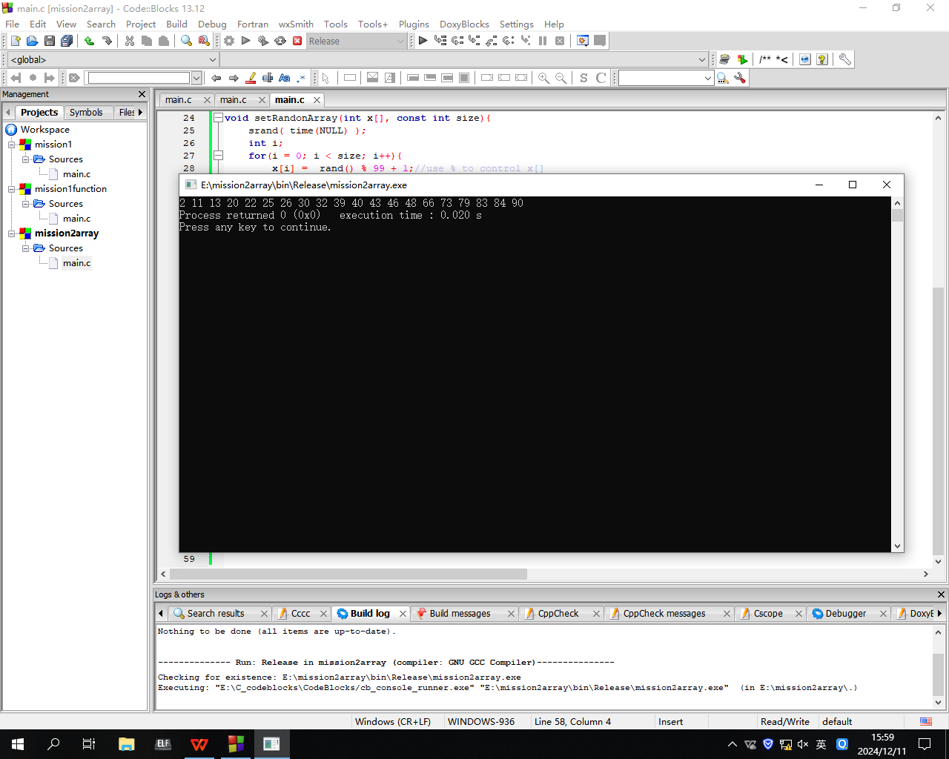

测试结果：合格

测试结论：该题的要求1和要求2已完成，要求3完成但无测试