

Concept of Systems

Version number/date

***1.0***

Customer name

*吳建達*

ECR name

**EC出貨明細表修改(eWMS)**

|  |  |
| --- | --- |
| Customer Name  (if applicable) | 吳建達 |
| Project Sponsor | Kevin |
| Approval auth: | Jacky |
| Author Name & Tel. No. | Ben |
| Project ID  (if applicable) |  |

|  |  |  |  |
| --- | --- | --- | --- |
| Document History | | | |
| Date | Version | Authors | Comments/Description of Change |
| 2023/10/23 | 1.0 | ben | First version |
|  |  |  |  |
|  |  |  |  |
|  |  |  |  |

DOCUMENT CONTROL

For Review By:

|  |  |  |  |
| --- | --- | --- | --- |
| Date | Organisation | Project Role | Name |
| 2023/06/27 | IT & AUTO | Solution design | Ben |
| 2023/06/27 | IT & AUTO | Developer | Jacky |
| 2023/06/27 | Operation | Customer | 吳建達 |

Owners and Approvers:

|  |  |  |  |  |  |  |  |
| --- | --- | --- | --- | --- | --- | --- | --- |
| Date | | Name | | Position | | Signature | |
|  | Ben | | Designer、BPO | |  | |
|  | Ken | | Solution leader | |  | |
|  | 吳建達 | | User | |  | |
|  | Jacky | | Developer | |  | |
|  | Kevin | | Develop leader | |  | |
|  | Kevin | | IT manager | |  | |

ECR sign off table:



Document Version Numbering

Document versions numbered ‘0.01, 0.02 etc’ are draft status and therefore can be changed without formal change control. Once a document has been formally approved and issued it is version numbered ‘Version 1.0’ and subsequent releases will be consecutively numbered, following formal change control. The version number appears in the footer of every page.

### *Definitions and Requirements*

Part 1 – The Business Case

1. What is the problem/opportunity we are addressing?
   1. Pursuit Summary

為避免消費者因出貨明細中的客戶名稱產生誤解。出貨明細表中的客戶名稱全部隱碼不顯示。

* 1. Summary of Business Requirements

現況說明 :

出貨明細中，客戶名稱只顯示第一個字，少部分客戶誤以為商品寄送錯誤。

業務需求說明 :

避免消費者因出貨明細中的客戶名稱，產生誤解。出貨明細中客戶名稱全部隱碼不顯示。

* 1. Objectives

修改eWMS EC出貨明細表(BarTender labels)中[客戶名稱]的數據庫來源為全部隱碼不顯示。

* 1. Financial Summary

N/A

1. What is the proposition/business change?
   1. Scope

Geography / Location : eslite Ping Zhen Logistics Park.

Product Users : eslite logistics High Jump User.

Organisation or Function : Warehouse personnel with eWMS authorization

1. 印出EC出貨明細表中[客戶名稱]及值為全部隱碼不顯示。

* Technology : SSMS、Bartender Label Design 。

# **In Scope**

1. Erp_site代碼: G016、C001

BarTender labels名稱: [EC 出貨明細表]樣本。

修改前[客戶]欄: 客戶名稱只顯示第一個字其他為隱碼，例如: 宋**。

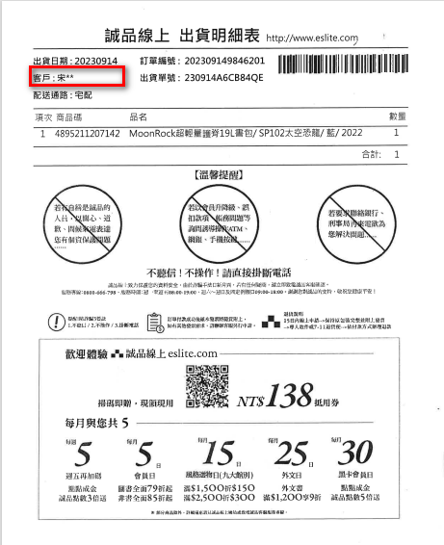

1. 修改後:

[客戶]欄 : 標題及資料來源全部不顯示，如圖。

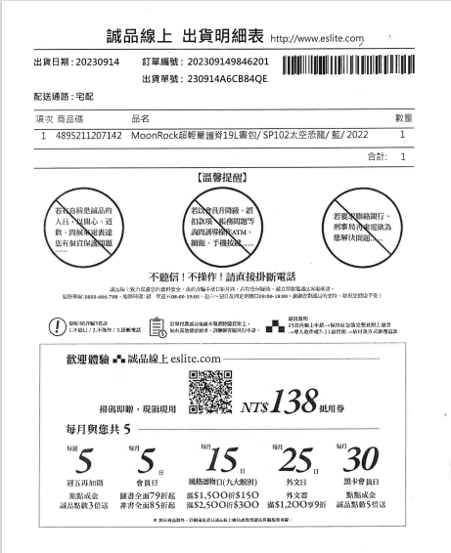

# **Out of Scope**

CB訂單及EC出貨到誠品門市、供應商的出貨單不在範圍內。

不在上述系統，不在此設定及驗證範圍。

* 1. Recommended Solution Design

1. Infrastructure
2. Peripherals (printers, PCs, RF unit s etc.)

N/A

1. Network (routers, cabling RF access points, LAN and WAN solution)

Existing network and Wi-Fi

1. Hosts (Servers for application)

BarTender server

1. Software (for PCs and Host, included Operating Systems, Databases, and other software needs).

BarTender

1. Development Environment

BarTender Label Design

1. Other Hardware

N/A

1. Integration
2. Specific transactions and type (e.g. EDI940, EDIFACT DESADV):

N/A

1. Transport mechanism (e.g., VAN, MQ Series):

|  |  |  |
| --- | --- | --- |
| **Data Interface Message Detail\*** | |  |
| 1 | No of EDI messages | N/A |
| 2 | Message Type* | N/A |
| 3 | Connectivity Protocol* | N/A |

1. Application

Bartending Services

1. Reporting

BarTender Label Design

1. Security And Data Sensitivity

N/A

1. IT Resilience
2. Any unique requirement to fulfil RTO (Recovery Time Objective) and RPO (Recovery Point Objective) requirements resulting from the Business Impact Analysis (BIA) and Risk Analysis (RA) (e.g. off-site storage, alternative locations)

To follow existing eslite backup policy. All usage records will be classified in the enterprise cloud, and data analysis can be carried out in accordance with regulations.

1. Any requirement regarding level of redundant network connections

To follow existing eslite Logistics network redundant structure.

1. Any unique requirement regarding Availability, Data Backup, Archiving / History Requirements

To follow existing eslite Logistics Interfaces

1. Interfaces
2. Internal applications

High Jump

1. Client applications

Windows 10、11

1. Third Party applications

N/A

1. Client Systems

Windows 10 PC: High Jump

1. External Organisations/Third Party Interfaces

N/A

1. Planning Assumptions

N/A

**

|  |  |  |
| --- | --- | --- |
|  | Planning Assumptions | Owner |
| 1 | eslite will run the WH for direct shipment to dealers or hospitals. In eslite WH, using WMS WMi to manage inventory level. |  |
| 2 | eslite will takeover shipment transportation and provide shipment track & trace |  |
| 3 | No EDI integration between eslite system and customer‘s ERP. |  |
| 4 | The quotation is based on current IT resource availability. The timeline or cost may be adjusted if local resource cannot support. |  |

1. Planning Constraints

No major constraints.

|  |  |  |
| --- | --- | --- |
|  | Planning Constraints | Owner |
| 1 |  |  |
| 2 |  |  |
| 3 |  |  |

Document the boundaries that are imposed on the project. Constraint Owner must be a person, not a job title.

1. Key Deliverables and Milestones
   1. Deliverable Schedule

Specify the key project deliverables for each phase of the project with a name and brief description. Please provide any key project delivery events within any of the above project stages.

(Information comes from IT slide)

|  |  |  |
| --- | --- | --- |
| NO | Key Milestone | Due date |
| 1 | Cos Determination | 2023/10/24 |
| 2 | SIT/FDD signed off | TDB |
| 4 | UAT signed off | TDB |
| 5 | WES go-live | TDB |
| 6 | Hyper Care | TDB |

1. Main Project Risks
   1. Enter both “indirect” risks e.g. “knock-on” impacts to the rest of the business and on outsourcers/3rd parties, and “Direct” risks, e.g. that requires system downtime, cannibalises existing products, draws scarce resources from BAU etc. Consider the level of risk in terms of the following questions:

* Is the Pursuit a new client or industry?
* Is this the first IT use of the Solution Set?
* Is there a lack of Executive Sponsorship?
* Do first year support costs exceed 40% or Project Cost?
* Has adequate Pursuit information been supplied?

|  |  |  |  |
| --- | --- | --- | --- |
| Risk Description | Probability  High/Medium/ Low | Impact  High/Medium/ Low | Management Action |
| User test | Low | Low | Test issue |
|  |  |  |  |
|  |  |  |  |

1. Service Level Agreements

Please document the key SLA’s as per the enclosed document.



1. Approach

Project Management is a key strategic enabler for the Logistics group that supports the effective delivery of customer solutions. The capability to successfully lead, manage and deliver projects, or new customer solutions, on time, on budget, and to required specifications is core to our business approach. The global project management process is employed by our skilled and experienced project management professionals to ensure the effective leadership and management of change.

eslite project management is a 5-phased project management methodology designed to meet the needs of all project management stakeholders regardless of project size or complexity. Aligned with the principles of the Project Management Institute (PMI), eslite project management provides a standard of project management methodology for eslite while ensuring adaptability to meet cultural needs.

The acronym, eslite project management ®, signifies the 5 phases of a eslite project: Define Plan, Implement, Control and Transition. As a project progresses through these five phases, governance is in place to ensure a continual quality, time and budget check.

1. Pursuit Controls
   1. Approvals Process

Summarise the internal approval process to which this Pursuit will be subjected.

* 1. Tolerances and Exception Procedure

What tolerances are permissible above and below the estimated time and cost without escalating the deviation to the next level of management for approval?

* 1. Change Management Procedures

What process will be followed, and what documentation will be used to manage any changes outside of the above tolerances?

* 1. Sign-Off Procedures

Detail below what documents will need to be signed off during this Pursuit, and the individuals who will be signing them off.

* 1. Document Repository

Where will the documents from this Pursuit be located? In most cases this should be Project folders. How will draft and signed-off documents be identified? What file structure will be used? Who will have access to this repository?

1. Items Not Included

N/A

Part 2 – Financial Case

1. IT Benefits

N/A

1. IT Cost Summar
   1. IT Cost Overview

|  |  |  |  |  |
| --- | --- | --- | --- | --- |
| NO | Item | Unit cost | Qty | Total |
| **Manpower** | | | | |
| 1 | Concept Of System | NTD15,000 | 3 | 45,000 |
| 1 | Developer | NTD15,000 | 5 | 75,000 |
| Sub total | | | | **NTD120,000** |
| **Purchase** | | | | |
|  |  | NTD0.0 | 0 | 0 |
| Sub total | | | | **NTD0** |
| Grand total | | | | **NTD120,000** |