

Concept of Systems

Version number/date

***1.0***

Customer name

*范淑順*

ECR name

**信義店撤店貨理貨報表修改(High Jump)**

|  |  |
| --- | --- |
| Customer Name  (if applicable) | 范淑順 |
| Project Sponsor | Kevin |
| Approval auth: | Jacky |
| Author Name & Tel. No. | Ben |
| Project ID  (if applicable) |  |

|  |  |  |  |
| --- | --- | --- | --- |
| Document History | | | |
| Date | Version | Authors | Comments/Description of Change |
| 2023/11/24 | 1.0 | ben | First version |
|  |  |  |  |
|  |  |  |  |
|  |  |  |  |

DOCUMENT CONTROL

For Review By:

|  |  |  |  |
| --- | --- | --- | --- |
| Date | Organisation | Project Role | Name |
|  | IT & AUTO | Solution design | Ben |
|  | IT & AUTO | Developer | Jacky |
|  | Operation | Customer | 范淑順 |

Owners and Approvers:

|  |  |  |  |
| --- | --- | --- | --- |
| Date | Name | Position | Signature |
|  | Ben | Designer |  |
|  | 范淑順 | User |  |
|  | Jacky | Developer |  |
|  | Kevin | Develop leader |  |
|  | Kevin | IT manager |  |

Project sign off table:



Document Version Numbering

Document versions numbered ‘0.01, 0.02 etc’ are draft status and therefore can be changed without formal change control. Once a document has been formally approved and issued it is version numbered ‘Version 1.0’ and subsequent releases will be consecutively numbered, following formal change control. The version number appears in the footer of every page.

### *Definitions and Requirements*

Part 1 – The Business Case

1. What is the problem/opportunity we are addressing?
   1. Pursuit Summary

信義店撤店貨2次退供模式(無來源到貨單號) ，無前段的到貨/收貨作業，後段發運流程相同，

退貨報表相關報表亦需跟進優化;將香港轉台灣退貨及信義店撤店貨2次退供納入報表。

* 1. Summary of Business Requirements

使用者現況描述:

* + - 1. 退貨人工喂入資料檔進Sorter 進行理貨作業.
      2. 貨物發運後己發運相關箱資料無串接現行報表。

需求說明:

1. 退貨經在庫及通過作業進行退貨行為

2. 做到貨登記/核單/指定流向/及人工制作檔案格式進Sorter作業的行為

3. SAP過帳號只要在如下單號的都須串接到退貨報表

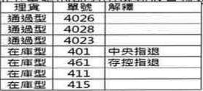

4. 退貨報表

4.1發運前報表

1. HJ_RPT_Pack_temp 退貨庫存暫存報表

4.2發運後報表

1. HJ_RPT_RTNSO_Shipping 退貨發運歷史資料
2. HJ_RPT_Manual_Food_Return 退貨單號查詢報表
3. HJ_RPT_Carrier_Return 退供-承運商運送報表

補充說明:

以上報表數據來源主體為包件暫表，經驗證A、C 的條件抓包件暫箱號識別退貨箱，測試可以正常查詢故不需修改。

B、C報表修正後，退貨發運批次號在執行發運確認後才能查詢，未完成發運結案亦查不到無法印[退供-承運商運送報表]。

* 1. Objectives

特殊退貨作業模式產生的4開頭退供單號，納入退貨發運報表:

1. HJ_RPT_RTNSO_Shipping 退貨發運歷史資料。
2. HJ_RPT_Carrier_Return 退供-承運商運送報。
   1. Financial Summary

N/A

1. What is the proposition/business change?
   1. Scope

Geography / Location : eslite Ping Zhen Logistics Park.

Product Users : eslite logistics High Jump User.

Organisation or Function : Warehouse personnel with HJ authorization

* Technology

SSRS 報表伺服器解決方案:

IT Designer Tools: Report Designer、Report Manager。

User Report view : Microsoft Edge, Google Chrome。

**In Scope**

1. 樣式不需變更 :

HJ_RPT_RTNSO_Shipping【退貨發運歷史資料】:

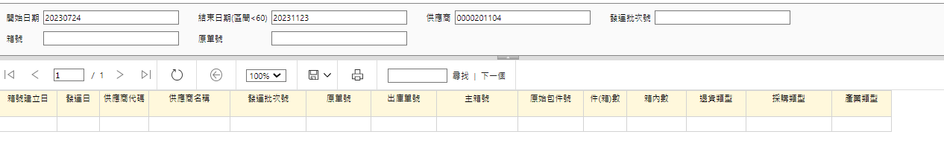

HJ_RPT_Carrier_Return【退供-承運商運送報】:

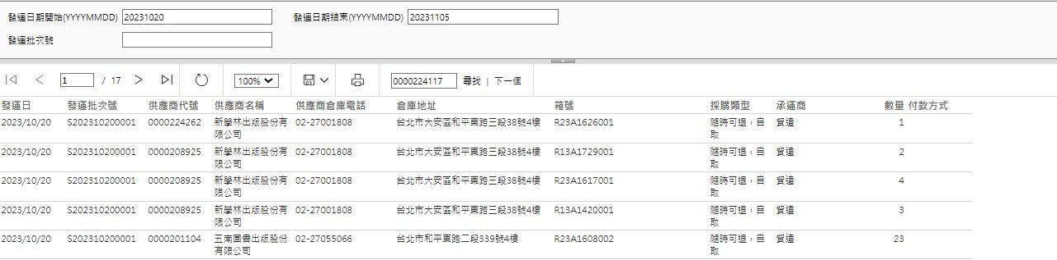

1. 報表來源資料說明:

* 【退貨發運歷史資料】報表來源:

|  |  |  |
| --- | --- | --- |
| **HJWMS..AAD**  **SP** | **資料表** | **功能說明** |
| _SP_HJ_RPT_RTNSO_Shipping | _t_order_carton_master | 包件管理 |
|  | _tv_vendor | 供應商資料 |
| 退貨包件條件:  採購單前3碼 等於 (505，515)  供應商代號<> F001 | | |
| 調整查詢條件: | | |
| 退貨包件條件:  出貨單前1碼在 (4)  且供應商代號 <> F001 | | |

* 【退供-承運商運送報】報表來源:

|  |  |  |
| --- | --- | --- |
| **HJWMS..AAD**  **SP** | **資料表** | **功能說明** |
|  | _t_order_carton_master | 包件管理 |
|  | _tv_vendor | 供應商資料 |
| 退貨包件條件:  採購單前3碼在(505，515) 或 carton_type 在 (RSO，REJ) | | |
| 調整查詢條件: | | |
| 退貨包件條件:  出貨單前1碼在 (4)  供應商代號<> F001 | | |

# **Out of Scope**

退貨報表若為分析用類型例如: [退貨進銷存報表]與到貨、收貨相關不適用特殊模式不在此範圍。

* 1. Recommended Solution Design

1. Infrastructure
2. Peripherals (printers, PCs, RF unit s etc.)

N/A

1. Network (routers, cabling RF access points, LAN and WAN solution)

Existing network and Wi-Fi

1. Hosts (Servers for application)

HJ DB、SSRS

1. Software (for PCs and Host, included Operating Systems, Databases, and other software needs).

SQL Server Reporting Services

1. Development Environment

SSRS

1. Other Hardware

N/A

1. Integration
2. Specific transactions and type (e.g. EDI940, EDIFACT DESADV):

N/A

1. Transport mechanism (e.g., VAN, MQ Series):

|  |  |  |
| --- | --- | --- |
| **Data Interface Message Detail\*** | |  |
| 1 | No of EDI messages | N/A |
| 2 | Message Type* | N/A |
| 3 | Connectivity Protocol* | N/A |

1. Application

SQL Server Reporting Services

1. Reporting

Report Designer

1. Security And Data Sensitivity

N/A

1. IT Resilience
2. Any unique requirement to fulfil RTO (Recovery Time Objective) and RPO (Recovery Point Objective) requirements resulting from the Business Impact Analysis (BIA) and Risk Analysis (RA) (e.g. off-site storage, alternative locations)

To follow existing eslite backup policy. All usage records will be classified in the enterprise cloud, and data analysis can be carried out in accordance with regulations.

1. Any requirement regarding level of redundant network connections

To follow existing eslite Logistics network redundant structure.

1. Any unique requirement regarding Availability, Data Backup, Archiving / History Requirements

To follow existing eslite Logistics Interfaces

1. Interfaces
2. Internal applications

SQL Server Reporting Services

1. Client applications

Windows 10、11

1. Third Party applications

N/A

1. Client Systems

Windows 10 PC: Microsoft Edge, Google Chrome

1. External Organisations/Third Party Interfaces

N/A

1. Planning Assumptions

N/A

**

|  |  |  |
| --- | --- | --- |
|  | Planning Assumptions | Owner |
| 1 | eslite will run the WH for direct shipment to dealers or hospitals. In eslite WH, using WMS WMi to manage inventory level. |  |
| 2 | eslite will takeover shipment transportation and provide shipment track & trace |  |
| 3 | No EDI integration between eslite system and customer‘s ERP. |  |
| 4 | The quotation is based on current IT resource availability. The timeline or cost may be adjusted if local resource cannot support. |  |

1. Planning Constraints

No major constraints.

|  |  |  |
| --- | --- | --- |
|  | Planning Constraints | Owner |
| 1 |  |  |
| 2 |  |  |
| 3 |  |  |

Document the boundaries that are imposed on the project. Constraint Owner must be a person, not a job title.

1. Key Deliverables and Milestones
   1. Deliverable Schedule

Specify the key project deliverables for each phase of the project with a name and brief description. Please provide any key project delivery events within any of the above project stages.

(Information comes from IT slide)

|  |  |  |
| --- | --- | --- |
| NO | Key Milestone | Due date |
| 1 | Cos Determination | 2023/11/24 |
| 2 | SIT/FDD signed off | TBD |
| 4 | UAT signed off | TBD |
| 5 | WMS go-live | TBD |
| 6 | Hyper Care | TBD |

1. Main Project Risks
   1. Enter both “indirect” risks e.g. “knock-on” impacts to the rest of the business and on outsourcers/3rd parties, and “Direct” risks, e.g. that requires system downtime, cannibalises existing products, draws scarce resources from BAU etc. Consider the level of risk in terms of the following questions:

* Is the Pursuit a new client or industry?
* Is this the first IT use of the Solution Set?
* Is there a lack of Executive Sponsorship?
* Do first year support costs exceed 40% or Project Cost?
* Has adequate Pursuit information been supplied?

|  |  |  |  |
| --- | --- | --- | --- |
| Risk Description | Probability  High/Medium/ Low | Impact  High/Medium/ Low | Management Action |
| User test | Low | Low | Test issue |
|  |  |  |  |
|  |  |  |  |

1. Service Level Agreements

Please document the key SLA’s as per the enclosed document.



1. Approach

Project Management is a key strategic enabler for the Logistics group that supports the effective delivery of customer solutions. The capability to successfully lead, manage and deliver projects, or new customer solutions, on time, on budget, and to required specifications is core to our business approach. The global project management process is employed by our skilled and experienced project management professionals to ensure the effective leadership and management of change.

eslite project management is a 5-phased project management methodology designed to meet the needs of all project management stakeholders regardless of project size or complexity. Aligned with the principles of the Project Management Institute (PMI), eslite project management provides a standard of project management methodology for eslite while ensuring adaptability to meet cultural needs.

The acronym, eslite project management ®, signifies the 5 phases of a eslite project: Define Plan, Implement, Control and Transition. As a project progresses through these five phases, governance is in place to ensure a continual quality, time and budget check.

1. Pursuit Controls
   1. Approvals Process

Summarise the internal approval process to which this Pursuit will be subjected.

* 1. Tolerances and Exception Procedure

What tolerances are permissible above and below the estimated time and cost without escalating the deviation to the next level of management for approval?

* 1. Change Management Procedures

What process will be followed, and what documentation will be used to manage any changes outside of the above tolerances?

* 1. Sign-Off Procedures

Detail below what documents will need to be signed off during this Pursuit, and the individuals who will be signing them off.

* 1. Document Repository

Where will the documents from this Pursuit be located? In most cases this should be Project folders. How will draft and signed-off documents be identified? What file structure will be used? Who will have access to this repository?

1. Items Not Included

N/A

Part 2 – Financial Case

1. IT Benefits

N/A

1. IT Cost Summar

|  |  |  |  |  |
| --- | --- | --- | --- | --- |
| NO | Item | Unit cost | Qty | Total |
| **Manpower** | | | | |
| 1 | Concept Of System | NTD15,000 | 3 | 45,000 |
| 1 | Developer | NTD15,000 | 5 | 75,000 |
| Sub total | | | | **NTD120,000** |
| **Purchase** | | | | |
|  |  | NTD0.0 | 0 | 0 |
| Sub total | | | | **NTD0** |
| Grand total | | | | **NTD120,000** |