Graph Generator Excel Add-in

Manual

Beta version

# Description

The aim of this Excel Add-in is to automate the manual process of plotting X-Y scatter plots (e.g. SPT N-Val vs Depth, Cu vs Depth etc.) for large geotechnical datasets which requires classification of the data based on multiple fields such as Location, Geological Formation, Strata and Borehole ID. This Add-in would be particularly useful for data processing where charts are required to be plotted against different classification labels to identify patterns or if the charts need to be updated regularly.

# Disclaimer

Please remember to always check the charts generated using the add-in. If you have encountered any bugs, please report to ngweijian1867@gmail.com

# Contents

Description 1

Beta Disclaimer 1

Contents 1

Section 1: Installing the Add-In 2

Section 2: Generating Charts with Chart and Series Format 3

Section 2.1: Key Rules 3

Section 2.2: Understanding Fields Input 3

Section 2.3: Examples 4

Combination 1 Example 4

Combination 2 Example 7

Combination 3 Example 8

Section 3: Updating Charts 9

Section 3.1: Update Chart Data Example 10

Section 3.2: Update Chart Format Example 11

Section 4: Additional Function - Applying Chart Template 13

Section 5: Additional Function - Applying Series format to charts 14

Appendix A: Graph Generation Form 15

# Section 1: Installing the Add-In

To install the Add-In, please follow the steps below.

1. Download and extract the Add-In package file (AddIn_ChartsGenerator)
2. Copy the file “GraphGeneratorV01_TaskPane.xlam”

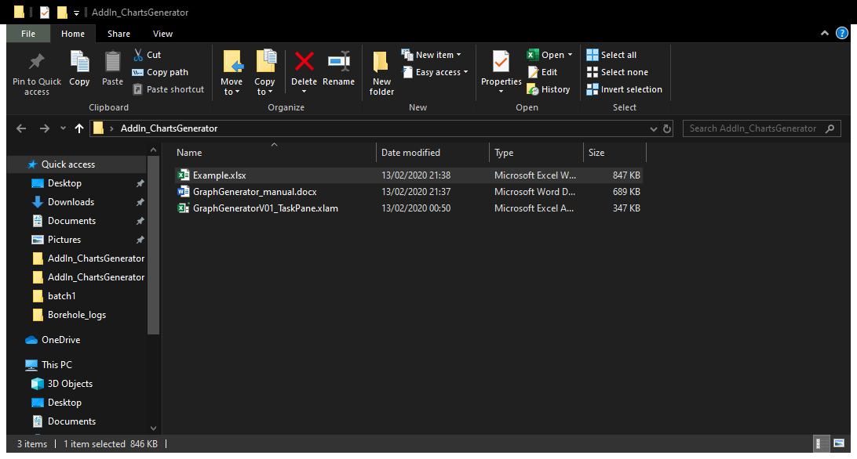

1. Paste it in the following folder: [%AppData%/Microsoft/Excel/XLSTART/](../../AppData/Roaming/Microsoft/Excel/XLSTART/)
2. Open Excel and the Add-In should be added under the heading called “Data Visualiser”

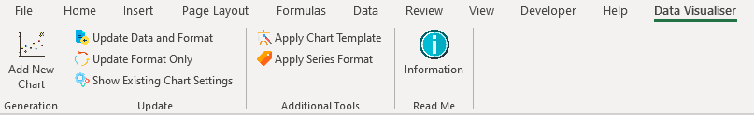

1. To uninstall the Add-In, remove the file “GraphGeneratorV01_TaskPane.xlam” from the following link: %AppData%/Microsoft/Excel/XLSTART/

# Section 2: Generating Charts with Chart and Series Format

## Section 2.1: Key Rules

To generate charts using the Add-in, please check for the following before proceeding:

1. Ensure first row of the Data is the Header.
2. Data starts from the second row onwards.
3. Field columns that classify each row of data (e.g. Location, Borehole Id, Geological Formation, Strata etc.) must not contain any blank data. Blank data in the field columns might cause error or incomplete plot. Therefore, it is recommended to fill in all the blanks in the field columns before charts generation.

Please note that the Add-in does run a simple algorithm to check for any possible blank data on the field columns, but it is the user’s responsibility to ensure that the data has been classified fully.

## Section 2.2: Understanding Fields Input

Fields are essentially the labels which classify each row of data. For a typical geotechnical dataset, this could be the location, geological strata, borehole ID, Geological Formation or Type of Chemical Test. Different combinations on the fields input for the chart generator will yield different set of charts being generated. The different combinations available are as detailed below:

1. **Combination 1 [Main Field – Exists, Secondary Field – None, Tertiary Field – None]:**

This would generate a single chart with the chart series defined by the unique values from the *Main Field* column.

1. **Combination 2 [Main Field – Exists, Secondary Field – Exists, Tertiary Field – None]:**

This would generate multiple charts as defined by the unique values from the *Main field* column and the chart series for each chart would be defined by the unique values from the *Secondary Field* column.

1. **Combination 3 [Main Field – Exists, Secondary Field – Exists, Tertiary Field – Exists]:**

This would generate multiple charts as defined by the unique values from the *Main* and *Secondary field* column. The chart title for all the charts would be a combination of the unique values from the *main and secondary field*. The chart series for each chart would be defined by the unique values from the *Tertiary Field* column.

This will be further clarified in the examples detailed in the next section.

## Section 2.3: Examples

This section demonstrates the different combination of charts that can be generated using the Add-in. Its highly recommended to follow through the example below to fully understand how different combinations on the fields input will yield different set of charts. I have provided an example data sheet (example.xlsx), located in the zip file for this Add-in. The “example1” sheet is part of a randomly generated CPTu data set and each row of the data has been classified by the following fields:

* PointID – Unique ID for the boreholes
* Assumed Material – The ground material where the field test has been undertaken
* Location – The general location of the borehole

### Combination 1 Example

**Plot undrained shear strength, NKT vs Depth;** **Su vs Depth; and Eu vs Depth in separate charts (side by side) and with series of the charts separated by Assumed Material.**

1. Under the “Data Visualiser” Tab, click on “Add New Chart”



1. Select the main data sheet from the drop-down list, in this case, “Example 1”.

*Note: The drop-down box is normally populated with the name of all the Worksheet that exists in the Workbook.*

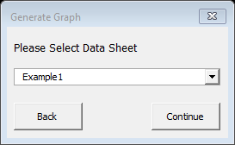

1. Click “Continue” and this would prompt the main Chart Generation Form to appear. See Appendix A for detail descriptions on each input field in the form.

*Note: By clicking continue, a “Template” sheet will also be added to the workbook if it doesn’t already exist. The template sheet contains the chart template which you can select to apply from the chart generation form. As a start a default template will be created.*

1. Fill in the form as shown in the figure below.

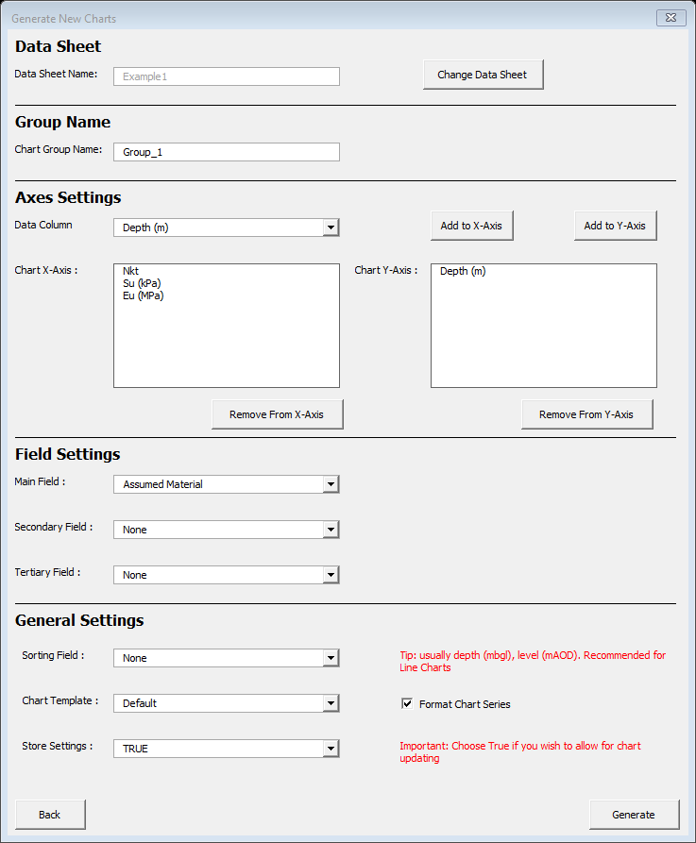

**Note:** You can change the chart template from this drop-down box. The drop-down box shows the different charts that are in the “Template” sheet.

The sorting key defines the axis to sort. This would sort the selected Axis before generating the chart

**Note:** You can have multiple X-Axis with a single Y-Axis or multiple Y-Axis with a single X-Axis but not multiple X and Y axis at the same time.

Use this to Add to X / Y axis.

1. Click generate and this would prompt a window which shows a summary on the chart settings.

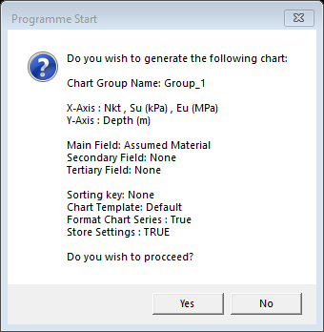

1. Click “Yes” and the programme will start. Status of the programme is shown on the bottom left hand corner of Excel window.



1. Once the programme has finished running, the following message box would appear.

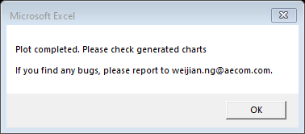

1. The charts generated are located at “Group_1_cht” sheet.

Based on the field combination, three charts have been generated –NKT, Su & Eu vs Depth for the charts with series for the charts separated by the Assumed Material. See figure below.

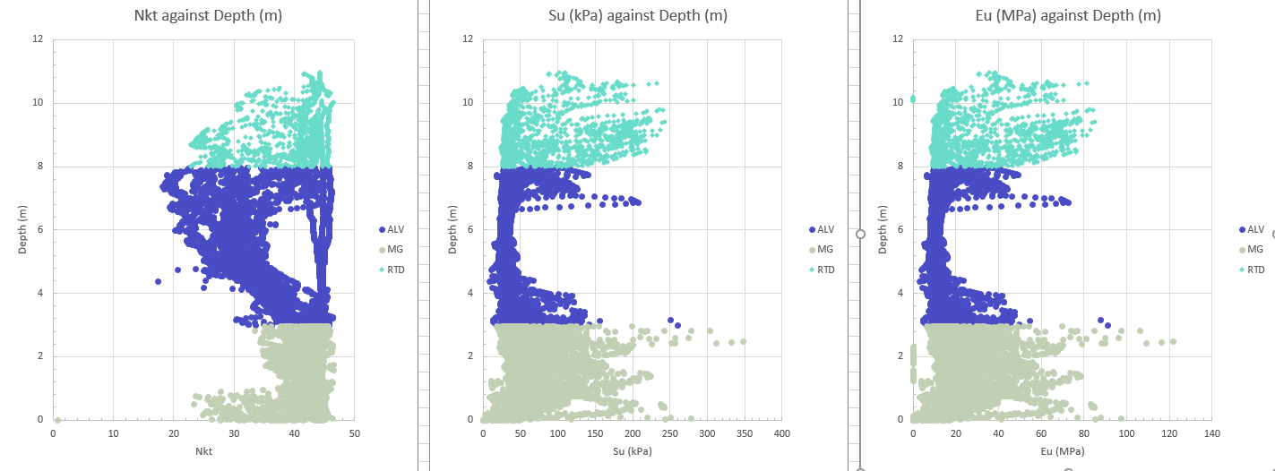

**Note:**

Chart Series separated by Assumed Material

**Important Note:**

1. All the charts generated are linked to the “Group_1” sheet which is a copy from the main data sheet (“Example 1”). This is to ensure that the programme will not modify the data from the main data sheet. Any changes made here will be reflected on the charts. **Do not change the sort settings at this page as this will cause the charts to reference incorrect cell ranges.**
2. Two additional sheets (“Settings” and “SeriesFormat”) have also been added to the workbook.

The “Settings” worksheet has been created to store the chart settings. This is to facilitate with charts updating which will be further discussed in Section 3.

The “SeriesFormat” worksheet has been created to store the series format. This is to facilitate with chart format updating which will be further discussed in Section 3.

### Combination 2 Example

**Plot NKT vs Depth; Su vs Depth; and Eu vs Depth for the different Locations and with series of the charts separated by Assumed Material.**

To do this, repeat steps 1 to 5 from example 1 but do the following:

1. Change the Group Plot Name to “Group_2”
2. Select “LOCATION” as the Main Field and select “Assumed Material” as the Secondary Field

This combination would yield 6 separate charts. One set of NKT vs Depth; Su vs Depth; and Eu vs Depth for Location A and another set for Location B. The series for the charts would be separated by Assumed Material.

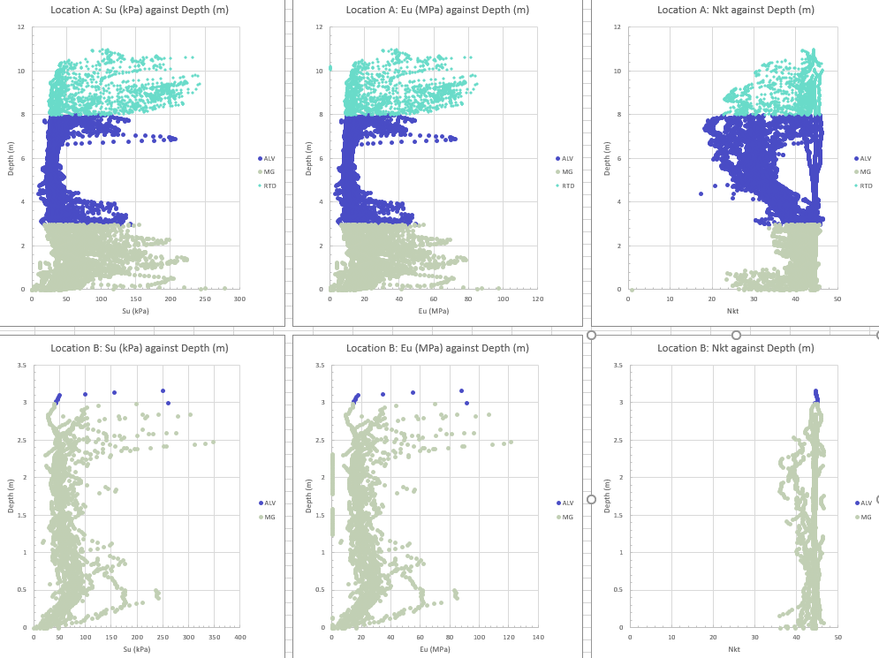

Charts for Location B

Charts for Location A

**Note:**

Chart Series separated by Assumed Material

### Combination 3 Example

**Plot NKT vs Depth; Su vs Depth; and Eu vs Depth for all Point Id and with series of the chart separated by Assumed Material. Additionally, each chart should also indicate the location it belongs to.**

To do this, follow steps 1 to 5 from example 1 but do the following:

1. Change the Group Plot Name to “Group_3”
2. Select “Location” as the Main Field, select “Point Id” as the Secondary Field and select “Assumed Material” as the Tertiary Field.

This process would yield 126 charts. 42 sets of NKT vs Depth; Su vs Depth; and Eu vs Depth charts, one for each borehole as defined by PointID. Additionally, the chart title for these charts would also show the location for these borehole (i.e. Location A or Location B) and the series for these charts would be separated by Assumed Material.

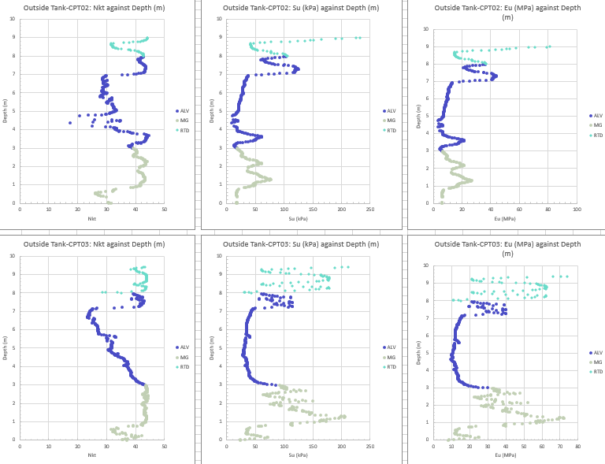

Chart Series separated by Assumed Material

Charts for each borehole.

Title showing location followed by PointID

# Section 3: Updating Charts

If you had selected “True” for the store setting (default setting) at the Chart Generation form, the chart settings will be saved in the “Settings” worksheet. Given the example above, the “Settings” worksheet should display the following:



To regenerate the charts with updated data or format, simply select “True” in the “Update Chart?” column and do the following:

1. Select “Update Data and Format”, if you wish to update the charts with an updated data and format. **Important Note: This would delete the existing Group Worksheets and it will regenerate the charts using the settings saved in the “Settings” worksheet. Consequently, this would update the charts with the new data and format.**



1. Select “Update Format Only” if you wish to update the chart formats only (Template and Series Format). **Important Note: This will update the chart formats only and it will not delete and regenerate the Group Worksheets as in the previous option.**



## Section 3.1: Update Chart Data Example

The example below demonstrates how the data for the charts generated in the previous examples can be updated to consider data from Location A only.

1. At the main data sheet, filter the data for Location A

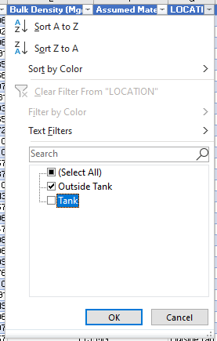

1. Click on the “Update Data and Format” button. This would prompt a pop-up window which shows a list of group plots that will be updated. **Note: You can select which group plots to update at the “Settings” sheet by choosing “True/False” at the “Update Chart?” column**





1. Click “Yes” and all the charts would be regenerated considering only the data from “Location A”

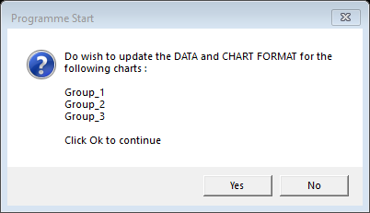

## Section 3.2: Update Chart Format Example

The example below demonstrates how the charts generated can be updated with a different chart template.

1. To create a new chart template, simply insert a new chart **(Scatter Plot)** and modify the chart format accordingly (resize, add legend, reposition legend, add chart title, add axis title etc.). For this example, I have created a chart with the following format.

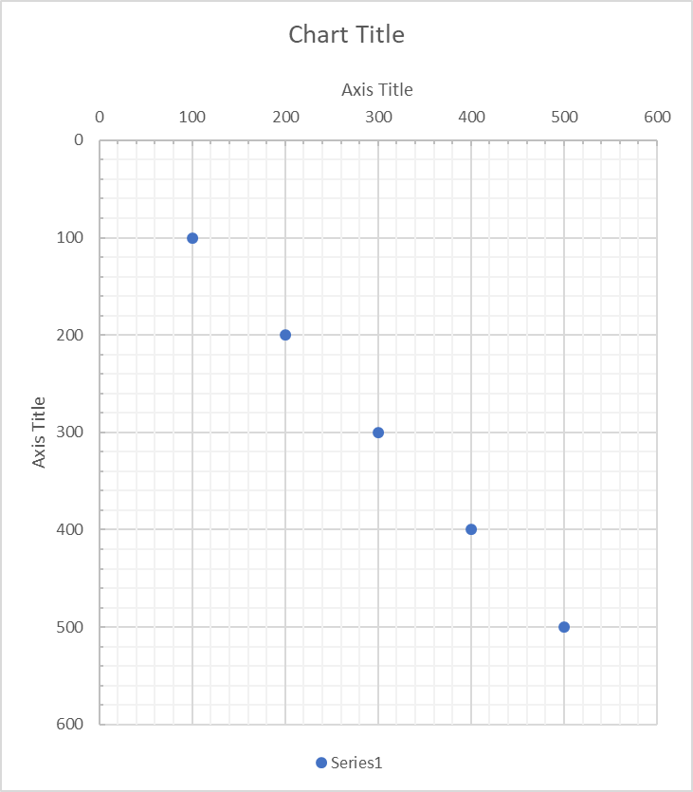

1. Rename the new template. To rename the new template, simply select the chart and rename the chart in the box located next to the Formula box as shown below. ***Note:*** *Remember to press* ***ENTER*** *after you have renamed the chart. Click on the chart again to confirm that the name has changed*

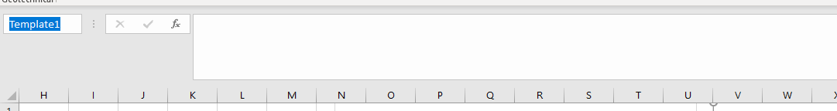

1. Format the chart series at the “SeriesFormat” sheet. Simply change the marker type, color and size according to your preference.

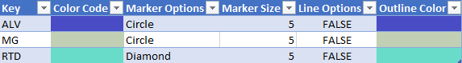

**Tips:** To generate line charts simply select “True” at the “Line Options” column and “None” for the Marker Options. To ensure smooth line charts, select the axis to be sorted at the “Settings” page and regenerate the charts by clicking “Update Data and Format” button.

1. Go back to “Settings” worksheet and change the template name (as defined in Step 2). In this case, “Template1”. **Please note that the following input is case sensitive**



1. Click on the “Update Format Only” button. This would prompt a pop-up window which shows a list of group plots that will be updated. **Note: You can select which group plots to update at the “Settings” sheet by choosing “True/False” at the “Update Chart?” column.**



1. Click “Yes” and all the charts would be updated with the selected chart template and series format as defined in the “Template” and “SeriesFormat” sheets.

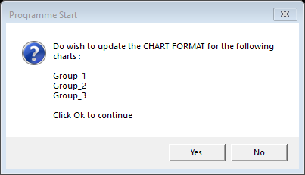

# Section 4: Additional Function - Applying Chart Template

To apply charts format to charts not generated by the Add-In, follow the steps below

1. Select “Apply Chart Template”.

*Note: By doing so, a “Template” sheet will be added to the workbook if it doesn’t already exist. The template sheet contains the chart template which you can select to apply from the chart generation form. As a start a default template will be created.*



1. Select the worksheet that has the charts you want to update at the Chart Sheet drop down list

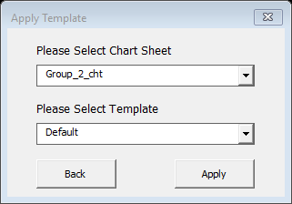

1. Select the template that you would like to use and click “Apply”

**Note:** To create your own template, simply follow steps 1 to 2 from Section 3.2



# Section 5: Additional Function - Applying Series format

To apply series format to charts not generated by the Add-In, follow the steps below

1. Select “Apply Series Format” at the Add-In task pane



1. Select the worksheet that has the charts to be updated from Chart Sheet drop down list

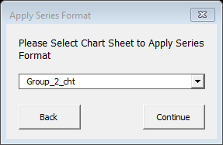

1. Click “Continue” and this would add a “SeriesFormat” sheet to the workbook and you will be prompted with the following message box. Click “Yes” and this would identify all the possible series from the chart worksheet you have selected earlier.

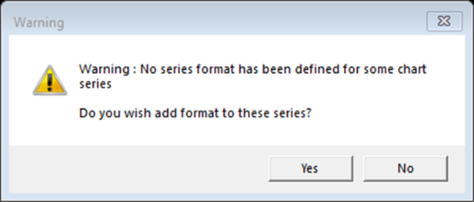

DF

1. After identifying all the possible series from the worksheet, you will be prompted with the following message box. Click “Yes” if you wish to update the charts with the auto generated default series format. Click “No” if you wish to change the series formatting first.

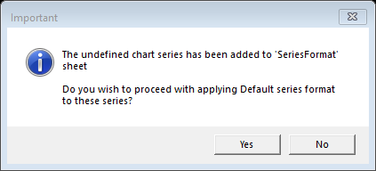

DF

# Appendix A: Graph Generation Form

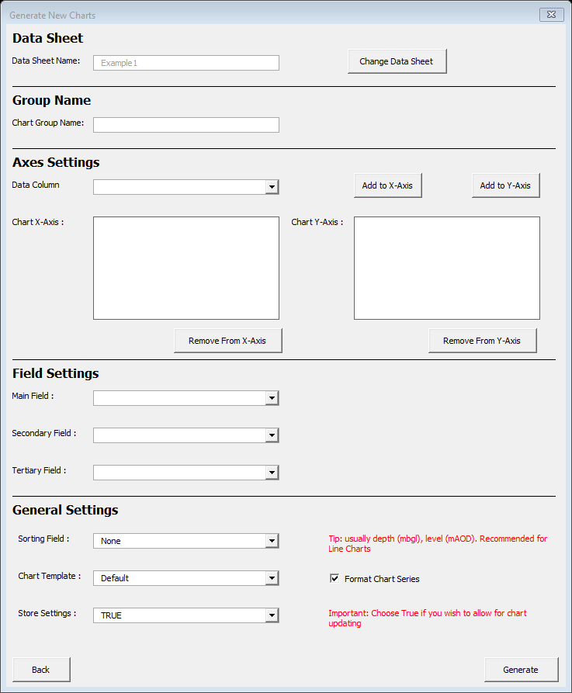

This define if you would like to format the chart series i.e. Changing marker size, color and type.

This define if you would like to store the chart settings. Storing the chart settings allows the charts to be updated with new data and format using the “Update” function.

This define the Axis where you want to sort the data. Useful if you are planning to plot line chart.

This define the Template that you would like to use for generating the charts. The template is defined in the “Template” sheet.

This define the field combination for your charts. See the different combinations on the next page.

List of X-Axis. You can have multiple X-axis that shares a common Y-Axis. This would generate charts side by side.

e.g. You can plot Cu vs Depth, Eu vs Depth side by side by specifying Cu and Eu for the X-Axis; and Depth for the Y-Axis.

List of Y-Axis. You can have multiple Y-axis that shares a common X-Axis. This would generate the charts side by side.

e.g. You can plot SPT N-Val vs Depth (mbgl) and SPT N-Val vs Elevation (mOD) side by side by specifying SPT N-Val for the X-Axis; and Depth (mbgl) and Elevation (mOD) for the Y-Axis.

Buttons to add data column to X or Y axis.

The Chart Group Name defines the title of the worksheet where your charts will be generated.

This dropdown list comprise of the header from the Data Sheet. You can select to add to X-Axis or Y-Axis.

This defines the name of your main data sheet. To change Data Sheet, click on the “Change Data Sheet” button on the right.