# 第四章 串

## 1 串的定长顺序存储

* 实现串插入操作 （不考虑截断情况）

#include <stdio.h>  
#include <string.h>  
​  
#define ERROR 0  
#define OK 1  
#define Status int  
​  
​  
//串的定长顺序存储表示  
#define MAXSTRLEN 255   
typedef unsigned char SString[MAXSTRLEN + 1];   
int StrInsert(SString *S,int pos,SString T)  
{  
}  
​  
void PrintStr(SString S)  
{  
}  
​  
​  
int main(void)  
{  
   SString s1 = {4,'a','b','c','d'};  
   SString s2 = {4,'e','f','g','h'};  
​  
   StrInsert(&s1,2,s2);  
​  
   PrintStr(s1);  
​  
   return 0;  
}

运行效果：

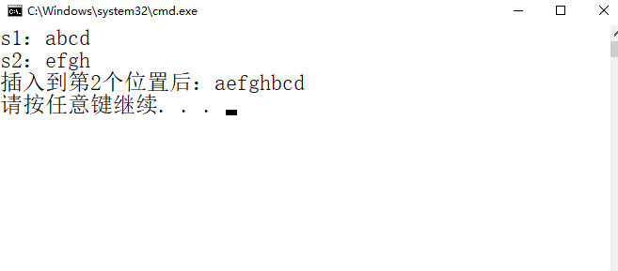

## 2 串的堆分配存储

* 查找S中是否有与T相同的子串，有的话，删除

#include <stdio.h>  
#include <stdlib.h>  
   
typedef struct {  
 char *ch;   
 int length;   
}HString;  
​  
int StrCompare(HString S,HString T)  
{  
}  
​  
int SubString(HString *Sub,HString S,int pos,int len)  
{  
​  
}  
​  
void PrintStr(HString S)  
{  
​  
}  
//查找S中是否有与T相同的子串，有的话，删除  
int strfun(HString *S,HString T)  
{  
}  
​  
int main(void)  
{  
 int i;  
 HString s1,T;  
 s1.ch = (char *)malloc(10 * sizeof(char));  
 s1.length = 10;  
 for (i = 0; i < s1.length; i++)  
 s1.ch[i] = 'a'+ i;  
 PrintStr(s1);  
 T.ch = (char *)malloc(3 * sizeof(char));  
 T.length = 3;  
 T.ch[0] = 'e';T.ch[1] = 'f';T.ch[2] = 'g';  
 PrintStr(T);  
   strfun(&s1,T);  
 PrintStr(s1);  
​  
 return 0;  
}

运行效果：

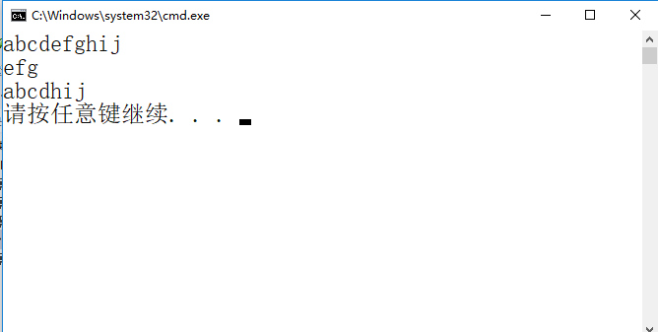

## 3 模式匹配算法

| **S** | **a** | **a** | **b** | **a** | **b** | **b** | **a** | **a** | **b** | **a** | **a** | **c** |
| --- | --- | --- | --- | --- | --- | --- | --- | --- | --- | --- | --- | --- |
| next | 0 | 1 | 2 | 1 | 2 | 1 | 1 | 2 | 3 | 1 | 1 | 1 |

| **P** | **a** | **a** | **b** | **a** | **b** | **c** |
| --- | --- | --- | --- | --- | --- | --- |
| next | 0 | 1 | 2 | 1 | 2 | 1 |

(1)主串S的next数组；

(2)模式串P的next数组；

(3)写出KMP算法匹配过程；