## Huffman树的应用——图像的压缩与解压

本题目是利用huffman编码方式对bmp格式的图像进行压缩与解压:

1. 根据图片格式利用fread函数，读取test.bmp图片文件；

2. 根据读取的数据，每个字节对应一个0~255的数值，生成Huffman树，并打印每个取值的Huffman编码（详见运行效果）；

3. 将test.bmp图片文件对应的0~255数值，用Huffman编码代替，并将总的01序列每8个压缩存储到1个字节，利用fwrite函数存储到test.bmp.zip文件中，实现文件压缩；

4. 将压缩的文件解压，即根据压缩文件，恢复原来的01序列，再根据01序列及Huffman树，利用fwrite函数恢复到原来图片，命名为：test.zip.bmp。

**运行效果**：

1. 控制台变化：

原来字节数为：3111

0~255数值对应编码：

0:1011010

1:11101111

2:111010010

3:11011111

4:10110011

5:01111010

6:11111100

7:11100000

8:0100111

9:01011001

10:01011010

11:01111011

12:0101000

13:11100001

14:01111100

15:100110100

16:00110000

17:11100010

18:00110001

19:10011101

20:00110010

21:01011011

22:01111101

23:10110110

24:11111101

25:01111110

26:00001100

27:111010011

28:10011110

29:10110111

30:00001101

31:01111111

32:00001110

33:11001011

34:0010010

35:10000000

36:10000001

37:10011111

38:10111000

39:1100101010

40:11111110

41:11111111

42:101100101

43:00001111

44:11001100

45:01011100

46:10000010

47:01011101

48:00010000

49:10100000

50:11110000

51:11110001

52:10100001

53:10100010

54:01011110

55:11110010

56:00110011

57:11001101

58:10100011

59:0000000

60:10000011

61:0010011

62:0010100

63:00010001

64:11001110

65:00110100

66:0010101

67:10100100

68:00110101

69:10111001

70:00010010

71:10000100

72:11001111

73:01011111

74:00110110

75:11110011

76:111010100

77:01100000

78:00010011

79:00110111

80:10111010

81:10100101

82:10111011

83:10111100

84:0010110

85:10000101

86:10000110

87:110001100

88:10000111

89:01100001

90:00010100

91:00010101

92:00010110

93:00010111

94:01100010

95:1100101011

96:01100011

97:10111101

98:00111000

99:10001000

100:11010000

101:00011000

102:01100100

103:10001001

104:01100101

105:01100110

106:01100111

107:00111001

108:11110100

109:10111110

110:111010101

111:00111010

112:10100110

113:10100111

114:00011001

115:10001010

116:0000001

117:10101000

118:01101000

119:01101001

120:10001011

121:01101010

122:01101011

123:00111011

124:10001100

125:00011010

126:01101100

127:01101101

128:00011011

129:00011100

130:100110101

131:10101001

132:10111111

133:11010001

134:11100011

135:01101110

136:11000000

137:10101010

138:00111100

139:01101111

140:110001101

141:10101011

142:11010010

143:111010110

144:110001110

145:10001101

146:11010011

147:10101100

148:0101001

149:00011101

150:111010111

151:00111101

152:01110000

153:10101101

154:11010100

155:111011000

156:10001110

157:11010101

158:00111110

159:00111111

160:11010110

161:110001111

162:01110001

163:111011001

164:00011110

165:010011010

166:111011010

167:10101110

168:10101111

169:01110010

170:01000000

171:11000001

172:10001111

173:01000001

174:11010111

175:10110000

176:11000010

177:11110101

178:10010000

179:110010000

180:110010001

181:110010010

182:11110110

183:01000010

184:11000011

185:11100100

186:01000011

187:00011111

188:01000100

189:111011011

190:01000101

191:10010001

192:00100000

193:10010010

194:11110111

195:111011100

196:01110011

197:01000110

198:0000010

199:11011000

200:11011001

201:11011010

202:01110100

203:01000111

204:10010011

205:11100101

206:10010100

207:01110101

208:11100110

209:11111000

210:100110110

211:11111001

212:11011011

213:11100111

214:00100001

215:10010101

216:01001000

217:11011100

218:111011101

219:11000100

220:010011011

221:100110111

222:11011101

223:11000101

224:01110110

225:010110000

226:0000011

227:11011110

228:11111010

229:10010110

230:110010011

231:100111000

232:0101010

233:10010111

234:10110001

235:10011000

236:11111011

237:00100010

238:100111001

239:10011001

240:01110111

241:0010111

242:01001001

243:01001010

244:0101011

245:010110001

246:01111000

247:0000100

248:01001011

249:110010100

250:11101000

251:01111001

252:101100100

253:0000101

254:01001100

255:00100011

压缩后占字节数为：3097

请按任意键继续. . .

1. 文件变化：
   1. 期初只有test.bmp

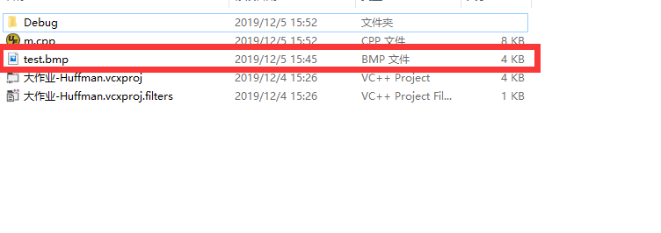

* 1. 运行完毕后：

