Introduction
Nasi Lemak – This iconic Malaysian dish is all about that fragrant coconut milk rice, topped with crispy anchovies, spicy sambal, hard-boiled eggs, roasted peanuts, and fresh cucumber.
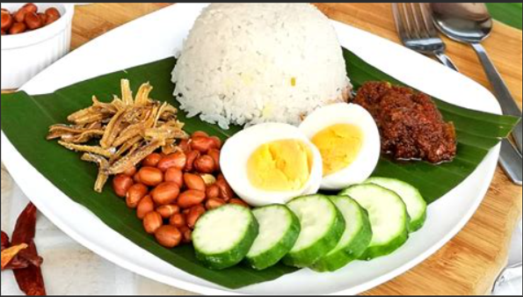
Nasi lemak typically includes fragrant coconut rice, served with a variety of accompaniments. Here’s a basic list of what goes into the recipe.
- Coconut Rice: Rice cooked with coconut milk, water, and pandan leaves, resulting in the sweet aroma of the nasi (rice).
- Sambal. Spice paste made from dried red chilies, shallots, garlic, and belacan (Malaysian prawn paste). Sambal is usually stir-fried with oil, along with onions and tamarind juice added for tanginess. Salt and sugar are used to balance the flavors.
- Dried anchovies or ikan bilis. Small dried anchovies fried until crispy, adding a salty crunch to the dish. In my recipe, I made sambal anchovies, but if you can’t find anchovies, feel free to swap them for Sambal Udang (spicy shrimp).
- Peanuts: Roasted peanuts, providing a nutty flavor and crunchy texture to the overall dish.
- Hard-boiled eggs.
- Cucumber: Sliced cucumber for a refreshing contrast to the spiciness of the sambal.
- Fish: Small fish such as mackerel or sardines are fried and served as an accompaniment to nasi lemak.
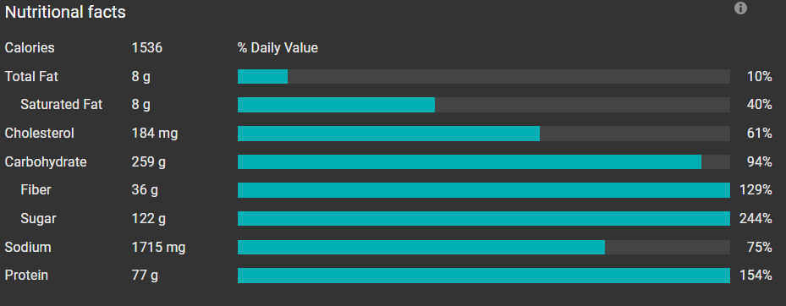

For the Coconut Rice:
- 2 cups of jasmine rice
- 1½ cups coconut milk
- 1½ cups water
- 1 pandan leaf, tied into a knot
- 1 tsp salt
For the Sambal (Spicy Sauce):
- 10 dried chilies, soaked in warm water
- 3 fresh red chilies
- 3 shallots
- 2 cloves garlic
- 1 tsp belacan (shrimp paste)
- 1 tbsp tamarind paste
- 1 tbsp sugar (palm sugar or brown sugar preferred)
- Salt to taste
- 1 onion, sliced thin (for caramelizing)

