Branch.io

**Overview:**

Branch.io is a fully customized SDK that not only support iOS and Android but also provide SDK that work with Web to provide a better APP experience between web and mobile device.

**Set Up:**

1. SDK Integration

Branch.io requires library installation meaning intergrade Branch.io’s SDK into customer’s app.

It only need to add a single dependency in build.gradle file.

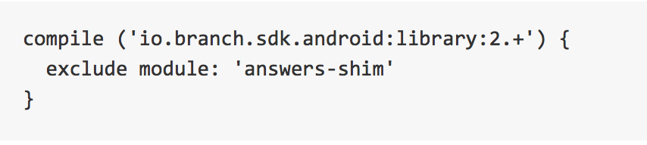

1. Register with branch.io & register for google play install referrer

Branch.io provides customer with a dashboard that would provide setting up deep link routes and later analytics of your app’s traffic. In the dashboard, it provides customer with a BranchKey that is used to for Branch.io to identify who or rather what app makes the API call.

Customer also need to declare the key value pair in their Manifest with <meta-data> tag.

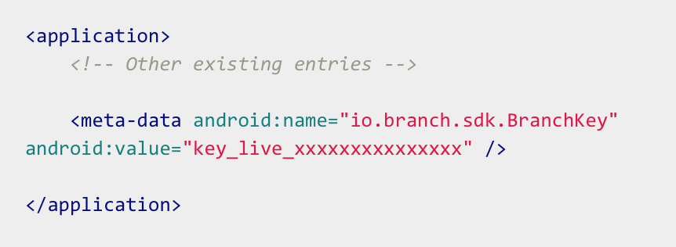

branch.io also need customer to register google play install referrer.

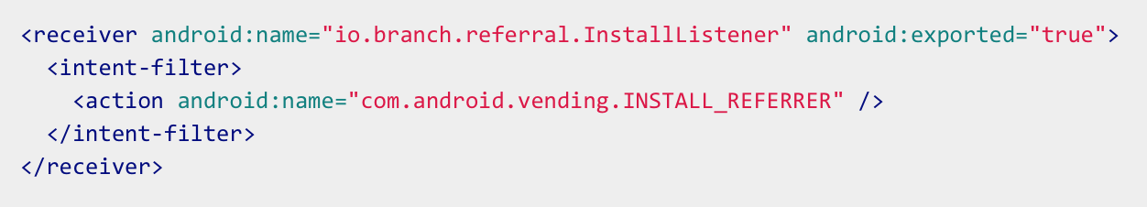

1. Register a URL scheme

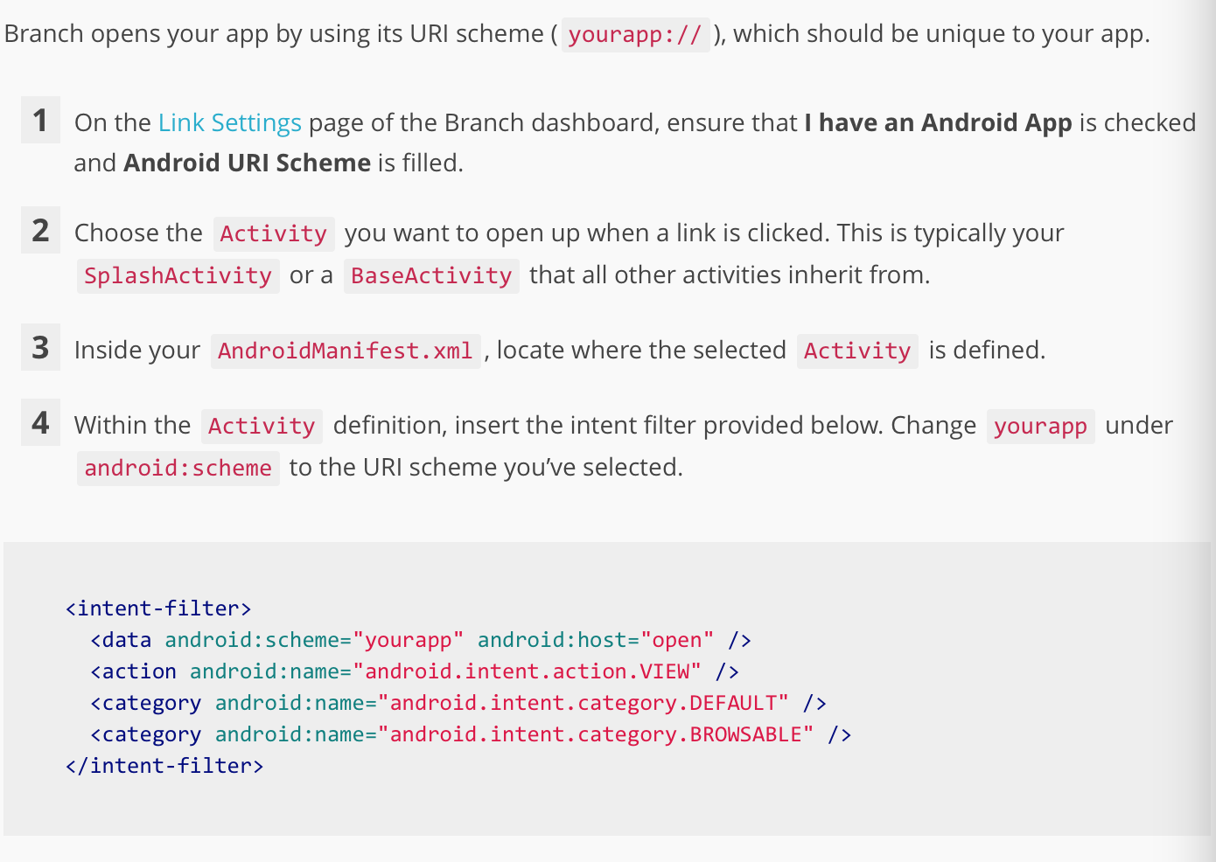

1. Start a Branch session

A Branch session needs to be started every single time the app opens. The branch session process would check if the user came to the app from a link. If so the call back method would return any deep link parameters for that link.

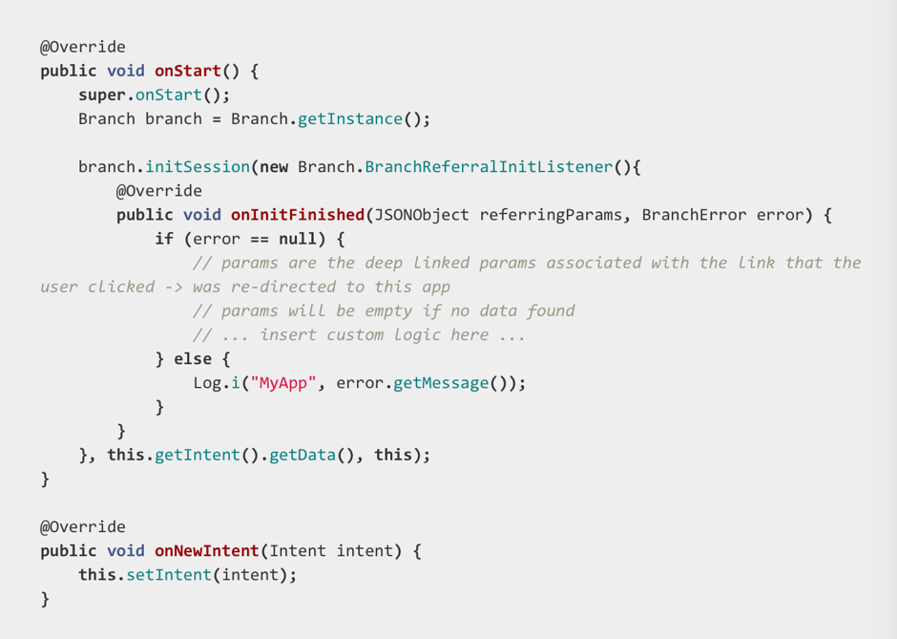

**How it works:**

When a branch link is opened, either your app launches or users are taken to Play store to download the app. Deep link improve this process by routing users directly to the content afer your app is launched.

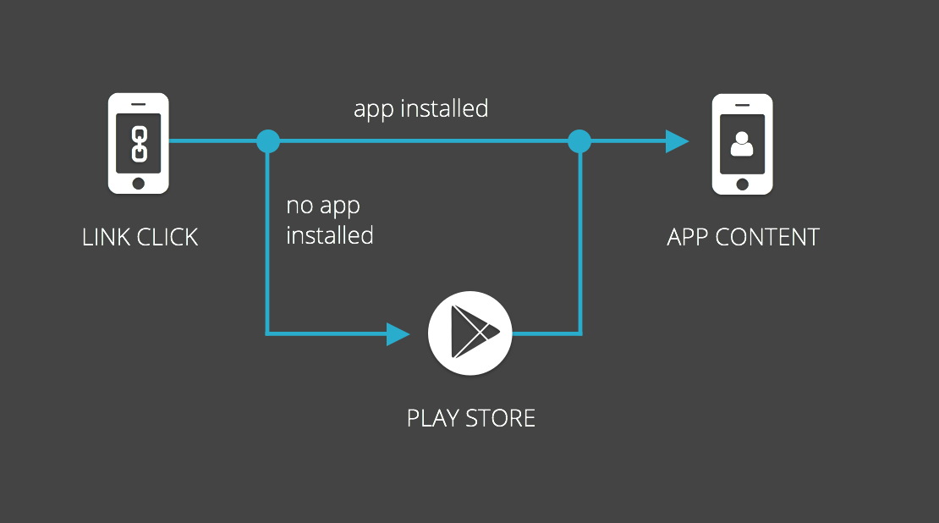

A critical thing to notice here is the term “branch link”. “branch link” means the link that is registered with branch.io through the dashboard. Once a branch link is clicked, the OS would pass the URI to the app and within that app the branch session would catch it and a callback function would process the data.

What’s more:

Branch.io is not merely provide the deep link routing mechanic. It also all more to it.

A branch link can pass parameters in the link. It requires the register those parameters with branch.io dashboard. When a link is clicked, branch.io would call the API and try to match the BranchKey and figure out how and what parameters would return to the app.

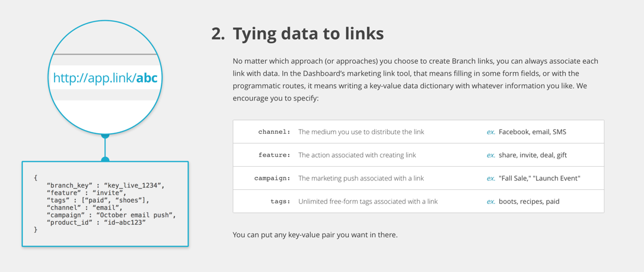

Conclusion:

Branch.io is a very complex API build around deep link router and it continue to add more ability to it. Now it also enables install app from a SMS message.