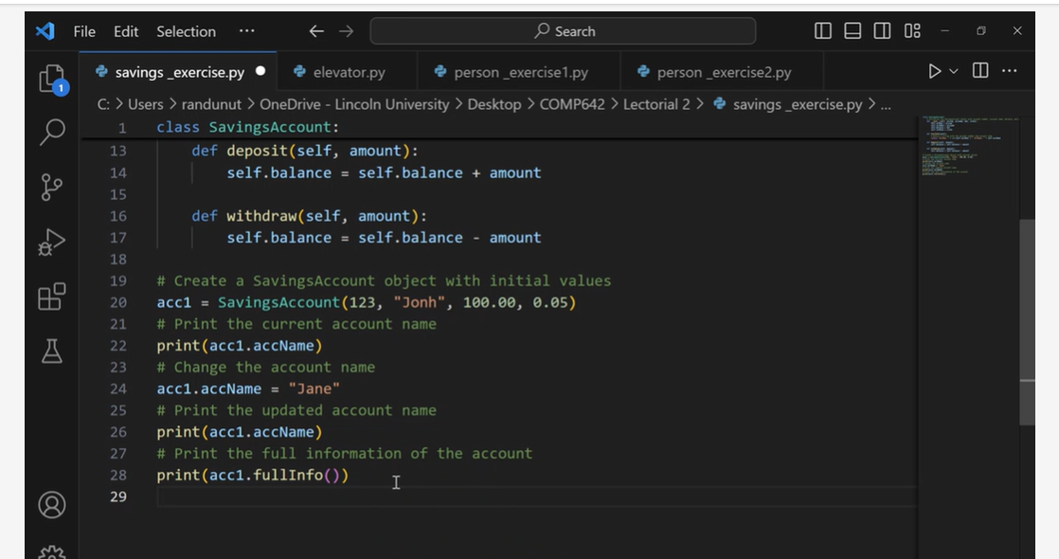

Use for loop

For each item in mystudent list print speak()

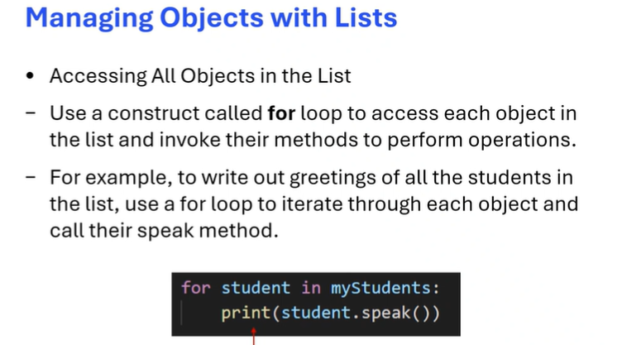

Def disTall():

For stu in myst:

If stu.height>1.7

Print(stu.fullName())

Or we can add the parameter for the height

Def disTall(aheight):

For stu in myst:

If stu.height> aheight:

Print(stu.fullName())

disTall(1.5)

disTall(1.8)

anotherlist=[]

anotherlist.append(person1)

anotherlist.append(person2)