Value and reference type:

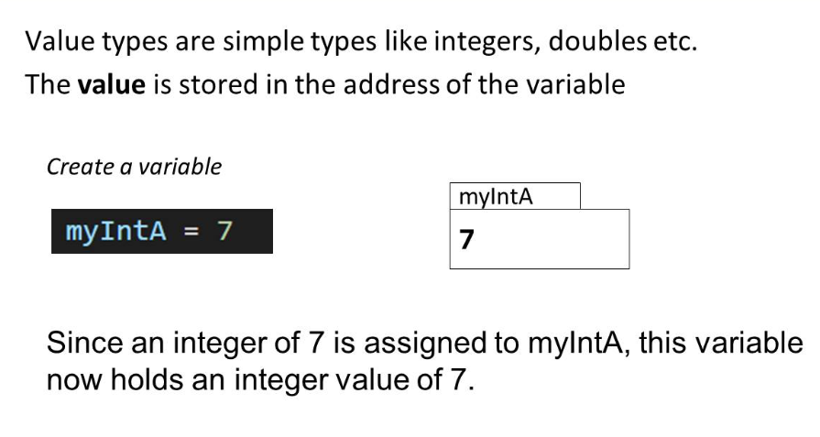

Value Types: The slide defines value types as simple types like integers and doubles, where the value is stored directly in the variable's address.

Create a Variable: It demonstrates creating a variable myIntA and assigning it the value of 7.

Storage of Value: The slide illustrates that myIntA directly holds the value 7, meaning the variable itself contains the actual integer value.

Explanation: It explains that since the integer 7 is assigned to myIntA, this variable now holds the integer value of 7 directly.

Reference types

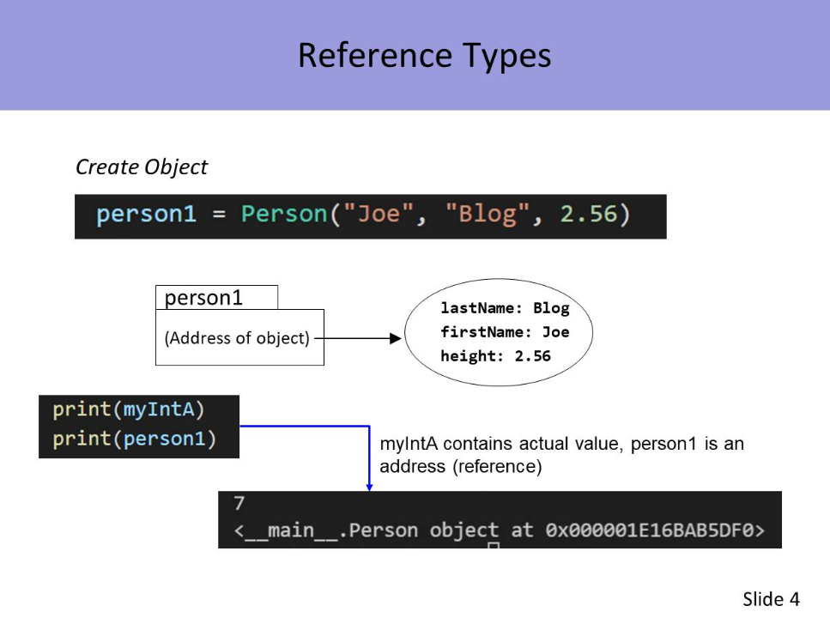

Create object

P1=per(“j,”111)

It creates the location storage the P1

Create Object: The slide shows the creation of an object person1 of the Person class, initialized with the values "Joe", "Blog", and 2.56.

Address of Object: It illustrates that person1 holds the address of the object, not the actual object itself. The object contains the attributes lastName: Blog, firstName: Joe, and height: 2.56.

Print Statements: The slide demonstrates the difference between printing a value and printing an object reference:

print(myIntA) prints the actual value of myIntA.

print(person1) prints the reference (memory address) of the person1 object.

Memory Address: The result of print(person1) shows a memory address (<__main__.Person object at 0x000001E16BAB5DF0>), indicating that person1 is a reference to the object stored at that memory location.

We create a object and tell person 1 where this object is located

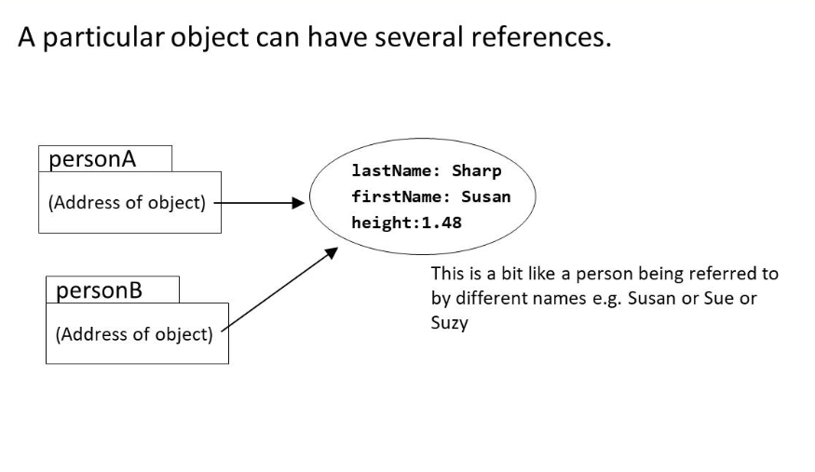

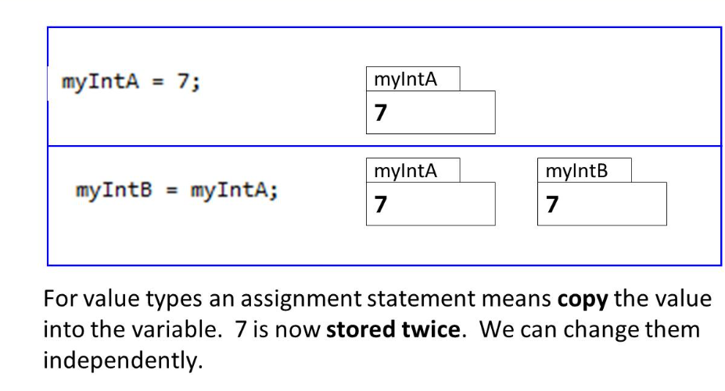

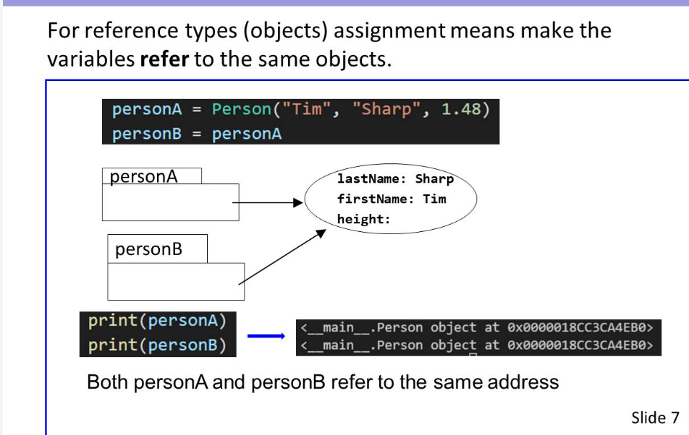

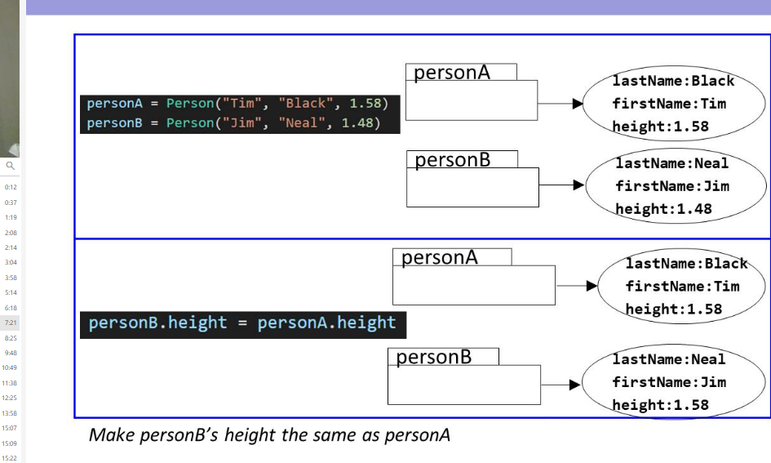

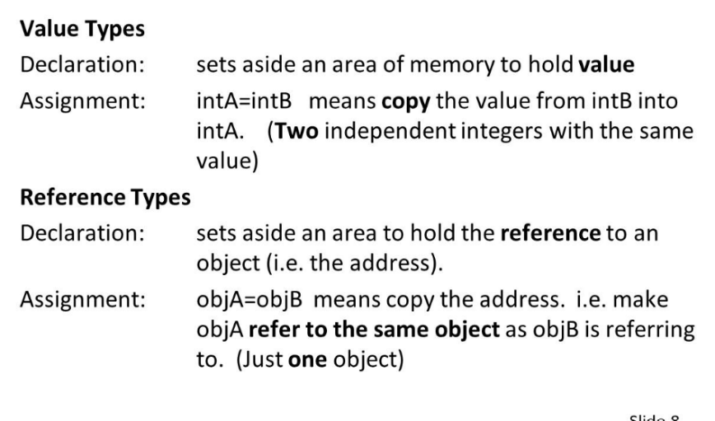

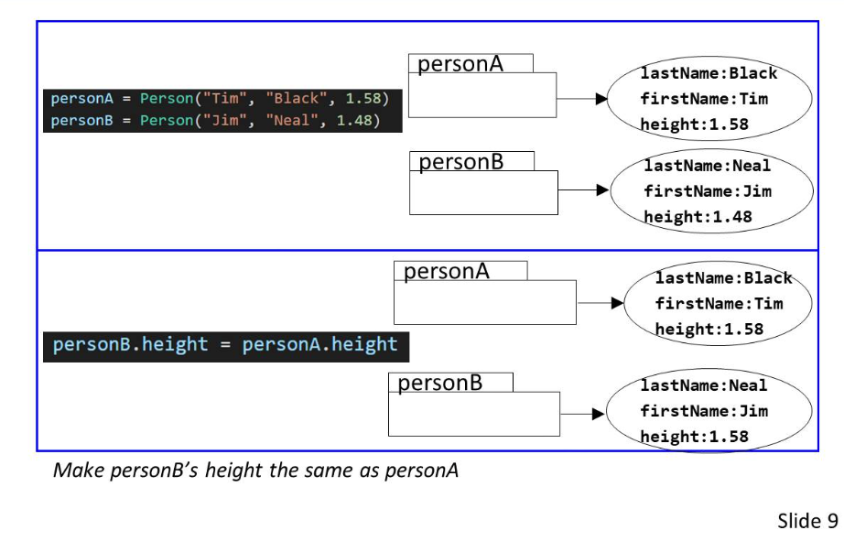

Create two object person A and B

Take the height of person A assign to person B

