Introduction

Oh My Zsh is a delightful community-driven (with 1,300+ contributors) framework for managing your zsh configuration. Includes 200+ optional plugins (rails, git, OSX, hub, capistrano, brew, ant, php, python, etc), over 140 themes to spice up your morning, and an auto-update tool so that makes it easy to keep up with the latest updates from the community. Oh My Zsh is an open source, community-driven framework for managing [zsh](https://www.zsh.org/) configuration. It is compatible with bash and has a powerful history function. When using the or direction key to find historical commands, zsh supports limiting the search. Multiple terminal sessions share history. It can intelligently spell and correct, with various completion functions: path completion, command completion, command parameter completion, plug-in content completion, and more. It can intelligently jump and browse and jump through directories.

Stakeholders

In this section we will describe the different stakeholder classers as proposed by Rozanski and Woods.

|  |  |
| --- | --- |
| Acquirers | The project was developed by Russell and later contributed by many programming enthusiasts. It is an open source project under the terms of the MIT license. |
| Assessors | Marc Cornellà is the official maintainer of this open source project. Robby Russell is the creator of this open source. They are responsible for code supervision during project development |
| Communicators | Robby Russell and Marc Cornellà are the major communicators. Many contributors in the community are responsible for completing and modifying the documentation. |
| Developers | many programming enthusiasts develop, expand, upgrade and test on Github. |
| Users | The main user of this Oh My Zsh project are developers. It will not make a developer a 10x developer, but it may make a developer feel like one. |
| Support staff | An active community of both users and programming enthusiasts are the main support staff. |
| Maintainers | Marc Cornellà oversees and maintains the project's architecture, and the rest of the developers can also report bugs. |

Context View

The context view describes the relationships, dependencies, and interactions between the system and its environment ( the people, systems, and external entities with which it interacts). This section examines oh-my-zsh’s scope, its dependencies on others and the interaction with other parties.

System scope & responsibilities

 Oh-my-zsh is a community-driven (with 1,300+ contributors) framework for managing zsh configuration. It includes 200+ optional plugins (rails, git, OSX, hub, capistrano, brew, ant, php, python, etc), over 140 themes to spice up your morning, and an auto-update tool so that makes it easy to keep up with the latest updates from the community. Thus, the scope of oh-my-zsh is to provide hundreds of powerful plugins and beautiful themes to user’s terminal shell and make it attractive and efficient.

External entities and interfaces

 Oh-my-zsh is a framework for managing zsh configuration. It includes 200+ optional plugins (rails, git, OSX, hub, capistrano, brew, ant, php, python, etc), over 140 themes and an auto-update tool. Below, these are elaborated upon and afterwards visualized in Figure 1.

·Written in Shell

·Unix-like operating systems (macOS or Linux) are supported.

·Supports many programming languages( Python, php, etc.)

·Robby Russel and more than 1350 contributors from the open source community.

·Users are individual developers.

·A GitHub repository filled with code, plugins and many issues is used to host the code base.

·Communication and support is provided via GitHub.

·The project is licensed under the MIT License, a permissive free software license originating at the Massachusetts Institute of Technology.

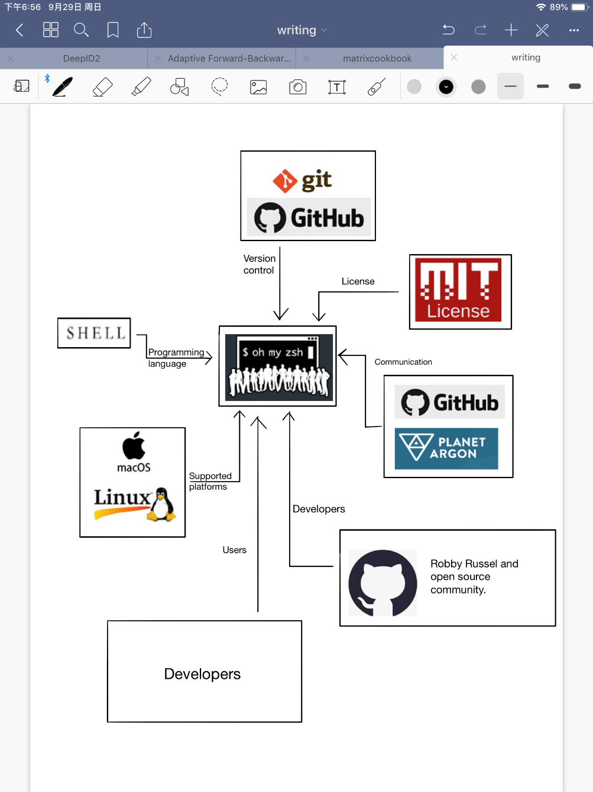

*Figure 1: The Context View of oh-my-zsh*