# Cocos2d-x: A cross-platform 2D game engine



## Abstract

Cocos2dx is an open source 2D game engine which support cross-platform and a wide range of languages like c++, javascript and lua. You can use cocos2dx to develop your game which can runs on windows, macOS, android, Linux and Web platform with only one set of code. It is supported by lots of people on github, you can easily download its source code and start building your application. The features of cocos are fast, free, easy to use. To find out how cocos achieves those features, we start looking at its architecture from the bottom. Below is the what we find about the architecture of cocos through different viewpoint and perspectives

## .Table of contents

1. Introduction
2. Stakeholder Analysis
3. Cocos structure
4. Functional view
5. Development View
6. Evolution perspective
7. Performance perspective
8. Conclusion
9. Reference

## Introduction

Cocos2d-x is a cross-platform game engine. A game engine is a piece of software that provides common functionality that all games need. You might have heard this referred to as an API or framework but in this guide, we'll be calling it a **game engine**.

**Game engines** usually support multiple platforms thus making it easy to develop your game and then deploy it to multiple platforms without much overhead at all. Since **Cocos2d-x** is a **game engine**, it provides a simplified API for developing cross-platform mobile and desktop games. By encapsulating the power inside an easy to use API, you can focus on developing your games and worry less about the implementation of the technical underpinnings. Cocos2d-x will take care of as much or as little of the heavy lifting as you want.

The original version of Cocos2d was written in python, then use objectiveC, which was applied to iphone. After that, someone in China changed it to C++ version according to the design concept. This version can run on iphone, widnows and android platforms. The latest version of cocos is 1.0.0. The C++ version of the engine also introduces the lua scripting system. Cocos2d is a completely open source engine which is widely used including Zynga, Nangong Meng and other well-known game companies. Cocos2d is not only a 2D graphics engine library, but also provides some systems to support game logic. Cocos2d provides a simple sound engine that supports playing mp3, wave, ogg etc. cocos2d can be used together with the physics engine box2d to achieve physical effects such as collisions. The structure of the cocos2d engine is clear, and the documents and examples are rich which makes cocos very easy to learn.

This chapter,we discuss in details about the architecture about cocos from different stakeholders’ view. We divide the whole system into different components which have a specific function and look at how they work tighter. I believe that after reading our report, you will have a better understanding of cocos.

## Stakeholder Analysis

In the book *Software System Architecture* we learned how to analysis the stakeholders of a standard software system by identify the roles which are played by those people/group who are involved in the process of construction. For this section we are going to analysis and identify the significant roles that of great importance.

### Acquirers

Acquirers, or called as investors, is the first part of the chain which decides the survival of tech companies. Cocos2d-x was developed by @*Ricardo Quesada* who was born in Argentina, and later on established the @Los cocos which was the prototype of cocos2d-x. Now we would like to claim that the cocos2d-x is sponsored or invested by a Chinese company @Chukong Technologies, which is the role of sponsor. This company decides the business and technical decisions and provides funds to cocos2d-x.

### Assessors

Assessors are stakeholders that test bugs in the system which is game engine in Cocos case, and report or modify the bug-list to the developers. For cocos, the job is taken by the group inside the company rather than give out to other testers. In the test part, testers would test every detail in System, like Actions test, Billboard test, Box2D test, ClickandMove test, etc. Each part will be allocated to a tester or two to make sure the System goes well. @minggo(Zhang XiaoMing), @drelaptop are active bug-testers in Cocos2d-x github who donate significant number of bugs.

### Developers

As an open-source program on GitHub, dozens of developers would like to take part in this job. A few of them can join in the program at last, however. As developer of game engine, they need to master the framework, web service techs, androids programming, js language, 3d developing and other skills, so the number of core developers are 13 only. As for framework/web service support, each part gets no more than 2 individuals. For certain many individual developers also did a great job and made the cocos grow faster ever.

### Supports

We divide the support characters as tech support and platform support to identify the concrete role. Tech support grant developers deploy their program on different platforms that are supported, which makes cocos efficient and powerful.

ⅰtech support

①C++

②Lua

③JavaScript

④Cocos platform framework tools and IDEs

ⅱplatform support

①iOS

②Android

③Windows phone

④Windows

⑤Mac OSX

⑥Tizen

### Support Staff

Cocos has dedicated support staff spreading in several websites: [Facebook](https://www.facebook.com/cocos2dx/), [Twitter](https://twitter.com/cocos2dx), [Blog](http://blog.cocos2d-x.org/), and most accessed [community](https://github.com/CocosStructure/cocos2d-x-1#where-to-get-help). At these places, developers who ran into troubles that unable to solve can obtain the details of APIs and notes of program, and get help from other experienced developers. Or, they can have a look at the [guide](https://github.com/CocosStructure/cocos2d-x-1#learning-resources) on github to acquire the most knowledge/guide that he/she needs.

### Communicators

Communicators often play an important role on explaining the architecture of the system and the function of each part of system to those who may buy/use the product and those who may join in and contribute to the program. Usually they may also take the job which need them to create linkage between different classes. As an open-source program, the importance of communicators is inevitably lower than others. For the core developers, the structure is established by themselves, so they could be seen as the communicators in Cocos program.

### Users

Cocos in China is a perfect successful case in commercial, almost 70% of games in Chinese market is developed by Cocos rather that unity in foreign countries. Without considering the sponsor is a Chinese company, it would also be a marvelous great achievement for a game engine. The user is not only including individual developers and game lovers but great organizations like Zynga、Wooga、Gamevil、Glu、GREE、Konami、TinyCo、HandyGames、IGG and Disney Mobiles. Also for big enterprises the cocos is a great choice, engineers in these companies such as Google, Microsoft, ARM, Intel are active in cocos developing.

### Competitors

As a game engine, at no circumstances can Cocos take in charge of game developing market. For certain, the **unity,** **unreal,Frostbite,IW** are powerful competitors which are trying their best to grasp the market share.

## Power-Interest-Grid View





*power*



*Web structure developer*

*Core developers*





*C++*

*Ordinary developers*

*Sponsor*

*API programmers*



*competitors*



*individual contributors*



*Support service*

*users*

*Interest*

# Cocos structure

Cocos2d-x is an open-source mobile 2D game framework released under the MIT license. This is a version of the cocos2d-iphone project.It's all written in C++. Cocos2d-x development focuses on the framework provided by Cocos2d cross-platform and cocos2d-x. Mobile games can be written in C++ or Lua, using an API that is fully compatible with the cocos2d-iphone version. The cocos2d-x project can easily be built and run on iOS, Android, Blackberry and other operating systems. Cocos2d-x also supports desktop operating systems like Windows, Mac and Linux.Therefore, the source code written by developers is easy to edit and debug in the desktop operating system.

Family members

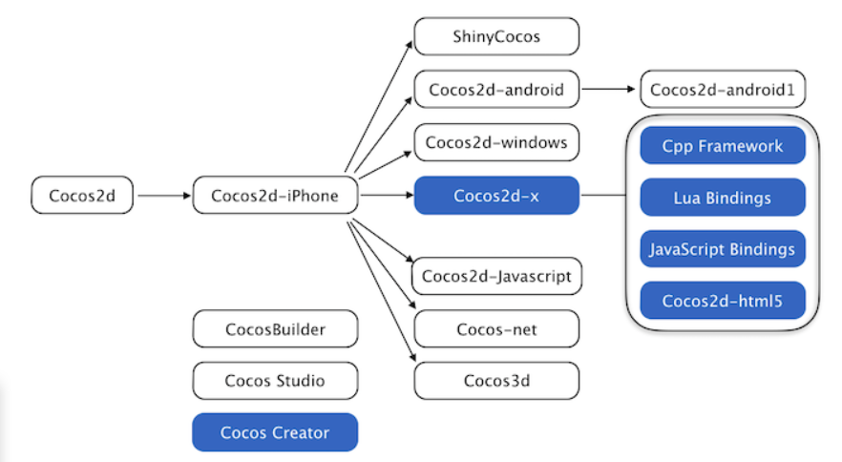

Branch engines and editors in the blue box are most active.

Cocos2d-x allows developers to use visual editor Cocos Creator for rapid prototyping, debugging packaging, and cross-platform deployment.

Features：

1.Easy to use: game developers can focus on the game without spending a lot of time learning the arcane OpenGL ES. Cocos2d-x offers plenty of specification.

2.Efficient: cocos2d-x performs graphics rendering based on OpenGL ES to maximize GPU performance of mobile devices.

3.Flexibility: easy to extend and integrate third-party libraries.

4.Free: the free open source framework based on the MIT protocol allows users to use without worrying about commercial licensing.

5.Community support: developers set up a community organizations, easy to access various technical problem.

version control and issue tracker: Git and Github.

Supported platforms: The core advantage of cocos2d-x is that it allows developers to leverage C++, Lua, and Javascript for cross-platform deployment, covering platforms include iOS、Android、Windows Phone、Windows, Mac OS、Tizen、Linux and so on.

Language of IDE: completely written in C++. the core engine has the smallest footprint, yet the fastest speed of any other game engine, and is optimized for running on all kinds of the devices including low-end Android systems.

Software project development language: C++、Lua and Javascript

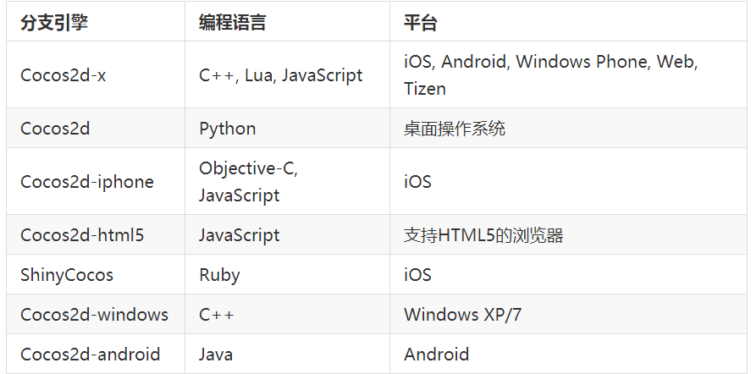

Users：Cocos2d-x users include not only individual developers and game development enthusiasts, but also many well-known large companies such as Zynga, Wooga, Glu, GREE, Konami, TinyCo and Disney Mobile.As of September 2013, more than 1.5 billion games were downloaded worldwide based on the cocos2d-x engine, many of which also dominated the apple AppStore and Google AppStore rankings.At the same time, many companies such as touch, Google, Microsoft, ARM, and Intel engineers are also very active in the cocos2d-x field.

Developers: Wang zhe and his team of Beijing touch technology co. LTD、open source community

Market position:cocos2d-x mainly occupies the high-end and low-end markets.In the development of 2D mobile games in China, the cocos2d-x engine accounts for more than 70%.There are 45 domestic monthly income over 10 million mobile game, 30 based on cocos2d-x.

License: Cocos2d-x is released under the MIT license.

Class diagram:

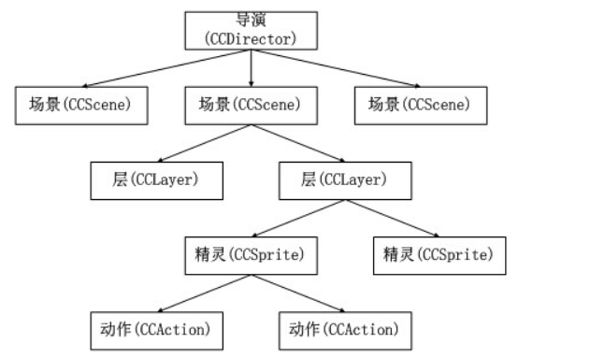

# Functional view

In this part, we focus on four important features that cocos has implemented. The four functions are animation support, cross-platform, node rendering and event-listenser. We will look deep into cocos to see how it achieve those goals.

Cocos-2dx 主要类的功能

|  |  |
| --- | --- |
| Stakeholder class | Description |
| Ref | *Ref* class is the base class for the Cocos-2dx project. It contains the related functions that the project uses for automatic memory management, and many classes inherit from it. It should be noted that the constructor of the Ref class is protected, so it can only be inherited and cannot be instantiated. |
| Director | *Director* class determines what is displayed on the screen, that is, through its related functions to achieve the display and hiding of certain nodes. |
| Node | *Node* class is the most basic element in the project scene graph [on the screen or the collection of elements that have been displayed or may be displayed], and most of the classes related to rendering come from Node. It mainly determines the position, size, angle, etc. of the element, and the *Node* class object can be used as a child node, using timers and performing actions. |
| Scene | *Scene* class is the basic unit of scene switching, and provides a rich switching effect. The unit that the project renders on the screen is the scene. There are three types: game content scenes; option class scenes; display class scenes. It should be noted that there can be multiple scenes in a project, but only one scene is active at the same time. |
| Layer | *Layer* class is the basic unit that makes up the scene. Multiple layers form a scene, which is convenient for layered processing to show different effects. The *Layer* class is a container for displaying content. It is usually used as a background for games, and can receive operations such as clicks from users and make corresponding changes. |
| Sprite | *Sprite* class is the most basic unit that players can see. |
| Renderer | *Renderer* class mainly implements the rendering function, and internally, it also needs to classify and sort the Render Command. |
| Event | *Event* class identifies the different types of events and records the specific data, which determines which *EventListener* to handle this event. |
| EventDispatcher/EventListener | *EventDispatcher* class performs like the control center of all events [equivalent to a relay], which manages the *EventListener*. When an Event arrives, it determines the calling sequence of CallBack. *EventListener* class establishes the mapping relationship from Event to CallBack, and the *EventDispatcher* calls the corresponding CallBack according to the relationship. |
| Scheduler | *Scheduler* class is similar to Timer in other languages and is used to implement delayed calls and timed calls. Its other sub-methods also enable control of timing operations, such as pauses, resumes, and so on. |

### ⅠHow does cocos2d-x play animation for its characters?

As a well-known powerful game engine, cocos2d-x is capable of generating animations which will be applied to characters and effects to make them looked like they are “alive”, and for certain those developers who use marvelous skills to modify their animation in their 2d game always get payed times more than those who do not. The structure of frame animation in cocos2d-x provides the fitful way to update games.

### How does it work?

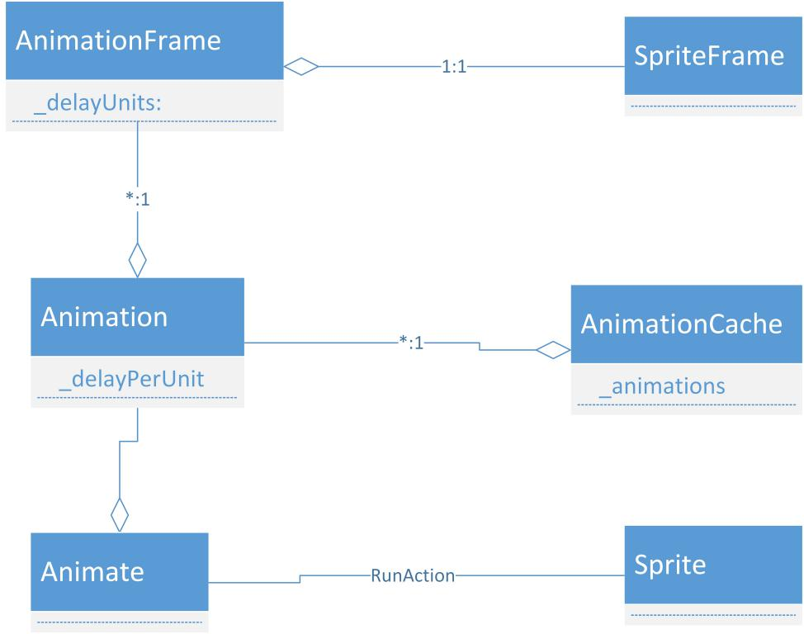

Brief description: Before applying the animation function into cocos system, the basic theory of animation or movies should be introduced. In 1835 the theory of *Persistence of Vision*,* which claims that due to the react speed of vision cell in our brain, lights will stay on retinal for a short time(1/10 seconds), was found by a Belgium physicist *Joseph Plateau*.* This brilliant discovery directly leads to the prosperity of film industry, also it inspires the authors of comics and animations. In a word, people can’t recognize pictures separately when they are played in a high speed one by one. The basic principle of structure of animation in cocos2d-x is not an exception.

#### Process:

1. Create the spriteFrame

At first the relationship among sprite, spriteFrame and texture2D need to be declared. Texture is created by single picture and is stored in GPU cache, and texture2D is a class that encapsulate the information of a texture. And a spriteFrame can be created by an object of class texture2d using the function **static SpriteFrame* create (const std::string & filename,const Rect & rect)** which take a texture file and a rect object as parameters. And a sprite is the encapsulation of spriteFrame and texture2D which will generate a “character” which includes the information of the picture(texture), and this “character” can run kinds of action and communicate.

1. create animationFrame according to those spriteFrames

AnimationFrame is the basic unit in Animation. By the theory *Persistence of Vision* we have introduced above, we can compare cocos to movie player, in which the AnimationFrame is equal to the frame in movie. AnimationFrame can and only can be created by SpriteFrame. The Function is like **static AnimationFrame* create(SpriteFrame * spriteFrame, float delayUnits, const ValueMap & userInfo)**

1. create animation

According to the information file for cocos2d-x, Animation objects are used to perform animations on spectacular sprite objects. It contains AnimaionFrame objects and some kind of possible delay between two frames, the way to create animation object is different from the way to create spriteFrames: using a create function without any parameters could create an animation object, and developer should add spriteFrame to the animation object or he/she could add spriteFrame from a file which contains image information, and the animationFrames will be stored in a Vector array. When called, the getFrames() method will return the Vector which contains every single frame for this animation, and setLoops(), getLoops() function will decide how to load this animation.

1. Invoke

Sprites perform animations, that means when needed, animation will be invoked by a specific sprite, and it will be activated by using animate action: **sprite->runAction(Animate::create(animation))**.

1. AnimationCache

As a resource, animation always take time to be loaded into graphic memory, so if many sprites calls for their animations, problems show up. To resolve this, cocos developer decide to create a class that stores/registers the animations instead of saving animations on the Sprite since v0.99.5. This class satisfy the principle of singleton pattern which means there are only one instance of object that can be used in whole system. All needed animations will be stored into this instance. Methods like addAnimation/removeAnimaion/getAnimation provides manipulation on those stored/pre-loaded animations. Also developers could add animations from a plist file after load them in the spriteFrameCache.

### ⅡEvent listener

**Functional capabilities:**

Functional capabilities defines what the system is required to do and what it is not required to do. The following table shows the core functionalities and describes what their responsibilities are.

|  |  |
| --- | --- |
| Functionality | Description |
| Event Listener | Every Event Listener consists of a callback function, a subscriber type, and a listenerID.  Its main responsibilities are implementing various triggering logics, and add the event to the event dispatcher to realize other functions. |
| Event Dispatcher | This component is responsible for scheduling and managing all event listeners, and when an event occurs, it should scheduling the corresponding events. |
| … | … |

All event types must inherit Event. Event is the parameter that the event source passes to the event listener. It contains some information about handling the event. The subclass of Event consists of a type “Event:: Type” and some data.

* enum class Type {

TOUCH,

KEYBOARD,

ACCELERATION,

MOUSE,

FOCUS,

CUSTOM

}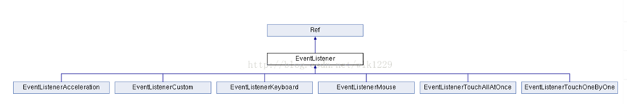

If a handler program is concerned about an event, create an instance corresponding to the EventListener subclass. For example, EventListenerTouch is corresponding to the Touch Event. The EventListener implements various triggering logics.

We use different methods to add EventListeners, then EventDispatcher has different processes as followed.

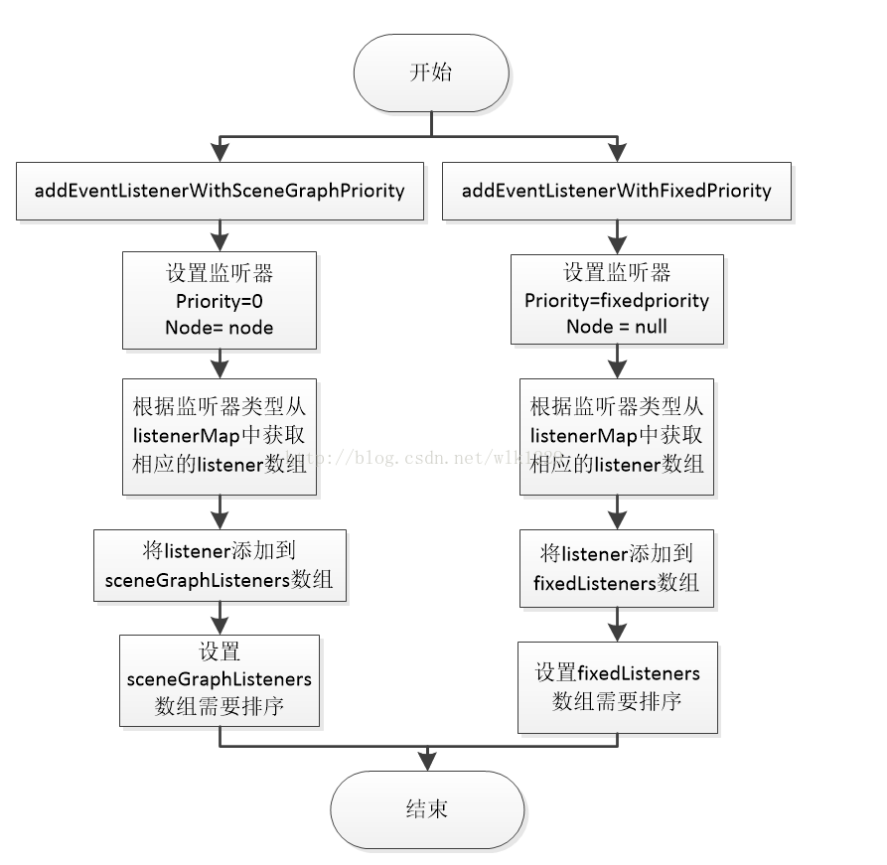

Process:

Firstly, we should register Event listeners. Usually, we use addEventListenerWithSceneGrphPriorith() or addEventListenerWithFixedPriority() to register. Then assign the callback functions to each response function of the event listener. We should use codes to implements every functions. The value of _fixedPriority will help decide the order of execution of callback functions.

Finally, register the event listener to the event distributor _eventDispatcher. The addEventListener() method will subscribe events. When an event occurs, it will use callback functions.

One tip: If one EventListener needs to be reused, we should use clone() method.

### Ⅲ Rendering function

### Rendering Tree

Cocos2d-x adopts a hierarchical management structure.As shown in the figure, the director class directly controls the root node of the game, namely the Scene.Scene controls the change of the Layer, and finally the Layer controls all the nodes displayed.Any two - dimensional game is created by controlling different images, positions, and presentation levels.

Render tree is a tree structure made up of various game elements according to hierarchical relations.Each node has its child nodes.All child nodes move with the parent.Drawing a parent node causes the drawing of a child node.The drawing method of the child node is also related to the attributes of the parent node.

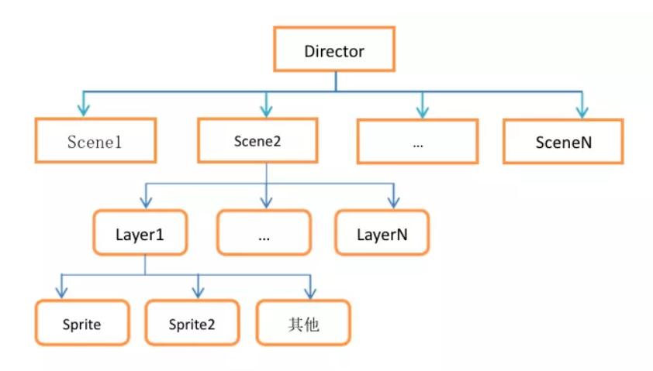

### Rendering Principle

Past rendering systems were drawn by the parent node by calling the underlying OpenGL function through the visit function, causing two problems.First, the flexibility of drawing order is lost.Second, there is no separation between logic and rendering.

Cocos2d-x3.0 made the following changes to the rendering system.

1. Decouple rendering from scene tree.Instead of calling any OpenGL functions in the visit function, the render instructions are put into a queue.This separates the rendering from the game logic and gives the rendering more flexibility.

2. Separate the rendering logic code that calls OpenGL from the main thread and open a separate thread.

3. SpriteBatchNode and ClippingNode to improve efficiency.

4. Customize nodes.

Rendering order

1. The main thread calls drawScene to start drawing the scene.

2. Recursively traverse the child nodes of the scene, that is, call the visit function.

3. Call the draw function of each child node.

4.Initialize the render command to put the QuadCommand object into the render queue.

Render logic: first, further process the render command, and execute the render command after the processing is completed

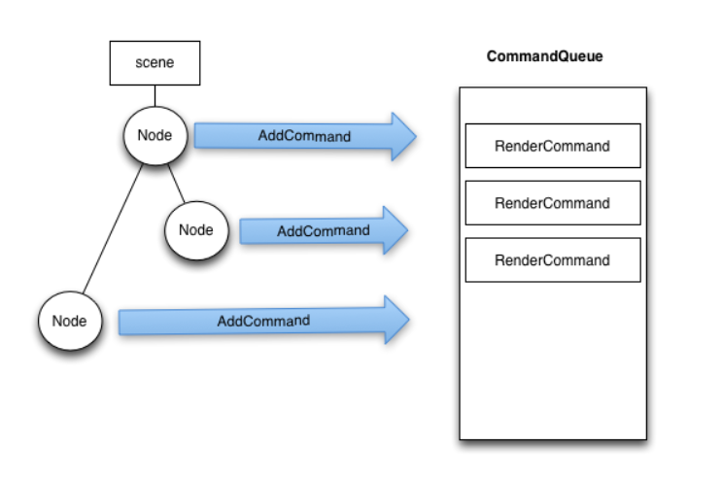

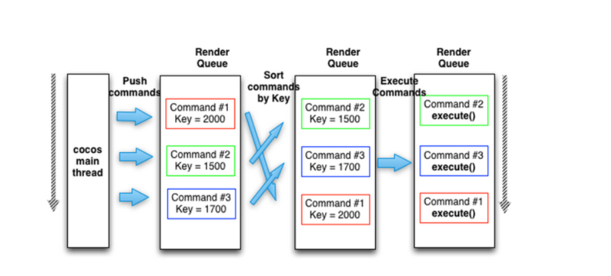

### Text Rendering

1. CCLabelAtlas class

The CCLabelAtlas class is a way of using images as text, which can be defined directly by images.

2．CCLabelBMFont class

The CCLabelBMFont class is also the text rendering label class.Each word in the CCLabelBMFont class is a Sprite class, meaning that each word can have its own spin action and support FNT type files

1. CCLabelTTF class

The CCLabelTTF class implements the font label through the system word

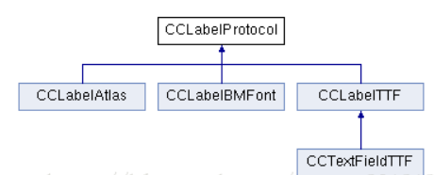

### Ⅳ Cross-platform

To see how cocos achieve cross-plarform, we first look in to the architecture of cocos.

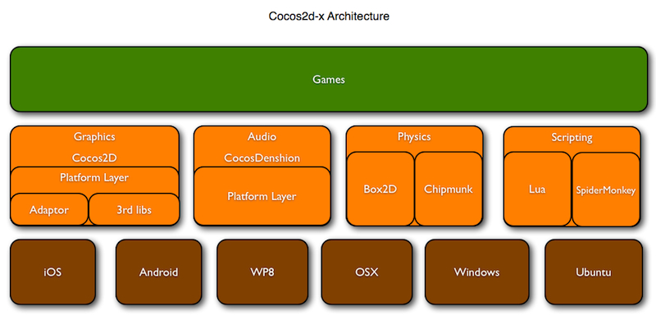

In the graph we can see that there is a layer called platform layer to interact with different platforms. On top of that, is the graphic library of cocos2d-x, which provide us with uniform interfaces so we don’t need to care about the differences between different operation system. With only one set of code, we can compile different versions for different operation system.

Project directory:

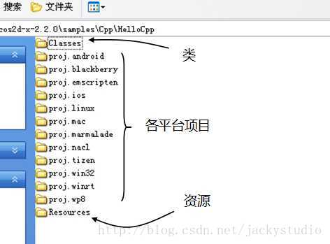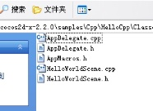

We can see that for each platform, cocos has write the entry function. In win32, we use Application::run() to launch your application. In Android, the entry function is Java_org_cocos2dx_lib_Cocos2dxRenderer._nativeInit in platform\android\jni to launch your game.

How does the compiler know which entry point to use?

All code related to platform is in the /cocos/platform directory, in CCPlatformConfig.h we can see such code:

#if defined(_WIN32) && defined(_WINDOWS)

#undef CC_TARGET_PLATFORM

#define CC_TARGET_PLATFORM CC_PLATFORM_WIN32

#endif

If we define _WIN32 and _WINDOWS which we are in windows platform, the macro variable CC_TARGET_PLATFORM is defined as CC_PLATFORM_WIN32, so the complier knows where to find the entry point of the program.

This is how cocos implements cross-platform functionbility.

# Development View

This view focus on how cocos was developed. Development view include code structure and dependencies, build and configuration management of deliverables, system-wide design constraints, and system-wide standards to ensure technical integrity and so on. In this view, we focus on four aspect of development view which are module organization, release process, source code structure and design patterns.

These four aspects has an significant influence on how cocos was developed, module shows the overall blueprint of cocos, they are usually developed individually, and integrated in the final stage of the develop. Release process shows how cocos was released, what work need to do is defined in this part. Source code structure define the common style of source code, if you want your pull request be accepted, you must follow them. Lots of Design pattern are used in cocos, they are used to solve certain problems, you should be familiar with them and follow the pattern if you want to contribute.

### ⅠModules of cocos2d-x

By accessing the website of cocos2d-x organization, we obtain the higher-level view of the modules that classify the classes exists in cocos2d-x project. Here is the list of all modules which are independent from each other:

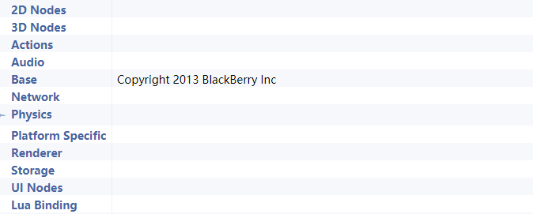

#### 2D nodes

See in this module, we would find

①the classes that actually implement the animation function of 2D games such as AnimationFrame/Animation/AnimationCache which are mentioned in the function view: animation part;

②the polygon classes which helps hold the required data to display Sprites.

③TMXTiledMap classes which are used to parse and render a TMX map

④Menu classes which would establish the menu system in a 2d game

⑤Node ,Scene,Particle, and transition classes which are used to establish the Scene;

#### 3D nodes

①the classes that are used to implement 3d animations are like Animaion3D which are just like those in 2D nodes;

②the classes that are used to establish a model which are like Bone3D, Skeleton3D, Mesh, MeshSkin, Sprite3D,Ray and textureCube classes

③the classes that are used to bound the other classes are like OBB

④the map classes that are like Skybox and terrain which would establish the 3D map/space;

#### Actions

This module is simple for the function it implemented. All of the actions/moves such as Follow, Ease, StopGrid, Waves3D, FlipX3D, MoveBy/MoveTo, FadeIn/FadeOut would be classified into the set of Action module.

#### Audio

This module controls the function of sound, or we called Audio officially. There are only two classes should be classified into the set of Audio module which are AudioEngine that offers a interface to play audio and the SimpleAudioEngine that plays background music and sound effects.

#### Base

This module is multi-functional; here are the classes that involved in this module;

①System release functions: the autoReleasePool class would manage autorelease objects; Configuration class would contain some variables; Controller class represents a connected physical game controller,etc;

②event classes: Event, EventAcceleration, EventCustom, EventListener, EventDispatcher etc classes would implement the event handle function which are mentioned in function view

③script classes: For Lua, Wrapper the script data that should be used to find the handler corresponding to the Lua function by the nativeobject pointer and store the value pointer which would be converted concretely by the different events,then the converted data would be passed into the Lua stack.

④colors, quad, vertex: system classes

#### Network

Network module handles the request and responds between clients and servers; The HttpRequest, SocketIO, Websocket classes would do the job.

#### Physics(Physics 2D)

Physics module implement the physical system of the whole cocos2d; The physicsBody class would create a body affect by physics, and other classes would do the operations on the body to make it perfect like it was affected by the actual physical system or following the physical laws

#### Platform Specific

This module is simple because it has only two classes which handles the file operations;

#### Renderer

This module is about the usage of command which are used to draw batches in one TextureAtlas class.

#### Storage

And this module is for local storage support for the JS bindings. The localStorageFree would allocated resources, and the Set and get classes would set/get item from the JS. Of course it has the release class.

#### UI nodes

This module involves all the components that would show up in UI. For example, Button, Checkbox, Hbix, EditBox, ImageView, etc would be classified into the UI node module.

#### Lua Binding

This module controls the function of building bridge between C and Lua

### Ⅱ Release process

* Since it first released in 2011, Cocos2d-x has released many versions. At the beginning, the primary version and the 2.X versions are maintaining the Objective-C interface style which is consistent with Cocos2d-iphone. However, after 3.0, Cocos began to abandon the Objective-C style, restore C++, and add some C++11 features to the engine interface, such as using clone() method to instead of copy(). There is also a new renderer and time distribution mechanism.
* It is worth noting that users not only can report debugs，but also can submitting patches. The procedure is as followed:
* Download the latest cocos2d-x develop branch from github:
* Apply your changes in the recently downloaded repository
* Commit your changes in your own repository
* Create a new branch with your patch: $ git checkout -b my_fix_branch
* Push your new branch to your public repository
* Send a “pull request” to user “cocos2d”

What's more, this mechanism motivates the external contributors as their contribution can be published once adopted. Lastly, it is a great opportunity for the contributors to develop techniques, tools and accumulate knowledge.

Releases are handled on GitHub using the release system and tags. The latest release V3.17 was released on may 17 2018 on GitHub.

Documentation updates are required to be created by the developer with the pull-request. Other documentation changes are handled with the same process as a code update with pull-request and issues.

### Ⅲ Source code structure

##### The structure of the directory hierarchy to store source code

After downloading the latest version of cocos2d-x, you can see the directory structure of the cocos2d-x source code, as shown in the figure below

Cocos2d-x 2.2.3 directory structure

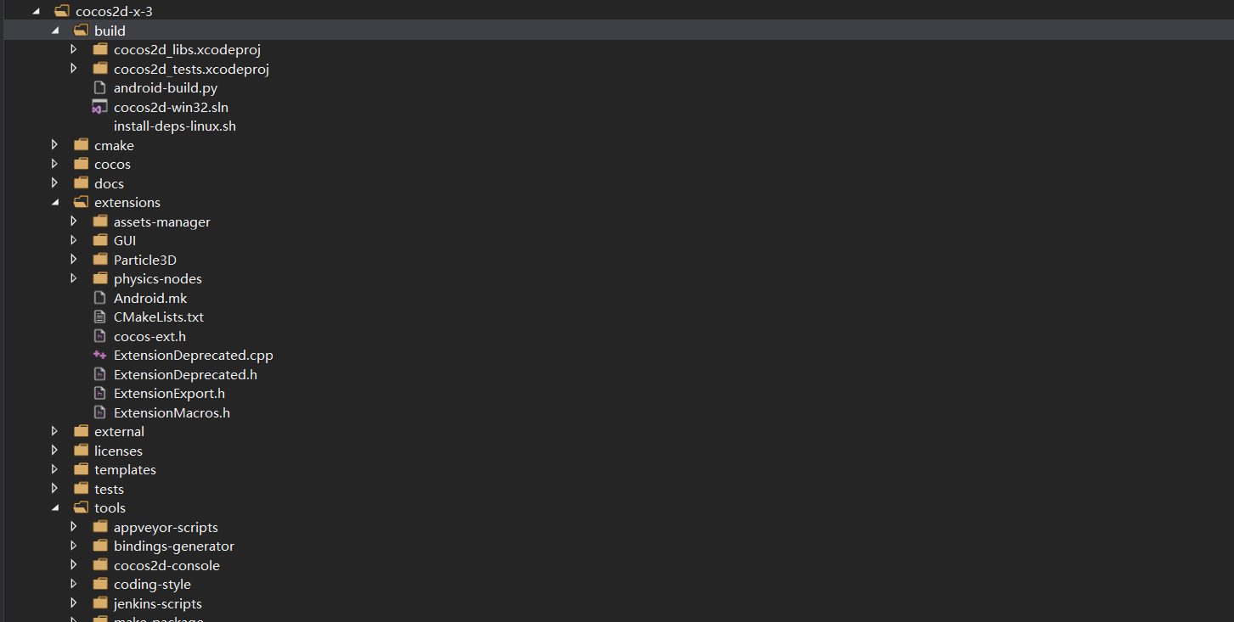

Analyze the function and correlation of the files in the cocos2d-x open source software library, sort out and draw the following picture

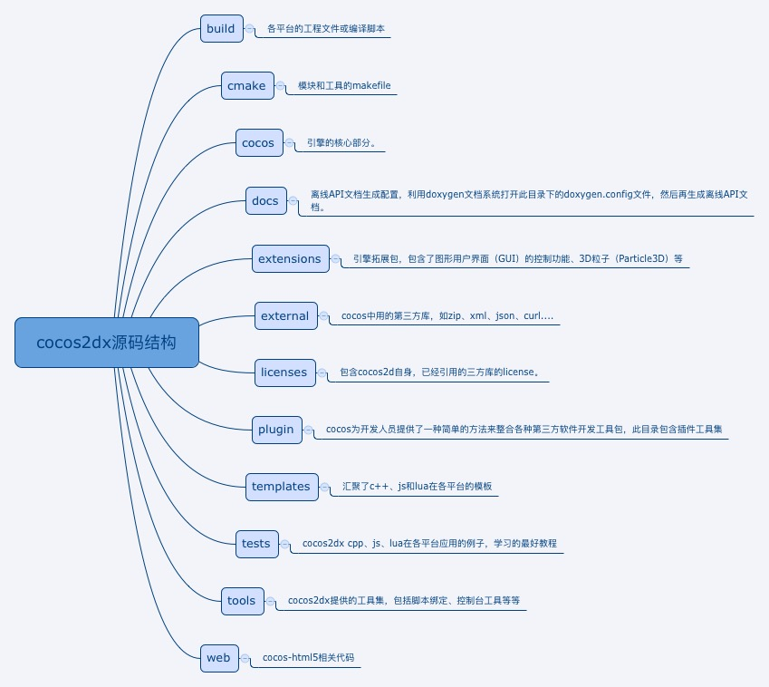

### Design patterns

#### Sec construction mode

**What and why is sec construction mode?**

In C++ we all know that to construct an object, we need to use new operator to call the constructor of the object. But there is some problem, if we want to use a image to create a sprite, what if the image does not exist? Usually we use a try-catch to handle the exception, but the constructor does not have a return value, so it’s different to know whether the operation success. On this condition, cocos uses the sec construction mode. The first step is use new to allocate memory of the object , second step is call init method to initiate the object.

Here is the code of Sprite::create():

Sprite* Sprite::create()

{

//分配内存

Sprite *sprite =newSprite();

//init初始化

if(sprite && sprite->init())

{

//内存管理的工作

sprite->autorelease();

return sprite;

}

CC_SAFE_DELETE(sprite);

Return nullptr;

}

As we can see, use sec construction mode also provide us with a way to manage the memory, because if the init() return true, we will add the object the autorelease pool which will auto release memory if the object has no reference attach to it. This makes developer don’t have to worry about memory leak and focus the application.

#### Factory mode

UML diagram of factory mode

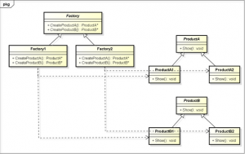

The above is a description of the factory mode. Let's take a look at the application of the factory model in cocos2dx. Refer to the book cocos2d-x advanced development tutorial: "The factory method is a classic design pattern in programming, referring to the base class. Only define the interface that creates the object, deferring the actual implementation to a subclass. Here, we will promote it a bit, referring to all static functions that generate and return an object." Everything that generates and returns an object's static function is a factory method. So, is there a lot of such methods in cocos2dx? For example, create a scene's createScene function, create a majority object's create function, a classic factory method like this

1Sprite* factoryMethod()

2{

3Sprite* ret =newSprite();

4//在这里对 ret 对象进行必要的初始化操作

5ret->autorelease();

6returnret;

7}

The application scenario that uses the factory pattern in our own program can be like this: we have to create a lot of bullets. If you use Sprite's create method to allocate memory each time, and the bullet is freed when the bullet is destroyed, the creation method is not efficient. If we use the factory method to accomplish this, our factory method facade maintains a container that holds the destroyed bullets and takes them out of the container when new bullets are needed. Depending on the type of bullet, change the texture, reset the position, reset the flight speed and direction, and then launch. If there are no bullets destroyed in the container, initialize one, so that you don't need new, delete each time, the number of bullets in the memory is certain, which can improve the efficiency of the

# Evolutionary perspective

The book <<software system architecture>> has told us that every system had the possibility to change, so we need a view to show the ability of a system to be flexible in the face of inevitable change that all systems experience after deployment. The main concerns of this perspective are Magnitude of change, dimensions of change, likelihood of change, timescale for change, when to pay for change, development complexity, preservation of knowledge, and reliability of change.

In 2010, the Cocos2d-x was born. “x” stands for Cross(cross platform). Cocos2d-x has already been developed for years. It is open-sourced on the Github. Now, Cocos2d-x has many versions and the latest is v3.17. it provides cross-platform support for developers to compiler game logic once written in the C++ language to IOS, Android and more mobile or PC platforms.

From the first version released in 2010 to the latest version 3.17 released in 2018, Cocos2d-x has many releases and has been added lots of features. In the followed information, we will highlight some important versions because they have some significant new features or turning points.

V2.0.3: this Windows phone 8 and Windows 8 platforms. It supports XAML.

V3.0: It replaces Objective-C patterns with C++(C++ 11) patterns. Labels and renderer are improved and it has new event dispatcher. We also should notice some changes in templated containers:

1. CCDictionary is replaced by cocos2d::Map<>
2. CCArray is replaced by cocos2d::Vector<>
3. CCBool, CCFLoat, CCDouble are replaced with cocos2d::Value

V3.2: Physics body supports scale and rotation;

1. Added Node::enumerateChildren and utils::findChildren, and support C++ 11 regular expression;
2. Added Node::setNormalizedPosition, Node's position in pixel will be calculated according its parent's content size

V3.6 & V3.7: Because Angle doesn't support WP8 any more, and WP8's market share is around 20% worldwide with variations across countries, so we removed WP8 support suggested by MS OPEN TECK guys since v3.6. Cocos2d-JS is merged into Cocos2d-x in v3.7.

V3.17: it can support iPhone X and Android Studio 3.0+.

（配图）

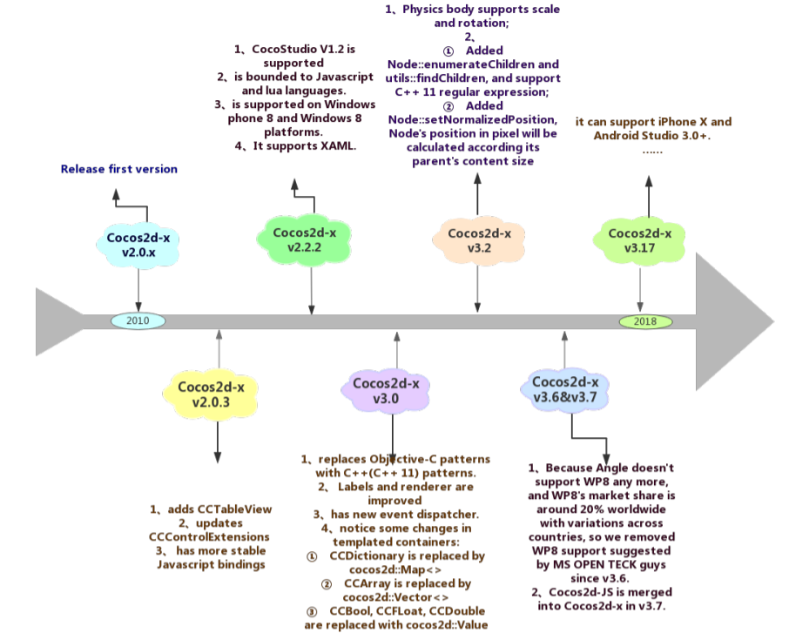

It is worth noting that v3.0 is a tuning point. This is reflected in two aspects, functional update and syntax update. Here, we will introduce two important changes and their problems.

1. In Version 2.x, when we listen out for Armature events, move it out of the scene if monitor the “COMPLETE”. However, in 3.0, we cannot do any operation in the callback function that might cause the release of this object. Otherwise, the pointer will be wrong. How it happens? Let us look at this picture.

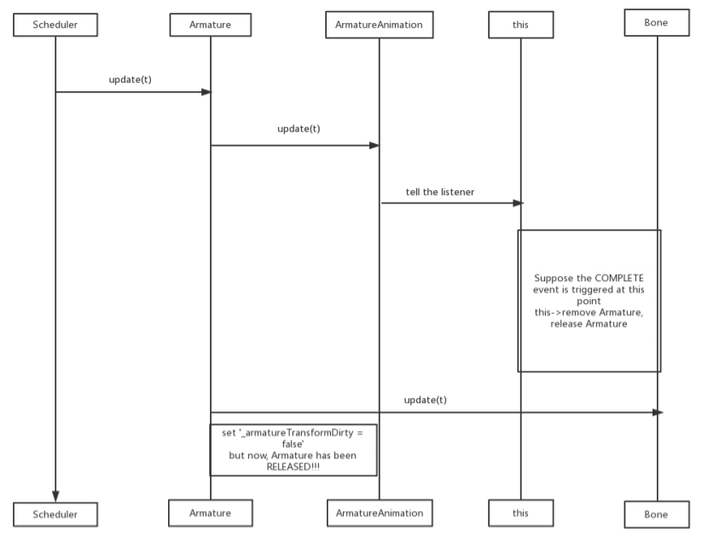

Don’t worry, we also have solutions. We can remove it with a timer. Firstly, add a public function virtual MovementData *getMovementData() const { return _movementData; }.Then, use Lmada expression to remove.

auto data = swf->getAnimation()->getMovementData();

float speed = data->scale;

float frames = data->duration;

float delay = frames/60/speed;

string id = FORMAT_TEXT( "%p", swf );

Director::getInstance()->getScheduler()->schedule( [swf](float t){swf->removeFromParent();},this,0,0,delay,false, id);

1. The anchorPoint in version 2.x affects both the position of the parent node and the position of the child node in the parent node; The anchorPoint in version 3.0 affects only its position in the parent node. We will give you an example:

A is the parent node, an B is its child node. They are both 10*10 squares

Originally:

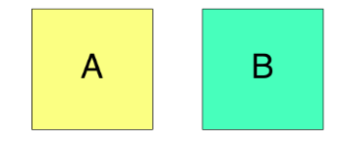

In 2.x:（overlap completely）

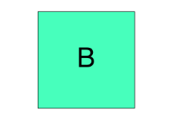

In 3.0: (The center of B overlaps with the lower left corner of A)

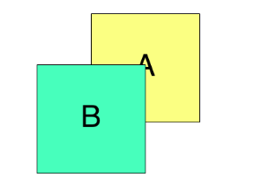

1. V3.0 had a new renderer. The way currently cocos2d-x v2.2 does rendering was OK but it was difficult to optimize, difficult to add new functionality and difficult to port to new platforms. However, new renderer had some new features to better it.
   1. Global Z order: a new method setGlobalZOrder() / getGlobalZOrder() was added to Node, and the old method getZOrder() were renamed to setLocalZOrder() / getLocalZOrder(). globalZOrder is used to sort the “draw commands” in the Renderer. It receives a float as argument. Low values has higher priority over high values. localZOrder is used to set the Node objects in its parent’s children Array. Nodes that have a globalZOrder of 0 (default value) will be drawn according to the Scene Graph order.
   2. Sprite vs. SpriteBatchNode. V2.2 recommended way to have good performance was to parent Sprite objects to a SpriteBatchNode. But it has some problems:
      1. Sprite objects can only have Sprite objects as children (if not, cocos2d-x will raise an Assert)
      2. All Sprite objects must share the same Textureld. (if not, will raise an Assert)

V3.0 still supports SpriteBatchNode but recommends to use Sprite objects without parenting them to a SpriteBatchNode. Make sure all Sprite objects share the same Textureld, shader and blending function, then the Sprites will perform almost as well as using SpriteBatchNode. The big differences between v2.2 and v3.0 are:

1. Sprite objects can have different Texture IDs.
2. Sprite objects can have any kind of Node as children, including ParticyleSystem.
3. Sprite objects can have different blending functions and use different shaders.
4. New EventDispatcher: All events such as touch event, keyboard event, acceleration event and custom event are dispatched by EventDispatcher. Removed TouchDispatcher, KeyboardDispatcher, etc. It has some new features:
   1. Diapatcher events based on rendering sequence.
   2. All events are dispatcher by EventDispatcher.
   3. Can use EventDispatcher to dispatch custom events
   4. Can register a lambda as call back function.

## Cocos2d-x 3.2.0 characters

### new 3d spine animation:

(HIGHER VIEW:the module “BASE NODE” is changed by adding some classes)

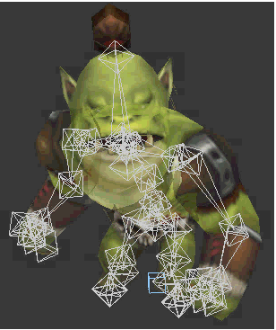

For a game engine, the ability of implementing the function of the movement, attack actions is necessary, and the way to implement it is to use the frame animation, or this new Spine animation which is added to cocos engine at the version of 3.2.

The difference between frame animation and spine animation is huge: frame animation receives amount of quick clips of the character’s movements as a frame of the animation, which means the number of frames decides the fluency effect of the animation.However, spine animation tries to bind the part of body to a series of bones that react to each other. So by controlling the changes of the positions of these bones, and the direction of rotate, the animation will be generated automatically.

Compared to frame animation which suits 2d games, spine animation is more likely to be used in 3d animation. Spine animation requires higher performance of processor, but it has more benefits, like less resources, smaller memory requirement, better fluency and other kind stuff.

### Game controller support

(HIGHER VIEW:a new module is added to the architecture)

In 3.2.0 version of cocos, a module which is composed by a series of standardized API which provide the tech-support of game controller is added to the engine, which means in iOS and Android operating system, the access of using game controller is now available.

# Performance perspective

### ⅠOptimize and speed up rendering

In the rendering and rendering of the game, it often consumes a lot of resources and memory. As the number of drawing sprites increases, the game card will be obvious. in order to optimize and improve the rendering efficiency. Cocos2d-x gives us SpriteBatchNode and auto-batching

##### SpriteBatchNode

SpriteBatchNode is mainly used to batch the rendering wizard to improve the rendering efficiency of the wizard. The more wizard needed to be painted, the more obvious the effect.

Cocos2d-x USES opengl es to draw pictures, and opengl es to draw every wizard will run: open-draw-close process.

SpriteBatchNode puts multiple sprites on one texture and draw the texture directly and uniformly. You do not need to draw the child nodes separately. So that when opengl es is drawn, it becomes: open-draw()-draw()...-draw()-close(), saving multiple times of open-close time. SpriteBatchNode internally encapsulates a TextureAtlas(TextureAtlas, which internally encapsulates a Texture2D) and an Array(the child node used to store SpriteBatchNode: a single Sprite). Note: since it is only open close once, all the children of the SpriteBatchNode object must be treated with the same texture(same image).In addChild, the texture of the child is checked to see if it has the same name as SpriteBatchNode.

##### Auto-batching

Auto-batching means to package a call from multiple draws into a big draw call (aka batch).

The rendering process of auto-batching

(1) drawScene begins to draw the scene

(2) traverse the child nodes of the scenario.Call the visit function to recursively traverse the child node.

(3) call the draw function on each child node

(4) initialize the QuadCommand object.The render command is thrown into the render queue.

(5) render logic traverses the render command queue.The ID of the current render command is compared to the ID of the previous one during the iteration.Assuming the discovery is the same, rendering is not done. Save the required information and move on to the next iteration.Let's say that the current ID is not the same as the last ID, and start rendering.This is a render batch.

##### Conclusion

In version 3.0, a new rendering mechanism is provided to separate the engine logic from rendering. This version number still supports SpriteBatchNode, but it is no longer recommended due to Auto batching’s better performance.

.

### ⅡOptimize memory use

#### Memory manage

#### First. Two Aspects of Cocos2d-x 3.2 Memory Management

1) add object to autoreleasepool to release objects automatically

2) use node management to ensure deletion of object after its discard

1. release discarded object in time

Condition: the object is a subclass of node class

Method: addChild, removeChild

Process: addchild//after addchild, the object can be used,

removeChild// after removeChild, the object can be deleted immediately

2. release unused object

Description: if the newly created object is not used in one frame, the object will be released automatically.

Condition: the object is created by CREAT_FUNC() macro or use autorelease method to be added in autoreleasepool.

**How memory is managed?**

When object is created , the reference count is added by one

When it is released, the reference count is decreased by one

When it is used , like being added to the tree by addChild method, the reference count will be added by one.

When the reference count reach 0, the object will be released

##### Second. A deeper look into memory management

Ref class: used to manage reference count, provide interface to the autoreleasepool

AutoreleasePool class: manage a vector of objects. Provide operation to manage the objects in the pool.

PoolManager class: manage a vector of autoreleasePool, in default there is only one autoreleasePool in the game, this class in provided to developer to add their own autoreleasePool to improve game performance.

DisplayLinkDirector class: this is a director class , provide the main loop of the game, implement resource releasement for every frame. This class inherit from Director class.

1.1 **Ref**

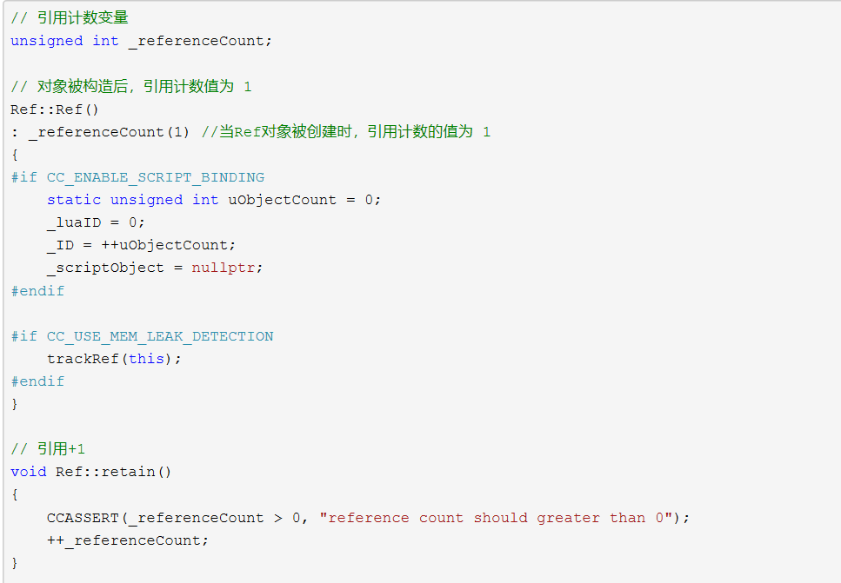

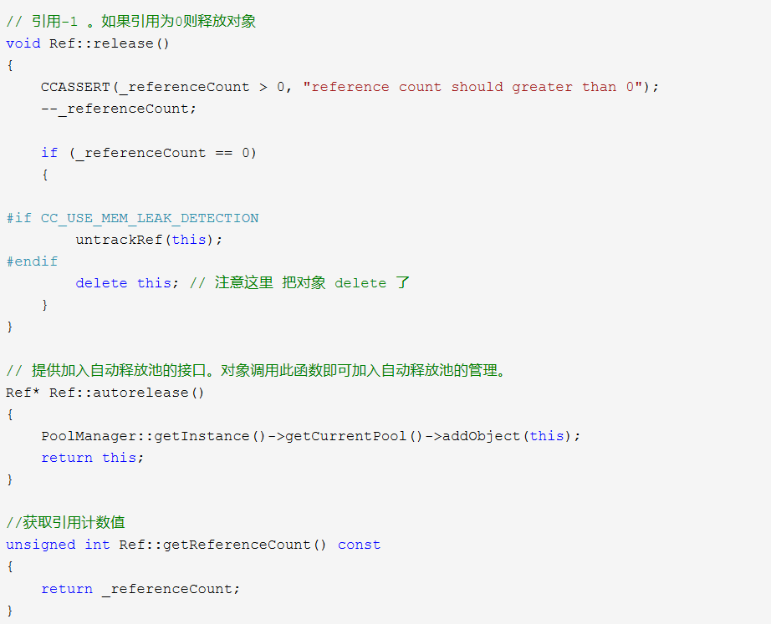

**AutorealeasePool**

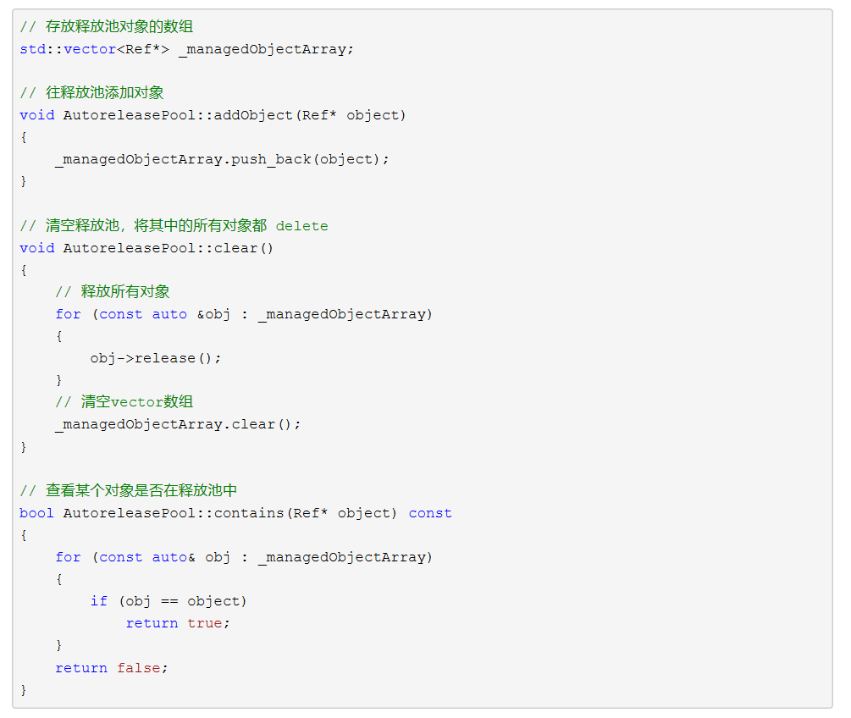

**PoolManager:**

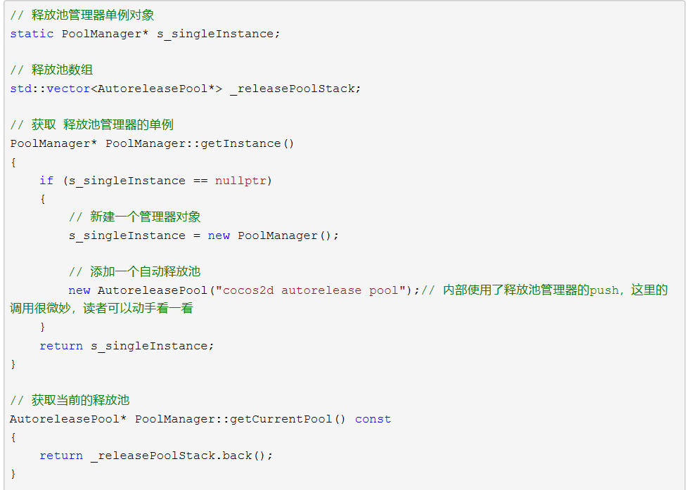

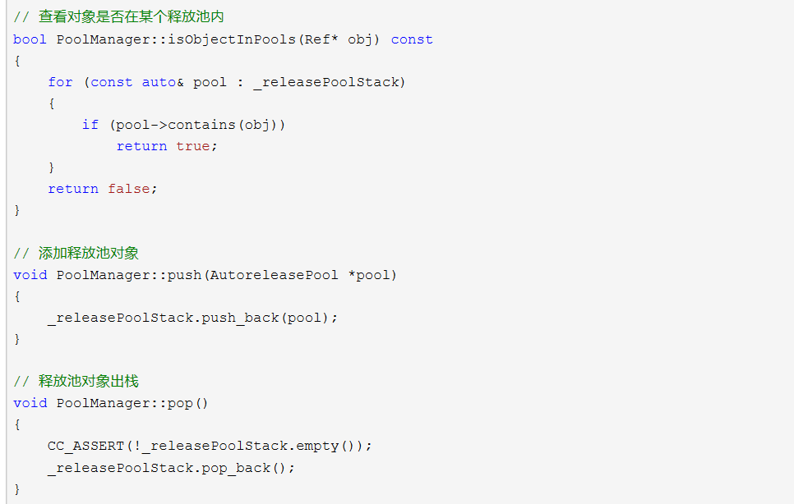

**Node:**

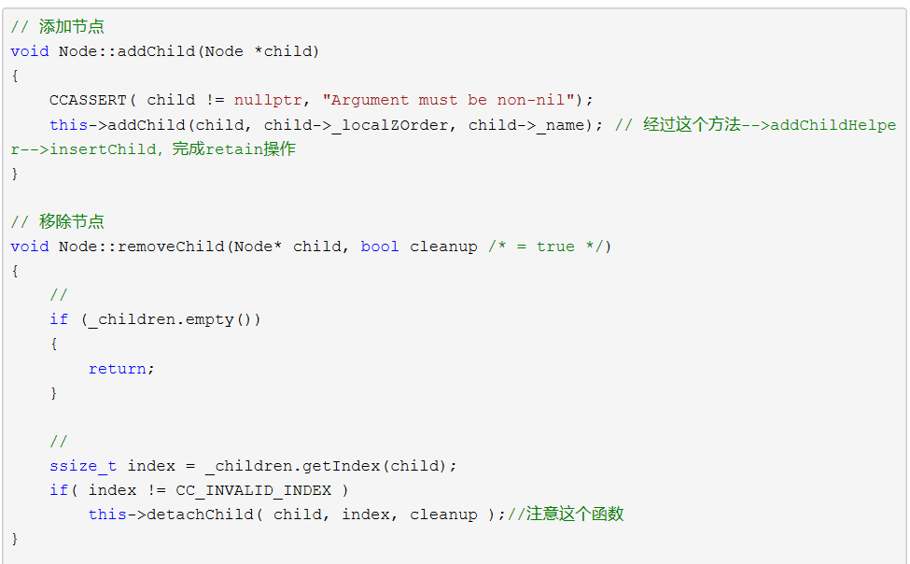

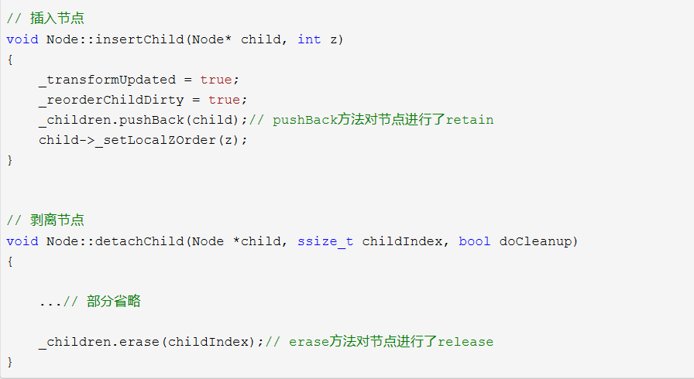

**Vector:**

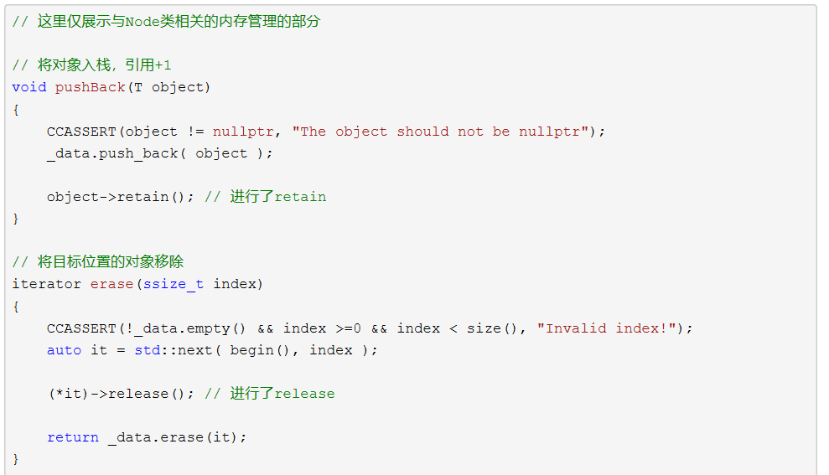

**Whole story: now we can take a look at how cocos manage its memory thoroughly. First, we create a Node object A which inherit from Red, so the reference count is 1. Then in the create() method ,we use autorelease() to add the object into auto autoreleasePool. Then we assumen there is a Node object B, we use B.addChild(A) to add the reference count of A, so the ref count of A is 2. Then at the end of the current frame, clear() is called so the ref count of A reduce to 1 but still greater than 0 so it’s not released. When we call B.removeChild(A),the ref count of A reduce to 0 and then be release.**

## Objects pool

We know that memory use is a significant aspect of game performance. Some game needs so much memory that cause very low FPS when there is not enough memory or just crash. Cocos has provided us with a good way to manage your memory which id object pool.

We know that new and destroy object is an expensive operation, but in a game such as shooting game, there are lots of bullet being created and destroyed when the game is in process. So if use original new and delete operation will obviously slow down our program. In this situation cocos use a mechanism called object pool to change the situation.

The class is called NodePool.

Initialization: first we should write the onLoad function which will be called when the pool is loaded, the variable initCount is the original pool size.

1. properties: {
2. enemyPrefab: cc.Prefab
3. },
4. onLoad: **function** () {
5. **this**.enemyPool = **new** cc.NodePool();
6. **let** initCount = 5;
7. **for** (**let** i = 0; i < initCount; ++i) {
8. **let** enemy = cc.instantiate(**this**.enemyPrefab); *// 创建节点*
9. **this**.enemyPool.put(enemy); *// 通过 putInPool 接口放入对象池*
10. }
11. }

After the initialization, we can use the pool to store and get objects, when we need to create an enemy, we firstly judge whether the pool has more enemies, if there has more object, we just get one, if there is not, we instantiate a new object. When the total number of objects is stable , the new operation is hardly called because the rate of creation and destroy is approximately equal, so there is no need to create new object. When the number of objects in the pool is too much , which means the size of the pool is too big , we can trim the size of pool to save more spaces.

1. CreateEnemy: **function** (parentNode) {
2. **let** enemy = null;
3. **if** (**this**.enemyPool.size() > 0) { *// 通过 size 接口判断对象池中是否有空闲的对象*
4. enemy = **this**.enemyPool.get();
5. } **else** { *// 如果没有空闲对象，也就是对象池中备用对象不够时，我们就用 cc.instantiate 重新创建*
6. enemy = cc.instantiate(**this**.enemyPrefab);
7. }
8. enemy.parent = parentNode; *// 将生成的敌人加入节点树*
9. enemy.getComponent('Enemy').init(); *//接下来就可以调用 enemy 身上的脚本进行初始化*
10. }

When the object is destroyed, we don’t destroy it, just put it back to pool for next use.

1. onEnemyKilled: **function** (enemy) {
2. *// enemy 应该是一个 cc.Node*
3. **this**.enemyPool.put(enemy); *// 和初始化时的方法一样，将节点放进对象池，这个方法会同时调用节点的 removeFromParent*
4. }

### Ⅲ Multi-thread and asynchronous loading

##### Part I: the way to measure the performance

One of the most significant and typical way to measure the performance of a system is to considerate the responsiveness, or we called response time. According to ***Software System Architecture***, we learned that as system workload goes up, the response time would increase slowly and seems linearly until it meets the point called “knee point” at which the parameter that represents response time starts to increase sharply, which is to say, the performance of system starts to crash. So the key to keep the response time stay low is to control the workload properly to make sure it won’t beyond the threshold.

##### Part II: multi-thread and asynchronous Loading

We would test the concurrency of cocos2d-x. This engine provides a large main cycle in which the system would update the state of every element in game separately between every frames. Of course it’s a clever approach to implement concurrency by using only one thread. However, consider this situation, if a task which requires huge amounts of compute resources occurs, it has no chance to get finished between two frames and it would stop the main cycle.

To avoid triggering this endless loop, cocos2d-x provides two solutions: multi-thread and asynchronous. There is a library for developers to use: pthread. To make it clear first, this library is not developed by cocos, however it is welcomed and has been merged into cocos2d-x by official team soon.

Pthread provides methods create and destroy threads that would be used in cocos engine, but still it cannot be used randomly. For a new thread, the operations that invokes cache and its resources would lead to system crashing. Besides, the correct arrangement of the tasks also matters, the reason of cocos engine occupying the main thread is to make sure the fluency of interface loading, that’s also why we use concurrency. Now we can put other code except those related to interface into other new threads, like file-reading/file-writing or http requests. For example, the picture resources need encode and decode which will cost huge CPU resources, so this process would be put into a new thread in order not to stuck the main thread.

# Conclusion

After reading our SA about Cocos2d-x, I really hope you can have an overall look on Cocos architecture. Cocos2d-x is such a complex system which we just show its structure form very high level, there are lots of details we didn’t talk about.

What’s more, we appreciated this opportunity to look inside Cocos to figure out its architecture techniques from which we really learned a lot about establishing a software system. It’s really hard for us to have a chance to get involved in constructing a big system. So this course gives us a chance to see how some successful architecture works, how they are constructed, and how different components communicate. This is such precious experience for us to build complex software in the future.

# References

1. Cocos2d-x.org docs:About Cocos <http://docs.cocos2d-x.org/api-ref/cplusplus/v3x/index.html>
2. Tutorial: Using sprite sheet animations: <https://www.codeandweb.com/texturepacker/tutorials/animations-and-spritesheets-in-cocos2d-x>
3. Cocos2d-x游戏引擎核心之八——多线程：<https://www.cnblogs.com/yyxt/p/4087123.html>
4. GitHub cocos:<https://github.com/CocosStructure/cocos2d-x-1>
5. Wikipedia, Persistence of vision:<https://zh.wikipedia.org/wiki/%E8%A6%96%E8%A6%BA%E6%9A%AB%E7%95%99>
6. itHub Cocos: [https://github.com/CocosStructure/cocos2d-x-1](javascript:void(0);)
7. Cocos2d-x documentation: <http://docs.cocos2d-x.org/cocos2d-x/en/>
8. Cocos2d游戏引擎发展历史：https://blog.csdn.net/gzylongxingtianxia/article/details/49885819
9. Cocos2d-x浅析几个重要类：https://blog.csdn.net/qq_34240791/article/details/80225563
10. Cocos Creator v2.0 User Manual <http://docs.cocos2d-x.org/creator/manual/en/>
11. Cocos2d-x 3.x 图形学渲染author:海洋 <https://blog.csdn.net/jxw167/article/details/54375036>
12. Read cocos2d-x source code author： [luckilyyu](https://me.csdn.net/LuckilyYu) [Read cocos2d-x source code](Read%20cocos2d-x%20source%20code)
13. Cocos2d/cocos2d-x <https://github.com/cocos2d/cocos2d-x>
14. cocos2d-x-3rd-party-libs-src <https://github.com/cocos2d/cocos2d-x-3rd-party-libs-src>