* **Brainstorm**

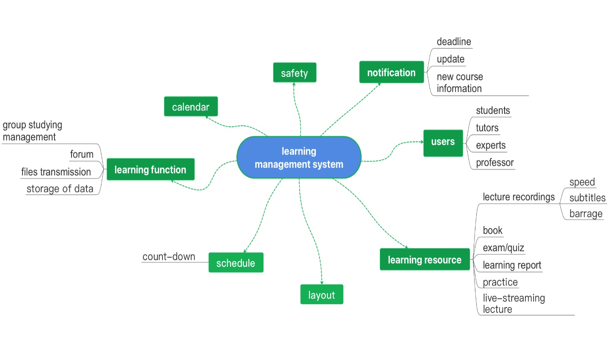

* **Intended audience**

postgraduate students, tutors, lecturers, professors, some other teaching staffs

* **Goals**

Helping users to achieve the online-learning goals through streaming or video recordings.

* **Product Description Statement**

This interactive learning system provides a platform to store lecture recordings which can help users consolidate and memorize knowledge through repeated viewing. ‘Lecture recording’ provides a passive learning mode.

Q7：What effect do you think online learning platforms have on your study?

Q8：How can your Moodle experience be further improved?

Q10：Can you easily find the materials you're looking for on moodle?

-Yes

-No

Q13：Do you think students should also be allowed to upload recording files to the course platform？

-Yes

-No

Q15：What functions do you think the course platform does not satisfy you？

Q20：Do you want the course platform to add the function of learning notes？

-Yes

-No