Lab 2 Report: Version Control, VectorBoardObjects, and MVC Design

1. Introduction
This report documents the work completed for Lab 2 of the Intelligent Agents and Simulation coursework. The purpose of this lab is to extend the existing Pac-Man C++ project by adding new object-oriented components, using version control, documenting the code, and analysing the project structure through design diagrams.
The original project already contains several board object classes, including BoardObject, Cookie, Player, and Wall. In this lab, the project was extended by adding a new vector-based collection class called VectorBoardObjects, as well as two new game object classes: Monster and Bomb.
The main objectives of this lab are:
- To understand the role of version control in software development.
- To implement a vector-based alternative to ListBoardObjects.
- To limit the vector collection to a maximum of four objects.
- To add Monster and Bomb as new BoardObject subclasses.
- To test the new implementation using a separate test program.
- To document the code using Doxygen-style comments.
- To represent the project structure using UML and MVC diagrams.

2. Version Control
Version control is an important part of software development because it allows developers to track changes, manage different versions of a project, collaborate with others, and recover previous versions when necessary.
Although the practical material introduces Subversion, this lab was submitted through GitHub using a shared repository link. GitHub provides similar version-control benefits, including commit history, file tracking, remote access, and shared project visibility.
The GitHub repository was created for Lab 2 and Lab 3 submission. The Lab 2 files are organised inside a dedicated Lab 2 folder, while Lab 3 can be added later in a separate folder.
The repository structure is planned as follows:
IntelligentAgents_Lab2_Lab3/
├── Lab2/
│ ├── PackMan.d/
│ ├── screenshots/
│ ├── diagrams/
│ ├── README.md
│ └── Lab2_Report.pdf
└── Lab3/
Using GitHub makes the project easier to share with the assessor and also provides evidence of the uploaded files and project updates.

3. Source Code Extension
The main source-code work was completed in the PackMan.d folder of the Lab 2 project. The original files were preserved in a separate original folder, while the modified version was edited in the working folder.
The following files were added:
VectorBoardObjectsH.h
VectorBoardObjects.cpp
MonsterH.h
Monster.cpp
BombH.h
Bomb.cpp
TestVectorBoardObjects.cpp
The following existing files were modified:
BoardObjectH.h
Makefile.make
The purpose of these changes was to extend the object-oriented structure of the Pac-Man project without rewriting the entire system. The new classes follow the existing design style of the project and reuse the BoardObject base class.

4. VectorBoardObjects Implementation
The new class VectorBoardObjects was implemented as a vector-based collection of BoardObject* pointers. It provides a similar interface to the existing ListBoardObjects class, but it uses std::vector internally instead of std::list.
The class was declared in:
VectorBoardObjectsH.h
and implemented in:
VectorBoardObjects.cpp
The main private data members are:
std::vector<BoardObject*> list
std::vector<BoardObject*>::iterator internalIterator
MAX_OBJECTS = 4
The maximum number of stored objects is limited to four. This was implemented by checking the size of the vector before adding a new object.
The implemented methods include:
theFirst()
theNext()
addOne()
removeOnePlayer()
isThereAWall()
isCookieValue()
size()
isFull()
The method addOne() only adds a new object if the vector is not full. If the vector already contains four objects, the new object is rejected and a message is printed.
This design makes it possible to test whether the original list-based object collection can be replaced by a vector-based implementation with only localised changes.

5. Monster and Bomb Implementation
Two new board object classes were added:
Monster
Bomb
Both classes inherit from the existing BoardObject base class.
The Monster class was implemented in:
MonsterH.h
Monster.cpp
The Bomb class was implemented in:
BombH.h
Bomb.cpp
The BoardObjectH.h file was modified to add two new object types:
A_MONSTER
A_BOMB
The updated enum became:
enum ObjectTypes { THE_BACKGROUND, A_COOKIE, A_PLAYER, A_WALL, A_MONSTER, A_BOMB };
The Monster class represents an enemy object, while the Bomb class represents a special board object. In this lab, both classes have simple behaviour. Their touch() methods change their colour to demonstrate that they can behave as independent subclasses of BoardObject.
This implementation shows that the existing object-oriented design can be extended with new game objects without changing the whole project structure.

6. Compilation and Testing
A separate test program was created:
TestVectorBoardObjects.cpp
This test program verifies the functionality of VectorBoardObjects, Monster, and Bomb.
The Makefile.make file was updated to compile the test program. A new object list was added:
TEST_OBJS = TestVectorBoardObjects.o VectorBoardObjects.o Cookie.o Player.o Wall.o Monster.o Bomb.o
A new build target was also added:
TestVectorBoardObjects : $(TEST_OBJS)
g++ $(DBG) $(TEST_OBJS) -o TestVectorBoardObjects
The test program was compiled using:
mingw32-make -f Makefile.make TestVectorBoardObjects
It was then executed using:
.\TestVectorBoardObjects.exe
The test output confirmed the following results:
- A monster object was added successfully.
- A bomb object was added successfully.
- A cookie object was added successfully.
- A wall object was added successfully.
- The collection reached size 4.
- The collection reported that it was full.
- A fifth object was rejected.
- A wall was detected.
- A cookie value was collected.
- A player was added after the cookie was removed.
- The player was removed successfully.
- The final collection contained the expected remaining objects.

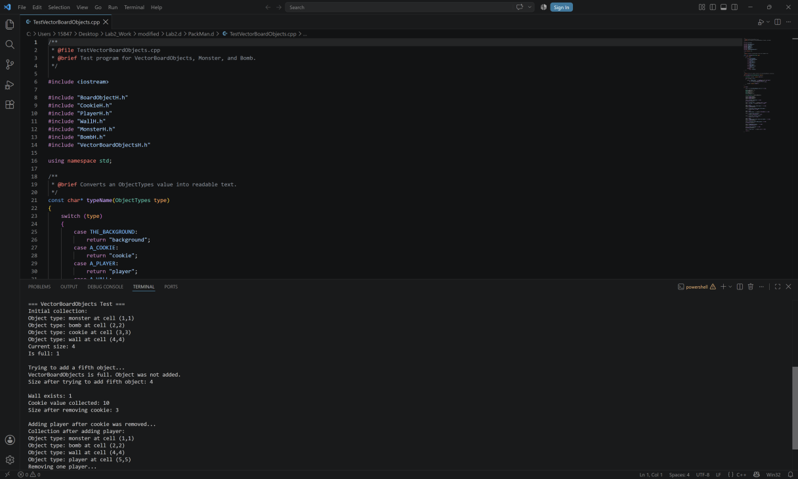

7. UML Class Diagram
A UML class diagram was created to represent the structure of the extended Lab 2 project.
The diagram includes the following main classes:
BoardObject
Cookie
Player
Wall
Monster
Bomb
ListBoardObjects
VectorBoardObjects
Board
VladPackManGame
The diagram shows that Cookie, Player, Wall, Monster, and Bomb all inherit from BoardObject. This inheritance structure allows all these objects to be treated through the same base class type.
The diagram also shows that both ListBoardObjects and VectorBoardObjects store pointers to BoardObject objects. This is important because it allows the collection to store different types of game objects through a common interface.

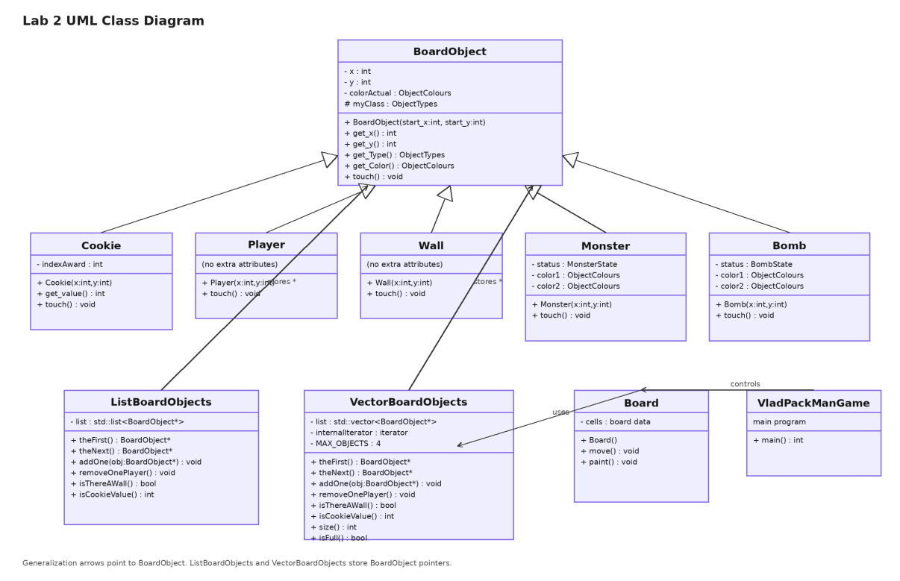

8. MVC / Sequence Diagram
An MVC and sequence diagram was also created to explain the overall project structure.
The project can be interpreted using the Model-View-Controller pattern:
Model:
BoardObject, Cookie, Player, Wall, Monster, Bomb, Board, ListBoardObjects, VectorBoardObjects

View:
Terminal output and board painting behaviour

Controller:
VladPackManGame and the main program flow
The model contains the game data and game objects. The view is responsible for displaying the game state. The controller coordinates the game execution and calls the appropriate model and view operations.
The sequence diagram shows a simplified execution flow:
1. The user runs the program.
2. VladPackManGame starts the game flow.
3. The Board manages the game state.
4. VectorBoardObjects stores BoardObject-derived objects.
5. The program retrieves object information.
6. The board state is displayed to the user.
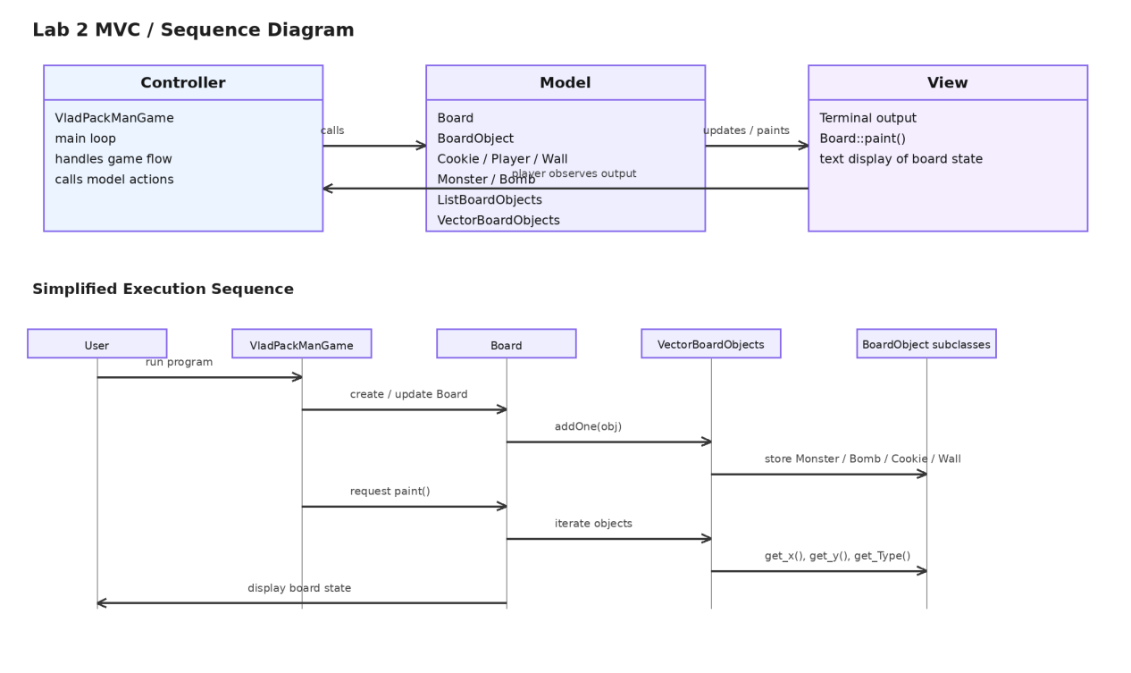

9. Doxygen Documentation
Doxygen-style comments were added to the new source files and header files. These comments describe the purpose of each class and method.
The following files include Doxygen-style comments:
VectorBoardObjectsH.h
VectorBoardObjects.cpp
MonsterH.h
Monster.cpp
BombH.h
Bomb.cpp
TestVectorBoardObjects.cpp
Examples of documented elements include:
- Class descriptions
- Constructor descriptions
- Method descriptions
- Parameter descriptions
- Return value descriptions
This documentation improves code readability and makes it easier for another developer to understand the purpose of the new classes. It also supports future automatic documentation generation using Doxygen.

10. Conclusion
Lab 2 extended the original Pac-Man C++ project by adding a new vector-based object collection and two new board object subclasses. The VectorBoardObjects class provides a similar interface to ListBoardObjects, but it stores objects using std::vector and limits the collection to four objects.
The new Monster and Bomb classes demonstrate how the project can be extended using inheritance. Both classes inherit from BoardObject and can be stored in the same object collection as existing objects such as Cookie, Player, and Wall.
The test program confirmed that the new vector collection works correctly. It successfully added objects, rejected a fifth object when full, detected a wall, collected a cookie value, added a player, removed a player, and preserved the expected remaining objects.
The UML and MVC diagrams helped explain the structure of the project and the relationship between different classes. Overall, this lab improved understanding of C++ object-oriented design, collection classes, version control, build automation, and software architecture documentation.

