Lab 3 Report: QtPackMan MVC, Coding Standards, and Doxygen Documentation
Intelligent Agents and Simulation – Lab 3

1. Introduction
This report documents the work completed for Lab 3. The lab focuses on the Qt version of the Pac-Man project, with emphasis on the Model-View-Controller structure, coding standards, memory management, and Doxygen documentation support.
The original QtPackMan project already contains a graphical board implemented with Qt widgets, a model that stores the board state, and a controller that coordinates the game flow. The work completed in this lab improves documentation and maintainability rather than changing the basic gameplay rules.

2. Project Structure
The main source files are located in QtPackMan.d. The most relevant classes are listed below.
File / Class | Purpose
BoardObject.h | Base class for board objects such as Cookie, Player, and Wall.
Cookie.h / Cookie.cpp | Represents collectible cookies and their prize value.
Player.h / Player.cpp | Represents the player object on the board.
Wall.h / Wall.cpp | Represents blocking wall objects.
ListBoardObjects.h / .cpp | Stores BoardObject pointers in each board cell.
Model.h / Model.cpp | Stores and updates the game state.
BoardCells.h / .cpp | Represents the visible board layout using Qt cells.
GameCell.h / .cpp | Represents an individual visible cell in the Qt board.
Controller.h / .cpp | Coordinates user input, timer events, model updates, and board display.
main.cpp | Starts the Qt application and creates the controller.

3. Coding Standards and Memory Management Improvements
The practical material highlights the importance of improving code quality and avoiding memory-management errors. The original project uses dynamic allocation through new, so explicit deletion is required when objects are no longer needed.
The following improvements were made:
- A virtual destructor was added to BoardObject so that derived objects can be deleted safely through BoardObject pointers.
- A destructor was added to ListBoardObjects to delete the BoardObject pointers stored in its internal vector.
- A destructor was added to Model to delete the dynamically allocated ListBoardObjects objects stored in mySpace.
- The Controller destructor was extended to delete gameTimer, myModel, and myBoard, then set those pointers to NULL.
These changes reduce memory leaks and improve the safety of the object-oriented design.

3.1 BoardObject Destructor
virtual ~BoardObject() {};
Because BoardObject is used polymorphically, the destructor should be virtual. This allows the correct destructor chain to run when a derived object is deleted through a BoardObject pointer.

3.2 ListBoardObjects Destructor
ListBoardObjects::~ListBoardObjects()
{
std::vector<p_BoardObject>::iterator it = list.begin();
while (it != list.end())
{
delete (*it);
*it = NULL;
it++;
}
list.clear();
}
This destructor releases the BoardObject pointers stored in the list and then clears the vector.

3.3 Model and Controller Destructors
The Model destructor releases every ListBoardObjects cell stored in the two-dimensional mySpace array. The Controller destructor releases the timer, model, and board view. These changes match the ownership relationships shown in the UML diagram.

4. Doxygen Documentation
A Doxygen configuration file named Doxyfile was added to QtPackMan.d. This allows automatic HTML documentation to be generated from source files and comments.
The Makefile was also extended with a documentation target:
doc:
doxygen Doxyfile
If Doxygen is installed, documentation can be generated from the QtPackMan.d folder using:
mingw32-make doc
or, depending on the local environment:
make doc
If Doxygen is not installed on the computer, the Doxyfile and Makefile target still document how project documentation can be generated in a configured environment.

5. UML Class Diagram
The UML class diagram shows the structure of the QtPackMan project. Cookie, Player, and Wall inherit from BoardObject. Model owns the board-state data, ListBoardObjects stores BoardObject pointers, and Controller coordinates the Model and BoardCells view.
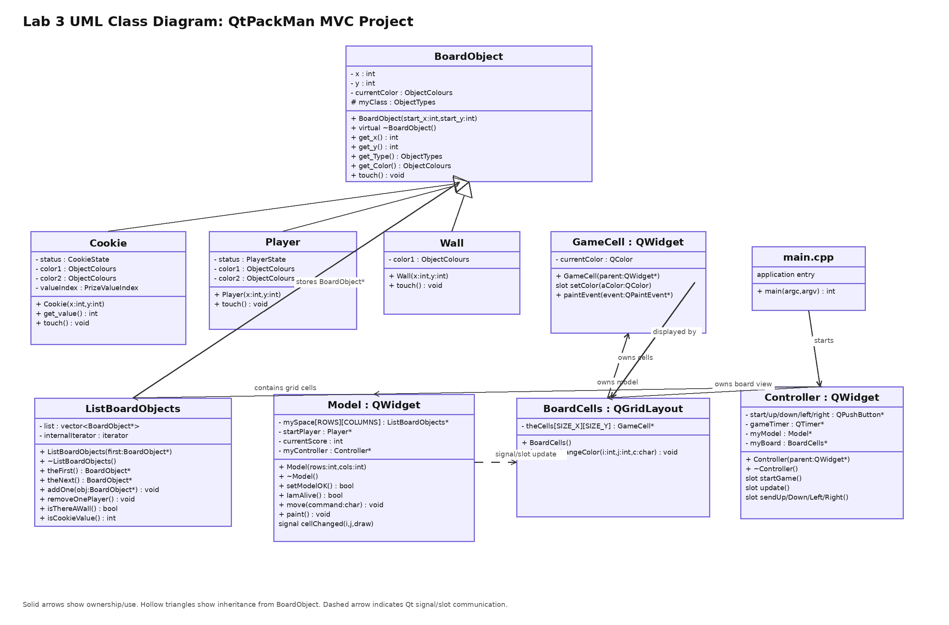
Figure 1. UML class diagram for the QtPackMan project.

6. MVC / Interaction Diagram
The project can be interpreted using the Model-View-Controller pattern. The Controller receives Qt button and timer events, the Model stores and updates game state, and the View displays the board using BoardCells and GameCell objects.
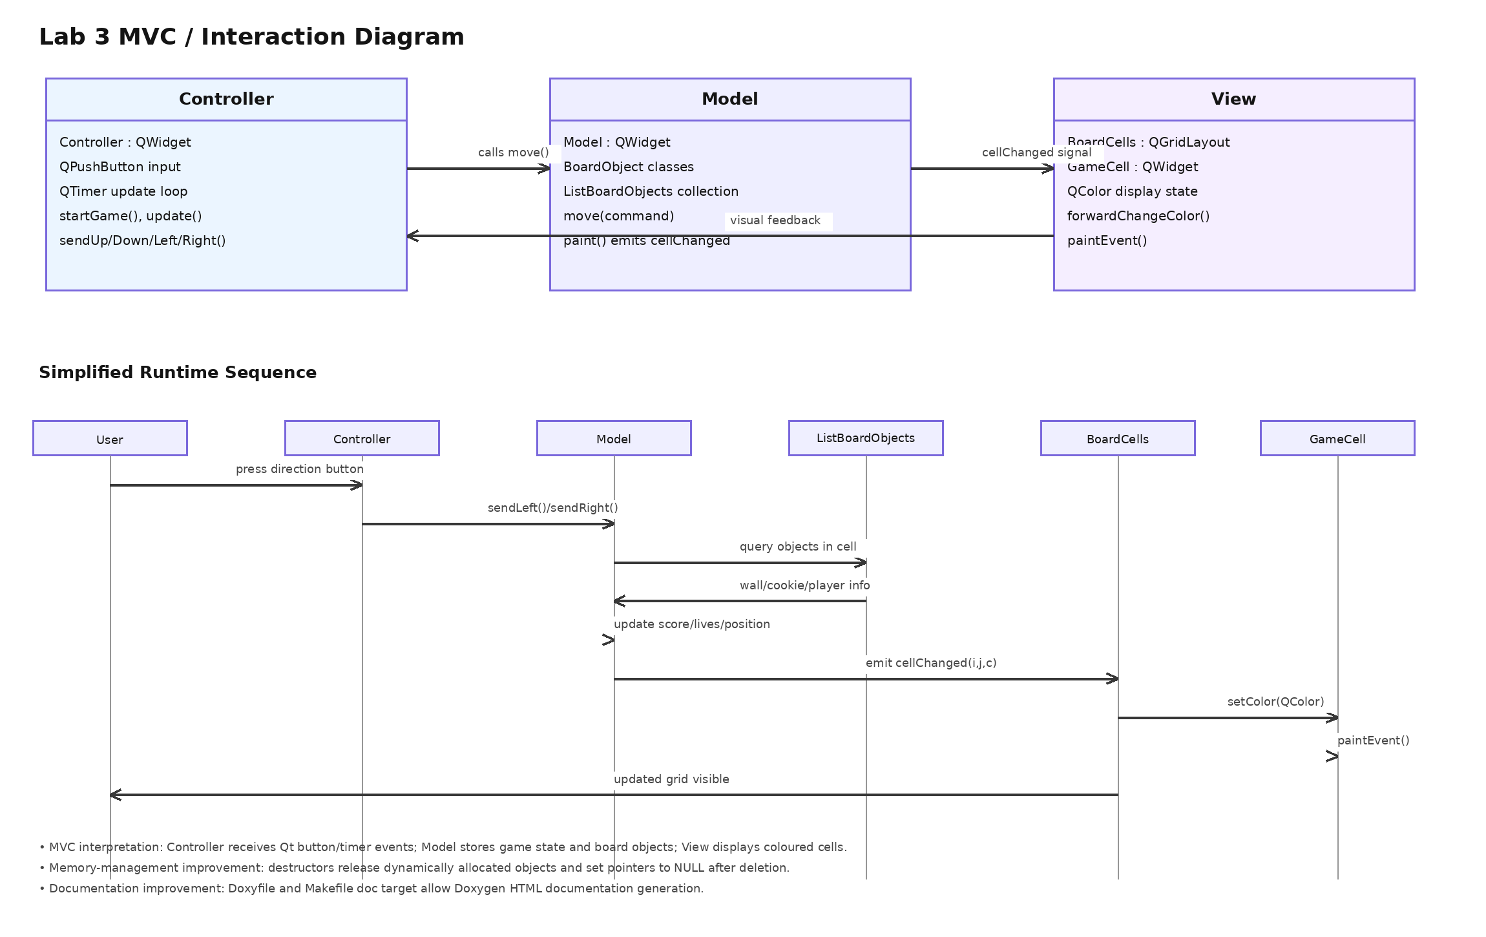
Figure 2. MVC and runtime interaction diagram.

7. Summary of Modified / Added Files
- BoardObject.h: added a virtual destructor.
- ListBoardObjects.h: added destructor declaration.
- ListBoardObjects.cpp: added destructor implementation to release stored BoardObject pointers.
- Model.h: added destructor declaration.
- Model.cpp: added destructor implementation to release allocated cell collections.
- Controller.cpp: updated destructor to release owned objects.
- Doxyfile: added Doxygen configuration.
- Makefile: added a doc target for Doxygen generation.

8. Conclusion
Lab 3 improved the QtPackMan project by analysing its MVC structure, documenting its class relationships, and applying basic coding-standard improvements. The memory-management changes address dynamically allocated objects, and the Doxygen configuration provides a path for automatic documentation generation. The UML and MVC diagrams clarify how the project is organised and how Qt events flow through the controller, model, and view components.

