1. (TensorBoard) Graph of loss and top5 accuracy curve

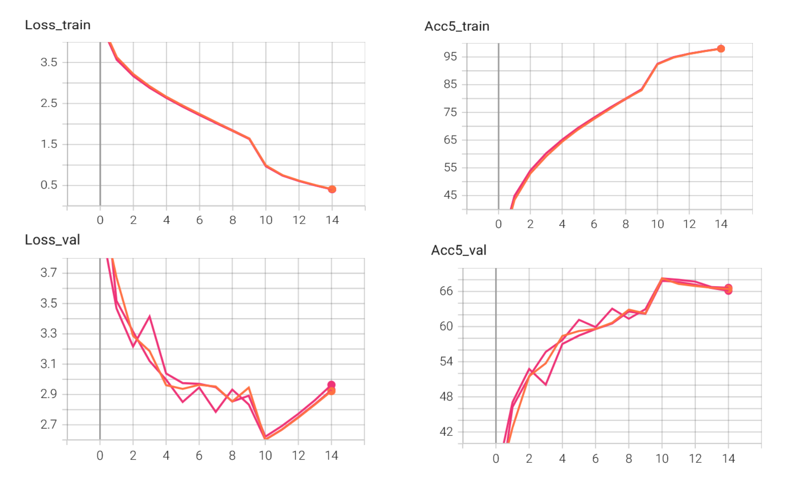

The training is based on the parameters of batch_size=256, learning rate=0.1 (decaying to 1/10 every 10 epochs), momentum=0.9, weight_decay=1e-4, epoch_num=15 for 3 times with no pre-trained models used.

1. A try to promote the Acc5_val

When loading the pre-trained model of Resnet18, setting the [parameter](javascript:;)s on resnet18, batch_size=256, learning rate=0.01, momentum=0.9, weight_decay=1e-4, the validation accuracy of the top5 can reach and [stabilize](javascript:;) at about 77% which is showed below.

