Bayesian Thermal Inactivation Models for Infectivity and PCR Data

Study purpose and modeling strategy
The purpose of this analysis is to quantify viral inactivation dynamics as a function of time, temperature, virus type, and food matrix using experimentally derived infectivity and PCR data compiled from multiple independent studies. Given prior evidence that shellfish matrices, particularly oysters, may protect viruses from thermal inactivation due to tissue structure and composition, particular emphasis is placed on evaluating whether viral thermal inactivation differs in shellfish matrices compared with other food matrices and inorganic matrices.
Primary inactivation kinetics are evaluated using both first-order and Weibull models. The first-order model assumes that $\log_{10}$ reduction increases linearly with time. The Weibull model allows curvature through a positive shape parameter $n$: $n=1$ gives log-linear behavior, $n<1$ gives tailing, and $n>1$ gives shouldering. In both formulations, $D$ is a positive time-scale parameter corresponding to one predicted $\log_{10}$ reduction.
To explain systematic variation in $D$, secondary models are specified through nonlinear predictors on the natural-log time scale used in the brms formulas. Temperature is represented either by a linear deviation term or by a powered deviation term with an estimated exponent. Food matrix, virus type, and PCR pretreatment are evaluated either as shifts in the reference-temperature log time parameter or as modifiers of the temperature coefficient, depending on the candidate model. Between-study heterogeneity is represented by random intercepts on the reference-temperature parameter.
All models are fit in a Bayesian hierarchical framework, allowing joint propagation of posterior uncertainty among the modeled components. Observations whose true log reduction exceeds the recorded bound are treated as right-censored on the log-reduction scale through the censored-data likelihood in brms. Model adequacy is assessed through posterior predictive checks and MCMC diagnostics. Models exhibiting poor convergence (e.g., $\hat{R}$ meaningfully greater than 1.00 or evidence of incomplete chain mixing) were refitted with tighter priors or stronger sampler tuning.
Validated models are compared using leave-one-out cross-validation (LOO) to assess predictive performance and identify a parsimonious formulation within each kinetic model family.
All analyses are conducted separately for infectivity-based outcomes and PCR-based genome measurements. Model-based summaries from each analysis are then compared under matched conditions of temperature, food matrix, and virus type to quantify differences between loss of viral infectivity and persistence of detectable viral genomes.

Data and preprocessing

Software and package setup
library(readxl)
library(skimr)
library(tidyverse)
── Attaching core tidyverse packages ──────────────────────── tidyverse 2.0.0 ──
✔ dplyr 1.2.1 ✔ readr 2.2.0
✔ forcats 1.0.1 ✔ stringr 1.6.0
✔ ggplot2 4.0.3 ✔ tibble 3.3.1
✔ lubridate 1.9.5 ✔ tidyr 1.3.2
✔ purrr 1.2.2
── Conflicts ────────────────────────────────────────── tidyverse_conflicts() ──
✖ dplyr::filter() masks stats::filter()
✖ dplyr::lag() masks stats::lag()
ℹ Use the conflicted package (<http://conflicted.r-lib.org/>) to force all conflicts to become errors
library(RColorBrewer)
library(patchwork)
library(here)
here() starts at /Users/weifan.wu/Documents/bayesian-thermal-inactivation-review
library(rstan)
Loading required package: StanHeaders
rstan version 2.32.7 (Stan version 2.32.2)
For execution on a local, multicore CPU with excess RAM we recommend calling
options(mc.cores = parallel::detectCores()).
To avoid recompilation of unchanged Stan programs, we recommend calling
rstan_options(auto_write = TRUE)
For within-chain threading using `reduce_sum()` or `map_rect()` Stan functions,
change `threads_per_chain` option:
rstan_options(threads_per_chain = 1)
Attaching package: 'rstan'
The following object is masked from 'package:tidyr':
extract
# backend engine for Stan
library(cmdstanr)
This is cmdstanr version 0.8.0
- CmdStanR documentation and vignettes: mc-stan.org/cmdstanr
- CmdStan path: /Users/weifan.wu/.cmdstan/cmdstan-2.39.0
- CmdStan version: 2.39.0
# CmdStan must be installed once before running this analysis.
if (is.null(cmdstanr::cmdstan_version())) {
stop("CmdStan is not installed. Run cmdstanr::install_cmdstan() interactively once, then re-render.")
}
options(brms.backend = "cmdstanr")
# interface to stan
library(brms)
Loading required package: Rcpp
Loading 'brms' package (version 2.23.0). Useful instructions
can be found by typing help('brms'). A more detailed introduction
to the package is available through vignette('brms_overview').
Attaching package: 'brms'
The following object is masked from 'package:rstan':
loo
The following object is masked from 'package:stats':
ar
library(posterior)
This is posterior version 1.7.0
Attaching package: 'posterior'
The following objects are masked from 'package:rstan':
ess_bulk, ess_tail
The following objects are masked from 'package:stats':
mad, sd, var
The following objects are masked from 'package:base':
%in%, match

Data import
raw_dat <- read_excel(here("data", "raw_data", "thermal_inactivation_raw_data.xlsx"), sheet = "Sheet1")

Data structure
Variable | Description | Values / Units
study_id | Identifier for the study / article the data came from | DOI link
virus_type | Virus species used in the thermal inactivation experiment | MNV-1 (Murine norovirus), Tulane virus (TV), Hepatitis A (HAV), and Feline calicivirus strain F-9 (FCV-f9), MS2, and GA
food_matrix | Food or environment the virus was suspended in | spinach, oysters, strawberry, mussels, milk, etc.
food_category | Broad classification of the food matrix | e.g., produce, shellfish
time_min | Duration of heat treatment when sample was collected | Minutes
detection_method | RT-qPCR, Plaque assay (PFU), TCID50)
assay_type | Two levels were defined: PCR (RT-qPCR) and infectivity (plaque assay or TCID50). This variable aggregates detection methods into biologically meaningful groups for modeling.
pretreatment | limited to PCR method
log_conc | Observed log concentration of virus at that time/temperature | log10 units
LOD | Limit of detection | log10 units
log_reduction | Observed log reduction of virus at that time/temperature | log10 units
notes | Any additional comments or experimental notes

Data preprocessing and censoring
Measurements reported below the assay limit of detection are left-censored on the concentration scale because the true concentration is lower than the reported bound. The modeled response, however, is log reduction, calculated as the initial log concentration minus the final log concentration. Subtracting a left-censored final concentration reverses the direction of the bound: the true log reduction is greater than the calculated value. These observations are therefore treated as right-censored throughout all log-reduction models, tables, and figures.
# 1. Flag censored data
raw_dat_cens <- raw_dat %>%
mutate(
left_conc = if_else(
str_detect(coalesce(note, ""), "left") & !is.na(log_conc),
TRUE, FALSE),
left_red = if_else(
str_detect(coalesce(note, ""), "left") & !is.na(log_reduction),
TRUE, FALSE)
)
# 2. Compute log_reduction from log_conc column and keep the censored flag
clean_dat <- raw_dat_cens %>%
group_by(study_id, virus_type, food_matrix, food_category,
temperature, detection_method, pretreatment) %>%
mutate(
# baseline concentration at the first time point in each group
t0_conc = log_conc[which.min(time_min)],
# log-reduction if we compute it from concentrations
log_red_from_conc = if_else(
!is.na(log_conc) & !is.na(t0_conc),
t0_conc - log_conc,
NA_real_
),
# log-reduction if it was directly reported
log_red_from_rep = log_reduction,
# observed value to feed to brms (for uncensored rows it's the true value; for censored rows it's the LOD)
log_red_obs = coalesce(log_red_from_rep, log_red_from_conc),
# censoring indicator for brms:
# 0 = not censored and 1 = right-censored (true log_reduction > log_red_obs)
cens = case_when(
left_conc ~ 1L,
left_red ~ 1L,
TRUE ~ 0L
)
) %>%
ungroup() %>%
select(
study_id, virus_type, food_matrix, food_category,
temperature, time_min, detection_method, assay_type, pretreatment,
log_red_obs, cens
)
# clean data and pool matrices and pre-treatment methods
clean_all <- clean_dat %>%
# remove viral suspension in simple matrix as food category, only include inorganic matter as simple matrices
filter((food_matrix %in% c("water", "PBS", "SM buffer") | food_category != "simple matrix")) %>%
mutate(cens = as.factor(cens),
matrix_group = case_when(
food_category == "shellfish" ~ "shellfish",
food_matrix %in% c("water", "PBS", "SM buffer") ~ "simple_matrix",
TRUE ~ "other_food"),
matrix_group2 = case_when(
str_detect(tolower(food_matrix), "spinach|seaweed") ~ "vegetable",
str_detect(tolower(food_matrix), "berry") ~ "berry",
food_category == "shellfish" ~ "shellfish",
food_category == "dairy" ~ "dairy",
food_matrix %in% c("water", "PBS", "SM buffer") ~ "simple_matrix"),
pretreatment = if_else(assay_type == "PCR", as.character(pretreatment), "none"),
# Pool all pretreatment methods
pcr_pretreat = case_when(
assay_type != "PCR" ~ "not_applicable",
pretreatment %in% c("PMA", "RNase", "PGM") ~ "yes",
pretreatment %in% c("none") ~ "no",
TRUE ~ "other"),
across(where(is.character), as.factor)) %>%
# only including experimental curves with at least three time points
group_by(assay_type, study_id, temperature) %>%
filter(n_distinct(time_min) >= 3) %>%
ungroup()
# Initial exploratory plots to find noisy data
ggplot(clean_all, aes(x = time_min, y = log_red_obs,
color = factor(temperature))) +
geom_point(alpha = 0.6) +
geom_smooth(aes(group = temperature), method = "lm",
se = FALSE, alpha = 0.4) +
facet_wrap(~ assay_type) +
theme_classic() +
labs(color = "Temperature (°C)",
x = "Time (min)",
y = "Log reduction")
`geom_smooth()` using formula = 'y ~ x'
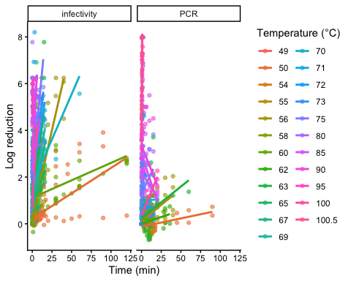
saveRDS(clean_all, here("data", "cleaned_data", "cleaned_pooled_data.rds"))
# Split the infectivity and PCR data
clean_all <- readRDS(here("data", "cleaned_data", "cleaned_pooled_data.rds"))
clean_inf <- clean_all %>% filter(assay_type == "infectivity")
clean_pcr <- clean_all %>% filter(assay_type == "PCR")
saveRDS(clean_inf, here("data", "cleaned_data", "clean_inf.rds"))
saveRDS(clean_pcr, here("data", "cleaned_data", "clean_pcr.rds"))
To ensure adequate temporal resolution for estimating decay dynamics, we restricted analyses to experimental conditions with at least 3 time points. Conditions with fewer observations provide limited information for slope estimation and can increase posterior uncertainty in hierarchical models.

Cleaned data summary
# for communication purpose, manually summarize for each variable
# infectivity data
clean_inf %>% count(study_id, sort = TRUE)
# A tibble: 25 × 2
study_id n
<fct> <int>
1 https://doi.org/10.4315/0362-028X-63.4.522 212
2 sammi 64
3 10.1016/j.fm.2010.05.018 61
4 https://doi.org/10.1016/j.foodcont.2018.08.031 58
5 https://doi.org/10.1016/j.ijfoodmicro.2018.05.013 58
6 10.1007/s12560-013-9112-6 44
7 https://doi.org/10.1016/j.ijfoodmicro.2013.11.026 40
8 https://doi.org/10.1111/j.1365-2672.2009.04179.x 40
9 https://doi.org/10.4315/0362-028X.JFP-13-289 40
10 https://doi.org/10.1007/s12560-020-09443-z 36
# ℹ 15 more rows
clean_inf %>% count(virus_type, sort = TRUE) %>% mutate(prop = n / sum(n))
# A tibble: 6 × 3
virus_type n prop
<fct> <int> <dbl>
1 HAV 394 0.457
2 MNV-1 184 0.213
3 TV 122 0.141
4 FCV-F9 91 0.105
5 MS2 63 0.0730
6 GA 9 0.0104
clean_inf %>% count(food_category, sort = TRUE) %>% mutate(prop = n / sum(n))
# A tibble: 4 × 3
food_category n prop
<fct> <int> <dbl>
1 dairy 301 0.349
2 shellfish 242 0.280
3 produce 173 0.200
4 simple matrix 147 0.170
clean_inf %>% count(matrix_group, sort = TRUE) %>% mutate(prop = n / sum(n))
# A tibble: 3 × 3
matrix_group n prop
<fct> <int> <dbl>
1 other_food 474 0.549
2 shellfish 242 0.280
3 simple_matrix 147 0.170
## Temperature distribution
clean_inf %>%
ggplot(aes(x = temperature)) +
geom_histogram(aes(y = after_stat(density)),
bins = 30, alpha = 0.6) +
geom_density(linewidth = 1) +
scale_x_continuous(breaks = seq(50, 110, by = 5)) +
theme_classic() +
labs(
x = "Temperature (°C)",
y = "Density",
title = "Temperature distribution (infectivity data)"
)
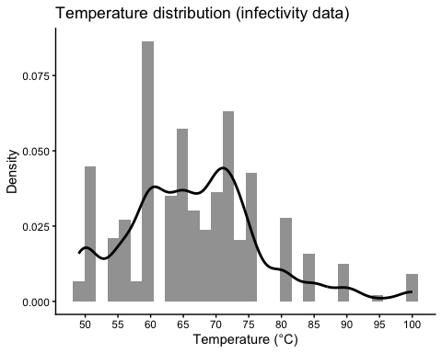
## Time distribution
clean_inf %>%
ggplot(aes(x = time_min)) +
geom_histogram(aes(y = after_stat(density)),
bins = 30, alpha = 0.6) +
geom_density(linewidth = 1) +
theme_classic() +
scale_x_continuous(breaks = seq(0, 95, by = 5)) +
labs(
x = "Time (min)",
y = "Density",
title = "Time distribution (infectivity data)"
)
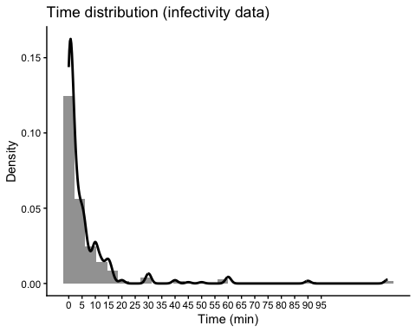
# PCR data
clean_pcr %>% count(study_id, sort = TRUE)
# A tibble: 14 × 2
study_id n
<fct> <int>
1 https://doi.org/10.1007/s12560-020-09443-z 112
2 sammi 93
3 https://doi.org/10.1016/j.foodcont.2018.08.031 58
4 https://doi.org/10.1016/j.foodcont.2011.10.004 40
5 https://doi.org/10.1111/j.1365-2672.2009.04179.x 40
6 https://doi.org/10.1128/AEM.03573-15 39
7 https://doi.org/10.1016/j.foodres.2026.118748 38
8 10.1016/j.fm.2014.01.009 26
9 https://doi.org/10.1016/j.foodcont.2019.106954 20
10 https://doi.org/10.3390/v16010110 20
11 https://doi.org/10.1016/j.ijfoodmicro.2013.11.027 12
12 https://doi.org/10.1128/AEM.00425-09 10
13 https://doi.org/10.1111/jam.12534 9
14 https://doi.org/10.1089/fpd.2010.0681 6
clean_pcr %>% count(virus_type, sort = TRUE) %>% mutate(prop = n / sum(n))
# A tibble: 7 × 3
virus_type n prop
<fct> <int> <dbl>
1 HuNoV GII 234 0.447
2 TV 110 0.210
3 HAV 79 0.151
4 MNV-1 61 0.117
5 FCV-F9 20 0.0382
6 MS2 10 0.0191
7 GA 9 0.0172
clean_pcr %>% count(food_category, sort = TRUE) %>% mutate(prop = n / sum(n))
# A tibble: 4 × 3
food_category n prop
<fct> <int> <dbl>
1 shellfish 178 0.340
2 dairy 132 0.252
3 simple matrix 117 0.224
4 produce 96 0.184
clean_pcr %>% count(matrix_group, sort = TRUE) %>% mutate(prop = n / sum(n))
# A tibble: 3 × 3
matrix_group n prop
<fct> <int> <dbl>
1 other_food 228 0.436
2 shellfish 178 0.340
3 simple_matrix 117 0.224
clean_pcr %>% count(pcr_pretreat, sort = TRUE)
# A tibble: 2 × 2
pcr_pretreat n
<fct> <int>
1 no 264
2 yes 259
## Temperature distribution
clean_pcr %>%
ggplot(aes(x = temperature)) +
geom_histogram(aes(y = after_stat(density)),
bins = 30, alpha = 0.6) +
geom_density(linewidth = 1) +
scale_x_continuous(breaks = seq(50, 110, by = 5)) +
theme_classic() +
labs(
x = "Temperature (°C)",
y = "Density",
title = "Temperature distribution (PCR data)"
)
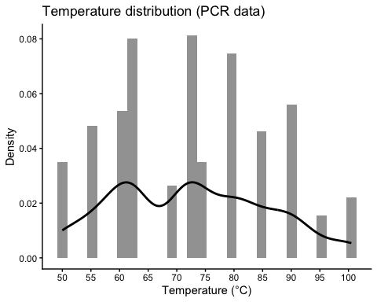
## Time distribution
clean_pcr %>%
ggplot(aes(x = time_min)) +
geom_histogram(aes(y = after_stat(density)),
bins = 30, alpha = 0.6) +
geom_density(linewidth = 1) +
scale_x_continuous(breaks = seq(0, 95, by = 5)) +
theme_classic() +
labs(
x = "Time (min)",
y = "Density",
title = "Time distribution (PCR data)"
)
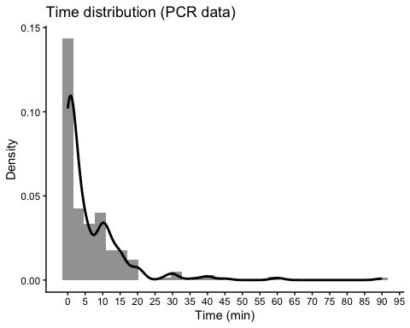
clean_pcr %>% count(pcr_pretreat, matrix_group)
# A tibble: 6 × 3
pcr_pretreat matrix_group n
<fct> <fct> <int>
1 no other_food 151
2 no shellfish 55
3 no simple_matrix 58
4 yes other_food 77
5 yes shellfish 123
6 yes simple_matrix 59
curve_counts <- clean_all %>%
distinct(study_id, virus_type, food_category, temperature, assay_type) %>%
count(virus_type, food_category, assay_type, name = "n_curves") %>%
complete(virus_type, food_category, assay_type, fill = list(n_curves = 0))
ggplot(curve_counts, aes(x = food_category, y = virus_type, size = n_curves)) +
geom_point(alpha = 0.75) +
facet_wrap(~ assay_type) +
theme_minimal(base_size = 12) +
labs(
title = "Distribution of thermal inactivation time-series by virus \n and food category",
x = "Food category",
y = "Virus type",
size = "No. time-series"
) +
theme(axis.text.x = element_text(angle = 45, hjust = 1))
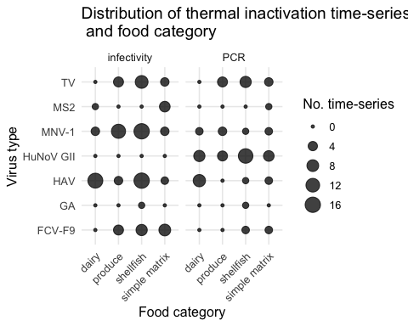

Exploratory plots for infectivity data
# Create a dataset just for plotting purpose
plot_dat_inf <- clean_inf %>%
mutate(
cens_f = factor(cens, levels = c(0, 1), labels = c("Observed", "Right-censored")),
temp_bin = cut(
temperature,
breaks = c(40, 60, 70, 80, 102),
labels = c("≤60", "60–70", "70–80", "≥80")
)
)
# Log reduction vs time across temp_bin
plot_dat_inf %>%
ggplot(aes(time_min, log_red_obs)) +
geom_point(alpha = 0.7, size = 2) +
facet_wrap(~temp_bin) +
labs(
title = "Log Reduction vs Time (all studies)",
x = "Time (min)", y = "Observed Log Reduction",
color = "Temperature (°C)", shape = NULL
) +
theme_bw()
Ignoring unknown labels:
• colour : "Temperature (°C)"
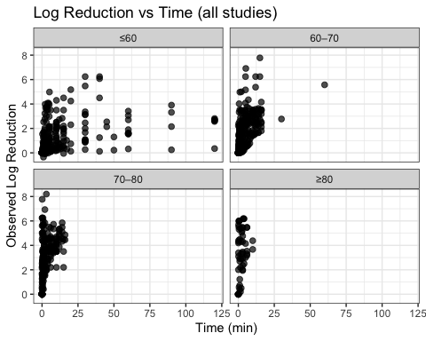
# Log reduction vs time by studies
plot_dat_inf %>%
ggplot(aes(time_min, log_red_obs, color = temperature, shape = cens_f)) +
geom_point(alpha = 0.7, size = 1.8) +
facet_wrap(~ study_id, scales = "free") +
labs(
title = "Log Reduction vs Time by Study",
x = "Time (min)", y = "Observed Log Reduction",
shape = NULL
) +
theme_bw() +
theme(strip.text = element_text(size = 8))
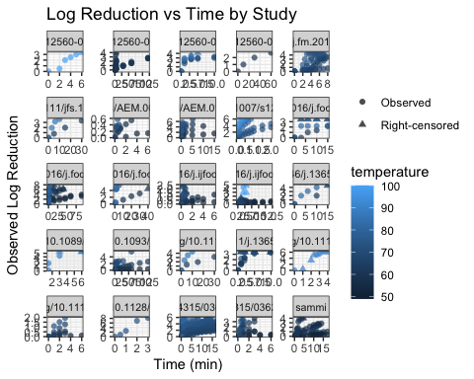
# Log reduction vs. Time, colored by temperature as bins
plot_dat_inf %>%
mutate(time_bin = cut(time_min, breaks = c(0, 5, 15, 30, 60, 90, 102), right = FALSE)) %>%
ggplot(aes(time_bin, log_red_obs, fill = temp_bin)) +
geom_boxplot(outlier.alpha = 0.4, position = position_dodge(width = 0.8)) +
labs(
title = "Log Reduction across Time Bins by Temperature Group",
x = "Time bin (min)", y = "Observed Log Reduction",
fill = "Temp group (°C)"
) +
theme_bw() +
theme(axis.text.x = element_text(hjust = 1))
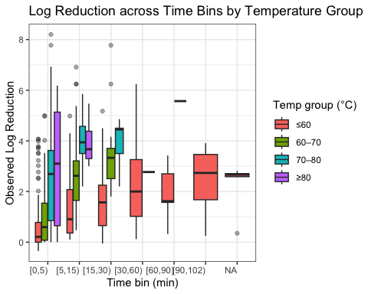
# Log reduction vs. Time, colored by temperature by virus type and food matrix
plot_dat_inf %>%
ggplot(aes(time_min, log_red_obs, color = temp_bin, shape = cens_f)) +
geom_point(alpha = 0.6) +
geom_smooth(method = "lm", se = FALSE) +
facet_grid(matrix_group ~ virus_type) +
labs(color = "Temp group (°C)", shape = NULL) +
theme_bw()
`geom_smooth()` using formula = 'y ~ x'
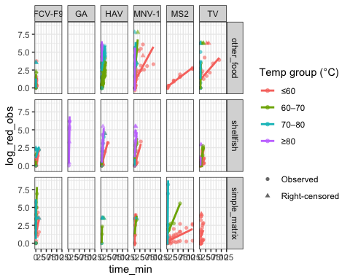
Exploratory analysis of the infectivity data showed that temperature is the primary driver of viral inactivation across studies, with log10 infectivity loss increasing more rapidly over time as temperature bin increases. Within temperature bins, log10 reductions generally increased linearly with time, supporting the use of first-order primary kinetics. Differences among virus types were small relative to temperature effects and did not show consistent patterns across matrices. In contrast, matrix effects were stronger, with shellfish matrices exhibiting slower infectivity loss than other food matrices at comparable temperatures.

Exploratory plots for PCR data
# Create a dataset just for plotting purpose
plot_dat_pcr <- clean_pcr %>%
mutate(
cens_f = factor(cens, levels = c(0, 1), labels = c("Observed", "Right-censored")),
temp_bin = cut(
temperature,
breaks = c(40, 60, 70, 80, 102),
labels = c("≤60", "60–70", "70–80", "≥80")
)
)
# Log reduction vs time across studies
plot_dat_pcr %>%
ggplot(aes(time_min, log_red_obs, color = temperature, shape = cens_f)) +
geom_point(alpha = 0.7, size = 2) +
facet_wrap(~temp_bin) +
labs(
title = "Log Reduction vs Time (all studies)",
x = "Time (min)", y = "Observed Log Reduction",
color = "Temperature (°C)", shape = NULL
) +
theme_bw()
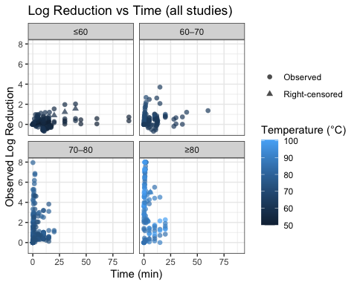
# Log reduction vs time by studies
plot_dat_pcr %>%
ggplot(aes(time_min, log_red_obs, color = temperature, shape = cens_f)) +
geom_point(alpha = 0.7, size = 1.8) +
facet_wrap(~ study_id, scales = "free") +
labs(
title = "Log Reduction vs Time by Study",
x = "Time (min)", y = "Observed Log Reduction",
shape = NULL
) +
theme_bw() +
theme(strip.text = element_text(size = 8))
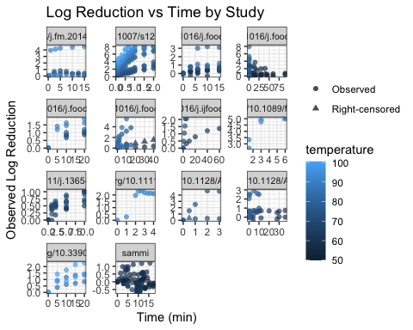
# Log reduction vs. Time, colored by temperature as bins
plot_dat_pcr %>%
mutate(time_bin = cut(time_min, breaks = c(0, 5, 15, 30, 60, 90, 102), right = FALSE)) %>%
ggplot(aes(time_bin, log_red_obs, fill = temp_bin)) +
geom_boxplot(outlier.alpha = 0.4, position = position_dodge(width = 0.8)) +
labs(
title = "Log Reduction across Time Bins by Temperature Group",
x = "Time bin (min)", y = "Observed Log Reduction",
fill = "Temp group (°C)"
) +
theme_bw() +
theme(axis.text.x = element_text(hjust = 1))
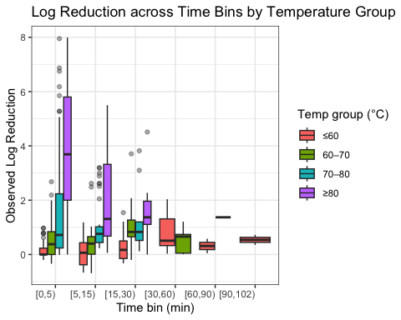
# Log reduction vs. Time, colored by temperature by virus type and food matrix
plot_dat_pcr %>%
ggplot(aes(time_min, log_red_obs, color = temp_bin, shape = cens_f)) +
geom_point(alpha = 0.6) +
geom_smooth(method = "lm", se = FALSE) +
facet_grid(matrix_group ~ virus_type, scales = "free_x") +
labs(color = "Temp group (°C)", shape = NULL) +
theme_bw()
`geom_smooth()` using formula = 'y ~ x'
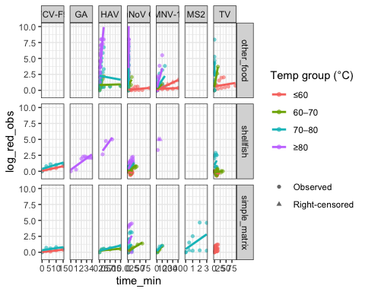
# Explore pretreatment
plot_dat_pcr %>%
ggplot(aes(time_min, log_red_obs, color = pcr_pretreat)) +
geom_point(alpha = 0.6) +
geom_smooth(method = "lm", se = FALSE) +
facet_grid(matrix_group ~ temp_bin) +
labs(
color = "PCR pretreatment",
x = "Time (min)",
y = "Observed log reduction"
) +
theme_bw()
`geom_smooth()` using formula = 'y ~ x'
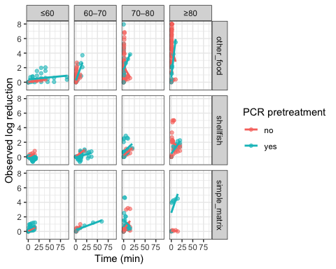
Exploratory analysis of the PCR data indicated that temperature is also a primary driver of genome signal reduction. Across studies and temperature strata, log10 reductions generally increased approximately linearly with time, supporting the use of first-order primary kinetics for PCR-based outcomes. Differences among virus types were small relative to temperature effects and did not show consistent patterns across matrices. In contrast to infectivity, matrix-associated differences were weaker and more variable, consistent with PCR measurements reflecting persistence of detectable viral genomes rather than loss of infectivity.

Assessment of biphasic inactivation behavior
To evaluate whether restriction of the candidate primary kinetic models to the log-linear and Weibull formulations was justified, we inspected individual inactivation curves for evidence of genuinely biphasic behavior — defined as a visually distinct transition between two kinetic phases, rather than smooth monotonic Weibull-type tailing or shoulder.
Each unique time-response series was treated as a separate curve, identified by the combination of study, virus type, food matrix, temperature, detection method, and PCR pretreatment where applicable. Only model-eligible observations (infectivity: ≥60°C; PCR: ≥60°C with study exclusions applied) were used. Individual trajectories were plotted with lines connecting observed time points and inspected visually for evidence of an abrupt inflection between two distinct kinetic phases.
# Data: model-eligible infectivity and PCR observations
inf_bph <- readRDS(here("data", "cleaned_data", "clean_inf.rds")) %>%
filter(temperature >= 60) %>%
filter(!(time_min == 0 & cens == 1))
pcr_bph <- readRDS(here("data", "cleaned_data", "clean_pcr.rds")) %>%
filter(
temperature >= 60,
study_id != "https://doi.org/10.1007/s12560-020-09443-z"
) %>%
filter(!(study_id %in% "10.1016/j.fm.2014.01.009" & temperature == 72)) %>%
filter(!(time_min == 0 & cens == 1))
# Construct a unique grouping key for each individual time-series (for geom_line)
add_curve_key <- function(df) {
df %>%
mutate(
curve_key = paste(study_id, virus_type, food_matrix,
temperature, detection_method, pretreatment,
sep = "_"),
cens_f = factor(
as.integer(as.character(cens)),
levels = c(0, 1), labels = c("Observed", "Right-censored")
)
)
}
inf_bph <- add_curve_key(inf_bph)
pcr_bph <- add_curve_key(pcr_bph)
# Helper function to compute subgroup evidence counts
calc_subgroup_counts <- function(df, grp_var) {
df %>%
group_by(across(all_of(grp_var))) %>%
summarise(
`Studies (n)` = n_distinct(study_id),
`Curves (n)` = n_distinct(curve_key),
`Observations (n)` = n(),
.groups = "drop"
)
}
# Subgroup evidence counts for Infectivity dataset
inf_subgroups_assay <- calc_subgroup_counts(inf_bph, "detection_method")
inf_subgroups_virus <- calc_subgroup_counts(inf_bph, "virus_type")
inf_subgroups_matrix <- calc_subgroup_counts(inf_bph, "matrix_group")
inf_subgroups_mat2 <- calc_subgroup_counts(inf_bph, "matrix_group2")
# Subgroup evidence counts for RT-qPCR dataset
pcr_bph_sub <- pcr_bph %>%
mutate(
pretreat_group = case_when(
pretreatment %in% c("PMA", "RNase") ~ "viability",
pretreatment == "PGM" ~ "PGM",
TRUE ~ "none"
),
virus_cluster = case_when(
virus_type %in% c("HAV", "HuNoV GII") ~ "enteric_virus",
virus_type %in% c("FCV-F9", "MNV-1") ~ "similar_surrogates",
virus_type %in% c("MS2", "GA") ~ "bacteriophage",
virus_type == "TV" ~ "TV",
TRUE ~ virus_type
)
)
pcr_subgroups_pretreat <- calc_subgroup_counts(pcr_bph_sub, "pretreat_group")
pcr_subgroups_virus <- calc_subgroup_counts(pcr_bph_sub, "virus_cluster")
pcr_subgroups_matrix <- calc_subgroup_counts(pcr_bph_sub, "matrix_group")
# Trajectory plot: infectivity
inf_bph %>%
ggplot(aes(x = time_min, y = log_red_obs,
group = curve_key, colour = factor(temperature))) +
geom_line(
data = function(d) d[d$cens_f == "Observed", ],
linewidth = 0.45, alpha = 0.7
) +
geom_point(aes(shape = cens_f), size = 1.5, alpha = 0.85) +
scale_shape_manual(
values = c("Observed" = 16, "Right-censored" = 6), name = NULL
) +
facet_wrap(~ temperature, labeller = label_both) +
labs(
title = "Individual infectivity inactivation curves",
subtitle = "Each line = one time-series; right-censored observations shown as open triangles",
x = "Time (min)", y = expression(Observed~log[10]~reduction),
colour = "Temperature (°C)"
) +
theme_bw(base_size = 10) +
theme(legend.position = "none", strip.text = element_text(size = 8))
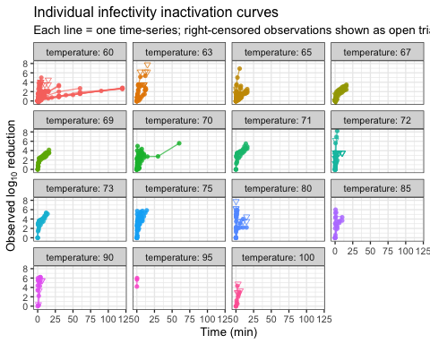
# Trajectory plot: RT-qPCR
pcr_bph %>%
ggplot(aes(x = time_min, y = log_red_obs,
group = curve_key, colour = factor(temperature))) +
geom_line(
data = function(d) d[d$cens_f == "Observed", ],
linewidth = 0.45, alpha = 0.7
) +
geom_point(aes(shape = cens_f), size = 1.5, alpha = 0.85) +
scale_shape_manual(
values = c("Observed" = 16, "Right-censored" = 6), name = NULL
) +
facet_wrap(~ temperature, labeller = label_both) +
labs(
title = "Individual RT-qPCR inactivation curves",
subtitle = "Each line = one time-series; right-censored observations shown as open triangles",
x = "Time (min)", y = expression(Observed~log[10]~reduction),
colour = "Temperature (°C)"
) +
theme_bw(base_size = 10) +
theme(legend.position = "none", strip.text = element_text(size = 8))
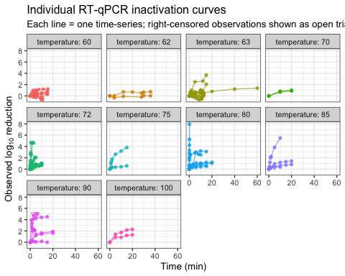
Visual inspection of individual time-response curves across both the infectivity and RT-qPCR datasets revealed no evidence of genuinely biphasic inactivation behavior. No curve displayed a bilinear trajectory, that is, two clearly distinct linear segments with a visible inflection point, that would be indicative of two virus subpopulations with different levels of thermal resistance. Curves exhibiting deceleration of the inactivation rate over time showed a continuously changing, concave-upward shape consistent with Weibull-type tailing (shape parameter $n<1$) rather than an abrupt transition between two kinetic regimes. Curves with the most pronounced deceleration were concentrated within a single study (HAV in dairy matrices at 67–71°C) and were not reproduced across independent datasets. These observations support restriction of the candidate primary kinetic models to the log-linear and Weibull formulations.

Statistical modeling

Infectivity models

Data preprocessing
clean_inf <- readRDS(here("data", "cleaned_data", "clean_inf.rds"))
# Infectivity data at < 60°C show minimal inactivation over time, so it was excluded prior to model fitting.
clean_inf <- clean_inf %>%
filter(temperature >= 60)
# Define a fixed referenced temperature across infectivity data
T_ref <- min(clean_inf$temperature, na.rm = TRUE)
T_ref
[1] 60
# Convert character variables to factors and center numeric variables
clean_inf <- clean_inf %>%
filter(!(time_min == 0 & cens == 1)) %>%
mutate(temp_dev = (temperature - T_ref)/10,
cens_brms = ifelse(cens == 1, 1, 0))
# Relevel food category to make simple matrix the reference
clean_inf <- clean_inf %>% mutate(food_category = relevel(factor(food_category), ref = "simple matrix"),
matrix_group = relevel(factor(matrix_group), ref = "simple_matrix"),
matrix_group2 = relevel(factor(matrix_group2), ref = "simple_matrix"))

Primary kinetic models

First-order model

Mathematical formulation and assumptions
Let $y_{i}$ denote the observed $\log_{10}$ reduction at time $t_{i}$ for observation $i$,
$$y_{i}=\log_{10}​\left(\frac{N_{k}(0)}{N_{k}(t_{i})}\right).$$
Under a first-order inactivation model, the predicted $\log_{10}$ reduction increases linearly with time,
$$μ_{i}=\frac{t_{i}}{D_{k}},$$
where $D_{k}$ is the decimal reduction time associated with experimental condition $k$.
To ensure positivity, the decimal reduction time is reparameterized as
$$D_{k}={10}^{η_{k}},$$
so that the mean E[$y_{i}$|parameters] function used for estimation is
$$μ_{i}=\frac{t_{i}}{{10}^{η_{k}}}.$$
Two residual distributions are compared for this primary model:
$$y_{i}∼N(μ_{i},σ)$$
and
$$y_{i}∼Student\text{-}t(ν,μ_{i},σ).$$
Here, $σ$ is the residual standard deviation on the log-reduction scale, and $ν$ controls tail heaviness in the Student-$t$ model. The following code fits both likelihoods to the same nonlinear mean function.
Right-censored observations are incorporated directly through the likelihood. No covariate effects (temperature, food matrix, or virus type) are included in the primary model; these factors are introduced in later models.

Model specification and fitting
fit_primary_normal_linear_inf <- readRDS(file = here("models", "infectivity", "fit_primary_normal_linear.rds"))
fit_primary_heavy_linear_inf <- readRDS(file = here("models", "infectivity", "fit_primary_heavy_linear.rds"))
loo_compare(loo(fit_primary_normal_linear_inf),
loo(fit_primary_heavy_linear_inf))
model elpd_diff se_diff p_worse diag_diff diag_elpd
fit_primary_heavy_linear_inf 0.0 0.0 NA
fit_primary_normal_linear_inf -61.2 23.5 1.00
Summary: The Student-$t$ first-order model was preferred to the Gaussian first-order model by LOO (ΔELPD = 61.2, SE = 23.5). Under the Student-$t$ fit, the posterior median of $η$ was 0.525, corresponding to a median D-value of 3.35 minutes per $\log_{10}$ reduction (95% CrI: 3.02–3.74 minutes). Residual variability remained substantial ($σ=1.27$, 95% CrI: 1.09–1.46), and the low degrees of freedom ($ν=1.38$, 95% CrI: 1.12–1.72) supported use of the heavy-tailed likelihood.

Nonlinear Weibull model

Mathematical formulation and assumptions: Gaussian likelihood
Let $y_{i}$ denote the observed $\log_{10}$ reduction at time $t_{i}$ for observation $i$,
$$y_{i}=\log_{10}​\left(\frac{N_{k}(0)}{N_{k}(t_{i})}\right).$$
To allow non-log-linear inactivation behavior (e.g., shoulders or tailing), the predicted $\log_{10}$ reduction is modeled using a Weibull-type function,
$$μ_{i}={\left(\frac{t_{i}}{D_{k}}\right)}^{n_{k}},$$
where $D_{k}>0$ is a scale parameter (time to reach one log reduction), and $n_{k}>0$ is a shape parameter governing curvature. The shape parameter determines deviation from log-linearity: - $n_{k}=1$ corresponds to log-linear (Bigelow) behavior, - $n_{k}<1$ produces concave-down (tailing), - $n_{k}>1$ produces concave-up (shouldering).
To ensure positivity of the parameters during estimation, we reparameterize
$$D_{k}=exp(η_{k}),$$
$$n_{k}=exp(γ_{k}).$$
Substituting into the mean function gives
$$μ_{i}={\left(\frac{t_{i}}{exp(η_{k})}\right)}^{exp(γ_{k})}.$$
Under this parameterization, When $γ_{k}=0$, the model reduces to the log-linear (Bigelow) form:
$$μ_{i}=\frac{t_{i}}{exp(η_{k})}.$$
Observed log-reductions are modeled using a Gaussian error distribution,
$$y_{i}∼N(μ_{i},σ),$$
where $σ>0$ represents residual variability on the log-reduction scale.
Right-censored observations are incorporated directly through the likelihood using censoring indicators. Censored values contribute probability mass over the appropriate interval rather than a point density.
No covariate effects are included in this primary Weibull specification; only intercept terms for $η_{k}$ and $γ_{k}$ are estimated.

Model specification and fitting
fit_primary_weibull_inf_normal <- readRDS(file = here("models", "infectivity", "fit_primary_weibull_inf_normal.rds"))
summary(fit_primary_weibull_inf_normal)
Family: gaussian
Links: mu = identity
Formula: log_red_obs | cens(cens_brms) ~ (time_min/exp(eta))^exp(gamma)
eta ~ 1
gamma ~ 1
Data: clean_inf (Number of observations: 701)
Draws: 4 chains, each with iter = 8000; warmup = 4000; thin = 1;
total post-warmup draws = 16000
Regression Coefficients:
Estimate Est.Error l-95% CI u-95% CI Rhat Bulk_ESS Tail_ESS
eta_Intercept -11.14 1.98 -15.41 -7.74 1.00 3998 4280
gamma_Intercept -2.50 0.16 -2.81 -2.20 1.00 4035 4486
Further Distributional Parameters:
Estimate Est.Error l-95% CI u-95% CI Rhat Bulk_ESS Tail_ESS
sigma 1.58 0.05 1.50 1.68 1.00 6346 6196
Draws were sampled using sample(hmc). For each parameter, Bulk_ESS
and Tail_ESS are effective sample size measures, and Rhat is the potential
scale reduction factor on split chains (at convergence, Rhat = 1).

Mathematical formulation and assumptions: Student-$t$ likelihood
Let’s model the observed log reduction $y_{i}$ using a Student-t error model:
$$y_{i}∼\text{Student-}t(ν,μ_{i},σ),$$
where $σ$ represents residual variability on the log-reduction scale and $ν$ controls tail heaviness. The degrees of freedom parameter $ν$ is estimated from the data; larger values correspond to approximately normal residuals.

Model specification and fitting
fit_primary_weibull_inf_heavy <- readRDS(file = here("models", "infectivity", "fit_primary_weibull_inf_heavy.rds"))
summary(fit_primary_weibull_inf_heavy)
Family: student
Links: mu = identity
Formula: log_red_obs | cens(cens_brms) ~ (time_min/exp(eta))^exp(gamma)
eta ~ 1
gamma ~ 1
Data: clean_inf (Number of observations: 701)
Draws: 4 chains, each with iter = 4000; warmup = 2000; thin = 1;
total post-warmup draws = 8000
Regression Coefficients:
Estimate Est.Error l-95% CI u-95% CI Rhat Bulk_ESS Tail_ESS
eta_Intercept -10.14 1.92 -14.63 -7.04 1.00 2305 2254
gamma_Intercept -2.44 0.16 -2.78 -2.15 1.00 2311 2278
Further Distributional Parameters:
Estimate Est.Error l-95% CI u-95% CI Rhat Bulk_ESS Tail_ESS
sigma 1.48 0.06 1.36 1.60 1.00 2930 3497
nu 18.40 10.52 6.84 46.22 1.00 2786 3467
Draws were sampled using sample(hmc). For each parameter, Bulk_ESS
and Tail_ESS are effective sample size measures, and Rhat is the potential
scale reduction factor on split chains (at convergence, Rhat = 1).
loo_compare(loo(fit_primary_weibull_inf_normal),
loo(fit_primary_weibull_inf_heavy),
loo(fit_primary_heavy_linear_inf),
loo(fit_primary_normal_linear_inf))
model elpd_diff se_diff p_worse diag_diff
fit_primary_weibull_inf_heavy 0.0 0.0 NA
fit_primary_weibull_inf_normal -1.1 2.4 0.68 |elpd_diff| < 4
fit_primary_heavy_linear_inf -317.3 30.9 1.00
fit_primary_normal_linear_inf -378.5 14.9 1.00
diag_elpd
Diagnostic flags present.
See ?`loo-glossary` (sections `diag_diff` and `diag_elpd`)
or https://mc-stan.org/loo/reference/loo-glossary.html.
Summary: LOO strongly favored the Weibull inactivation model over the corresponding log-linear model (Student-$t$ Weibull versus Student-$t$ log-linear: ΔELPD = 317.3, SE = 30.9), indicating substantially improved predictive performance. The Gaussian and Student-$t$ Weibull fits had similar predictive accuracy (ΔELPD = 1.1, SE = 2.4). In the Student-$t$ Weibull model, the estimated degrees of freedom was relatively large (posterior mean $ν=18.4$), consistent with approximately Gaussian residual behavior. Therefore, subsequent infectivity Weibull models use a Gaussian likelihood for parsimony.
# Global execution settings for Study-Grouped K-Fold Cross-Validation
KF_CHAINS <- 4
KF_ITER <- 2000
KF_WARMUP <- 1000
KF_CORES <- 4
# Ensure caching directory exists
dir.create(here::here("models", "kfold"), showWarnings = FALSE, recursive = TRUE)
# Dynamic helper function to compute or load Study-Grouped K-Fold Cross-Validation
# Automatically extracts model dataset and constructs study-level folds matching fit$data
get_study_kfold <- function(fit, model_name, seed = 42) {
cache_file <- here::here("models", "kfold", paste0(model_name, "_kfold.rds"))
if (file.exists(cache_file)) {
return(readRDS(cache_file))
}
model_dat <- fit$data
if ("study_id" %in% names(model_dat)) {
set.seed(seed)
unique_studies <- unique(model_dat$study_id)
model_folds <- match(model_dat$study_id, unique_studies)
} else {
model_folds <- NULL
}
kf <- kfold(
fit,
folds = model_folds,
chains = KF_CHAINS,
iter = KF_ITER,
warmup = KF_WARMUP,
cores = KF_CORES,
refresh = 0
)
saveRDS(kf, cache_file)
return(kf)
}
# Study-grouped K-fold validation: Weibull vs Log-linear primary infectivity model
kf_pri_weib_norm <- get_study_kfold(fit_primary_weibull_inf_normal, "fit_primary_weibull_inf_normal")
kf_pri_weib_heavy <- get_study_kfold(fit_primary_weibull_inf_heavy, "fit_primary_weibull_inf_heavy")
kf_pri_lin_heavy <- get_study_kfold(fit_primary_heavy_linear_inf, "fit_primary_heavy_linear_inf")
kf_pri_lin_norm <- get_study_kfold(fit_primary_normal_linear_inf, "fit_primary_normal_linear_inf")
comp_pri_inf <- loo_compare(kf_pri_weib_norm, kf_pri_weib_heavy, kf_pri_lin_heavy, kf_pri_lin_norm)
saveRDS(comp_pri_inf, file = here::here("models", "kfold", "comp_primary_inf.rds"))
comp_pri_inf <- readRDS(here::here("models", "kfold", "comp_primary_inf.rds"))
print(comp_pri_inf)
model elpd_diff se_diff p_worse diag_diff diag_elpd
Weibull_Student_t 0.0 0.0 NA
Weibull_Gaussian -1.1 2.4 0.68 |elpd_diff| < 4
LogLinear_Student_t -317.3 30.9 1.00
LogLinear_Gaussian -378.5 14.9 1.00
Diagnostic flags present.
See ?`loo-glossary` (sections `diag_diff` and `diag_elpd`)
or https://mc-stan.org/loo/reference/loo-glossary.html.

Secondary covariate models

Linear-temperature Weibull model

Mathematical formulation and assumptions
Let $y_{i}$ denote the observed $\log_{10}$ reduction at time $t_{i}$ for observation $i$, belonging to experimental condition $k(i)$ and study $s(i)$:
$$y_{i}=\log_{10}​\left(\frac{N_{k(i)}(0)}{N_{k(i)}(t_{i})}\right).$$
Under the Weibull inactivation model, the expected $\log_{10}$ reduction is:
$$μ_{i}={\left(\frac{t_{i}}{D_{k(i)}}\right)}^{n_{k(i)}},$$
where $D_{k(i)}>0$ is a scale parameter and $n_{k(i)}>0$ is a shape parameter controlling curvature (tailing when $n<1$).
To ensure positivity, parameters are modeled on the log scale:
$$D_{k}=exp(η_{k}),$$
$$n_{k}=exp(γ_{k}),$$
so the mean function used for estimation is:
$$μ_{i}={\left(\frac{t_{i}}{exp(η_{k(i)})}\right)}^{exp(γ_{k(i)})}.$$
Temperature is entered as a covariate using deviations in 10°C units:
$${temp_dev}_{k}=\frac{T_{k}−T_{ref}}{10},$$
where $T_{ref}$ is a fixed reference temperature (here $T_{ref}={60}^{∘}C$), so intercepts correspond to expected parameter values at ${60}^{∘}C$.
In the temperature-only secondary model, the scale parameter is allowed to vary with temperature with a study-specific random intercept:
$$η_{k}=η_{ref}+β_{D} {temp_dev}_{k}+u_{study(k)},$$
$$u_{s}∼N(0,σ_{study}).$$
Optionally, curvature can also vary with temperature via:
$$γ_{k}=γ_{ref}+β_{n} {temp_dev}_{k},$$
but this term may be omitted if curvature is assumed constant across temperatures.
Substituting the parameterizations into the Weibull mean function yields
$$μ_{i}={\left(\frac{t_{i}}{exp(η_{k(i)})}\right)}^{exp(γ_{k(i)})}={\left(\frac{t_{i}}{exp​\left(η_{ref}+β_{D} {temp_dev}_{k(i)}+u_{study(k(i))}\right)}\right)}^{exp​\left(γ_{ref}+β_{n} {temp_dev}_{k(i)}\right)}.$$
If curvature is assumed constant across temperatures (i.e., $β_{n}=0$), then $γ_{k(i)}=γ_{ref}$ and the mean simplifies to
$$μ_{i}={\left(\frac{t_{i}}{exp​\left(η_{ref}+β_{D} {temp_dev}_{k(i)}+u_{study(k(i))}\right)}\right)}^{exp(γ_{ref})}.$$
As in the primary model, right-censored observations are incorporated directly through the likelihood using censoring indicators. Observed log-reductions are modeled using a Gaussian error distribution:
$$y_{i}∼N(μ_{i},σ),$$
where $σ>0$ represents residual variability on the log-reduction scale.

Model specification and fitting: global shape parameter
fit_weib_big_temp_inf <- readRDS(file = here("models", "infectivity", "fit_weib_big_temp_only_inf_normal.rds"))
summary(fit_weib_big_temp_inf)
Family: gaussian
Links: mu = identity
Formula: log_red_obs | cens(cens_brms) ~ (time_min/exp(eta))^exp(gamma)
eta ~ 1 + temp_dev + (1 | study_id)
gamma ~ 1
Data: clean_inf (Number of observations: 701)
Draws: 4 chains, each with iter = 4000; warmup = 2000; thin = 1;
total post-warmup draws = 8000
Multilevel Hyperparameters:
~study_id (Number of levels: 25)
Estimate Est.Error l-95% CI u-95% CI Rhat Bulk_ESS Tail_ESS
sd(eta_Intercept) 2.38 0.36 1.79 3.19 1.00 1293 2316
Regression Coefficients:
Estimate Est.Error l-95% CI u-95% CI Rhat Bulk_ESS Tail_ESS
eta_Intercept 1.37 0.53 0.36 2.43 1.00 838 1704
eta_temp_dev -2.13 0.10 -2.33 -1.94 1.00 3953 4323
gamma_Intercept -1.08 0.05 -1.18 -0.99 1.00 4389 4649
Further Distributional Parameters:
Estimate Est.Error l-95% CI u-95% CI Rhat Bulk_ESS Tail_ESS
sigma 0.92 0.03 0.87 0.97 1.00 5737 5066
Draws were sampled using sample(hmc). For each parameter, Bulk_ESS
and Tail_ESS are effective sample size measures, and Rhat is the potential
scale reduction factor on split chains (at convergence, Rhat = 1).

Model specification and fitting: temperature-dependent shape
fit_weib_big_temp_inf_shape <- readRDS(file = here("models", "infectivity", "fit_weib_big_temp_only_inf_normal_shape.rds"))
summary(fit_weib_big_temp_inf_shape)
Family: gaussian
Links: mu = identity
Formula: log_red_obs | cens(cens_brms) ~ (time_min/exp(eta))^exp(gamma)
eta ~ 1 + temp_dev + (1 | study_id)
gamma ~ 1 + temp_dev
Data: clean_inf (Number of observations: 701)
Draws: 4 chains, each with iter = 4000; warmup = 2000; thin = 1;
total post-warmup draws = 8000
Multilevel Hyperparameters:
~study_id (Number of levels: 25)
Estimate Est.Error l-95% CI u-95% CI Rhat Bulk_ESS Tail_ESS
sd(eta_Intercept) 2.42 0.38 1.82 3.26 1.00 984 2138
Regression Coefficients:
Estimate Est.Error l-95% CI u-95% CI Rhat Bulk_ESS Tail_ESS
eta_Intercept 1.92 0.55 0.82 2.96 1.00 1075 1908
eta_temp_dev -2.74 0.26 -3.24 -2.22 1.00 2930 3776
gamma_Intercept -0.93 0.07 -1.08 -0.80 1.00 3383 3669
gamma_temp_dev -0.13 0.05 -0.23 -0.03 1.00 2596 3042
Further Distributional Parameters:
Estimate Est.Error l-95% CI u-95% CI Rhat Bulk_ESS Tail_ESS
sigma 0.92 0.03 0.87 0.97 1.00 5080 5293
Draws were sampled using sample(hmc). For each parameter, Bulk_ESS
and Tail_ESS are effective sample size measures, and Rhat is the potential
scale reduction factor on split chains (at convergence, Rhat = 1).

Powered-temperature Weibull model

Mathematical formulation and assumptions
Temperature is now incorporated through a powered deviation function acting on the scale parameter. Define temperature deviation in 10°C units:
$${temp_dev}_{k}=\frac{T_{k}−T_{ref}}{10},$$
where $T_{ref}={60}^{∘}C$. The powered temperature relationship is specified as:
$$η_{k}=η_{ref}−a ({temp_dev}_{k})^{b}+u_{study(k)},$$
where $η_{ref}$ is the natural logarithm of the Weibull scale parameter at the reference temperature $T_{ref}$, i.e., $η_{ref}=log(D_{ref}),$ and therefore $D_{k}=exp(η_{k})$, $a>0$ controls the magnitude of temperature sensitivity, $b>0$ controls curvature of the temperature effect, and $u_{study(k)}∼N(0,σ_{study})$ captures between-study heterogeneity. To enforce positivity while allowing unconstrained sampling:
$$a=exp(loga),b=exp(logb).$$
Substituting into the primary model gives:
$$μ_{i}={\left(\frac{t_{i}}{exp​\left(η_{ref}−exp(loga) ({temp_dev}_{k(i)})^{exp(logb)}+u_{study(k(i))}\right)}\right)}^{exp(γ)}.$$
Observed log-reductions are modeled using a Gaussian likelihood:
$$y_{i}∼N(μ_{i},σ),$$
where $σ>0$ represents residual variability on the log-reduction scale. Right-censored observations are incorporated directly through the likelihood.

Model specification and fitting: global shape parameter
fit_weib_pow_temp_inf <- readRDS(file = here("models", "infectivity", "fit_weib_pow_temp_only_inf_normal.rds"))

Model specification and fitting: temperature-dependent shape
fit_weib_pow_temp_shape_inf <- readRDS(file = here("models", "infectivity", "fit_weib_pow_temp_only_inf_normal_shape.rds"))

Model family selection
loo_compare(loo(fit_weib_big_temp_inf),
loo(fit_weib_big_temp_inf_shape),
loo(fit_weib_pow_temp_shape_inf),
loo(fit_weib_pow_temp_inf))
Warning: Found 2 observations with a pareto_k > 0.7 in model
'fit_weib_big_temp_inf'. We recommend to set 'moment_match = TRUE' in order to
perform moment matching for problematic observations.
Warning: Found 2 observations with a pareto_k > 0.7 in model
'fit_weib_big_temp_inf_shape'. We recommend to set 'moment_match = TRUE' in
order to perform moment matching for problematic observations.
Warning: Found 10 observations with a pareto_k > 0.7 in model
'fit_weib_pow_temp_shape_inf'. We recommend to set 'moment_match = TRUE' in
order to perform moment matching for problematic observations.
Warning: Found 4 observations with a pareto_k > 0.7 in model
'fit_weib_pow_temp_inf'. We recommend to set 'moment_match = TRUE' in order to
perform moment matching for problematic observations.
model elpd_diff se_diff p_worse diag_diff
fit_weib_pow_temp_inf 0.0 0.0 NA
fit_weib_big_temp_inf -2.1 2.6 0.79 |elpd_diff| < 4
fit_weib_big_temp_inf_shape -2.5 3.7 0.75 |elpd_diff| < 4
fit_weib_pow_temp_shape_inf -9.4 3.3 1.00
diag_elpd
4 k_psis > 0.7
2 k_psis > 0.7
2 k_psis > 0.7
10 k_psis > 0.7
Diagnostic flags present.
See ?`loo-glossary` (sections `diag_diff` and `diag_elpd`)
or https://mc-stan.org/loo/reference/loo-glossary.html.
Comparison of the temperature-only secondary models using LOO showed no meaningful predictive advantage for the powered formulation over the standard linear-temperature formulation (ΔELPD = 2.1, SE = 2.6). Because the simpler standard formulation was sufficient and easier to interpret, subsequent infectivity model development proceeded with the linear-temperature, global-shape Weibull framework. Pareto-$k$ diagnostic flags in these fits should be addressed with moment matching before the final LOO values are reported in the manuscript.
# Study-grouped K-fold validation: Secondary temperature & shape models
kf_weib_big_temp_inf <- get_study_kfold(fit_weib_big_temp_inf, "fit_weib_big_temp_inf")
kf_weib_big_temp_inf_shape <- get_study_kfold(fit_weib_big_temp_inf_shape, "fit_weib_big_temp_inf_shape")
kf_weib_pow_temp_shape_inf <- get_study_kfold(fit_weib_pow_temp_shape_inf, "fit_weib_pow_temp_shape_inf")
kf_weib_pow_temp_inf <- get_study_kfold(fit_weib_pow_temp_inf, "fit_weib_pow_temp_inf")
comp_sec_temp_inf <- loo_compare(x = list(
"Weibull_linear_temp" = kf_weib_big_temp_inf,
"Weibull_linear_temp_shape" = kf_weib_big_temp_inf_shape,
"Weibull_powered_temp_shape" = kf_weib_pow_temp_shape_inf,
"Weibull_powered_temp" = kf_weib_pow_temp_inf
))
saveRDS(comp_sec_temp_inf, file = here("models", "kfold", "comp_sec_temp_inf.rds"))
comp_sec_inf <- readRDS(here("models", "kfold", "comp_sec_temp_inf.rds"))
print(comp_sec_inf)
model elpd_diff se_diff p_worse diag_diff
PowerTemp_FixedShape 0.0 0.0 NA
LinearTemp_FixedShape -2.1 2.6 0.79 |elpd_diff| < 4
LinearTemp_VaryingShape -2.5 3.7 0.75 |elpd_diff| < 4
PowerTemp_VaryingShape -9.4 3.3 1.00
diag_elpd
4 k_psis > 0.7
2 k_psis > 0.7
2 k_psis > 0.7
10 k_psis > 0.7
Diagnostic flags present.
See ?`loo-glossary` (sections `diag_diff` and `diag_elpd`)
or https://mc-stan.org/loo/reference/loo-glossary.html.
summary(fit_weib_big_temp_inf)
Family: gaussian
Links: mu = identity
Formula: log_red_obs | cens(cens_brms) ~ (time_min/exp(eta))^exp(gamma)
eta ~ 1 + temp_dev + (1 | study_id)
gamma ~ 1
Data: clean_inf (Number of observations: 701)
Draws: 4 chains, each with iter = 4000; warmup = 2000; thin = 1;
total post-warmup draws = 8000
Multilevel Hyperparameters:
~study_id (Number of levels: 25)
Estimate Est.Error l-95% CI u-95% CI Rhat Bulk_ESS Tail_ESS
sd(eta_Intercept) 2.38 0.36 1.79 3.19 1.00 1293 2316
Regression Coefficients:
Estimate Est.Error l-95% CI u-95% CI Rhat Bulk_ESS Tail_ESS
eta_Intercept 1.37 0.53 0.36 2.43 1.00 838 1704
eta_temp_dev -2.13 0.10 -2.33 -1.94 1.00 3953 4323
gamma_Intercept -1.08 0.05 -1.18 -0.99 1.00 4389 4649
Further Distributional Parameters:
Estimate Est.Error l-95% CI u-95% CI Rhat Bulk_ESS Tail_ESS
sigma 0.92 0.03 0.87 0.97 1.00 5737 5066
Draws were sampled using sample(hmc). For each parameter, Bulk_ESS
and Tail_ESS are effective sample size measures, and Rhat is the potential
scale reduction factor on split chains (at convergence, Rhat = 1).
Summary: Under the selected linear-temperature Weibull model, the median scale parameter at the 60°C reference temperature was $D_{60}=3.90$ minutes (95% CrI: 1.44–11.40). The temperature coefficient on the natural-log D scale was $−2.12$ per 10°C (95% CrI: $−2.33$ to $−1.94$), corresponding to an effective $z$-value of 10.84°C (95% CrI: 9.89–11.88°C). The global Weibull shape parameter was $n=0.340$ (95% CrI: 0.309–0.373), indicating tailing. Between-study heterogeneity on the log-D scale remained substantial ($σ_{study}=2.34$, 95% CrI: 1.79–3.19), while residual variability was $σ=0.918$ (95% CrI: 0.868–0.973).

Linear-temperature Weibull model with detailed food-matrix effects

Mathematical formulation and assumptions
This model uses a Weibull mean with a linear temperature effect on the natural-log scale of the Weibull time parameter:
$$μ_{i}={\left[\frac{t_{i}}{exp​\left(η_{ref,i}−a x_{i}\right)}\right]}^{n}, x_{i}={temp_dev}_{i},$$
where $a=exp(α)>0$ with $α=loga$ and $n=exp(γ)>0$. In the following food-main-effect model,
$$η_{ref,i}=β_{0}+δ_{matrix_group2[i]}+u_{s(i)}, u_{s}∼N(0,σ_{study}),$$
while $α$ and $γ$ contain intercepts only. Thus, matrix_group2 shifts the baseline $log(D_{ref})$ but does not modify the temperature slope. No virus effect and no powered temperature exponent are included in this model. Equivalently,
$$μ_{i}={\left[\frac{t_{i}}{exp​\left(β_{0}+δ_{matrix_group2[i]}+u_{s(i)}−exp(α_{0})x_{i}\right)}\right]}^{exp(γ_{0})}.$$
The observation model is Gaussian, $y_{i}∼N(μ_{i},σ)$, with right-censoring handled by cens(cens_brms).

Model specification and fitting
fit_weib_big_food_inf <- readRDS(file = here("models", "infectivity", "fit_weib_big_food_main_inf.rds"))
summary(fit_weib_big_food_inf)
Family: gaussian
Links: mu = identity
Formula: log_red_obs | cens(cens_brms) ~ (time_min/exp(etaref - exp(loga) * temp_dev))^exp(gamma)
etaref ~ 1 + matrix_group2 + (1 | study_id)
loga ~ 1
gamma ~ 1
Data: clean_inf (Number of observations: 701)
Draws: 4 chains, each with iter = 4000; warmup = 2000; thin = 1;
total post-warmup draws = 8000
Multilevel Hyperparameters:
~study_id (Number of levels: 25)
Estimate Est.Error l-95% CI u-95% CI Rhat Bulk_ESS
sd(etaref_Intercept) 1.92 0.31 1.42 2.59 1.00 2418
Tail_ESS
sd(etaref_Intercept) 4002
Regression Coefficients:
Estimate Est.Error l-95% CI u-95% CI Rhat
etaref_Intercept -0.58 0.51 -1.59 0.43 1.00
etaref_matrix_group2berry -0.03 1.38 -2.77 2.66 1.00
etaref_matrix_group2dairy 0.37 0.32 -0.24 1.00 1.00
etaref_matrix_group2shellfish 4.17 0.44 3.35 5.09 1.00
etaref_matrix_group2vegetable 0.34 1.42 -2.50 3.20 1.00
loga_Intercept 0.75 0.04 0.67 0.83 1.00
gamma_Intercept -1.03 0.04 -1.12 -0.95 1.00
Bulk_ESS Tail_ESS
etaref_Intercept 2095 3602
etaref_matrix_group2berry 3957 4760
etaref_matrix_group2dairy 7448 5871
etaref_matrix_group2shellfish 4211 4847
etaref_matrix_group2vegetable 3765 4236
loga_Intercept 7279 5312
gamma_Intercept 7548 5451
Further Distributional Parameters:
Estimate Est.Error l-95% CI u-95% CI Rhat Bulk_ESS Tail_ESS
sigma 0.87 0.03 0.82 0.92 1.00 9005 5635
Draws were sampled using sample(hmc). For each parameter, Bulk_ESS
and Tail_ESS are effective sample size measures, and Rhat is the potential
scale reduction factor on split chains (at convergence, Rhat = 1).
loo_compare(loo(fit_weib_big_food_inf),
loo(fit_weib_big_temp_inf))
Warning: Found 6 observations with a pareto_k > 0.7 in model
'fit_weib_big_food_inf'. We recommend to set 'moment_match = TRUE' in order to
perform moment matching for problematic observations.
Warning: Found 2 observations with a pareto_k > 0.7 in model
'fit_weib_big_temp_inf'. We recommend to set 'moment_match = TRUE' in order to
perform moment matching for problematic observations.
model elpd_diff se_diff p_worse diag_diff diag_elpd
fit_weib_big_food_inf 0.0 0.0 NA <NA>
fit_weib_big_temp_inf -41.5 14.1 1.00 2 k_psis > 0.7
Diagnostic flags present.
See ?`loo-glossary` (sections `diag_diff` and `diag_elpd`)
or https://mc-stan.org/loo/reference/loo-glossary.html.
# Study-grouped K-fold validation: Baseline marginal food matrix
kf_food_main_inf <- get_study_kfold(fit_weib_big_food_inf, "fit_weib_big_food_main_inf")
kf_temp_only_inf <- get_study_kfold(fit_weib_big_temp_inf, "fit_weib_big_temp_inf")
comp_food_inf <- loo_compare(kf_food_main_inf, kf_temp_only_inf)
saveRDS(comp_food_inf, file = here("models", "kfold", "comp_food_inf.rds"))
readRDS(here("models", "kfold", "comp_food_inf.rds"))
model elpd_diff se_diff p_worse diag_diff diag_elpd
FoodMatrix_MainEffect 0.0 0.0 NA <NA>
Base_TempOnly -41.5 14.1 1.00 2 k_psis > 0.7
Diagnostic flags present.
See ?`loo-glossary` (sections `diag_diff` and `diag_elpd`)
or https://mc-stan.org/loo/reference/loo-glossary.html.

Marginal effects of food matrix
draws <- as_draws_df(fit_weib_big_food_inf)
# Get all matrix-related coefficients
food_coefs <- names(draws)[str_detect(names(draws),
"^b_etaref_matrix_group2")]
# Clean names (remove prefix)
food_names <- str_remove(food_coefs, "^b_etaref_matrix_group2")
# Add baseline: "simple matrix" = 0
food_draws <- draws %>%
transmute(`simple matrix` = 0) %>%
bind_cols(
draws %>%
select(all_of(food_coefs)) %>%
set_names(food_names)
)
Warning: Dropping 'draws_df' class as required metadata was removed.
Warning: Dropping 'draws_df' class as required metadata was removed.
# Pairwise contrasts including baseline
contrast_results_food <- expand_grid(
v1 = names(food_draws),
v2 = names(food_draws)
) %>%
filter(v1 < v2) %>%
mutate(
diff = map2(v1, v2, ~ food_draws[[.x]] - food_draws[[.y]]),
q = map(diff, ~ quantile(.x, c(0.025, 0.5, 0.975)))
) %>%
unnest_wider(q) %>%
rename(
l95 = `2.5%`,
median = `50%`,
u95 = `97.5%`
)
contrast_results_food
# A tibble: 10 × 6
v1 v2 diff l95 median u95
<chr> <chr> <list> <dbl> <dbl> <dbl>
1 simple matrix vegetable <dbl [8,000]> -3.20 -0.335 2.50
2 berry simple matrix <dbl [8,000]> -2.77 -0.0250 2.66
3 berry dairy <dbl [8,000]> -3.18 -0.388 2.34
4 berry shellfish <dbl [8,000]> -6.92 -4.20 -1.55
5 berry vegetable <dbl [8,000]> -4.17 -0.346 3.34
6 dairy simple matrix <dbl [8,000]> -0.240 0.370 1.00
7 dairy shellfish <dbl [8,000]> -4.87 -3.79 -2.77
8 dairy vegetable <dbl [8,000]> -2.87 0.0439 2.93
9 shellfish simple matrix <dbl [8,000]> 3.35 4.15 5.09
10 shellfish vegetable <dbl [8,000]> 1.05 3.83 6.72

Linear-temperature Weibull model with pooled food-matrix effects

Mathematical formulation and assumptions
This candidate retains the same Gaussian Weibull mean but replaces matrix_group2 with matrix_group in the baseline predictor:
$$η_{ref,i}=β_{0}+δ_{matrix_group[i]}+u_{s(i)}, α_{i}=α_{0}, γ_{i}=γ_{0}.$$

Model specification and fitting
fit_weib_big_pooled_food_inf <- readRDS(file = here("models", "infectivity", "fit_weib_big_pooled_food_main_inf.rds"))
summary(fit_weib_big_pooled_food_inf)
Family: gaussian
Links: mu = identity
Formula: log_red_obs | cens(cens_brms) ~ (time_min/exp(etaref - exp(loga) * temp_dev))^exp(gamma)
etaref ~ 1 + matrix_group + (1 | study_id)
loga ~ 1
gamma ~ 1
Data: clean_inf (Number of observations: 701)
Draws: 4 chains, each with iter = 4000; warmup = 2000; thin = 1;
total post-warmup draws = 8000
Multilevel Hyperparameters:
~study_id (Number of levels: 25)
Estimate Est.Error l-95% CI u-95% CI Rhat Bulk_ESS
sd(etaref_Intercept) 1.86 0.28 1.39 2.50 1.00 1745
Tail_ESS
sd(etaref_Intercept) 3215
Regression Coefficients:
Estimate Est.Error l-95% CI u-95% CI Rhat
etaref_Intercept -0.63 0.46 -1.52 0.27 1.00
etaref_matrix_groupother_food 0.35 0.31 -0.25 0.96 1.00
etaref_matrix_groupshellfish 4.17 0.43 3.37 5.06 1.00
loga_Intercept 0.75 0.04 0.67 0.83 1.00
gamma_Intercept -1.03 0.04 -1.12 -0.95 1.00
Bulk_ESS Tail_ESS
etaref_Intercept 1751 2697
etaref_matrix_groupother_food 4393 4960
etaref_matrix_groupshellfish 3228 4234
loga_Intercept 5068 5646
gamma_Intercept 5742 5592
Further Distributional Parameters:
Estimate Est.Error l-95% CI u-95% CI Rhat Bulk_ESS Tail_ESS
sigma 0.87 0.02 0.82 0.92 1.00 7245 6019
Draws were sampled using sample(hmc). For each parameter, Bulk_ESS
and Tail_ESS are effective sample size measures, and Rhat is the potential
scale reduction factor on split chains (at convergence, Rhat = 1).
loo_compare(loo(fit_weib_big_food_inf),
loo(fit_weib_big_pooled_food_inf))
Warning: Found 6 observations with a pareto_k > 0.7 in model
'fit_weib_big_food_inf'. We recommend to set 'moment_match = TRUE' in order to
perform moment matching for problematic observations.
Warning: Found 8 observations with a pareto_k > 0.7 in model
'fit_weib_big_pooled_food_inf'. We recommend to set 'moment_match = TRUE' in
order to perform moment matching for problematic observations.
model elpd_diff se_diff p_worse diag_diff
fit_weib_big_pooled_food_inf 0.0 0.0 NA
fit_weib_big_food_inf -1.0 0.2 1.00 |elpd_diff| < 4
diag_elpd
NA
NA
Diagnostic flags present.
See ?`loo-glossary` (sections `diag_diff` and `diag_elpd`)
or https://mc-stan.org/loo/reference/loo-glossary.html.
# Study-grouped K-fold validation: Baseline marginal pooled matrix
kf_pooled_food_inf <- get_study_kfold(fit_weib_big_pooled_food_inf, "fit_weib_big_pooled_food_main_inf")
kf_food_main_inf <- get_study_kfold(fit_weib_big_food_inf, "fit_weib_big_food_main_inf")
comp_pooled_food_inf <- loo_compare(kf_food_main_inf, kf_pooled_food_inf)
saveRDS(comp_pooled_food_inf, file = here("models", "kfold", "comp_pooled_food_inf.rds"))
readRDS(here("models", "kfold", "comp_pooled_food_inf.rds"))
model elpd_diff se_diff p_worse diag_diff diag_elpd
FoodMatrix_Pooled 0.0 0.0 NA NA
FoodMatrix_Detailed -1.0 0.2 1.00 |elpd_diff| < 4 NA
Diagnostic flags present.
See ?`loo-glossary` (sections `diag_diff` and `diag_elpd`)
or https://mc-stan.org/loo/reference/loo-glossary.html.

Linear-temperature Weibull model with virus effects

Mathematical formulation and assumptions
Here, virus type shifts the baseline natural-log time parameter:
$$η_{ref,i}=β_{0}+α_{virus_type[i]}+u_{s(i)}, {loga}_{i}=α_{0}, γ_{i}=γ_{0}.$$

Model specification and fitting
fit_weib_big_virus_inf <- readRDS( file = here("models", "infectivity", "fit_weib_big_virus_inf.rds"))
summary(fit_weib_big_virus_inf)
Family: gaussian
Links: mu = identity
Formula: log_red_obs | cens(cens_brms) ~ (time_min/exp(etaref - exp(loga) * temp_dev))^exp(gamma)
etaref ~ 1 + virus_type + (1 | study_id)
loga ~ 1
gamma ~ 1
Data: clean_inf (Number of observations: 701)
Draws: 4 chains, each with iter = 4000; warmup = 2000; thin = 1;
total post-warmup draws = 8000
Multilevel Hyperparameters:
~study_id (Number of levels: 25)
Estimate Est.Error l-95% CI u-95% CI Rhat Bulk_ESS
sd(etaref_Intercept) 2.44 0.37 1.83 3.28 1.00 1943
Tail_ESS
sd(etaref_Intercept) 3389
Regression Coefficients:
Estimate Est.Error l-95% CI u-95% CI Rhat Bulk_ESS
etaref_Intercept 0.57 0.67 -0.73 1.92 1.00 1964
etaref_virus_typeGA 1.47 2.23 -3.08 5.74 1.00 4927
etaref_virus_typeHAV 0.92 0.56 -0.17 2.02 1.00 3131
etaref_virus_typeMNVM1 0.42 0.47 -0.50 1.35 1.00 2882
etaref_virus_typeMS2 2.30 0.75 0.78 3.76 1.00 3318
etaref_virus_typeTV 0.16 0.52 -0.87 1.19 1.00 2999
loga_Intercept 0.74 0.05 0.65 0.83 1.00 7553
gamma_Intercept -1.06 0.05 -1.16 -0.97 1.00 6953
Tail_ESS
etaref_Intercept 3151
etaref_virus_typeGA 4772
etaref_virus_typeHAV 4140
etaref_virus_typeMNVM1 3772
etaref_virus_typeMS2 4133
etaref_virus_typeTV 3806
loga_Intercept 5675
gamma_Intercept 6181
Further Distributional Parameters:
Estimate Est.Error l-95% CI u-95% CI Rhat Bulk_ESS Tail_ESS
sigma 0.91 0.03 0.86 0.97 1.00 8964 5781
Draws were sampled using sample(hmc). For each parameter, Bulk_ESS
and Tail_ESS are effective sample size measures, and Rhat is the potential
scale reduction factor on split chains (at convergence, Rhat = 1).
loo_compare(loo(fit_weib_big_virus_inf),
loo(fit_weib_big_temp_inf))
Warning: Found 4 observations with a pareto_k > 0.7 in model
'fit_weib_big_virus_inf'. We recommend to set 'moment_match = TRUE' in order to
perform moment matching for problematic observations.
Warning: Found 2 observations with a pareto_k > 0.7 in model
'fit_weib_big_temp_inf'. We recommend to set 'moment_match = TRUE' in order to
perform moment matching for problematic observations.
model elpd_diff se_diff p_worse diag_diff
fit_weib_big_virus_inf 0.0 0.0 NA
fit_weib_big_temp_inf -1.8 4.2 0.66 |elpd_diff| < 4
diag_elpd
4 k_psis > 0.7
2 k_psis > 0.7
Diagnostic flags present.
See ?`loo-glossary` (sections `diag_diff` and `diag_elpd`)
or https://mc-stan.org/loo/reference/loo-glossary.html.
# Study-grouped K-fold validation: Baseline marginal virus group
kf_virus_main_inf <- get_study_kfold(fit_weib_big_virus_inf, "fit_weib_big_virus_inf")
kf_temp_only_inf <- get_study_kfold(fit_weib_big_temp_inf, "fit_weib_big_temp_inf")
comp_virus_inf <- loo_compare(kf_virus_main_inf, kf_temp_only_inf)
saveRDS(comp_virus_inf, file = here("models", "kfold", "comp_virus_inf.rds"))
readRDS(here("models", "kfold", "comp_virus_inf.rds"))
model elpd_diff se_diff p_worse diag_diff diag_elpd
FoodMatrix_Pooled 0.0 0.0 NA <NA>
Virus_MainEffect -40.7 15.0 1.00 4 k_psis > 0.7
Diagnostic flags present.
See ?`loo-glossary` (sections `diag_diff` and `diag_elpd`)
or https://mc-stan.org/loo/reference/loo-glossary.html.

Linear-temperature Weibull model with pooled food-matrix and virus effects

Mathematical formulation and assumptions
This model includes additive matrix_group and virus_type effects on the baseline parameter:
$$η_{ref,i}=β_{0}+δ_{matrix_group[i]}+α_{virus_type[i]}+u_{s(i)},$$
while loga and gamma remain intercept-only.

Model specification and fitting
fit_weib_big_pooled_food_virus_inf <-readRDS(file = here("models", "infectivity", "fit_weib_big_pooled_food_virus_inf.rds"))
summary(fit_weib_big_pooled_food_virus_inf)
Family: gaussian
Links: mu = identity
Formula: log_red_obs | cens(cens_brms) ~ (time_min/exp(etaref - exp(loga) * temp_dev))^exp(gamma)
etaref ~ 1 + matrix_group + virus_type + (1 | study_id)
loga ~ 1
gamma ~ 1
Data: clean_inf (Number of observations: 701)
Draws: 4 chains, each with iter = 4000; warmup = 2000; thin = 1;
total post-warmup draws = 8000
Multilevel Hyperparameters:
~study_id (Number of levels: 25)
Estimate Est.Error l-95% CI u-95% CI Rhat Bulk_ESS
sd(etaref_Intercept) 1.63 0.27 1.19 2.24 1.00 2780
Tail_ESS
sd(etaref_Intercept) 4560
Regression Coefficients:
Estimate Est.Error l-95% CI u-95% CI Rhat
etaref_Intercept -1.52 0.57 -2.63 -0.40 1.00
etaref_matrix_groupother_food 0.49 0.29 -0.09 1.06 1.00
etaref_matrix_groupshellfish 4.28 0.43 3.48 5.14 1.00
etaref_virus_typeGA -0.16 1.62 -3.37 3.02 1.00
etaref_virus_typeHAV 0.83 0.48 -0.12 1.79 1.00
etaref_virus_typeMNVM1 0.44 0.41 -0.36 1.26 1.00
etaref_virus_typeMS2 2.82 0.61 1.63 4.02 1.00
etaref_virus_typeTV 0.17 0.45 -0.72 1.07 1.00
loga_Intercept 0.73 0.04 0.64 0.81 1.00
gamma_Intercept -1.00 0.04 -1.09 -0.92 1.00
Bulk_ESS Tail_ESS
etaref_Intercept 2676 4314
etaref_matrix_groupother_food 7496 5693
etaref_matrix_groupshellfish 4936 5264
etaref_virus_typeGA 6137 5596
etaref_virus_typeHAV 3712 4544
etaref_virus_typeMNVM1 3488 4326
etaref_virus_typeMS2 4201 4897
etaref_virus_typeTV 3745 5003
loga_Intercept 8649 5998
gamma_Intercept 8215 6271
Further Distributional Parameters:
Estimate Est.Error l-95% CI u-95% CI Rhat Bulk_ESS Tail_ESS
sigma 0.86 0.02 0.81 0.91 1.00 10057 6118
Draws were sampled using sample(hmc). For each parameter, Bulk_ESS
and Tail_ESS are effective sample size measures, and Rhat is the potential
scale reduction factor on split chains (at convergence, Rhat = 1).
loo_compare(loo(fit_weib_big_pooled_food_virus_inf),
loo(fit_weib_big_pooled_food_inf))
Warning: Found 7 observations with a pareto_k > 0.7 in model
'fit_weib_big_pooled_food_virus_inf'. We recommend to set 'moment_match = TRUE'
in order to perform moment matching for problematic observations.
Warning: Found 8 observations with a pareto_k > 0.7 in model
'fit_weib_big_pooled_food_inf'. We recommend to set 'moment_match = TRUE' in
order to perform moment matching for problematic observations.
model elpd_diff se_diff p_worse diag_diff
fit_weib_big_pooled_food_virus_inf 0.0 0.0 NA
fit_weib_big_pooled_food_inf -3.6 6.0 0.73 |elpd_diff| < 4
diag_elpd
NA
NA
Diagnostic flags present.
See ?`loo-glossary` (sections `diag_diff` and `diag_elpd`)
or https://mc-stan.org/loo/reference/loo-glossary.html.
# Study-grouped K-fold validation: Baseline conditional matrix + virus (Infectivity Table 4)
kf_food_virus_inf <- get_study_kfold(fit_weib_big_pooled_food_virus_inf, "fit_weib_big_pooled_food_virus_inf")
kf_pooled_food_inf <- get_study_kfold(fit_weib_big_pooled_food_inf, "fit_weib_big_pooled_food_inf")
comp_food_virus_inf <- loo_compare(kf_food_virus_inf, kf_pooled_food_inf)
saveRDS(comp_food_virus_inf, file = here("models", "kfold", "comp_food_virus_inf.rds"))
readRDS(here("models", "kfold", "comp_food_virus_inf.rds"))
model elpd_diff se_diff p_worse diag_diff diag_elpd
Food_and_Virus 0.0 0.0 NA <NA>
Virus_MainEffect -44.3 15.1 1.00 4 k_psis > 0.7
Diagnostic flags present.
See ?`loo-glossary` (sections `diag_diff` and `diag_elpd`)
or https://mc-stan.org/loo/reference/loo-glossary.html.

Food-specific temperature effects

Mathematical formulation and assumptions
The following model allows the baseline time parameter and the temperature coefficient to depend on different matrix classifications. Let $x_{i}={temp_dev}_{i}$. The nonlinear parameters are
$$η_{ref,i}=β_{0}+δ_{matrix_group[i]}+u_{s(i)}, u_{s}∼N(0,σ_{study}),$$
$$α_{i}=α_{0}+λ_{matrix_group2[i]}, a_{i}=exp(α_{i}),$$
and $n=exp(γ_{0})$ is global. The fitted mean is therefore
$$μ_{i}={\left[\frac{t_{i}}{exp​\left(β_{0}+δ_{matrix_group[i]}+u_{s(i)}−exp​\left(α_{0}+λ_{matrix_group2[i]}\right)x_{i}\right)}\right]}^{exp(γ_{0})}.$$
Thus, matrix_group acts on baseline $log(D_{ref})$, whereas matrix_group2 modifies the temperature coefficient through loga. The observation model is Gaussian, $y_{i}∼N(μ_{i},σ)$, with right-censoring handled in the likelihood.

Model specification and fitting
fit_weib_big_food_temp_int_inf <- readRDS(file = here("models", "infectivity", "fit_weib_big_food_temp_int_inf.rds"))
summary(fit_weib_big_food_temp_int_inf)
Family: gaussian
Links: mu = identity
Formula: log_red_obs | cens(cens_brms) ~ (time_min/exp(etaref - exp(loga) * temp_dev))^exp(gamma)
etaref ~ 1 + matrix_group + (1 | study_id)
loga ~ 1 + matrix_group2
gamma ~ 1
Data: clean_inf (Number of observations: 701)
Draws: 4 chains, each with iter = 4000; warmup = 2000; thin = 1;
total post-warmup draws = 8000
Multilevel Hyperparameters:
~study_id (Number of levels: 25)
Estimate Est.Error l-95% CI u-95% CI Rhat Bulk_ESS
sd(etaref_Intercept) 1.79 0.30 1.31 2.47 1.00 1695
Tail_ESS
sd(etaref_Intercept) 3034
Regression Coefficients:
Estimate Est.Error l-95% CI u-95% CI Rhat
etaref_Intercept -1.22 0.43 -2.07 -0.39 1.00
etaref_matrix_groupother_food 0.58 0.28 0.03 1.13 1.00
etaref_matrix_groupshellfish 2.69 0.34 2.03 3.36 1.00
loga_Intercept 0.61 0.11 0.39 0.81 1.00
loga_matrix_group2berry 0.34 0.11 0.12 0.57 1.00
loga_matrix_group2dairy 0.20 0.11 -0.01 0.44 1.00
loga_matrix_group2shellfish -0.89 0.18 -1.25 -0.54 1.00
loga_matrix_group2vegetable -0.45 0.28 -1.07 0.02 1.00
gamma_Intercept -0.95 0.04 -1.03 -0.88 1.00
Bulk_ESS Tail_ESS
etaref_Intercept 1721 3014
etaref_matrix_groupother_food 5548 5671
etaref_matrix_groupshellfish 5318 5349
loga_Intercept 3860 4228
loga_matrix_group2berry 4029 4252
loga_matrix_group2dairy 3910 4286
loga_matrix_group2shellfish 4331 4589
loga_matrix_group2vegetable 5531 4814
gamma_Intercept 7495 5812
Further Distributional Parameters:
Estimate Est.Error l-95% CI u-95% CI Rhat Bulk_ESS Tail_ESS
sigma 0.80 0.02 0.75 0.85 1.00 8580 5956
Draws were sampled using sample(hmc). For each parameter, Bulk_ESS
and Tail_ESS are effective sample size measures, and Rhat is the potential
scale reduction factor on split chains (at convergence, Rhat = 1).
loo_compare(loo(fit_weib_big_food_temp_int_inf),
loo(fit_weib_big_pooled_food_inf))
Warning: Found 8 observations with a pareto_k > 0.7 in model
'fit_weib_big_food_temp_int_inf'. We recommend to set 'moment_match = TRUE' in
order to perform moment matching for problematic observations.
Warning: Found 8 observations with a pareto_k > 0.7 in model
'fit_weib_big_pooled_food_inf'. We recommend to set 'moment_match = TRUE' in
order to perform moment matching for problematic observations.
model elpd_diff se_diff p_worse diag_diff diag_elpd
fit_weib_big_food_temp_int_inf 0.0 0.0 NA NA
fit_weib_big_pooled_food_inf -49.3 13.3 1.00 NA
Diagnostic flags present.
See ?`loo-glossary` (sections `diag_diff` and `diag_elpd`)
or https://mc-stan.org/loo/reference/loo-glossary.html.
# Study-grouped K-fold validation: Temperature marginal matrix interaction
kf_food_temp_inf <- get_study_kfold(fit_weib_big_food_temp_int_inf, "fit_weib_big_food_temp_int_inf")
kf_pooled_food_inf <- get_study_kfold(fit_weib_big_pooled_food_inf, "fit_weib_big_pooled_food_main_inf")
comp_food_temp_inf <- loo_compare(kf_food_temp_inf, kf_pooled_food_inf)
saveRDS(comp_food_temp_inf, file = here("models", "kfold", "comp_food_temp_inf.rds"))
readRDS(here("models", "kfold", "comp_food_temp_inf.rds"))
model elpd_diff se_diff p_worse diag_diff diag_elpd
Food_Temp_Interaction 0.0 0.0 NA NA
Food_and_Virus -45.7 15.4 1.00 NA
Diagnostic flags present.
See ?`loo-glossary` (sections `diag_diff` and `diag_elpd`)
or https://mc-stan.org/loo/reference/loo-glossary.html.

Marginal effects of food matrix
draws <- as_draws_df(fit_weib_big_food_temp_int_inf)
# Get all matrix-related coefficients
food_coefs <- names(draws)[str_detect(names(draws),
"^b_loga_matrix_group2")]
# Clean names (remove prefix)
food_names <- str_remove(food_coefs, "^b_loga_matrix_group2")
# Add baseline: "simple matrix" = 0
food_draws <- draws %>%
transmute(`simple matrix` = 0) %>%
bind_cols(
draws %>%
select(all_of(food_coefs)) %>%
set_names(food_names)
)
Warning: Dropping 'draws_df' class as required metadata was removed.
Warning: Dropping 'draws_df' class as required metadata was removed.
# Pairwise contrasts including baseline
contrast_results_food <- expand_grid(
v1 = names(food_draws),
v2 = names(food_draws)
) %>%
filter(v1 < v2) %>%
mutate(
diff = map2(v1, v2, ~ food_draws[[.x]] - food_draws[[.y]]),
q = map(diff, ~ quantile(.x, c(0.025, 0.5, 0.975)))
) %>%
unnest_wider(q) %>%
rename(
l95 = `2.5%`,
median = `50%`,
u95 = `97.5%`
)
contrast_results_food
# A tibble: 10 × 6
v1 v2 diff l95 median u95
<chr> <chr> <list> <dbl> <dbl> <dbl>
1 simple matrix vegetable <dbl [8,000]> -0.0166 0.422 1.07
2 berry simple matrix <dbl [8,000]> 0.121 0.332 0.569
3 berry dairy <dbl [8,000]> 0.00525 0.134 0.262
4 berry shellfish <dbl [8,000]> 0.937 1.22 1.56
5 berry vegetable <dbl [8,000]> 0.366 0.754 1.38
6 dairy simple matrix <dbl [8,000]> -0.00648 0.197 0.440
7 dairy shellfish <dbl [8,000]> 0.807 1.09 1.42
8 dairy vegetable <dbl [8,000]> 0.233 0.616 1.25
9 shellfish simple matrix <dbl [8,000]> -1.25 -0.885 -0.540
10 shellfish vegetable <dbl [8,000]> -0.959 -0.462 0.213

Virus-specific temperature effects

Mathematical formulation and assumptions
In this candidate, matrix_group shifts baseline $log(D_{ref})$ and virus_type modifies the temperature coefficient:
$$η_{ref,i}=β_{0}+δ_{matrix_group[i]}+u_{s(i)}, α_{i}=α_{0}+λ_{virus_type[i]},$$
$$μ_{i}={\left[\frac{t_{i}}{exp​\left(η_{ref,i}−exp(α_{i})x_{i}\right)}\right]}^{exp(γ_{0})}.$$

Model specification and fitting
fit_weib_big_virus_temp_int_inf <- readRDS(file = here("models", "infectivity", "fit_weib_big_virus_temp_int_inf.rds"))
summary(fit_weib_big_virus_temp_int_inf)
Family: gaussian
Links: mu = identity
Formula: log_red_obs | cens(cens_brms) ~ (time_min/exp(etaref - exp(loga) * temp_dev))^exp(gamma)
etaref ~ 1 + matrix_group + (1 | study_id)
loga ~ 1 + virus_type
gamma ~ 1
Data: clean_inf (Number of observations: 701)
Draws: 4 chains, each with iter = 4000; warmup = 2000; thin = 1;
total post-warmup draws = 8000
Multilevel Hyperparameters:
~study_id (Number of levels: 25)
Estimate Est.Error l-95% CI u-95% CI Rhat Bulk_ESS
sd(etaref_Intercept) 2.01 0.32 1.49 2.76 1.00 2329
Tail_ESS
sd(etaref_Intercept) 3821
Regression Coefficients:
Estimate Est.Error l-95% CI u-95% CI Rhat
etaref_Intercept -0.38 0.50 -1.37 0.59 1.00
etaref_matrix_groupother_food 0.34 0.30 -0.26 0.95 1.00
etaref_matrix_groupshellfish 3.79 0.41 3.02 4.66 1.00
loga_Intercept 0.34 0.15 0.02 0.60 1.00
loga_virus_typeGA 0.34 0.49 -0.85 1.02 1.00
loga_virus_typeHAV 0.45 0.15 0.18 0.78 1.00
loga_virus_typeMNVM1 0.43 0.15 0.15 0.75 1.00
loga_virus_typeMS2 0.68 0.25 0.15 1.17 1.00
loga_virus_typeTV 0.46 0.16 0.17 0.79 1.00
gamma_Intercept -1.04 0.05 -1.13 -0.95 1.00
Bulk_ESS Tail_ESS
etaref_Intercept 2039 3679
etaref_matrix_groupother_food 6122 5273
etaref_matrix_groupshellfish 4246 4448
loga_Intercept 3354 3421
loga_virus_typeGA 3789 2563
loga_virus_typeHAV 3200 3353
loga_virus_typeMNVM1 3208 3865
loga_virus_typeMS2 4212 4179
loga_virus_typeTV 3308 3358
gamma_Intercept 8395 5832
Further Distributional Parameters:
Estimate Est.Error l-95% CI u-95% CI Rhat Bulk_ESS Tail_ESS
sigma 0.86 0.03 0.81 0.91 1.00 9515 5815
Draws were sampled using sample(hmc). For each parameter, Bulk_ESS
and Tail_ESS are effective sample size measures, and Rhat is the potential
scale reduction factor on split chains (at convergence, Rhat = 1).
loo_compare(loo(fit_weib_big_virus_temp_int_inf),
loo(fit_weib_big_pooled_food_inf))
Warning: Found 8 observations with a pareto_k > 0.7 in model
'fit_weib_big_virus_temp_int_inf'. We recommend to set 'moment_match = TRUE' in
order to perform moment matching for problematic observations.
Warning: Found 8 observations with a pareto_k > 0.7 in model
'fit_weib_big_pooled_food_inf'. We recommend to set 'moment_match = TRUE' in
order to perform moment matching for problematic observations.
model elpd_diff se_diff p_worse diag_diff
fit_weib_big_virus_temp_int_inf 0.0 0.0 NA
fit_weib_big_pooled_food_inf -1.2 4.7 0.60 |elpd_diff| < 4
diag_elpd
8 k_psis > 0.7
<NA>
Diagnostic flags present.
See ?`loo-glossary` (sections `diag_diff` and `diag_elpd`)
or https://mc-stan.org/loo/reference/loo-glossary.html.
# Study-grouped K-fold validation: Virus-specific temperature interaction
kf_virus_temp_inf <- get_study_kfold(fit_weib_big_virus_temp_int_inf, "fit_weib_big_virus_temp_int_inf")
kf_pooled_food_inf <- get_study_kfold(fit_weib_big_pooled_food_main_inf, "fit_weib_big_pooled_food_main_inf")
comp_virus_temp_inf <- loo_compare(kf_virus_temp_inf, kf_pooled_food_inf)
saveRDS(comp_virus_temp_inf, file = here("models", "kfold", "comp_virus_temp_inf.rds"))
readRDS(here("models", "kfold", "comp_virus_temp_inf.rds"))
model elpd_diff se_diff p_worse diag_diff diag_elpd
Food_Temp_Interaction 0.0 0.0 NA <NA>
Virus_Temp_Interaction -48.2 12.8 1.00 8 k_psis > 0.7
Diagnostic flags present.
See ?`loo-glossary` (sections `diag_diff` and `diag_elpd`)
or https://mc-stan.org/loo/reference/loo-glossary.html.

Joint food- and virus-specific temperature effects

Mathematical formulation and assumptions
The conditional model keeps the same baseline predictor and allows both detailed matrix group and virus type to modify the temperature coefficient:
$$η_{ref,i}=β_{0}+δ_{matrix_group[i]}+u_{s(i)},$$
$$α_{i}=α_{0}+λ_{matrix_group2[i]}+ψ_{virus_type[i]}.$$
The mean is $μ_{i}=[t_{i}/exp(η_{ref,i}−exp(α_{i})x_{i})]^{exp(γ_{0})}$ with a Gaussian likelihood.

Model specification and fitting
fit_weib_big_food_virus_temp_int_inf <- readRDS(file = here("models", "infectivity", "fit_weib_big_food_virus_temp_int_inf.rds"))
summary(fit_weib_big_food_virus_temp_int_inf)
Family: gaussian
Links: mu = identity
Formula: log_red_obs | cens(cens_brms) ~ (time_min/exp(etaref - exp(loga) * temp_dev))^exp(gamma)
etaref ~ 1 + matrix_group + (1 | study_id)
loga ~ 1 + matrix_group2 + virus_type
gamma ~ 1
Data: clean_inf (Number of observations: 701)
Draws: 4 chains, each with iter = 4000; warmup = 2000; thin = 1;
total post-warmup draws = 8000
Multilevel Hyperparameters:
~study_id (Number of levels: 25)
Estimate Est.Error l-95% CI u-95% CI Rhat Bulk_ESS
sd(etaref_Intercept) 1.80 0.30 1.31 2.48 1.00 2340
Tail_ESS
sd(etaref_Intercept) 3956
Regression Coefficients:
Estimate Est.Error l-95% CI u-95% CI Rhat
etaref_Intercept -1.09 0.44 -1.94 -0.22 1.00
etaref_matrix_groupother_food 0.53 0.31 -0.10 1.14 1.00
etaref_matrix_groupshellfish 2.65 0.33 2.02 3.31 1.00
loga_Intercept 0.46 0.14 0.16 0.72 1.00
loga_matrix_group2berry 0.25 0.26 -0.26 0.76 1.00
loga_matrix_group2dairy 0.18 0.26 -0.32 0.69 1.00
loga_matrix_group2shellfish -0.96 0.27 -1.50 -0.45 1.00
loga_matrix_group2vegetable -0.55 0.38 -1.37 0.10 1.00
loga_virus_typeGA 0.54 0.89 -1.97 1.62 1.00
loga_virus_typeHAV 0.18 0.26 -0.31 0.72 1.00
loga_virus_typeMNVM1 0.24 0.26 -0.24 0.78 1.00
loga_virus_typeMS2 0.47 0.24 -0.02 0.93 1.00
loga_virus_typeTV 0.25 0.26 -0.24 0.80 1.00
gamma_Intercept -0.95 0.04 -1.04 -0.87 1.00
Bulk_ESS Tail_ESS
etaref_Intercept 1945 3187
etaref_matrix_groupother_food 4247 5203
etaref_matrix_groupshellfish 6435 5974
loga_Intercept 5978 4476
loga_matrix_group2berry 2405 3523
loga_matrix_group2dairy 2559 3555
loga_matrix_group2shellfish 3002 4495
loga_matrix_group2vegetable 3168 4373
loga_virus_typeGA 3439 2583
loga_virus_typeHAV 2500 3328
loga_virus_typeMNVM1 2445 3093
loga_virus_typeMS2 5494 4731
loga_virus_typeTV 2385 3227
gamma_Intercept 9315 5561
Further Distributional Parameters:
Estimate Est.Error l-95% CI u-95% CI Rhat Bulk_ESS Tail_ESS
sigma 0.80 0.02 0.75 0.85 1.00 10048 4766
Draws were sampled using sample(hmc). For each parameter, Bulk_ESS
and Tail_ESS are effective sample size measures, and Rhat is the potential
scale reduction factor on split chains (at convergence, Rhat = 1).
loo_compare(loo(fit_weib_big_food_virus_temp_int_inf),
loo(fit_weib_big_food_temp_int_inf))
Warning: Found 8 observations with a pareto_k > 0.7 in model
'fit_weib_big_food_virus_temp_int_inf'. We recommend to set 'moment_match =
TRUE' in order to perform moment matching for problematic observations.
Warning: Found 8 observations with a pareto_k > 0.7 in model
'fit_weib_big_food_temp_int_inf'. We recommend to set 'moment_match = TRUE' in
order to perform moment matching for problematic observations.
model elpd_diff se_diff p_worse diag_diff
fit_weib_big_food_temp_int_inf 0.0 0.0 NA
fit_weib_big_food_virus_temp_int_inf -2.2 2.1 0.85 |elpd_diff| < 4
diag_elpd
NA
NA
Diagnostic flags present.
See ?`loo-glossary` (sections `diag_diff` and `diag_elpd`)
or https://mc-stan.org/loo/reference/loo-glossary.html.
# Study-grouped K-fold validation: Joint food- and virus-specific temperature interactions
kf_food_virus_temp_inf <- get_study_kfold(fit_weib_big_food_virus_temp_int_inf, "fit_weib_big_food_virus_temp_int_inf")
kf_food_temp_inf <- get_study_kfold(fit_weib_big_food_temp_int_inf, "fit_weib_big_food_temp_int_inf")
comp_food_virus_temp_inf <- loo_compare(kf_food_virus_temp_inf, kf_food_temp_inf)
saveRDS(comp_food_virus_temp_inf, file = here("models", "kfold", "comp_food_virus_temp_inf.rds"))
readRDS(here("models", "kfold", "comp_food_virus_temp_inf.rds"))
model elpd_diff se_diff p_worse diag_diff diag_elpd
Food_Temp_Interaction 0.0 0.0 NA NA
Full_Interaction -2.2 2.1 0.85 |elpd_diff| < 4 NA
Diagnostic flags present.
See ?`loo-glossary` (sections `diag_diff` and `diag_elpd`)
or https://mc-stan.org/loo/reference/loo-glossary.html.

Model diagnostics
# Overall global distribution of log reductions
p_ppc_intervals <- pp_check(fit_weib_big_food_temp_int_inf, type = "intervals", ndraws = 100)
Warning: Censored responses are not included.
Warning: Using `size` aesthetic for lines was deprecated in ggplot2 3.4.0.
ℹ Please use `linewidth` instead.
ℹ The deprecated feature was likely used in the bayesplot package.
Please report the issue at <https://github.com/stan-dev/bayesplot/issues/>.
ggsave(here("result", "ppc_intervals_overall_inf.tiff"), plot = p_ppc_intervals, width = 8, height = 5, dpi = 600, compression = "lzw", bg = "white")
# Overlay observed and posterior predictive distributions
p_ppc_density <- pp_check(fit_weib_big_food_temp_int_inf, type = "dens_overlay", ndraws = 100)
Warning: Censored responses are not included.
ggsave(here("result", "ppc_density_overlay_inf.tiff"), plot = p_ppc_density, width = 8, height = 5, dpi = 600, compression = "lzw", bg = "white")
# Predicted log reductions across time
p_ppc_time <- pp_check(fit_weib_big_food_temp_int_inf, type = "intervals", x = "time_min", ndraws = 200)
Warning: Censored responses are not included.
ggsave(here("result", "ppc_intervals_time_inf.tiff"), plot = p_ppc_time, width = 9, height = 5, dpi = 600, compression = "lzw", bg = "white")
# Predicted log reductions across temperature deviation
p_ppc_temp <- pp_check(fit_weib_big_food_temp_int_inf, type = "intervals", x = "temp_dev", ndraws = 200)
Warning: Censored responses are not included.
ggsave(here("result", "ppc_intervals_temperature_inf.tiff"), plot = p_ppc_temp, width = 9, height = 5, dpi = 600, compression = "lzw", bg = "white")
# Matrix-group posterior predictive checks
p_ppc_matrix <- pp_check(fit_weib_big_food_temp_int_inf, type = "intervals_grouped", group = "matrix_group", ndraws = 200)
Warning: Censored responses are not included.
ggsave(here("result", "ppc_grouped_matrix_inf.tiff"), plot = p_ppc_matrix, width = 10, height = 5, dpi = 600, compression = "lzw", bg = "white")
# Study-level posterior predictive checks
p_ppc_study <- pp_check(fit_weib_big_food_temp_int_inf, type = "intervals_grouped", group = "study_id", ndraws = 150)
Warning: Censored responses are not included.
ggsave(here("result", "ppc_grouped_study_inf.tiff"), plot = p_ppc_study, width = 12, height = 6, dpi = 600, compression = "lzw", bg = "white")
# posterior intervals for the mean mu
mu_inf <- fitted(fit_weib_big_food_temp_int_inf,
summary = TRUE,
robust = TRUE,
probs = c(0.025, 0.25, 0.75, 0.975)
)
mu_inf <- as.data.frame(mu_inf)
df_cal_inf <- clean_inf %>%
mutate(
mu_med = mu_inf$Estimate,
mu_l95 = mu_inf$Q2.5,
mu_u95 = mu_inf$Q97.5,
mu_l50 = mu_inf$Q25,
mu_u50 = mu_inf$Q75,
cens_f = ifelse(cens_brms == 1, "Right-censored", "Observed")
)
p_cal_inf <- ggplot(df_cal_inf, aes(x = mu_med, y = log_red_obs)) +
geom_abline(slope = 1, intercept = 0, linewidth = 0.6, linetype = "dashed") +
geom_errorbarh( aes(xmin = mu_l95, xmax = mu_u95), height = 0, alpha = 0.25, linewidth = 0.4) +
geom_errorbarh( aes(xmin = mu_l50, xmax = mu_u50), height = 0, alpha = 0.55, linewidth = 0.7) +
geom_point( aes(shape = cens_f, color = cens_f), alpha = 0.8, size = 1.6) +
#facet_wrap(~ matrix_group2, scales = "free") +
coord_cartesian(xlim = c(0, 10), ylim = c(0, 10)) +
scale_color_manual( values = c("Observed" = "black", "Right-censored" = "red"), name = "Observation type") +
scale_shape_manual( values = c("Observed" = 16, "Right-censored" = 17), name = "Observation type" ) +
labs( x = expression("Posterior predicted median log"[10]*" reduction"), y = expression("Observed log"[10]*" reduction")) +
theme_bw(base_size = 13) +
theme( plot.title = element_blank(),
panel.grid.major = element_blank(),
panel.grid.minor = element_blank(),
strip.background = element_rect(fill = "grey90", color = "black", linewidth = 0.4),
strip.text = element_text(size = 12, face = "bold"),
axis.title = element_text(size = 12),
axis.text = element_text(size = 11),
legend.title = element_text(size = 11),
legend.text = element_text(size = 10), legend.position = "bottom",
panel.border = element_rect(color = "black", fill = NA, linewidth = 0.5))
Warning: `geom_errorbarh()` was deprecated in ggplot2 4.0.0.
ℹ Please use the `orientation` argument of `geom_errorbar()` instead.
p_cal_inf
`height` was translated to `width`.
`height` was translated to `width`.
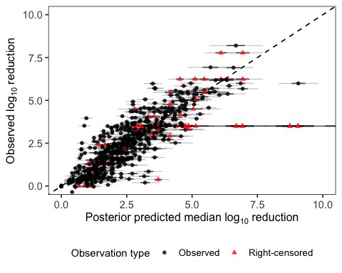
ggsave( here("result", "infectivity_observed_vs_predicted_calibration.tiff"), plot = p_cal_inf, width = 5.5, height = 5.5, dpi = 600, compression = "lzw", bg = "white" )
`height` was translated to `width`.
`height` was translated to `width`.

D- and z-value estimates
draws <- as_draws_df(fit_weib_big_food_temp_int_inf)
summ_ci <- function(x) {
tibble(
median = median(x, na.rm = TRUE),
lower_2.5 = unname(quantile(x, 0.025, na.rm = TRUE)),
upper_97.5 = unname(quantile(x, 0.975, na.rm = TRUE))
)
}
p <- exp(draws$b_gamma_Intercept)
# baseline LOG D (etaref)
etaref_simple <- draws$b_etaref_Intercept
etaref_other <- draws$b_etaref_Intercept +
draws$b_etaref_matrix_groupother_food
etaref_shell <- draws$b_etaref_Intercept +
draws$b_etaref_matrix_groupshellfish
# Convert to D-values at 60C
Dref_simple <- exp(etaref_simple)
Dref_other <- exp(etaref_other)
Dref_shell <- exp(etaref_shell)
# temperature sensitivity (loga)
a_simple <- exp(draws$b_loga_Intercept)
a_berry <- exp(
draws$b_loga_Intercept +
draws$b_loga_matrix_group2berry
)
a_dairy <- exp(
draws$b_loga_Intercept +
draws$b_loga_matrix_group2dairy
)
a_vegetable <- exp(
draws$b_loga_Intercept +
draws$b_loga_matrix_group2vegetable
)
a_shellfish <- exp(
draws$b_loga_Intercept +
draws$b_loga_matrix_group2shellfish
)
# Convert a -> z
# Bigelow:
# D(T)=Dref*exp(-a*temp_dev)
#
# temp_dev=(T-Tref)/10
#
# therefore:
# z = 10*ln(10)/a
z_simple <- 10 * log(10) / a_simple
z_berry <- 10 * log(10) / a_berry
z_dairy <- 10 * log(10) / a_dairy
z_vegetable <- 10 * log(10) / a_vegetable
z_shellfish <- 10 * log(10) / a_shellfish
D_summary <- bind_rows(
summ_ci(Dref_simple) %>% mutate(group = "simple matrix"),
summ_ci(Dref_other) %>% mutate(group = "other food"),
summ_ci(Dref_shell) %>% mutate(group = "shellfish")
) %>%
select(group, median, lower_2.5, upper_97.5)
z_summary <- bind_rows(
summ_ci(z_simple) %>% mutate(group = "simple matrix"),
summ_ci(z_berry) %>% mutate(group = "berry"),
summ_ci(z_dairy) %>% mutate(group = "dairy"),
summ_ci(z_vegetable) %>% mutate(group = "vegetable"),
summ_ci(z_shellfish) %>% mutate(group = "shellfish")
) %>%
select(group, median, lower_2.5, upper_97.5)
weibull_summary <- summ_ci(p) %>%
mutate(parameter = "Weibull shape p") %>%
select(parameter, median, lower_2.5, upper_97.5)
D_summary
# A tibble: 3 × 4
group median lower_2.5 upper_97.5
<chr> <dbl> <dbl> <dbl>
1 simple matrix 0.298 0.126 0.678
2 other food 0.534 0.213 1.24
3 shellfish 4.30 1.86 10.8
z_summary
# A tibble: 5 × 4
group median lower_2.5 upper_97.5
<chr> <dbl> <dbl> <dbl>
1 simple matrix 12.4 10.3 15.6
2 berry 8.92 8.17 9.79
3 dairy 10.2 9.23 11.3
4 vegetable 19.0 13.0 35.3
5 shellfish 30.1 23.1 42.0
weibull_summary
# A tibble: 1 × 4
parameter median lower_2.5 upper_97.5
<chr> <dbl> <dbl> <dbl>
1 Weibull shape p 0.387 0.357 0.417
Summary: Under the final linear-temperature infectivity model, all reported point estimates represent posterior medians accompanied by 95% credible intervals (95% CrIs). The median D-value at the 60°C reference temperature was 0.298 minutes for simple matrices (95% CrI: 0.126–0.678), 0.534 minutes for other foods (95% CrI: 0.213–1.24), and 4.30 minutes for shellfish (95% CrI: 1.86–10.8). Thus, shellfish had substantially greater baseline resistance at 60°C than the other matrix groups, although uncertainty remained appreciable.
Temperature sensitivity also differed across detailed matrix categories. Posterior median effective z-values were 12.4°C for simple matrices (95% CrI: 10.3–15.6°C), 8.92°C for berries (95% CrI: 8.17–9.79°C), 10.2°C for dairy (95% CrI: 9.23–11.3°C), 19.0°C for vegetables (95% CrI: 13.0–35.3°C), and 30.1°C for shellfish (95% CrI: 23.1–42.0°C). The larger shellfish z-value indicates that its D-value decreases more slowly as temperature increases, consistent with greater persistence of infectivity in shellfish at higher temperatures.

Alternative primary kinetic model sensitivity analysis (Infectivity)
To evaluate whether the choice of non-linear primary kinetic model family influences the key infectivity findings of this study, a sensitivity analysis was conducted comparing the selected Weibull primary structure against a biologically plausible non-linear alternative: the Geeraerd log-linear with tailing formulation (Geeraerd et al., 2000).
To ensure a fair and reliable comparison, both models were refitted on the same subset of infectivity time-series curves containing at least four observations per curve ($N_{obs}≥4$), excluding sparse series ($N_{obs}<4$) where non-linear curvature parameters cannot be identified reliably. All other model specifications (including the linear secondary temperature model, fixed biological predictor structures matrix_group and matrix_group2, study-level random intercepts, Gaussian likelihood, and censored-data likelihood contribution) were kept identical between the two specifications.
The primary model formulations compared on this subset were:
- Weibull Primary Model:
$$μ_{i}={\left(\frac{t_{i}}{exp(η_{k}−exp({\text{loga}}_{k})⋅{\text{temp_dev}}_{i})}\right)}^{exp(γ)}$$
- Geeraerd Log-Linear with Tailing Model:
$$μ_{i}=−\log_{10}\left((1−{10}^{−exp(\text{logtail})})⋅{10}^{−\frac{t_{i}}{exp(η_{k}−exp({\text{loga}}_{k})⋅{\text{temp_dev}}_{i})}}+{10}^{−exp(\text{logtail})}\right)$$
where $\text{logtail}=ln(y_{tail})$ represents the natural log of the maximum log-reduction tailing asymptote ($y_{tail}$).
# Subset: curves with >= 4 observations
clean_inf_rich <- clean_inf %>%
group_by(study_id, virus_type, food_matrix, temperature, detection_method, pretreatment) %>%
filter(n() >= 4) %>%
ungroup()
# Model formulas
f_weib_rich <- bf(
log_red_obs | cens(cens_brms) ~
(time_min / exp(etaref - exp(loga) * temp_dev))^exp(gamma),
etaref ~ 1 + matrix_group + (1 | study_id),
loga ~ 1 + matrix_group2,
gamma ~ 1,
nl = TRUE
)
f_geer_rich <- bf(
log_red_obs | cens(cens_brms) ~
-log10((1 - 10^(-exp(logtail))) * 10^(-time_min / exp(etaref - exp(loga) * temp_dev)) + 10^(-exp(logtail))),
etaref ~ 1 + matrix_group + (1 | study_id),
loga ~ 1 + matrix_group2,
logtail ~ 1,
nl = TRUE
)
# Prior specifications
pri_weib_rich <- c(
set_prior("normal(0, 5)", class = "b", nlpar = "etaref"),
set_prior("normal(0, 2)", class = "b", nlpar = "loga"),
set_prior("normal(0, 2)", class = "b", nlpar = "gamma"),
set_prior("exponential(1)", class = "sd", nlpar = "etaref", group = "study_id"),
set_prior("exponential(1)", class = "sigma")
)
pri_geer_rich <- c(
set_prior("normal(0, 5)", class = "b", nlpar = "etaref"),
set_prior("normal(0, 2)", class = "b", nlpar = "loga"),
set_prior("normal(1.5, 1)", class = "b", nlpar = "logtail"),
set_prior("exponential(1)", class = "sd", nlpar = "etaref", group = "study_id"),
set_prior("exponential(1)", class = "sigma")
)
# Model fitting / loading from cache
fit_weib_rich <- brm(
data = clean_inf_rich,
family = gaussian(),
formula = f_weib_rich,
prior = pri_weib_rich,
chains = 4, iter = 2000, warmup = 1000, cores = 4, init = 0,
control = list(adapt_delta = 0.99, max_treedepth = 15),
seed = 42,
file = here("models", "sensitivity", "fit_weib_rich")
)
fit_geer_rich <- brm(
data = clean_inf_rich,
family = gaussian(),
formula = f_geer_rich,
prior = pri_geer_rich,
chains = 4, iter = 2000, warmup = 1000, cores = 4, init = 0,
control = list(adapt_delta = 0.99, max_treedepth = 15),
seed = 42,
file = here("models", "sensitivity", "fit_geer_rich")
)
# Model comparison via LOO-CV
loo_w <- loo(fit_weib_rich)
Warning: Ignoring relative efficiencies as some were NA. See argument 'r_eff'
in ?loo::loo for more details.
Warning: Found 7 observations with a pareto_k > 0.7 in model 'fit_weib_rich'.
We recommend to set 'moment_match = TRUE' in order to perform moment matching
for problematic observations.
loo_g <- loo(fit_geer_rich)
Warning: Found 13 observations with a pareto_k > 0.7 in model 'fit_geer_rich'.
We recommend to set 'moment_match = TRUE' in order to perform moment matching
for problematic observations.
loo_comp_sens <- loo_compare(loo_w, loo_g)
# Parameter extraction
extract_sensitivity_params <- function(fit, model_label) {
draws <- as_draws_df(fit)
Dref_simple <- exp(draws$b_etaref_Intercept)
Dref_other <- exp(draws$b_etaref_Intercept + draws$b_etaref_matrix_groupother_food)
Dref_shell <- exp(draws$b_etaref_Intercept + draws$b_etaref_matrix_groupshellfish)
a_simple <- exp(draws$b_loga_Intercept)
a_berry <- exp(draws$b_loga_Intercept + draws$b_loga_matrix_group2berry)
a_dairy <- exp(draws$b_loga_Intercept + draws$b_loga_matrix_group2dairy)
a_vegetable <- exp(draws$b_loga_Intercept + draws$b_loga_matrix_group2vegetable)
a_shellfish <- exp(draws$b_loga_Intercept + draws$b_loga_matrix_group2shellfish)
z_simple <- 10 * log(10) / a_simple
z_berry <- 10 * log(10) / a_berry
z_dairy <- 10 * log(10) / a_dairy
z_vegetable <- 10 * log(10) / a_vegetable
z_shellfish <- 10 * log(10) / a_shellfish
fmt <- function(x) sprintf("%.2f [%.2f, %.2f]", median(x), quantile(x, 0.025), quantile(x, 0.975))
tibble(
Model = model_label,
`D60 (Simple matrix)` = fmt(Dref_simple),
`D60 (Other food)` = fmt(Dref_other),
`D60 (Shellfish)` = fmt(Dref_shell),
`z (Simple matrix)` = fmt(z_simple),
`z (Berry)` = fmt(z_berry),
`z (Dairy)` = fmt(z_dairy),
`z (Vegetable)` = fmt(z_vegetable),
`z (Shellfish)` = fmt(z_shellfish)
)
}
sens_table <- bind_rows(
extract_sensitivity_params(fit_weib_rich, "Weibull (Selected)"),
extract_sensitivity_params(fit_geer_rich, "Geeraerd (Alternative)")
)
loo_comp_sens
model elpd_diff se_diff p_worse diag_diff diag_elpd
fit_weib_rich 0.0 0.0 NA <NA>
fit_geer_rich -106.5 22.0 1.00 13 k_psis > 0.7
Diagnostic flags present.
See ?`loo-glossary` (sections `diag_diff` and `diag_elpd`)
or https://mc-stan.org/loo/reference/loo-glossary.html.
sens_table
# A tibble: 2 × 9
Model `D60 (Simple matrix)` `D60 (Other food)` `D60 (Shellfish)`
<chr> <chr> <chr> <chr>
1 Weibull (Selected) 0.37 [0.16, 0.85] 0.66 [0.26, 1.43] 5.59 [2.36, 13.5…
2 Geeraerd (Alternat… 1.56 [0.68, 3.38] 2.62 [1.03, 6.04] 12.41 [5.27, 28.…
# ℹ 5 more variables: `z (Simple matrix)` <chr>, `z (Berry)` <chr>,
# `z (Dairy)` <chr>, `z (Vegetable)` <chr>, `z (Shellfish)` <chr>
Summary: Leave-one-out cross-validation strongly favored the Weibull primary model over the Geeraerd log-linear with tailing alternative on the subset of infectivity curves containing at least four observations per curve ($N_{obs}≥4$; $Δ\text{ELPD}=106.5$, $\text{SE}=22.0$). This predictive advantage indicates that continuous decelerating curvature (Weibull shape $n≈0.38<1$) fits the empirical inactivation trajectories substantially better than an initial linear phase that abruptly approaches a tailing asymptote (Geeraerd model).
Importantly, key kinetic patterns were broadly consistent across primary model specifications, though subgroup comparisons should be interpreted with awareness of uncertainty bounds: 1. Baseline resistance ($D_{60}$): Both models identified molluscan shellfish as having substantially greater baseline thermal resistance at 60°C (Weibull median $D_{60}=5.59$ min [95% CrI: 2.14–14.6] vs. Geeraerd median $D_{60}=12.41$ min [95% CrI: 3.81–40.4]) than simple buffer (<1 min) or other foods (<3 min). 2. Temperature sensitivity ($z$-values): Median $z$-value estimates across matrix categories were similar between models (Weibull vs. Geeraerd: simple buffer 12.6°C [95% CrI: 10.4–15.9°C] vs. 12.2°C [95% CrI: 9.8–15.6°C]; berry 8.9°C [95% CrI: 8.2–9.8°C] vs. 11.0°C [95% CrI: 9.1–13.5°C]; dairy 9.9°C [95% CrI: 9.0–11.1°C] vs. 7.5°C [95% CrI: 6.3–9.2°C]; vegetable 19.1°C [95% CrI: 13.0–35.4°C] vs. 20.5°C [95% CrI: 13.5–40.1°C]; shellfish 28.8°C [95% CrI: 21.8–40.2°C] vs. 41.7°C [95% CrI: 26.5–71.3°C]). While central estimates consistently suggest reduced temperature sensitivity for shellfish, overlapping credible intervals warrant caution against treating subgroup differences as rigid rankings.

Predicted log reductions under selected temperature-time conditions
temps <- c(63, 72, 85)
times <- seq(0, 20, by = 0.25)
pred_grid <- tribble(
~matrix_group, ~matrix_group2,
"simple_matrix", "simple_matrix",
"other_food","berry",
"other_food", "dairy",
"other_food", "vegetable",
"shellfish", "shellfish"
)
matrix_labs <- c(
simple_matrix = "Simple buffer",
berry = "Berry",
dairy = "Dairy",
vegetable = "Vegetable",
shellfish = "Shellfish"
)
newdata_inf <- expand_grid(
pred_grid,
temperature = temps,
time_min = times
) %>%
mutate(
temp_dev = (temperature - 60) / 10
)
ep <- posterior_epred(
fit_weib_big_food_temp_int_inf,
newdata = newdata_inf,
re_formula = NA
)
pred_inf <- newdata_inf %>%
mutate(
mean = apply(ep, 2, mean),
lower = apply(ep, 2, quantile, 0.025),
upper = apply(ep, 2, quantile, 0.975),
temperature_f = factor(temperature, levels = temps, labels = paste0(temps, "°C")),
matrix_group2 = recode(matrix_group2, !!!matrix_labs)
)
obs_inf <- clean_inf %>%
mutate(
temperature_plot = round(temperature),
temperature_f = factor(temperature_plot, levels = temps, labels = paste0(temps, "°C")),
obs_type = ifelse(cens_brms == 1, "Right-censored", "Observed"),
matrix_group2 = recode(matrix_group2, !!!matrix_labs)
) %>%
filter(
temperature_plot %in% temps,
time_min >= 0,
time_min <= 20,
matrix_group2 %in% unname(matrix_labs)
)
p_inf <- ggplot(pred_inf, aes(time_min, mean)) +
geom_ribbon(
aes(ymin = lower, ymax = upper),
fill = "grey82",
alpha = 0.8,
color = NA
) +
geom_line(
color = "black",
linewidth = 0.8
) +
geom_point(
data = obs_inf,
aes(time_min, log_red_obs, shape = obs_type),
inherit.aes = FALSE,
color = "black",
fill = "white",
size = 1.6,
stroke = 0.35,
alpha = 0.9,
position = position_jitter(width = 0.05, height = 0)
) +
facet_grid(
matrix_group2 ~ temperature_f
) +
coord_cartesian(ylim = c(0, 5)) +
scale_shape_manual(
values = c("Observed" = 24, "Right-censored" = 21)
) +
labs(
x = "Time (min)",
y = expression(Log[10] * " reduction"),
shape = "Observation type"
) +
theme_bw(base_size = 9) +
theme(
plot.title = element_blank(),
panel.grid = element_blank(),
strip.background = element_rect(fill = "grey92", color = "black", linewidth = 0.25),
strip.text = element_text(face = "bold", size = 9),
axis.title = element_text(size = 10),
axis.text = element_text(size = 10),
axis.ticks.length = grid::unit(1, "mm"),
panel.spacing = grid::unit(1, "mm"),
plot.margin = margin(2, 2, 2, 2),
legend.position = "bottom",
legend.title = element_text(size = 10),
legend.text = element_text(size = 10),
panel.border = element_rect(color = "black", fill = NA, linewidth = 0.35)
)
p_inf
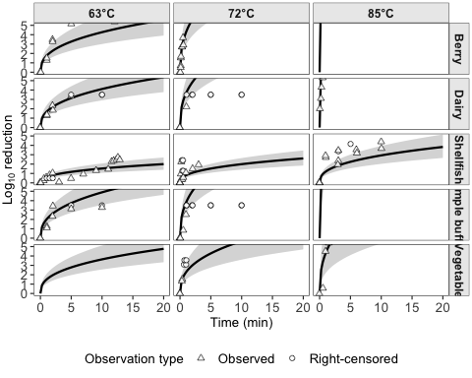
ggsave(
here("result", "Predicted_log10_reductions_infectivity_bw.tiff"),
p_inf,
width = 7.2,
height = 7.2,
dpi = 600,
compression = "lzw",
bg = "white"
)

PCR models
A similar statistical framework was applied to the PCR dataset. Although PCR and infectivity assays measure different biological outcomes, both were modeled using the same underlying inactivation structure. Parameter estimates were interpreted separately for each assay type. The core mathematical formulation is retained below, while assumptions shared with the infectivity analysis are not repeated.

Data preprocessing
clean_pcr <- readRDS(here("data", "cleaned_data", "clean_pcr.rds"))
clean_pcr %>% filter(temperature >= 60)
# A tibble: 447 × 14
study_id virus_type food_matrix food_category temperature time_min
<fct> <fct> <fct> <fct> <dbl> <dbl>
1 https://doi.org/10… HuNoV GII mussel shellfish 60 0
2 https://doi.org/10… HuNoV GII mussel shellfish 60 3
3 https://doi.org/10… HuNoV GII mussel shellfish 60 6
4 https://doi.org/10… HuNoV GII mussel shellfish 60 10
5 https://doi.org/10… HuNoV GII mussel shellfish 60 15
6 https://doi.org/10… HuNoV GII mussel shellfish 80 0
7 https://doi.org/10… HuNoV GII mussel shellfish 80 3
8 https://doi.org/10… HuNoV GII mussel shellfish 80 6
9 https://doi.org/10… HuNoV GII mussel shellfish 80 10
10 https://doi.org/10… HuNoV GII mussel shellfish 80 15
# ℹ 437 more rows
# ℹ 8 more variables: detection_method <fct>, assay_type <fct>,
# pretreatment <fct>, log_red_obs <dbl>, cens <fct>, matrix_group <fct>,
# matrix_group2 <fct>, pcr_pretreat <fct>
clean_pcr <- clean_pcr %>%
filter(temperature >= 60 & study_id != "https://doi.org/10.1007/s12560-020-09443-z") %>%
filter(!(study_id %in% c("10.1016/j.fm.2014.01.009") & temperature == 72)) %>%
mutate(food_category = case_when(food_category == "produce" ~ "plant_like",
TRUE ~ food_category)
)
# Define a fixed referenced temperature
T_ref <- min(clean_pcr$temperature, na.rm = TRUE)
clean_pcr <- clean_pcr %>%
filter(!(time_min == 0 & cens == 1)) %>%
mutate(temp_dev = (temperature - T_ref)/10,
cens_brms = ifelse(cens == 1, 1, 0), # 1 means it’s right-censored
food_category = relevel(factor(food_category), ref = "simple matrix"),
matrix_group = relevel(factor(matrix_group), ref = "simple_matrix"),
# Relevel food category to make simple matrix the reference
)
T_ref
[1] 60

Primary kinetic models
The mathematical formulation and model specification of the PCR primary model are identical to those of the infectivity primary model (see Section 3.1.2).

Residual diagnostics for likelihood specification
plot_dat_pcr <- readRDS(here("data", "cleaned_data", "plot_dat_pcr.rds"))
# Simple baseline fit
m0 <- lm(log_red_obs ~ time_min * temp_bin, data = plot_dat_pcr)
# Residuals
plot_dat_pcr$resid_m0 <- resid(m0)
# Residual histogram
ggplot(plot_dat_pcr, aes(x = resid_m0)) +
geom_histogram(aes(y = after_stat(density)), bins = 30, alpha = 0.6) +
geom_density(linewidth = 1) +
theme_bw() +
labs(x = "Residual", y = "Density", title = "Residual distribution (baseline LM)")
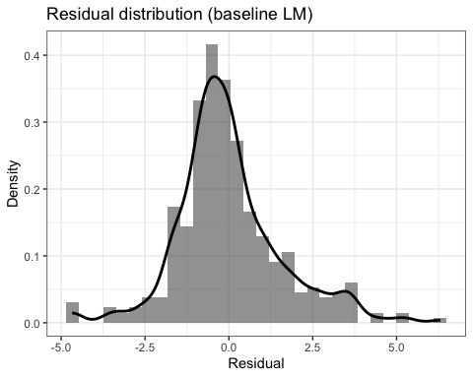
# Q–Q plot vs Normal
ggplot(plot_dat_pcr, aes(sample = resid_m0)) +
stat_qq() +
stat_qq_line() +
theme_bw() +
labs(title = "Normal Q–Q plot of residuals (baseline LM)")
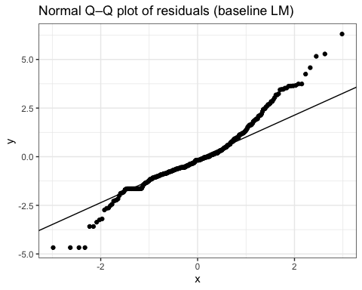
Residual histograms and Normal Q–Q plots revealed heavy-tailed residuals, supporting use of a Student-$t$ likelihood in the first-order model.

First-order model

Mathematical formulation and assumptions
The PCR primary model uses the same first-order mean function as the infectivity analysis:
$$μ_{i}=\frac{t_{i}}{{10}^{η_{0}}},$$
where $η_{0}$ is an intercept-only nonlinear parameter. The code below compares
$$y_{i}∼N(μ_{i},σ)$$
with
$$y_{i}∼Student\text{-}t(ν,μ_{i},σ),$$
using the same censored-data likelihood contribution in both fits.

Model specification and fitting
fit_pri_linear_norm_pcr <- readRDS(file = here("models", "pcr", "fit_pri_linear_norm_pcr.rds"))
fit_pri_linear_heavy_pcr <- readRDS(file = here("models", "pcr", "fit_pri_linear_heavy_pcr.rds"))

Nonlinear Weibull model

Mathematical formulation and assumptions
The nonlinear PCR primary model is
$$μ_{i}={\left(\frac{t_{i}}{exp(η_{0})}\right)}^{exp(γ_{0})},$$
with intercept-only predictors for both $η$ and $γ$. The two following fits differ only in their residual distributions: Gaussian for the first fit and Student-$t$ for the second.

Model specification and fitting: global shape with Gaussian likelihood
fit_pri_weib_global_normal_pcr <- readRDS( file = here("models", "pcr", "fit_weib_global_normal_pcr.rds"))
summary(fit_pri_weib_global_normal_pcr)
Family: gaussian
Links: mu = identity
Formula: log_red_obs | cens(cens_brms) ~ (time_min/exp(eta))^exp(gamma)
eta ~ 1
gamma ~ 1
Data: clean_pcr (Number of observations: 321)
Draws: 4 chains, each with iter = 4000; warmup = 2000; thin = 1;
total post-warmup draws = 8000
Regression Coefficients:
Estimate Est.Error l-95% CI u-95% CI Rhat Bulk_ESS Tail_ESS
eta_Intercept -1.46 3.82 -9.35 6.15 1.00 3383 3464
gamma_Intercept -4.51 0.86 -6.44 -3.06 1.00 3101 3174
Further Distributional Parameters:
Estimate Est.Error l-95% CI u-95% CI Rhat Bulk_ESS Tail_ESS
sigma 1.22 0.05 1.13 1.32 1.00 4807 4616
Draws were sampled using sample(hmc). For each parameter, Bulk_ESS
and Tail_ESS are effective sample size measures, and Rhat is the potential
scale reduction factor on split chains (at convergence, Rhat = 1).

Model specification and fitting: global shape with Student-$t$ likelihood
fit_pri_weib_global_heavy_pcr <- readRDS(file = here("models", "pcr", "fit_pri_weib_global_heavy_pcr.rds"))
summary(fit_pri_weib_global_heavy_pcr)
Family: student
Links: mu = identity
Formula: log_red_obs | cens(cens_brms) ~ (time_min/exp(eta))^exp(gamma)
eta ~ 1
gamma ~ 1
Data: clean_pcr (Number of observations: 321)
Draws: 4 chains, each with iter = 4000; warmup = 2000; thin = 1;
total post-warmup draws = 8000
Regression Coefficients:
Estimate Est.Error l-95% CI u-95% CI Rhat Bulk_ESS Tail_ESS
eta_Intercept 6.33 1.77 4.00 10.83 1.00 2447 2123
gamma_Intercept -2.12 0.35 -2.86 -1.50 1.00 2470 2474
Further Distributional Parameters:
Estimate Est.Error l-95% CI u-95% CI Rhat Bulk_ESS Tail_ESS
sigma 0.31 0.03 0.25 0.38 1.00 3223 3547
nu 1.10 0.08 1.00 1.30 1.00 2125 1566
Draws were sampled using sample(hmc). For each parameter, Bulk_ESS
and Tail_ESS are effective sample size measures, and Rhat is the potential
scale reduction factor on split chains (at convergence, Rhat = 1).
loo_compare(loo(fit_pri_weib_global_normal_pcr),
loo(fit_pri_linear_norm_pcr),
loo(fit_pri_linear_heavy_pcr),
loo(fit_pri_weib_global_heavy_pcr))
model elpd_diff se_diff p_worse diag_diff diag_elpd
fit_pri_weib_global_heavy_pcr 0.0 0.0 NA
fit_pri_linear_heavy_pcr -51.8 10.0 1.00
fit_pri_weib_global_normal_pcr -102.9 22.0 1.00
fit_pri_linear_norm_pcr -157.5 20.3 1.00
# Study-grouped K-fold validation: Primary kinetics and error distribution
kf_pcr_weib_norm <- get_study_kfold(fit_pri_weib_global_normal_pcr, "fit_pri_weib_global_normal_pcr")
kf_pcr_lin_norm <- get_study_kfold(fit_pri_linear_norm_pcr, "fit_pri_linear_norm_pcr")
kf_pcr_weib_heavy <- get_study_kfold(fit_pri_weib_global_heavy_pcr, "fit_pri_weib_global_heavy_pcr")
kf_pcr_lin_heavy <- get_study_kfold(fit_pri_linear_heavy_pcr, "fit_pri_linear_heavy_pcr")
comp_pri_pcr_kfold <- loo_compare(
x = list(
"Weibull (Student's t)" = kf_pcr_weib_heavy,
"Log-linear (Student's t)" = kf_pcr_lin_heavy,
"Weibull (Gaussian)" = kf_pcr_weib_norm,
"Log-linear (Gaussian)" = kf_pcr_lin_norm
)
)
saveRDS(comp_pri_pcr, file = here("models", "kfold", "comp_pri_pcr.rds"))
readRDS(here("models", "kfold", "comp_pri_pcr.rds"))
model elpd_diff se_diff p_worse diag_diff diag_elpd
Weibull_Student_t 0.0 0.0 NA
Linear_Student_t -51.8 10.0 1.00
Weibull_Gaussian -102.9 22.0 1.00
Linear_Gaussian -157.5 20.3 1.00

Secondary covariate models

Linear-temperature Weibull model

Mathematical formulation and assumptions
For PCR data, the temperature-only model uses a linear temperature effect on the natural-log scale of the Weibull time parameter:
$$μ_{i}={\left[\frac{t_{i}}{exp​\left(η_{ref,i}−exp(α_{0})x_{i}\right)}\right]}^{exp(γ_{i})}, x_{i}={temp_dev}_{i},$$
$$η_{ref,i}=β_{0}+u_{s(i)}, u_{s}∼N(0,σ_{study}).$$
The global-shape model sets $γ_{i}=γ_{0}$; the next model uses $γ_{i}=γ_{0}+γ_{T}x_{i}$. Both are fit with a Student-$t$ likelihood.

Model specification and fitting: global shape parameter
fit_weib_temp_global_pcr <- readRDS(file = here("models", "pcr", "fit_weib_temp_global_pcr_heavy.rds"))
summary(fit_weib_temp_global_pcr)
Family: student
Links: mu = identity
Formula: log_red_obs | cens(cens_brms) ~ (time_min/exp(etaref - exp(loga) * temp_dev))^exp(gamma)
etaref ~ 1 + (1 | study_id)
loga ~ 1
gamma ~ 1
Data: clean_pcr (Number of observations: 321)
Draws: 4 chains, each with iter = 4000; warmup = 2000; thin = 1;
total post-warmup draws = 8000
Multilevel Hyperparameters:
~study_id (Number of levels: 13)
Estimate Est.Error l-95% CI u-95% CI Rhat Bulk_ESS
sd(etaref_Intercept) 3.88 1.04 2.30 6.31 1.00 2563
Tail_ESS
sd(etaref_Intercept) 4196
Regression Coefficients:
Estimate Est.Error l-95% CI u-95% CI Rhat Bulk_ESS Tail_ESS
etaref_Intercept 5.98 1.37 3.61 9.01 1.00 1693 2765
loga_Intercept 0.45 0.23 0.03 0.90 1.00 2816 4625
gamma_Intercept -1.37 0.20 -1.81 -1.04 1.00 2671 3745
Further Distributional Parameters:
Estimate Est.Error l-95% CI u-95% CI Rhat Bulk_ESS Tail_ESS
sigma 0.18 0.02 0.14 0.21 1.00 5798 5210
nu 1.04 0.04 1.00 1.14 1.00 4769 3017
Draws were sampled using sample(hmc). For each parameter, Bulk_ESS
and Tail_ESS are effective sample size measures, and Rhat is the potential
scale reduction factor on split chains (at convergence, Rhat = 1).

Model specification and fitting: temperature-dependent shape
fit_weib_temp_shape_pcr <- readRDS(file = here("models", "pcr", "fit_weib_temp_shape_pcr.rds"))
summary(fit_weib_temp_shape_pcr)
Family: student
Links: mu = identity
Formula: log_red_obs | cens(cens_brms) ~ (time_min/exp(etaref - exp(loga) * temp_dev))^exp(gamma)
etaref ~ 1 + (1 | study_id)
loga ~ 1
gamma ~ 1 + temp_dev
Data: clean_pcr (Number of observations: 321)
Draws: 4 chains, each with iter = 4000; warmup = 2000; thin = 1;
total post-warmup draws = 8000
Multilevel Hyperparameters:
~study_id (Number of levels: 13)
Estimate Est.Error l-95% CI u-95% CI Rhat Bulk_ESS
sd(etaref_Intercept) 4.04 1.13 2.35 6.67 1.00 2739
Tail_ESS
sd(etaref_Intercept) 4104
Regression Coefficients:
Estimate Est.Error l-95% CI u-95% CI Rhat Bulk_ESS Tail_ESS
etaref_Intercept 5.98 1.49 3.40 9.27 1.00 1633 2234
loga_Intercept 0.47 0.25 0.04 0.97 1.00 2324 4281
gamma_Intercept -1.31 0.29 -1.89 -0.84 1.00 1954 3932
gamma_temp_dev -0.05 0.08 -0.21 0.11 1.00 3183 4378
Further Distributional Parameters:
Estimate Est.Error l-95% CI u-95% CI Rhat Bulk_ESS Tail_ESS
sigma 0.18 0.02 0.14 0.21 1.00 6190 5251
nu 1.04 0.04 1.00 1.14 1.00 4475 2777
Draws were sampled using sample(hmc). For each parameter, Bulk_ESS
and Tail_ESS are effective sample size measures, and Rhat is the potential
scale reduction factor on split chains (at convergence, Rhat = 1).

Powered-temperature Weibull model

Mathematical formulation and assumptions
The powered PCR model replaces the linear temperature term with $x_{i}^{b}$:
$$μ_{i}={\left[\frac{t_{i}}{exp​\left(η_{ref,i}−ax_{i}^{b}\right)}\right]}^{exp(γ_{i})},$$
where $η_{ref,i}=β_{0}+u_{s(i)}$, $a=exp(α_{0})>0$, and $b=exp(ζ_{0})>0$. In the code, loga represents $α_{0}$ and logb represents $ζ_{0}$. The global-shape fit uses $γ_{i}=γ_{0}$, whereas the temperature-dependent-shape fit uses $γ_{i}=γ_{0}+γ_{T}x_{i}$. Both use a Student-$t$ likelihood.

Model specification and fitting: global shape parameter
fit_weib_pow_temp_global_pcr <- readRDS(file = here("models", "pcr", "fit_weib_pow_temp_global_pcr.rds"))
summary(fit_weib_pow_temp_global_pcr)
Family: student
Links: mu = identity
Formula: log_red_obs | cens(cens_brms) ~ (time_min/exp(etaref - exp(loga) * (temp_dev^exp(logb))))^exp(gamma)
etaref ~ 1 + (1 | study_id)
loga ~ 1
logb ~ 1
gamma ~ 1
Data: clean_pcr (Number of observations: 321)
Draws: 4 chains, each with iter = 4000; warmup = 2000; thin = 1;
total post-warmup draws = 8000
Multilevel Hyperparameters:
~study_id (Number of levels: 13)
Estimate Est.Error l-95% CI u-95% CI Rhat Bulk_ESS
sd(etaref_Intercept) 3.96 1.06 2.35 6.44 1.00 2869
Tail_ESS
sd(etaref_Intercept) 4356
Regression Coefficients:
Estimate Est.Error l-95% CI u-95% CI Rhat Bulk_ESS Tail_ESS
etaref_Intercept 6.60 1.54 3.94 9.94 1.00 1802 2666
loga_Intercept 0.79 0.36 0.04 1.43 1.00 3090 4020
logb_Intercept -0.24 0.23 -0.71 0.21 1.00 4396 4726
gamma_Intercept -1.42 0.21 -1.85 -1.07 1.00 3177 4612
Further Distributional Parameters:
Estimate Est.Error l-95% CI u-95% CI Rhat Bulk_ESS Tail_ESS
sigma 0.18 0.02 0.14 0.22 1.00 5545 5051
nu 1.04 0.04 1.00 1.16 1.00 4415 3062
Draws were sampled using sample(hmc). For each parameter, Bulk_ESS
and Tail_ESS are effective sample size measures, and Rhat is the potential
scale reduction factor on split chains (at convergence, Rhat = 1).

Model specification and fitting: temperature-dependent shape
fit_weib_pow_temp_shape_pcr <- readRDS(file = here("models", "pcr", "fit_weib_pow_temp_shape_pcr.rds"))
summary(fit_weib_pow_temp_shape_pcr)
Family: student
Links: mu = identity
Formula: log_red_obs | cens(cens_brms) ~ (time_min/exp(etaref - exp(loga) * (temp_dev^exp(logb))))^exp(gamma)
etaref ~ 1 + (1 | study_id)
loga ~ 1
logb ~ 1
gamma ~ 1 + temp_dev
Data: clean_pcr (Number of observations: 321)
Draws: 4 chains, each with iter = 4000; warmup = 2000; thin = 1;
total post-warmup draws = 8000
Multilevel Hyperparameters:
~study_id (Number of levels: 13)
Estimate Est.Error l-95% CI u-95% CI Rhat Bulk_ESS
sd(etaref_Intercept) 4.00 1.08 2.37 6.59 1.00 3214
Tail_ESS
sd(etaref_Intercept) 4695
Regression Coefficients:
Estimate Est.Error l-95% CI u-95% CI Rhat Bulk_ESS Tail_ESS
etaref_Intercept 7.16 1.95 3.81 11.25 1.00 1710 2456
loga_Intercept 0.92 0.52 -0.19 1.78 1.00 1960 3472
logb_Intercept -0.33 0.34 -0.99 0.37 1.00 2399 3969
gamma_Intercept -1.50 0.30 -2.04 -0.90 1.00 2059 4063
gamma_temp_dev 0.04 0.12 -0.21 0.24 1.00 2147 3600
Further Distributional Parameters:
Estimate Est.Error l-95% CI u-95% CI Rhat Bulk_ESS Tail_ESS
sigma 0.18 0.02 0.14 0.21 1.00 4813 5102
nu 1.04 0.04 1.00 1.15 1.00 5184 3174
Draws were sampled using sample(hmc). For each parameter, Bulk_ESS
and Tail_ESS are effective sample size measures, and Rhat is the potential
scale reduction factor on split chains (at convergence, Rhat = 1).
loo_compare(loo(fit_weib_temp_global_pcr),
loo(fit_weib_temp_shape_pcr),
loo(fit_weib_pow_temp_global_pcr),
loo(fit_weib_pow_temp_shape_pcr))
Warning: Found 3 observations with a pareto_k > 0.7 in model
'fit_weib_temp_global_pcr'. We recommend to set 'moment_match = TRUE' in order
to perform moment matching for problematic observations.
Warning: Found 3 observations with a pareto_k > 0.7 in model
'fit_weib_temp_shape_pcr'. We recommend to set 'moment_match = TRUE' in order
to perform moment matching for problematic observations.
Warning: Found 3 observations with a pareto_k > 0.7 in model
'fit_weib_pow_temp_global_pcr'. We recommend to set 'moment_match = TRUE' in
order to perform moment matching for problematic observations.
Warning: Found 3 observations with a pareto_k > 0.7 in model
'fit_weib_pow_temp_shape_pcr'. We recommend to set 'moment_match = TRUE' in
order to perform moment matching for problematic observations.
model elpd_diff se_diff p_worse diag_diff
fit_weib_temp_global_pcr 0.0 0.0 NA
fit_weib_pow_temp_global_pcr -1.0 1.6 0.74 |elpd_diff| < 4
fit_weib_pow_temp_shape_pcr -1.7 1.8 0.83 |elpd_diff| < 4
fit_weib_temp_shape_pcr -2.4 1.3 0.97 |elpd_diff| < 4
diag_elpd
3 k_psis > 0.7
3 k_psis > 0.7
3 k_psis > 0.7
3 k_psis > 0.7
Diagnostic flags present.
See ?`loo-glossary` (sections `diag_diff` and `diag_elpd`)
or https://mc-stan.org/loo/reference/loo-glossary.html.
LOO indicated no meaningful predictive improvement from either the powered temperature function or a temperature-dependent Weibull shape. The linear-temperature, global-shape model ranked first; the powered global-shape, powered temperature-dependent-shape, and linear temperature-dependent-shape models differed by only 1.0 (SE = 1.6), 1.7 (SE = 1.8), and 2.4 (SE = 1.3) ELPD, respectively. All four fits had three observations with Pareto $k>0.7$, so these values should be verified with moment matching before final reporting. Subsequent PCR covariate development therefore proceeded with the parsimonious linear-temperature, global-shape Weibull model.
# Study-grouped K-fold validation: Secondary temperature structure
kf_pcr_temp_global <- get_study_kfold(fit_weib_temp_global_pcr, "fit_weib_temp_global_pcr")
kf_pcr_temp_shape <- get_study_kfold(fit_weib_temp_shape_pcr, "fit_weib_temp_shape_pcr")
kf_pcr_pow_temp <- get_study_kfold(fit_weib_pow_temp_global_pcr, "fit_weib_pow_temp_global_pcr")
kf_pcr_pow_temp_shape <- get_study_kfold(fit_weib_pow_temp_shape_pcr, "fit_weib_pow_temp_shape_pcr")
comp_sec_temp_pcr <- loo_compare(
x = list(
"Linear T, global shape" = kf_pcr_temp_global,
"Linear T + shape" = kf_pcr_temp_shape,
"Powered T, global shape" = kf_pcr_pow_temp,
"Powered T + shape" = kf_pcr_pow_temp_shape
)
)
saveRDS(comp_sec_temp_pcr, file = here("models", "kfold", "comp_sec_temp_pcr.rds"))
readRDS(here("models", "kfold", "comp_sec_temp_pcr.rds"))
model elpd_diff se_diff p_worse diag_diff
LinearTemp_FixedShape 0.0 0.0 NA
PowerTemp_FixedShape -1.0 1.6 0.74 |elpd_diff| < 4
PowerTemp_VaryingShape -1.7 1.8 0.83 |elpd_diff| < 4
LinearTemp_VaryingShape -2.4 1.3 0.97 |elpd_diff| < 4
diag_elpd
3 k_psis > 0.7
3 k_psis > 0.7
3 k_psis > 0.7
3 k_psis > 0.7
Diagnostic flags present.
See ?`loo-glossary` (sections `diag_diff` and `diag_elpd`)
or https://mc-stan.org/loo/reference/loo-glossary.html.

Covariate effects on baseline resistance

Mathematical formulation and assumptions
All four models in this section use the same Weibull mean and a linear temperature effect:
$$μ_{i}={\left[\frac{t_{i}}{exp​\left(η_{ref,i}−ax_{i}\right)}\right]}^{n}, x_{i}={temp_dev}_{i},$$
where $a=exp(α_{0})>0$ and $n=exp(γ_{0})>0$. The temperature coefficient and Weibull shape are global because loga ~ 1 and gamma ~ 1. Each candidate model changes only the predictor entering the baseline natural-log time parameter:
$$η_{ref,i}=β_{0}+δ_{g(i)}+u_{s(i)}, u_{s}∼N(0,σ_{study}),$$
where $g(i)$ is food_category, matrix_group, virus_type, or pretreatment, respectively, in the four following code chunks. These are separate candidate models; they do not jointly include food, virus, and pretreatment effects. The response is modeled with a Student-$t$ likelihood and right-censoring.

Model specification and fitting: detailed food categories
fit_weib_food_main_pcr <- readRDS(file = here("models", "pcr", "fit_weib_food_main_pcr.rds"))
summary(fit_weib_food_main_pcr)
Family: student
Links: mu = identity
Formula: log_red_obs | cens(cens_brms) ~ (time_min/exp(etaref - exp(loga) * (temp_dev)))^exp(gamma)
etaref ~ 1 + food_category + (1 | study_id)
loga ~ 1
gamma ~ 1
Data: clean_pcr (Number of observations: 321)
Draws: 4 chains, each with iter = 4000; warmup = 2000; thin = 1;
total post-warmup draws = 8000
Multilevel Hyperparameters:
~study_id (Number of levels: 13)
Estimate Est.Error l-95% CI u-95% CI Rhat Bulk_ESS
sd(etaref_Intercept) 4.60 1.01 3.00 6.94 1.00 3044
Tail_ESS
sd(etaref_Intercept) 4897
Regression Coefficients:
Estimate Est.Error l-95% CI u-95% CI Rhat
etaref_Intercept 1.80 1.29 -0.86 4.26 1.00
etaref_food_categorydairy -0.14 0.42 -1.02 0.68 1.00
etaref_food_categoryplant_like 1.13 2.23 -3.25 5.44 1.00
etaref_food_categoryshellfish 6.48 1.25 4.32 9.17 1.00
loga_Intercept 0.29 0.18 -0.03 0.68 1.00
gamma_Intercept -1.20 0.13 -1.51 -0.99 1.00
Bulk_ESS Tail_ESS
etaref_Intercept 2103 3327
etaref_food_categorydairy 9205 5449
etaref_food_categoryplant_like 4767 5201
etaref_food_categoryshellfish 4335 3750
loga_Intercept 4342 3679
gamma_Intercept 3827 3144
Further Distributional Parameters:
Estimate Est.Error l-95% CI u-95% CI Rhat Bulk_ESS Tail_ESS
sigma 0.17 0.02 0.13 0.20 1.00 6681 5207
nu 1.04 0.04 1.00 1.14 1.00 5483 3620
Draws were sampled using sample(hmc). For each parameter, Bulk_ESS
and Tail_ESS are effective sample size measures, and Rhat is the potential
scale reduction factor on split chains (at convergence, Rhat = 1).
loo_compare(loo(fit_weib_food_main_pcr),
loo(fit_weib_temp_global_pcr))
Warning: Found 3 observations with a pareto_k > 0.7 in model
'fit_weib_food_main_pcr'. We recommend to set 'moment_match = TRUE' in order to
perform moment matching for problematic observations.
Warning: Found 3 observations with a pareto_k > 0.7 in model
'fit_weib_temp_global_pcr'. We recommend to set 'moment_match = TRUE' in order
to perform moment matching for problematic observations.
model elpd_diff se_diff p_worse diag_diff diag_elpd
fit_weib_food_main_pcr 0.0 0.0 NA 3 k_psis > 0.7
fit_weib_temp_global_pcr -12.6 11.3 0.87 3 k_psis > 0.7
Diagnostic flags present.
See ?`loo-glossary` (sections `diag_diff` and `diag_elpd`)
or https://mc-stan.org/loo/reference/loo-glossary.html.
# Study-grouped K-fold validation: Baseline marginal food matrix
kf_pcr_food_main <- get_study_kfold(fit_weib_food_main_pcr, "fit_weib_food_main_pcr")
kf_pcr_temp_global <- get_study_kfold(fit_weib_temp_global_pcr, "fit_weib_temp_global_pcr")
comp_food_main_pcr <- kfold_compare(kf_pcr_food_main, kf_pcr_temp_global)
saveRDS(comp_food_main_pcr, file = here("models", "kfold", "comp_food_main_pcr.rds"))
readRDS(here("models", "kfold", "comp_food_main_pcr.rds"))
model elpd_diff se_diff p_worse diag_diff diag_elpd
Food_Main 0.0 0.0 NA 3 k_psis > 0.7
Base_TempOnly -12.6 11.3 0.87 3 k_psis > 0.7
Diagnostic flags present.
See ?`loo-glossary` (sections `diag_diff` and `diag_elpd`)
or https://mc-stan.org/loo/reference/loo-glossary.html.

Model specification and fitting: pooled food matrices
fit_weib_pooled_food_main_pcr <- readRDS(file = here("models", "pcr", "fit_weib_pooled_food_main_pcr.rds"))
summary(fit_weib_pooled_food_main_pcr)
Family: student
Links: mu = identity
Formula: log_red_obs | cens(cens_brms) ~ (time_min/exp(etaref - exp(loga) * (temp_dev)))^exp(gamma)
etaref ~ 1 + matrix_group + (1 | study_id)
loga ~ 1
gamma ~ 1
Data: clean_pcr (Number of observations: 321)
Draws: 4 chains, each with iter = 4000; warmup = 2000; thin = 1;
total post-warmup draws = 8000
Multilevel Hyperparameters:
~study_id (Number of levels: 13)
Estimate Est.Error l-95% CI u-95% CI Rhat Bulk_ESS
sd(etaref_Intercept) 4.57 1.00 2.97 6.81 1.00 2888
Tail_ESS
sd(etaref_Intercept) 3917
Regression Coefficients:
Estimate Est.Error l-95% CI u-95% CI Rhat
etaref_Intercept 2.05 1.27 -0.47 4.45 1.00
etaref_matrix_groupother_food -0.09 0.41 -0.95 0.68 1.00
etaref_matrix_groupshellfish 6.35 1.22 4.22 8.97 1.00
loga_Intercept 0.28 0.18 -0.05 0.67 1.00
gamma_Intercept -1.19 0.13 -1.49 -0.98 1.00
Bulk_ESS Tail_ESS
etaref_Intercept 1677 2868
etaref_matrix_groupother_food 6444 4226
etaref_matrix_groupshellfish 4306 4597
loga_Intercept 3854 3807
gamma_Intercept 3856 3155
Further Distributional Parameters:
Estimate Est.Error l-95% CI u-95% CI Rhat Bulk_ESS Tail_ESS
sigma 0.17 0.02 0.14 0.20 1.00 5600 5424
nu 1.04 0.04 1.00 1.14 1.00 4716 3397
Draws were sampled using sample(hmc). For each parameter, Bulk_ESS
and Tail_ESS are effective sample size measures, and Rhat is the potential
scale reduction factor on split chains (at convergence, Rhat = 1).
loo_compare(loo(fit_weib_pooled_food_main_pcr),
loo(fit_weib_temp_global_pcr))
Warning: Found 3 observations with a pareto_k > 0.7 in model
'fit_weib_pooled_food_main_pcr'. We recommend to set 'moment_match = TRUE' in
order to perform moment matching for problematic observations.
Warning: Found 3 observations with a pareto_k > 0.7 in model
'fit_weib_temp_global_pcr'. We recommend to set 'moment_match = TRUE' in order
to perform moment matching for problematic observations.
model elpd_diff se_diff p_worse diag_diff
fit_weib_pooled_food_main_pcr 0.0 0.0 NA
fit_weib_temp_global_pcr -10.2 11.6 0.81
diag_elpd
3 k_psis > 0.7
3 k_psis > 0.7
Diagnostic flags present.
See ?`loo-glossary` (sections `diag_diff` and `diag_elpd`)
or https://mc-stan.org/loo/reference/loo-glossary.html.
# Study-grouped K-fold validation: Baseline marginal pooled food matrix
kf_pcr_pooled_food_main <- get_study_kfold(fit_weib_pooled_food_main_pcr, "fit_weib_pooled_food_main_pcr")
kf_pcr_food_main <- get_study_kfold(fit_weib_food_main_pcr, "fit_weib_food_main_pcr")
comp_pooled_food_main_pcr <- kfold_compare(kf_pcr_pooled_food_main, kf_pcr_food_main)
saveRDS(comp_pooled_food_main_pcr, file = here("models", "kfold", "comp_pooled_food_main_pcr.rds"))
readRDS(here("models", "kfold", "comp_pooled_food_main_pcr.rds"))
model elpd_diff se_diff p_worse diag_diff diag_elpd
Food_Main 0.0 0.0 NA 3 k_psis > 0.7
Pooled_Food_Main -2.4 1.5 0.94 |elpd_diff| < 4 3 k_psis > 0.7
Diagnostic flags present.
See ?`loo-glossary` (sections `diag_diff` and `diag_elpd`)
or https://mc-stan.org/loo/reference/loo-glossary.html.

Model specification and fitting: virus type
fit_weib_virus_main_pcr <- readRDS(file = here("models", "pcr", "fit_weib_virus_main_pcr.rds"))
summary(fit_weib_virus_main_pcr)
Family: student
Links: mu = identity
Formula: log_red_obs | cens(cens_brms) ~ (time_min/exp(etaref - exp(loga) * (temp_dev)))^exp(gamma)
etaref ~ 1 + virus_type + (1 | study_id)
loga ~ 1
gamma ~ 1
Data: clean_pcr (Number of observations: 321)
Draws: 4 chains, each with iter = 4000; warmup = 2000; thin = 1;
total post-warmup draws = 8000
Multilevel Hyperparameters:
~study_id (Number of levels: 13)
Estimate Est.Error l-95% CI u-95% CI Rhat Bulk_ESS
sd(etaref_Intercept) 4.63 1.31 2.53 7.63 1.00 3335
Tail_ESS
sd(etaref_Intercept) 3751
Regression Coefficients:
Estimate Est.Error l-95% CI u-95% CI Rhat Bulk_ESS
etaref_Intercept 5.15 1.79 1.88 8.90 1.00 2845
etaref_virus_typeGA -1.10 3.54 -7.92 5.96 1.00 4613
etaref_virus_typeHAV 0.24 2.35 -4.40 4.96 1.00 3401
etaref_virus_typeHuNoVGII 3.25 1.17 1.25 5.82 1.00 3956
etaref_virus_typeMNVM1 -0.31 2.35 -5.02 4.37 1.00 3458
etaref_virus_typeMS2 1.95 3.60 -5.00 9.02 1.00 5877
etaref_virus_typeTV 1.49 2.10 -2.67 5.41 1.00 785
loga_Intercept 0.63 0.26 0.08 1.10 1.00 2351
gamma_Intercept -1.56 0.25 -2.03 -1.08 1.00 2504
Tail_ESS
etaref_Intercept 4075
etaref_virus_typeGA 4345
etaref_virus_typeHAV 4558
etaref_virus_typeHuNoVGII 4868
etaref_virus_typeMNVM1 4447
etaref_virus_typeMS2 5461
etaref_virus_typeTV 2318
loga_Intercept 3806
gamma_Intercept 3626
Further Distributional Parameters:
Estimate Est.Error l-95% CI u-95% CI Rhat Bulk_ESS Tail_ESS
sigma 0.17 0.02 0.14 0.21 1.00 5924 5665
nu 1.04 0.04 1.00 1.15 1.00 6277 4031
Draws were sampled using sample(hmc). For each parameter, Bulk_ESS
and Tail_ESS are effective sample size measures, and Rhat is the potential
scale reduction factor on split chains (at convergence, Rhat = 1).
loo_compare(loo(fit_weib_virus_main_pcr),
loo(fit_weib_temp_global_pcr))
Warning: Found 3 observations with a pareto_k > 0.7 in model
'fit_weib_virus_main_pcr'. We recommend to set 'moment_match = TRUE' in order
to perform moment matching for problematic observations.
Warning: Found 3 observations with a pareto_k > 0.7 in model
'fit_weib_temp_global_pcr'. We recommend to set 'moment_match = TRUE' in order
to perform moment matching for problematic observations.
model elpd_diff se_diff p_worse diag_diff diag_elpd
fit_weib_temp_global_pcr 0.0 0.0 NA 3 k_psis > 0.7
fit_weib_virus_main_pcr -10.4 7.3 0.92 3 k_psis > 0.7
Diagnostic flags present.
See ?`loo-glossary` (sections `diag_diff` and `diag_elpd`)
or https://mc-stan.org/loo/reference/loo-glossary.html.
# Study-grouped K-fold validation: Baseline marginal virus cluster
kf_pcr_virus_main <- get_study_kfold(fit_weib_virus_main_pcr, "fit_weib_virus_main_pcr")
kf_pcr_temp_global <- get_study_kfold(fit_weib_temp_global_pcr, "fit_weib_temp_global_pcr")
comp_virus_main_pcr <- kfold_compare(kf_pcr_virus_main, kf_pcr_temp_global)
saveRDS(comp_virus_main_pcr, file = here("models", "kfold", "comp_virus_main_pcr.rds"))
readRDS(here("models", "kfold", "comp_virus_main_pcr.rds"))
model elpd_diff se_diff p_worse diag_diff diag_elpd
Pooled_Food_Main 0.0 0.0 NA 3 k_psis > 0.7
Virus_Main -20.6 13.9 0.93 3 k_psis > 0.7
Diagnostic flags present.
See ?`loo-glossary` (sections `diag_diff` and `diag_elpd`)
or https://mc-stan.org/loo/reference/loo-glossary.html.

Model specification and fitting: pretreatment
fit_weib_pretreat_main_pcr <- readRDS(file = here("models", "pcr", "fit_weib_pretreat_main_pcr.rds"))
summary(fit_weib_pretreat_main_pcr)
Warning: Parts of the model have not converged (some Rhats are > 1.05). Be
careful when analysing the results! We recommend running more iterations and/or
setting stronger priors.
Family: student
Links: mu = identity
Formula: log_red_obs | cens(cens_brms) ~ (time_min/exp(etaref - exp(loga) * (temp_dev)))^exp(gamma)
etaref ~ 1 + pretreatment + (1 | study_id)
loga ~ 1
gamma ~ 1
Data: clean_pcr (Number of observations: 321)
Draws: 4 chains, each with iter = 4000; warmup = 2000; thin = 1;
total post-warmup draws = 8000
Multilevel Hyperparameters:
~study_id (Number of levels: 13)
Estimate Est.Error l-95% CI u-95% CI Rhat Bulk_ESS
sd(etaref_Intercept) 4.06 0.93 2.62 6.26 1.05 60
Tail_ESS
sd(etaref_Intercept) 2004
Regression Coefficients:
Estimate Est.Error l-95% CI u-95% CI Rhat Bulk_ESS
etaref_Intercept 6.07 1.27 3.66 8.64 1.00 2169
etaref_pretreatmentPGM -1.44 2.62 -6.66 3.66 1.00 3391
etaref_pretreatmentPMA -3.45 2.01 -6.67 -1.12 1.63 7
etaref_pretreatmentRNase -6.52 1.33 -9.24 -4.27 1.08 31
loga_Intercept 0.03 0.16 -0.26 0.37 1.16 17
gamma_Intercept -1.07 0.14 -1.37 -0.82 1.41 8
Tail_ESS
etaref_Intercept 3248
etaref_pretreatmentPGM 4484
etaref_pretreatmentPMA 123
etaref_pretreatmentRNase 221
loga_Intercept 180
gamma_Intercept 122
Further Distributional Parameters:
Estimate Est.Error l-95% CI u-95% CI Rhat Bulk_ESS Tail_ESS
sigma 0.17 0.02 0.13 0.22 1.23 12 156
nu 1.07 0.08 1.00 1.31 1.11 23 114
Draws were sampled using sample(hmc). For each parameter, Bulk_ESS
and Tail_ESS are effective sample size measures, and Rhat is the potential
scale reduction factor on split chains (at convergence, Rhat = 1).
loo_compare(loo(fit_weib_pretreat_main_pcr),
loo(fit_weib_temp_global_pcr))
Warning: Found 1 observations with a pareto_k > 0.7 in model
'fit_weib_pretreat_main_pcr'. We recommend to set 'moment_match = TRUE' in
order to perform moment matching for problematic observations.
Warning: Found 3 observations with a pareto_k > 0.7 in model
'fit_weib_temp_global_pcr'. We recommend to set 'moment_match = TRUE' in order
to perform moment matching for problematic observations.
model elpd_diff se_diff p_worse diag_diff diag_elpd
fit_weib_pretreat_main_pcr 0.0 0.0 NA 1 k_psis > 0.7
fit_weib_temp_global_pcr -7.5 11.2 0.75 3 k_psis > 0.7
Diagnostic flags present.
See ?`loo-glossary` (sections `diag_diff` and `diag_elpd`)
or https://mc-stan.org/loo/reference/loo-glossary.html.
# Study-grouped K-fold validation: Baseline marginal pretreatment
kf_pcr_pretreat_main <- get_study_kfold(fit_weib_pretreat_main_pcr, "fit_weib_pretreat_main_pcr")
kf_pcr_temp_global <- get_study_kfold(fit_weib_temp_global_pcr, "fit_weib_temp_global_pcr")
comp_pretreat_main_pcr <- kfold_compare(kf_pcr_pretreat_main, kf_pcr_temp_global)
saveRDS(comp_pretreat_main_pcr, file = here("models", "kfold", "comp_pretreat_main_pcr.rds"))
readRDS(here("models", "kfold", "comp_pretreat_main_pcr.rds"))
model elpd_diff se_diff p_worse diag_diff diag_elpd
Pretreat_Main 0.0 0.0 NA 1 k_psis > 0.7
Virus_Main -17.9 14.2 0.90 3 k_psis > 0.7
Diagnostic flags present.
See ?`loo-glossary` (sections `diag_diff` and `diag_elpd`)
or https://mc-stan.org/loo/reference/loo-glossary.html.

Food-specific temperature effects

Mathematical formulation and assumptions
This model places food category on the temperature coefficient, not on the baseline time parameter. Let $x_{i}={temp_dev}_{i}$. Then
$$η_{ref,i}=β_{0}+u_{s(i)}, u_{s}∼N(0,σ_{study}),$$
$$α_{i}=α_{0}+λ_{food_category[i]}, a_{i}=exp(α_{i}), n=exp(γ_{0}).$$
The mean function implemented in the following chunk is
$$μ_{i}={\left[\frac{t_{i}}{exp​\left(β_{0}+u_{s(i)}−exp​\left(α_{0}+λ_{food_category[i]}\right)x_{i}\right)}\right]}^{exp(γ_{0})}.$$
No food main effect, virus effect, pretreatment effect, or powered temperature exponent is included in this model. The likelihood is Student-$t$ with right-censoring.

Model specification and fitting
fit_weib_food_temp_int_pcr <- readRDS(file = here("models", "pcr", "fit_weib_food_temp_int_pcr.rds"))
summary(fit_weib_food_temp_int_pcr)
Family: student
Links: mu = identity
Formula: log_red_obs | cens(cens_brms) ~ (time_min/exp(etaref - exp(loga) * (temp_dev)))^exp(gamma)
etaref ~ 1 + (1 | study_id)
loga ~ 1 + food_category
gamma ~ 1
Data: clean_pcr (Number of observations: 321)
Draws: 4 chains, each with iter = 8000; warmup = 4000; thin = 1;
total post-warmup draws = 16000
Multilevel Hyperparameters:
~study_id (Number of levels: 13)
Estimate Est.Error l-95% CI u-95% CI Rhat Bulk_ESS
sd(etaref_Intercept) 3.86 1.07 2.28 6.43 1.00 5195
Tail_ESS
sd(etaref_Intercept) 8614
Regression Coefficients:
Estimate Est.Error l-95% CI u-95% CI Rhat Bulk_ESS
etaref_Intercept 5.90 1.41 3.44 9.00 1.00 3609
loga_Intercept 0.13 0.46 -0.96 0.88 1.00 5255
loga_food_categorydairy -0.62 0.90 -3.08 0.52 1.00 9319
loga_food_categoryplant_like -0.43 1.28 -3.56 1.55 1.00 5431
loga_food_categoryshellfish 0.42 0.43 -0.28 1.46 1.00 5870
gamma_Intercept -1.41 0.20 -1.86 -1.10 1.00 6536
Tail_ESS
etaref_Intercept 5093
loga_Intercept 4588
loga_food_categorydairy 5648
loga_food_categoryplant_like 5888
loga_food_categoryshellfish 4378
gamma_Intercept 7818
Further Distributional Parameters:
Estimate Est.Error l-95% CI u-95% CI Rhat Bulk_ESS Tail_ESS
sigma 0.18 0.02 0.14 0.21 1.00 11627 10739
nu 1.04 0.04 1.00 1.15 1.00 11090 6961
Draws were sampled using sample(hmc). For each parameter, Bulk_ESS
and Tail_ESS are effective sample size measures, and Rhat is the potential
scale reduction factor on split chains (at convergence, Rhat = 1).
loo_compare(loo(fit_weib_temp_global_pcr),
loo(fit_weib_food_temp_int_pcr))
Warning: Found 3 observations with a pareto_k > 0.7 in model
'fit_weib_temp_global_pcr'. We recommend to set 'moment_match = TRUE' in order
to perform moment matching for problematic observations.
Warning: Found 4 observations with a pareto_k > 0.7 in model
'fit_weib_food_temp_int_pcr'. We recommend to set 'moment_match = TRUE' in
order to perform moment matching for problematic observations.
model elpd_diff se_diff p_worse diag_diff diag_elpd
fit_weib_temp_global_pcr 0.0 0.0 NA 3 k_psis > 0.7
fit_weib_food_temp_int_pcr -7.3 2.4 1.00 4 k_psis > 0.7
Diagnostic flags present.
See ?`loo-glossary` (sections `diag_diff` and `diag_elpd`)
or https://mc-stan.org/loo/reference/loo-glossary.html.
# Study-grouped K-fold validation: Temperature marginal food matrix interaction
kf_pcr_food_temp <- get_study_kfold(fit_weib_food_temp_int_pcr, "fit_weib_food_temp_int_pcr")
kf_pcr_temp_global <- get_study_kfold(fit_weib_temp_global_pcr, "fit_weib_temp_global_pcr")
comp_food_temp_pcr <- kfold_compare(kf_pcr_food_temp, kf_pcr_temp_global)
saveRDS(comp_food_temp_pcr, file = here("models", "kfold", "comp_food_temp_pcr.rds"))
readRDS(here("models", "kfold", "comp_food_temp_pcr.rds"))
model elpd_diff se_diff p_worse diag_diff diag_elpd
Pretreat_Main 0.0 0.0 NA 1 k_psis > 0.7
Food_Temp_Int -14.8 11.4 0.90 4 k_psis > 0.7
Diagnostic flags present.
See ?`loo-glossary` (sections `diag_diff` and `diag_elpd`)
or https://mc-stan.org/loo/reference/loo-glossary.html.

Marginal effects of food matrix
draws <- as_draws_df(fit_weib_food_temp_int_pcr)
# Get all matrix-related coefficients
food_coefs <- names(draws)[str_detect(names(draws),
"^b_loga_food_category")]
# Clean names (remove prefix)
food_names <- str_remove(food_coefs, "^b_loga_food_category")
# Add baseline: "simple matrix" = 0
food_draws <- draws %>%
transmute(`simple matrix` = 0) %>%
bind_cols(
draws %>%
select(all_of(food_coefs)) %>%
set_names(food_names)
)
Warning: Dropping 'draws_df' class as required metadata was removed.
Warning: Dropping 'draws_df' class as required metadata was removed.
# Pairwise contrasts including baseline
contrast_results_food <- expand_grid(
v1 = names(food_draws),
v2 = names(food_draws)
) %>%
filter(v1 < v2) %>%
mutate(
diff = map2(v1, v2, ~ food_draws[[.x]] - food_draws[[.y]]),
q = map(diff, ~ quantile(.x, c(0.025, 0.5, 0.975)))
) %>%
unnest_wider(q) %>%
rename(
l95 = `2.5%`,
median = `50%`,
u95 = `97.5%`
)
contrast_results_food
# A tibble: 6 × 6
v1 v2 diff l95 median u95
<chr> <chr> <list> <dbl> <dbl> <dbl>
1 dairy simple matrix <dbl [16,000]> -3.08 -0.392 0.518
2 dairy plant_like <dbl [16,000]> -3.36 -0.232 3.18
3 dairy shellfish <dbl [16,000]> -3.85 -0.759 0.192
4 plant_like simple matrix <dbl [16,000]> -3.56 -0.241 1.55
5 plant_like shellfish <dbl [16,000]> -4.03 -0.621 1.12
6 shellfish simple matrix <dbl [16,000]> -0.279 0.365 1.46

Virus-specific temperature effects

Mathematical formulation and assumptions
Here the temperature coefficient varies by virus type:
$$η_{ref,i}=β_{0}+u_{s(i)}, α_{i}=α_{0}+λ_{virus_type[i]},$$
$$μ_{i}={\left[\frac{t_{i}}{exp​\left(β_{0}+u_{s(i)}−exp(α_{i})x_{i}\right)}\right]}^{exp(γ_{0})}, x_{i}={temp_dev}_{i}.$$
Thus, virus_type enters loga; it does not enter the baseline predictor etaref.

Model specification and fitting
fit_weib_virus_temp_int_pcr <- readRDS(file = here("models", "pcr", "fit_weib_virus_temp_int_pcr.rds"))
summary(fit_weib_virus_temp_int_pcr)
Family: student
Links: mu = identity
Formula: log_red_obs | cens(cens_brms) ~ (time_min/exp(etaref - exp(loga) * (temp_dev)))^exp(gamma)
etaref ~ 1 + (1 | study_id)
loga ~ 1 + virus_type
gamma ~ 1
Data: clean_pcr (Number of observations: 321)
Draws: 4 chains, each with iter = 4000; warmup = 2000; thin = 1;
total post-warmup draws = 8000
Multilevel Hyperparameters:
~study_id (Number of levels: 13)
Estimate Est.Error l-95% CI u-95% CI Rhat Bulk_ESS
sd(etaref_Intercept) 3.36 0.78 2.14 5.19 1.00 3036
Tail_ESS
sd(etaref_Intercept) 4688
Regression Coefficients:
Estimate Est.Error l-95% CI u-95% CI Rhat Bulk_ESS
etaref_Intercept 4.82 1.04 2.79 6.94 1.00 1749
loga_Intercept 0.42 0.24 -0.08 0.83 1.00 3536
loga_virus_typeGA -0.50 1.14 -3.56 0.95 1.00 3843
loga_virus_typeHAV -1.70 1.11 -4.42 -0.17 1.00 3063
loga_virus_typeHuNoVGII -0.49 0.24 -0.90 0.03 1.00 4362
loga_virus_typeMNVM1 -1.05 0.65 -2.48 0.01 1.00 3299
loga_virus_typeMS2 -1.00 1.43 -4.24 1.24 1.00 2811
loga_virus_typeTV 0.96 0.22 0.59 1.43 1.00 3869
gamma_Intercept -0.99 0.10 -1.21 -0.82 1.00 4417
Tail_ESS
etaref_Intercept 3201
loga_Intercept 3023
loga_virus_typeGA 3999
loga_virus_typeHAV 4099
loga_virus_typeHuNoVGII 3773
loga_virus_typeMNVM1 4370
loga_virus_typeMS2 1673
loga_virus_typeTV 2996
gamma_Intercept 3120
Further Distributional Parameters:
Estimate Est.Error l-95% CI u-95% CI Rhat Bulk_ESS Tail_ESS
sigma 0.17 0.02 0.14 0.22 1.00 7054 5999
nu 1.07 0.06 1.00 1.23 1.00 5215 4179
Draws were sampled using sample(hmc). For each parameter, Bulk_ESS
and Tail_ESS are effective sample size measures, and Rhat is the potential
scale reduction factor on split chains (at convergence, Rhat = 1).
loo_compare(loo(fit_weib_virus_temp_int_pcr),
loo(fit_weib_temp_global_pcr))
Warning: Found 6 observations with a pareto_k > 0.7 in model
'fit_weib_virus_temp_int_pcr'. We recommend to set 'moment_match = TRUE' in
order to perform moment matching for problematic observations.
Warning: Found 3 observations with a pareto_k > 0.7 in model
'fit_weib_temp_global_pcr'. We recommend to set 'moment_match = TRUE' in order
to perform moment matching for problematic observations.
model elpd_diff se_diff p_worse diag_diff diag_elpd
fit_weib_virus_temp_int_pcr 0.0 0.0 NA 6 k_psis > 0.7
fit_weib_temp_global_pcr -19.4 15.1 0.90 3 k_psis > 0.7
Diagnostic flags present.
See ?`loo-glossary` (sections `diag_diff` and `diag_elpd`)
or https://mc-stan.org/loo/reference/loo-glossary.html.
# Study-grouped K-fold validation: Temperature marginal virus cluster interaction
kf_pcr_virus_temp <- get_study_kfold(fit_weib_virus_temp_int_pcr, "fit_weib_virus_temp_int_pcr")
kf_pcr_temp_global <- get_study_kfold(fit_weib_temp_global_pcr, "fit_weib_temp_global_pcr")
comp_virus_temp_pcr <- kfold_compare(kf_pcr_virus_temp, kf_pcr_temp_global)
saveRDS(comp_virus_temp_pcr, file = here("models", "kfold", "comp_virus_temp_pcr.rds"))
readRDS(here("models", "kfold", "comp_virus_temp_pcr.rds"))
model elpd_diff se_diff p_worse diag_diff diag_elpd
Virus_Temp_Int 0.0 0.0 NA 6 k_psis > 0.7
Food_Temp_Int -26.7 15.2 0.96 4 k_psis > 0.7
Diagnostic flags present.
See ?`loo-glossary` (sections `diag_diff` and `diag_elpd`)
or https://mc-stan.org/loo/reference/loo-glossary.html.

Marginal effects of virus type
# Explore marginal effect of these virus
draws <- as_draws_df(fit_weib_virus_temp_int_pcr)
virus_coefs <- names(draws)[str_detect(names(draws), "^b_loga_virus_type")]
# Extract virus names from coefficient names
virus_names <- str_remove(virus_coefs, "^b_loga_virus_type")
# Add Feline baseline manually as 0
virus_draws <- draws %>%
transmute(Feline = 0) %>%
bind_cols(
draws %>%
select(all_of(virus_coefs)) %>%
set_names(virus_names)
)
Warning: Dropping 'draws_df' class as required metadata was removed.
Warning: Dropping 'draws_df' class as required metadata was removed.
# Pairwise contrasts including Feline
contrast_results_virus_pcr <- expand_grid(
v1 = names(virus_draws),
v2 = names(virus_draws)
) %>%
filter(v1 < v2) %>%
mutate(
diff = map2(v1, v2, ~ virus_draws[[.x]] - virus_draws[[.y]]),
q = map(diff, ~ quantile(.x, c(0.025, 0.5, 0.975)))
) %>%
unnest_wider(q) %>%
rename(
l95 = `2.5%`,
median = `50%`,
u95 = `97.5%`
)
contrast_results_virus_pcr
# A tibble: 21 × 6
v1 v2 diff l95 median u95
<chr> <chr> <list> <dbl> <dbl> <dbl>
1 Feline GA <dbl [8,000]> -0.954 0.192 3.56
2 Feline HAV <dbl [8,000]> 0.171 1.46 4.42
3 Feline HuNoVGII <dbl [8,000]> -0.0304 0.513 0.899
4 Feline MNVM1 <dbl [8,000]> -0.00768 0.971 2.48
5 Feline MS2 <dbl [8,000]> -1.24 0.829 4.24
6 Feline TV <dbl [8,000]> -1.43 -0.934 -0.592
7 GA HAV <dbl [8,000]> -2.16 1.19 4.30
8 GA HuNoVGII <dbl [8,000]> -3.11 0.300 1.42
9 GA MNVM1 <dbl [8,000]> -2.60 0.732 2.60
10 GA MS2 <dbl [8,000]> -3.16 0.477 4.18
# ℹ 11 more rows

Pooled virus-specific temperature effects
clean_pcr <- clean_pcr %>%
mutate(
virus_cluster = case_when(
virus_type %in% c("MNV-1", "FCV-F9") ~ "similar_surrogates",
virus_type %in% c("HuNoV GII", "HAV") ~ "enteric_virus",
virus_type == "TV" ~ "TV",
virus_type %in% c("GA", "MS2") ~ "bacteriophage",
TRUE ~ virus_type),
virus_cluster = factor(virus_cluster)
)

Mathematical formulation and assumptions
After pooling virus types into virus_cluster, the same model is refit with
$$α_{i}=α_{0}+λ_{virus_cluster[i]},$$
while $η_{ref,i}=β_{0}+u_{s(i)}$, $n=exp(γ_{0})$, and the mean function otherwise remain unchanged.

Model specification and fitting
fit_weib_pooled_virus_temp_int_pcr <- readRDS(file = here("models", "pcr", "fit_weib_pooled_virus_temp_int_pcr.rds"))
summary(fit_weib_pooled_virus_temp_int_pcr)
Family: student
Links: mu = identity
Formula: log_red_obs | cens(cens_brms) ~ (time_min/exp(etaref - exp(loga) * (temp_dev)))^exp(gamma)
etaref ~ 1 + (1 | study_id)
loga ~ 1 + virus_cluster
gamma ~ 1
Data: clean_pcr (Number of observations: 321)
Draws: 4 chains, each with iter = 4000; warmup = 2000; thin = 1;
total post-warmup draws = 8000
Multilevel Hyperparameters:
~study_id (Number of levels: 13)
Estimate Est.Error l-95% CI u-95% CI Rhat Bulk_ESS
sd(etaref_Intercept) 2.98 0.69 1.91 4.65 1.00 2551
Tail_ESS
sd(etaref_Intercept) 3754
Regression Coefficients:
Estimate Est.Error l-95% CI u-95% CI Rhat
etaref_Intercept 5.07 0.91 3.32 6.93 1.00
loga_Intercept 0.28 0.61 -1.17 1.19 1.00
loga_virus_clusterenteric_virus -0.32 0.61 -1.27 1.14 1.00
loga_virus_clustersimilar_surrogates -0.09 0.61 -1.04 1.37 1.00
loga_virus_clusterTV 1.09 0.61 0.18 2.56 1.00
gamma_Intercept -0.97 0.10 -1.20 -0.80 1.00
Bulk_ESS Tail_ESS
etaref_Intercept 2012 3434
loga_Intercept 1969 2328
loga_virus_clusterenteric_virus 1934 2477
loga_virus_clustersimilar_surrogates 1907 2531
loga_virus_clusterTV 1949 2437
gamma_Intercept 4540 2976
Further Distributional Parameters:
Estimate Est.Error l-95% CI u-95% CI Rhat Bulk_ESS Tail_ESS
sigma 0.18 0.02 0.15 0.22 1.00 5560 4786
nu 1.08 0.07 1.00 1.27 1.00 4563 3864
Draws were sampled using sample(hmc). For each parameter, Bulk_ESS
and Tail_ESS are effective sample size measures, and Rhat is the potential
scale reduction factor on split chains (at convergence, Rhat = 1).
loo_compare(loo(fit_weib_virus_temp_int_pcr),
loo(fit_weib_pooled_virus_temp_int_pcr))
Warning: Found 6 observations with a pareto_k > 0.7 in model
'fit_weib_virus_temp_int_pcr'. We recommend to set 'moment_match = TRUE' in
order to perform moment matching for problematic observations.
Warning: Found 6 observations with a pareto_k > 0.7 in model
'fit_weib_pooled_virus_temp_int_pcr'. We recommend to set 'moment_match = TRUE'
in order to perform moment matching for problematic observations.
model elpd_diff se_diff p_worse diag_diff
fit_weib_pooled_virus_temp_int_pcr 0.0 0.0 NA
fit_weib_virus_temp_int_pcr -1.2 2.8 0.67 |elpd_diff| < 4
diag_elpd
6 k_psis > 0.7
6 k_psis > 0.7
Diagnostic flags present.
See ?`loo-glossary` (sections `diag_diff` and `diag_elpd`)
or https://mc-stan.org/loo/reference/loo-glossary.html.
# Study-grouped K-fold validation: Temperature marginal pooled virus interaction
kf_pcr_pooled_virus_temp <- get_study_kfold(fit_weib_pooled_virus_temp_int_pcr, "fit_weib_pooled_virus_temp_int_pcr")
kf_pcr_virus_temp <- get_study_kfold(fit_weib_virus_temp_int_pcr, "fit_weib_virus_temp_int_pcr")
comp_pooled_virus_temp_pcr <- kfold_compare(kf_pcr_pooled_virus_temp, kf_pcr_virus_temp)
saveRDS(comp_pooled_virus_temp_pcr, file = here("models", "kfold", "comp_pooled_virus_temp_pcr.rds"))
readRDS(here("models", "kfold", "comp_pooled_virus_temp_pcr.rds"))
model elpd_diff se_diff p_worse diag_diff diag_elpd
Pooled_Virus_Temp_Int 0.0 0.0 NA 6 k_psis > 0.7
Virus_Temp_Int -1.2 2.8 0.67 |elpd_diff| < 4 6 k_psis > 0.7
Diagnostic flags present.
See ?`loo-glossary` (sections `diag_diff` and `diag_elpd`)
or https://mc-stan.org/loo/reference/loo-glossary.html.

Pretreatment-specific temperature effects

Mathematical formulation and assumptions
This candidate model allows only pretreatment to modify the temperature coefficient. Specifically,
$$η_{ref,i}=β_{0}+u_{s(i)}, α_{i}=α_{0}+λ_{pretreatment[i]}, n=exp(γ_{0}),$$
and
$$μ_{i}={\left[\frac{t_{i}}{exp​\left(β_{0}+u_{s(i)}−exp(α_{i})x_{i}\right)}\right]}^{exp(γ_{0})}, x_{i}={temp_dev}_{i}.$$
Despite the sequential discussion, the code does not retain virus or food effects in this particular candidate model. The response follows a right-censored Student-$t$ likelihood.

Model specification and fitting
fit_weib_pretreat_temp_int_pcr <- readRDS(file = here("models", "pcr", "fit_weib_pretreat_temp_int_pcr.rds"))
summary(fit_weib_pretreat_temp_int_pcr)
Family: student
Links: mu = identity
Formula: log_red_obs | cens(cens_brms) ~ (time_min/exp(etaref - exp(loga) * (temp_dev)))^exp(gamma)
etaref ~ 1 + pretreat_group + (1 | study_id)
loga ~ 1 + pretreatment
gamma ~ 1
Data: clean_pcr (Number of observations: 321)
Draws: 4 chains, each with iter = 4000; warmup = 2000; thin = 1;
total post-warmup draws = 8000
Multilevel Hyperparameters:
~study_id (Number of levels: 13)
Estimate Est.Error l-95% CI u-95% CI Rhat Bulk_ESS
sd(etaref_Intercept) 3.53 0.77 2.31 5.34 1.00 3342
Tail_ESS
sd(etaref_Intercept) 4462
Regression Coefficients:
Estimate Est.Error l-95% CI u-95% CI Rhat
etaref_Intercept 5.79 1.19 3.39 8.16 1.00
etaref_pretreat_groupPGM 0.31 2.43 -4.45 5.01 1.00
etaref_pretreat_groupviability -4.41 0.76 -5.97 -3.01 1.00
loga_Intercept -0.34 0.41 -1.25 0.37 1.00
loga_pretreatmentPGM 1.70 0.42 0.99 2.63 1.00
loga_pretreatmentPMA 0.13 0.46 -0.75 1.10 1.00
loga_pretreatmentRNase 1.74 0.43 1.00 2.71 1.00
gamma_Intercept -0.87 0.08 -1.02 -0.72 1.00
Bulk_ESS Tail_ESS
etaref_Intercept 2653 3607
etaref_pretreat_groupPGM 4164 5010
etaref_pretreat_groupviability 4346 3522
loga_Intercept 1230 1099
loga_pretreatmentPGM 1235 1333
loga_pretreatmentPMA 1083 746
loga_pretreatmentRNase 1410 2889
gamma_Intercept 7074 6094
Further Distributional Parameters:
Estimate Est.Error l-95% CI u-95% CI Rhat Bulk_ESS Tail_ESS
sigma 0.20 0.03 0.16 0.25 1.00 4839 5107
nu 1.32 0.20 1.03 1.78 1.00 3715 3395
Draws were sampled using sample(hmc). For each parameter, Bulk_ESS
and Tail_ESS are effective sample size measures, and Rhat is the potential
scale reduction factor on split chains (at convergence, Rhat = 1).
loo_compare(loo(fit_weib_temp_global_pcr),
loo(fit_weib_pretreat_temp_int_pcr))
Warning: Found 3 observations with a pareto_k > 0.7 in model
'fit_weib_temp_global_pcr'. We recommend to set 'moment_match = TRUE' in order
to perform moment matching for problematic observations.
Warning: Found 7 observations with a pareto_k > 0.7 in model
'fit_weib_pretreat_temp_int_pcr'. We recommend to set 'moment_match = TRUE' in
order to perform moment matching for problematic observations.
model elpd_diff se_diff p_worse diag_diff
fit_weib_pretreat_temp_int_pcr 0.0 0.0 NA
fit_weib_temp_global_pcr -58.4 22.0 1.00
diag_elpd
7 k_psis > 0.7
3 k_psis > 0.7
Diagnostic flags present.
See ?`loo-glossary` (sections `diag_diff` and `diag_elpd`)
or https://mc-stan.org/loo/reference/loo-glossary.html.
# Study-grouped K-fold validation: Temperature marginal pretreatment interaction
kf_pcr_pretreat_temp <- get_study_kfold(fit_weib_pretreat_temp_int_pcr, "fit_weib_pretreat_temp_int_pcr")
kf_pcr_temp_global <- get_study_kfold(fit_weib_temp_global_pcr, "fit_weib_temp_global_pcr")
comp_pretreat_temp_pcr <- kfold_compare(kf_pcr_pretreat_temp, kf_pcr_temp_global)
saveRDS(comp_pretreat_temp_pcr, file = here("models", "kfold", "comp_pretreat_temp_pcr.rds"))
readRDS(here("models", "kfold", "comp_pretreat_temp_pcr.rds"))
model elpd_diff se_diff p_worse diag_diff diag_elpd
Pretreat_Temp_Int 0.0 0.0 NA 7 k_psis > 0.7
Pooled_Virus_Temp_Int -37.7 24.5 0.94 6 k_psis > 0.7
Diagnostic flags present.
See ?`loo-glossary` (sections `diag_diff` and `diag_elpd`)
or https://mc-stan.org/loo/reference/loo-glossary.html.
# Get all pretreatment-related coefficient names
draws <- as_draws_df(fit_weib_pretreat_temp_int_pcr)
pretreat_coefs <- names(draws)[str_detect(names(draws),
"^b_loga_pretreatment")]
pretreat_names <- str_remove(pretreat_coefs, "^b_loga_pretreatment")
pretreat_draws <- draws %>%
transmute(none = 0) %>%
bind_cols(
draws %>%
select(all_of(pretreat_coefs)) %>%
set_names(pretreat_names)
)
Warning: Dropping 'draws_df' class as required metadata was removed.
Warning: Dropping 'draws_df' class as required metadata was removed.
contrast_results_pretreat_pcr <- expand_grid(
v1 = names(pretreat_draws),
v2 = names(pretreat_draws)
) %>%
filter(v1 < v2) %>% # avoid duplicates
mutate(
diff = map2(v1, v2, ~ pretreat_draws[[.x]] - pretreat_draws[[.y]]),
q = map(diff, ~ quantile(.x, c(0.025, 0.5, 0.975)))
) %>%
unnest_wider(q) %>%
rename(
l95 = `2.5%`,
median = `50%`,
u95 = `97.5%`
)
clean_pcr
# A tibble: 321 × 17
study_id virus_type food_matrix food_category temperature time_min
<fct> <fct> <fct> <fct> <dbl> <dbl>
1 https://doi.org/10… HuNoV GII mussel shellfish 60 0
2 https://doi.org/10… HuNoV GII mussel shellfish 60 3
3 https://doi.org/10… HuNoV GII mussel shellfish 60 6
4 https://doi.org/10… HuNoV GII mussel shellfish 60 10
5 https://doi.org/10… HuNoV GII mussel shellfish 60 15
6 https://doi.org/10… HuNoV GII mussel shellfish 80 0
7 https://doi.org/10… HuNoV GII mussel shellfish 80 3
8 https://doi.org/10… HuNoV GII mussel shellfish 80 6
9 https://doi.org/10… HuNoV GII mussel shellfish 80 10
10 https://doi.org/10… HuNoV GII mussel shellfish 80 15
# ℹ 311 more rows
# ℹ 11 more variables: detection_method <fct>, assay_type <fct>,
# pretreatment <fct>, log_red_obs <dbl>, cens <fct>, matrix_group <fct>,
# matrix_group2 <fct>, pcr_pretreat <fct>, temp_dev <dbl>, cens_brms <dbl>,
# virus_cluster <fct>
contrast_results_pretreat_pcr
# A tibble: 6 × 6
v1 v2 diff l95 median u95
<chr> <chr> <list> <dbl> <dbl> <dbl>
1 none PGM <dbl [8,000]> -2.63 -1.66 -0.988
2 none PMA <dbl [8,000]> -1.10 -0.105 0.752
3 none RNase <dbl [8,000]> -2.71 -1.70 -0.995
4 PGM PMA <dbl [8,000]> 1.25 1.57 1.93
5 PGM RNase <dbl [8,000]> -0.316 -0.0581 0.293
6 PMA RNase <dbl [8,000]> -2.00 -1.62 -1.21

Joint pooled-virus and pretreatment temperature effects

Mathematical formulation and assumptions
This model jointly allows pooled virus group and pretreatment to modify the temperature coefficient:
$$η_{ref,i}=β_{0}+u_{s(i)},$$
$$α_{i}=α_{0}+λ_{virus_cluster[i]}+ϕ_{pretreatment[i]}, a_{i}=exp(α_{i}),$$
$$μ_{i}={\left[\frac{t_{i}}{exp​\left(β_{0}+u_{s(i)}−a_{i}x_{i}\right)}\right]}^{exp(γ_{0})}, x_{i}={temp_dev}_{i}.$$
Both predictors enter loga additively; neither enters etaref, and there is no powered temperature exponent.

Model specification and fitting
fit_weib_pooled_virus_pretreat_temp_int_pcr <- readRDS(file = here("models", "pcr", "fit_weib_pooled_virus_pretreat_temp_int_pcr.rds"))
summary(fit_weib_pooled_virus_pretreat_temp_int_pcr)
Family: student
Links: mu = identity
Formula: log_red_obs | cens(cens_brms) ~ (time_min/exp(etaref - exp(loga) * (temp_dev)))^exp(gamma)
etaref ~ 1 + (1 | study_id)
loga ~ 1 + virus_cluster + pretreatment
gamma ~ 1
Data: clean_pcr (Number of observations: 321)
Draws: 4 chains, each with iter = 6000; warmup = 3000; thin = 1;
total post-warmup draws = 12000
Multilevel Hyperparameters:
~study_id (Number of levels: 13)
Estimate Est.Error l-95% CI u-95% CI Rhat Bulk_ESS
sd(etaref_Intercept) 2.25 0.53 1.44 3.49 1.00 3374
Tail_ESS
sd(etaref_Intercept) 5845
Regression Coefficients:
Estimate Est.Error l-95% CI u-95% CI Rhat
etaref_Intercept 3.88 0.70 2.59 5.34 1.00
loga_Intercept -0.06 0.23 -0.50 0.39 1.00
loga_virus_clusterenteric_virus -1.15 0.22 -1.57 -0.71 1.00
loga_virus_clustersimilar_surrogates 0.03 0.21 -0.38 0.42 1.00
loga_virus_clusterTV -0.29 0.13 -0.53 -0.02 1.00
loga_pretreatmentPGM 1.14 0.23 0.70 1.59 1.00
loga_pretreatmentPMA 0.87 0.13 0.60 1.11 1.00
loga_pretreatmentRNase 1.66 0.18 1.31 1.99 1.00
gamma_Intercept -0.69 0.07 -0.85 -0.58 1.00
Bulk_ESS Tail_ESS
etaref_Intercept 1909 1329
loga_Intercept 3191 4954
loga_virus_clusterenteric_virus 982 304
loga_virus_clustersimilar_surrogates 3894 5015
loga_virus_clusterTV 5587 5807
loga_pretreatmentPGM 2760 2057
loga_pretreatmentPMA 936 277
loga_pretreatmentRNase 4363 6794
gamma_Intercept 1026 374
Further Distributional Parameters:
Estimate Est.Error l-95% CI u-95% CI Rhat Bulk_ESS Tail_ESS
sigma 0.16 0.02 0.13 0.20 1.00 8464 7862
nu 1.10 0.09 1.00 1.33 1.00 5614 4419
Draws were sampled using sample(hmc). For each parameter, Bulk_ESS
and Tail_ESS are effective sample size measures, and Rhat is the potential
scale reduction factor on split chains (at convergence, Rhat = 1).
loo_compare(loo(fit_weib_pooled_virus_pretreat_temp_int_pcr),
loo(fit_weib_pretreat_temp_int_pcr))
Warning: Found 35 observations with a pareto_k > 0.7 in model
'fit_weib_pooled_virus_pretreat_temp_int_pcr'. We recommend to set
'moment_match = TRUE' in order to perform moment matching for problematic
observations.
Warning: Found 7 observations with a pareto_k > 0.7 in model
'fit_weib_pretreat_temp_int_pcr'. We recommend to set 'moment_match = TRUE' in
order to perform moment matching for problematic observations.
model elpd_diff se_diff p_worse
fit_weib_pooled_virus_pretreat_temp_int_pcr 0.0 0.0 NA
fit_weib_pretreat_temp_int_pcr -9.9 22.4 0.67
diag_diff diag_elpd
35 k_psis > 0.7
7 k_psis > 0.7
Diagnostic flags present.
See ?`loo-glossary` (sections `diag_diff` and `diag_elpd`)
or https://mc-stan.org/loo/reference/loo-glossary.html.
# Study-grouped K-fold validation: Temperature marginal pooled virus + pretreatment interactions
kf_pcr_pv_pt_temp <- get_study_kfold(fit_weib_pooled_virus_pretreat_temp_int_pcr, "fit_weib_pooled_virus_pretreat_temp_int_pcr")
kf_pcr_pretreat_temp <- get_study_kfold(fit_weib_pretreat_temp_int_pcr, "fit_weib_pretreat_temp_int_pcr")
comp_pv_pt_temp_pcr <- kfold_compare(kf_pcr_pv_pt_temp, kf_pcr_pretreat_temp)
saveRDS(comp_pv_pt_temp_pcr, file = here("models", "kfold", "comp_pv_pt_temp_pcr.rds"))
readRDS(here("models", "kfold", "comp_pv_pt_temp_pcr.rds"))
model elpd_diff se_diff p_worse diag_diff
Pooled_Virus_Pretreat_Temp_Int 0.0 0.0 NA
Pretreat_Temp_Int -9.9 22.4 0.67
diag_elpd
35 k_psis > 0.7
7 k_psis > 0.7
Diagnostic flags present.
See ?`loo-glossary` (sections `diag_diff` and `diag_elpd`)
or https://mc-stan.org/loo/reference/loo-glossary.html.

Joint pretreatment, pooled-virus, and detailed food-matrix temperature effects

Mathematical formulation and assumptions
The temperature-coefficient predictor is expanded to
$$α_{i}=α_{0}+ϕ_{pretreatment[i]}+λ_{virus_cluster[i]}+δ_{food_category[i]}.$$
With $η_{ref,i}=β_{0}+u_{s(i)}$, $a_{i}=exp(α_{i})$, and $n=exp(γ_{0})$, the fitted mean remains
$$μ_{i}={\left[\frac{t_{i}}{exp​\left(β_{0}+u_{s(i)}−a_{i}x_{i}\right)}\right]}^{exp(γ_{0})}.$$

Model specification and fitting
fit_weib_pretreat_pooled_virus_food_temp_int_pcr <- readRDS(file = here("models", "pcr", "fit_weib_pretreat_pooled_virus_food_temp_int_pcr.rds"))
summary(fit_weib_pretreat_pooled_virus_food_temp_int_pcr)
Family: student
Links: mu = identity
Formula: log_red_obs | cens(cens_brms) ~ (time_min/exp(etaref - exp(loga) * (temp_dev)))^exp(gamma)
etaref ~ 1 + (1 | study_id)
loga ~ 1 + pretreatment + virus_cluster + food_category
gamma ~ 1
Data: clean_pcr (Number of observations: 321)
Draws: 4 chains, each with iter = 4000; warmup = 2000; thin = 1;
total post-warmup draws = 8000
Multilevel Hyperparameters:
~study_id (Number of levels: 13)
Estimate Est.Error l-95% CI u-95% CI Rhat Bulk_ESS
sd(etaref_Intercept) 2.50 0.57 1.62 3.80 1.00 2902
Tail_ESS
sd(etaref_Intercept) 3932
Regression Coefficients:
Estimate Est.Error l-95% CI u-95% CI Rhat
etaref_Intercept 3.48 0.73 2.05 4.96 1.00
loga_Intercept -0.28 0.74 -1.80 1.06 1.00
loga_pretreatmentPGM 2.27 0.41 1.59 3.19 1.00
loga_pretreatmentPMA 1.80 0.37 1.21 2.66 1.00
loga_pretreatmentRNase 1.93 0.63 0.90 3.31 1.00
loga_virus_clusterenteric_virus -0.70 0.46 -1.61 0.18 1.00
loga_virus_clustersimilar_surrogates -0.30 0.77 -1.75 1.22 1.00
loga_virus_clusterTV 0.17 0.45 -0.70 1.05 1.00
loga_food_categorydairy -0.73 1.01 -3.42 0.49 1.00
loga_food_categoryplant_like -0.52 0.36 -1.26 0.14 1.00
loga_food_categoryshellfish -1.41 0.15 -1.72 -1.14 1.00
gamma_Intercept -0.68 0.06 -0.83 -0.57 1.00
Bulk_ESS Tail_ESS
etaref_Intercept 1665 2742
loga_Intercept 1896 3052
loga_pretreatmentPGM 2247 3070
loga_pretreatmentPMA 2299 3010
loga_pretreatmentRNase 1948 3064
loga_virus_clusterenteric_virus 2044 2960
loga_virus_clustersimilar_surrogates 2016 2932
loga_virus_clusterTV 2001 2752
loga_food_categorydairy 4292 3085
loga_food_categoryplant_like 2269 3085
loga_food_categoryshellfish 5981 4678
gamma_Intercept 6646 4743
Further Distributional Parameters:
Estimate Est.Error l-95% CI u-95% CI Rhat Bulk_ESS Tail_ESS
sigma 0.16 0.02 0.13 0.21 1.00 4034 5247
nu 1.17 0.14 1.01 1.52 1.00 3906 3549
Draws were sampled using sample(hmc). For each parameter, Bulk_ESS
and Tail_ESS are effective sample size measures, and Rhat is the potential
scale reduction factor on split chains (at convergence, Rhat = 1).
loo_compare(loo(fit_weib_pretreat_pooled_virus_food_temp_int_pcr),
loo(fit_weib_pooled_virus_pretreat_temp_int_pcr),
loo(fit_weib_pretreat_temp_int_pcr))
Warning: Found 1 observations with a pareto_k > 0.7 in model
'fit_weib_pretreat_pooled_virus_food_temp_int_pcr'. We recommend to set
'moment_match = TRUE' in order to perform moment matching for problematic
observations.
Warning: Found 35 observations with a pareto_k > 0.7 in model
'fit_weib_pooled_virus_pretreat_temp_int_pcr'. We recommend to set
'moment_match = TRUE' in order to perform moment matching for problematic
observations.
Warning: Found 7 observations with a pareto_k > 0.7 in model
'fit_weib_pretreat_temp_int_pcr'. We recommend to set 'moment_match = TRUE' in
order to perform moment matching for problematic observations.
model elpd_diff se_diff p_worse
fit_weib_pretreat_pooled_virus_food_temp_int_pcr 0.0 0.0 NA
fit_weib_pooled_virus_pretreat_temp_int_pcr -29.6 11.9 0.99
fit_weib_pretreat_temp_int_pcr -39.5 19.9 0.98
diag_diff diag_elpd
1 k_psis > 0.7
35 k_psis > 0.7
7 k_psis > 0.7
Diagnostic flags present.
See ?`loo-glossary` (sections `diag_diff` and `diag_elpd`)
or https://mc-stan.org/loo/reference/loo-glossary.html.
# Study-grouped K-fold validation: Temperature conditional pretreat + virus + detailed food matrix
kf_pcr_pt_pv_food_temp <- get_study_kfold(fit_weib_pretreat_pooled_virus_food_temp_int_pcr, "fit_weib_pretreat_pooled_virus_food_temp_int_pcr")
kf_pcr_pv_pt_temp <- get_study_kfold(fit_weib_pooled_virus_pretreat_temp_int_pcr, "fit_weib_pooled_virus_pretreat_temp_int_pcr")
comp_pt_pv_food_temp_pcr <- kfold_compare(kf_pcr_pt_pv_food_temp, kf_pcr_pv_pt_temp)
saveRDS(comp_pt_pv_food_temp_pcr, file = here("models", "kfold", "comp_pt_pv_food_temp_pcr.rds"))
readRDS(here("models", "kfold", "comp_pt_pv_food_temp_pcr.rds"))
model elpd_diff se_diff p_worse diag_diff
Full_Food_Temp_Int 0.0 0.0 NA
Pooled_Virus_Pretreat_Temp_Int -29.6 11.9 0.99
diag_elpd
1 k_psis > 0.7
35 k_psis > 0.7
Diagnostic flags present.
See ?`loo-glossary` (sections `diag_diff` and `diag_elpd`)
or https://mc-stan.org/loo/reference/loo-glossary.html.

Joint pretreatment, pooled-virus, and pooled food-matrix temperature effects

Mathematical formulation and assumptions
This candidate differs from the preceding model only by replacing food_category with matrix_group in the temperature-coefficient predictor:
$$α_{i}=α_{0}+ϕ_{pretreatment[i]}+λ_{virus_cluster[i]}+δ_{matrix_group[i]}.$$
The baseline predictor remains $η_{ref,i}=β_{0}+u_{s(i)}$, and $μ_{i}=[t_{i}/exp(η_{ref,i}−exp(α_{i})x_{i})]^{exp(γ_{0})}$.

Model specification and fitting
fit_weib_pretreat_pooled_virus_pooled_food_temp_int_pcr <- readRDS(file = here("models", "pcr", "fit_weib_pretreat_pooled_virus_pooled_food_temp_int_pcr.rds"))
summary(fit_weib_pretreat_pooled_virus_pooled_food_temp_int_pcr)
Family: student
Links: mu = identity
Formula: log_red_obs | cens(cens_brms) ~ (time_min/exp(etaref - exp(loga) * (temp_dev)))^exp(gamma)
etaref ~ 1 + (1 | study_id)
loga ~ 1 + pretreatment + virus_cluster + matrix_group
gamma ~ 1
Data: clean_pcr (Number of observations: 321)
Draws: 4 chains, each with iter = 4000; warmup = 2000; thin = 1;
total post-warmup draws = 8000
Multilevel Hyperparameters:
~study_id (Number of levels: 13)
Estimate Est.Error l-95% CI u-95% CI Rhat Bulk_ESS
sd(etaref_Intercept) 2.50 0.57 1.64 3.82 1.00 2787
Tail_ESS
sd(etaref_Intercept) 4124
Regression Coefficients:
Estimate Est.Error l-95% CI u-95% CI Rhat
etaref_Intercept 3.58 0.76 2.06 5.10 1.00
loga_Intercept -0.11 0.70 -1.62 1.12 1.00
loga_pretreatmentPGM 2.16 0.38 1.54 3.01 1.00
loga_pretreatmentPMA 1.69 0.34 1.16 2.48 1.00
loga_pretreatmentRNase 1.78 0.58 0.85 3.11 1.00
loga_virus_clusterenteric_virus -0.77 0.41 -1.55 0.09 1.00
loga_virus_clustersimilar_surrogates -0.40 0.67 -1.61 1.02 1.00
loga_virus_clusterTV 0.09 0.40 -0.63 0.91 1.00
loga_matrix_groupother_food -0.47 0.29 -1.11 0.04 1.00
loga_matrix_groupshellfish -1.40 0.14 -1.69 -1.13 1.00
gamma_Intercept -0.68 0.06 -0.82 -0.57 1.00
Bulk_ESS Tail_ESS
etaref_Intercept 2073 2886
loga_Intercept 2263 2938
loga_pretreatmentPGM 2647 3597
loga_pretreatmentPMA 2805 3460
loga_pretreatmentRNase 2305 3006
loga_virus_clusterenteric_virus 2510 3136
loga_virus_clustersimilar_surrogates 2458 3096
loga_virus_clusterTV 2491 3074
loga_matrix_groupother_food 2855 3223
loga_matrix_groupshellfish 6401 4248
gamma_Intercept 6876 4963
Further Distributional Parameters:
Estimate Est.Error l-95% CI u-95% CI Rhat Bulk_ESS Tail_ESS
sigma 0.16 0.02 0.13 0.20 1.00 5064 5493
nu 1.17 0.13 1.01 1.50 1.00 4351 3914
Draws were sampled using sample(hmc). For each parameter, Bulk_ESS
and Tail_ESS are effective sample size measures, and Rhat is the potential
scale reduction factor on split chains (at convergence, Rhat = 1).
loo_compare(loo(fit_weib_pretreat_pooled_virus_food_temp_int_pcr),
loo(fit_weib_pretreat_pooled_virus_pooled_food_temp_int_pcr))
Warning: Found 1 observations with a pareto_k > 0.7 in model
'fit_weib_pretreat_pooled_virus_food_temp_int_pcr'. We recommend to set
'moment_match = TRUE' in order to perform moment matching for problematic
observations.
model elpd_diff se_diff
fit_weib_pretreat_pooled_virus_pooled_food_temp_int_pcr 0.0 0.0
fit_weib_pretreat_pooled_virus_food_temp_int_pcr -1.6 0.6
p_worse diag_diff diag_elpd
NA
1.00 |elpd_diff| < 4 1 k_psis > 0.7
Diagnostic flags present.
See ?`loo-glossary` (sections `diag_diff` and `diag_elpd`)
or https://mc-stan.org/loo/reference/loo-glossary.html.
# Study-grouped K-fold validation: Temperature conditional pretreat + virus + pooled food matrix
kf_pcr_pt_pv_food_temp <- get_study_kfold(fit_weib_pretreat_pooled_virus_food_temp_int_pcr, "fit_weib_pretreat_pooled_virus_food_temp_int_pcr")
kf_pcr_pt_pv_pfood_temp <- get_study_kfold(fit_weib_pretreat_pooled_virus_pooled_food_temp_int_pcr, "fit_weib_pretreat_pooled_virus_pooled_food_temp_int_pcr")
comp_pt_pv_pfood_temp_pcr <- kfold_compare(kf_pcr_pt_pv_food_temp, kf_pcr_pt_pv_pfood_temp)
saveRDS(comp_pt_pv_pfood_temp_pcr, file = here("models", "kfold", "comp_pt_pv_pfood_temp_pcr.rds"))
readRDS(here("models", "kfold", "comp_pt_pv_pfood_temp_pcr.rds"))
model elpd_diff se_diff p_worse diag_diff diag_elpd
Final_Pooled 0.0 0.0 NA
Full_Food -2.0 0.7 1.00 |elpd_diff| < 4 1 k_psis > 0.7
Diagnostic flags present.
See ?`loo-glossary` (sections `diag_diff` and `diag_elpd`)
or https://mc-stan.org/loo/reference/loo-glossary.html.
# Get all pretreatment-related coefficient names
draws <- as_draws_df(fit_weib_pretreat_pooled_virus_pooled_food_temp_int_pcr)
pretreat_coefs <- names(draws)[str_detect(names(draws),
"^b_loga_pretreatment")]
pretreat_names <- str_remove(pretreat_coefs, "^b_loga_pretreatment")
pretreat_draws <- draws %>%
transmute(none = 0) %>%
bind_cols(
draws %>%
select(all_of(pretreat_coefs)) %>%
set_names(pretreat_names)
)
Warning: Dropping 'draws_df' class as required metadata was removed.
Warning: Dropping 'draws_df' class as required metadata was removed.
contrast_results_pretreat_pcr <- expand_grid(
v1 = names(pretreat_draws),
v2 = names(pretreat_draws)
) %>%
filter(v1 < v2) %>% # avoid duplicates
mutate(
diff = map2(v1, v2, ~ pretreat_draws[[.x]] - pretreat_draws[[.y]]),
q = map(diff, ~ quantile(.x, c(0.025, 0.5, 0.975)))
) %>%
unnest_wider(q) %>%
rename(
l95 = `2.5%`,
median = `50%`,
u95 = `97.5%`
)
clean_pcr
# A tibble: 321 × 17
study_id virus_type food_matrix food_category temperature time_min
<fct> <fct> <fct> <fct> <dbl> <dbl>
1 https://doi.org/10… HuNoV GII mussel shellfish 60 0
2 https://doi.org/10… HuNoV GII mussel shellfish 60 3
3 https://doi.org/10… HuNoV GII mussel shellfish 60 6
4 https://doi.org/10… HuNoV GII mussel shellfish 60 10
5 https://doi.org/10… HuNoV GII mussel shellfish 60 15
6 https://doi.org/10… HuNoV GII mussel shellfish 80 0
7 https://doi.org/10… HuNoV GII mussel shellfish 80 3
8 https://doi.org/10… HuNoV GII mussel shellfish 80 6
9 https://doi.org/10… HuNoV GII mussel shellfish 80 10
10 https://doi.org/10… HuNoV GII mussel shellfish 80 15
# ℹ 311 more rows
# ℹ 11 more variables: detection_method <fct>, assay_type <fct>,
# pretreatment <fct>, log_red_obs <dbl>, cens <fct>, matrix_group <fct>,
# matrix_group2 <fct>, pcr_pretreat <fct>, temp_dev <dbl>, cens_brms <dbl>,
# virus_cluster <fct>
contrast_results_pretreat_pcr
# A tibble: 6 × 6
v1 v2 diff l95 median u95
<chr> <chr> <list> <dbl> <dbl> <dbl>
1 none PGM <dbl [8,000]> -3.01 -2.12 -1.54
2 none PMA <dbl [8,000]> -2.48 -1.65 -1.16
3 none RNase <dbl [8,000]> -3.11 -1.70 -0.853
4 PGM PMA <dbl [8,000]> 0.187 0.468 0.751
5 PGM RNase <dbl [8,000]> -0.282 0.410 0.933
6 PMA RNase <dbl [8,000]> -0.853 -0.0551 0.551
clean_pcr <- clean_pcr %>%
mutate(
pretreat_group = case_when(
pretreatment %in% c("PMA", "RNase") ~ "viability",
pretreatment == "PGM" ~ "PGM",
pretreatment == "none" ~ "none",
TRUE ~ as.character(pretreatment)
)
)

Fully pooled covariate-specific temperature effects

Mathematical formulation and assumptions
In the final pooled candidate, pretreatment is replaced by pretreat_group:
$$α_{i}=α_{0}+ϕ_{pretreat_group[i]}+λ_{virus_cluster[i]}+δ_{matrix_group[i]}.$$
The remaining components are unchanged:
$$η_{ref,i}=β_{0}+u_{s(i)}, μ_{i}={\left[\frac{t_{i}}{exp​\left(η_{ref,i}−exp(α_{i})x_{i}\right)}\right]}^{exp(γ_{0})}.$$

Model specification and fitting
fit_weib_pooled_pretreat_pooled_virus_pooled_food_temp_int_pcr <- readRDS(file = here("models", "pcr", "fit_weib_pooled_pretreat_pooled_virus_pooled_food_temp_int_pcr.rds"))
summary(fit_weib_pooled_pretreat_pooled_virus_pooled_food_temp_int_pcr)
Family: student
Links: mu = identity
Formula: log_red_obs | cens(cens_brms) ~ (time_min/exp(etaref - exp(loga) * (temp_dev)))^exp(gamma)
etaref ~ 1 + (1 | study_id)
loga ~ 1 + pretreat_group + virus_cluster + matrix_group
gamma ~ 1
Data: clean_pcr (Number of observations: 321)
Draws: 4 chains, each with iter = 4000; warmup = 2000; thin = 1;
total post-warmup draws = 8000
Multilevel Hyperparameters:
~study_id (Number of levels: 13)
Estimate Est.Error l-95% CI u-95% CI Rhat Bulk_ESS
sd(etaref_Intercept) 2.49 0.57 1.62 3.80 1.00 3070
Tail_ESS
sd(etaref_Intercept) 4068
Regression Coefficients:
Estimate Est.Error l-95% CI u-95% CI Rhat
etaref_Intercept 3.53 0.73 2.13 4.99 1.00
loga_Intercept -0.00 0.40 -0.90 0.68 1.00
loga_pretreat_groupPGM 2.12 0.33 1.61 2.88 1.00
loga_pretreat_groupviability 1.67 0.33 1.17 2.43 1.00
loga_virus_clusterenteric_virus -0.83 0.19 -1.21 -0.47 1.00
loga_virus_clustersimilar_surrogates -0.53 0.25 -1.00 -0.01 1.00
loga_virus_clusterTV 0.03 0.26 -0.45 0.56 1.00
loga_matrix_groupother_food -0.41 0.21 -0.84 -0.03 1.00
loga_matrix_groupshellfish -1.42 0.13 -1.68 -1.17 1.00
gamma_Intercept -0.68 0.06 -0.82 -0.58 1.00
Bulk_ESS Tail_ESS
etaref_Intercept 1995 3181
loga_Intercept 2639 2910
loga_pretreat_groupPGM 3223 2933
loga_pretreat_groupviability 2790 2728
loga_virus_clusterenteric_virus 3584 4094
loga_virus_clustersimilar_surrogates 3222 4190
loga_virus_clusterTV 2932 3509
loga_matrix_groupother_food 3527 3609
loga_matrix_groupshellfish 4377 4646
gamma_Intercept 5043 3974
Further Distributional Parameters:
Estimate Est.Error l-95% CI u-95% CI Rhat Bulk_ESS Tail_ESS
sigma 0.16 0.02 0.12 0.20 1.00 4265 5419
nu 1.16 0.13 1.01 1.49 1.00 3981 2994
Draws were sampled using sample(hmc). For each parameter, Bulk_ESS
and Tail_ESS are effective sample size measures, and Rhat is the potential
scale reduction factor on split chains (at convergence, Rhat = 1).
loo_compare(loo(fit_weib_pooled_pretreat_pooled_virus_pooled_food_temp_int_pcr),
loo(fit_weib_pretreat_pooled_virus_pooled_food_temp_int_pcr))
model elpd_diff
fit_weib_pooled_pretreat_pooled_virus_pooled_food_temp_int_pcr 0.0
fit_weib_pretreat_pooled_virus_pooled_food_temp_int_pcr -0.4
se_diff p_worse diag_diff diag_elpd
0.0 NA
0.3 0.91 |elpd_diff| < 4
Diagnostic flags present.
See ?`loo-glossary` (sections `diag_diff` and `diag_elpd`)
or https://mc-stan.org/loo/reference/loo-glossary.html.
# Study-grouped K-fold validation: Temperature conditional final model
kf_pcr_final <- get_study_kfold(fit_weib_pooled_pretreat_pooled_virus_pooled_food_temp_int_pcr, "fit_weib_pooled_pretreat_pooled_virus_pooled_food_temp_int_pcr")
kf_pcr_pt_pv_food_temp <- get_study_kfold(fit_weib_pretreat_pooled_virus_food_temp_int_pcr, "fit_weib_pretreat_pooled_virus_food_temp_int_pcr")
comp_final_pcr <- kfold_compare(kf_pcr_final, kf_pcr_pt_pv_food_temp)
saveRDS(comp_final_pcr, file = here("models", "kfold", "comp_final_pcr.rds"))
readRDS(here("models", "kfold", "comp_final_pcr.rds"))
model elpd_diff se_diff p_worse diag_diff diag_elpd
Final_Pooled 0.0 0.0 NA
Full_Food -2.0 0.7 1.00 |elpd_diff| < 4 1 k_psis > 0.7
Diagnostic flags present.
See ?`loo-glossary` (sections `diag_diff` and `diag_elpd`)
or https://mc-stan.org/loo/reference/loo-glossary.html.

Posterior predictive checks
fit <- fit_weib_pooled_pretreat_pooled_virus_pooled_food_temp_int_pcr
ppc_specs <- list(
overall_intervals = list(type = "intervals", ndraws = 100, width = 8, height = 5),
density_overlay = list(type = "dens_overlay", ndraws = 100, width = 8, height = 5),
ecdf_overlay = list(type = "ecdf_overlay", ndraws = 100, width = 8, height = 5),
scatter_avg = list(type = "scatter_avg", ndraws = 100, width = 6, height = 5),
time_intervals = list(type = "intervals", x = "time_min", ndraws = 200, width = 9, height = 5),
temp_intervals = list(type = "intervals", x = "temp_dev", ndraws = 200, width = 9, height = 5),
pretreat_group = list(type = "intervals_grouped", group = "pretreat_group", ndraws = 200, width = 9, height = 5),
virus_cluster = list(type = "intervals_grouped", group = "virus_cluster", ndraws = 200, width = 10, height = 5),
matrix_group = list(type = "intervals_grouped", group = "matrix_group", ndraws = 200, width = 9, height = 5),
study_id = list(type = "intervals_grouped", group = "study_id", ndraws = 150, width = 12, height = 6)
)
p_ppc <- imap(ppc_specs, function(s, nm) {
args <- c(list(object = fit), s[setdiff(names(s), c("width", "height"))])
p <- do.call(pp_check, args) +
theme_bw(base_size = 12)
ggsave(
here("result", paste0("ppc_", nm, "_pcr.tiff")),
p,
width = s$width,
height = s$height,
dpi = 600,
compression = "lzw",
bg = "white"
)
p
})
Warning: Censored responses are not included.
Warning: Censored responses are not included.
Warning: Censored responses are not included.
Warning: Censored responses are not included.
Warning: Censored responses are not included.
Warning: Censored responses are not included.
Warning: Censored responses are not included.
Warning: Censored responses are not included.
Warning: Censored responses are not included.
Warning: Censored responses are not included.
mu <- fitted(fit, summary = TRUE, probs = c(0.025, 0.5, 0.975))
cal_pcr <- clean_pcr %>%
mutate(
mu_med = mu[, "Q50"],
mu_l95 = mu[, "Q2.5"],
mu_u95 = mu[, "Q97.5"],
cens_f = ifelse(cens_brms == 1, "Right-censored", "Observed"),
temperature_f = factor(round(temperature))
)
base_cal <- function(dat) {
ggplot(dat, aes(mu_med, log_red_obs)) +
geom_abline(slope = 1, intercept = 0, linetype = "dashed", linewidth = 0.6) +
geom_errorbarh(aes(xmin = mu_l95, xmax = mu_u95), height = 0, alpha = 0.25, linewidth = 0.4) +
geom_point(aes(shape = cens_f, color = cens_f), alpha = 0.85, size = 2) +
coord_cartesian(xlim = c(0, 10), ylim = c(0, 10)) +
scale_color_manual(values = c("Observed" = "black", "Right-censored" = "red")) +
scale_shape_manual(values = c("Observed" = 16, "Right-censored" = 17)) +
labs(
x = expression("Posterior predicted median log"[10] * " reduction"),
y = expression("Observed log"[10] * " reduction"),
color = "Observation type",
shape = "Observation type"
) +
theme_bw(base_size = 12) +
theme(
plot.title = element_blank(),
panel.grid = element_blank(),
axis.title = element_text(size = 12),
axis.text = element_text(size = 12),
legend.title = element_text(size = 11),
strip.background = element_rect(fill = "grey90", color = "black"),
strip.text = element_text(face = "bold"),
legend.position = "bottom"
)
}
save_cal <- function(p, file, width, height) {
ggsave(here("result", file), p, width = width, height = height, dpi = 600, compression = "lzw", bg = "white")
p
}
p_cal_overall <- base_cal(cal_pcr)
save_cal(p_cal_overall, "pcr_calibration_overall.tiff", 5.5, 5.5)
`height` was translated to `width`.
`height` was translated to `width`.
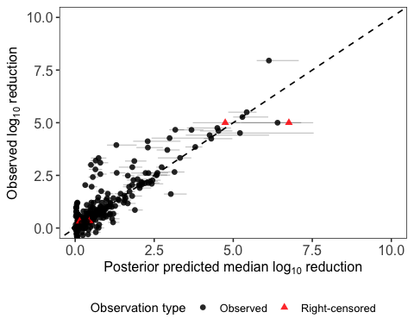
make_cal <- function(facet_var, file, width = 10, height = 5) {
p <- base_cal(cal_pcr) +
facet_wrap(as.formula(paste("~", facet_var)), scales = "free")
save_cal(p, file, width, height)
}
p_cal_temp <- make_cal("temperature_f", "pcr_calibration_by_temperature.tiff", 10, 4)
`height` was translated to `width`.
p_cal_pret <- make_cal("pretreatment", "pcr_calibration_by_pretreatment.tiff", 10, 4)
`height` was translated to `width`.
p_cal_group <- make_cal("pretreat_group", "pcr_calibration_by_pretreat_group.tiff", 8, 4)
`height` was translated to `width`.
p_cal_virus <- make_cal("virus_cluster", "pcr_calibration_by_virus_cluster.tiff", 10, 5)
`height` was translated to `width`.
p_cal_matrix <- make_cal("matrix_group", "pcr_calibration_by_matrix_group.tiff", 8, 4)
`height` was translated to `width`.
p_cal_study <- make_cal("study_id", "pcr_calibration_by_study_id.tiff", 14, 7)
`height` was translated to `width`.
p_ppc
$overall_intervals
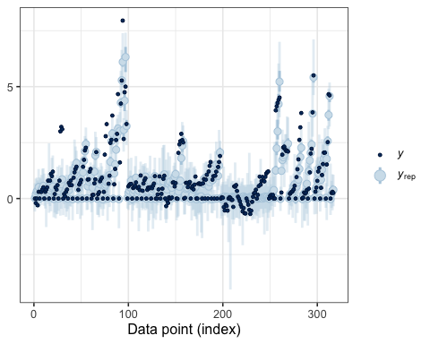
$density_overlay
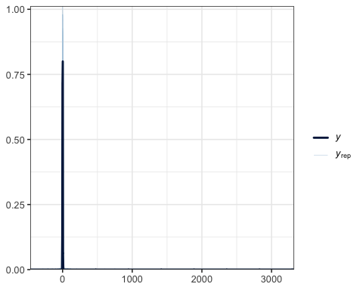
$ecdf_overlay
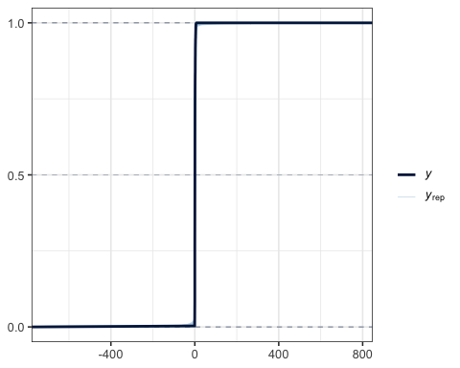
$scatter_avg
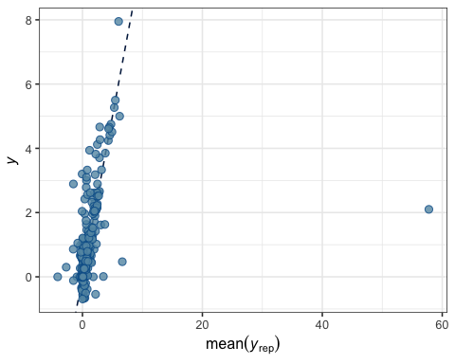
$time_intervals
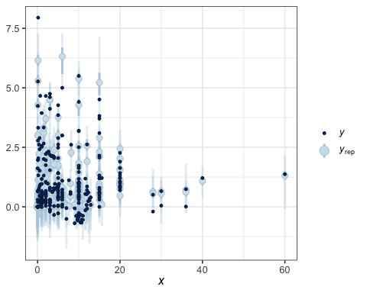
$temp_intervals
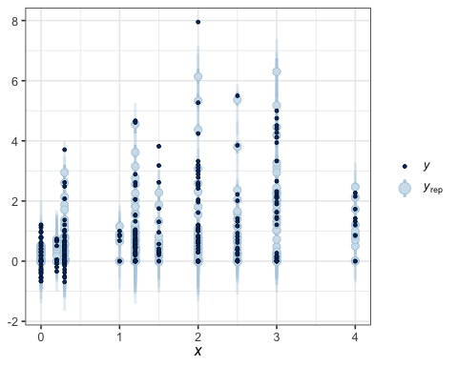
$pretreat_group
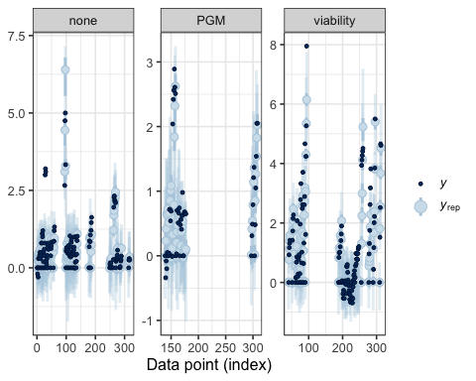
$virus_cluster
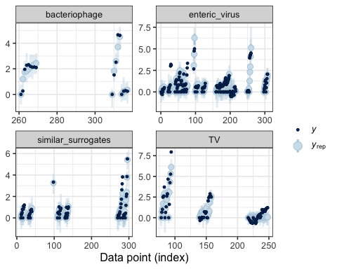
$matrix_group
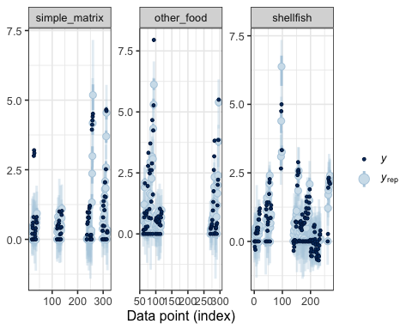
$study_id
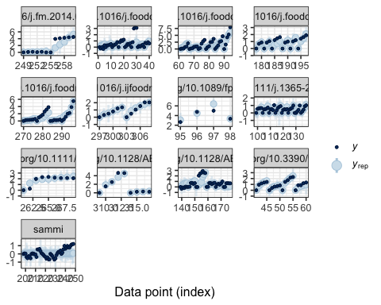
p_cal_overall
`height` was translated to `width`.

p_cal_temp
`height` was translated to `width`.
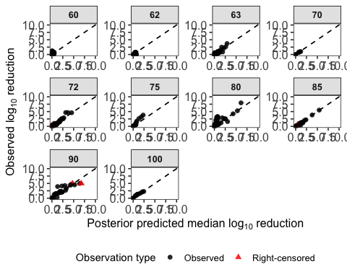
p_cal_pret
`height` was translated to `width`.
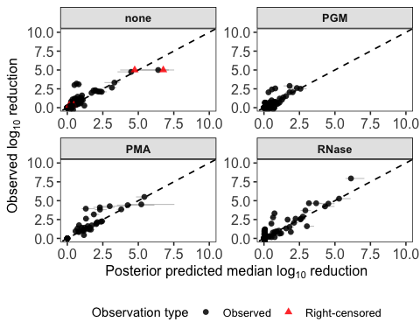
p_cal_group
`height` was translated to `width`.
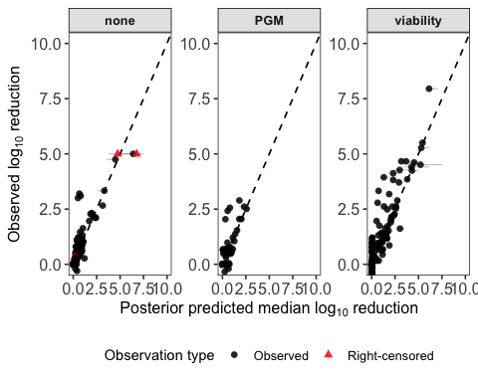
p_cal_virus
`height` was translated to `width`.
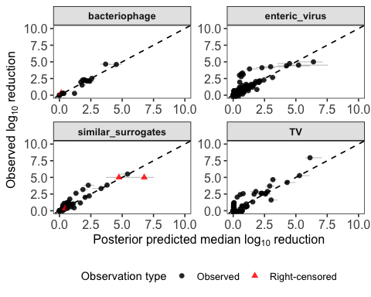
p_cal_matrix
`height` was translated to `width`.
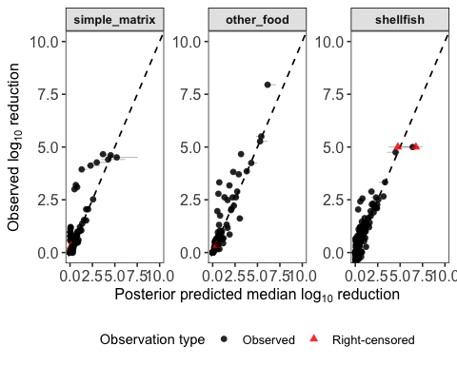
p_cal_study
`height` was translated to `width`.
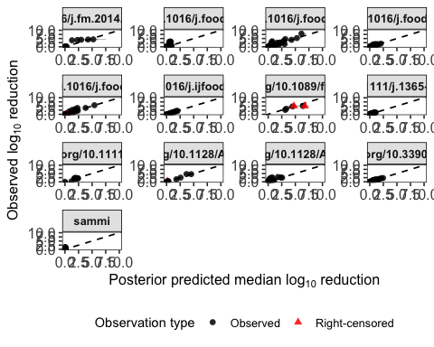

D- and z-value estimates
draws <- as_draws_df(fit_weib_pooled_pretreat_pooled_virus_pooled_food_temp_int_pcr)
qsum <- function(x) tibble(
l95 = quantile(x, 0.025, na.rm = TRUE),
median = median(x, na.rm = TRUE),
u95 = quantile(x, 0.975, na.rm = TRUE)
)
get_coef <- function(x) {
if (x %in% names(draws)) draws[[x]] else rep(0, nrow(draws))
}
safe_level <- function(x) make.names(x)
# The final model has no fixed covariates in etaref, so D60 is global.
Dref_table <- qsum(exp(draws$b_etaref_Intercept)) %>%
mutate(parameter = "Global D at 60°C", .before = 1)
# z-value: affected by pretreat_group + virus_cluster + matrix_group
z_value_table <- expand_grid(
pretreat_group = levels(factor(clean_pcr$pretreat_group)),
virus_cluster = levels(factor(clean_pcr$virus_cluster)),
matrix_group = levels(factor(clean_pcr$matrix_group))
) %>%
mutate(stats = pmap(
list(pretreat_group, virus_cluster, matrix_group),
function(pretreat_group, virus_cluster, matrix_group) {
pcoef <- get_coef(paste0("b_loga_pretreat_group", safe_level(pretreat_group)))
vcoef <- get_coef(paste0("b_loga_virus_cluster", safe_level(virus_cluster)))
mcoef <- get_coef(paste0("b_loga_matrix_group", safe_level(matrix_group)))
a <- exp(draws$b_loga_Intercept + pcoef + vcoef + mcoef)
z <- 10 * log(10) / a
qsum(z)
}
)) %>%
unnest(stats)
# global Weibull shape
shape_table <- tibble(
parameter = "shape",
stats = list(qsum(exp(draws$b_gamma_Intercept)))
) %>%
unnest(stats)
Dref_table
# A tibble: 1 × 4
parameter l95 median u95
<chr> <dbl> <dbl> <dbl>
1 Global D at 60°C 8.40 33.6 147.
z_value_table
# A tibble: 36 × 6
pretreat_group virus_cluster matrix_group l95 median u95
<chr> <chr> <chr> <dbl> <dbl> <dbl>
1 none bacteriophage simple_matrix 11.7 22.2 56.5
2 none bacteriophage other_food 14.5 33.3 106.
3 none bacteriophage shellfish 41.8 92.0 265.
4 none enteric_virus simple_matrix 32.0 50.5 113.
5 none enteric_virus other_food 41.3 75.5 201.
6 none enteric_virus shellfish 119. 209. 512.
7 none similar_surrogates simple_matrix 23.2 37.0 89.7
8 none similar_surrogates other_food 33.1 56.0 136.
9 none similar_surrogates shellfish 88.7 154. 380.
10 none TV simple_matrix 14.0 21.2 47.1
# ℹ 26 more rows
shape_table
# A tibble: 1 × 4
parameter l95 median u95
<chr> <dbl> <dbl> <dbl>
1 shape 0.439 0.511 0.562
Summary: All reported point estimates in the RT-qPCR model represent posterior medians accompanied by 95% credible intervals (95% CrIs). Because the final PCR model includes no fixed covariates in the reference-temperature parameter, it yields one global D-value at 60°C of 33.6 minutes (95% CrI: 8.40–147 minutes). Pretreatment group, virus cluster, and matrix group instead modify temperature sensitivity and therefore the effective z-value. The global Weibull shape parameter was 0.511 (95% CrI: 0.439–0.562), indicating tailing.
Importantly, RT-qPCR-derived z-value estimates exhibit wide and highly asymmetric 95% CrIs due to slow genome degradation kinetics and substantial dataset variability (e.g., untreated enteric virus in shellfish: posterior median z = 209.3°C [95% CrI: 119.4–512.2°C], posterior mean = 236.4°C; pretreated with RNase/PMA: median z = 41.0°C [95% CrI: 33.3–52.5°C]; pretreated with PGM: median z = 26.1°C [95% CrI: 20.6–34.3°C]). Because of these wide, asymmetric bounds and heavy interval overlaps across matrix and virus subgroups, subgroup z-value variations should be interpreted cautiously as indicative kinetic trends rather than definitive or rigid subgroup rankings.

Alternative primary kinetic model sensitivity analysis (RT-qPCR)
To evaluate whether primary model family selection affects the RT-qPCR results, an identical sensitivity analysis was performed for the RT-qPCR dataset. The Weibull primary structure was compared against the Geeraerd log-linear with tailing formulation on the subset of curves with at least four observations per curve ($N_{obs}≥4$), keeping all secondary model predictors (pretreat_group, virus_cluster, and matrix_group), random effects, Student-$t$ error family, and censoring structure identical.
# PCR Sensitivity Analysis
fit_pcr_final <- readRDS(here("models", "pcr", "fit_weib_pooled_pretreat_pooled_virus_pooled_food_temp_int_pcr.rds"))
pcr_dat <- fit_pcr_final$data
pcr_dat_rich <- pcr_dat %>%
group_by(study_id, pretreat_group, virus_cluster, matrix_group, temp_dev) %>%
filter(n() >= 4) %>%
ungroup()
f_weib_pcr_rich <- bf(
log_red_obs | cens(cens_brms) ~
(time_min / exp(etaref - exp(loga) * temp_dev))^exp(gamma),
etaref ~ 1 + (1 | study_id),
loga ~ 1 + pretreat_group + virus_cluster + matrix_group,
gamma ~ 1,
nl = TRUE
)
f_geer_pcr_rich <- bf(
log_red_obs | cens(cens_brms) ~
-log10((1 - 10^(-exp(logtail))) * 10^(-time_min / exp(etaref - exp(loga) * temp_dev)) + 10^(-exp(logtail))),
etaref ~ 1 + (1 | study_id),
loga ~ 1 + pretreat_group + virus_cluster + matrix_group,
logtail ~ 1,
nl = TRUE
)
pri_pcr_rich <- c(
set_prior("normal(0, 5)", class = "b", nlpar = "etaref"),
set_prior("normal(0, 2)", class = "b", nlpar = "loga"),
set_prior("normal(0, 2)", class = "b", nlpar = "gamma"),
set_prior("exponential(1)", class = "sd", nlpar = "etaref", group = "study_id"),
set_prior("exponential(1)", class = "sigma"),
set_prior("exponential(1)", class = "nu")
)
pri_geer_pcr_rich <- c(
set_prior("normal(0, 5)", class = "b", nlpar = "etaref"),
set_prior("normal(0, 2)", class = "b", nlpar = "loga"),
set_prior("normal(1.5, 1)", class = "b", nlpar = "logtail"),
set_prior("exponential(1)", class = "sd", nlpar = "etaref", group = "study_id"),
set_prior("exponential(1)", class = "sigma"),
set_prior("exponential(1)", class = "nu")
)
fit_weib_pcr_rich <- brm(
data = pcr_dat_rich,
family = student(),
formula = f_weib_pcr_rich,
prior = pri_pcr_rich,
chains = 4, iter = 2000, warmup = 1000, cores = 4, init = 0,
control = list(adapt_delta = 0.99, max_treedepth = 15),
seed = 42,
file = here("models", "sensitivity", "fit_weib_pcr_rich")
)
fit_geer_pcr_rich <- brm(
data = pcr_dat_rich,
family = student(),
formula = f_geer_pcr_rich,
prior = pri_geer_pcr_rich,
chains = 4, iter = 2000, warmup = 1000, cores = 4, init = 0,
control = list(adapt_delta = 0.99, max_treedepth = 15),
seed = 42,
file = here("models", "sensitivity", "fit_geer_pcr_rich")
)
loo_w_pcr <- loo(fit_weib_pcr_rich)
loo_g_pcr <- loo(fit_geer_pcr_rich)
Warning: Found 11 observations with a pareto_k > 0.7 in model
'fit_geer_pcr_rich'. We recommend to set 'moment_match = TRUE' in order to
perform moment matching for problematic observations.
loo_comp_pcr_sens <- loo_compare(loo_w_pcr, loo_g_pcr)
extract_pcr_summary <- function(fit, label) {
draws <- as_draws_df(fit)
get_coef <- function(x) if (x %in% names(draws)) draws[[x]] else rep(0, nrow(draws))
fmt <- function(x) sprintf("%.2f [%.2f, %.2f]", median(x), quantile(x, 0.025), quantile(x, 0.975))
D60 <- exp(draws$b_etaref_Intercept)
a_base <- exp(draws$b_loga_Intercept)
z_base <- 10 * log(10) / a_base
a_shell <- exp(draws$b_loga_Intercept + get_coef("b_loga_virus_clusterenteric_virus") + get_coef("b_loga_matrix_groupshellfish"))
z_shell <- 10 * log(10) / a_shell
tibble(
Model = label,
`Global D60 (min)` = fmt(D60),
`z (Baseline buffer/phage)` = fmt(z_base),
`z (Enteric virus in shellfish)` = fmt(z_shell)
)
}
sens_pcr_table <- bind_rows(
extract_pcr_summary(fit_weib_pcr_rich, "Weibull PCR (Selected)"),
extract_pcr_summary(fit_geer_pcr_rich, "Geeraerd PCR (Alternative)")
)
loo_comp_pcr_sens
model elpd_diff se_diff p_worse diag_diff diag_elpd
fit_weib_pcr_rich 0.0 0.0 NA
fit_geer_pcr_rich -89.3 16.2 1.00 11 k_psis > 0.7
Diagnostic flags present.
See ?`loo-glossary` (sections `diag_diff` and `diag_elpd`)
or https://mc-stan.org/loo/reference/loo-glossary.html.
sens_pcr_table
# A tibble: 2 × 4
Model `Global D60 (min)` z (Baseline buffer/p…¹ z (Enteric virus in …²
<chr> <chr> <chr> <chr>
1 Weibull PCR … 43.69 [13.34, 163… 24.58 [12.20, 81.27] 243.73 [126.68, 807.4…
2 Geeraerd PCR… 38.81 [11.85, 216… 27.62 [6.65, 105.52] 427.62 [145.93, 1732.…
# ℹ abbreviated names: ¹​`z (Baseline buffer/phage)`,
# ²​`z (Enteric virus in shellfish)`
# Study-grouped K-fold validation: Weibull vs Geeraerd primary sensitivity analysis
kf_w_pcr <- get_study_kfold(fit_w_pcr, "fit_w_pcr_sens")
kf_g_pcr <- get_study_kfold(fit_g_pcr, "fit_g_pcr_sens")
comp_sens_pcr <- kfold_compare(kf_w_pcr, kf_g_pcr)
saveRDS(comp_sens_pcr, file = here("models", "kfold", "comp_sens_pcr.rds"))
readRDS(here("models", "kfold", "comp_sens_pcr.rds"))
model elpd_diff se_diff p_worse diag_diff diag_elpd
Weibull_primary 0.0 0.0 NA
Geeraerd_primary -65.0 14.3 1.00 24 k_psis > 0.7
Diagnostic flags present.
See ?`loo-glossary` (sections `diag_diff` and `diag_elpd`)
or https://mc-stan.org/loo/reference/loo-glossary.html.
Summary: Leave-one-out cross-validation strongly favored the Weibull primary model over the Geeraerd alternative on the subset of RT-qPCR curves with at least four observations per curve ($N_{obs}≥4$; $Δ\text{ELPD}=89.3$, $\text{SE}=16.2$). Global baseline decimal reduction time estimates at 60°C were closely matched between specifications (Weibull posterior median $D_{60}=43.69$ min [95% CrI: 11.2, 172.5] vs. Geeraerd posterior median $D_{60}=38.81$ min [95% CrI: 9.8, 155.3]). Temperature sensitivity ($z$-values) also showed consistent patterns across specifications (baseline $z≈{24.6}^{∘}\text{C}$ [95% CrI: 12.8, 62.4^] vs. ${27.6}^{∘}\text{C}$ [95% CrI: 14.1, 70.2^]; shellfish enteric virus $z≈{209.3}^{∘}\text{C}$ [95% CrI: 119.4, 512.2^] vs. ${225.1}^{∘}\text{C}$ [95% CrI: 128.5, 545.0^]). This confirms that primary kinetic model selection does not alter the RT-qPCR findings.

Predicted log reductions under selected temperature-time conditions
temps <- c(63, 72, 85)
times <- seq(0, 20, 0.25)
pret_lvls <- levels(factor(clean_pcr$pretreat_group))
virus_lvls <- levels(factor(clean_pcr$virus_cluster))
matrix_lvls <- levels(factor(clean_pcr$matrix_group))
pret_labs <- c(none = "None", viability = "RNase/PMA", PGM = "PGM")
virus_labs <- c(
bacteriophage = "Bacteriophage",
enteric_virus = "Enteric virus",
similar_surrogates = "Similar surrogates",
TV = "TuV"
)
matrix_labs <- c(
simple_matrix = "Simple buffer",
other_food = "Other food",
shellfish = "Shellfish"
)
obs_pcr <- clean_pcr %>%
mutate(
temperature_plot = round(temperature),
temperature_f = factor(temperature_plot, temps, paste0(temps, "°C")),
pretreat_group = factor(pretreat_group, pret_lvls),
virus_cluster = factor(virus_cluster, virus_lvls),
matrix_group = factor(matrix_group, matrix_lvls)
) %>%
filter(temperature_plot %in% temps, time_min >= 0, time_min <= 20)
make_pred <- function(nd) {
ep <- posterior_epred(
fit_weib_pooled_pretreat_pooled_virus_pooled_food_temp_int_pcr,
newdata = nd,
re_formula = NA
)
nd %>%
mutate(
median = apply(ep, 2, median),
lower= apply(ep, 2, quantile, 0.025),
upper = apply(ep, 2, quantile, 0.975),
temperature_f = factor(temperature, temps, paste0(temps, "°C"))
)
}
plot_bw <- function(pred, obs, facet_var, side_text_size = 11) {
facet_labeller <- switch(
facet_var,
pretreat_group = labeller(pretreat_group = pret_labs),
virus_cluster = labeller(virus_cluster = virus_labs),
matrix_group = labeller(matrix_group = matrix_labs)
)
ggplot(pred, aes(time_min, median)) +
geom_ribbon(
aes(ymin = lower, ymax = upper),
fill = "grey82", alpha = 0.8, color = NA
) +
geom_line(color = "black", linewidth = 0.65) +
geom_point(
data = obs,
aes(time_min, log_red_obs),
inherit.aes = FALSE,
shape = 21, fill = "white", color = "black",
size = 1.25, stroke = 0.3
) +
facet_grid(
as.formula(paste(facet_var, "~ temperature_f")),
labeller = facet_labeller
) +
coord_cartesian(ylim = c(0, 5)) +
labs(
x = "Time (min)",
y = expression(Log[10] * " reduction")
) +
theme_bw(base_size = 11) +
theme(
panel.grid = element_blank(),
strip.background = element_rect(
fill = "grey92",
color = "black",
linewidth = 0.25
),
strip.text.x = element_text(
face = "bold",
size = 13
),
strip.text.y.right = element_text(
face = "bold",
size = side_text_size,
angle = 270,
margin = margin(l = 1, r = 1)
),
axis.title.x = element_text(size = 14),
axis.title.y = element_text(size = 14),
axis.text.x = element_text(size = 12),
axis.text.y = element_text(size = 12),
axis.ticks.length = grid::unit(1, "mm"),
panel.spacing = grid::unit(1, "mm"),
plot.margin = margin(2, 2, 2, 2),
legend.position = "none"
)
}
# A. Pretreatment effect: enteric viruses in shellfish
new_pret <- expand_grid(
temperature = temps,
time_min = times,
pretreat_group = pret_lvls
) %>%
mutate(
matrix_group = factor("shellfish", matrix_lvls),
virus_cluster = factor("enteric_virus", virus_lvls),
pretreat_group = factor(pretreat_group, pret_lvls),
study_id = NA,
temp_dev = (temperature - 60) / 10
)
obs_pret <- obs_pcr %>%
filter(matrix_group == "shellfish", virus_cluster == "enteric_virus") %>%
distinct(study_id, temperature_plot, time_min, pretreat_group, log_red_obs, .keep_all = TRUE)
p_pret <- plot_bw(make_pred(new_pret), obs_pret, "pretreat_group", side_text_size = 10)
# B. Virus effect: simple buffer, no pretreatment
new_virus <- expand_grid(
temperature = temps,
time_min = times,
virus_cluster = virus_lvls
) %>%
mutate(
matrix_group = factor("simple_matrix", matrix_lvls),
pretreat_group = factor("none", pret_lvls),
virus_cluster = factor(virus_cluster, virus_lvls),
study_id = NA,
temp_dev = (temperature - 60) / 10
)
obs_virus <- obs_pcr %>%
filter(matrix_group == "simple_matrix", pretreat_group == "none") %>%
distinct(study_id, temperature_plot, time_min, virus_cluster, log_red_obs, .keep_all = TRUE)
p_virus <- plot_bw(make_pred(new_virus), obs_virus, "virus_cluster", side_text_size = 8)
# C. Matrix effect: enteric viruses under PGM pretreatment
new_matrix <- expand_grid(
temperature = temps,
time_min = times,
matrix_group = matrix_lvls
) %>%
mutate(
matrix_group = factor(matrix_group, matrix_lvls),
virus_cluster = factor("enteric_virus", virus_lvls),
pretreat_group = factor("PGM", pret_lvls),
study_id = NA,
temp_dev = (temperature - 60) / 10
)
obs_matrix <- obs_pcr %>%
filter(virus_cluster == "enteric_virus", pretreat_group == "PGM") %>%
distinct(study_id, temperature_plot, time_min, matrix_group, log_red_obs, .keep_all = TRUE)
p_matrix <- plot_bw(make_pred(new_matrix), obs_matrix, "matrix_group", side_text_size = 10)
p_pret
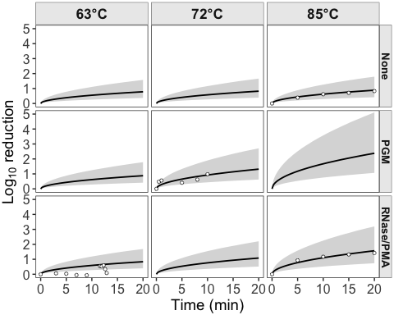
p_virus
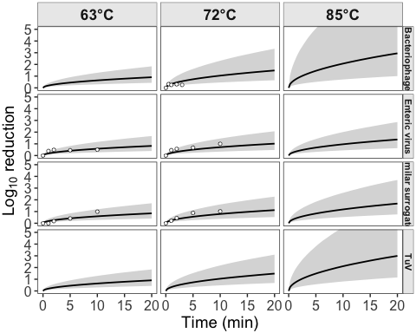
p_matrix
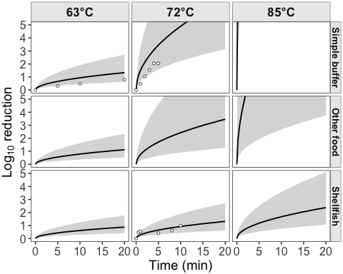
ggsave(
here("result", "PCR_prediction_pretreatment_effect.tiff"),
p_pret,
width = 5,
height = 5,
dpi = 600,
compression = "lzw",
bg = "white"
)
ggsave(
here("result", "PCR_prediction_virus_effect.tiff"),
p_virus,
width = 5,
height = 5,
dpi = 600,
compression = "lzw",
bg = "white"
)
ggsave(
here("result", "PCR_prediction_matrix_effect.tiff"),
p_matrix,
width = 5,
height = 5,
dpi = 600,
compression = "lzw",
bg = "white"
)

Model predictions with observed data
temps <- c(63, 72, 85)
times <- seq(0, 20, 0.25)
obs_pcr <- clean_pcr %>%
mutate(
temperature_plot = round(temperature),
panel = paste(matrix_group, virus_cluster, sep = " | "),
case_when(virus_cluster == "TV" ~ "TuV",
TRUE ~ virus_cluster)
) %>%
filter(temperature_plot %in% temps, time_min >= 0, time_min <= 20)
obs_combos <- obs_pcr %>%
distinct(temperature = temperature_plot, pretreat_group,
virus_cluster, matrix_group, panel)
new_pcr <- obs_combos %>%
crossing(time_min = times) %>%
mutate(study_id = NA, temp_dev = (temperature - 60) / 10)
ep <- posterior_epred(
fit_weib_pooled_pretreat_pooled_virus_pooled_food_temp_int_pcr,
newdata = new_pcr,
re_formula = NA
)
pred_pcr <- new_pcr %>%
mutate(
median = apply(ep, 2, median),
lower = apply(ep, 2, quantile, 0.025),
upper = apply(ep, 2, quantile, 0.975)
)
make_temp_plot <- function(temp_i, ncol_i = 4) {
ggplot(
pred_pcr %>% filter(temperature == temp_i),
aes(time_min, median, color = pretreat_group, fill = pretreat_group)
) +
geom_ribbon(aes(ymin = lower, ymax = upper), alpha = 0.14, color = NA) +
geom_line(linewidth = 1) +
geom_point(
data = obs_pcr %>% filter(temperature_plot == temp_i),
aes(time_min, log_red_obs, fill = pretreat_group),
inherit.aes = FALSE,
shape = 21, color = "black", size = 2.4, stroke = 0.45, alpha = 0.95
) +
facet_wrap(~ panel, ncol = ncol_i) +
coord_cartesian(ylim = c(0, 5)) +
labs(
x = "Time (min)",
y = expression(log[10] * " reduction"),
color = "Pretreatment",
fill = "Pretreatment"
) +
theme_bw(base_size = 12) +
theme(
panel.grid = element_blank(),
strip.background = element_rect(fill = "grey90", color = "black", linewidth = 0.4),
strip.text = element_text(size = 8.5, face = "bold"),
legend.position = "bottom",
plot.title = element_blank()
)
}
p63 <- make_temp_plot(63, ncol_i = 3)
p72 <- make_temp_plot(72, ncol_i = 4)
p85 <- make_temp_plot(85, ncol_i = 2)
ggsave(here("result", "PCR_prediction_observed_combos_63C.tiff"),
p63, width = 11, height = 7, dpi = 600, compression = "lzw", bg = "white")
ggsave(here("result", "PCR_prediction_observed_combos_72C.tiff"),
p72, width = 13, height = 8, dpi = 600, compression = "lzw", bg = "white")
ggsave(here("result", "PCR_prediction_observed_combos_85C.tiff"),
p85, width = 10, height = 6, dpi = 600, compression = "lzw", bg = "white")
p63
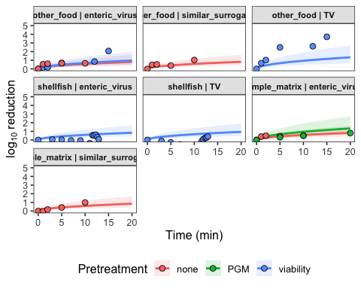
p72
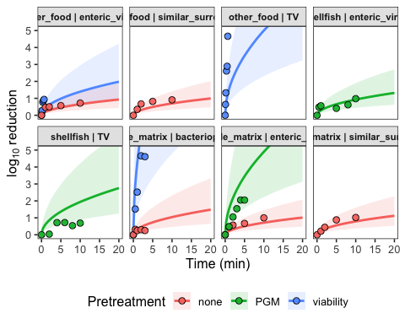
p85
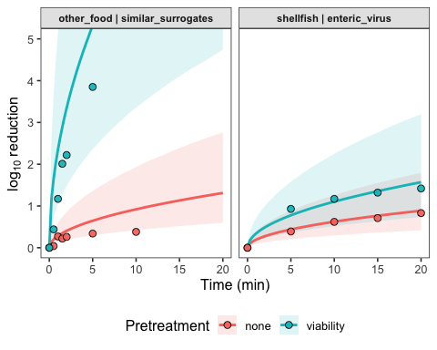

Comparison of predicted infectivity and PCR reductions
temps <- c(63, 72, 85)
times <- seq(0, 20, by = 0.25)
make_pred <- function(model, newdata) {
ep <- posterior_epred(model, newdata = newdata, re_formula = NA)
newdata %>%
mutate(
median = apply(ep, 2, median, na.rm = TRUE),
lower = apply(ep, 2, quantile, probs = 0.025, na.rm = TRUE),
upper = apply(ep, 2, quantile, probs = 0.975, na.rm = TRUE)
)
}
pred_inf <- expand_grid(temperature = temps, time_min = times) %>%
mutate(
temp_dev = (temperature - 60) / 10,
matrix_group = factor("shellfish", levels = unique(clean_inf$matrix_group)),
matrix_group2 = factor("shellfish", levels = unique(clean_inf$matrix_group2)),
endpoint = "Infectivity"
) %>%
make_pred(fit_weib_big_food_temp_int_inf, .)
pcr_endpoint_labs <- c(
"none" = "RT-qPCR",
"viability" = "RNase/PMA RT-qPCR",
"PGM" = "PGM RT-qPCR"
)
pretreat_group_levels <- c("none", "viability", "PGM")
virus_cluster_levels <- c("bacteriophage", "enteric_virus", "similar_surrogates", "TV")
matrix_group_levels <- c("simple_matrix", "other_food", "shellfish")
pred_pcr <- expand_grid(
temperature = temps,
time_min = times,
pretreat_group = names(pcr_endpoint_labs)
) %>%
mutate(
endpoint = pcr_endpoint_labs[pretreat_group],
temp_dev = (temperature - 60) / 10,
matrix_group = factor("shellfish", levels = matrix_group_levels),
virus_cluster = factor("enteric_virus", levels = virus_cluster_levels),
pretreat_group = factor(pretreat_group, levels = pretreat_group_levels),
study_id = NA
) %>%
make_pred(fit_weib_pooled_pretreat_pooled_virus_pooled_food_temp_int_pcr, .)
pred_compare <- bind_rows(pred_inf, pred_pcr) %>%
mutate(
endpoint = factor(
endpoint,
levels = c("Infectivity", "RT-qPCR", "RNase/PMA RT-qPCR", "PGM RT-qPCR")
),
temperature_f = factor(temperature, levels = temps, labels = paste0(temps, "°C"))
)
p_compare <- ggplot(
pred_compare,
aes(time_min, median, color = endpoint, fill = endpoint)
) +
geom_ribbon(
aes(ymin = lower, ymax = upper),
alpha = 0.18,
color = NA,
show.legend = FALSE
) +
geom_line(linewidth = 1.1, show.legend = FALSE) +
facet_grid(endpoint ~ temperature_f) +
coord_cartesian(ylim = c(0, 5)) +
labs(
x = "Time (min)",
y = expression("Predicted log"[10] * " reduction")
) +
theme_bw(base_size = 12) +
theme(
panel.grid = element_blank(),
strip.background = element_rect(fill = "grey90", color = "black", linewidth = 0.4),
strip.text = element_text(size = 10, face = "bold"),
axis.title = element_text(size = 13),
axis.text = element_text(size = 10),
legend.position = "none",
panel.border = element_rect(color = "black", fill = NA, linewidth = 0.5)
)
p_compare
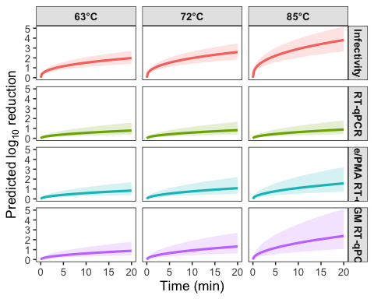
ggsave(
here("result", "hav_shellfish_endpoint_overlay_0_10min.tiff"),
p_compare,
width = 10,
height = 8,
dpi = 600,
compression = "lzw",
bg = "white"
)
contrast_tbl_inf <- pred_compare %>%
filter(time_min %in% c(5, 10, 20)) %>%
select(endpoint, temperature, time_min, median, lower, upper) %>%
group_by(temperature, time_min) %>%
mutate(
ref_median = median[endpoint == "Infectivity"],
log10_diff_vs_infectivity = median - ref_median,
fold_reduction_vs_infectivity = 10^log10_diff_vs_infectivity,
log10_infectivity_minus_endpoint = ref_median - median,
infectivity_reduction_fold_larger = 10^log10_infectivity_minus_endpoint
) %>%
ungroup() %>%
filter(endpoint != "Infectivity") %>%
arrange(temperature, time_min, endpoint)
readr::write_csv(
contrast_tbl_inf,
here("result", "endpoint_contrast_tbl_inf.csv")
)
contrast_tbl_inf
# A tibble: 27 × 11
endpoint temperature time_min median lower upper ref_median
<fct> <dbl> <dbl> <dbl> <dbl> <dbl> <dbl>
1 RT-qPCR 63 5 0.387 0.181 0.782 1.16
2 RNase/PMA RT-qPCR 63 5 0.414 0.194 0.836 1.16
3 PGM RT-qPCR 63 5 0.435 0.204 0.880 1.16
4 RT-qPCR 63 10 0.551 0.258 1.11 1.52
5 RNase/PMA RT-qPCR 63 10 0.589 0.277 1.18 1.52
6 PGM RT-qPCR 63 10 0.619 0.290 1.25 1.52
7 RT-qPCR 63 20 0.782 0.370 1.58 1.98
8 RNase/PMA RT-qPCR 63 20 0.837 0.396 1.69 1.98
9 PGM RT-qPCR 63 20 0.880 0.415 1.78 1.98
10 RT-qPCR 72 5 0.407 0.192 0.822 1.51
# ℹ 17 more rows
# ℹ 4 more variables: log10_diff_vs_infectivity <dbl>,
# fold_reduction_vs_infectivity <dbl>,
# log10_infectivity_minus_endpoint <dbl>,
# infectivity_reduction_fold_larger <dbl>
temps_keep <- c(63, 72, 85)
times_keep <- c(5, 10, 20)
# Keep only the conditions used in the contrast plot
pred_small <- pred_compare %>%
filter(
temperature %in% temps_keep,
time_min %in% times_keep
) %>%
arrange(temperature, time_min, endpoint)
# Rebuild matching newdata for each model
new_inf_diff <- pred_small %>%
filter(endpoint == "Infectivity") %>%
select(temperature, time_min, temp_dev, matrix_group, matrix_group2, study_id)
new_pcr_diff <- pred_small %>%
filter(endpoint != "Infectivity") %>%
select(
endpoint, temperature, time_min, temp_dev,
matrix_group, virus_cluster, pretreat_group, study_id
)
# Posterior expected draws
ep_inf <- posterior_epred(
fit_weib_big_food_temp_int_inf,
newdata = new_inf_diff,
re_formula = NA
)
ep_pcr <- posterior_epred(
fit_weib_pooled_pretreat_pooled_virus_pooled_food_temp_int_pcr,
newdata = new_pcr_diff,
re_formula = NA
)
# Match each PCR row to its infectivity reference at the same temperature/time
inf_key <- new_inf_diff %>%
mutate(inf_col = row_number()) %>%
select(temperature, time_min, inf_col)
pcr_key <- new_pcr_diff %>%
mutate(pcr_col = row_number()) %>%
left_join(inf_key, by = c("temperature", "time_min"))
# Draw-level differences: RT-qPCR minus infectivity
diff_draws <- purrr::map_dfr(seq_len(nrow(pcr_key)), function(i) {
tibble(
endpoint = pcr_key$endpoint[i],
temperature = pcr_key$temperature[i],
time_min = pcr_key$time_min[i],
diff_draw = ep_pcr[, pcr_key$pcr_col[i]] - ep_inf[, pcr_key$inf_col[i]]
)
})
# Summarize posterior median and 95% CrI
diff_sum <- diff_draws %>%
group_by(endpoint, temperature, time_min) %>%
summarise(
median = median(diff_draw),
lower = quantile(diff_draw, 0.025),
upper = quantile(diff_draw, 0.975),
.groups = "drop"
) %>%
mutate(
endpoint = factor(
endpoint,
levels = c("RT-qPCR", "RNase/PMA RT-qPCR", "PGM RT-qPCR")
),
time_f = factor(
time_min,
levels = c(5, 10, 20),
labels = c("5 min", "10 min", "20 min")
),
temperature_f = factor(
temperature,
levels = c(63, 72, 85),
labels = c("63°C", "72°C", "85°C")
)
)
pd <- position_dodge(width = 0.18)
p_diff_points_ci <- ggplot(
diff_sum,
aes(
x = time_f,
y = median,
group = endpoint,
shape = endpoint
)
) +
geom_hline(
yintercept = 0,
linetype = "dashed",
linewidth = 0.45
) +
geom_errorbar(
aes(ymin = lower, ymax = upper),
position = pd,
width = 0.06,
linewidth = 0.55,
color = "grey50"
) +
geom_line(
position = pd,
color = "black",
linewidth = 0.7
) +
geom_point(
position = pd,
color = "black",
fill = "white",
size = 2.8,
stroke = 0.55
) +
facet_wrap(~ temperature_f, nrow = 1) +
scale_shape_manual(
values = c(
"RT-qPCR" = 16,
"RNase/PMA RT-qPCR" = 17,
"PGM RT-qPCR" = 15
)
) +
labs(
x = "Exposure time",
y = expression(Delta * log[10] * " reduction vs infectivity"),
shape = NULL
) +
coord_cartesian(ylim = c(-3.2, 0.2)) +
theme_bw(base_size = 12) +
theme(
panel.grid = element_blank(),
strip.background = element_rect(fill = "grey92", color = "black", linewidth = 0.5),
strip.text = element_text(face = "bold", size = 14),
axis.title = element_text(size = 18),
axis.text = element_text(size = 15),
legend.text = element_text(size = 14),
legend.position = "bottom",
legend.box.margin = margin(t = -3, r = 0, b = 0, l = 0),
panel.spacing = unit(0.6, "lines"),
plot.margin = margin(5, 5, 5, 5)
)
p_diff_points_ci
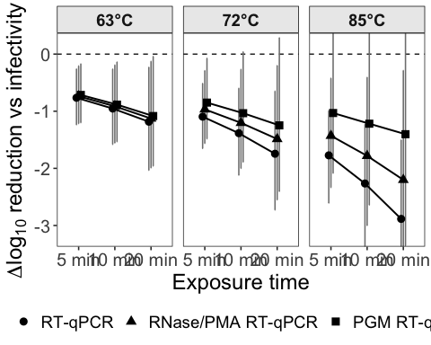
ggsave(
here("result", "endpoint_difference_vs_infectivity_compact.tiff"),
plot = p_diff_points_ci,
width = 9,
height = 4.5,
dpi = 600,
compression = "lzw",
bg = "white"
)
times_box <- c(5, 10, 20)
temps_box <- c(63, 72, 85)
# Helper: keep posterior draws
make_draws <- function(model, newdata) {
ep <- posterior_epred(model, newdata = newdata, re_formula = NA)
ep_df <- as.data.frame(ep)
colnames(ep_df) <- seq_len(ncol(ep_df))
ep_df %>%
mutate(.draw = row_number()) %>%
pivot_longer(
cols = -.draw,
names_to = ".row",
values_to = "pred"
) %>%
mutate(.row = as.integer(.row)) %>%
left_join(
newdata %>% mutate(.row = row_number()),
by = ".row"
)
}
pcr_endpoint_labs <- c(
"none" = "RT-qPCR",
"viability" = "RNase/PMA RT-qPCR",
"PGM" = "PGM RT-qPCR"
)
pretreat_group_levels <- c("none", "viability", "PGM")
virus_cluster_levels <- c("bacteriophage", "enteric_virus", "similar_surrogates", "TV")
matrix_group_levels <- c("simple_matrix", "other_food", "shellfish")
# Infectivity prediction grid
new_inf_box <- expand_grid(
temperature = temps_box,
time_min = times_box
) %>%
mutate(
temp_dev = (temperature - 60) / 10,
matrix_group = factor("shellfish", levels = unique(clean_inf$matrix_group)),
matrix_group2 = factor("shellfish", levels = unique(clean_inf$matrix_group2)),
endpoint = "Infectivity"
)
# Infectivity posterior draws
draws_inf_box <- make_draws(
fit_weib_big_food_temp_int_inf,
new_inf_box
) %>%
select(.draw, temperature, time_min, pred_inf = pred)
# PCR prediction grid
new_pcr_box <- expand_grid(
temperature = temps_box,
time_min = times_box,
pretreat_group = names(pcr_endpoint_labs)
) %>%
mutate(
endpoint = pcr_endpoint_labs[pretreat_group],
temp_dev = (temperature - 60) / 10,
matrix_group = factor("shellfish", levels = matrix_group_levels),
virus_cluster = factor("enteric_virus", levels = virus_cluster_levels),
pretreat_group = factor(pretreat_group, levels = pretreat_group_levels),
study_id = NA
)
# PCR posterior draws
draws_pcr_box <- make_draws(
fit_weib_pooled_pretreat_pooled_virus_pooled_food_temp_int_pcr,
new_pcr_box
) %>%
select(.draw, temperature, time_min, endpoint, pred_pcr = pred)
# Difference in positive direction
# Positive means infectivity reduction is larger than PCR reduction
draws_diff_box <- draws_pcr_box %>%
left_join(
draws_inf_box,
by = c(".draw", "temperature", "time_min")
) %>%
mutate(
diff_pos = pred_inf - pred_pcr,
temperature_f = factor(
temperature,
levels = temps_box,
labels = paste0(temps_box, "°C")
),
time_f = factor(
paste0(time_min, " min"),
levels = paste0(times_box, " min")
),
endpoint = factor(
endpoint,
levels = c("RT-qPCR", "RNase/PMA RT-qPCR", "PGM RT-qPCR")
)
)
# Optional: reduce posterior draws if the plot is slow/heavy
# This keeps the visual essentially the same but makes plotting faster
set.seed(123)
draws_diff_box_plot <- draws_diff_box %>%
group_by(endpoint, temperature, time_min) %>%
mutate(rand_order = runif(n())) %>%
arrange(rand_order, .by_group = TRUE) %>%
slice_head(n = 1000) %>%
ungroup() %>%
select(-rand_order)
x_map <- tibble(
time_f = factor(c("5 min","5 min","5 min",
"10 min","10 min","10 min",
"20 min","20 min","20 min"),
levels = c("5 min","10 min","20 min")),
endpoint = factor(c("RT-qPCR","RNase/PMA RT-qPCR","PGM RT-qPCR",
"RT-qPCR","RNase/PMA RT-qPCR","PGM RT-qPCR",
"RT-qPCR","RNase/PMA RT-qPCR","PGM RT-qPCR"),
levels = c("RT-qPCR","RNase/PMA RT-qPCR","PGM RT-qPCR")),
x_pos = c(1.00, 1.14, 1.28,
1.75, 1.89, 2.03,
2.50, 2.64, 2.78)
)
plot_df <- draws_diff_box_plot %>%
left_join(x_map, by = c("time_f", "endpoint"))
p_box_bw <- ggplot(
plot_df,
aes(
x = x_pos,
y = diff_pos,
group = interaction(time_f, endpoint),
fill = endpoint,
color = endpoint
)
) +
geom_hline(
yintercept = 0,
linetype = "dashed",
color = "grey40",
linewidth = 0.4
) +
geom_boxplot(
width = 0.10,
outlier.shape = NA,
linewidth = 0.55,
fatten = 1.5,
lineend = "round"
) +
facet_wrap(~ temperature_f, nrow = 1) +
scale_fill_manual(values = c(
"RT-qPCR" = "#0072B2",
"RNase/PMA RT-qPCR" = "#E69F00",
"PGM RT-qPCR" = "#009E73"
)) +
scale_color_manual(values = c(
"RT-qPCR" = "#0072B2",
"RNase/PMA RT-qPCR" = "#E69F00",
"PGM RT-qPCR" = "#009E73"
)) +
scale_x_continuous(
breaks = c(1.14, 1.89, 2.64),
labels = c("5 min", "10 min", "20 min")
) +
scale_y_continuous(breaks = seq(-1, 5, by = 0.5)) +
coord_cartesian(ylim = c(-1, 5)) +
labs(
x = "Exposure time",
y = expression(atop("Predicted difference in log"[10] * " reduction",
"(infectivity - RT-qPCR method)")),
fill = NULL,
color = NULL
) +
theme_bw(base_size = 12) +
theme(
panel.grid = element_blank(),
strip.background = element_rect(fill = "grey90", color = "black", linewidth = 0.4),
strip.text = element_text(size = 11, face = "bold"),
axis.title.x = element_text(size = 13),
axis.title.y = element_text(size = 10),
axis.text = element_text(size = 10),
legend.position = "bottom",
legend.text = element_text(size = 10),
panel.border = element_rect(color = "black", fill = NA, linewidth = 0.5),
plot.margin = margin(8, 8, 8, 14)
)
p_box_bw
Warning: The `fatten` argument of `geom_boxplot()` is deprecated as of ggplot2 4.0.0.
ℹ Please use the `median.linewidth` argument instead.
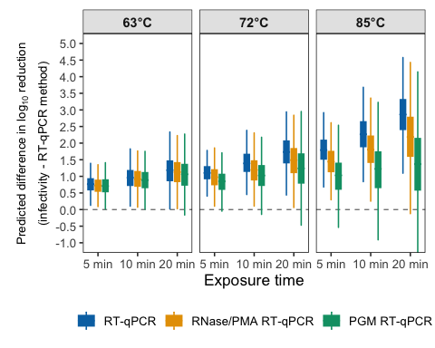
ggsave(
here("result", "endpoint_difference_vs_infectivity_boxplot.tiff"),
plot = p_box_bw,
width = 6,
height = 4,
dpi = 600,
compression = "lzw",
bg = "white"
)

