F14076083 魏湧致

1.22

(a) sample mean = (6.72+6.77+6.82+6.70+6.78+6.70+6.62+6.75+6.66+6.66+6.64+

6.76+6.73+6.80+6.72+6.76+6.76+6.68+6.66+6.62+6.72+6.76+6.70+6.78+6.76+

6.67+6.70+6.72+6.74+6.81+6.79+6.78+6.66+6.76+6.76+6.72)÷36 = 6.7261

sample standard deviation = ${(\sum_{i=1}^{36}{\frac{{(x_{i}-6.7261)}^{2}}{35}})}^{\frac{1}{2}}$ = 0.0528

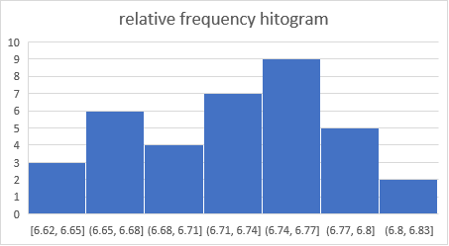(b)

(c) 由長條圖可看出資料是左偏的。

2.8

(a) A = { (3, 6), (4, 5), (4, 6), (5, 4), (5, 5), (5, 6), (6, 3), (6, 4), (6, 5), (6, 6) }

(b) B = { (1, 2), (2, 2), (3, 2), (4, 2), (5, 2), (6, 2) , (2, 1) , (2, 3), (2, 4),(2, 5), (2, 6) }

(c) C = { (5, 1), (5, 2), (5, 3), (5, 4), (5, 5), (5, 6), (6, 1), (6, 2), (6, 3), (6, 4), (6, 5),

(6, 6) }

(d) A ∩ C = { (5, 4), (5, 5), (5, 6), (6, 3), (6, 4), (6, 5), (6, 6) }

(e) A ∩ B = ϕ

(f) B ∩ C ={ (5, 2), (6, 2) }

(g)

B

B∩C

A∩C

C

A

2.20

(a) 6 (在V中而不在M和T中)

(b) 2 (在M和V中而不在T中)

(c) 2 (有M和V沒有T); 5 (有M沒有V和T); 6 (有V沒有M和T)

(d) 4 (有M和T沒有V); 5 (有M沒有T和V); 7 (有T沒有M和V); 8 (沒有 M,V,T)

2.38

(a) 6! = 720

(b) 3! × $2^{3}$ = 48

(c) 3! × 3! = 36

1.25

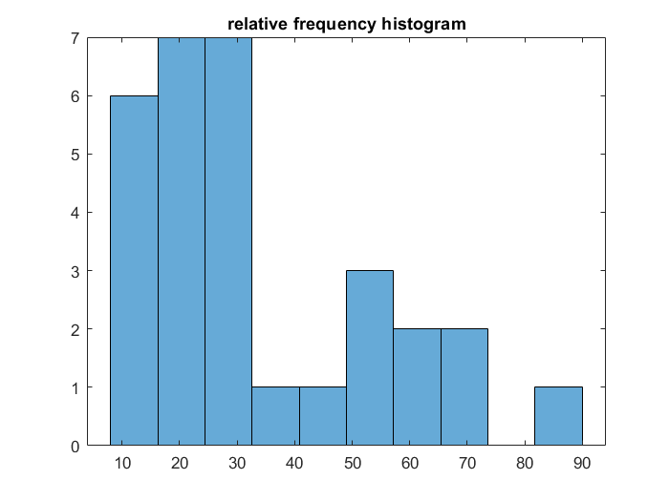由此圖可以看出這組資料是右偏的，資料大部分分布在長條圖左邊，而(d)小題算出的10% trimmed mean落在(a)算出的sample mean與(b)算出的sample median中間也能推論出資料右偏，與圖形符合。