Alien Blaster

Game Design Document

George Nikolai Kotula

# Concept

The game is a top-down, 3D space shooter similar in feel to such arcade games as Galaga. The player will assume control of the ship, and the goal is to clear all the waves of enemy aliens. Elements of fun include the ability to customize the ship in a shop format where the player can spend money gathered from enemy kills to upgrade their ship. Ship upgrades will come in different forms to allow many different styles of gameplay. The player could upgrade their offense, defense, or exotic abilities.

# Gameplay

## Elements of Fun

* Score is determined by number of enemies killed.
  + Tougher enemies are worth more points and money to spend on upgrades.
* Ship upgrade tech trees allow for many different play styles.
* Dodging enemies’ attacks while hitting as many enemies as possible is the high skill cap, low skill floor mechanic of the game.
* After the player wins the game, they can go into “deep space” mode.
  + Deep space mode is where the player takes their current ship and fights against endless levels of additional enemies to get a higher score.
  + There will not be any upgrade stations between levels, but the enemies will get progressively harder until the player dies.
  + This allows for replayability since the more upgraded the ship is by the end of the game, the higher score they can get.

## Perspective

* The game itself is 3D.
* Top-down only view.
* Movement restricted to a plane.
* Top of screen is the facing direction of the player.

## Controls

* Both WASD and arrow keys move the player ship in the plane.
* Spacebar is shoot.
* ESC is the pause menu.
* Shift: Activate Super

## Combat

* Unlike Galaga, the player ship will have health. This means the ship can be hit multiple times before dying.
* Stronger enemies will deal more damage and have more health.
* Holding down the fire key will shoot slowly, but automatically.
* The fire key will shoot as quickly as the player can press it if they’re not holding it down.
* Each enemy kill will charge the player’s super slightly.

## Enemies

* Enemies will be aliens. This means creepy-looking creatures, not ships.
  + Concept art TBD
* All enemy movement, attacks, and behaviors will be “scripted.”
  + Scripted, in this sense, means that it is entirely repeatable.
  + E.G. Every single shot from every enemy will be in the exact same place at a given time in the level.
  + E.G. If there is an opening in the shots that the ship can slip through, that opening will be present in every playthrough of the level.
* Enemies will fire their weapons in predictable patterns that will vary between enemy types.
  + Modes of firing:
    - Spirals of shots.
    - Circles of shots (all shots start from enemy and move radially outward).
    - No shots; the enemies are just there for the player to dodge.
    - Charge shots only in up/down direction.
      * Big AOE and damage, but has visual and audio indicators for when about to fire.
  + All modes of firing can be tweaked to get other desired effects.
    - E.G. A very slow-turning spiral looks like the enemy is looking at player and firing.
* Enemy movement is also predictable in patterns that vary between enemy types.
  + Patterns include (assume enemies can be firing at any point during these patterns):
    - Fly in and fly out without stopping.
      * Both curved and straight paths should be allowed.
    - Fly in, stop, then fly out.
    - Moving in a circle pattern.
    - Figure eight pattern.
    - Bouncing back and forth (side-to-side motion).
      * Both sinusoidal and “bouncing off invisible walls.”
  + Patterns can and should be superimposed on each other to create complicated movement.
    - E.G. simply having enemies move in a circle is not enough. They should move in a circle pattern, but that circle pattern should also move across the screen.
  + Movement specific to the types of enemies should be up to the level designers to implement and balance.
* Bosses
  + Each boss will have unique behavior that is custom scripted.
    - The behaviors will have exposed tweakable parameters that allow designers to balance the gameplay while not having to know any code.
  + Individual boss mechanics TBD

## Ship Upgrades

* Between each level there will be a chance to spend money on upgrading the player ship.
* There will be different “tech trees” that the player can upgrade.
  + Defense
  + Offense
  + Exotic
* Each step in the tech tree gives progressively better stats according to the theme of the tree.
* Each upgrade will visually upgrade the ship model.
  + I.E. spread-fire weapons give additional cannon models off to the sides of the ship model.

### Defense

* Armor
  + Player can choose to add additional armor to their ship (effectively increasing their total health, but I’m not going to call it ‘health’ since that’s lazy).
  + Each tier will cost more than the previous thus making it difficult to max out health without a significant investment.
* Shields
  + Shields recharge over time, but they don’t provide nearly as much protection as increasing armor.
  + Tiers alternate between faster recharge times and more shields.

### Offense

* Spread-fire lasers
  + Each tier adds another set of lasers that fire from the sides.
  + This allows the player to not necessarily be lined up with their targets to shoot them.
* Primary lasers
  + Each tier makes the forward-facing lasers more powerful.
  + Bigger colliders make the lasers also feel more powerful.

### Exotic

* Time Slow
  + When activated, all enemy entities (shots, positions, etc.) will slow down dramatically.
  + Tiers alternate between slowing for longer and decreasing the speed more.
* Invincibility
  + When activated, the player “phases rapidly in and out of existence” (becomes invincible) for a short time.
  + First tier slows down player’s movement.
  + Tiers will give invincibility for longer and/or restore the movement speed back to original.
* Mind Control
  + All enemies on the screen (bosses excepted) become your allies, where a simple AI takes over and they shoot at the enemies until they die.
  + Different tiers will give better AI (going from staying in one place to dodging enemy attacks, etc.).

# Story

## Premise

Aliens have invaded Earth, and it is up to the hero to stop them! Using a highly advanced and experimental ship, the hero will fight their way through the waves of aliens to reach their home planet. There, the hero will destroy their queen, thus shattering the hive mind and saving the world. Along the way, there are human outposts where the ship will refuel and repair. At these outposts, the ship can be outfitted with advanced weaponry and upgrades to aid the hero on their journey. After they have beaten the queen, humanity will request that the hero continue their quest to defeat all the remaining aliens that float out in “deep space.”

## Tone

The story will take on a humorous tone. The “hero” is the main player, who assumes the role of “someone who’s good at video games,” and that is why humanity has picked them to pilot this extremely advanced prototype ship. They will be forced into piloting this ship with no qualifications, and the hero will make constant mention of the sheer absurdity of the situations they are placed in.

Examples of absurdities would include, “Why do aliens drop money when they die?” and “How is there sound in space?”

It will also be a humorous aspect of the story where, despite the main character’s rational objections to everything the governments are putting them through, the governments will move forward with their plans with ironic bravado. It will seem like the main character will say one thing, and the government officials will hear something completely different. An example of this would be something like:

MAIN CHARACTER

Wait, so let me get this straight, you’re picking me to save the world *just* because I’m good at video games??

OFFICIAL

Yes! You are our last and only hope!

MAIN CHARACTER

That’s insane! I can’t *actually* fly a ship! Just because I’m good at video games doesn’t mean I’m a good pilot...

OFFICIAL

Excellent! We knew we could count on you. Thank you, brave soldier. The world is counting on you...

MAIN CHARACTER

Wait, what? I didn’t agree to –

[MC gets cut off as the screen fades to black]

This is all to create a fourth-wall breaking commentary on the “railroading” aspect to games like this. “Railroading” is where the player assumes a role without any choices allowed to them. In this case, the player assumes the role of a hero, but in real life the player is just “someone who is good at video games.” This game should not be taken too seriously. Games like this exist to have fun and test your skills, so putting too much weight on the story would make it fall short. Going to the opposite extreme will keep everything lighthearted.

# Audio

## Music

* Futuristic, upbeat, spacy music will be the general background music for each level.
* More dramatic music for bosses/mini-bosses.
* Main Menu music will be similar in feel to the level music, but much more subtle and laid back.
* Upgrade UI music will resemble the old games’ shop music.
  + One excellent example of the tone we’re going for is Legend of Zelda, Ocarina of Time shop music.
  + Silly, upbeat, and resembling elevator music in a way.
  + The absurdity of how much this music does *not* fit with the UI and what the player is actively doing is the humorous goal.
* No music in pause menu.
* Triumphant music for when player beats the game and when each boss is defeated.

## SFX

* Each weapon type (player and enemy) needs its own SFX.
  + Lasers should sound like, well, lasers.
  + Enemy shots should sound more organic and “squishy.”
* Enemy charging weapons need charging SFX.
* Beeping SFX for when player’s health is low.
* SFX for enemies dying. A sort of squishy sound you’d hear when squashing a bug.
  + Each enemy type should have its own SFX.
* A damage sound for when the player ship gets hit. Sounds like crunching metal.
  + Should have several sounds, which are picked randomly when player gets hit.
  + Also vary pitch a bit of each hit SFX when played.
* Super attacks:
  + Time Slow
    - Music and all other SFX are slowed and pitched down.
    - Also needs a firing sound, which should be low-pitched “slow-down” sound.
  + Invincibility
    - Should be a “spinning-up” sound. The kind of sound that indicates something is spinning really quickly.
  + Mind Control
    - One-time reverberating “wah-wah” SFX when fired.
* Menu SFX for clicking on items and mouse hover.
  + A kind of “tick” feedback to the user when they mouse over an item.
  + “Cool technological tone” for when user clicks on menu item (can be anything really).
  + Menu items include main menu, pause menu, and ship upgrades menu

# UI

## Game Screen

Below is a mockup of what the game screen will look like. The health, super energy, and score will be a bar across the top to keep it out of the way of the gameplay. This mockup also includes the controls that will be present on the mobile version of the game. The joystick will be in the bottom left, the fire button will be in the bottom right, and the activate super button will be in the middle. All these UI elements will be semi-transparent to not distract the user from what is happening on screen. The top bar will be fully opaque.

What is shown is also that the player’s ship will always appear above everything else. Additionally, this mockup is in 16:9 aspect ratio, so the relative scale and positions of things are as they will appear in-game. The font choice, colors, ship design, etc., however, are not as they will appear in-game. This is simply a guide for the layout of the UI on the game screen.

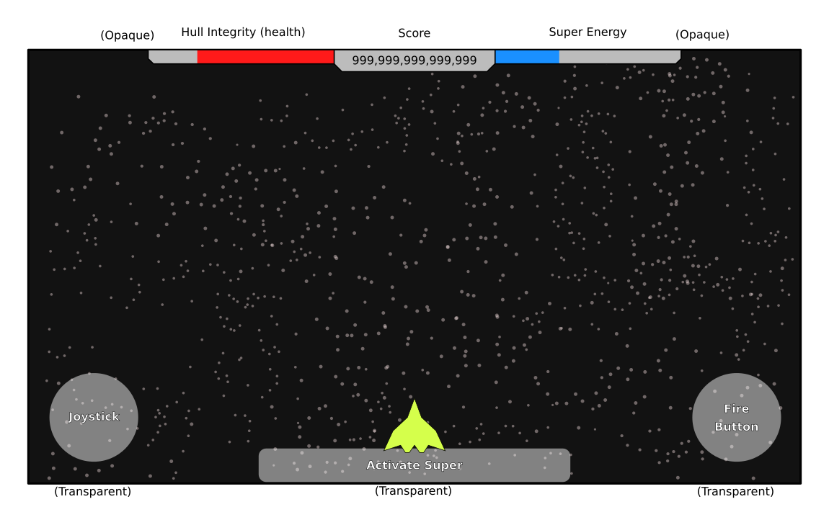

## Menus

### Main Menu

Below is the Main Menu control flowchart. It is fairly simple with an options screen, an instructions screen, and a Play button.

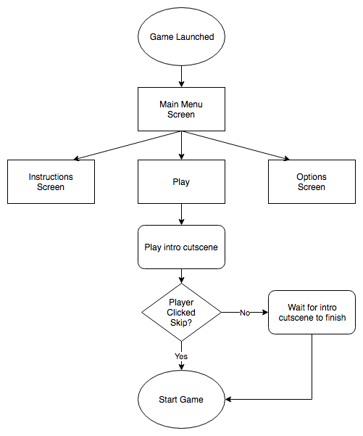

The sketch for the main menu follows (this is subject to change as the design of the logo is fleshed out):

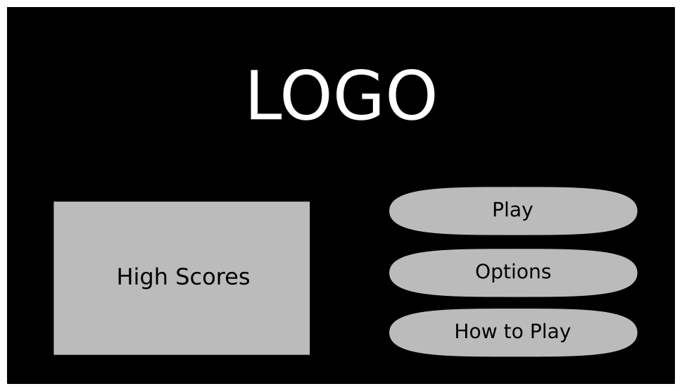

### Pause Menu

Below is the flowchart for the pause menu. It has the same options screen as the main menu, and additionally it has several buttons for resume/quit functionality.

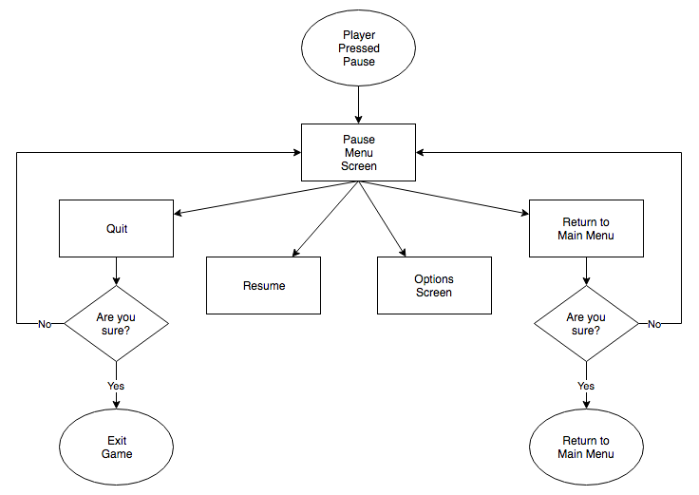

The sketch for the pause menu is found below.

