Xie, Weiliang  
40100475  
COMP352

**Assignment 3-4**

**Question 1:**

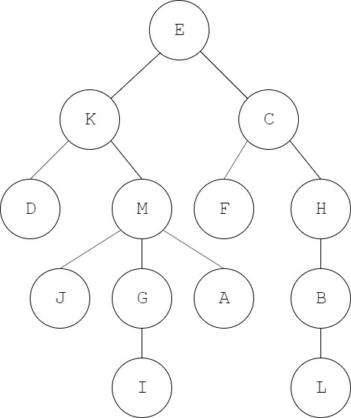

**Question 3:**

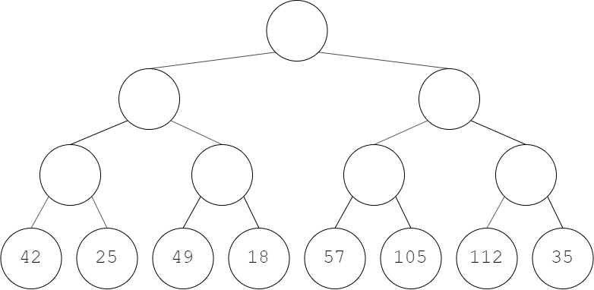

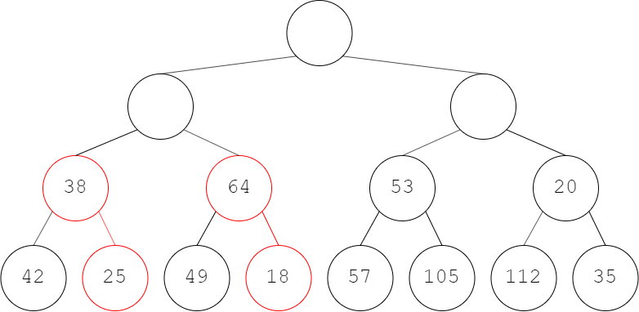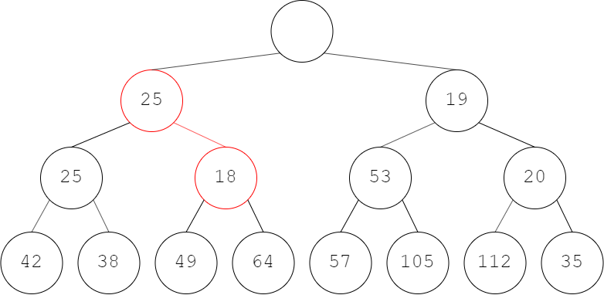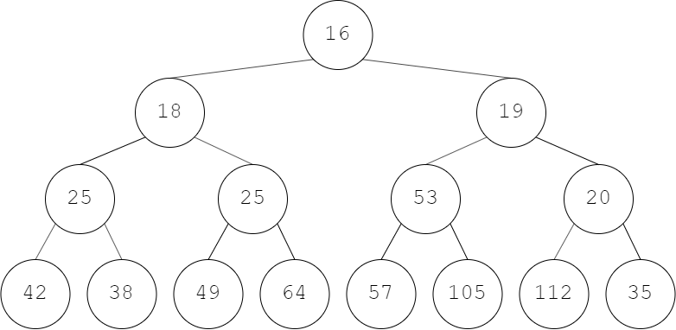

Performing first removeMin

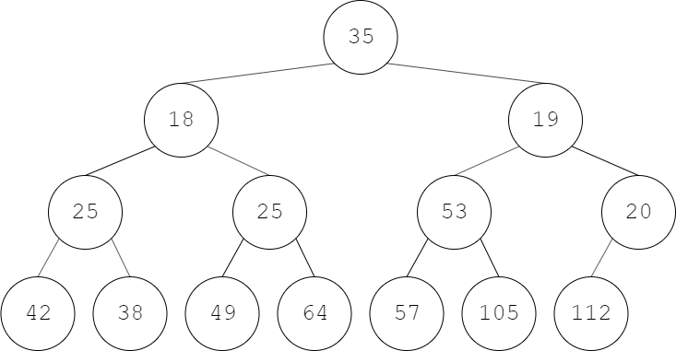

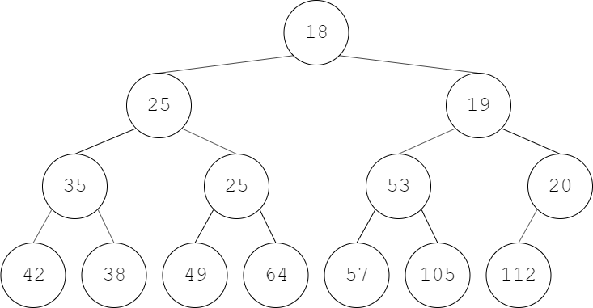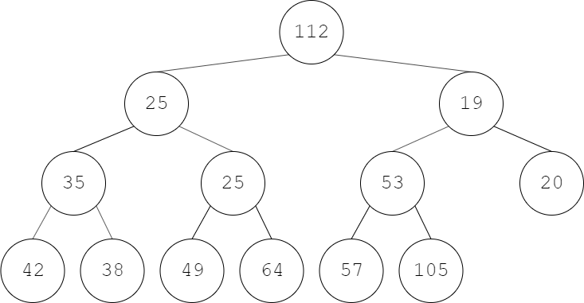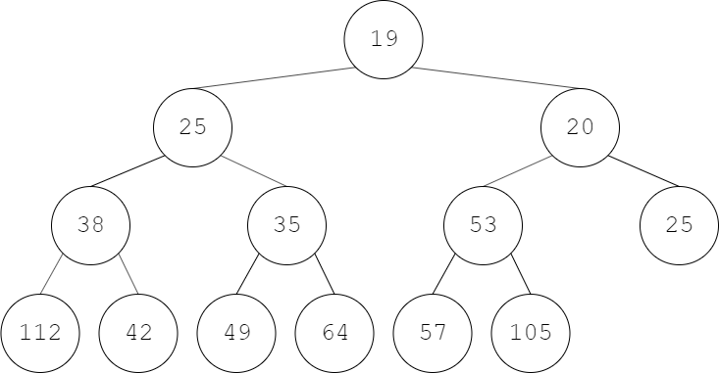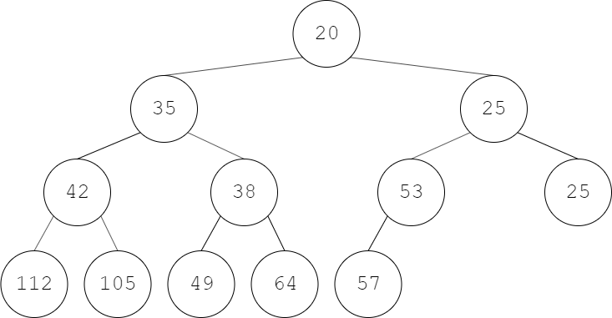

**Question 4:**

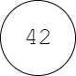

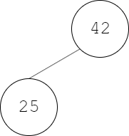

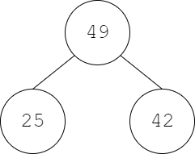

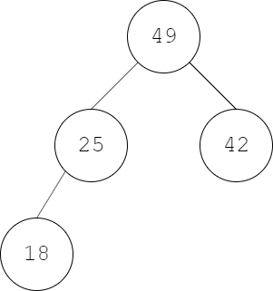

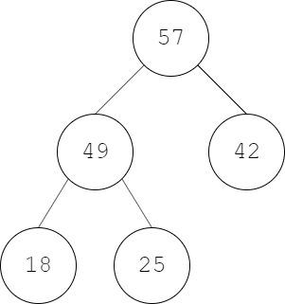

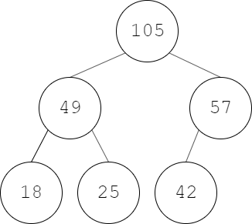

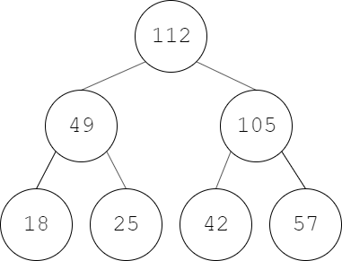

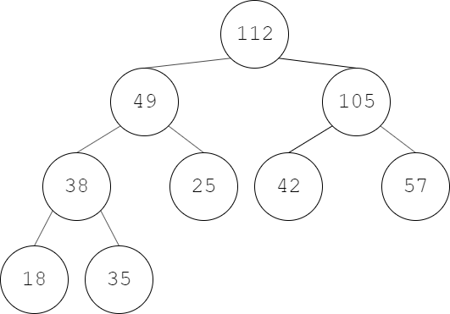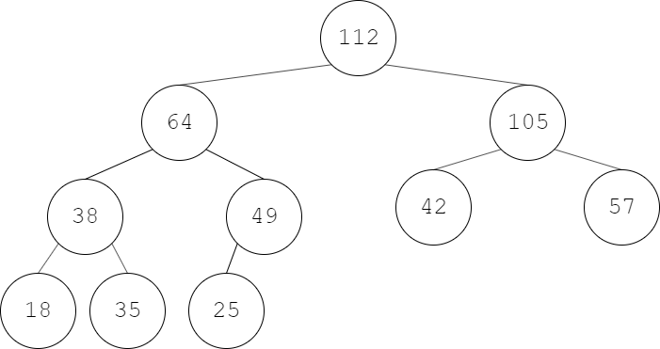

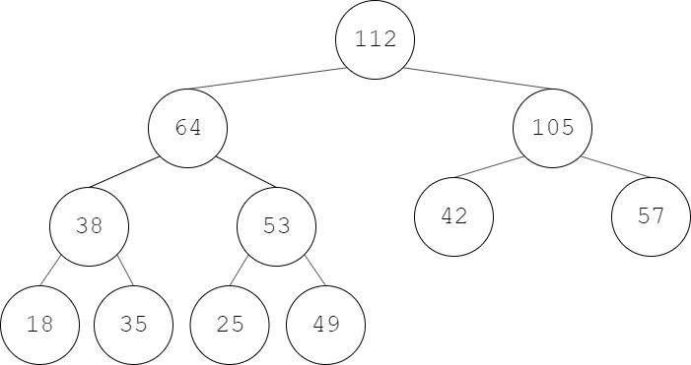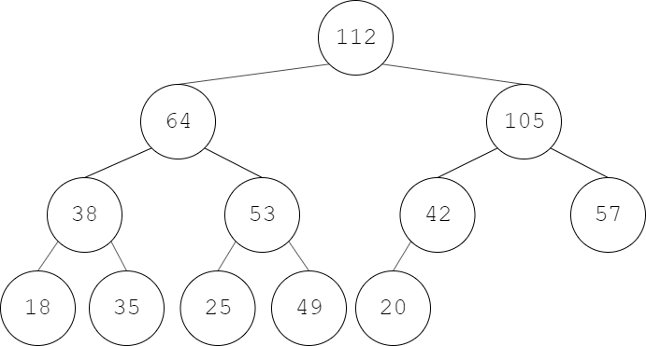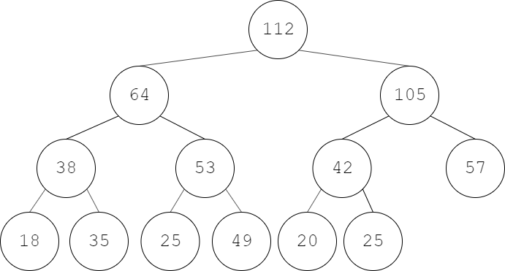

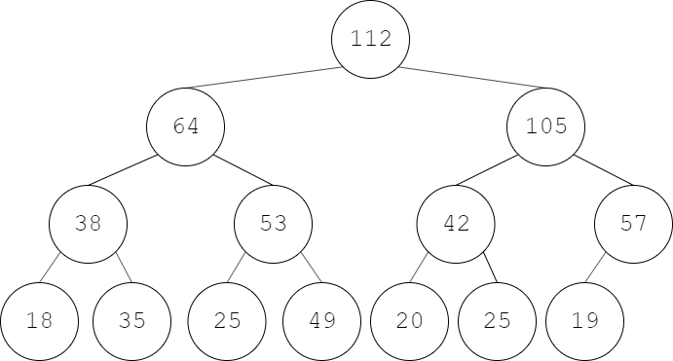

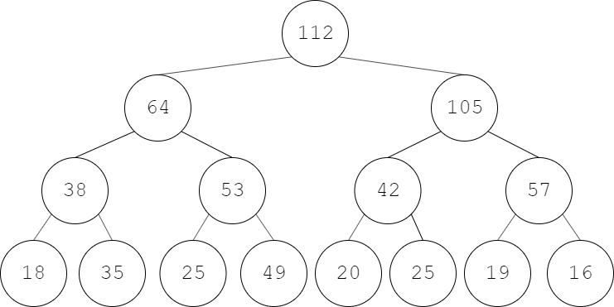

**Question 7:**

1. 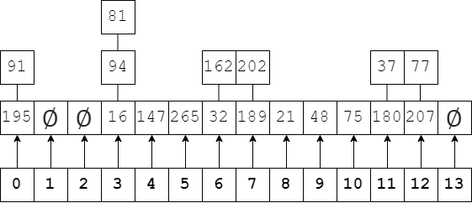After insertions:
2. There are 7 collisions in total.

**Question 8:**

There would be no difference because the hash function changes alongside the problem size. A bigger problem size means that there are just as many chances of collision as a smaller problem size with its size as a coefficient in the hash function.

**Question 9:**

1. After all operations:

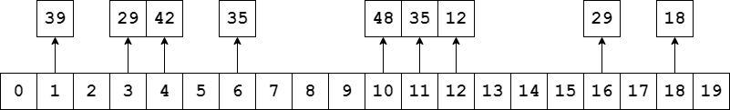

1. The longest cluster is of size 3
2. Total of 10 collisions
3. The load factor is $\frac{9}{19}=47.37\%$

**Question 10:**

|  |  |  |  |  |  |  |  |  |  |  |
| --- | --- | --- | --- | --- | --- | --- | --- | --- | --- | --- |
| 91 | 411 | 832 | 172 | 292 | 682 | 243 | 573 | 326 | 96 | 489 |

|  |  |  |  |  |  |  |  |  |  |  |
| --- | --- | --- | --- | --- | --- | --- | --- | --- | --- | --- |
| 411 | 326 | 836 | 243 | 172 | 573 | 682 | 489 | 91 | 96 | 292 |

|  |  |  |  |  |  |  |  |  |  |  |
| --- | --- | --- | --- | --- | --- | --- | --- | --- | --- | --- |
| 91 | 96 | 172 | 243 | 292 | 326 | 411 | 489 | 573 | 682 | 836 |