Stuyvesant High School

General Information

**School Name**

*Stuyvesant High School*

**Principal**

*Mr. Eric Contreras*

**Principal's Email**

*mailto:ECONTRE@SCHOOLS.NYC.GOV*

**Type**

*Regular school*

**Grade Span**

*9-12*

**Address**

*345 Chambers Street, New York, NY 10282*

**Phone**

*(212) 312-4800*

**Website**

*http://www.stuy.edu/*

**Associations/Communities**

*Nyc Geog District # 2 - Manhattan*

**GreatSchools Summary Rating**

*10/10*

**U.S.News Rankings**

*#25 in National Rankings*

School Details

**Charter**

*No*

**Magnet**

*No*

Enrolment Data

**Enrolment by Race/Ethnicity**

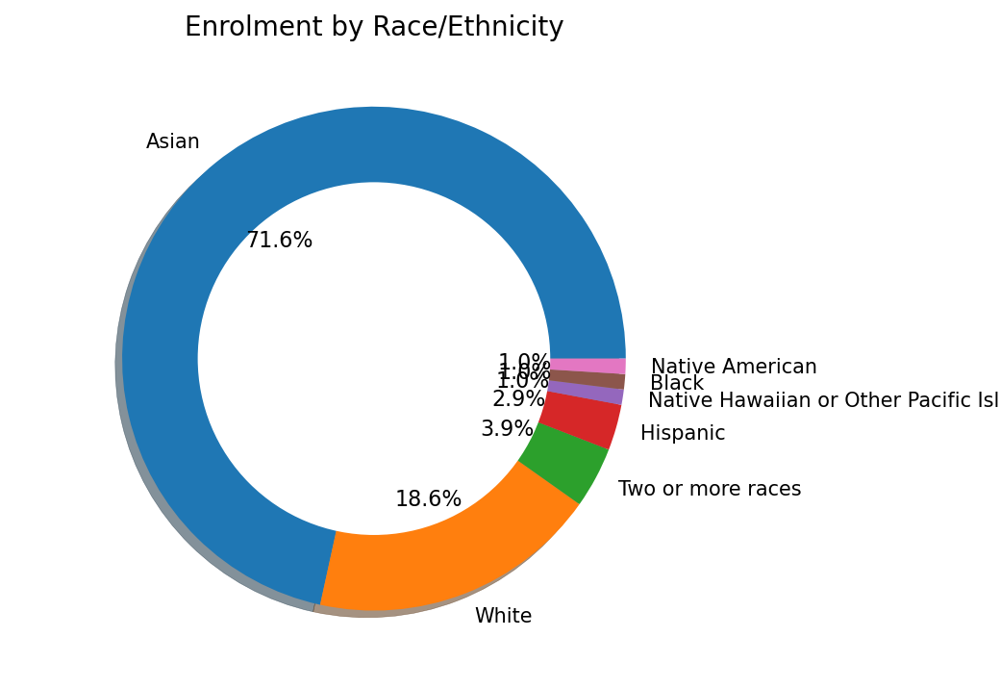

**Enrolment by Gender**

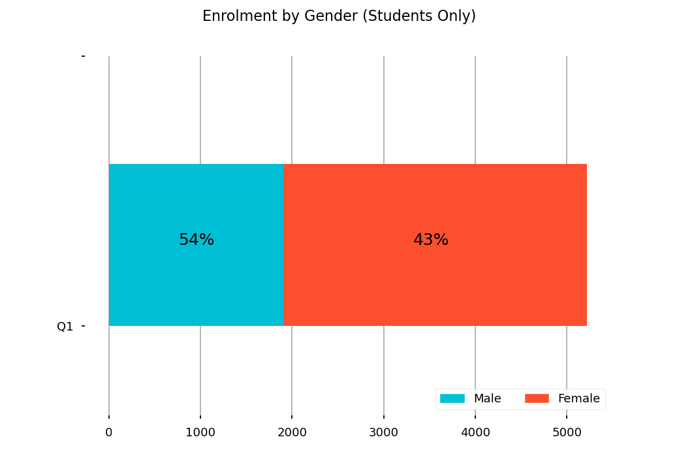

**Enrolment by Grade**

