**Title**: Unable to access individual car model page.

**Severity:** High

**Frequency:** High

**Environment:**

OS: macOS Big Sur v11.6

Browser: Firefox v100.0.2, Safari v15.0

**Description**:

When accessing the individual car model page, it displays an indefinitely progress bar. If opening the web tool console, the issue is ‘Access-Control-Allow-Origin’ missing from the request header

Screenshot:

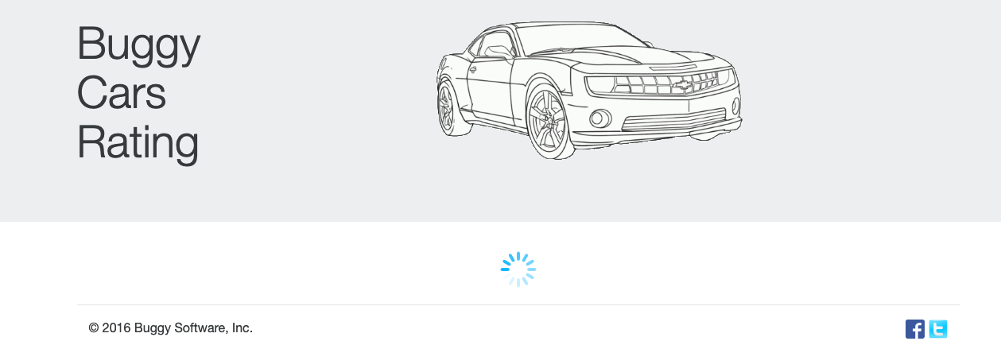

Error message:

Cross-Origin Request Blocked: The Same Origin Policy disallows reading the remote resource at https://k51qryqov3.execute-api.ap-southeast-2.amazonaws.com/prod/models/c4u1mqnarscc72is00ng|c4u1mqnarscc72is00o0. (Reason: CORS header ‘Access-Control-Allow-Origin’ missing). Status code: 400.

Steps to reproduce:

1. Access <https://buggy.justtestit.org/> website
2. Click on any car rating category selection (e.g., Popular Maker Alfra Romo)
3. Select any model (e.g., [Guilia Quadrifoglio](https://buggy.justtestit.org/model/c4u1mqnarscc72is00ng%7Cc4u1mqnarscc72is00sg))

Expected Result: Page for selected car model is displayed

Actual Result: Page is stuck on the indefinitely progress bar