**Title**: Clicking on Buggy Rating link won’t navigate back to the home page from the most popular maker page.

**Severity:** Medium

**Frequency:** High

**Environment:**

OS: macOS Big Sur v11.6

Browser: Firefox v100.0.2, Safari v15.0

**Description**:

When it is the popular maker page, it won’t bring users back to the home page, if clicking on the Buggy Rating hyperlink from the top of the page.

I also noticed that the url for the hyperlink is **https://buggy.justtestit.org/broken**

Screenshot:

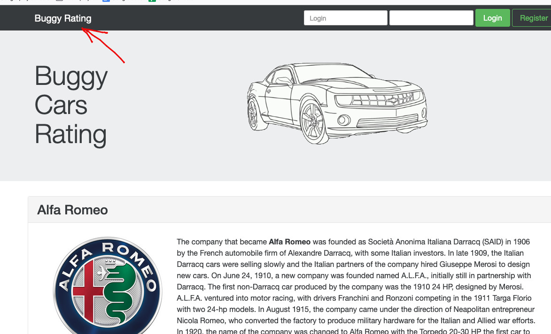

Error message:

Unhandled Promise rejection: Cannot match any routes: 'broken' ; Zone: angular ; Task: Promise.then ; Value: Error: Cannot match any routes: 'broken'

Steps to reproduce:

1. Access <https://buggy.justtestit.org/> website
2. Click on the popular maker category
3. Click on the Buggy Rating hyperlink

Expected Result: It brings the users back to the home page.

Actual Result: The hyperlink is broken. In order to go back to the home page, the users have to click on the go back one page button from the browser.