**Title**: Password error messages are misleading when the length is not enough.

**Severity:** Medium

**Frequency:** High

**Environment:**

OS: macOS Big Sur v11.6

Browser: Firefox v100.0.2, Safari v15.0

**Description**:

When entering a password with length less than 6, the error message will say the minimum field size is 6. However, if entering a password with length 6 or 7, a new error message will state the password is not long enough. It only works when entering a password of length 8, with the combination of numbers, symbols, uppercase and lowercase letters.

Screenshot:

When the length of password is less than 6

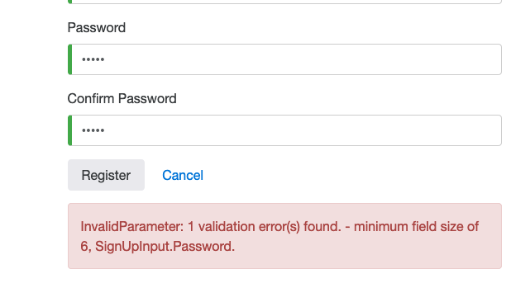

When the length of password is less than 8

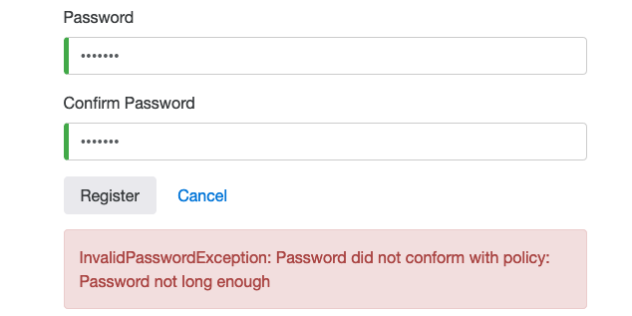

Steps to reproduce:

1. Access <https://buggy.justtestit.org/> website
2. Go to registration page by clicking on Register button at the top
3. Fill all the fields with password length less than 6
4. Enter a new password with length 6 or 7

Expected Result: It should have a consistent and correct error message as instruction for the users to correct password input

Actual Result: It displays incorrect information for the minimum length of the password, and two different error messages when entering a length less than 8.