LIve Session 2 CLT

Bivin

9/6/2018

# Simulator to Demonstrate CLT

## Control Parameters

n = 10 # sample size per sample  
simulations = 1000 #number of samples and thus number of xbars we will generate.   
mu = 0; # mean parameter for use with normal distribuions  
sigma = 1; # standard deviation parameter for use with normal distribuions

## Data Holder

xbar_holder = numeric(simulations) # This will hold all the sample means.

## Simulate and Store

Generate 1000 samples each of size 10 and find the mean of each sample. Then store each mean in the xbar_holder vector.

for (i in 1:simulations)  
{   
 sample = rnorm(n,mean = mu, sd = sigma)  
 xbar = mean(sample)  
 xbar_holder[i] = xbar  
}

## display the distribution of sample means (plot a histogram of the sample means)

hist(xbar_holder, col = "blue", main = paste("Distribution of the sample mean: n = ", n), xlab = "Sample Means", xlim = c(-4,4))

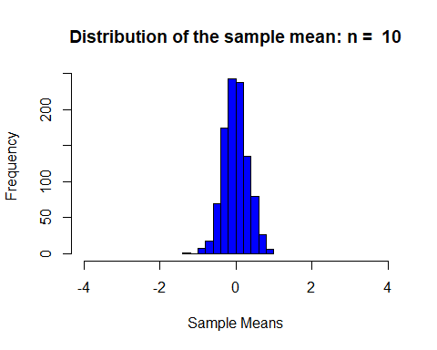

## summary statistics of the distribution of the simulated sample means.

summary(xbar_holder)

## Min. 1st Qu. Median Mean 3rd Qu. Max.   
## -1.216084 -0.209348 -0.014044 -0.005453 0.198004 0.893309