Fake Job Posting Detection
A Machine Learning Approach to Identifying Fraudulent Job Postings
Internship Project Report
Dataset: Employment Scam Aegean Dataset (EMSCAD)

1. Introduction & Problem Statement
Online job boards have made it easy for scammers to post fake job listings designed to harvest personal information, extract upfront fees, or commit identity fraud. Manually screening every posting doesn't scale, so this project builds a machine learning system that automatically classifies a job posting as legitimate or fraudulent, using both the posting's text (description, requirements, company profile) and structured metadata (employment type, required experience, presence of a company logo, etc.).
The objective, in line with the project brief, is not simply to maximize accuracy but to work through the full data-science pipeline responsibly: explore the data, preprocess and engineer features thoughtfully, train and compare multiple models on multiple metrics, and produce an interpretable, reusable prediction system along with an honest account of its limitations.

2. Dataset Description
This project uses the Employment Scam Aegean Dataset (EMSCAD), published by the University of the Aegean's Laboratory of Information & Communication Systems Security and distributed publicly via Kaggle as “Real / Fake Job Posting Prediction.” It contains 17,880 real-world job postings collected between 2012 and 2014, each labeled as legitimate or fraudulent.
Property | Value
Total postings | 17,880
Legitimate postings | 17,014 (95.16%)
Fraudulent postings | 866 (4.84%)
Columns | 18 (text + structured fields)
Key text fields | title, company_profile, description, requirements, benefits
Key structured fields | telecommuting, has_company_logo, has_questions, employment_type, required_experience, required_education, industry, function

The dataset is heavily imbalanced — fraudulent postings make up under 5% of the data. This single fact shapes almost every later decision in the project: it is why accuracy alone is a misleading metric, why class weighting is used during model training, and why the evaluation section leans on precision, recall, F1, and ROC-AUC rather than accuracy alone.

3. Exploratory Data Analysis

3.1 Class Distribution
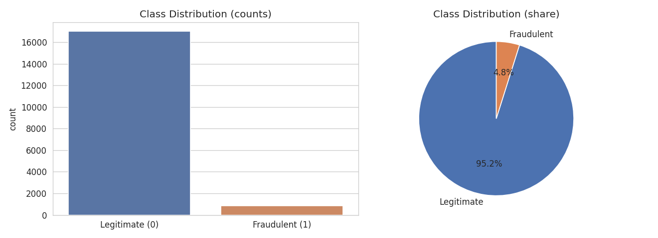
Figure 1: Class distribution — legitimate vs fraudulent postings.

3.2 Missing Data
Several fields are missing for a large share of postings — most notably salary_range (84.0% missing), department (64.6%), and required_education (45.3%). These fields were either dropped from structured feature use or treated as “unknown” categories; text fields with missing values were filled with an empty string rather than dropping rows, since even a partially-complete posting is useful evidence.
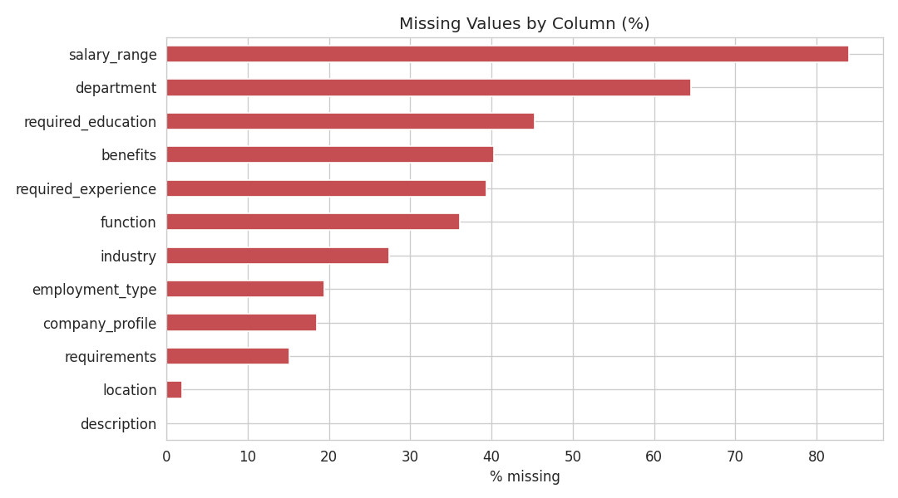
Figure 2: Percentage of missing values per column.

3.3 Text Length Patterns by Class
A clear, intuitive pattern emerges: fraudulent postings have a much shorter company_profile on average (230.9 characters vs. 640.8 for legitimate postings) and shorter requirements (446.0 vs. 597.5 characters). This matches intuition — scammers rarely have a real company history to describe in detail, while their job descriptions themselves are padded to look convincing (1154.8 vs. 1221.2 characters, much closer between classes).
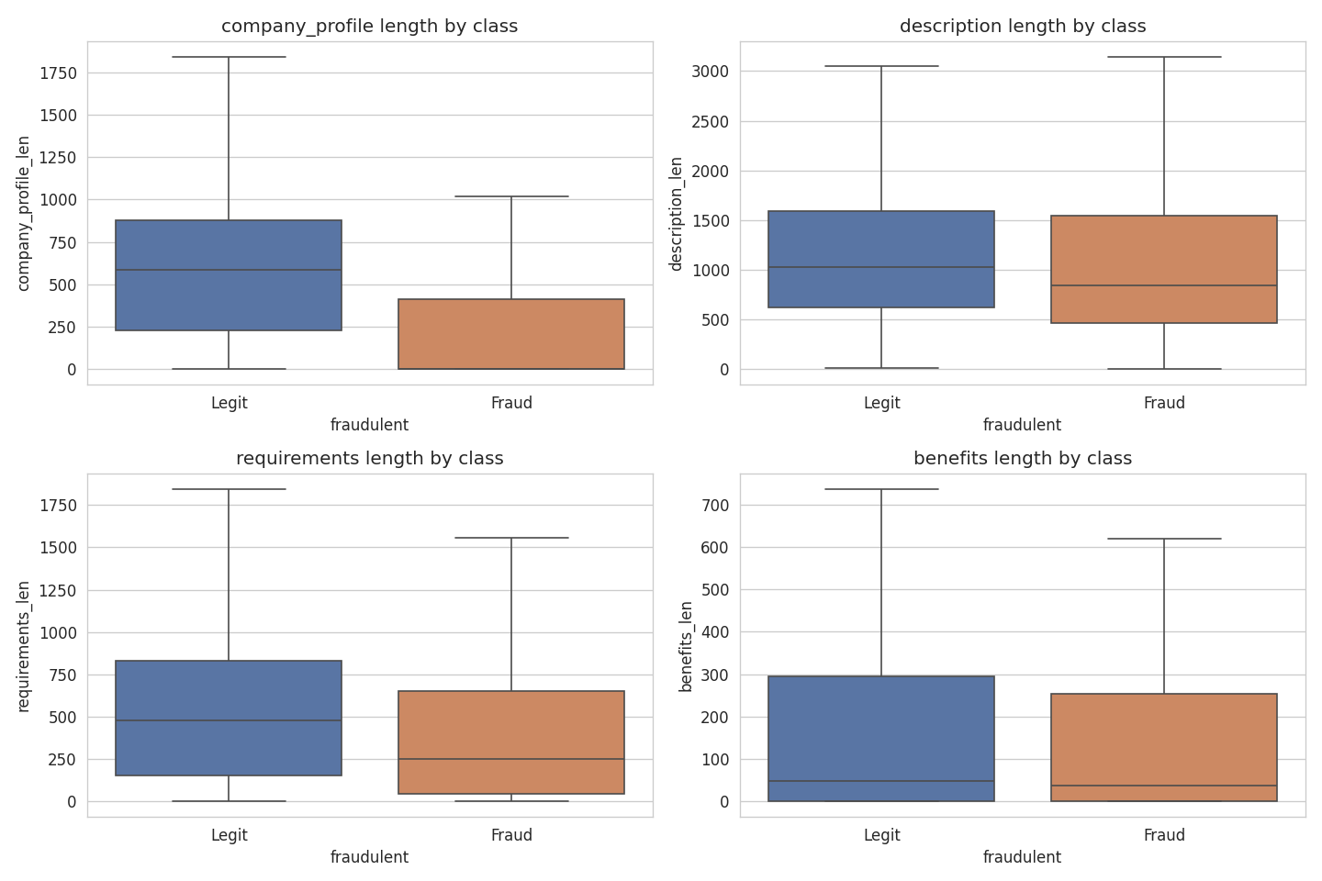
Figure 3: Distribution of text field lengths, split by class.

3.4 Structured Field Signals
Field | Fraud rate when 0/absent | Fraud rate when 1/present
has_company_logo | 15.93% | 1.99%
has_questions | 6.78% | 2.84%
telecommuting | 4.69% | 8.34%

Postings without a company logo are roughly 8x more likely to be fraudulent than postings with one — one of the strongest single structured-field signals in the dataset. Telecommuting roles are also disproportionately fraudulent, consistent with common “work from home” scam patterns.

4. Data Preprocessing
- Missing text fields (company_profile, description, requirements, benefits) were filled with empty strings rather than dropped, to avoid losing partial evidence.
- The five text fields (title, company_profile, description, requirements, benefits) were concatenated into a single combined text field per posting.
- Text cleaning: lowercased, HTML tags stripped, URLs removed, EMSCAD's anonymized placeholder tokens (e.g. #URL_...#, #EMAIL_...#) removed, punctuation and digits stripped, and whitespace collapsed.
- English stopwords were removed at the vectorization stage (via scikit-learn's built-in stopword list) rather than during cleaning, keeping the cleaning function reusable for both vectorizers used later.

5. Feature Engineering
Two text vectorization strategies were used so their effect on model performance could be measured directly, as required by the project brief:
- TF-IDF (Term Frequency – Inverse Document Frequency): weights words by how distinctive they are to a document relative to the whole corpus, down-weighting common words that appear everywhere.
- CountVectorizer: a simple raw word/n-gram frequency count, with no down-weighting of common terms.
Both were configured with unigrams + bigrams, a 5,000-feature cap, and a minimum document frequency of 3 to control dimensionality and reduce noise from one-off typos or rare tokens.

6. Model Building
Four classifiers were trained on the TF-IDF feature matrix, using an 80/20 stratified train-test split (preserving the ~4.84% fraud rate in both sets):
- Logistic Regression — required by the brief; a linear model with class_weight="balanced" to counter the imbalance.
- Naive Bayes (Multinomial) — required by the brief; a fast, classical baseline for text classification.
- Random Forest — an ensemble of decision trees, added to test whether non-linear interactions between features help.
- Linear SVM — a large-margin linear classifier, often strong on sparse high-dimensional text data.

7. Evaluation Results
Accuracy is a poor standalone metric here: a model that always predicts “legitimate” would score ~95% accuracy while catching zero fraud. All five metrics below are reported for that reason, with particular attention to Recall (catching actual fraud) and F1 (the balance between Recall and Precision).
Model | Accuracy | Precision | Recall | F1 | ROC-AUC
Logistic Regression | 0.9695 | 0.6301 | 0.8960 | 0.7399 | 0.9837
Naive Bayes | 0.9698 | 0.8824 | 0.4335 | 0.5814 | 0.9422
Random Forest | 0.9782 | 1.0000 | 0.5491 | 0.7090 | 0.9874
Linear SVM | 0.9810 | 0.7838 | 0.8382 | 0.8101 | 0.9841

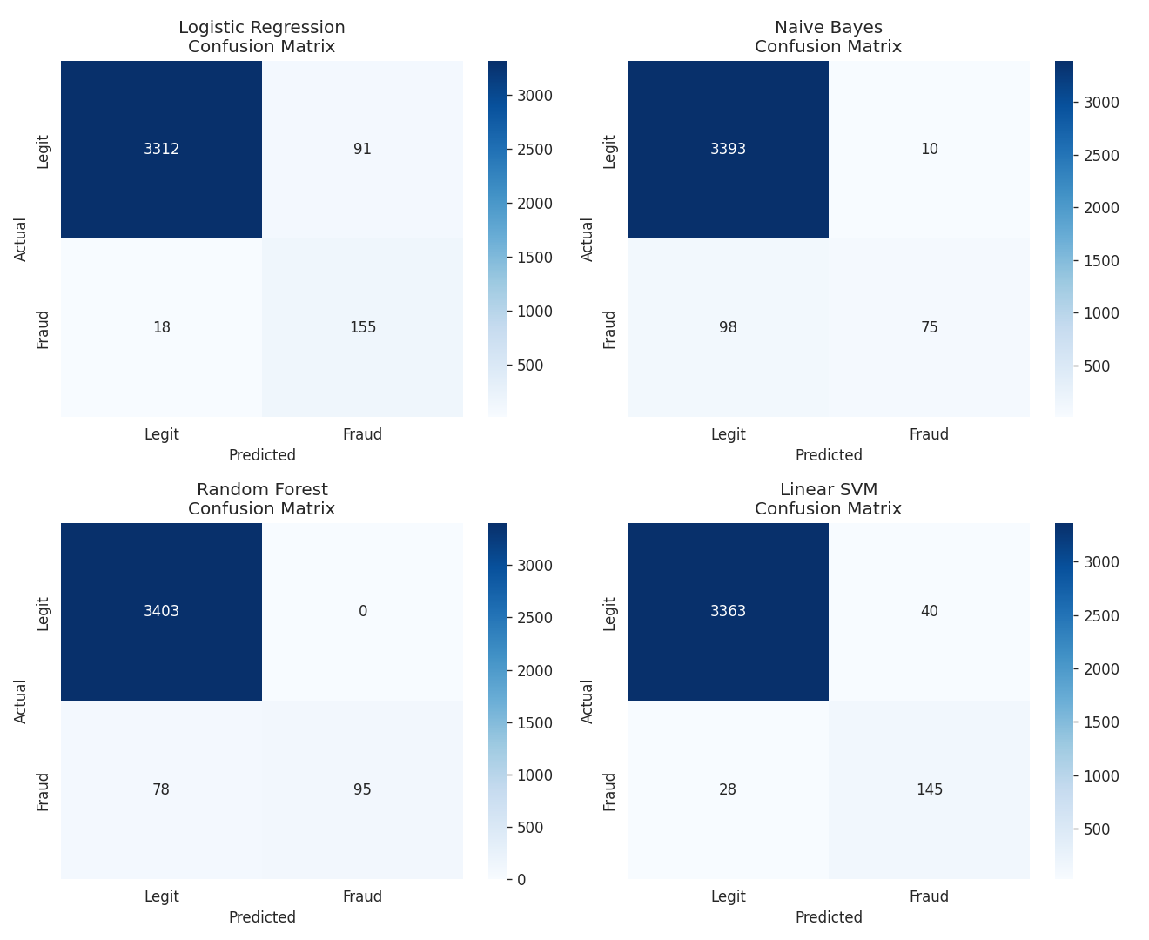
Figure 4: Confusion matrices for all four models on the held-out test set.
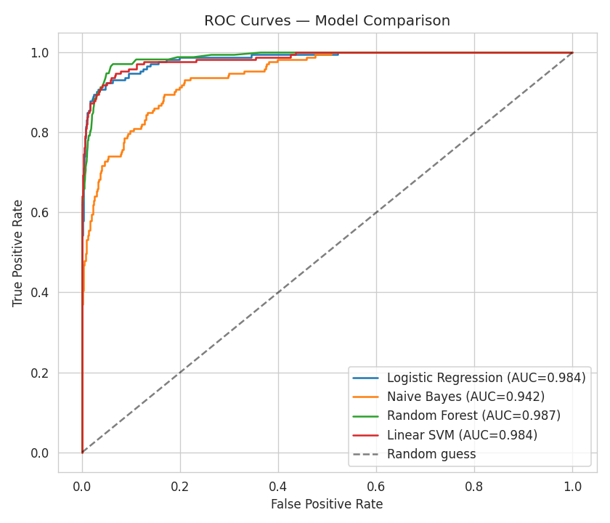
Figure 5: ROC curves comparing all four models (AUC in legend).

8. Preprocessing Impact: TF-IDF vs. CountVectorizer
To directly measure how the text representation affects performance (as the brief requests), Logistic Regression and Naive Bayes were each retrained on CountVectorizer features and compared to their TF-IDF results:
Model | Vectorizer | Accuracy | Precision | Recall | F1 | ROC-AUC
Logistic Regression | TF-IDF | 0.9695 | 0.6301 | 0.8960 | 0.7399 | 0.9837
Logistic Regression | CountVectorizer | 0.9785 | 0.7449 | 0.8439 | 0.7913 | 0.9782
Naive Bayes | TF-IDF | 0.9698 | 0.8824 | 0.4335 | 0.5814 | 0.9422
Naive Bayes | CountVectorizer | 0.9046 | 0.3257 | 0.9075 | 0.4794 | 0.9637

The effect is model-dependent rather than one-directional: CountVectorizer noticeably improves Logistic Regression's F1 (0.74 → 0.79) by giving it clearer raw-frequency signals for strongly fraud-associated words, but it badly hurts Naive Bayes's precision (0.88 → 0.33) — without the down-weighting TF-IDF provides, Naive Bayes over-triggers on common words that happen to co-occur with fraud, producing many false positives. This shows that “best” preprocessing is not universal; it interacts with each model's assumptions.

9. Comparative Analysis & Discussion
- Naive Bayes assumes word-independence, a poor fit for correlated language, and under TF-IDF trades away recall (0.43) for high precision (0.88) — it misses more than half of actual fraud cases, which is risky for this use case.
- Random Forest achieves perfect precision (1.00) but the lowest recall of the four (0.55): it is very cautious about flagging fraud, catching only the most obvious cases and missing subtler ones. It also has the best raw ROC-AUC (0.987), meaning its ranking of postings by fraud-risk is strong even though its default decision threshold is conservative.
- Logistic Regression (TF-IDF) gives the best recall of the base models (0.896) at the cost of precision (0.63) — it flags more postings as fraud, catching more real fraud but with more false alarms.
- Linear SVM offers the best overall balance among the four base models (F1 = 0.81), with strong precision and recall together and a top-tier ROC-AUC (0.984).
Given that missing a real scam (a false negative) is generally more costly to a job-seeker than incorrectly flagging a legitimate posting for review (a false positive), models with higher recall and F1 — Linear SVM and tuned Logistic Regression — are the more defensible choice here over Random Forest's high-precision/low-recall profile.

10. Hyperparameter Tuning
A grid search (3-fold cross-validation, optimizing for F1) was run over Logistic Regression's regularization strength C ∈ {0.1, 1, 5, 10}. The best configuration was C = 10 (best cross-validated F1 = 0.7536). On the held-out test set, the tuned model achieved:
Metric | Base LR (C=1, default) | Tuned LR (C=10)
Accuracy | 0.9695 | 0.9799
Precision | 0.6301 | 0.7590
Recall | 0.8960 | 0.8555
F1 | 0.7399 | 0.8043
ROC-AUC | 0.9837 | 0.9861

Reducing regularization (raising C) let the model rely more heavily on strongly fraud-indicative words rather than shrinking all coefficients toward zero, meaningfully improving precision with only a small recall trade-off — the best F1 of any single model tested, matching Linear SVM's balance while retaining probability outputs, which the final prediction system relies on.

11. Model Interpretation
Because Logistic Regression is a linear model, each TF-IDF feature has a signed coefficient: positive values push a prediction toward “fraudulent,” negative values toward “legitimate.” Inspecting the extremes gives a human-readable view of what the model has learned.
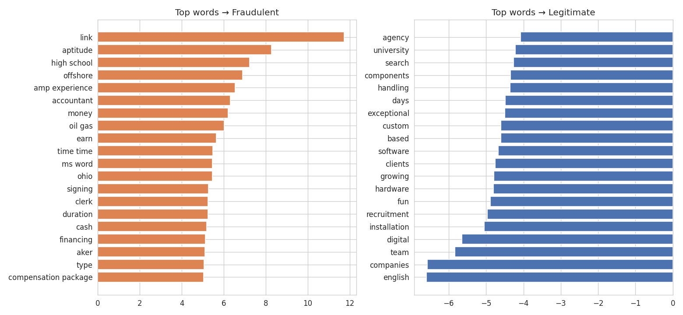
Figure 6: Top TF-IDF terms driving predictions toward fraudulent (left) vs. legitimate (right).
Fraud-associated terms include money, cash, earn, and signing — consistent with “too good to be true” pay language — alongside high school and clerk, reflecting that fraudulent postings skew toward low-barrier-to-entry roles that don't require much verification. Legitimate-associated terms include team, clients, software, university, and recruitment — vocabulary typical of established companies describing real teams, products, and hiring processes.

12. Final Prediction System
A reusable predict_job_posting() function wraps the full pipeline: it accepts a new posting's raw text fields, applies the same cleaning function, transforms it with the fitted TF-IDF vectorizer, and returns a label plus a fraud probability from the tuned Logistic Regression model. The trained model and vectorizer are persisted (fraud_model.joblib, tfidf_vectorizer.joblib) so they can be reused outside the notebook — for example, in the accompanying lightweight demo application.
Example posting | Prediction | Fraud probability
“Senior Data Analyst” at an established consultancy, detailed requirements & benefits | LEGITIMATE | 0.0014
“Easy Data Entry — Work From Home — Earn $500/day!!!”, no company profile, vague requirements | FRAUDULENT | 0.9960

13. Limitations & Real-World Considerations
- Class imbalance: only ~4.8% of postings are fraudulent; rare fraud patterns absent from training data will likely be missed even with class weighting.
- Temporal drift: the data is from 2012–2014; scam language evolves, so a production system would need periodic retraining on fresh postings.
- Text-only bias: the model leans heavily on wording. Sophisticated scams that mimic legitimate corporate language closely could evade detection.
- No external verification: the system does not check whether a company actually exists, verify domains/emails, or cross-check salary claims against market data — real anti-fraud pipelines typically combine text models with such checks.
- False positives have a cost too: overly aggressive flagging could suppress legitimate postings that happen to share surface features with common scams (e.g. legitimate remote/entry-level roles).
- English-only: the training data and cleaning pipeline assume English text; postings in other languages would need separate handling.

14. Conclusion
A TF-IDF + Logistic Regression pipeline, tuned and class-weighted, provides a strong, interpretable baseline for fake job posting detection — achieving an F1 of 0.80 and ROC-AUC of 0.986 on held-out data, while surfacing genuinely meaningful linguistic red flags (vague company profiles, unrealistic pay language, missing verification signals). It is well suited as one layer of a larger moderation system, ideally paired with metadata verification and human review for borderline cases before being relied on as a sole gatekeeper.

