

PRACTICAL FILE

# SESSION: 2024-25

**OBJECT ORIENTED PROGRAMMING (AIML 252)**

**II Year, IV Sem**

**Submitted to: Submitted by:**

Name: Mr. Aman Kumar Name: Nimesh Chauhan

Designation: Asst. Professor Enrollment No.:00318011623 Sec:AIML

 **EXPERIMENT – 1(a)**

**AIM: Generate a random number up to 100 and print whether it is prime or not. CODE:**

import java.util.Random; public class PrimeCheck {

public static void main(String[] args) {

// Generate a random number up to 100 Random random = new Random();

int number = random.nextInt(101); // Random number between 0 and 100 System.out.println("Generated Number: " + number);

// Check if the number is prime if (isPrime(number)) {

System.out.println(number + " is a prime number.");

} else {

System.out.println(number + " is not a prime number.");

}

}

// Function to check if a number is prime public static boolean isPrime(int num) { if (num <= 1) {

return false; // 0 and 1 are not prime

}

for (int i = 2; i <= Math.sqrt(num); i++)

{ if (num % i == 0) {

return false; // Divisible by a number other than 1 and itself

}

}

return true; // Prime number

}

}

**OUTPUT:**





**(b)**

**AIM: Design a program to generate first 10 terms of Fibonacci series. CODE:**

public class FibonacciSeries {

public static void main(String[] args) {

int n = 10; // Number of terms to generate int firstTerm = 0;

int secondTerm = 1;

System.out.println("First " + n + " terms of the Fibonacci series:");

// Print the first two terms System.out.print(firstTerm + ", " + secondTerm);

// Generate the remaining terms for (int i = 3; i <= n; i++) {

int nextTerm = firstTerm + secondTerm; System.out.print(", " + nextTerm);

// Update terms for the next iteration firstTerm = secondTerm; secondTerm = nextTerm;

}

}

}

**OUTPUT:**



# EXPERIMENT – 2



**(a)**

**AIM: Design a class that performs String operations (Equal, Reverse the string, change case).**

**CODE:**

import java.util.Scanner; class StringOperations {

private String str;

public StringOperations(String str)

{ this.str = str;

}

public boolean isEqual(String anotherStr)

{ return str.equals(anotherStr);

}

public String reverseString() {

return new StringBuilder(str).reverse().toString();

}

public String changeCase() {

StringBuilder changedStr = new StringBuilder(); for (char ch : str.toCharArray()) {

if (Character.isUpperCase(ch)) { changedStr.append(Character.toLowerCase(ch));

} else if (Character.isLowerCase(ch)) { changedStr.append(Character.toUpperCase(ch));

} else {

changedStr.append(ch);

}

}

return changedStr.toString();

}

public static void main(String[] args)

{ Scanner scanner = new Scanner(System.in);

System.out.print("Enter a string: ");

String inputString = scanner.nextLine();

StringOperations strOps = new StringOperations(inputString); System.out.print("Enter another string to compare: ");

String compareString = scanner.nextLine();

System.out.println("Strings are equal: " + strOps.isEqual(compareString)); System.out.println("Reversed String: " + strOps.reverseString()); System.out.println("Changed Case String: " + strOps.changeCase());

scanner.close();

}

}

**OUTPUT:**

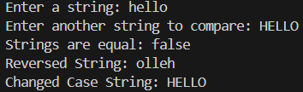



**(b)**

**AIM: Find the average and sum of array of N numbers entered by user.**

**CODE:**

import java.util.Scanner;

public class ArraySumAverage { public static void main(String[] args)

{ Scanner scanner = new Scanner(System.in);

System.out.print("Enter the number of elements: "); int n = scanner.nextInt();

int[] numbers = new int[n]; int sum = 0;

System.out.println("Enter " + n + " numbers:"); for (int i = 0; i < n; i++) {

numbers[i] = scanner.nextInt(); sum += numbers[i];

}

double average = (double) sum / n;

System.out.println("Sum: " + sum); System.out.println("Average: " + average);

scanner.close();

}

}

**OUTPUT:**

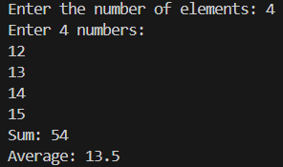



# EXPERIMENT – 3 (A)

**AIM: Demonstrate the use of final keyword with data member, function and class. CODE:**

1. final class FinalClass { final int finalVariable = 10;

final void display() {

System.out.println("Final Variable: " + finalVariable);

}

}

public class Main {

public static void main(String[] args)

{ FinalClass obj = new FinalClass(); obj.display();

}

}

**OUTPUT:**



**CODE:**

1. class BaseClass {

final int finalVariable = 10; void display() {

System.out.println("Final Variable in BaseClass: " + finalVariable);

}

}

class SubClass extends BaseClass

{ void modifyFinalVariable() { finalVariable = 20; }

}

public class Main {

public static void main(String[] args)

{ SubClass subObj = new SubClass(); subObj.display(); subObj.modifyFinalVariable();

}

}

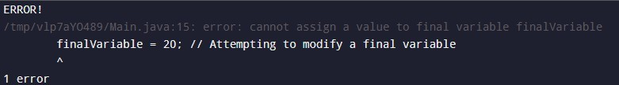**OUTPUT:**

**(B)**

**AIM: Design a program to demonstrate multi-threading using Thread Class. CODE:**

class MyThread extends Thread { private String threadName;

public MyThread(String name)

{ this.threadName = name;

}

@Override

public void run() {

for (int i = 0; i < 5; i++)

{ System.out.println(threadName + " - Count: " + i); try {

Thread.sleep(500);

} catch (InterruptedException e)

{ System.out.println(threadName + " interrupted.");

}

}

System.out.println(threadName + " has finished execution.");

}

}

public class MultiThreadingExample

{ public static void main(String[] args) {

MyThread thread1 = new MyThread("Thread 1"); MyThread thread2 = new MyThread("Thread 2");

thread1.start()

;

thread2.start()

; try {

thread1.join(); thread2.join();

} catch (InterruptedException e)

{ System.out.println("Main thread interrupted.");

}

System.out.println("Main thread has finished execution.");

}

}

**OUTPUT:**

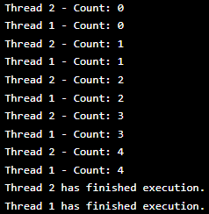

**EXPERIMENT – 4 (A)**

**AIM: Demonstrate the use of key word try ,catch finally ,throw and throws CODE:**

import java.util.Scanner; public class ExceptionDemo {

// Method to demonstrate the use of throw and throws public static void checkAge(int age) throws Exception {

if (age < 18) {

// Throwing an exception explicitly

throw new Exception("Age must be 18 or older.");

} else {

System.out.println("Age is valid.");

}

}

public static void main(String[] args) { Scanner scanner = new Scanner(System.in);

try {

System.out.print("Enter your age: "); int age = scanner.nextInt();

// Calling the method that might throw an exception checkAge(age);

// Simulate another operation System.out.println("Proceeding with the next steps...");

} catch (Exception e) {

// Handling the exception thrown in the try block System.out.println("Caught an exception: " + e.getMessage());

} finally {

// This block is always executed, regardless of an exception System.out.println("Finally block: Cleaning up resources..."); scanner.close(); // Closing scanner

}

System.out.println("Program continues after try-catch-finally block.");

}

}

**OUTPUT:**

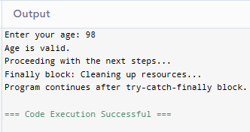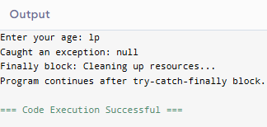

**EXPERIMENT – 4 (B)**

**AIM: Design a program to demonstrate and create the game of ‘tic tac toe’ CODE:**

import java.util.Scanner;

public class TicTacToe {

static char[][] board = new char[3][3]; // Game board static char currentPlayer = 'X'; // Start with 'X'

// Initialize the board with empty spaces public static void initializeBoard() {

for (int i = 0; i < 3; i++) { for (int j = 0; j < 3; j++) {

board[i][j] = ' ';

}

}

}

// Display the board

public static void displayBoard() { for (int i = 0; i < 3; i++) {

for (int j = 0; j < 3; j++) { System.out.print(board[i][j]); if (j < 2) System.out.print("|");

}

System.out.println();

if (i < 2) System.out.println(" ");

}

}

// Check for a winner

public static boolean checkWin() { for (int i = 0; i < 3; i++) {

// Check rows and columns

if ((board[i][0] == currentPlayer && board[i][1] == currentPlayer && board[i][2] == currentPlayer)

||

(board[0][i] == currentPlayer && board[1][i] == currentPlayer && board[2][i] == currentPlayer))

{

return true;

}

}

// Check diagonals

if ((board[0][0] == currentPlayer && board[1][1] == currentPlayer && board[2][2] == currentPlayer) || (board[0][2] == currentPlayer && board[1][1] == currentPlayer && board[2][0] == currentPlayer))

{

return true;

}

return false;

}

// Check if the board is full (draw) public static boolean checkDraw() {

for (int i = 0; i < 3; i++) { for (int j = 0; j < 3; j++) {

if (board[i][j] == ' ') return false;

}

}

return true;

}

// Main method to start the game public static void main(String[] args) {

Scanner scanner = new Scanner(System.in); initializeBoard();

displayBoard();

while (true) {

System.out.println("Player " + currentPlayer + "'s turn:"); System.out.print("Enter row (0-2): ");

int row = scanner.nextInt(); System.out.print("Enter column (0-2): "); int col = scanner.nextInt();

// Validate move

if (row >= 0 && row < 3 && col >= 0 && col < 3 && board[row][col] == ' ') { board[row][col] = currentPlayer;

displayBoard();

if (checkWin()) {

System.out.println("Player " + currentPlayer + " wins!"); break;

}

if (checkDraw()) { System.out.println("It's a draw!"); break;

}

// Switch player

currentPlayer = (currentPlayer == 'X') ? 'O' : 'X';

} else {

System.out.println("Invalid move, try again.");

}

}

scanner.close();

}

}

**OUTPUT:**

