

|  |  |
| --- | --- |
| logo_100-01 | **PORTUGAL HOLIDAY RENTALS**  Apartado 194 2500-Caldas da Rainha, **Portugal**  Telephone: Office: +351 262 824 221  Telephone Mobile: +351 966 397 886  Telephone Mobile: +351 93 466 4982  Email: [fabhols@gmail.com](mailto:fabhols@gmail.com)  info@portugalrentalcottages.com  www.portugalrentalcottages.com |
| VILLA REF: «LegacyReference» | *Property ID: «HomeawayReference»* ***-*** *«HouseName» Booking Reference: «LegacyReference»* |

**RETURN OF SECURITY DEPOSIT**

|  |  |  |  |
| --- | --- | --- | --- |
| «FirstName» | First Name: «FirstName» | | Surname: «LastName» |
| Full Postal Address: «FirstName» «FirstName» «FirstName» | | | |
| Post Code : «Country» | Country: «Country» | | |
| Day Tel No: «DayTimeTelephone» | | Home Tel No. «DayTimeTelephone» | |
| Mobile Phone No: «DayTimeTelephone» | | Alternative Mobile Phone: «Country» | |
| E-mail address: «DayTimeTelephone» | | | |

Ref No: *«LegacyReference»*

«CurrentDate»

Dear Andrew

I trust that you enjoyed your recent stay in our «HouseName»«LegacyReference» in «LegacyReference», and that you found everything to your satisfaction. Please note that an amount of «DayTimeTelephone» «DayTimeTelephone» «DayTimeTelephone»/- was remitted to you today by bank transfer using the bank details you provided during the booking process. I trust you find all in order.

If you have any queries regarding this or any other matter concerning your payments, please contact me using the details below. Kindly keep this document for your records.

It remains for me to thank you, once again, for booking with us and we look forward to welcoming you again in the future.

Sincerely

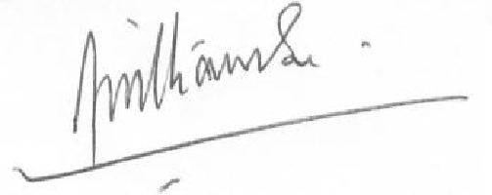

Brendon Williamson

Apartado 194 2500-Caldas da Rainha,

**Portugal**

Telephone: Office: +351 262 824 221

Telephone Mobile: +44 7906 137718

Telephone Mobile: +351 93 466 4982

[villaadriana@live.co.u](mailto:villaadriana@live.co.uk)

[Cenarioatlantico@live.co.u](mailto:Cenarioatlantico@live.co.uk)