**REMITTANCE ADVICE**

«FirstName» «LastName» (Home Owner)

**Postal Address**

«FirstName»

|  |  |
| --- | --- |
| Contact Phone No: «FirstName» | Mobile Phone: «FirstName» |

E-mail address: «FirstName»

«FirstName»

Dear «FirstName»

I write to inform you that an amount of **of «DayTimeTelephone» «DayTimeTelephone»2.970/-** has been transferred to your villa management account today in respect of the rental amount due to you for bookings in August 2014, after deduction of our 20% commission and fees. Please see the breakdown below:

• ***«LegacyReference»***...........«DayTimeTelephone» «DayTimeTelephone» «DayTimeTelephone» (70% of agreed rental value)

If you have any queries regarding this or any other matter concerning your payments, please contact me using the details below. Kindly keep this document for your records. It remains for me to thank you for renting with us this season.

Sincerely

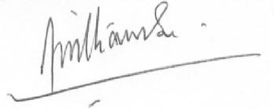

Brendon Williamson