REMITTANCE ADVICE

«FirstName» «LastName» (Home Owner)
Postal Address
«FirstName»

Contact Phone No: «FirstName» | Mobile Phone: «FirstName»
Email Address
«FirstName»

«FirstName»

Dear «FirstName»

I write to inform you that an amount of Euro 2.880,00€ is being paid to you today in respect of the booking below for Villa M, during the month of August 2014, after deduction of our seasonal 20% commission. Please be aware that because we advertise in GB£ Sterling, sometimes there can be variations in the Euro amounts we send you. We always of course keep to the amounts already declared in the BCT documentation. 1. PHR-296/13 - 07 nights from 02 - 09 August 2014. Amount due is Euro 2.880,00€ (J. Newbold) If you have any queries regarding this or any other matter concerning your payments, please contact me using the details below. Kindly keep this document for your records

Sincerely
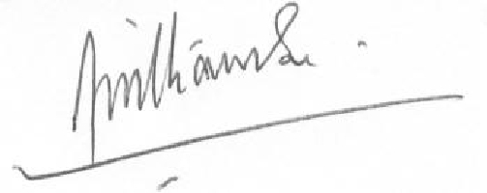

Brendon Williamson
Portugal Holiday Rentals
+44 7906 137718 (UK Mobile)
+351 93 466 4982 (Portugal Mobile)

