PORTUGAL HOLIDAY RENTALS

Apartado 194 2500-Caldas da Rainha, Portugal Telephone: Office: +351 262 824 221 Telephone Mobile: +351 966 397 886 Telephone Mobile: +351 93 466 4982 Email: phrvillas@gmail.com fabhols@gmail.com Site: www.portugalrentalcottages.com

VILLA REF: «LegacyReference» Booking Reference: «LegacyReference»X
REMITTANCE ADVICE

«FirstName» «LastName» (Home Owner)X

Postal Address
«FirstName»X

Contact Phone No: «FirstName»X
Mobile Phone: «FirstName»X

E-mail address: «FirstName»X

«FirstName»X

Dear «FirstName»X

I write to inform you that an amount of «FirstName» is being remitted to you via bank transfer today in respect of the balance rental amount for the booking reference below for Villa Dom Carlos, taken for May 2013. This remittance completes your rental payment for this booking. The initial deposit amount of «DayTimeTelephone» «DayTimeTelephone» «DayTimeTelephone» was for this booking was duly remitted to you by bank transfer on «DayTimeTelephone».X

• «LegacyReference»...........«DayTimeTelephone» «DayTimeTelephone» «DayTimeTelephone» (70% of agreed rental value)X

If you have any queries regarding this or any other matter concerning your payments, please contact me using the details below. Kindly keep this document for your records. It remains for me to thank you for renting with us this season.

Sincerely
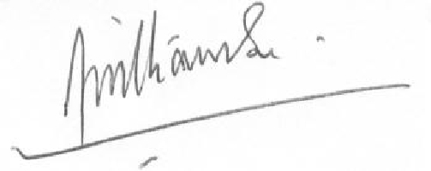

Brendon Williamson
Portugal Holiday Rentals (UK Office)

91 Bushey Mill Lane

Watford WD24 7QZ

Hertfordshire
07906 137718 (UK Mobile)

+351 93 466 4982 (Portugal Mobile)

A subsidiary of FAB Holidays (UK) Ltd.
1

