 |  | PORTUGAL HOLIDAY RENTALS
 |  |  | Apartado 194 2500-Caldas da Rainha, Portugal
 |  |  | Telephone: Office: +351 262 824 221
Portugal |  |  | Telephone Mobile: +351 96 919 2361
Portugal |  |  | Telephone Mobile: +351 93 466 498
HolidayRentals |  |  | Email: phrvillas@gmail.com
HolidayRentals |  |  | www.portugalrentalcottages.com
Discover Portugal with us…
VILLA REF: PRCV-027 | HR Original Ref: | 443578 | Booking Reference: PHR-052A/11


RETURN OF SECURITY DEPOSIT

Ms./Mrs./Mr.: Dr. | First Name: ANDREW |  | Surname: WILSON
Full Postal Address: 24 Carr Bank Avenue, Ramsbottom, Bury,Lancs
Post Code : BL0 9DW | Country: UNITED KINGDOM
Day Tel No: +44 1706 828622 |  | Home Tel No. +44 1706 828622
Mobile Phone No:+44 7881715837 |  | Alternative Mobile Phone:
E-mail address: anawilson@tiscali.co.uk

Ref No: PHR-052A/11

19 August 2011

Dear Andrew

I trust that you enjoyed your recent stay in our Casa Boavista PRCV-027 in Foz do Arelho, and that you found everything to your satisfaction. Please note that an amount of Euro €300/- was remitted to you today by bank transfer using the bank details you provided during the booking process. I trust you find all in order.

If you have any queries regarding this or any other matter concerning your payments, please contact me using the details below. Kindly keep this document for your records.

It remains for me to thank you, once again, for booking with us and we look forward to welcoming you again in the future.

Sincerely
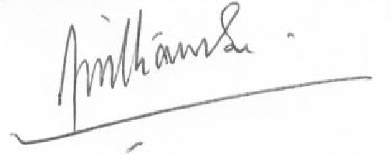

Brendon Williamson

Apartado 194 2500-Caldas da Rainha,

Portugal

Telephone: Office: +351 262 824 221
Telephone Mobile: +44 7906 137718
Telephone Mobile: +351 93 466 4982
villaadriana@live.co.uk
Cenarioatlantico@live.co.uk

A subsidiary of FAB Holidays (UK) limited

Page 1

PDF to Word

