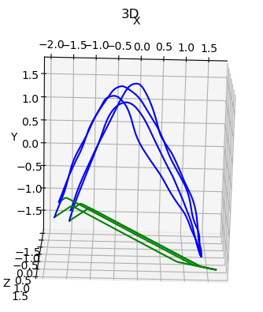
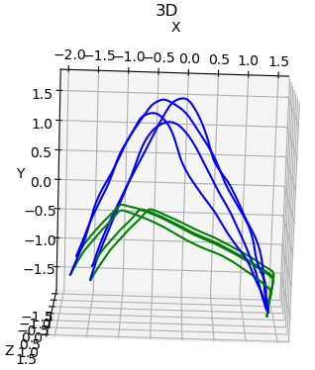
With normal coupling layer
With ResNetcoupling layer

-----epoch:1/100
#### IROS EVALUATION ####
The Frechet Distance is:2.7849053094294245
The DTW Distance is: 1879.7048508780358
-----epoch:1/100
The Frechet Distance is: 1.9066616217466592
The DTW Distance is: 1011.8983180361143

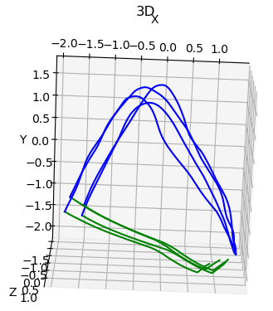

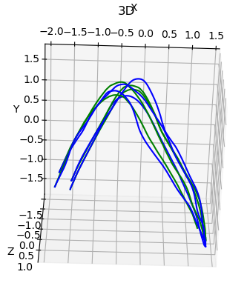

-----epoch:21/100
#### IROS EVALUATION ####
The Frechet Distance is: 3.0678591685580114
The DTW Distance is: 2708.456153932916
-----epoch:21/100
The Frechet Distance is: 0.36110388427164497
The DTW Distance is: 277.3351601731748

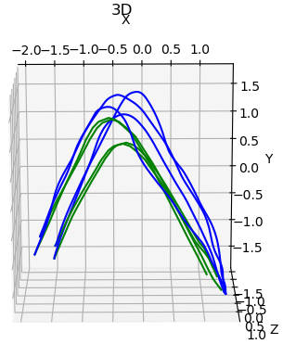
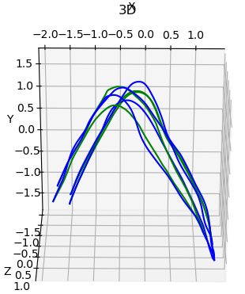

-----epoch:41/100
#### IROS EVALUATION ####
The Frechet Distance is: 0.6197863449701524
The DTW Distance is: 521.1965943577685
-----epoch:41/100
The Frechet Distance is: 0.4925452451367441
The DTW Distance is: 273.6284039421955

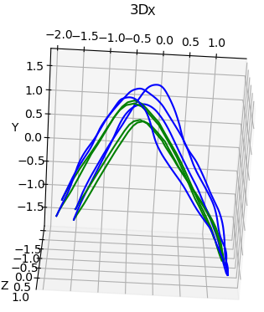
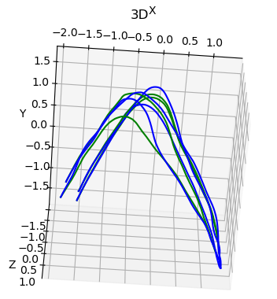

-----epoch:61/100
2000
#### IROS EVALUATION ####
The Frechet Distance is: 0.451071903064434
The DTW Distance is: 272.22784830381045
-----epoch:61/100
#### IROS EVALUATION ####
The Frechet Distance is: 0.584696881141304
The DTW Distance is: 437.34966106640604

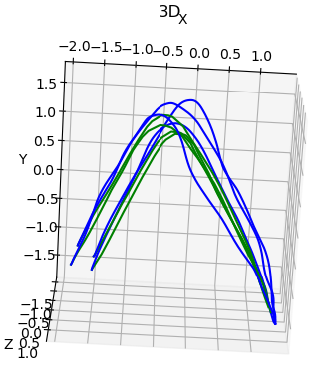
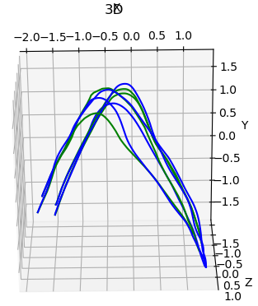

-----epoch:81/100
#### IROS EVALUATION ####
The Frechet Distance is: 0.516566177661647
The DTW Distance is: 259.2610437601089
-----epoch:81/100
#### IROS EVALUATION ####
The Frechet Distance is: 0.48250169011715033
The DTW Distance is: 383.52757151973844

5s for 1 epoch
15-20s for generating one trajectory
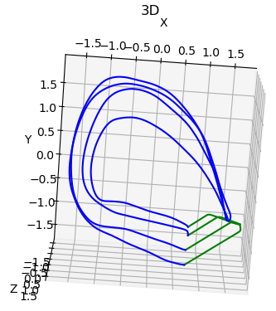
BendedLine
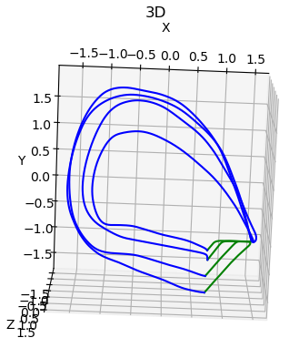

-----epoch:1/100
2000
#### IROS EVALUATION ####
The Frechet Distance is: 3.628943578234668
The DTW Distance is: 2374.8546619462295
##########################
Validation data Log Likelihood: 0.04676379635930061 | log pz : 2.600912094116211 | log detJ : -2.5541481971740723
-----epoch:1/200
#### IROS EVALUATION ####
The Frechet Distance is: 3.627448226980841
The DTW Distance is: 1986.6154191928324
##########################
Validation data Log Likelihood: 1.8638412952423096 | log pz : 6.001935958862305 | log detJ : -4.138094902038574

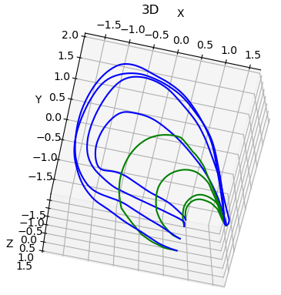
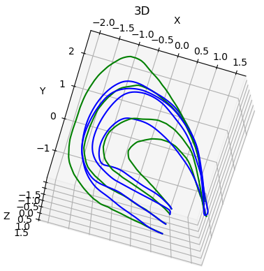

-----epoch:81/100
#### IROS EVALUATION ####
The Frechet Distance is: 2.5634694548091685
The DTW Distance is: 1344.5472871260727
##########################
Validation data Log Likelihood: -0.2223292589187622 | log pz : 1.2440767288208008 | log detJ : -1.466405987739563
-----epoch:21/200
#### IROS EVALUATION ####
The Frechet Distance is: 1.23007203667004
The DTW Distance is: 790.1772551281605
##########################
Validation data Log Likelihood: 4.44175386428833 | log pz : 4.665234565734863 | log detJ : -0.22348123788833618

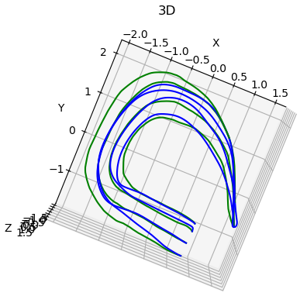

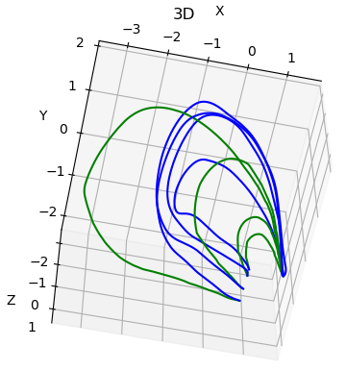

-----epoch:121/100
#### IROS EVALUATION ####
The Frechet Distance is: 2.2207366057816103
The DTW Distance is: 1201.6800573993407
##########################
Validation data Log Likelihood: -0.9484444260597229 | log pz : -0.024296972900629044 | log detJ : -0.9241474866867065
-----epoch:41/100
#### IROS EVALUATION ####
The Frechet Distance is: 0.9204504968539148
The DTW Distance is: 571.4221254956692
##########################
Validation data Log Likelihood: 4.999522686004639 | log pz : 4.5256829261779785 | log detJ : 0.4738397002220154

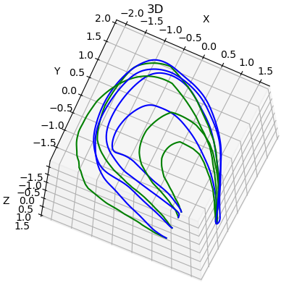
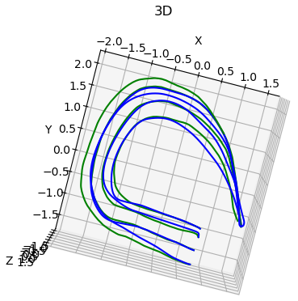

-----epoch:181/100
#### IROS EVALUATION ####
The Frechet Distance is: 0.9340720128193017
The DTW Distance is: 579.7782408189064
##########################
Validation data Log Likelihood: -1.4938721656799316 | log pz : -0.9977052211761475 | log detJ : -0.4961669147014618
-----epoch:61/100
#### IROS EVALUATION ####
The Frechet Distance is: 0.8704533942629358
The DTW Distance is: 509.1556945377219
##########################
Validation data Log Likelihood: 5.176161766052246 | log pz : 4.379368305206299 | log detJ : 0.7967932820320129

G
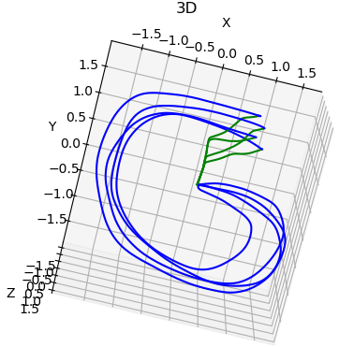
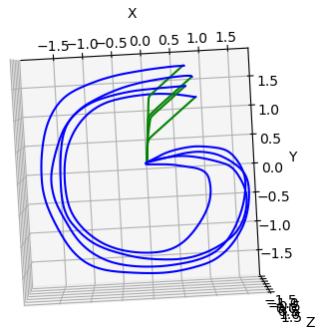

-----epoch:1/200
2000
#### IROS EVALUATION ####
The Frechet Distance is: 2.349506900409937
The DTW Distance is: 1512.7815925120121
##########################
Validation data Log Likelihood: 2.5151331424713135 | log pz : 5.936056613922119 | log detJ : -3.4209232330322266
-----epoch:1/200
generating time:0.31461548805236816
449
#### IROS EVALUATION ####
The Frechet Distance is: 2.4216886297912796
The DTW Distance is: 1502.0680667146887
##########################
Validation data Log Likelihood: -3.490771770477295 | log pz : -1.3685334920883179 | log detJ : -2.1222381591796875

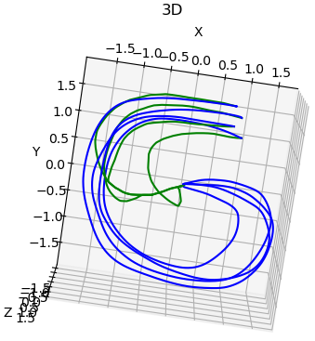
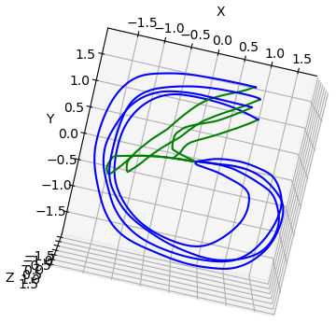

-----epoch:21/200
#### IROS EVALUATION ####
The Frechet Distance is: 2.1709902764262092
The DTW Distance is: 1437.9615183797562
##########################
Validation data Log Likelihood: 2.375694513320923 | log pz : 2.647326707839966 | log detJ : -0.27163198590278625

-----epoch:81/200
generating time:0.6271328926086426
1039
#### IROS EVALUATION ####
The Frechet Distance is: 2.03248561743778
The DTW Distance is: 1557.094505345463
##########################
Validation data Log Likelihood: -0.6797381043434143 | log pz : 0.4396955668926239 | log detJ : -1.1194335222244263

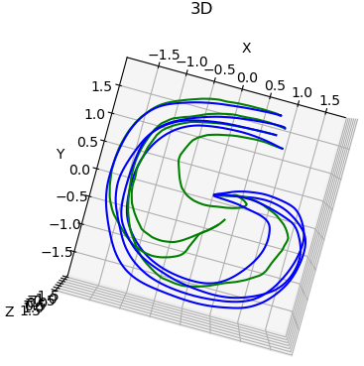
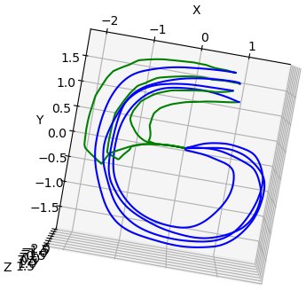

-----epoch:41/200
#### IROS EVALUATION ####
The Frechet Distance is: 1.3236903544412237
The DTW Distance is: 871.2032537209366
##########################
Validation data Log Likelihood: 3.938159465789795 | log pz : 3.2861034870147705 | log detJ : 0.6520556211471558
-----epoch:101/200
generating time:0.880211591720581
1663
#### IROS EVALUATION ####
The Frechet Distance is: 2.0057653492762997
The DTW Distance is: 1614.8093236594248
##########################
Validation data Log Likelihood: -1.5299203395843506 | log pz : -0.9678077697753906 | log detJ : -0.56211256980896

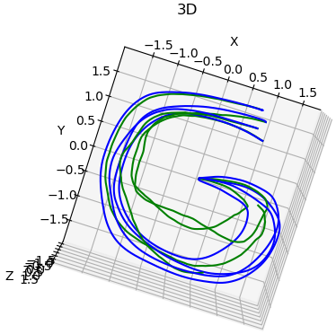
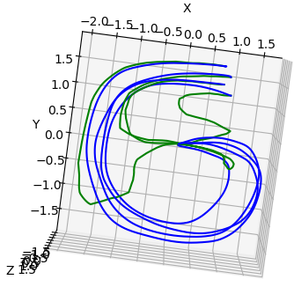
-----epoch:161/200
#### IROS EVALUATION ####
The Frechet Distance is: 1.2362745264505781
The DTW Distance is: 652.7231058524465
##########################
Validation data Log Likelihood: 6.147097587585449 | log pz : 3.9997401237487793 | log detJ : 2.147357225418091

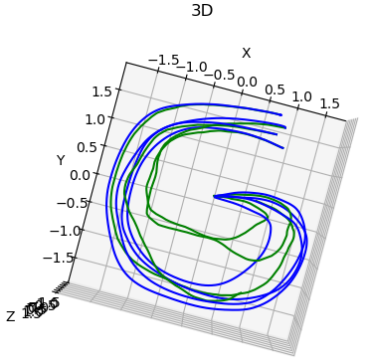

-----epoch:181/200
#### IROS EVALUATION ####
The Frechet Distance is: 1.1133427194447496
The DTW Distance is: 612.9957082341617
##########################
Validation data Log Likelihood: 5.940398693084717 | log pz : 3.703869581222534 | log detJ : 2.2365288734436035

S
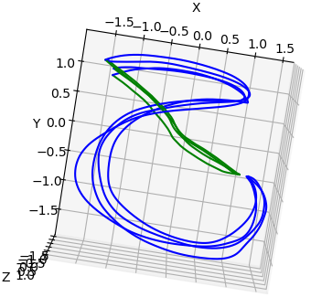

-----epoch:1/200
generating time:1.2532539367675781
generated points for 1th trajectory:3001
generated points for 2th trajectory:3001
generated points for 3th trajectory:3001
generated points for 4th trajectory:3001
#### IROS EVALUATION ####
The Frechet Distance is: 1.9392489880289767
The DTW Distance is: 1477.130980586779
##########################
Validation data Log Likelihood: 1.09004545211792 | log pz : 4.9437103271484375 | log detJ : -3.8536651134490967

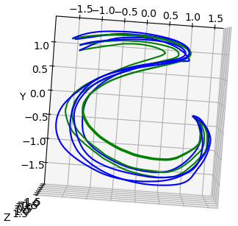

-----epoch:21/200
generating time:0.7986819744110107
generated points for 1th trajectory:1926
generated points for 2th trajectory:1757
generated points for 3th trajectory:1890
generated points for 4th trajectory:1919
#### IROS EVALUATION ####
The Frechet Distance is: 2.0757662065460916
The DTW Distance is: 1022.0874926775108
##########################
Validation data Log Likelihood: 4.693714141845703 | log pz : 6.199976444244385 | log detJ : -1.506262183189392

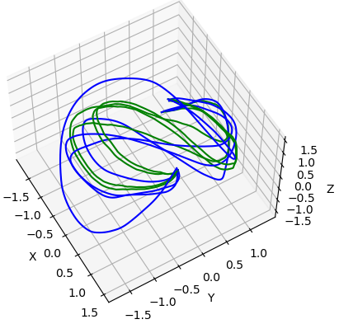

-----epoch:41/200
generating time:1.2544026374816895
generated points for 1th trajectory:3001
generated points for 2th trajectory:3001
generated points for 3th trajectory:3001
generated points for 4th trajectory:3001
#### IROS EVALUATION ####
The Frechet Distance is: 1.572052739399116
The DTW Distance is: 810.3428918478558
##########################
Validation data Log Likelihood: 5.139379978179932 | log pz : 6.058481693267822 | log detJ : -0.9191016554832458

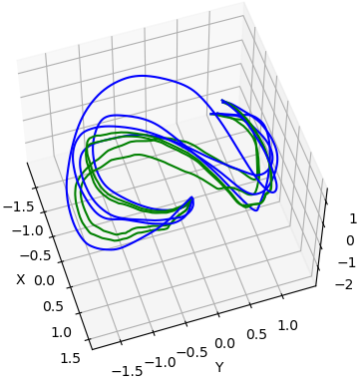
-----epoch:61/200
generating time:1.4351210594177246
generated points for 1th trajectory:3001
generated points for 2th trajectory:3001
generated points for 3th trajectory:3001
generated points for 4th trajectory:3001
#### IROS EVALUATION ####
The Frechet Distance is: 1.8052195495890602
The DTW Distance is: 1104.7875483341497
##########################
Validation data Log Likelihood: 4.419239044189453 | log pz : 5.003162860870361 | log detJ : -0.5839235782623291

