Pesticide Water Calculator 3

PWC3 User Manual

Dirk F. Young, Marissa Liang

USEPA, 2024

# Introduction

The Pesticide Water Calculator version 3 (PWC3) is a program for calculating pesticide concentrations in waterbodies for use in risk assessments as typically used in government regulatory work. PWC3 is a major upgrade from earlier PWC versions that offers greater productivity when conducting pesticide exposure assessments, especially for spatially and temporally comprehensive assessments. To enhance productivity, the user interface is streamlined with only the most necessary inputs brought forward for user interactions. Parameters that are seldomly altered and those that should not be altered for standard risk assessments are placed in a less distracting location. Importantly, PWC3 is more computationally efficient than previous versions, as portions of the program have been revised to improve speed and eliminate unnecessary file reads and writes. PWC3 includes massive batch run capabilities that the regulatory community is trending towards. These new batch capabilities include runs with multiple applications methods, various application timings, multiple scenarios, and multiple water bodies. In this way, PWC3 addresses the newer ways for conducting regulatory water exposure assessments in an efficient and speedy manner.

## Conceptual Model Overview

The conceptual model that USEPA uses is shown in Figure 1. A detailed description of the mechanics of the model can be found in Young (2024) and a high-level overview in Young (2019). Briefly, PWC3 conceptualizes an agricultural field with a crop and an adjacent water body. After pesticide is applied to the field, subsequent rainfalls and irrigation water may create runoff and erosion that can transport pesticide to the adjacent waterbody. Pesticide drift may also occur on the day of application. The model accounts for typical degradation and dissipation process such as metabolism, volatilization, photodegradation, leaching, uptake into sediment, and washout.

Figure 1. Conceptual Model for PWC3

# PWC3 Interface Overview

PWC3 inputs are organized by tab pages, with the main pages showing by default at startup as shown in Figure 2. The main tab pages are ***Chemical*,** ***Watershed/Waterbody***, and ***Schemes***. These tab pages are discussed in detail below. At the top of the interface is a menu bar with ***File,*** ***More******Tabs***, and ***Help***. Work can be saved at any time by selecting ***File*** then the subitem ***Save***. Likewise previous work can be loaded by selecting ***File*** then ***Retrieve***. The ***More Tabs*** item gives users the option to open the less-frequently needed tabs for advanced work as discussed later. The Help tab provides general support and contact information. The Calculate button on the bottom right starts the simulation. On the lower left are locations and names of your saved work which become populated after you use ***File***\***Save*** or ***File****\****Retrieve***. For convenience, double clicking on the directory path in the lower left will open the working directory in a Windows file browser. Output and input files will be in this directory.

## Saving and Retrieving Work

The ***File*** menu item has two main subitems ***Save*** and ***Retrieve*** and two ancillary items for saving (writing) and loading schemes for advanced work. Saving work with ***File***\***Save*** will open a standard Windows file browser requesting you to ***Save As****.* All saves are save as to help with accidently making unintentional saves. The ***Save As*** command will specifically request the name you want to use for the file save and will again ask if you are sure about this. Work is saved by default in a file with a PWC extension (e.g., *anyfilename.PWC*). However, it is not necessary to use this extension if a user needs to change it for some advanced application. Input files are plain text files with a structure detailed in the PWC3 Technical Manual (Young, 2024), and input files can be easily examined or edited with any text reader. External editing though should be done with caution and only by advanced users. Previously saved files can be loaded with File\Retrieve. The default extension is PWC, but PWC3 can read any file if it is a text file with the proper structuring. Whenever ***File***\***Save*** or ***File***\***Retrieve*** are used, the directory path at the lower left will be populated with the path corresponding to the ***Save*** or ***Retrieve*** location (See Figure 3). This location is where all output will be delivered at the end of a simulation. A convenient feature is that the path itself can be double clicked so that a user can easily access that location. The name the user chooses for the input file is recorded at the bottom right as *Family Name*. The family name will be included in the file names of the subsequently produced output files to help with organizing associated work.

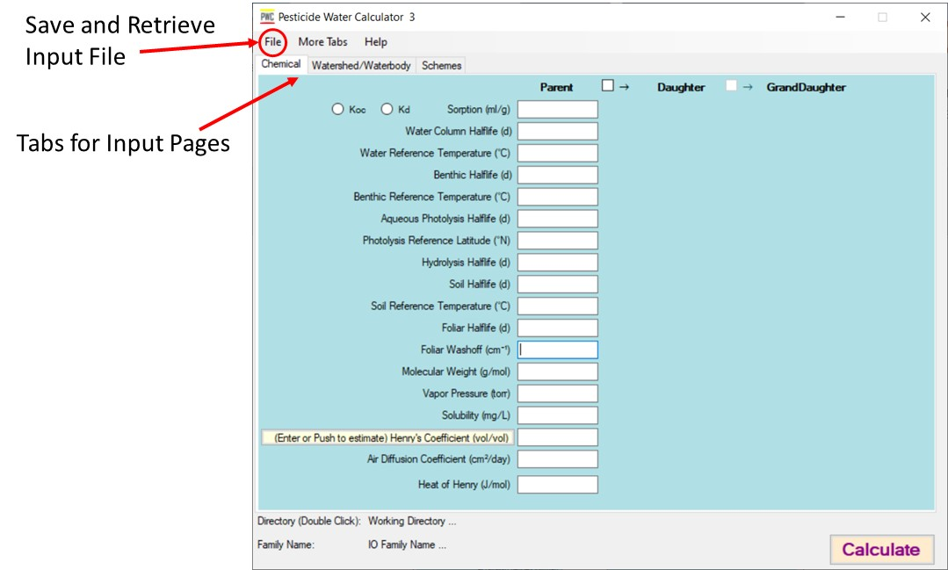

Figure 2. PWC3 user interface on startup.

## Saving and Loading Schemes

The File menu also includes items to save and load schemes. Schemes ae discussed in detail below, but briefly a scheme contains all the information to describe the time place and amount of the pesticide applications. Selecting *File/Write Scheme Table to File* will write all the scheme information to a comma delimited file which can be edited externally with a text editor and then reloaded using File/Load Scheme Table. In some circumstances, this may be simpler than editing inside the GUI. The scheme table also provide a convenient table to load into a report such as a risk assessment.

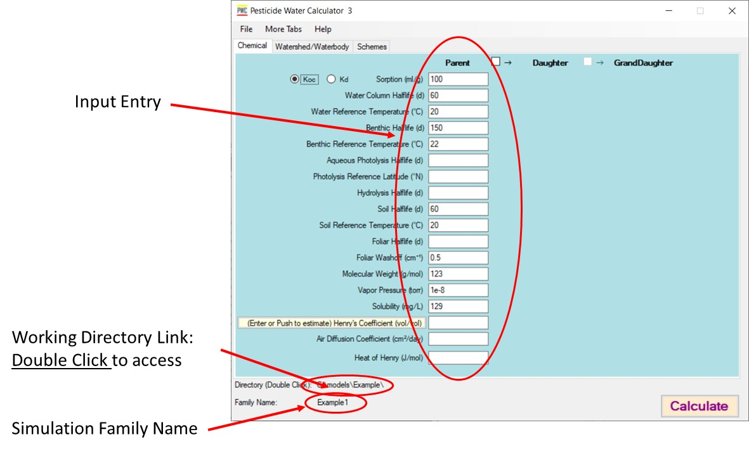

Figure 3. PWC3 after loading or saving an input file.

## Chemical Input Tab

Chemical Inputs appear on the first tab page upon starting PWC3 (Fig 2 and 3) These inputs are for the primary (or ***Parent***) compound, that is it is for the chemical that will be directly applied to the field. Degradate properties are discussed later in this document. Most chemical properties can be left blank if information is unknown, and in such cases, the function will be disabled for that process. For example, if hydrolysis is left blank, the effective degradation rate for hydrolysis will be zero (i.e., infinite half-life). For the case where a parameter must be populated (e.g., Koc), the program will warn the user to enter a value. Details of the chemical inputs are as follows:

**Koc or Kd** - Choose Kd if the sorption input is the standard sorption coefficient referenced to total solid mass. Choose Koc if the sorption input is referenced to organic carbon mass. These are well-known standard definition available in any environmental chemical transport reference.

**Sorption (mL/g)** - This is the value of either Kd or Koc

**Water Column Half-life (d)** - This is a value for water column degradation that acts on all phases of the compound. The water column, as described elsewhere, contains suspended solids and other material that can sorb the chemical. This water column degradation parameter will act on these sorbed chemical phases as well as any dissolved in the water phase.

**Water Reference Temperature (°C)** - This is the temperature at which the Water Column Half-life was obtained. PWC3 uses this temperature as a reference when adjusting the degradation as environmental temperatures change during a simulation.

**Benthic Half-life (d)** - This is a value for benthic degradation that acts on all phases of the compound. The benthos, as described elsewhere, contains solids that can sorb the chemical. This benthic degradation parameter will act on all chemical phases in the benthos.

**Benthic Reference Temperature (°C)** - This is the temperature at which the Benthic Half-life was obtained. PWC3 uses this temperature as a reference when adjusting the degradation as environmental temperatures change during a simulation.

**Aqueous Photolysis Half-Life (d)** - This is the near-surface half-life due to photolysis of the chemical dissolved in water. It should be the overall daily average value that (optimally) best represents the daylight hours when the pesticide is most actively in the environment, but 12 hours of light would be a fine assumption.

**Photolysis Reference Latitude (°N)** - This is the latitude that the photolysis study is meant to represent. PWC3 uses this latitude as a reference when adjusting the degradation for different locations.

**Hydrolysis Half-life (d)** - This is a value for degradation by hydrolysis. This parameter acts only on the aqueous phases in the model. It is effective in both the water column and the benthic region. There are no temperature adjustments on this parameter in the water body.

**Soil Half-life (d)** – This is a value for total soil degradation. This acts on all phases of the compound (water and sorbed).

**Soil Reference Temperature (°C)** – This is the temperature at which the Soil Half-life was obtained. PWC3 uses this temperature as a reference when adjusting the degradation as environmental temperatures change during a simulation.

**Foliar Half-life (d)** - This is the degradation half-life of chemical that is on the foliage. This is chemical half-life and should not include washoff due to precipitation. It could include dissipation due to volatilization if that information is available.

**Foliar Washoff (cm-1)** – Washoff coefficient that specifies the fractional removal of chemical on foliage that rain removes for every 1 cm of precipitation. PWC suggests a value of 0.5, as this information is typically not readily available. The USEPA has used 0.5 as a default value for the past 30 years in PWC-type exposure assessments.

**Molecular Weight (g/mol)** - Common molecular weight

**Vapor Pressure (Torr)** - Vapor pressure of compound (preferably at standard temperature, 25°C)

**Solubility (mg/L)** - Solubility of compound (preferably at standard temperature, 25°C)

**Henry’s Coefficient (vol/vol)** - Volumetric Henrys coefficient (preferably at standard temperature, 25°C)

**Air Diffusion Coefficient (cm2/d)** - Diffusion coefficient of the chemical in air

**Heat of Henry (J/mol)** - Enthalpy of phase change from water solution to air solution

### Daughter and Granddaughter

Checking the ***Daughter*** and the ***GrandDaughter*** boxes will allow entry and calculation of direct degradates of the parent chemical as shown in Figure 4 Definitions of inputs are the same as for the parent chemical. For each degradation process there is an entry required to specify how many moles of the degradate is produced per mole degrading of the preceding chemical. For example, if hydrolysis of one mole of parent produces two moles of daughter, then the box between parent and daughter on the hydrolysis row should be populated with 2.

Figure 4. Daughter and granddaughter inputs

## Watershed/Waterbody Tab

This tab specifies the type of waterbodies that receive the chemical coming off the field. PWC3 has two hard-coded waterbody systems that are standard for USEPA risk assessments—the ***USEPA Pond Watershed*** and the ***USEPA Reservoir Watershed***. See Figure 5. These two waterbodies can be simulated by checking the appropriate boxes.

PWC3 can also simulate any number of custom water bodies that may be run along with the reservoir and pond. These additional waterbodies are parameterized in external files as described later. To run additional waterbodies, check the ***Others***box then use the ***Select Other Water Bodies*** button which opens a file browser allowing users to choose any number of waterbody files. Waterbody files have the extension WAT. These WAT files are plain text files that can be created by means discussed later. Waterbody files can be removed from the list with the self-explanatory buttons: ***Clear Selected*** and ***Clear All***. Users can select as many hard-coded and custom waterbodies as needed, and all will be processed in a single run.

In addition, PWC3 offers output that mimics the USEPA’s Plant Assessment Tool (USEPA 2024). These additional receiving areas are known as the WPEZ and the TPEZ (see USEPA 2024 for definitions). The WPEZ is a variation of the USEPA standard Pond with a shallower depth and the allowance of flow through. The TPEZ is a terrestrial receiving area. Checking the ***USEPA TPEZ & WPEZ*** button will produce output for these additional receiving areas. The USEPA Pond simulation must always be run simultaneously these runs since the TPEZ and WPEZ use the runoff and erosion from the USEPA pond simulation (i.e, the TPEZ/WPEZ check box is enabled only if USEPA pond box is checked). The ***Use spraydrift buffers for TPEZ*** button allows the TPEZ to use the same spraydrift buffers as the pond, but normally, the TPEZ is set at the edge of field, so no spray drift buffers would be required and this box would not be checked.

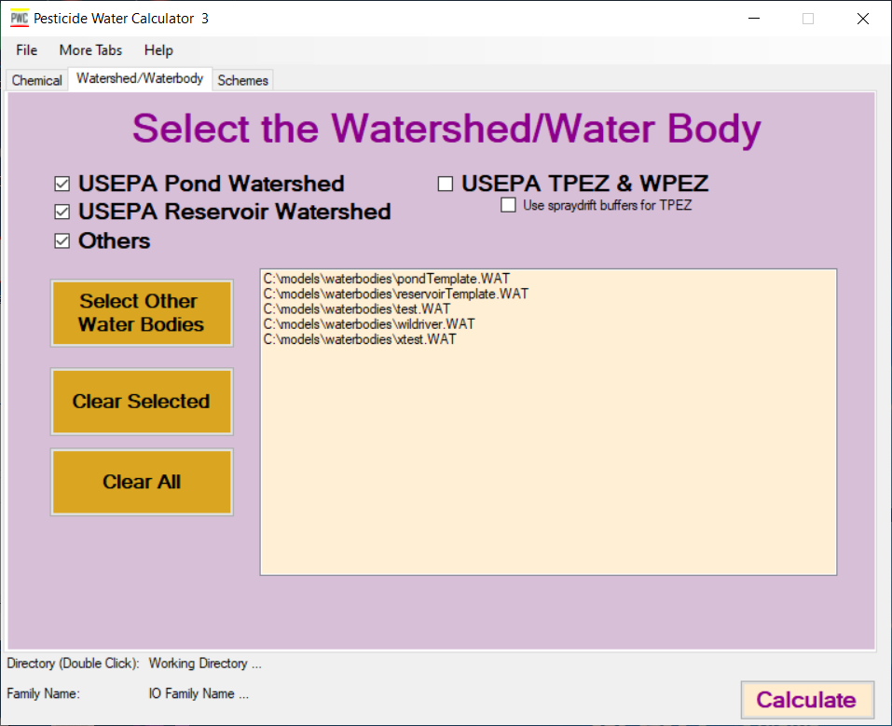

Figure 5. Tab for selecting waterbodies.

## Schemes

Schemes allow different application types and different scenarios to be simulated and processed in a single run. A scheme is the combination of a specific application schedule along with all the scenarios that it applies to. For example, one scheme could be obtained from a pesticide label that says “Apply 1 lb. per acre to all corn across the continental United States”. Another scheme could say “Apply 1lb/acre and then 1.5 lb./acre 7 days later to radish in the Southeast”. The number of schemes that can be simulated is unlimited, and rows will appear as needed as rows are populated. By using schemes, all the possible uses of a pesticide can be simulated in a single run.

Creating or editing a scheme begin by opening the ***Schemes***tab. Then check an appropriate edit box to create or edit a scheme. Write a brief description of the scheme you wish to create (see Figure 6) in the ***Scheme Description*** column of the scheme table. The description has no effect on the program, it is for your reference only, but the description should provide enough information for you to easily identify its characteristics. This scheme description will remind you on later tabs which scheme you are working on. Scheme descriptions are not recorded in output displays, since the text would be too long; instead, schemes are identified in the output by the scheme number in the first column.

After checking the ***Edit*** box, two additional tabs appear (***Applications*** and ***Scenarios*** tabs). These new tabs allow users to create and edit the scheme properties. The ***Commit*** buttons on the scheme table (on ***Schemes*** Tab) saves the edits to volatile memory. This means that the edits will apply to the current simulation but will not be saved if the program is shut down. To permanently save any work, use the ***File***\***Save*** command after you make commits. The ***Delete*** button removes the scheme from the run. The number of schemes is unlimited, and more rows will appear as needed as rows are populated. ***Scheme******No.*** in the first column simply specifies the numerical order of the schemes in the scheme table.

Any time that a scheme is changed whether on the ***Schemes*** page, the ***Applications*** page or the ***Scenarios*** page, you must press the ***Commit*** button next to the scheme on the ***Schemes*** page to keep the changes. **Importantly, commits are saved in volatile memory for the duration of the session (just like any text box). If you want to permanently save the commits (or any text box changes), then save your work to a hard file with the *File*/*Save* command.** Also, before a new scheme can be added, all previous schemes must have been committed (PWC3 ensures this with alerts). Once a scheme has been committed, a new scheme can be added on the last row.

All scenarios include a reference to a weather file name. Weather files may be located anywhere on your computer network, so any simulation requires that you specify the location of the weather files. Click on the ***Weather File Directory*** button to open a Windows file browser, then find the location of your weather files. This only needs to be done once, and the location will apply to all schemes.

After entering the scheme description, click the ***Edit*** box for the scheme. Checking the edit box allows you to enter information for that scheme on the following two tab pages (i.e., ***Applications*** tab and ***Scenarios*** tab).

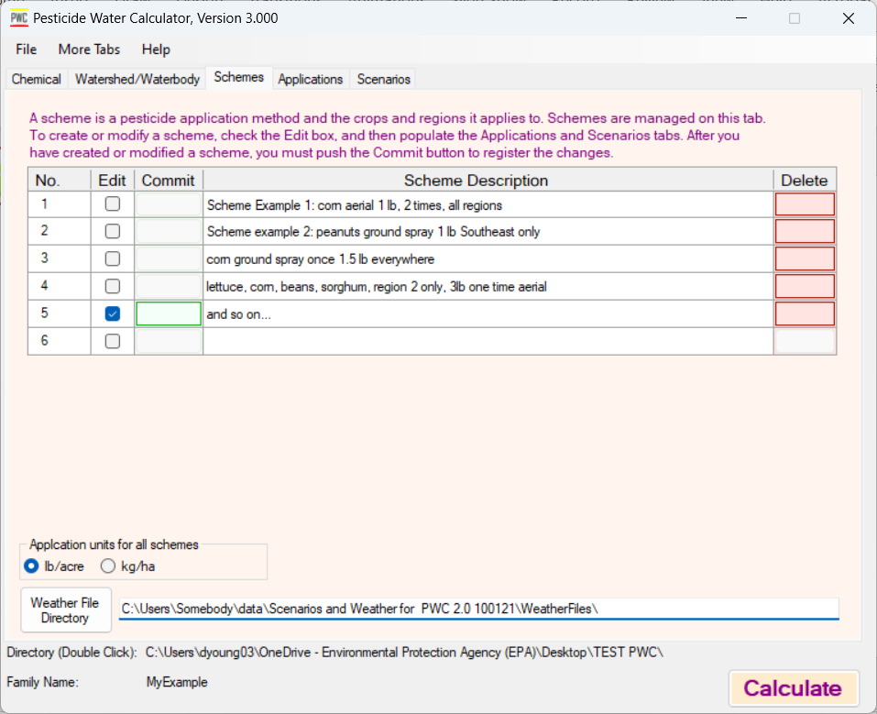

Figure 6. Schemes summary page

### Applications Tab Page

After checking the ***Edit*** box for the scheme that you want to create or edit, go to the ***Applications*** tab(see Figure 7). The ***Applications*** tab is the first page for parameter entry for a scheme. At the top on the***Applications*** tab*,* you will see the *Scheme Number* and the *Scheme Description* that you previously entered. This will remind you of the scheme you are working on. Enter and manipulate application specifics for the pesticide on this tab as follows:

1. Choose the **Application Units** wither lb./acre or kg/ha (This is on the Schemes Tab)
2. Choose the appropriate ***Dates Relative To*** which specifies how relative application dates are referenced or if absolute dates are to be used.
3. Populate application table as follows:
   1. ***Days*** can be the integer number of days after emergence, maturity or harvest. Negative values are used to indicate days before and positive values indicate day after. Zero value means application is on the exact day specified. Absolute dates are specified by the format Mon/Day where Mon and Day are integers (e.g., March 23 is 3/23). Absolute date can be optionally specified with a year as for example 3/23/1991. In this case, the application would only be applied during the year 1991. For all other cases where year is not specified, applications occur every year of the simulation.
   2. Enter the ***Amount*** of pesticide applied for the application on the respective date. Units depend on the choice from step 1.
   3. Choose the ***Depth*** that the pesticide penetrates the soil at the time of application. There is a standard default depth for some of the application methods (i.e., 4cm) which will auto-populate, and the user will be unable to change this value.
   4. Select the ***Split*** for the T-band option if applicable. This specifies what fraction of the pesticide application resides in the upper 2 cm of the soil during a T-band application. This will be auto populated for some application methods.
   5. Choose the ***Drift Type***. The drop-down menu lists the most typical aerial applications for regulatory work. Additionally advanced users can specify custom choices as described later in ***Watershed/Waterbody*** file development.
   6. Enter the ***Drift Buffer*** distance relevant to spray drift. Standard buffer attenuations are pre-calculated in the ***Watershed/Waterbody*** files so no additional external work is needed to obtain these values.
   7. Enter the ***Period*** of the application. This normally will be set to 1, which means applications occur every 1 year. A value of 3 would mean applications occur once every three years, and so on.
   8. Enter the ***Lag*** time. This is the start year for the applications. Normally the lag would be zero which mean that the applications are not lagged and occur on the first year of the simulation. A value of one would mean that application is delayed one year and then would start on the second year of the simulation. The combination of ***Period*** and ***Lag*** allow users to develop more complex application schemes that vary from year to year.
   9. If an application needs to be removed, then push the ***Delete*** button.
4. The ***Clear Table*** button on the top right can be used to easily remove all entries in the application table.
5. Check the ***Use an Application Window*** if you want to simulate the impact of application day on the output. This will initiate additional simulations for different application start days. Populate the following:
   1. ***Window Span*** is the number of days out that the simulation should cover. If you want to simulate the window between June 1 and June 30, enter 30 for the ***Window Span***.
   2. ***Step*** is the number of days until the next simulation occurring within the window spam. For example, if you want to simulate every application start day within the window span, then enter 1. If you want simulations only every 3rd day, enter 3, and so on.
6. Check the ***Adjust Application Dates if Raining*** if you want to include a farmer’s potential to consider predicted rainfall on their application date. This routine will adjust the application date according to the weather and the following parameters:
   1. ***Intolerable Rain*** is the amount of rain (in cm) that will prevent the farmer from applying pesticide on that day.
   2. ***Intolerable Rain Window*** is the number of days into the future that the Intolerable Rain should not occur.
   3. ***Optimum Application Window*** is the number of days around the application date that it is acceptable to apply the pesticide.
   4. ***Minimum Days Between Application*** is the legal minimum number of days between applications when multiple applications per season are allowed. Note: To get maximum effectiveness from this routine, the applications date in the application table should be greater than this minimum.

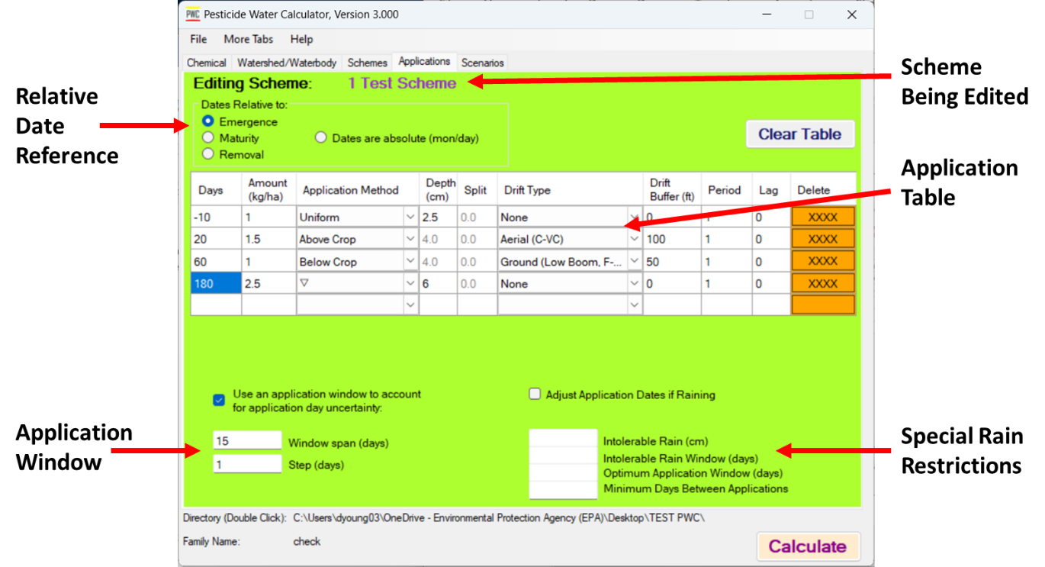

Figure 7. Applications tab for Scheme #1

### Scenarios Page

Th ***Scenarios*** page (Figure 8) is the second part of the scheme. Here you specify all the scenarios that are used with the pesticide application that you specified on the ***Applications*** tab. Scenarios can be added to the scheme by pushing the ***Select Scenarios*** button. This opens a Widows file browser and scenarios can be selected. Multiple scenarios can be selected using the normal Windows functions with the Control and Shift keys. Scenarios can be removed from the list with the ***Clear Al*l** and the ***Clear Selected*** buttons. Scenario paths and names can also be edited by double clicking on an individual scenario, in which case an edit box opens where edits can be made (Figure 9).

Alternatively, scenarios can be read in from a file with specific formatting and ordering (EPA 2019). To use this option, check the box labeled ***Get scenarios from a csv file***. Then, find for the file using the Windows file browser that pops up. This option may be convenient for massive batches of scenarios that have been chosen by procedures external to PWC, as in high resolution spatially explicit assessments.



Figure 8. Scenario Page Tab escribing the scenarios that are used in a scheme.

Figure 9. Double clicking scenario name will bring up an Edit box where file and location name can be changed.

### Printing and Editing Schemes Externally

Schemes may also be externally edited which may provide some benefit to advanced users who want to make quick and complex edits, as well as allow for an easy way to add the scheme details into a risk assessment. Selecting ***File***/***Write Scheme Table to File*** on the top menu will create a comma separated file with the scheme details. This file can be edited and then uploaded back in to PWC3 by the ***File***/***Load Scheme Table*** menu item. The external editing is more limited than the interface but will be usable for nearly all practical application schemes. The limitations are that the maximum number of applications per season is 10 and if the intent is to reload an edited scheme back into the PWC3, then the scenarios in each scheme need to be all from the same directory. This latter limitation, is because the PWC3 in an effort to minimize clutter, only records the path of the first scenario in the external scheme table. An example of a scheme table created and then opened in Excel is given in Figure 10 (not all columns are shown in this example). This table can be edited and reloaded into PWC3 or copied into a Word document and formatted for a risk assessment.

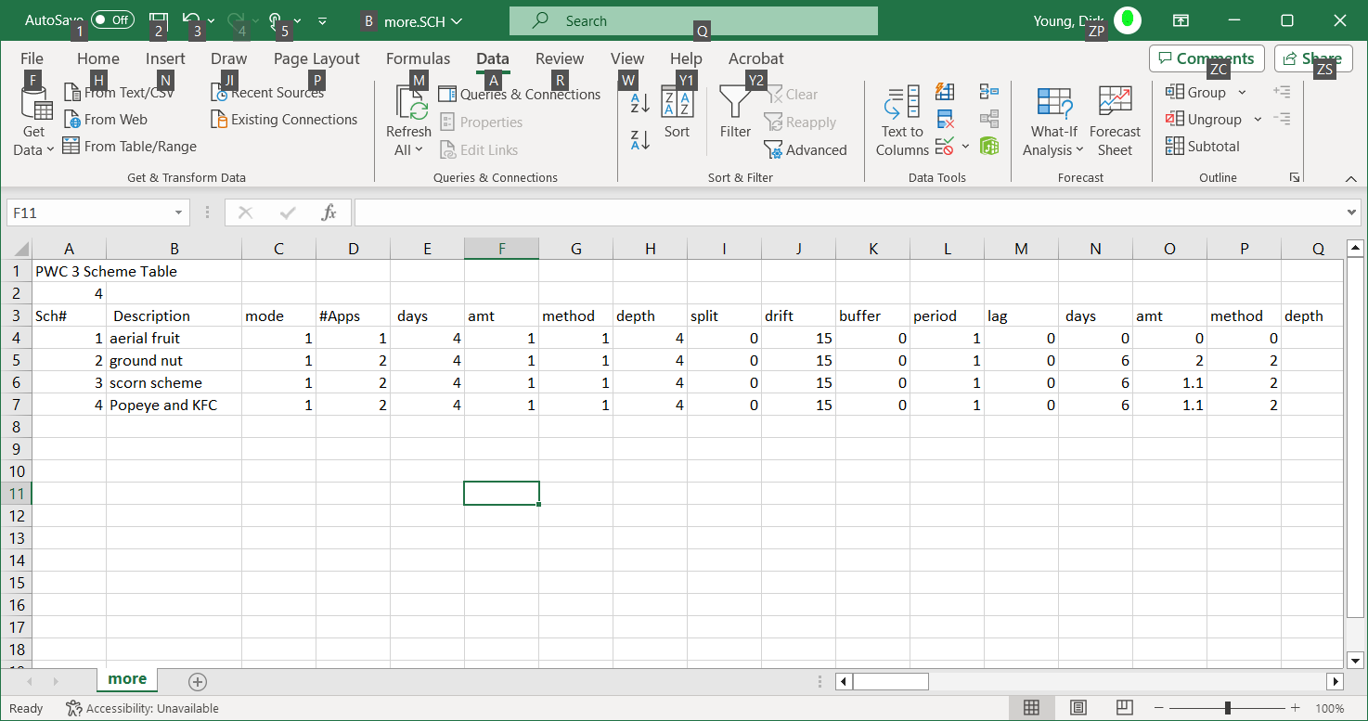

Figure 10. Example of Scheme Table opened with Excel.

# More Tabs (Advanced Options)

The menu item at the top of PWC3 labeled ***More Tabs*** allows for more advanced work that would not typically be needed for regulatory work. These advanced tab pages can be opened (and closed) by selecting the specific submenu item. The specifics of the advanced tab pages are described in the following:

## Toggle Advanced

***Toggle Advanced*** - Opens and closes the ***Advanced*** tab page with some features that are not typically used but may be of interest in advanced work. Users of these features should be expertly familiar with the PRZM5/VVWM theoretical documentation. A brief summary of the features is given here:

***Adjust CN for Soil Moisture*** - Normally in PWC, the curve number is a adjusted for with higher curve numbers occurring as soil moisture increases, but for some validation or sensitivity analyses it may be required to fix the curve number at the known input value. Unchecking this box will fix the daily curve numbers to the input values without further adjustment based on moisture.

***Erosion Model (1,2,3)*** - By default PWC uses MUSS to calculate erosion. Two other models are available and can be selected by entering the appropriate number.

***Q10*** - By default, degradation changes by a factor of 2 for every 10°C increase in temperature. This Q10 value can be altered by entering a different value in this box.

***Use Freundlich Isotherm*** - This will allow the use of the Freundlich exponents (N on this same tab page), and nonlinear sorption will be simulated in the field portion (i.e., PRZM) of PWC. Nonlinear sorption is not simulated in the waterbody (i.e, VVWM). Use of this feature may thus be most appropriate for groundwater estimates.

***Use Nonequilibrium*** - This will allow the use of sorption nonequilibrium routines for the field portion (PRZM) of the program and requires population of the nonequilibrium parameters on this same tab page. Refer to the PRZM-VVWM theoretical documentation for use of this advanced feature. Nonequilibrium sorption is not simulated in the waterbody (VVWM). Use of this feature may thus be most appropriate for groundwater estimates.

***Sub Time Steps*** - When using Nonlinear and Nonequilibrium option, the program may become unstable and imprecise if large time steps like for the 1-day default that the program normally uses. This option allows the time step to be subdivided by the factor entered here. By default, this value is set to 1, as normal runs do not have stability problems.

***Lowest Concentration for Freundlich*** - Because Freundlich isotherms approach infinite sorption as concentration decreases, a minimum concentration must be given so that the isotherm becomes linear below that value. This prevents program crashes. A value is not need unless Freundlich isotherms are used.

***Nonequilibrium and Freundlich Parameters*** - See PRZM-VVWM documentation for explanation of these parameters.

***Pesticide Mass in Nonequilibrium Region*** – Delivers respective output to output file.

***Pesticide Mass in Equilibrium Region*** – Delivers respective output to output file.

***Make HED files*** - Produces output files for use by HED

***Soil Degradation –*** option to use aqueous-phase only or total degradation for soil metabolism.

***Developer stuff*** – utility to find fonts and symbols for interface development.

***Subsurface Degradation Profile for Soil Metabolic Degradation*** - The default degradation profile is set to 10 cm constant degradation that corresponds to the input soil degradation rate. This rate then declines to zero at 200 cm. Actual total degradation will depend on competing degradation processes (i.e., hydrolysis). In addition to the default profile, users can design any ramp-type profile, a constant or an exponentially declining profile. See PRZM/VVWM documentation for details.

## Toggle Scenario Examiner

This opens the ***Scenario Examiner*** page. This page allows a user to create or edit or inspect a scenario. To create a scenario, fill out the required fields and then push the ***Push Here to Save this Scenario*** button. To inspect or edit an existing scenario, push the ***Push Here to Examine a Scenario*** button. The scenario will be loaded, and the fields populated. When finished save the scenario with the ***Push Here to Save this Scenario*** button. Fields on this page are more precisely defined in the technical documentation (Young, 2024), but are briefly summarized below:

***Scenario ID*** - Any text that identifies the scenario.

***Get Weather File*** - Specifies the weather file.

***Scenario Latitude*** - Typically the latitude of the weather file.

***Adjust PET factor*** - Allows proportional manipulation of the evaporation (i.e., 0 eliminates evaporation, 2 doubles it). For WEA files, value should be set to 1.

***Volatilization Boundary Layer*** - Film layer on field for volatilization, typically 5 cm.

***Irrigation***

***None*** - No irrigation.

***Over Canopy*** - Canopy intercepts and holds irrigation water.

***Under Canopy*** - No canopy interception.

***Max Rate*** - Maximum amount of irrigation water in a day.

***Allowed Depletion*** - Fraction of available water below which irrigation applies.

***Extra Water Fraction*** - Additional fraction of required water applied for salt removal.

***Soil Irrigation Depth***:

***Root Zone*** - Irrigates to bottom of root zone.

***User Specified*** value - Irrigates to user-specified depth.

***Depth of soil evaporation*** - Minimum soil depth available for evaporation when root development is low

***Simulate Temperature*** – Check for yes and uncheck for no.

***Lower BC Temperature*** - Temperature at bottom of soil profile. The default value is 10 ℃.

***Albedo*** - Self explanatory. The default value is 0.2.

***Soil Profile*** - This is a table to populate the soil characteristics. The table adds a blank row automatically as and users can delete rows by pushing the Delete(***X***) button on the far right Each row represents a soil layer with uniform properties with the properties that follow:

***#*** - Any number used for identification.

***Thickness*** - Layer thickness.

***Rho (ρ)*** - Bulk density

***Max Cap*** - Maximum water capacity during transport (somewhere between field capacity and porosity).

***Min Cap*** - Lowest water content, frequently wilting point used.

***O.C.*** - Organic carbon content.

***Delta (Δ)*** - Increment size for numerical calculations, also used to simulate dispersion (see below).

***Dispersion Control and the Auto Profile***

Standardized profile assumes soil profile data is raw data. It ignores the delta values and automatically conforms the data to the discretization scheme selected here. Additionally, the profile will be extended to the depth selected here and the water contents below 10 cm will be adjusted to reflect halfway between field cap and porosity. The last line will be saturated and assumed to be the aquifer output of interest. The lowest profile characteristics will be extrapolated to all points below. This conforms to the NAFTA standard GW profile, ensuring proper dispersion.

Vertical Dispersion is controlled by numerical dispersion through the backward differencing of the finite difference routine implemented in the transport calculations. Larger increments mean larger amounts of dispersion. Dispersion can be precisely controlled by specifying the appropriate increments in the associated table. USEPA gives recommended values in the adjacent table. Aquifer screen (where output is taken) is from the compartments of the last line. To maintain USEPA recommended dispersion, the depth should only be adjusted by changing the 5th row and the 50 cm increment size should be maintained.

***Crop***

The crop table is detailed in the technical documentation and is relatively self-explanatory. Emergence is the date when the crop emerges from the soil. Maturity is the date when the crop has a maximum canopy. Harvest is the date that the canopy disappears. Root depth is the maximum root depth,; Cover is the maximum fractional area coverage of the canopy. Height impacts volatilization and is the maximum crop height. Hold up is the amount water that the canopy can hold at the canopy’s maximum cover. Removal refers to what is done with the canopy at harvest. Periodicity specifies how often the crop is planted. Lag refers to the number of years after the simulation starts that the crop is planted.

## *Evergreen* - If this box is checked, the crop table is ignored, and the evergreen specifications are used. Toggle Waterbody Examiner

This opens the Waterbody Examiner Page (see figure 12). This page allows a user to create or edit or inspect a waterbody/watershed. To create a waterbody/watershed, fill out the required fields and then push the ***Push Here to Save the Water Body*** button. To inspect or edit an existing waterbody, push the ***Push Here to Examine Water Body*** button. The waterbody will be loaded, and the fields populated. When finished save the waterbody with the ***Push Here to Save the Water Body*** button.

Figures 12 and 13 show an example of a loaded watershed file. A brief description of the parameters on this tab page are given here, and details of the parameters including their theoretical basis can be found in the PRZM/VVM documentation (Young, 2024).

***Simulation Type***: this is an indicator for how water flow through the waterbody is simulated.

***Simulation Type 1*** will simulate a varying volume water body where the volume of the waterbody will fluctuate depending on the water amounts entering and exiting the body. Water will overflow and exit the system if the entering water exceeds the **Maximum Depth** (parameterized in the first column of boxes). Water can enter the system by runoff from the adjacent field, direct precipitation, or by **Base Flow** (see box below). Water can exit the system by overflow and evaporation. PRZM/VVWM sets a minimum water depth to 10-8 meters (essentially zero) to prevent numerical errors and divide-by-zero issues.

***Simulation Type 2*** keeps the waterbody at a constant volume and water does not enter or exit the water body. Water losses by evaporation losses also do not occur. Chemical mass associated with any incoming water does enter the system. This could be conceived by assuming that entering runoff and direct precipitation exactly matches the evaporating water, thus keeping volume constant.

***Simulation Type 3*** will keep the waterbody volume constant but will allow flow through the waterbody. Water into the system occurs by runoff. Evaporation, direct precipitation, and base flow are ignored.

***Water Body Area*** - Area of the water body, necessary for spray drift, evaporation, volatilization, benthic exchange etc.

***Initial Depth*** - Depth at the start of the simulation. Specifies the constant depth for Simulation Type 2 and Type 3.

***Maximum Depth*** - Depth at which water overflows. Only used for Simulation Type 1. Does not impact Type 2 or 3.

***Flow averaging*** - For Simulation Type 1 and Type 3, the runoff volumes can be smoothed out by averaging the runoff. This could simulate the effects of a reservoir dam where flow out is buffered or less spiky than the flow in. A value of 0 is a flag to average all flow so that there is a constant daily outflow. A value of 1 means each day’s runoff flows out of the waterbody on the same day. A value of 30 would mean that a day’s runoff entering the waterbody would be evenly distributed in the outflow over the next 30 days.

***Base Flow*** - A constant input water flow (without chemical) that applies to Simulation Type 1 and 3

***Field Area*** - The area of the adjacent runoff-producing field.

***Flow Length*** - The hydrologic length of the field, typically the longest runoff path of the field (square root of field area for a square field would be fine).

***Benthic Depth*** - Depth of lower compartment in VVWM.

***D/dx*** - An overall first-order mass transfer coefficient between b4enthic and water column.

***Benthic Porosity*** - Porosity of benthic region.

***Benthic Bulk Density*** - Bulk density of benthic region.

***Benthic OC*** - Organic carbon fraction of benthic sediment.

***Benthic DOC*** - dissolved organic carbon in benthic pore water.

***Benthic Biomass*** - concentration of benthic biota in pore water

***DFAC***- attenuation parameter for photolysis

***Suspended Solids*** - suspended solids concentration in water column.

***Chlorophyll***- chlorophyll concentration in water column

***Water Column Foc*** - organic carbon fraction on suspended solids in water column

***Water Column DOC*** - dissolved organic carbon in water column.

***Water Column Biomass*** - biomass concentration in water column

***Special Condition***

***Zero* Concentration *when Water Level Drops Below*** – for some simulations it may be desirable to ignore aquatic concentration in VVWM when the water depth are so low that they cannot support life. Concentrations in such cases may be very high, but only microscopic amounts of water exist. In this case, calculations for risk assessments in water may be of more practical use if these concentrations were ignored. Checking this box allows user to specify a depth below which concentrations are ignored only for the sake of output processing and display. Mass balance throughout the simulation is maintained always.

***What Depth?*** - Specify the depth if the check box above is checked.

***Spray Drift Fractions*** - This is a table of spray drift values as determined from Adrift and for which apply to the specific waterbody. The applications in the left column are the most common methods used in exposure assessments and should cover nearly every case. These methods correspond to those on the ***Applications*** page tab in the***Drift Type*** drop down menu. In the Figure 12 table, buffer distances are in the top row. If a user on the ***Applications*** page tab selects an in-between buffer, then distance is linearly interpolated.

Figure 12

F

Figure 13. Spray Drift Table on Watershed Tab

## Toggle More Output

This toggles the ***Optional Output*** tab page. Normally the PWC3 creates a single output file summarizing all batch runs. However, users can find more output by using this tab page. Checking the boxes provides the most common output which appears in a file with a ZTS extension. These are time series files giving daily values for the selected parameters. Additionally, more obscure output can be obtained by specifying the parameter fields in the table, which has the same traditional PRZM definitions. See PRZM3 manual (https://archive.epa.gov/scipoly/sap/meetings/web/pdf/przm.pdf) for details. Daily output for the water body appears in its own file that have an ending of *_WB.OUT*. Separate files will be produced for degradates.

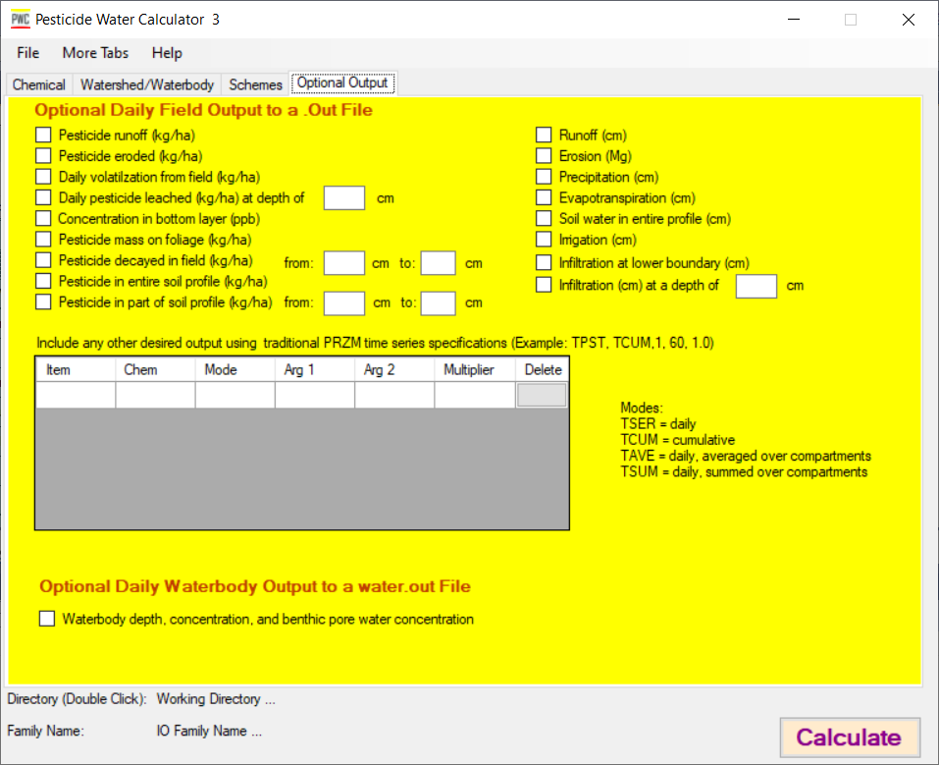

Figure 14. Optional output tab in PWC3

# Running PWC3

Simply push the ***Calculate*** button in the lower right corner of PWC3. This will start the simulations with output delivered to the ***Working Directory*** (double click the directory to go directly to it). The PWC3 will produce only he most necessary files needed for a risk assessment, and clutter is at a minimum. The basic file for any run will be:

**run_status.txt** - Information on the run. If an error occurs, this file will provide troubleshooting information. If everything is fine, *Total clock time* will be reported as the final statement.

**PRZMVVWM.txt** - This is the input file for the PRZM-VVWM program. Normally you do not need to interact with this file. However, it may be useful to know that it is exactly the same internally as the *.PW3 input file, so it may come in handy if the *.PW3 is ever accidently lost or altered and this file could provide backup.

***familyname*_summary.txt** - This provides a summary of every simulation, including every simulation in the application window, every waterbody, and every scenario.

**medians_*Waterbody*.txt** - For each *waterbody* one of these files will be created. It will contain only the median values of the application window, so it can be considerably more concise than the *familyname*_summary.txt file.

If the TPEZ/WPEZ are simulated, the following additional files will be created:

***familyname*_summary_TPEZ.txt** -This provides a summary of every simulation, including every simulation in the application window, for the TPEZ, and every scenario.

***familyname*_summary_WPEZ.txt** - **T**his provides a summary of every simulation, including every simulation in the application window, for the WPEZ, and every scenario.

**medians_TPEZ.txt** - For the TPEZ, this will contain only the median values of the application window, so it can be considerably more concise than the *familyname*_summary.txt file.

**medians_WPEZ.txt** - For the WPEZ, this will contain only the median values of the application window, so it can be considerably more concise than the *familyname*_summary.txt file.

If optional daily field files are selected, the following will be created:

***Familyname_scenario_id_watershed_window#.out*** - Daily file of user-selected field data. One file for each simulation will be created.

***Familyname_scenario_id_watershed_window#_species_waterbody.out*** - daily file of waterbody depths and concentration.

# Reference

Young, D.F., 2019. The USEPA Model for Estimating Pesticides in Surface Water, in *Pesticides in Surface Water: Monitoring, Modeling, Risk Assessment, and Management*. American Chemical Society, editors Goh, Kean, and Young.

Young, D.F., 2024 PRZM-VVWM with TPEZ For Use with PWC 3. D.F. Young, Office of Pesticide Programs, U.S. Environmental Protection Agency, Washington, D.C. 20460 (In press).

USEPA, 2019 Estimating Field and Watershed Parameters Used in USEPA’s Office of Pesticide Programs Aquatic Exposure Models – The Pesticide Water Calculator (PWC)/Pesticide Root Zone Model (PRZM) and Spatial Aquatic Model (SAM) 2019). U.S. Environmental Protection Agency, Washington, D.C. 20460

Appendix A Scheme Table

|  |  |  |
| --- | --- | --- |
| Column | Heading |  |
| A | Sch# | scheme number |
| B | Description | scheme description |
| C | mode | 0=absolute date, 1=relative to emergence, 2=maturity, 3=harvest |
| D | #Apps | Number of pesticide applications in application table |
| E | days | Either relative date (e.g., 3) or an absolute date (6/4) |
| F | amt | Pesticide mass applied for the date in col E |
| G | method | Application method:  1 = Below crop,  2=Above crop,  3=Uniform,  4=At specific depth,  5=T band,  6=Increasing distribution with depth,  7=Decreasing distribution with depth |
| H | depth | Depth relevant to col G |
| I | split | Upper fraction for a T-band if applicable |
| J | drift | Drift Method:  1=Aerial (very fine to fine)  2=Aerial (fine to medium)  3=Aerial (medium to coarse)  4=Aerial (coarse to very coarse)  5=Ground High Boom (very fine to fine)  6=Ground High Boom (fine to medium)  7=Ground Low Boom  8= Ground Low Boom  9=Airblast  10=Airblast  11=Airblast  12 Airblast  13=Airblast  14=Directly Applied  15=None |
| K | buffer |  |
| L | period |  |
| M | lag |  |
| N | days |  |
| O | amt |  |
| P | method |  |
| Q | depth |  |
| R | split |  |
| S | drift |  |
| T | buffer |  |
| U | period |  |
| V | lag |  |
| W | days |  |
| X | amt |  |
| Y | method |  |
| Z | depth |  |
| AA | split |  |
| AB | drift |  |
| AC | buffer |  |
| AD | period |  |
| AE | lag |  |
| AF | days |  |
| AG | amt |  |
| AH | method |  |
| AI | depth |  |
| AJ | split |  |
| AK | drift |  |
| AL | buffer |  |
| AM | period |  |
| AN | lag |  |
| AO | days |  |
| AP | amt |  |
| AQ | method |  |
| AR | depth |  |
| AS | split |  |
| AT | drift |  |
| AU | buffer |  |
| AV | period |  |
| AW | lag |  |
| AX | days |  |
| AY | amt |  |
| AZ | method |  |
| BA | depth |  |
| BB | split |  |
| BC | drift |  |
| BD | buffer |  |
| BE | period |  |
| BF | lag |  |
| BG | days |  |
| BH | amt |  |
| BI | method |  |
| BJ | depth |  |
| BK | split |  |
| BL | drift |  |
| BM | buffer |  |
| BN | period |  |
| BO | lag |  |
| BP | days |  |
| BQ | amt |  |
| BR | method |  |
| BS | depth |  |
| BT | split |  |
| BU | drift |  |
| BV | buffer |  |
| BW | period |  |
| BX | lag |  |
| BY | days |  |
| BZ | amt |  |
| CA | method |  |
| CB | depth |  |
| CC | split |  |
| CD | drift |  |
| CE | buffer |  |
| CF | period |  |
| CG | lag |  |
| CH | days |  |
| CI | amt |  |
| CJ | method |  |
| CK | depth |  |
| CL | split |  |
| CM | drift |  |
| CN | buffer |  |
| CO | period |  |
| CP | lag |  |
| CQ | window |  |
| CR | span |  |
| CS | step |  |
| CT | raifast |  |
| CU | rainlimit |  |
| CV | intolwindow |  |
| CW | optwindow |  |
| CX | mindays |  |
| CY | #scn |  |
| CZ | scn dir |  |
| DA…ZZ | No heading-scenarios |  |