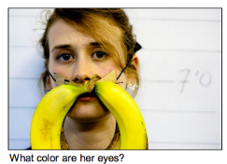3. evaluation

3. Evaluation

2. Data Collection



Answer visual question



Group 2

**+**



Answer visual question

Give rationale



Group 1

1. Crowd annotation