Principles of Communications
Analog Modulation

Aim of the Project
To study the principles of the analog modulation and familiar with the spectrum properties (AM, FM and PM).

Requirement of the Project
  - This project requires two students to work as a team. In case a team cannot be formed, one student working alone is also acceptable.
  - You must submit the electronic copy of lab report. The report should consist of answers to all the questions, simulation results, analysis and discussion.
  - Send the final project report to the TA’s email address with the subject “Lab1” .

Contents of the Project
- Generate a sine wave, and modulate it at a certain carrier frequency using AM (amplitude-modulation) modulation. The modulation parameters, such as carrier frequency, amplitude and modulation index, should be changeable through the front panel. Display the waveform of the modulated signal and the envelope and their spectrum on the front panel. Please compare conventional AM and DSB-SC. (Do NOT use the internal modules of the LabVIEW)
- Generate a sine wave, and modulate it at a certain carrier frequency using FM modulation. The modulation parameters, such as carrier frequency and frequency deviation constants, should be changeable through the front panel. Display the waveform of the modulated signal and the original signal on the front panel respectively.
- (Do NOT use the internal modules of the LABVIEW)

Programming Demonstration:
- AM modulation
The following steps describe how to build a VI which implements the longer of the two equations shown above for Amplitude Modulation. Inspect the front panel and block diagram shown in Fig.1 and Fig.2 respectively. When this VI is completed, you will be able to select the amplitude and frequency of both the carrier and data signals as well as see the time and frequency domain representation of the signals. The graphs display the behavior of the carrier and sideband signals as modulation parameters (amplitude and frequency) change. The following front panel represents the operation of a completed VI:
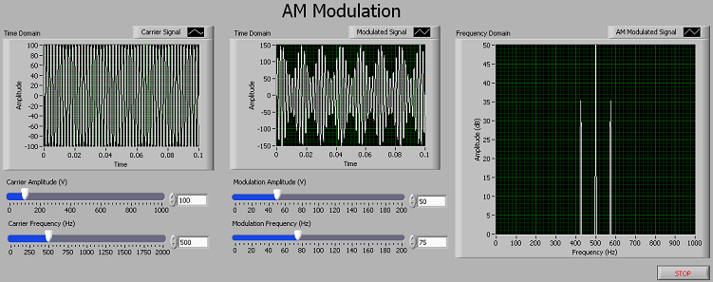
Fig1. Front Panel of Completed AM modulation VI
The block diagram consists of a while loop which contains various controls and graphs to display and control the AM signal component information.
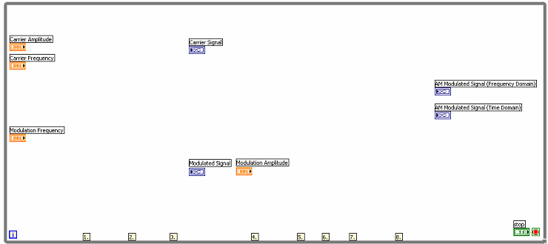
Fig2. AM modulation example block diagram
    - Place an “Add” and “Subtract” VI on the block diagram. Wire the “Carrier Frequency” and “Modulation Frequency” slider controls into the add function. Wire the “Carrier Frequency” into the top connector on the subtract function and “Modulation Frequency” into the bottom connector to subtract the two values.
    - Place a “Simulate Signal” Express VI on the bock diagram. A dialog box will open to configure the function. Select the signal type to be a sine wave, set the frequency to 10 Hz, and the amplitude to 1 volt. Increase the samples per second to be 100000. Deselect the option to automatically select the number of samples, and set the value to also be 100000. Once you have finished, the dialog box should resemble the image below:
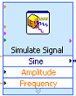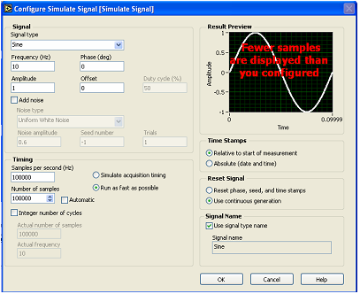
(a) (b)
Fig3. Final dialog box options for the Simulate Signal Express VI
Select the “OK” button. LabVIEW will now generate all of the code required for this function. Make three copies of the function by selecting the VI on the block diagram and holding CTRL while dragging the cursor to an open area. For the first Simulate Signal VI, wire the Carrier Amplitude into amplitude input and Carrier Frequency into frequency input. For the second Simulate Signal VI, wire the output of the add function into the frequency input. Wire a constant value of 1 into the amplitude input by right-clicking on the connector and selecting “Create>>Constant”. For the third Simulate Signal VI, wire the output of the subtract function into the frequency input. Again, wire a constant value of 1 into the amplitude input by right-clicking on the connector and selecting “Create>>Constant”.
    - Place a “Multiply” VI on the block diagram. Wire the sine wave outputs of the second and third Simulate Signal VIs into the multiply function. Wire the output of the multiply function into the Modulated Signal graph. Also, wire the output of the first Simulate Signal VI into the Carrier Signal graph.
    - Place a “Divide” VI on the block diagram. Right-click on the lower input connector and create a constant value of 2. Highlight the constant and the divide function on the block diagram and make a copy by holding CTRL while dragging the cursor to an open area. Wire the input of one of the divide functions to the output of the second Simulate Signal VI. Wire the input of the other divide functions to the output of the third Simulate Signal VI.
    - Place two “Multiply” VIs on the block diagram. Wire the Modulation Amplitude control and the output of one of the divide functions into the first multiply function. Wire the output of the second Divide function and the Modulation Amplitude control into the second multiply function.
    - Place a “Subtract” VI on the block diagram and wire the outputs of both of the multiply functions from the last step into the inputs. Connect the inputs so the data from the second Simulate Signal VI is being subtracted from the third Simulate Signal VI.
    - Place an “Add” VI on the block diagram and wire the output of the subtract function from the last step into the function. Also wire the output from the first Simulate Signal VI into the add function.
    - Place a “Spectral Measurements” Express VI on the block diagram. A dialog box will open to configure the function. Select the spectral measurement to be magnitude (peak) in dB. Set the Window to be “7 Term B-Harris” (do not enable averaging). Once you have finished, the dialog box should resemble the image below:
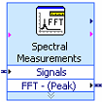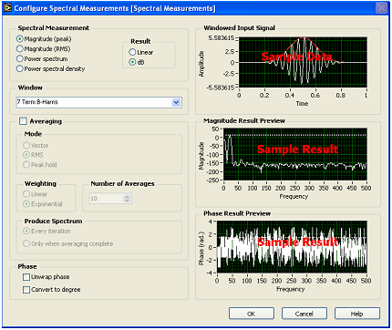
(a) (b)
Fig4. Final dialog box options for the Spectrum Measurements Express VI
Select the OK button. LabVIEW will now generate the code for the function. Wire the output of the add function from the previous step in the signals input connector. Also wire the output of the add function to the AM Modulated Signal (Time Domain) graph. Finally wire the output of the Spectral Measurements Express VI to the AM Modulated Signal (Frequency Domain) graph.
Your VI is now complete. The block diagram of the completed program should resemble the image below. Press the run icon to execute your VI. Vary the values for the carrier and modulation amplitude and frequency to see the effect it has on the signal.
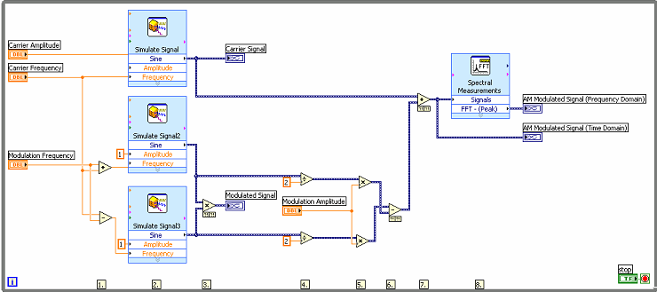
Fig5. Completed AM modulation block diagram
- FM modulation
The following demonstration will introduce more practical aspects of frequency modulation and will examine the effect of the carrier frequency and FM deviation on the resulting FM signal.
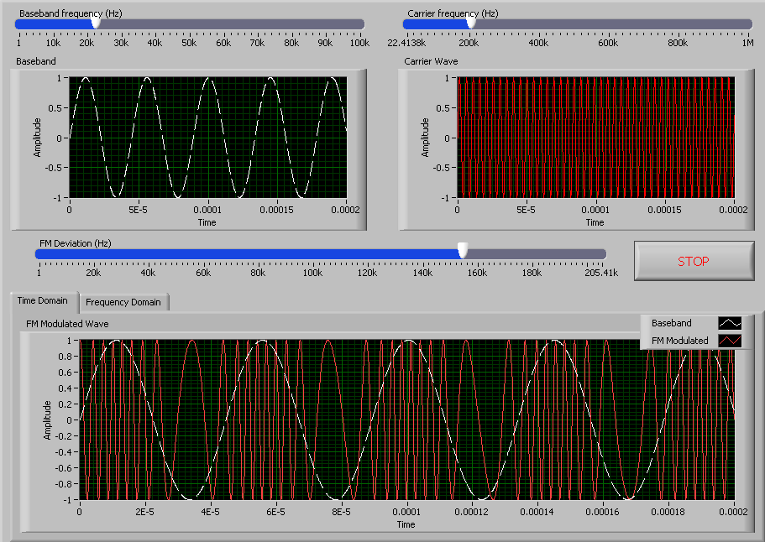
Fig 6. FM modulation VI front panel
- First, the front panel of the FM Modulation VI should be like Figure 6. Notice that there are three basic parameters that we will adjust. First, the ‘Baseband Frequency’ adjusts the frequency of the message signal that we desire to send. Second, the Carrier Frequency is the frequency which we will utilize to carry our message signal. Finally, the FM Deviation determines the frequency difference between the greatest instantaneous frequency of the modulated signal and the carrier frequency. In this step, adjust the baseband frequency and observe the effect on the graph entitled FM modulated Wave.
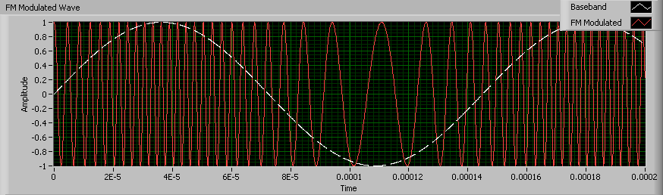
- Next, we will experiment with the carrier frequency and observe the effect on modulated FM signal. Notice, that the minimum carrier frequency is equivalent to the frequency of the baseband. In addition, the frequency deviation is also automatically adjusted so that it is never greater than the carrier frequency. Below, we show a scenario where the carrier frequency is equal to the frequency of the baseband. Because these frequencies are identical, the modulated FM signal is not purely sinusoidal.
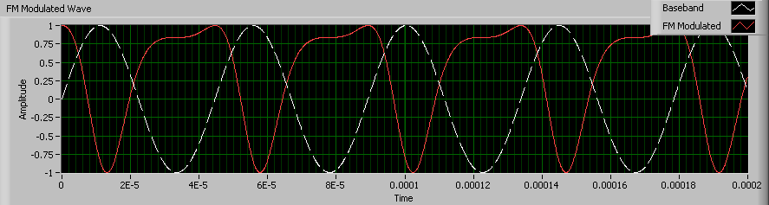
As the image above illustrates, the baseband signal cannot be well represented in this scenario. Ideally, the carrier frequency should be substantially greater than the frequency of the baseband signal. In the graph below, we show the results of increasing the carrier frequency. Here, you can see that the full period of each frequency is represented.
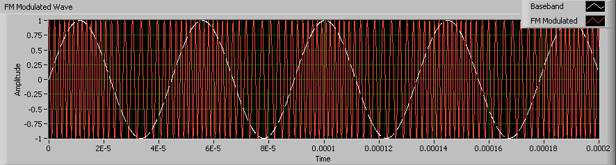
- Finally, we will observe the effect of the modulation index on the FM signal. To do this, adjust the carrier frequency to its maximum, 1MHz. You will notice that the maximum FM Deviation has now automatically been adjusted to 500 kHz. Slide the FM Deviation slider to the maximum, 500 kHz and observe the results. As you can see in the graph below, that the frequency of the resulting time domain signal shows substantial variation. In fact, as the graph illustrates, the minimum level of the baseband signal are represented by 0 Hz. In addition, the maximum level of the baseband signal is represented by 2MHz.
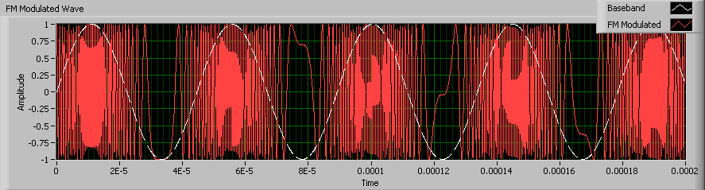
While significant FM deviation is visually obvious, smaller FM deviation values are not. To observe this, change the FM deviation to 200 kHz. At this setting, various levels of the baseband signal will be represented by frequencies ranging from 800 kHz to 1.2MHz. The time domain of the modulated waveform is shown below:
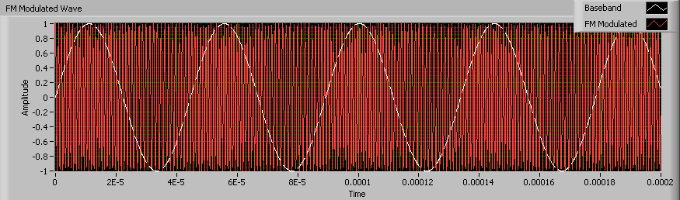
As the graph above, changes in the frequency deviation is less obvious in the time domain. However, it is important to observe its effect on a communications system. Ideally, a communications system should have a maximum frequency deviation to more accurately represent the baseband signal. However, this is not without tradeoffs. By increasing the frequency deviation, we also increase the power required to generate the signal and the frequency bandwidth that it occupies.
- Finally, click on the “Frequency Domain” tab to view an FFT power spectrum of the modulated signal. While viewing this graph, slowly adjust the frequency deviation variable and observe the effect on the channel width. You will notice that the higher the frequency deviation, the greater bandwidth that the channel occupies. Below, we show a FM signal with a carrier of 1 MHz and a frequency deviation of 500 KHz. As you can observe from the graph below, the modulated signal occupies over 1 MHz of bandwidth
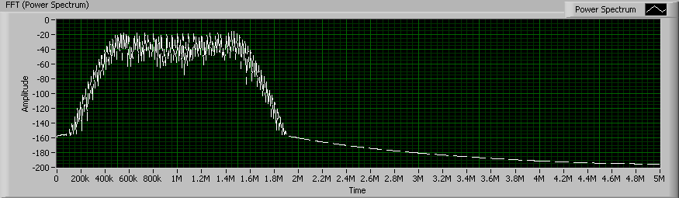

- FM Demodulation
Incoherent envelope detection method is used in FM Demodulation.
The modulated signal is first differentiated.
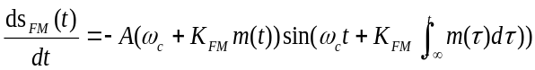
Then Hilbert transform
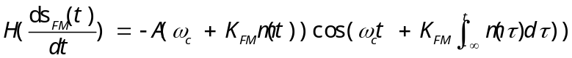
The 2 signals expressed by the above expressions are the real part and the imaginary part of a complex signal respectively. The amplitude of the complex signal is obtained by using the function of calculating the amplitude of complex signal.
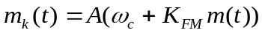
After DC removal and normalization, m(t) can be obtained.

