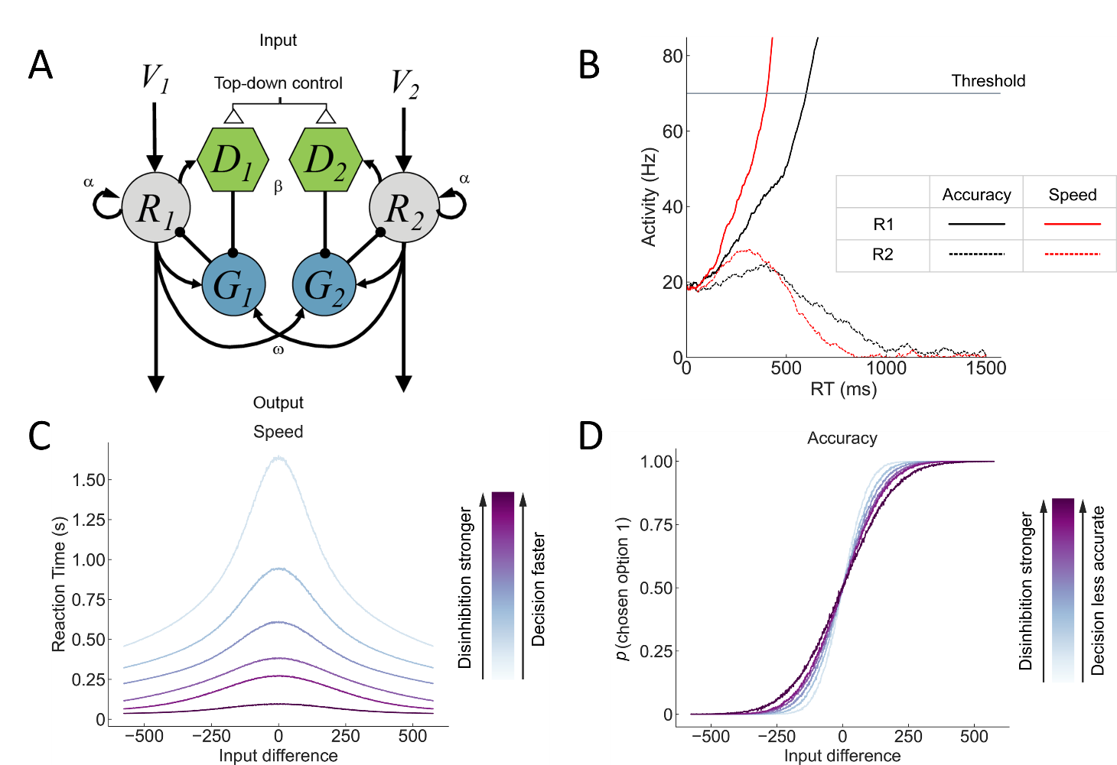

**Figure 1. Speed-accuracy tradeoffs in the circuit of LDDM.** (**A**) The motifs of the LDDM, with the assumption of cholinergic modulation as a potential mechanism of speed control. (**B**) *R1* (solid) and *R2* (dashed) neural dynamic predicted by LDDM. Red corresponds to the speed condition; black corresponds to the accuracy condition. Stronger beta value drives the circuit a faster winner-take-all dynamic (accuracy: *α* = 25, *β* = 1.2; speed: *α* = 25, *β* = 1.7). (**C**) Reaction time predicted by LDDM with different disinhibition levels. Dark purple corresponds to a bigger beta value, indicating stronger disinhibition with shorter reaction time. Given a fixed input coherence, reaction time decreases as beta increases (*α* = 25, *β* = 0.9, 1.1, 1.3, 1.5, 1.6, 1.7) (**D**) Choice Accuracy predicted by LDDM with different disinhibition levels. Dark purple corresponds to a bigger beta value, indicating stronger disinhibition with smaller accuracy rate. Given a fixed input coherence, accuracy rate decreases as beta increases (*α* = 25, *β* = 0.9, 1.1, 1.3, 1.5, 1.6, 1.7).

// disinhibition paragraph

By turning on disinhibition – increasing *β* to a positive value – the circuit demonstrates the winner-take-all activity, with R1 neurons (solid lines) ramping up and R2 neurons (dashed lines) dwindling. We switch between the accuracy condition (black) and speed condition (red) with a weak disinhibition level (smaller *β*) and a strong disinhibition level (larger *β*) respectively. The R1 neuron reaches the threshold with less reaction time under the speed condition than it does under the accuracy condition.

Panel C shows the reaction time taken for the neurons to reach the decision threshold at different input levels. Reaction time decreases sharply as the absolute value of input difference decreases. At a given input level, the trial with stronger disinhibition (dark purple) takes less reaction time to make a decision than the trials with weaker disinhibition (light blue) does.

The proportion of trials accurately choosing option 1 at different input levels is demonstrated in panel D. The accuracy rate increases as V1 grows stronger than V2. At a certain input difference, trials with stronger disinhibition (dark purple) tend to have a smaller accuracy rate than trials with weaker disinhibition (light blue) do.

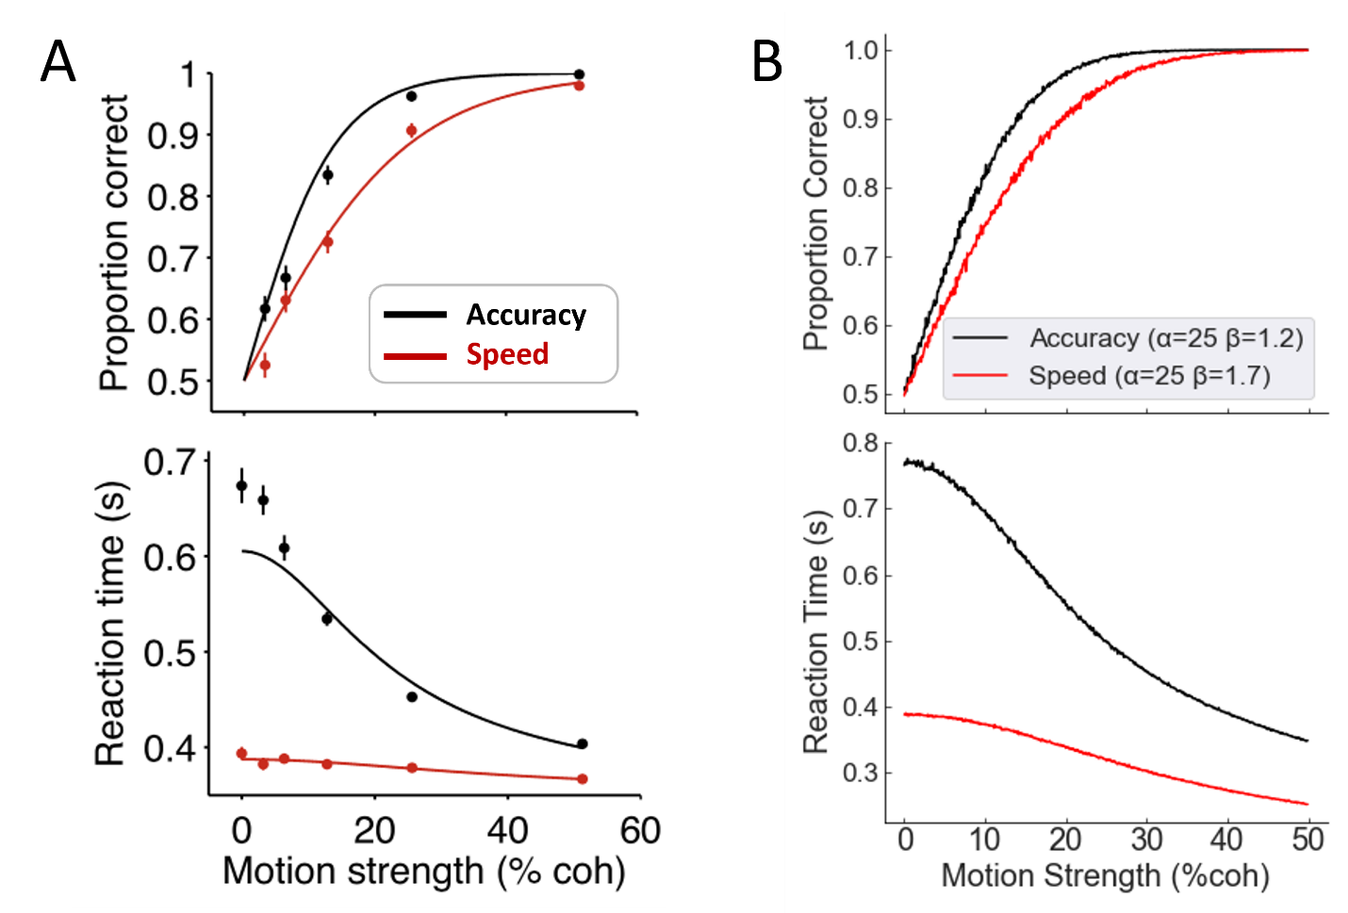

**Figure 2. Speed-accuracy tradeoffs in the circuit of LDDM.** (**A**) Empirical data from monkeys (Hanks et al. 2014). The accuracy condition is demonstrated in black, and the speed condition is demonstrated in red. Traces show fits to the data, represented by symbols and lines in the graph, with the bounded accumulation model. The upper panel shows the choice accuracy, and the lower panel shows the reaction time. (**B**) LDDM Model predictions. The model predicted choice accuracy (upper panel) and reaction time (lower panel) over different levels of input strength under high (red) and low (black) values of beta.