**First Draft**

**The Significance of Impact from International Crude Oil Price**

**on Chinese Macro Economy**

**BY**

**WEN Xiang**

**1430001100**

**Applied Economics**

**KONG Weizhen**

**1430001037**

**Applied Economics**

**Submitted to**

**Dr. Eric Wong**

**Beijing Normal University – Hong Kong Baptist University**

**United International College**

**April 2018**

**Table of Contents**

**I. Introduction 2**

**1. Statement of the problem 2**

**2. Literature review 3**

**3. Objectives of the study 7**

**4. Statement of hypothesis 7**

**II. Methodology 7**

**1. Data source 7**

**2. Data description 8**

**3. Modelling 8**

**III. Result Description 9**

**1. Unit root test 9**

**2. ARDL 16**

**3. Implications 18**

**IV. References 21**

# I. Introduction

## 1. Statement of the problem

As one of the crucial resources to the development of modern society, crude oil has drawn a huge amount of attention in economic researches. The relationship between crude oil price and economic activities in various countries has been investigated. A number of existed research studies have tested the correlation between crude oil price and variables as well as indicators in Chinese macroeconomy on the basis of strong and positive expectations toward Chinese economic growth and the oil price trend. However, the fluctuations of crude oil price during 2016 to the present switched global investor confidence dramatically, thus making the previous prediction unreliable. According to the analysis and forecast report written in February, 2017 by Ji Qiang, a researcher from the Chinese Academy of Sciences, the supply-demand relationship of international crude oil was expected to approach equilibrium and the demand would slightly increase in 2017 (Ji, Liu, & Zhao, 2017). In reality, Huang Haishun, a reporter from Economic Daily, reported that the actual trend of crude oil price in the global market undulated and glided down in the first half of the year because of the solid international oil oversupply pattern (Huang, 2017).

There are certain factors driving the downward trend of the international oil price. The behaviors of Organization of Petroleum Exporting Countries (OPEC), the main supplier of petroleum, has significantly and continuously directed the global investor expectation in the oil market. Besides, the innovation of shale oil exploiting technology has boosted the oil production in the United States by a big margin and increased U.S. net oil export, thus substantially weakening the monopolistic bargaining power of OPEC in the market. China has also found substantial reserves of shale oil resources. According to a Chinese oil shale resource evaluation report, “the concentration of organic carbon in Chinese oil shale is high” and “resources in China are abundant with a high potential for exploitation” (Liu, et al., 2017). It indicates that there could be further influence to the crude oil market structure around the world in the future. The strength of the dollar and the demand for crude oil in Asia both play an important role in affecting the oil price and the investing expectation. Such complex various factors lead the demand to be unpredictable. A number of researchers are motivated to investigate the correlation and make further predictions. However, the unpredictable demand performance results in the increased degree of difficulty for the previous studies and forecasts that they could still hold in the future.

## 2. Literature review

2.1 Macroeconomic responses to the oil price fluctuations

There are a number of studies and researches investigating the macro economic responses to the oil price movements in various countries. Du, He and Wei (2010) used monthly vector auto regression (VAR) model to investigate the relationship between oil price in fluctuation and different indicators that represent Chinese macro-economy activities during 1995:1 to 2008:12, which witnessed the remarkable development in China. They concluded that the influence of oil price shocks is growing to be significant because of the growing dependence on imported oil and consumption.

There are other research studies investigating the oil price-macro economy relationship in other countries and areas. Jbir and Zouari-Ghorbel (2008) tested the oil price impact by analyzing the role of subsidy policy established by Tunisian government and claimed that the asymmetric relation cannot be proved significant and the influence resulted from oil price shocks can be transmitted through Tunisian government spending. Lorde, Jackman and Thomas (2009) investigated the impact of oil price on Trinidad and Tobago, a country which has larger oil production and is less dependent on imported oil. Beside the indicators which are tested in the above two other researches, they observed the local government revenue and consumption in response to the volatility of oil prices. The result was stated that the oil price is playing a major role in determining the economic activity in that “small open oil producing country”, cited from the conclusion part. Omojolaibi (2014) conducted a study on macroeconomic dynamics in response to oil price fluctuation period in Nigeria where is also oil-independent, using the structural vector auto regression (SVAR) method to examine the sources of economic volatility. He claimed that Nigeria domestic policies rather than oil price boom were the major reasons to inflation and money shocks had more significant impacts on gross domestic production (GDP) fluctuation than oil shocks did.

There are studies concerning about the different impacts of international crude oil prices between developed countries and developing countries. Rafiq, Sali and Bloch (2008) conducted the investigation in the context of Thai economy, which regarded the oil as primary input and raw materials in the production process and analyze the impact of the commodity price volatility on domestic macro-economic variables in a developing country. They claimed that the causality was unidirectional and significant from oil price to investment and unemployment rate in the shorter time horizon.

2.2 Impacts of change in global energy market structure

Researches also are conducted in the impacts of change in global energy market among economies. According to the study conducted by Brune (2015), the technological innovation in shale gas production in the U.S. had influence the oil market structure around the world. He predicted the United States as an energy exporter in 2022 and the potential influence in Africa. “The U.S. energy boom has been a game changer”, as he concluded, the shale boom in U.S. provide the oil-producing countries an opportunity to restructure their economies. Baumeister and Kilian (2016) explored the sustained decline in crude oil price has certain effect on U.S. real GDP growth and analyzed the U.S. economy’s response to the oil price shocks before and after the shrinking petroleum trade deficit because of shale oil. The conclusion of the research was that although shale oil did cause certain changes, the U.S. economy was not fundamentally altered by shale oil boom in respect of the economic response to oil price shocks.

2.3 Asymmetric effects of oil prices in economic variables

Mohanty, Tawfeek and Bugshan (2012) proved that the effect of oil price was asymmetric toward various companies earnings in the energy industry. According to their report, the responses of the stock risk and oil return variance were stronger toward the decline in oil prices rather than in the increase of oil prices. There is another study also confirming the strong asymmetric effect of oil price to regional economy. From the analysis of Mohanty, Tawfeek and Bugshan (2012), Auto-Regressive Distributed Lag model (ARDL) model was used to estimate the effect of oil price on state income in the United States. The effect varied in different states because of various proportions of oil industry in the economies. The study created by Mansor H. Ibrahim and Rusmawati Said (2017) suggested that the oil price has a positive but weak impact on inflation and that the correlation ranged between 0.07 to 0.08 in South Africa whose economics is highly dependent on imported oil. Since 1986 when the country had increased its oil import, such impact grew significantly.

2.4 Chinese researches on domestic economic responses to international oil prices

According to Liu and Jiang (2009), the fluctuations of international crude oil prices not only had impacts on Chinese economy, which was growingly dependent on imported oil in 2009, but also resulted in the variance of domestic product oil, thus influencing the economy indirectly. Using models such as generalized autoregressive conditional heteroskedasticity (GARCH) and MS-VAR, Liu (2008) proved that the fluctuations of oil prices have nonlinear and asymmetric effects on Chinese domestic output. According to the report written by Zhao (2015), the domestic price level had same direction behavior as the oil price did and remained increasing trend in half of the year under the positive oil price shock. Li (2015) tested the ICA-SVR2 model in explaining and predicting the WTI price trend, basing on three independent components. The report contributed to the method of better explaining the predicted results. Li Z. and Li L. (2011) proved that the crude oil price and Chinese macro economic indicators had significant co-integration relationship and the response of domestic macro economy was lagged to the fluctuation of oil prices.

Leung, Li and Walls (2012) documented the changing patterns of Chinese domestic demand for various refined petroleum products and concluded that the imported low-quality crude oil brought challenges to domestic refined oil suppliers. Zaouali (2007) suggested that the oil price increase caused the increased cost of Chinese economy, thus reducing the domestic welfare. According to the study, Chinese strong demand for oil was expected to continue in the long run.

The impact difference between different economic levels are studied. The research (2016) assessed and compared the crude oil price movements on GDP and consumer price index (CPI) in the developed countries (U.S. and Japan) and the developing countries, China. It suggested that the impact of oil price fluctuations on developed economies are milder than on the emerging economy because of the fuel substitution effect and domestic population. Tilak Abeysinghe (2001) suggested that the oil prices did have both direct and indirect effect on the growth GDP. But the effect was more significant on small developing countries than big open countries. The effect of oil shock was related to the interaction between the shock and the investors of the countries. The report (2000) created a new concept called “net oil price change”, which was used to exempt the influence of exogenous influence such as political effect in middle east.

## 3. Objectives of the study

The objective of the present study is to provide predictions on influencing significance of international oil price toward Chinese macroeconomy in better accuracy and make certain comparison among various relationships between crude oil price in global market and different economic indicators in respect of significance. The impact of oil prices toward gross national production and inflation are investigated and the mutual influences among the three variables are also tested.

## 4. Statement of hypothesis

The following hypothesizes are written only in null hypothesis forms.

Hypothesis 1: The change of oil price will positively influence the sensitivity of change in GDP;

Hypothesis 2: The sensitivity of CPI change rate will positively influence the sensitivity of change in GDP;

Hypothesis 3: Previous rate of changes in GDP will have positive effect present rate of change in GDP;

# II. Methodology

## 1. Data source

The data including the oil prices, GDP index and CPI are collected from the database as the secondary data.

In terms of selection in oil price data, the Brent crude oil prices were observed in the model since the Brent price plays a role of benchmark in two-third of trade volumes in international oil market and it isflexible in avoiding risk. The data of Brent crude oil price was collected quarterly from 1995:1 to 2016:12 from the database of U.S. Energy Information Administration (EIA).

The GDP and CPI indexes are collected from the official website of the National Bureau of Statistics of China. All the data from 1995 to 2016 are gathered in order to perform a better fitted model with substantial observations. The complete quarterly data in 2017 is still unavailable when the present proposal is written.

## 2. Data description

As the data of GDP and CPI provided by the National Bureau of Statistics of China is detailed only to quarters, the quarterly data of crude oil price is collected, which can be transferred by the website, averaging the daily data in each quarter from 1995 to 2016. Therefore, the three variables data match in quarterly time intervals.

The difference values among GDP, CPI, and the processed data of oil prices between each two adjacent periods are presented in the form of Δ in the formula. Δy stands for the change in GDP between one value and its former value. In the same way, Δo and Δx represent the differences between two adjacent data of oil prices and CPI respectively.

## 3. Modelling

The framework of the analysis is to investigate the influence of change in oil prices (independent variable, IV) to GDP (dependent variable, DV) with sensitivity of CPI index (control variable, CV). As the graph illustrated below, the change in crude oil price is assumed to impose influence on the sensitivity of GDP index and the sensitivity of CPI index is assumed to affect the IV-DV relation.

Change of crude oil price

Sensitivity of GDP index

Sensitivity of CPI index

The formula is established to measure the mutual effects and former data effect by using autoregressive distributed lag model（ARDL）. Suppose that there would be relativeness between two macroeconomic indicators are also tested. The new concept that Hamilton (2003) created called “net oil price change” was used to eliminate the influence of exogenous factors like political factors.

In this model, the change in GDP depends on its lagged data, the change in oil prices and the change in CPI during the previous four quarters. All these three variables are expected to have positive effects on change in GDP.

# III. Result Description

## 1. Unit root test

Before test the ARDL model, the stability of every variable should be tested. Only the stable data can be tested in time series or it would be bias for forecasting. The proper testing method is unit root test. Assuming one-unit root exits, the test is run to verify the significant level of the assumption that the data is stable. By comparing the t-value or directly detecting whether the p-value is smaller than 0.05, the stability would be verified because there should not be any unit root for stable time series data.

All the three variables (historical seasonal GDP data as dependent variable; seasonal CPI and seasonal averaged price of Brent oil as independent variables) would be tested before running the assumed model. The longitude is from 1992 to 2017, so each variable has 96 items after adjustment. Three conditions of trend including linear，constant and none trend of different variables should be tested respectively. Below is the ordered process.

**1.1 For dependent variable: GDP**

First, the data is tested for stationary data. The possibility that the time series data have a unit root test is close to 1. It is far bigger than the ideal value 0.05, making the assumption that raw data of GDP is stationary failed to accept. Unit root test of non-difference series data with both intercept and trend, which is the most possible stationary data, is also fail to meet the requirement. Therefore, the time series still cannot be applied in the ARDL model because all the three conditions of time series are not stable.

Then, the data will be processed in 1st difference. The first step is to test the stability of data with no intercept and trend. Once the data can be verified as stable, it should be converted into difference of one lag before applying them in ARDL model. The second step is to test the stability of time series data with intercept. And the third step is the same as the process of testing level data, considering the lag data as being influenced by the trend and intercept. The result suggests that the p value of the lag data with trend and intercept is merely more than 0.05, failing to meet the requirement of ARDL.

Because the former level and first difference are both failed to reject the null hypothesis, the second difference is further adjusted to get the data stable. The same order of the three kinds of conditions. The first is the mere second difference without and intercept and trend. The result is significant enough to reject the null hypothesis because the p value is zero and greatly different from 0.05.

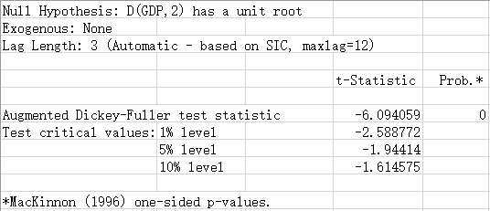

In order to continually detect the element of the time series, the following two conditions should also be tested. The result is till satisfying but only different from the former result in the AIC, SC and HQ value.

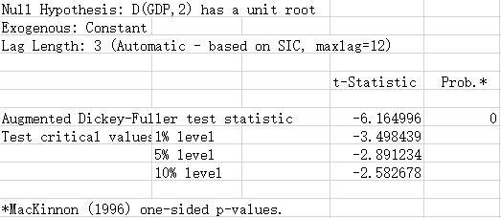

The last condition of the second difference is listed as below. All the three conditions have perfect p value to reject the null hypothesis.

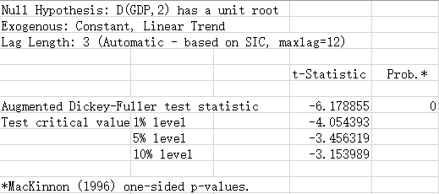

Then, the result that data with influence of intercept has the lowest AIC, SC and HQ illustrates that the second difference result is the process influenced by nothing.

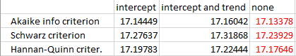

**1.2 For independent variable: CPI**

All the process to test the stability of CPI are definitely same as those for GDP. Each process and the result would be presented in the appendix. The result for intercept, intercept and trend and none of level statue is respectively 0.2201, 0.5583 and 0.4196. None of them is small enough to reject the null hypothesis. The graph below illustrates that the time series is pure process of data but not stable.

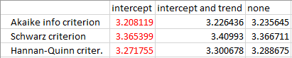

The result of p value for none, intercept and intercept and trend of level statue is all zero. That means the first difference of the raw data would be stable.

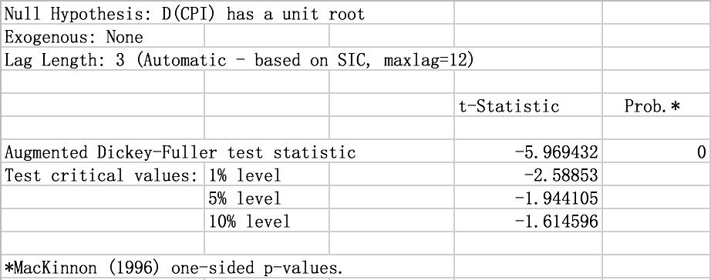

After calculating the value of AIC, SC and HQ, the first difference of CPI data means process without component of intercept or trend.

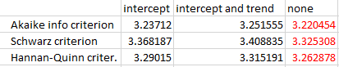

The final result of CPI for stable is to execute the first difference and then the time series can be stable to be applied into ARDL model.

**1.3 For independent variable: Brent oil index**

The result of unit root test of level statue of Brent oil also cannot reject the null hypothesis. The p value for three conditions (intercept, intercept and trend, none) are respectively 0.4175, 0.4441 and 0.4504 which are too larger than 0.005. The p value for first difference are all zero which can efficiently reject the null hypothesis.

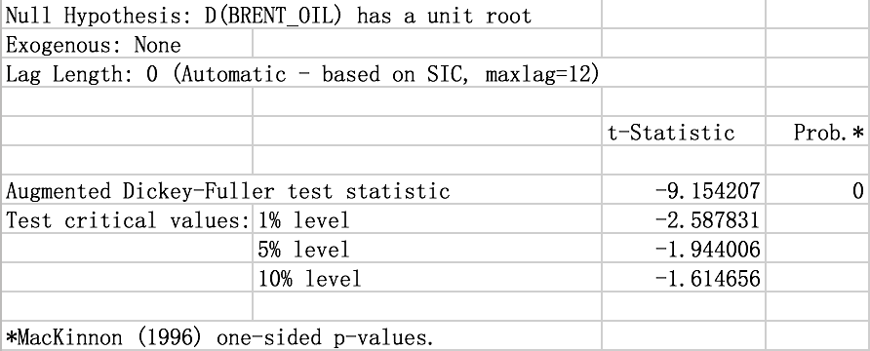

By comparing the value of AIC, SC and HQ, the time series of first difference are independent stable. Even though the unit root test of second difference of the Brent oil is also qualified, the value of AIC, SC and HQ are larger than those of second difference. So, the Brent oil index should also implement the first difference.

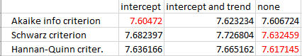

After the unit root test described before, the final implementations of the three variables are also identified. For GDP, the data should be processed with the second difference. The CPI and Brent oil should both be implemented the first difference. Then the time series would be stable enough to be applied in ARDL model.

## 2. ARDL

Based on the analysis of unit root test, the statue for three variables is respectively second difference, first difference and first difference. The original data is noted as I(2), I(1) and I(1) and all the three converted to I(0) after difference. Then the variables after difference are inserted into the model. In order to get consistent estimation of t test of ARDL model, HAC (Newey-West) should be used to get consistent estimation if there exists Heteroscedasticity or Autocorrelation.

The result of lag for three variables are respectively 6, 1 and 0. For each lag item, except for the forth lag of GDP, the first lag of CPI and C cannot be used rationally because the p-value is far larger than 0.05, the other items can be used into the formulas directly. But the three items should be kept because the mutual influence needs time and tools to be conveyed. The influence may be gradual change rather than significant mutation in short time.

R square and adjusted R square reach 0.99721 and 0.996918, the number means that the independent variable can account for more than 99 percent of the change of dependent variable. The three criterions named AIC, SC and HQ are small enough that two of them is even lower than zero. Besides, the value of Durbin-Watson statistic is 2.05609 which is nearly equal to 2, which means the model does not exist conditions of Heteroscedasticity.





**2.1 Serial correlation LM test**

After the estimation of the lag numbers of ARDL model, the serial correlation LM test should be finished to verify whether there is any serial correlation for residuals. Because the observed data is limited, the lag is specified to 2 to run the LM test. As the result shows, the F-statistic is about 0.45 and the F-statistic for degree of freedom to 83 and lag times to two is about 3.11. 0.45 is far less than 3.11 and F-value is about 0.64 which shows that the residual has no serial correlation.

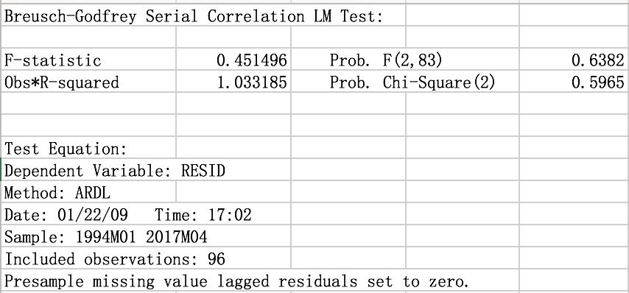

**2.2 ARDL model**

After assuring the lag terms of the different variable, the final model would be established as below:

The coefficient is solved by adding all the coefficient of the lag terms. From the final formula, the effect can be noticed that the former GDP has a significant negative effect on the change of GDP but the CPI and the oil price have a small positive effect on the change of GDP.

## 3. Implications

Using the ARDL model, this paper investigates the impact of international crude oil price on China economy, while also tests the influences from CPI and the effect of time lag between current GDP and its historical data. There are always time lags between current GDP and historical CPI data and historical crude oil prices respectively in the model. In order to achieve the stationary state of the three measurements, removing the interruption of pricing factors or seasonal factors, the model assesses the differences between the changes in data from time point (t-1) to (t) and the changes in data from time point (t-2) to (t-1) among all the three variables after taking logarithm: log(GDP), log(CPI) and log(Brent crude oil price).

Therefore, the tested new variables can be interpreted as how the changing trend of the growth in GDP is affected by the difference between the changes of oil price in last two time-lags. The results indicate that there are four time-lags in the impact on GDP from oil prices and one time-lag from CPI, while the past GDP also contribute considerable effect on the current GDP in four time-lags. The positive effect of CPI and oil price toward GDP in all time-lags are noticed, implying that the continuous growth in CPI and oil price will boost the future growth in GDP.

The R-square and Adjusted R-square are high because of the ARDL model considering GDP as one of the independent variables that affects GDP as the dependent variable by the way of time lag effect. It indicates that the historical data of GDP play an important role in shifting the growth rate direction. Indeed, the GDP could not bring out fluctuations or trends to itself automatically, so the effect observed in the model leads to the existence of the Chinese government intervention in the current market-based economy. As the Five-Year Plans are established regularly in each half of the decades, the Chinese government directs the great construction projects and productivity distribution, contributing to the growth rate of GDP in order to meet the goals of the Five-Year Plans. In all the four-time lags, only the coefficient of lag four turns to be positive, meaning that the effects of difference between changes in growth rates in exact previous one year are positive. When the time lag is 1, 2 or 3 quarters, such effect turns to be negative, in which the national economy behaviors and production patterns can be different in each quarter.

The time-lag effect of change in CPI is one quarter. As the CPI data is collected seasonally, the fiscal policy and price regulation from the government are launched based on this index observation, not only stabilizing the selling prices in the market but also adjusting the macro economy in which refers to GDP. Both CPI and GDP measure the macro-economic growth, so the result also prove the relevancy between these two variables in affecting the significant representation of the domestic economy.

Besides, the coefficients of oil price indicate that the accumulated effect of all the time-lags in change rate of crude oil price can explain the 10% of the difference between the last two growth rate of GDP. The GDP, representing the movement of domestic economy, could be influenced by multitudinous factors, therefore, the one tenth contribution from the international crude oil price is considerable. The change rate in oil price indicates that the effect of time lag last for four quarters, all remaining positive. The equal length of time-lag effect from GDP and crude oil price represents the synergistic influence on Chinese macro economy. While historical GDP can result in the future systematic macro-control from the government, the crude oil, as the important and extensive capital goods, is not purchased for immediate usage in production, therefore the price and cost effect will not deliver the impact on the current production cost. The data collected in this paper for reference to oil price is the Brent oil coming from the London InterContinental Exchange (ICE), and this benchmarking price of crude oil futures play rather an important role in affecting the market expectation. Therefore, the change rate of oil price in this model is affecting the future change rate of GDP by means of influencing the expectation of the economic growth in the domestic market.

# IV. References

Abeysinghe, T. (2001). Estimation of direct and indirect impact of oil price on growth. *Economics Letters*, pp. 147-153.

Balcilar, M., Uwlingiye, J., & Gupta, R. (2017, 1). Dynamic relationship between oil price and inflations in South Africa. *The Journal of Developing Areas*, pp. 73-93.

Baumeister, C., & Kilian, L. (2016, 9). Low oil prices and the U.S. economy: Is this time different? *Brookings Papers on Economic Activity*, pp. 287-357.

Brune, N. E. (2015, 11). The impact of the U.S. shale boom in Africa. *Journal of International Affairs*, pp. 101-120.

Du, L., He, Y., & Wei, C. (2010, 4 13). The relationship between oil price shocks and China's macro-economy: An empirical analysis. *Energy Policy*, pp. 4142-4151.

Hamilton, J. D. (2000, 6). What is an oil shock. *NBER Working Paper*, p. E3.

Huang, H. (2017, 8 1). International curde oil are fluctuating and declining. *Economic Daily*, p. 12.

Jbir, R., & Zouari-Ghorbel, S. (2008, 12 24). Recent oil price shck and Tunisian economy. *Energy Policy*, pp. 1041-1051.

Ji, Q., Liu, B., & Zhao, W. (2017, 2 6). International crude oil market trend analysis and price forecast in 2017. *Strategy & Policy Decision Research of Chinese Academy of Sciences*, pp. 196-201.

Kang, W. (2011). *Three essays on the effects of oil prices on state economies.* Murfreesboro: Middle Tennessee State University.

Leung, G. C., Li, R., & Walls, W. D. (2012, 9). Transitions in the Chinese market for refined petroleum products. *OPEC Energy Review*, pp. 349-373.

Liu, Z., Meng, Q., Dong, Q., Zhu, J., Guo, W., Ye, S., . . . Jia, J. (2017, 1). Characteristics and resource potential of oil shale in China. *Oil Shale*, pp. 15-41.

Lorde, T., Jackman, M., & Thomas, C. (2009, 4 3). The macroeconomic effects of oil price fluctuations on a small open oil-producing country: The case of Trinidad and Tobago. *Energy Policy*, pp. 2708-2716.

Mohanty, S. K., Akhigbe, A., Al-Khysal, T. A., & Bugshan, T. (2012, 8 29). Oil and stock market activity when prices go up and down: The case of the oil and gas industry. *Review Quantitative Finance and Accounting*, pp. 253-272.

Omojolaibi, J. A. (2014, 9). Crude oil price dynamics and transmission mechanism of the macroeconomic indicators in Nigeia. *OPEC Energy Review*, pp. 341-355.

Rafiq, S., Salim, R., & Bloch, H. (2008, 9 11). Impact of crude oil price volatility on economic activities: An empirical investigation in the Thai economy. *Resources Policy*, pp. 121-132.

Taghizadeh-Hesary, F., Yoshino, N., Mohammadi Hossein Abadi, M., & Farboundmanesh, R. (2016, 2 1). Response of macro variables of emerging and developed oil importers to oil price movements. *Journal of the Asia Pacific Economy*, pp. 91-102.

Zaouali, S. (2007, 9 1). Impact of higher oil prices on the Chinese economy. *OPEC Review*, pp. 191-214.

李, 慧. (2015). *基于独立成分分析的国际原油价格分析预测研究 (Predictive analysis and investigation on international crude oil price based on independent component analysis).* Nanjing: Nanjing University of Aeronautics and Astronautics.

李, 卓., & 李, 林. (2011, 5 15). 国际原油价格波动对中国宏观经济影响的重新考察 (Reexamination on the fluctuation influence of international crude oil price on Chinese marco economy). *Economic Review*, pp. 77-87.

刘, 刚. (2008). *国际石油价格波动对我国宏观经济影响的计量分析 (Quantitative analysis on the influence of the fluctuation in international oil prices to domestic macro economy).* Changchun: Jilin University.

刘, 建., & 蒋, 殿. (2009, 10). 国际原油价格冲击对我国经济的影响——基于结构VAR模型的经验分析 (The influence on domestic economy from international crude oil price shock: Empirical analysis based on SVAR model). *World Economic Research*, pp. 33-38&67.

赵, 丹. (2015). *国际原油价格冲击下我国经济波动及货币政策规则选择 (Domestic economic fluctuation and the choice of monetary policies under the international crude oil price shock).* Beijing: University of International Business and Economics.