**If you don't want to wait for the software analysis process, we provide a way to directly view the analysis results.**

(1).select plugin.

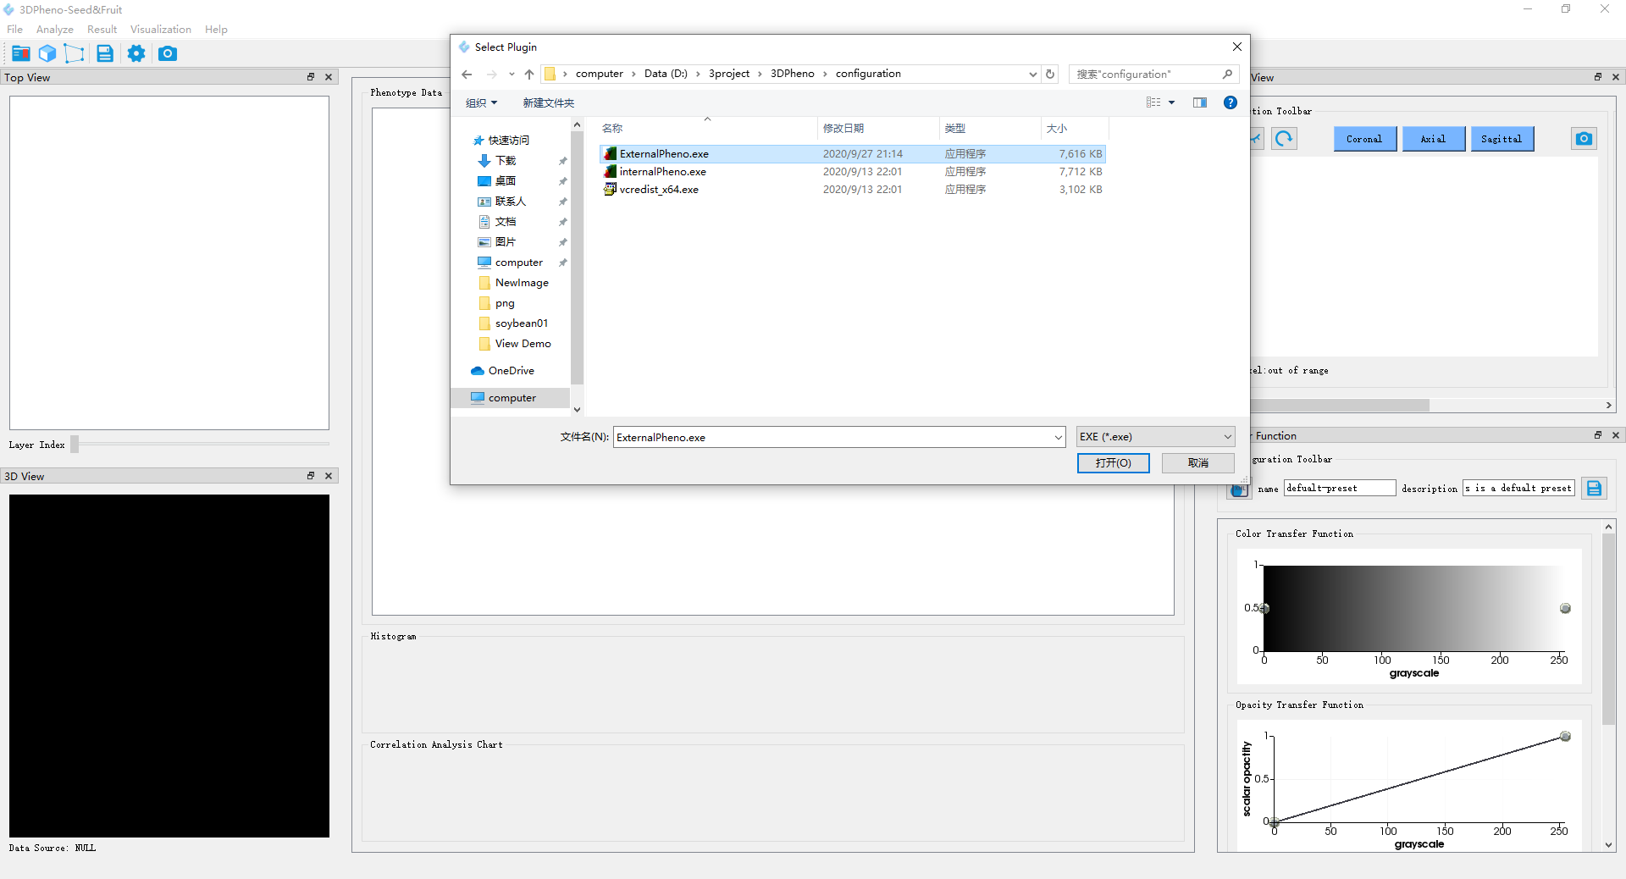

(2) Check the View Demo button，and select the data to be analyzed, and the corresponding results, and then click the confirm button

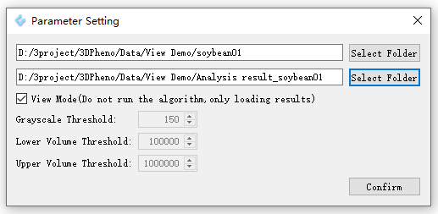

(3) Display analysis results

