Project Document
Project title: Matching a medical prescription with a pharmacy list
Section: 2800-23
Supervisor: Prasanna Lakshmi
Date: September 2026

Team members
- Norah Saeed Alqahtani (445804256)
- Noura Hamad Hasan (445804642)
- Rawan Ali Almeshary (445804606)
- Wejdan Bandar (444820762)
- Zinah Ibrahem Saeed (445804594)

1. Introduction
The user enters medicines from a prescription. The program checks if they exist in the pharmacy SQLite database. If the medicine is there, it shows the scientific name, trade names, side effects, and any drug-drug interaction when there are two or more drugs. If it is not there, it shows “not available”.
The project uses two SQLite databases. The check page runs SQL (SELECT / JOIN) on those databases.
The data is a small academic sample. It is not medical advice.

2. Objective
enter prescription → SQL match with pharmacy database → show result

3. Databases
The application has two SQLite databases: sql/prescriptions.db and sql/pharmacy.db.
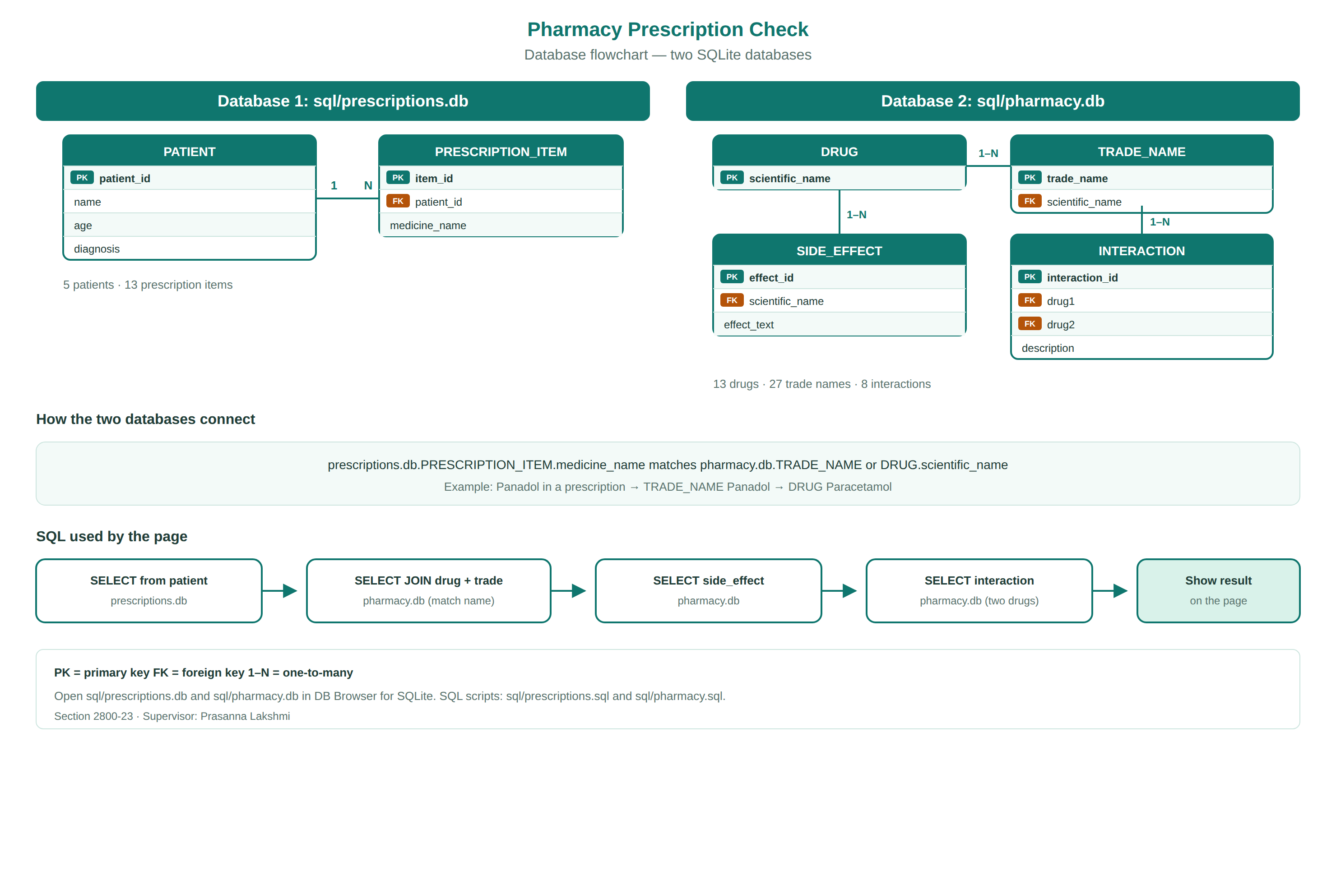
Figure 1. Database flowchart
Open the .db files in DB Browser for SQLite. Schema: sql/prescriptions.sql and sql/pharmacy.sql.

4. Flow
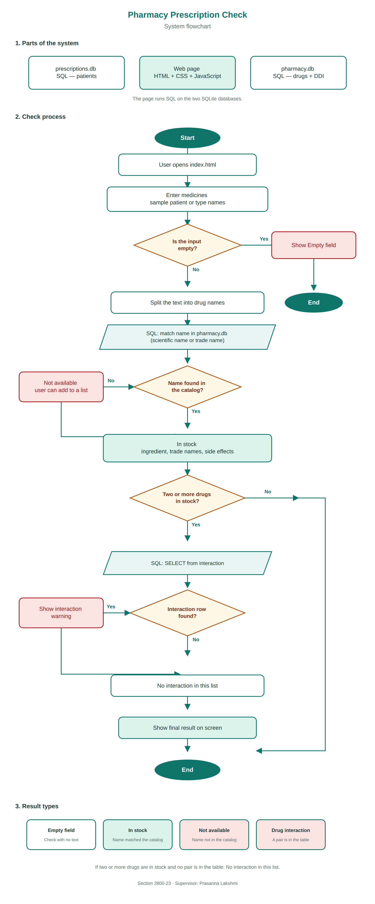
Figure 2. System flowchart

5. How to run
Open index.html in Chrome or Safari.
To view the tables, open sql/prescriptions.db and sql/pharmacy.db in DB Browser for SQLite.

