Практическое занятие №1
Авторизация
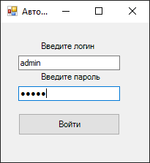
SqlConnection con = new SqlConnection(@"Data Source=DESKTOP-UJNMDI1\SQLEXPRESS;Initial Catalog=ZaharovBase;Integrated Security=True");
con.Open();
SqlCommand cmd = new SqlCommand("Select login, [password] From Users where login = '" + textBox1.Text + "' and [password] = '" + textBox2.Text + "'", con);
if (cmd.ExecuteScalar() == null) { MessageBox.Show("Пароль не верен"); } else
{
Menu menu = new Menu();
menu.Show();
Hide();
textBox1.Text = "";
textBox2.Text = "";
}
con.Close();
Меню 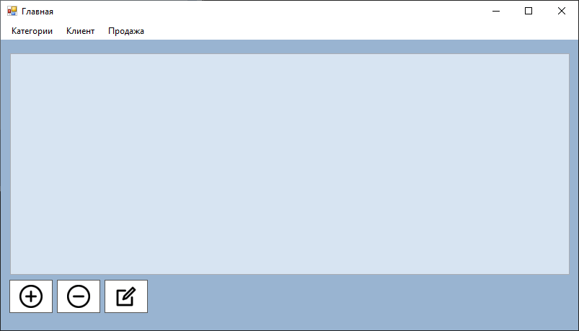

Категории
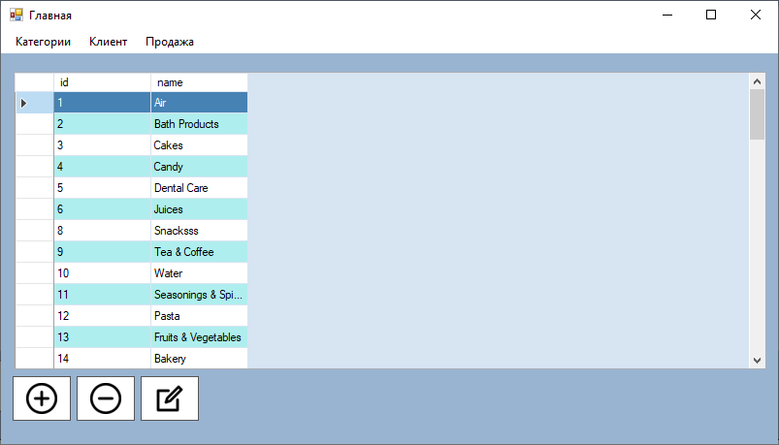
tabs("Category");
now_tab = "Category";
private void tabs(string s)
{
ds.Tables.Clear();
da.Dispose();
SqlCommand cmd = new SqlCommand("Select * From " + s, con);
da.SelectCommand = cmd;
da.Fill(ds);
dataGridView1.DataSource = ds.Tables[0];
}
Клиент 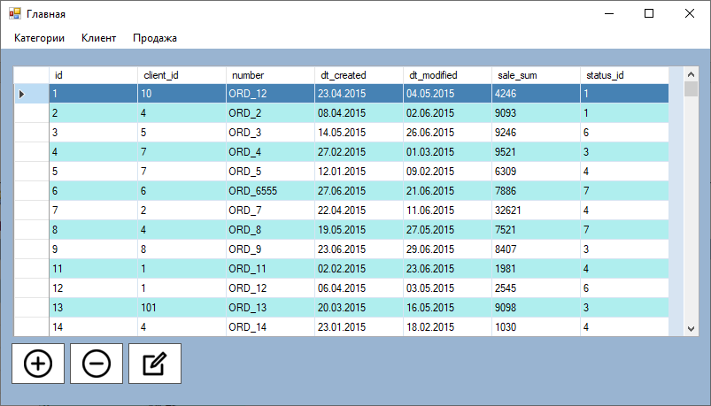
Продажа
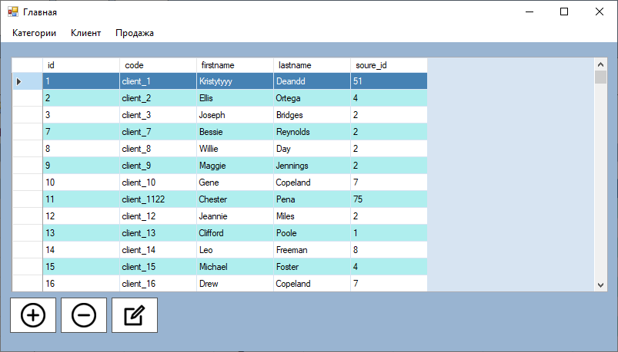
Кнопка Добавить
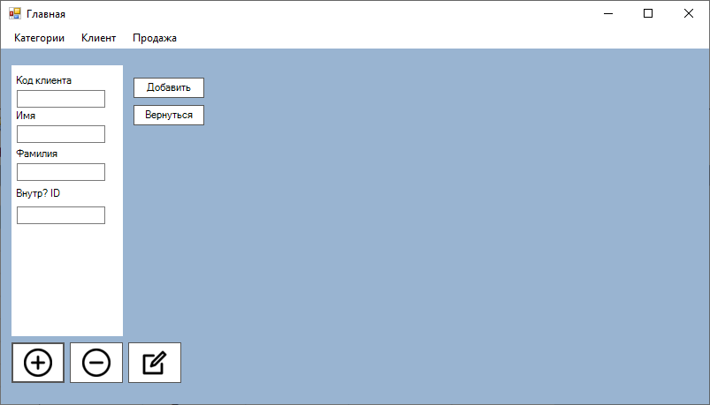
dataGridView1.Visible = false;

switch (now_tab)
{
case "Category":
Name_category_text.Text = "";
break;
case "client":
code_client_text.Text = "";
first_name_text.Text = "";
Last_name_text.Text = "";
Soure_id_text.Text = "";
break;
case "sale":
client_id_text.Text = "";
sale_number_text.Text = "";
dateTimePicker1.Value = Convert.ToDateTime(DateTime.Now);
dateTimePicker2.Value = Convert.ToDateTime(DateTime.Now);
sale_sum_text.Text = "";
status_id_text.Text = "";
break;
}

switch (now_tab)
{
case "Category":
category_panel.Visible = true;
Add_button.Visible = true;
Return_button.Visible = true;
break;
case "client":
client_panel.Visible = true;
Add_button.Visible = true;
Return_button.Visible = true;
break;
case "sale":
sale_panel.Visible = true;
Add_button.Visible = true;
Return_button.Visible = true;
break;
default:
MessageBox.Show("Выберите вкладку");
dataGridView1.Visible = true;
break;
}
Кнопка удалить
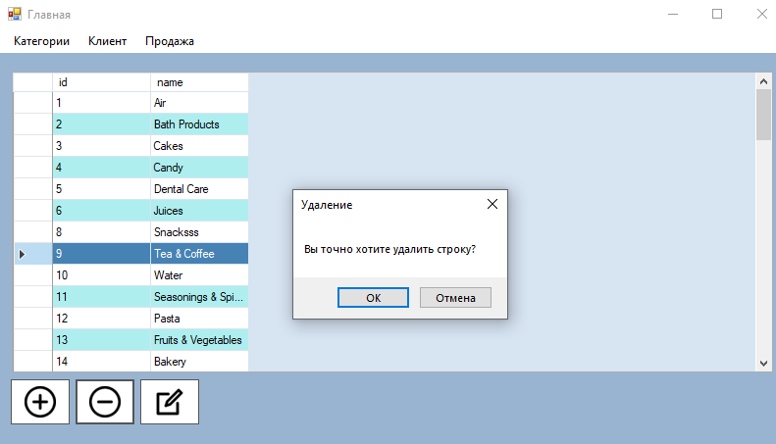
switch (now_tab)
{
case "Category":

DialogResult result = MessageBox.Show("Вы точно хотите удалить строку?","Удаление", MessageBoxButtons.OKCancel);
if (result == DialogResult.OK)
{
int i = Convert.ToInt32(dataGridView1.CurrentRow.Cells[0].Value);
SqlCommand cmddel = new SqlCommand("Delete From Category Where id = " + i, con);
cmddel.ExecuteNonQuery();
tabs(now_tab);
return_tabs_after_add();
}

break;
case "client":
DialogResult result1 = MessageBox.Show("Вы точно хотите удалить строку?", "Удаление", MessageBoxButtons.OKCancel);
if (result1 == DialogResult.OK)
{
int i = Convert.ToInt32(dataGridView1.CurrentRow.Cells[0].Value);
SqlCommand cmddel = new SqlCommand("Delete From client Where id = " + i, con);
cmddel.ExecuteNonQuery();
tabs(now_tab);
return_tabs_after_add();
}
break;
case "sale":
DialogResult result2 = MessageBox.Show("Вы точно хотите удалить строку?","Удаление", MessageBoxButtons.OKCancel);
if (result2 == DialogResult.OK)
{
int i = Convert.ToInt32(dataGridView1.CurrentRow.Cells[0].Value);
SqlCommand cmddel = new SqlCommand("Delete From sale Where id = " + i, con);
cmddel.ExecuteNonQuery();
tabs(now_tab);
return_tabs_after_add();
}
break;
}
Кнопка изменить
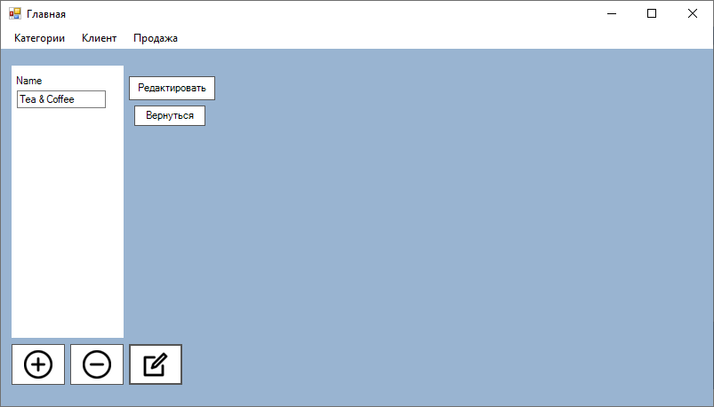
Edit.Visible = true;
Return_button.Visible = true;
dataGridView1.Visible = false;

int ind = dataGridView1.CurrentRow.Index;

switch (now_tab)
{
case "Category":
category_panel.Visible = true;
Name_category_text.Text = dataGridView1[1, ind].Value.ToString();
break;
case "client":
client_panel.Visible = true;
code_client_text.Text = dataGridView1[1, ind].Value.ToString();
first_name_text.Text = dataGridView1[2, ind].Value.ToString();
Last_name_text.Text = dataGridView1[3, ind].Value.ToString();
Soure_id_text.Text = dataGridView1[4, ind].Value.ToString();
break;
case "sale":
sale_panel.Visible = true;
client_id_text.Text = dataGridView1[1, ind].Value.ToString();
sale_number_text.Text = dataGridView1[2, ind].Value.ToString();
dateTimePicker1.Value = Convert.ToDateTime(dataGridView1[3, ind].Value.ToString());
dateTimePicker2.Value = Convert.ToDateTime(dataGridView1[4, ind].Value.ToString());
sale_sum_text.Text = dataGridView1[5, ind].Value.ToString();
status_id_text.Text = dataGridView1[6, ind].Value.ToString();
break;
}

Практическое занятие №2
База данных
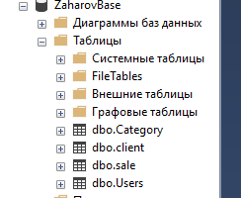
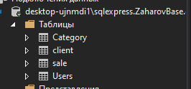
Практическое занятие №3

