# 1. Conceptualization

Personal Health Management System Using JSP and Servlet

https://github.com/WelecomeMe/js-Personal-Health

Student No：22113877

## Name：딩카이

E-mail：q1[793632722@gmail.com](mailto:793632722@gmail.com)

[ Revision history ]

|  |  |  |  |
| --- | --- | --- | --- |
| **Revision date** | **Version #** | **Description** | **Author** |
| 2025/3.25 | 1.00 | First Draft |  |
|  |  |  |  |
|  |  |  |  |
|  |  |  |  |
|  |  |  |  |
|  |  |  |  |

# = Contents =

1.Background and Motivation ................................................................1

2. System context diagram ....................................................................

3. Use case list .........................................................................................

4. Concept of operation ............................................................................

5. Problem statement ................................................................................

6. Glossary .................................................................................................

7. References .................................................................................................

1.Background and Motivation

- Project background, motivation, Goal, Target market etc.

* 12pt, 160%

This project aims to develop a web-based Personal Health Management System that helps users monitor and manage their health-related data, including daily records, physical checkups, health education activities, and online doctor consultations. It is designed to improve users’ health awareness and offer accessible health information management.

Moreover, the system distinguishes between different user roles—regular users, doctors, and administrators—offering customized interfaces and functionalities for each role. Regular users can track their health metrics and consult with professionals, while doctors can respond to inquiries and provide feedback. Administrators are responsible for managing user accounts, health articles, and doctor profiles.

In summary, this project not only serves as a practical application of modern web development technologies but also addresses real-world needs in the realm of personal health management.

# 2.System context diagram

- In our project, the **Personal Health Management System** interacts with three main user roles: **Regular User**, **Doctor**, and **Administrator**. The context model below illustrates the operational boundaries of the system and its interaction with external entities.

* 12pt, 160%

### ****System and Users Context Diagram****

In our project, the **Personal Health Management System** interacts with three main user roles: **Regular User**, **Doctor**, and **Administrator**. The context model below illustrates the operational boundaries of the system and its interaction with external entities.

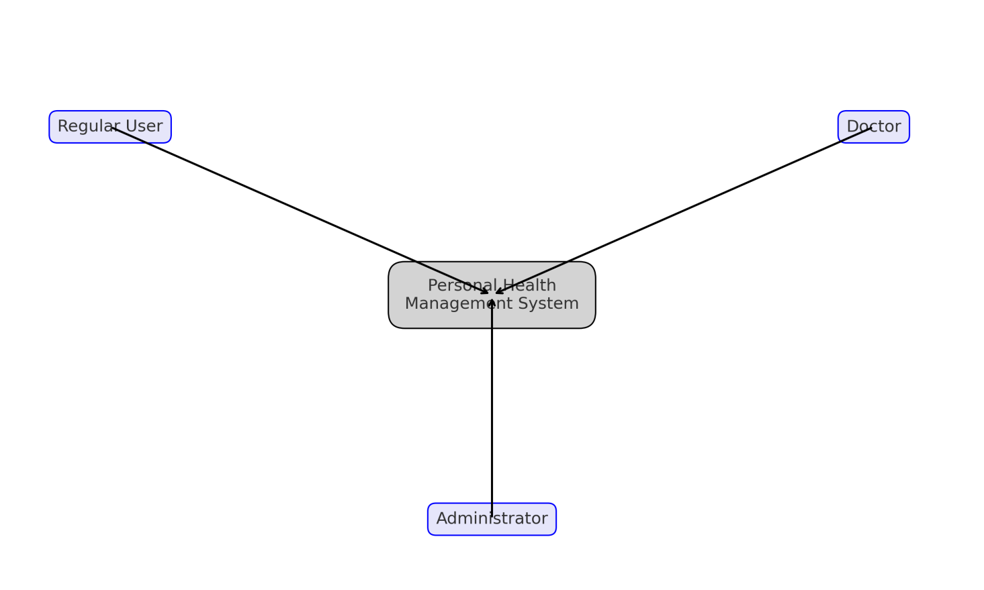

#### ****Diagram Description:****

**System (Personal Health Management System)**  
The central platform that provides health data recording, consultation, management, and information services.

**Regular User**  
Can register and log in to the system, record daily health data (diet, exercise, sleep), view physical examination results, read health articles, and consult doctors

**Doctor**  
Receives user consultations, views submitted health questions, and sends back replies or suggestions.

**Administrator**  
Manages the system by adding or removing users, publishing health-related content, managing doctor profiles, and ensuring data security and consistency.

# 3.Use case list

- Find use cases in your project.

- Make your short description for each use case (table type).

* 12pt, 160%.

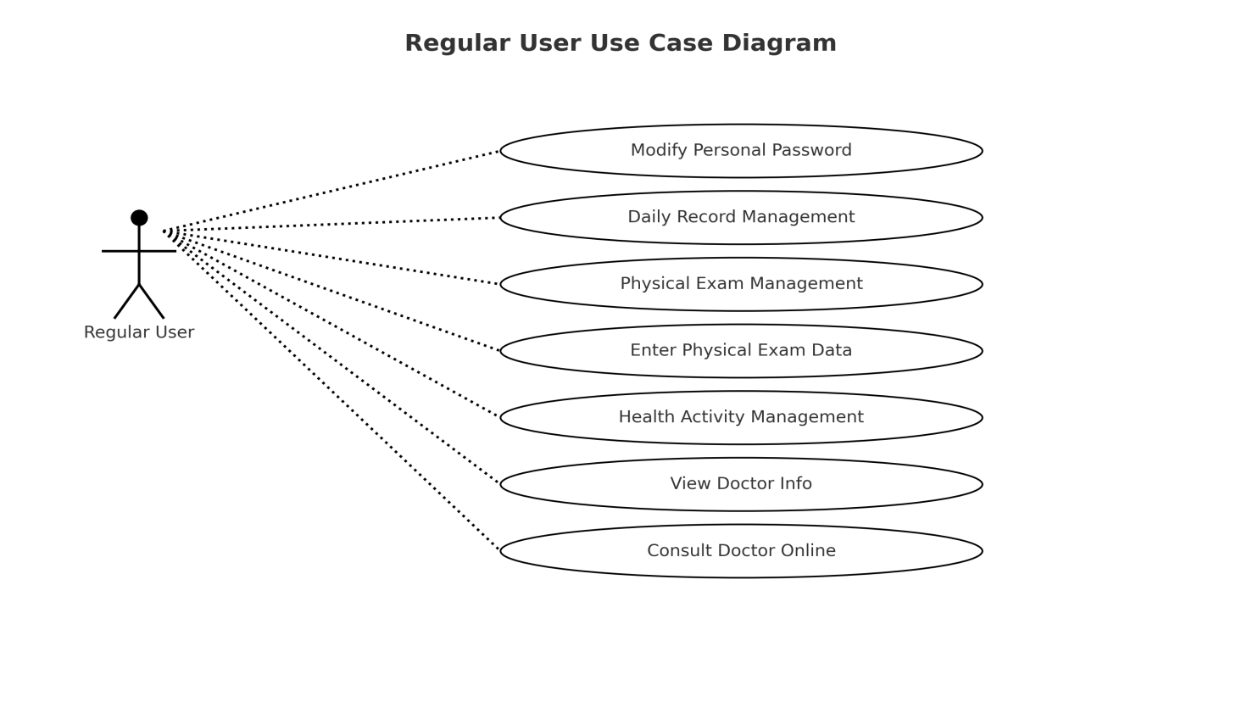

Regular users can log into the system and perform a variety of health-related operations. These include recording daily health data, managing physical examination results, viewing and participating in health education activities, and consulting with doctors online.

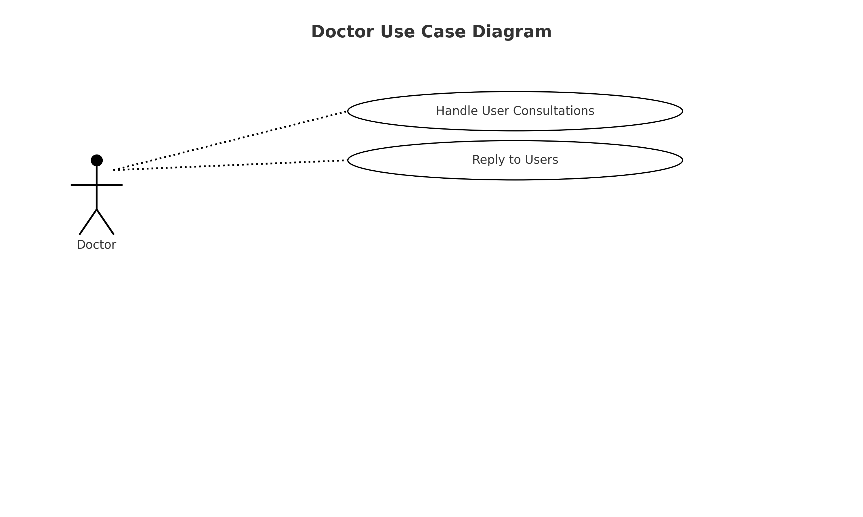Doctors mainly interact with the system to respond to users’ consultation requests. After logging into the system, doctors can view consultation messages and provide professional replies.

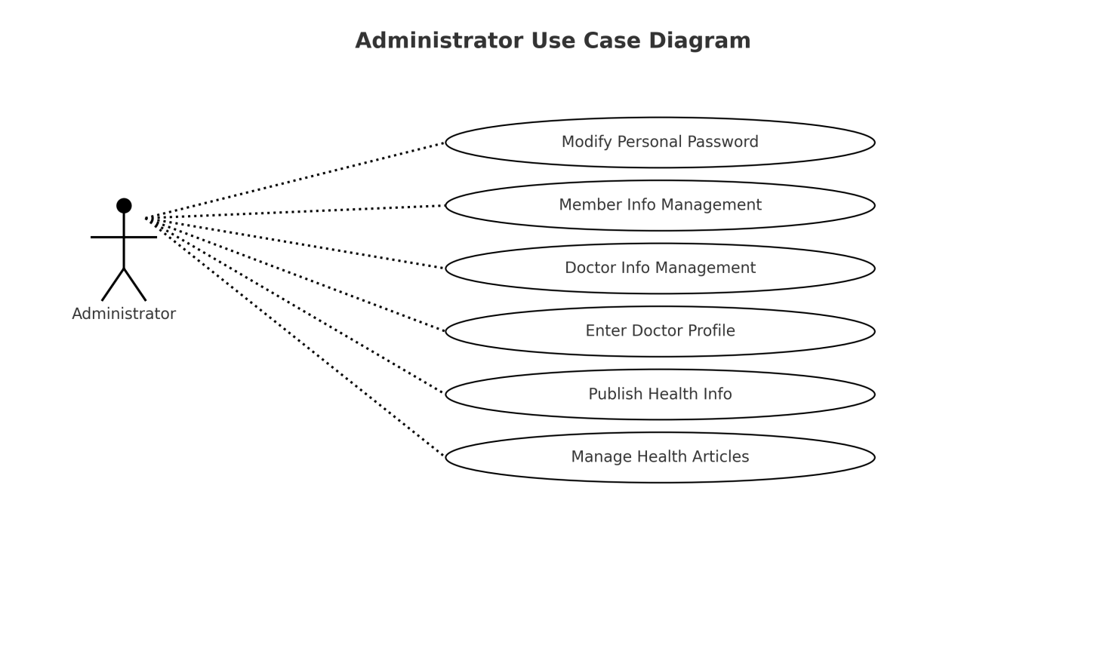

Administrators are responsible for maintaining system operations. Their duties include managing user and doctor accounts, publishing health-related articles, and overseeing system content. They also have the ability to modify their own account credentials.

# 4.Concept of operation

- Describe how to operate the use cases (table type).

* 12pt, 160%.

The system's main feature is its simple operation and user-friendly prompts. The system is designed to implement the following core functions:

The system features a clean and elegant interface, easy to operate, and provides friendly error messages to guide users.

Administrator users have access to member information management, health information management, doctor profile management, publishing health articles, and modifying personal passwords.

Regular users can manage daily health records, physical examination data, health education activities, and consult with doctors.

Doctor users are responsible for handling users’ health inquiries and providing professional feedback.

The system ensures a high level of security to prevent malicious user behavior.

The system’s function structure is divided into three platforms:

Regular User Platform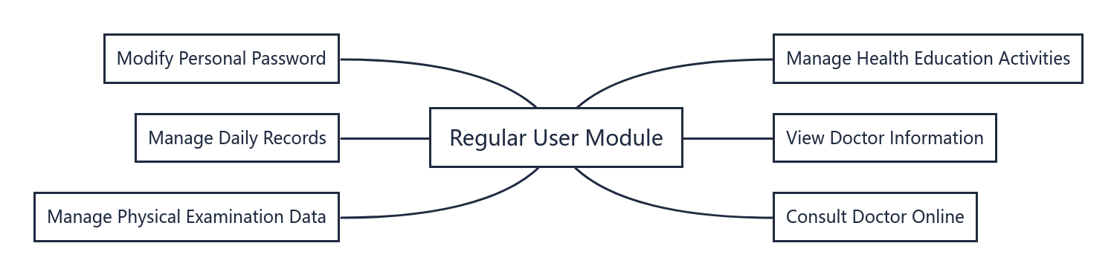

Administrator Platform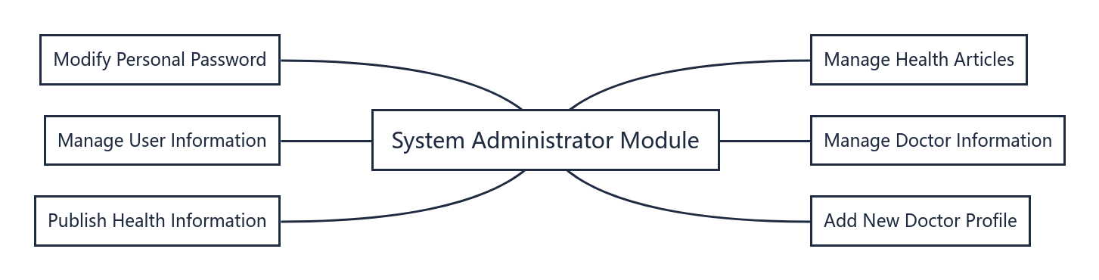

Doctor Platform

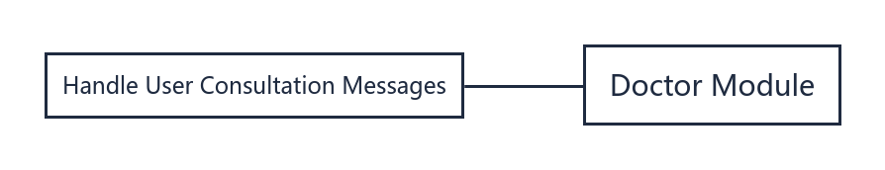

# 5.Problem statement

- Describe the problems the project should be considered (including technical difficulties).

* Describe the Non-Functional Requirements (NFRs).
* 12pt, 160%.

The system is easy to expand and maintain.

Since the Personal Health Management System is based on JSP and Servlet technologies and follows a modular B/S architecture, it is inherently easy to maintain and scale. The use of a relational database (SQL Server) with good scalability further ensures that the system can be modified and extended to meet future functional or performance requirements.

Security remains a challenge.

The system handles sensitive user health data, including personal records and consultation history. However, in its current form, the system lacks robust security mechanisms such as advanced authentication, data encryption, and access control policies, which leaves it vulnerable to data breaches or unauthorized access.

Low development cost brings both benefits and drawbacks.

Due to the use of open-source technologies and simplified interfaces, the development cost of the system is relatively low. While this is advantageous for small-scale deployment, it also limits the visual polish and modular independence of components. The coupling between front-end and back-end logic is still relatively tight, and issues such as data redundancy and slower performance during multi-user access have been observed.

# 6.Glossary

- Specifically describe all of the terms used in this documents.

* 12pt, 160%.

Personal Health Management System:  
A software system that allows users to record, manage, and monitor personal health information through an online platform.

User:  
An individual who uses the system to track daily health data, view physical examination results, read health information, and consult with doctors.

Doctor:  
A healthcare professional registered in the system who provides medical advice or responds to user consultations.

Administrator:  
A system manager responsible for managing user accounts, doctor information, health articles, and maintaining system security and integrity.

Daily Record:  
Health-related data entered by users on a daily basis, including diet, exercise, sleep patterns, and other wellness indicators.

Physical Examination Data:  
Information recorded by users or healthcare providers from medical check-ups, such as blood pressure, blood sugar, BMI, and other health metrics.

Health Education Activity:  
Health-related programs or events that users can participate in and record, aimed at improving health literacy and behavior.

Consultation:  
A feature that allows users to submit health-related questions to doctors through the system and receive professional advice.

Health Article:  
Educational content uploaded by administrators to provide users with tips and knowledge about disease prevention, healthy habits, and general wellness.

Login Authentication:  
The process through which the system verifies a user's identity based on a username and password.

Data Security:  
Mechanisms implemented within the system to protect sensitive health data from unauthorized access or leaks.

# 7.References

- Describe all of your references (book, paper, technical report etc).

* 12pt, 160%.

This system is developed based on a B/S (Browser/Server) architecture, using JSP and Servlet technologies to implement the core functionalities.

MyEclipse is a widely used integrated development environment (IDE) for Java and J2EE applications. It provides powerful support for Java Web development and improves development efficiency through integrated debugging tools and visual editors. MyEclipse can compile and translate Java source files directly and supports various file types with strong compatibility and stability. It also offers comprehensive plug-in support, allowing developers to customize the environment according to specific project needs.  
In this system, which uses JSP and Servlet as core technologies to build a Personal Health Management System, MyEclipse serves as the primary development platform, offering convenient tools for front-end and back-end integration, making it an ideal environment for Web-based health system development.

[1] Bai Qiuchan, Gao Aihua, Shen Xianlai. Physical Examination Management Information System for General Users Based on VFP [J]. Computer and Digital Engineering, 2006, 34(01): 143–145.

[2] Shu Pan, Chen Jingang. Implementation and Design of Physical Examination Management System in Digital Campus Construction [J]. Journal of Wuhan Institute of Technology, 2008, 30(04): 108–111.

[3] Xu Chaoyi. Object-Oriented Analysis of Personal Health Management System [J]. Journal of Anhui University of Science and Technology (Natural Science Edition), 2005, 25(03): 62–64.

[4] Ai Lingxian. Design and Implementation of Department-Level Website Construction Platform in Colleges and Universities [J]. Science and Technology Information, Issue 16, 2008.

[5] Zhang Guoyu, Mou Zongguo. Discussion on Strengthening and Improving Personal Health Management Work [J]. Journal of Sichuan College of Education, 2007, 23(Supplement): 19–20.