# Report, cv1

## DBLP network

DBLP (Digital Bibliography & Library Project) is a well-known online repository that contains an extensive catalog of scientific works and publications in the field of computer science and related disciplines. One of the key features of DBLP is the ability to analyze collaboration networks within the field of computer science and the academic world in general. The collaboration network in DBLP connects authors and scientific works based on collaborations among individual authors.

The collaboration network in DBLP identifies connections (collaborations) between authors based on shared publications. If two authors have collaborated on the same scientific work (for example, as co-authors), they are linked within this network.

The collaboration network is typically displayed in the form of a graph, where individual authors are represented as nodes (or vertices), and the connections between them represent collaborations. Each node (author) can have connections (edges) to other authors with whom they have collaborated.

## Network attributes visualisations

### Time step: 1 year

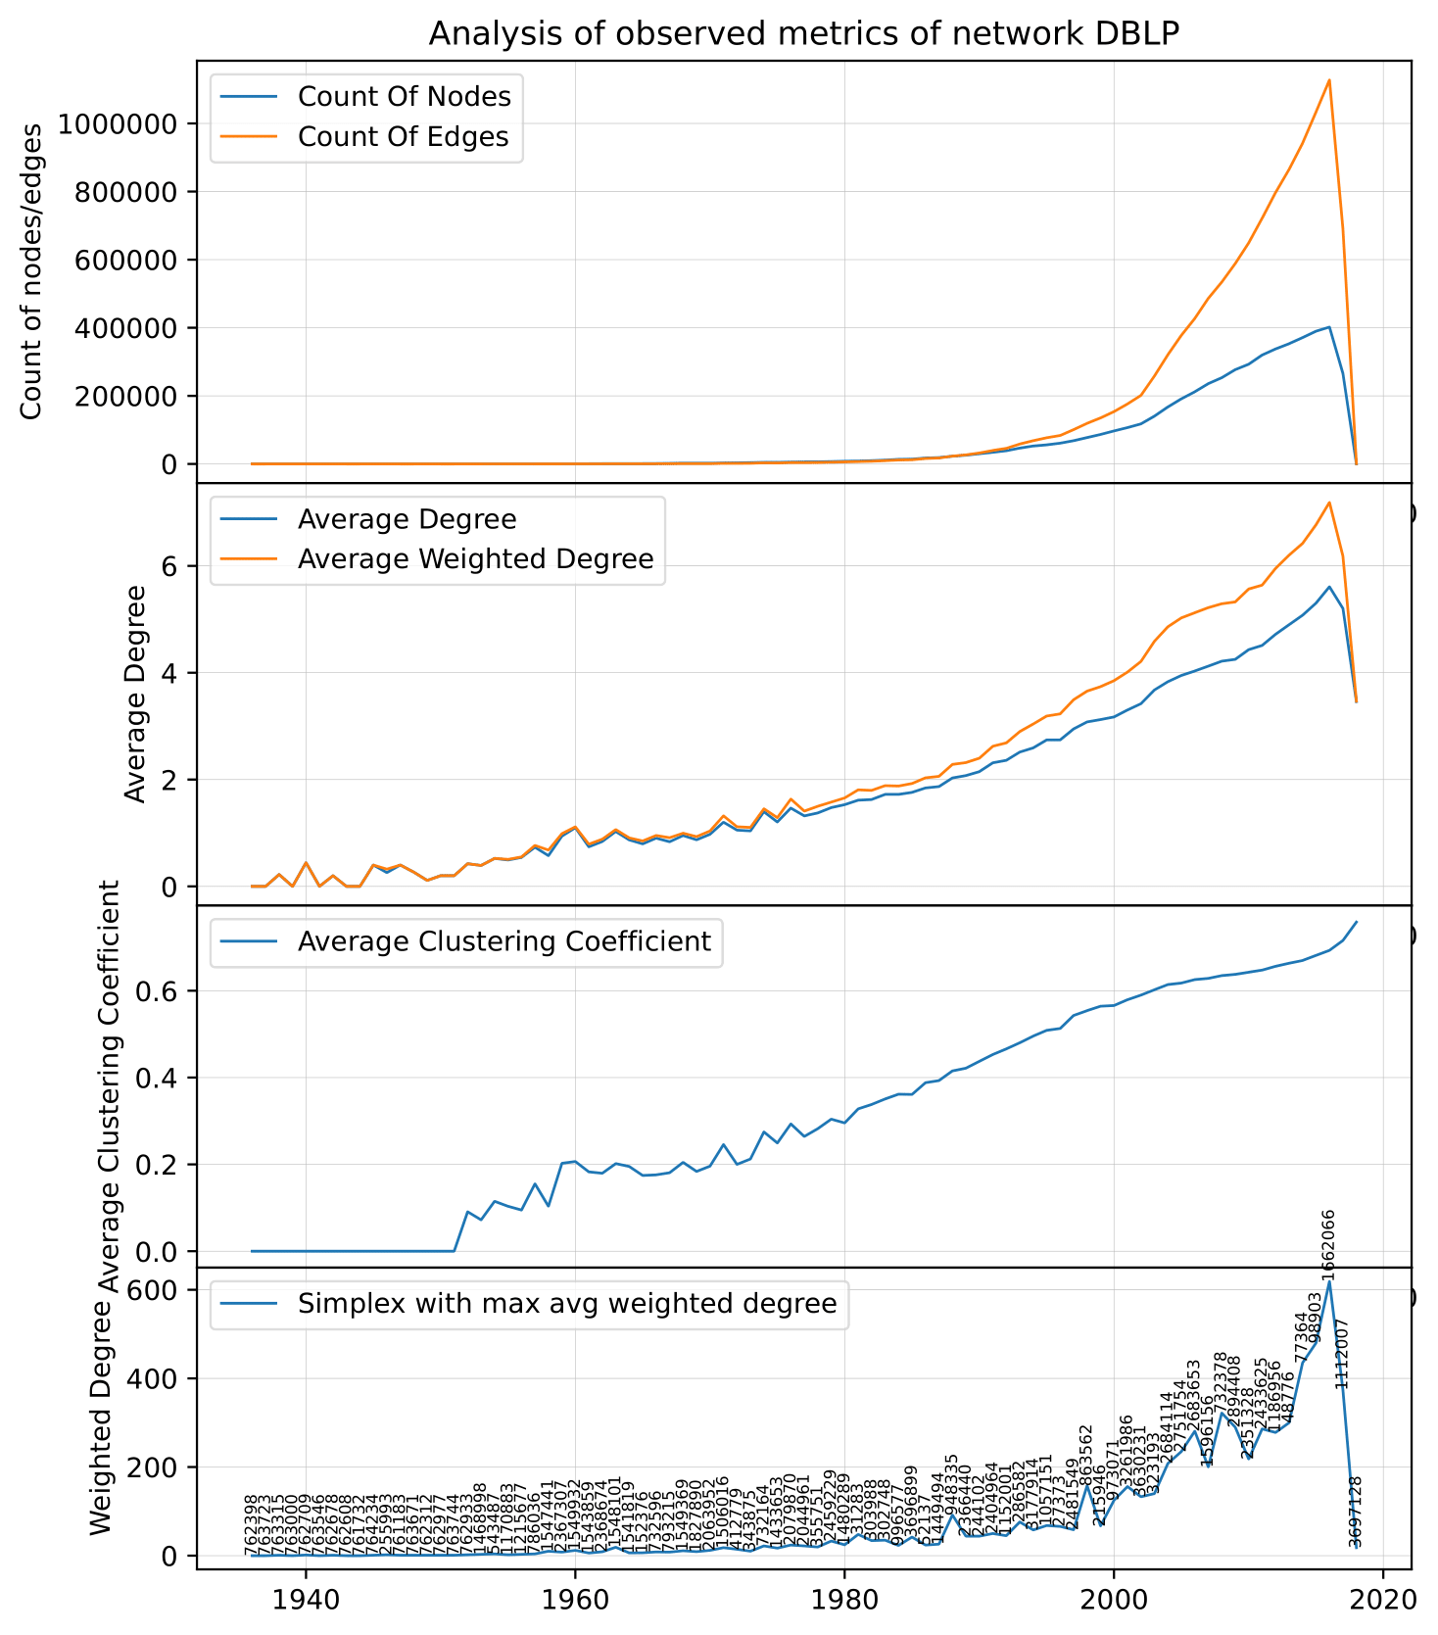

### Time step: 10 years

