Nepal Earthquake Damage Prediction

This complete technical report integrates the project’s data-quality audit, preprocessing, feature engineering, exploratory data analysis, model development, controlled experiments, explainability, geographic generalization tests, inspection-prioritization analysis, and public-leaderboard optimization into one document.
Its purpose is to give all group members a reproducible and evidence-based account of what the coding subgroup implemented, what the data reveal, how modeling decisions were justified, which claims are supported by held-out evidence, and how the final competition score was achieved.

Executive summary. The official training data contain 260,601 buildings and 38 raw predictor variables, with no missing cells and one-to-one ID alignment between features and labels. The target is moderately imbalanced: Grade 2 accounts for 56.89%, Grade 3 for 33.47%, and Grade 1 for 9.64%. EDA reveals especially strong heterogeneity across geography, foundation, roof, construction material, age, and floor count. The final preprocessing pipeline produces 48 usable model features after removing building_id. On the fixed stratified validation split, LightGBM with one-hot categorical encoding achieved Micro F1 = 0.7474. Ablation shows geography is the dominant predictive signal, while structural variables add incremental value. Performance falls substantially on completely unseen Geo-Level-1 regions, highlighting a transferability limitation. For the public competition, targeted CatBoost/LightGBM tuning and probability ensembling improved the score from 0.7440 to 0.7515, ranking 252nd among 2,761 competitors at the time recorded, approximately the top 9.1%.

1. Scope and Data Sources
The preprocessing stage uses the four official competition files and leaves the raw CSV files unchanged. All engineered features, split files, plots, and summaries are written to separate output locations. The identifier building_id is preserved for joins and final submission, then excluded from the model feature matrix at fit time.
File | Rows | Columns | Role
train_values.csv | 260,601 | 39 | Training predictors plus building_id
train_labels.csv | 260,601 | 2 | building_id and damage_grade
test_values.csv | 86,868 | 39 | Official test predictors plus building_id
submission_format.csv | 86,868 | 2 | Official submission template

The train and test feature schemas match exactly. building_id is unique within each file. Training IDs align one-to-one with the label file, and test IDs align one-to-one with the submission template.

2. Data Quality and Integrity Checks
Check | Result
Missing values | Zero missing cells were found in all four official input tables.
Duplicate rows | No fully duplicated rows were found in the official tables.
Identifier integrity | building_id is unique and the feature/label ID sets match.
Schema consistency | Training and test predictor columns are identical.
Binary indicators | Superstructure and secondary-use indicator fields contain valid 0/1 values.
Secondary-use consistency | The broad has_secondary_use indicator has no logical conflict with the detailed secondary-use indicators.

Key finding: The official data are unusually clean for a real-world tabular problem. Most preprocessing effort therefore focuses on representation, robust feature construction, and leakage-safe validation rather than missing-value repair.

3. Preprocessing Principles and Leakage Controls
Geographic IDs are categorical identities. geo_level_1_id, geo_level_2_id, and geo_level_3_id do not represent ordered numeric quantities, so they are treated as strings/categories for models that require explicit type handling.
Categorical encoding, numerical imputation, scaling, resampling, or any learned transformation must be fit on the training subset only. Validation and test data receive transform-only operations.
The agreed split is a stratified 80/20 train-validation split with random_state = 42. This produces 208,480 training observations and 52,121 validation observations while preserving the target proportions.
Observed geographic damage rates use damage_grade and therefore remain EDA-only outputs. They are never merged into the model matrix. Any future geography target encoding must be implemented out of fold.

4. Feature Engineering
The final preprocessing design keeps the original official predictors and adds a small set of interpretable derived variables. The first group came from the original preprocessing work; the second group was added in the supplementary notebook so that the modeling stage receives a more complete feature table.
Feature | Definition | Reason
age_is_995 | 1 when age = 995; 0 otherwise | Preserves the information carried by the special high-age code.
age_capped_100 | min(age, 100) | Creates a robust age copy with reduced influence from the 995 code and other high values.
material_count | Row-wise sum of available has_superstructure_* indicators | Represents structural-material combination complexity.
height_per_floor | height_percentage / count_floors_pre_eq | Controls height for the number of floors.
families_per_floor | count_families / count_floors_pre_eq | Simple occupancy-density proxy.
has_reinforced_concrete | 1 when either RC indicator is present | Broad reinforced-concrete indicator.
secondary_use_count | Sum of 10 detailed secondary-use indicators | Distinguishes buildings with no, one, or multiple secondary uses.
area_per_family | area_percentage / count_families; 0 when count_families = 0 | Simple space-per-family proxy with finite values for zero-family buildings.
rc_category | no_rc / non_engineered_rc / engineered_rc / mixed_rc | Retains the important distinction between engineered and non-engineered RC.
age_group | 0-10, 11-20, 21-40, 41-60, 61-100, 100+, 995_special | Captures nonlinear age effects and isolates the special age code.

Implementation note: the initial written report described material_count as the sum of 10 superstructure flags. The project schema contains 11 has_superstructure_* indicators, including has_superstructure_other. The consolidated definition above follows the implemented row-wise sum of all available superstructure indicators.
Supplementary feature | Observed training-data summary
secondary_use_count | 0 uses: 231,445; 1 use: 28,599; 2 uses: 557.
area_per_family | 8.01% of buildings have count_families = 0 and therefore receive area_per_family = 0. Median area_per_family is 7.0.
rc_category | no_rc: 245,464; non_engineered_rc: 11,004; engineered_rc: 4,038; mixed_rc: 95.
age_group | 995_special contains 1,390 buildings (0.53%). Ordinary age >100 excluding 995 contains 734 buildings.

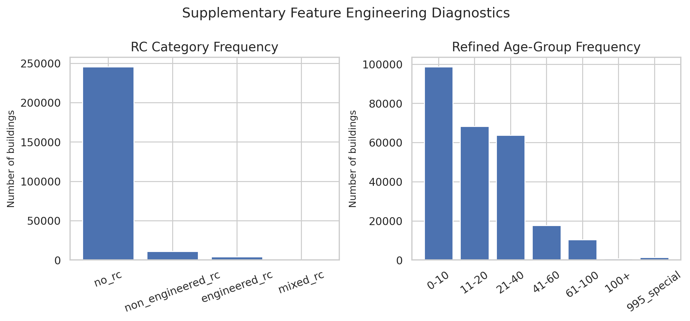
Figure 1. Supplementary feature-engineering diagnostics: RC category frequency and refined age-group frequency.
Key finding: The refined features preserve distinctions that the original broad variables hide, especially engineered versus non-engineered reinforced concrete and the special age value 995.

5. Exploratory Data Analysis and Findings
The following figures reproduce and consolidate the major EDA outputs in English. All percentages are descriptive associations from the training data. They identify patterns worth modeling, while predictive value must later be confirmed on held-out data.

5.1 Target Distribution
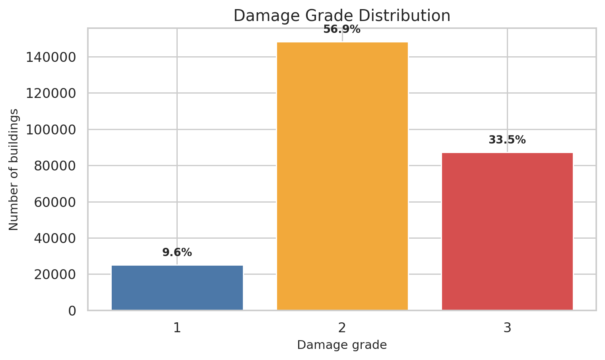
Figure 2. Distribution of the three earthquake damage grades in the training data.
Grade 2 is the majority class with 148,259 buildings (56.89%). Grade 3 contains 87,218 buildings (33.47%), while Grade 1 contains only 25,124 buildings (9.64%).
This imbalance is material enough to affect evaluation. A model that over-predicts Grade 2 can obtain a superficially respectable overall accuracy. For this single-label multiclass task, micro F1 is numerically equal to accuracy. The modeling stage should therefore report micro F1 together with macro F1, per-class precision/recall/F1, and a confusion matrix.
Key finding: Evaluation must account for class imbalance; overall accuracy or micro F1 alone can hide poor performance on Grade 1 or Grade 3.

5.2 Building Age and Damage Severity
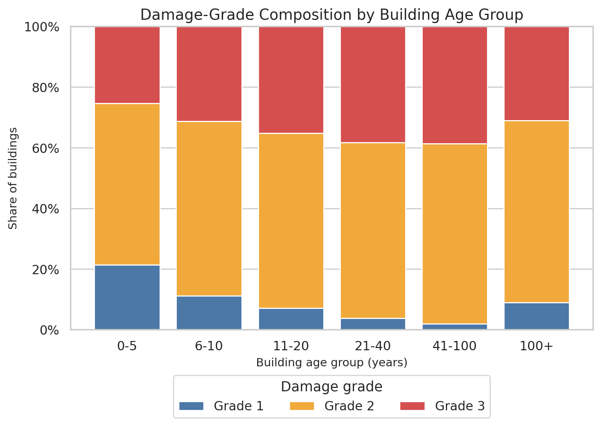
Figure 3. Damage-grade composition by building age group. The initial EDA groups age >100 together, while later feature engineering isolates age = 995.
The observed Grade-3 share rises from 25.42% for buildings aged 0-5 years to 38.34% for ages 21-40 and 38.64% for ages 41-100. The 100+ group drops to 30.98%, which is partly explained by the special age value 995 being mixed into this bucket in the initial EDA.
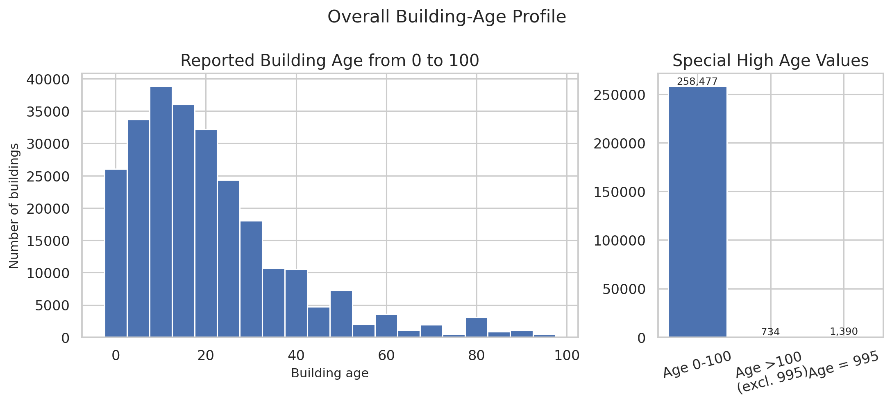
Figure 4. Overall building-age profile. The 995 code appears 1,390 times and is handled explicitly in the engineered features.
There are 1,390 records with age = 995 (0.53% of training data), plus 734 other records above 100. Instead of deleting these observations, the pipeline keeps the original age and adds age_is_995, age_capped_100, and a 995_special age group.
Key finding: Damage severity generally increases with building age across ordinary age bands, and the 995 code requires separate treatment to avoid distorting the high-age group.

5.3 Foundation Type
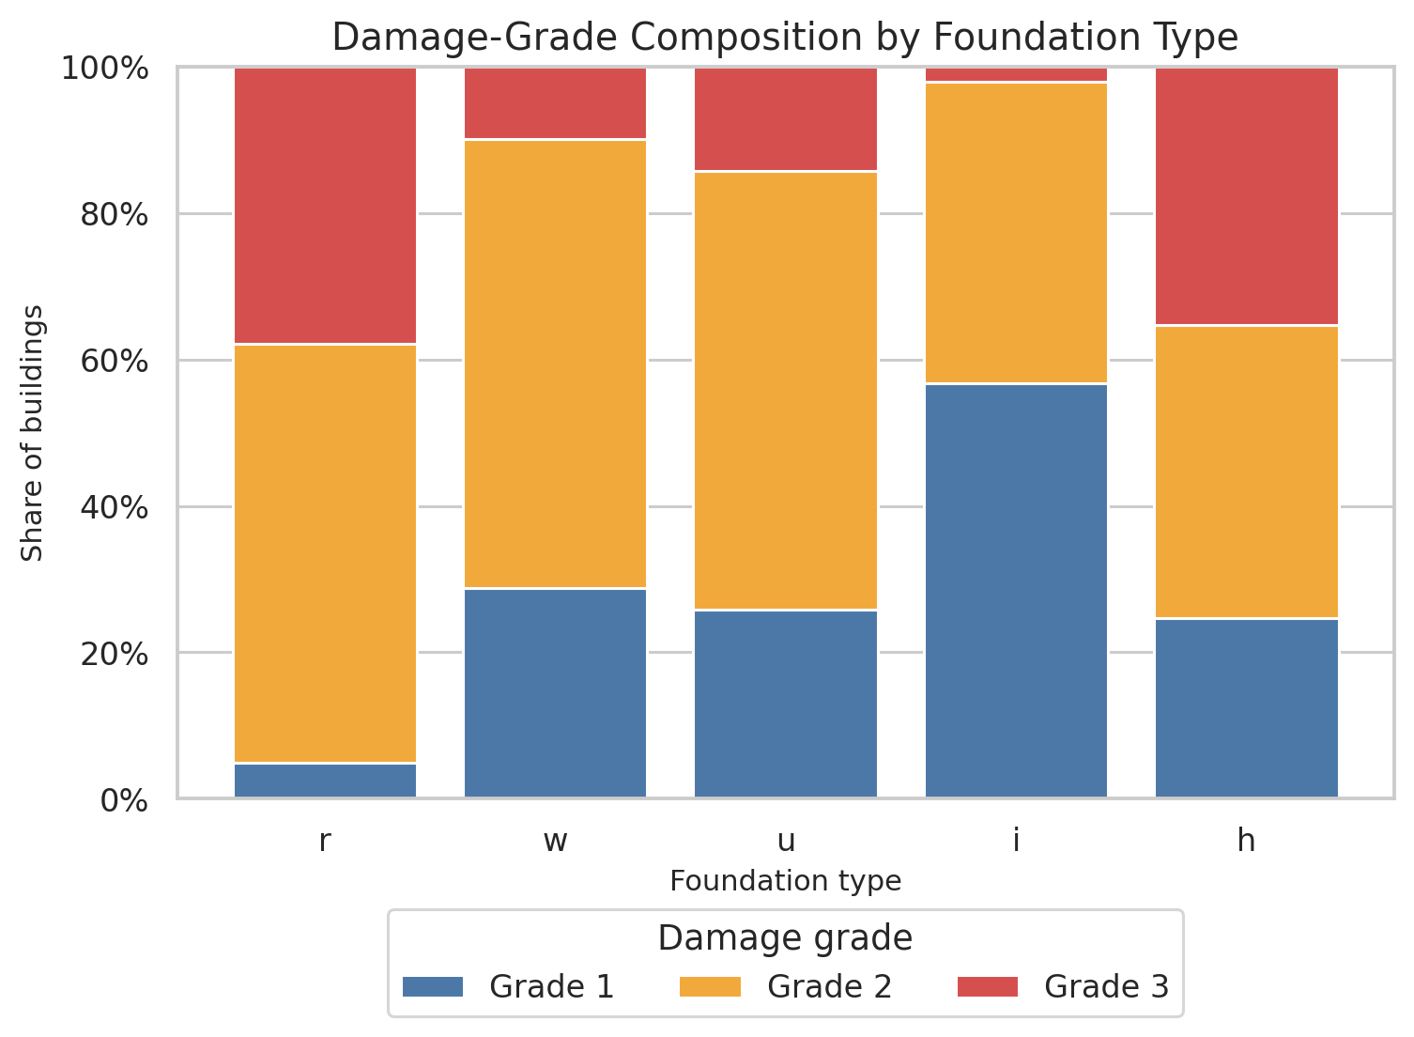
Figure 5. Damage-grade composition by foundation type.
Foundation | N | Grade 1 | Grade 2 | Grade 3
h | 1,448 | 24.7% | 40.0% | 35.3%
i | 10,579 | 56.8% | 41.2% | 2.1%
r | 219,196 | 4.9% | 57.3% | 37.8%
u | 14,260 | 25.9% | 59.9% | 14.2%
w | 15,118 | 28.8% | 61.3% | 9.9%

Foundation type shows a large separation in observed severe damage. Type r has a Grade-3 rate of 37.85%, while type i has only 2.09%. The spread from roughly 2% to 38% is large enough to make foundation type a strong candidate predictor and interpretation variable.
Key finding: Foundation type is one of the clearest structural associations in the EDA and is likely to interact with age, number of floors, and construction material.

5.4 Roof Type
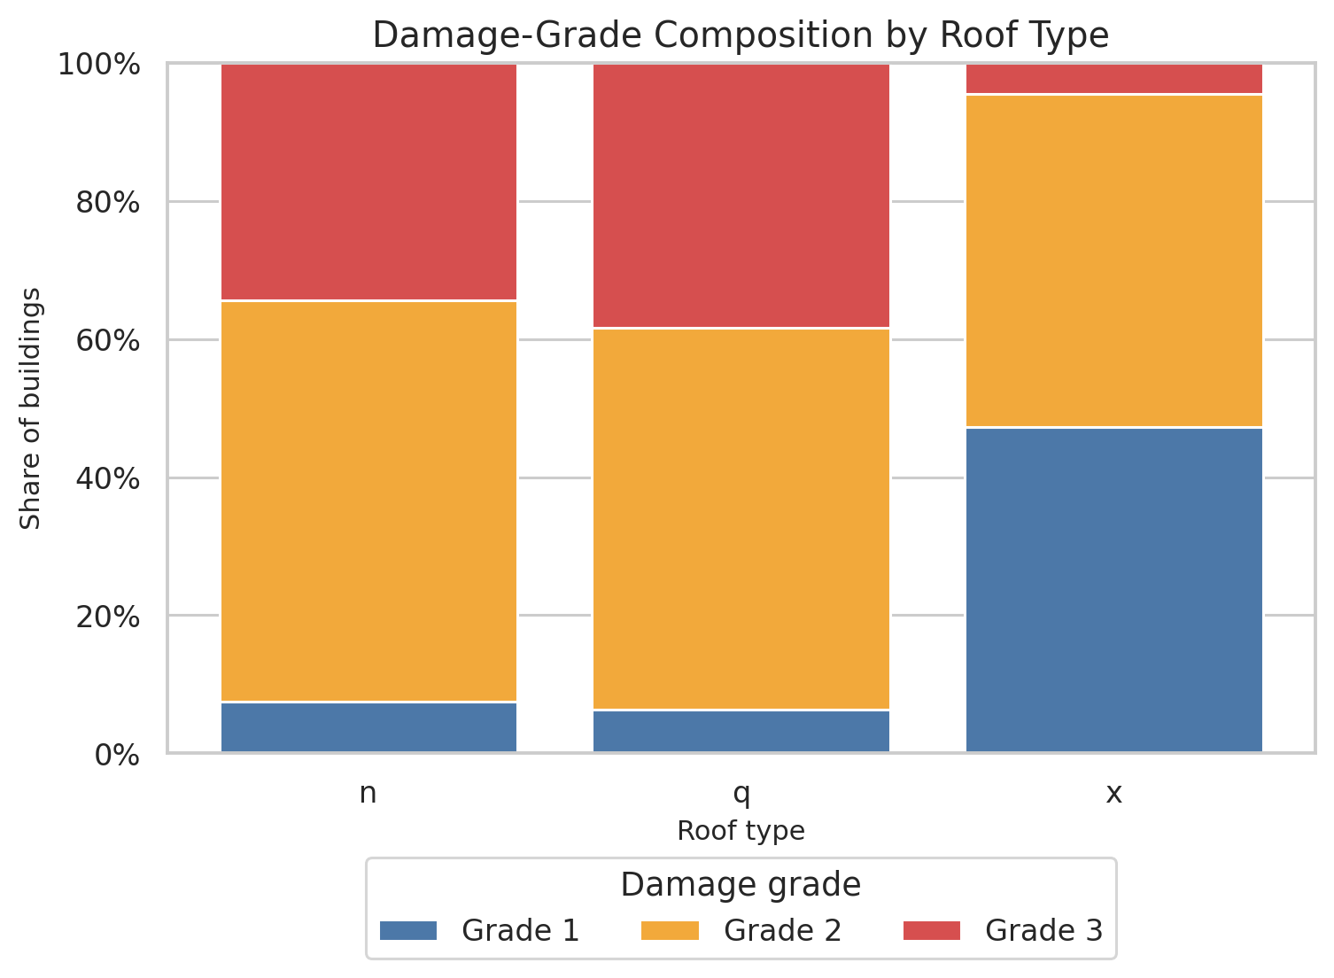
Figure 6. Damage-grade composition by roof type.
Roof | N | Grade 1 | Grade 2 | Grade 3
n | 182,842 | 7.4% | 58.2% | 34.4%
q | 61,576 | 6.4% | 55.2% | 38.4%
x | 16,183 | 47.3% | 48.2% | 4.5%

Roof type is also strongly associated with damage. Type q has an observed Grade-3 rate of 38.39%, compared with only 4.50% for type x. This categorical variable should therefore be retained and encoded safely for models that cannot consume categories natively.
Key finding: Roof type produces a large shift in the damage distribution and should remain available for both prediction and feature-importance analysis.

5.5 Secondary Use
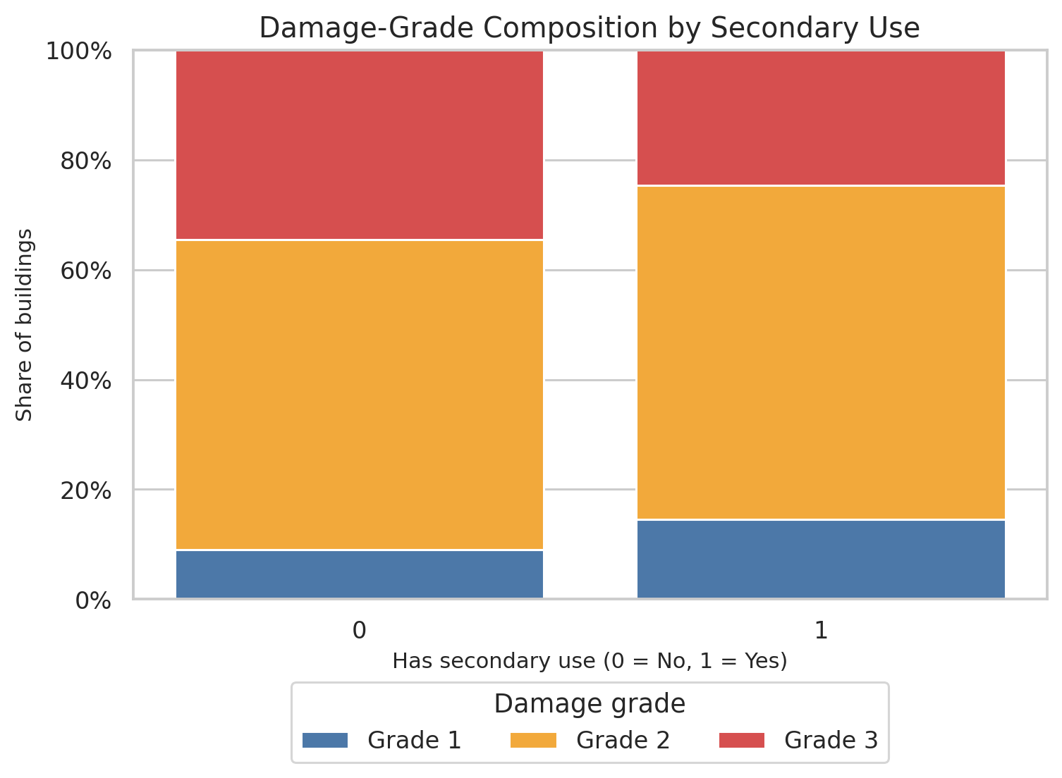
Figure 7. Damage-grade composition for buildings with and without secondary use.
Buildings without secondary use have an observed Grade-3 rate of 34.58%; buildings with secondary use have a lower observed Grade-3 rate of 24.67%. Grade 1 is correspondingly more common among buildings with secondary use (14.57% versus 9.02%).
This is an observational association. Secondary use may proxy for building type, location, construction quality, economic activity, or other correlated characteristics. The feature should be modeled, while causal interpretation should be avoided.
Key finding: Secondary use is informative in the raw EDA, and secondary_use_count adds finer detail beyond the broad yes/no indicator.

5.6 Numeric Building Characteristics by Damage Grade
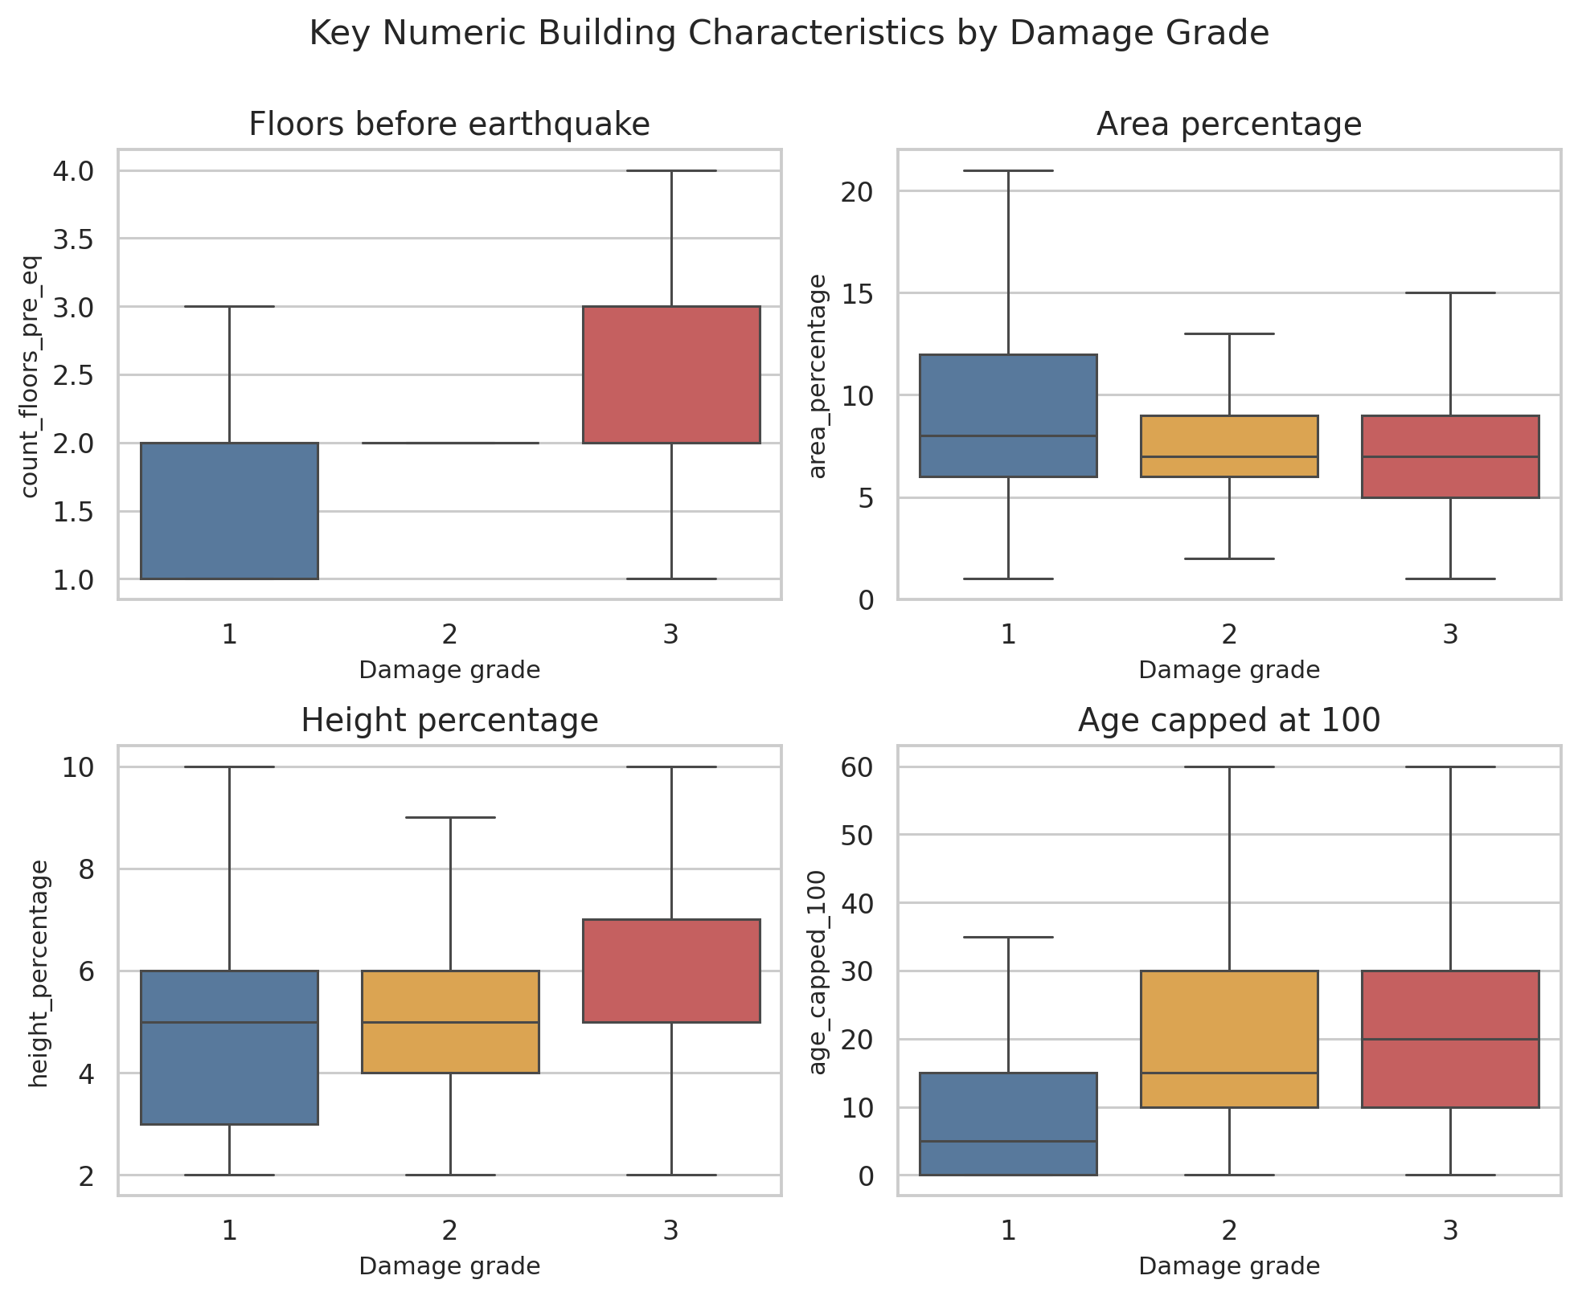
Figure 8. Boxplots for floors, area, height, and robust age by damage grade.
Variable | Grade 1 median | Grade 2 median | Grade 3 median
Floors | 2.00 | 2.00 | 2.00
Area % | 8.00 | 7.00 | 7.00
Height % | 5.00 | 5.00 | 5.00
Age capped 100 | 5.00 | 15.00 | 20.00

The boxplots indicate that severely damaged buildings occupy different structural profiles from lightly damaged buildings. Grade 3 is shifted toward greater height and shows a wider upper range in floor count, while Grade 1 tends to have larger area percentages. The class distributions still overlap substantially, and the later floor-by-floor analysis shows that floor count itself is non-monotonic. No single numeric feature can separate the classes on its own.
Key finding: The numeric predictors contain useful signal, yet the overlap across grades suggests that nonlinear interactions and categorical context will be important.

5.7 Overall Numeric Distributions
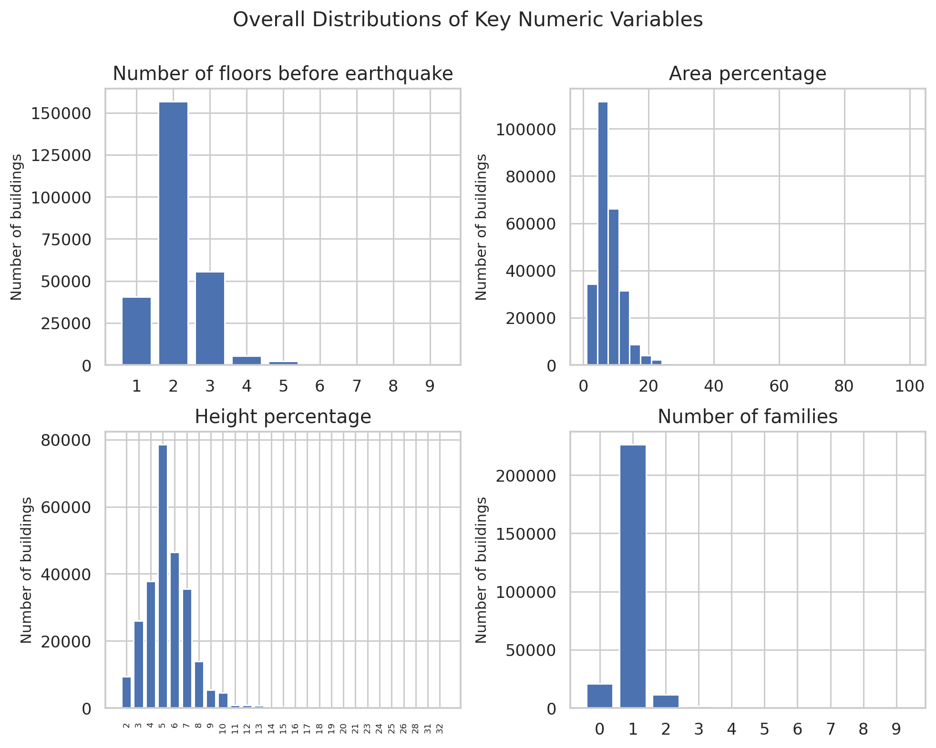
Figure 9. Overall distributions of floors, area percentage, height percentage, and number of families.
Several core variables are strongly concentrated rather than approximately Gaussian. Most buildings have two or three floors, area_percentage and height_percentage are right-skewed, and count_families is highly concentrated around one family. These shapes support the decision to avoid unnecessary distributional assumptions and make tree-based models particularly attractive.
Key finding: The raw numeric variables are discrete or skewed, so robust tree-based models can use their structure without requiring aggressive transformation.

5.8 Categorical Frequency Profiles
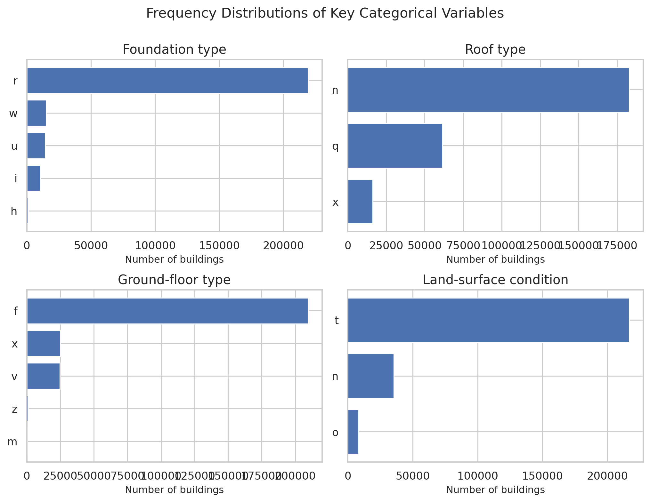
Figure 10. Frequency distributions of major categorical building variables.
The categorical features are imbalanced internally. Foundation type 'r' represents 84.1% of buildings, while roof type 'n' represents 70.2%. Rare categories are also present. Encoding methods therefore need to tolerate unseen or low-frequency categories without failing.
Key finding: Category frequency is highly uneven, which favors encoders with unknown-category handling and motivates CatBoost-style native categorical treatment.

5.9 Correlation Among Numeric and Engineered Variables
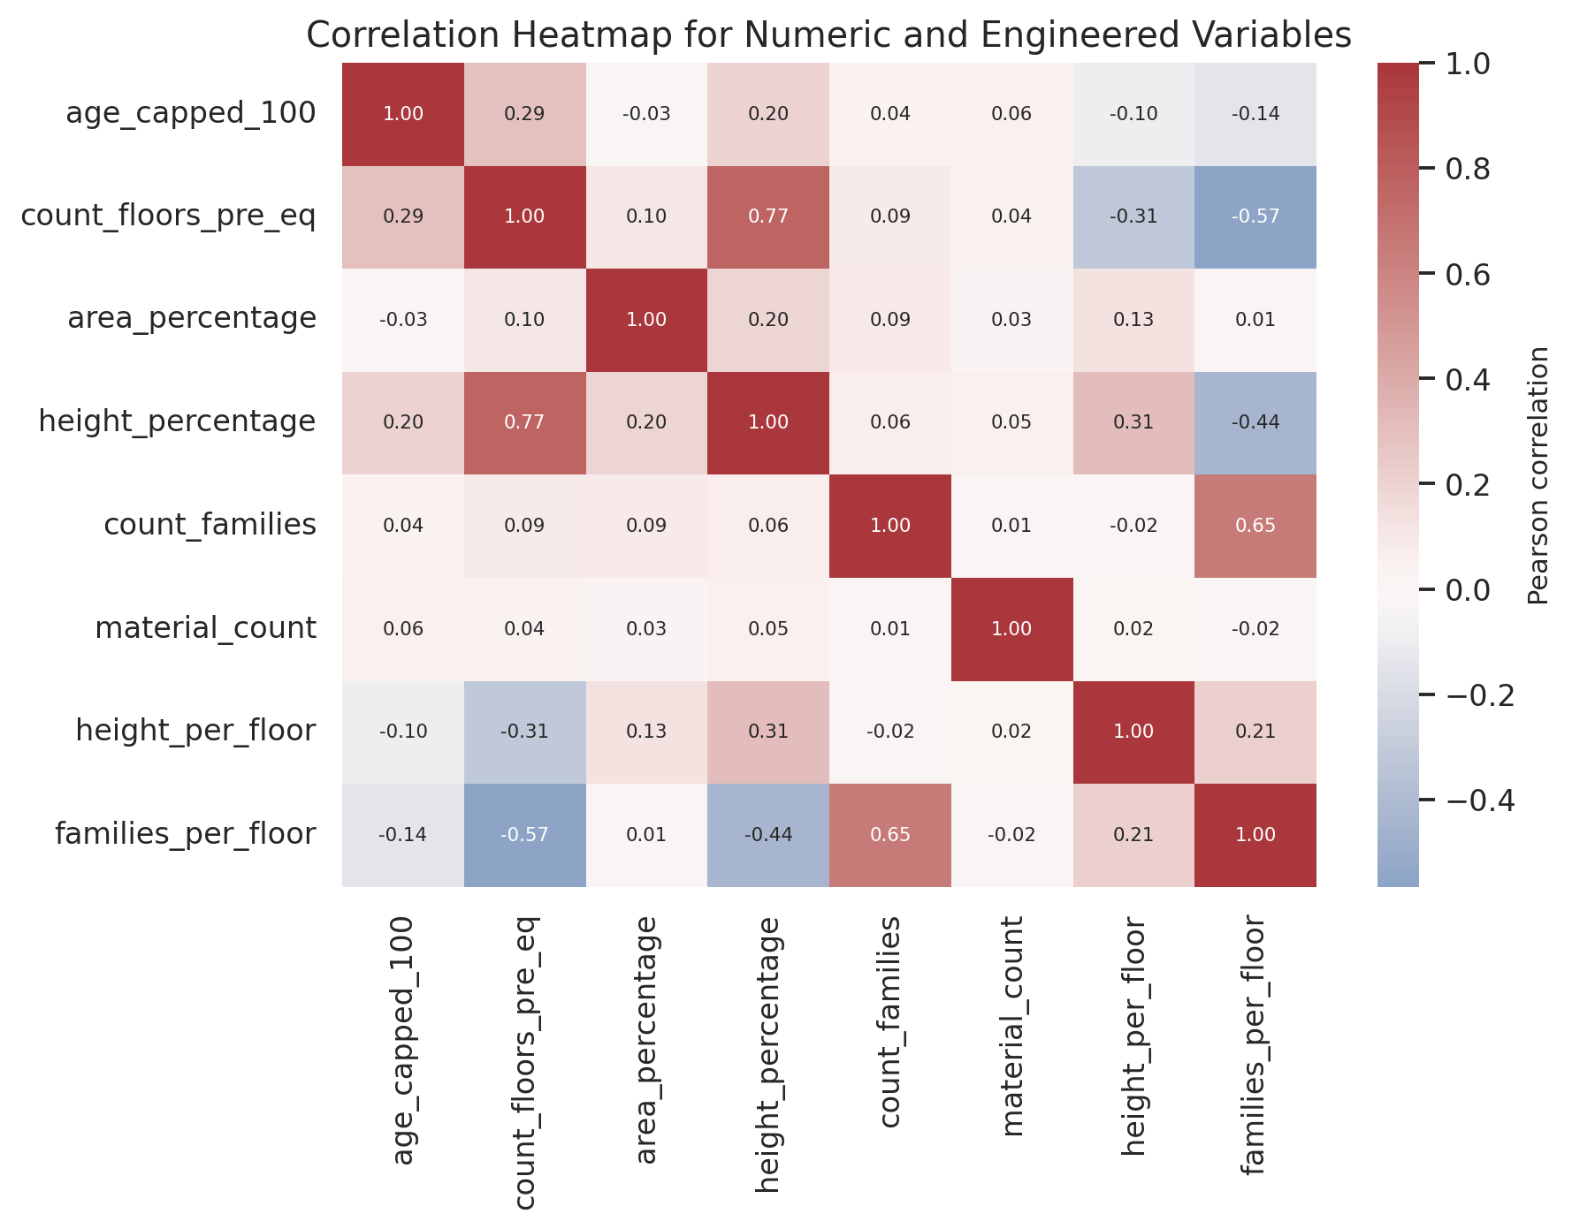
Figure 11. Pearson correlations among selected numeric and engineered variables.
The strongest pairwise correlation is between count_floors_pre_eq and height_percentage (r = 0.77), which is expected because taller buildings usually have more floors. count_families and families_per_floor are also correlated (r = 0.65), while count_floors_pre_eq and families_per_floor are negatively related (r = -0.57).
This heatmap is a diagnostic for redundancy and linear dependence among predictors. It is not a direct measure of predictive importance for damage_grade, especially because many of the most informative features are categorical and relationships may be nonlinear.
Key finding: Some engineered features are mathematically related to their source variables, so regularized linear models may face redundancy; tree ensembles are less sensitive to this issue.

5.10 Construction Materials and Severe Damage
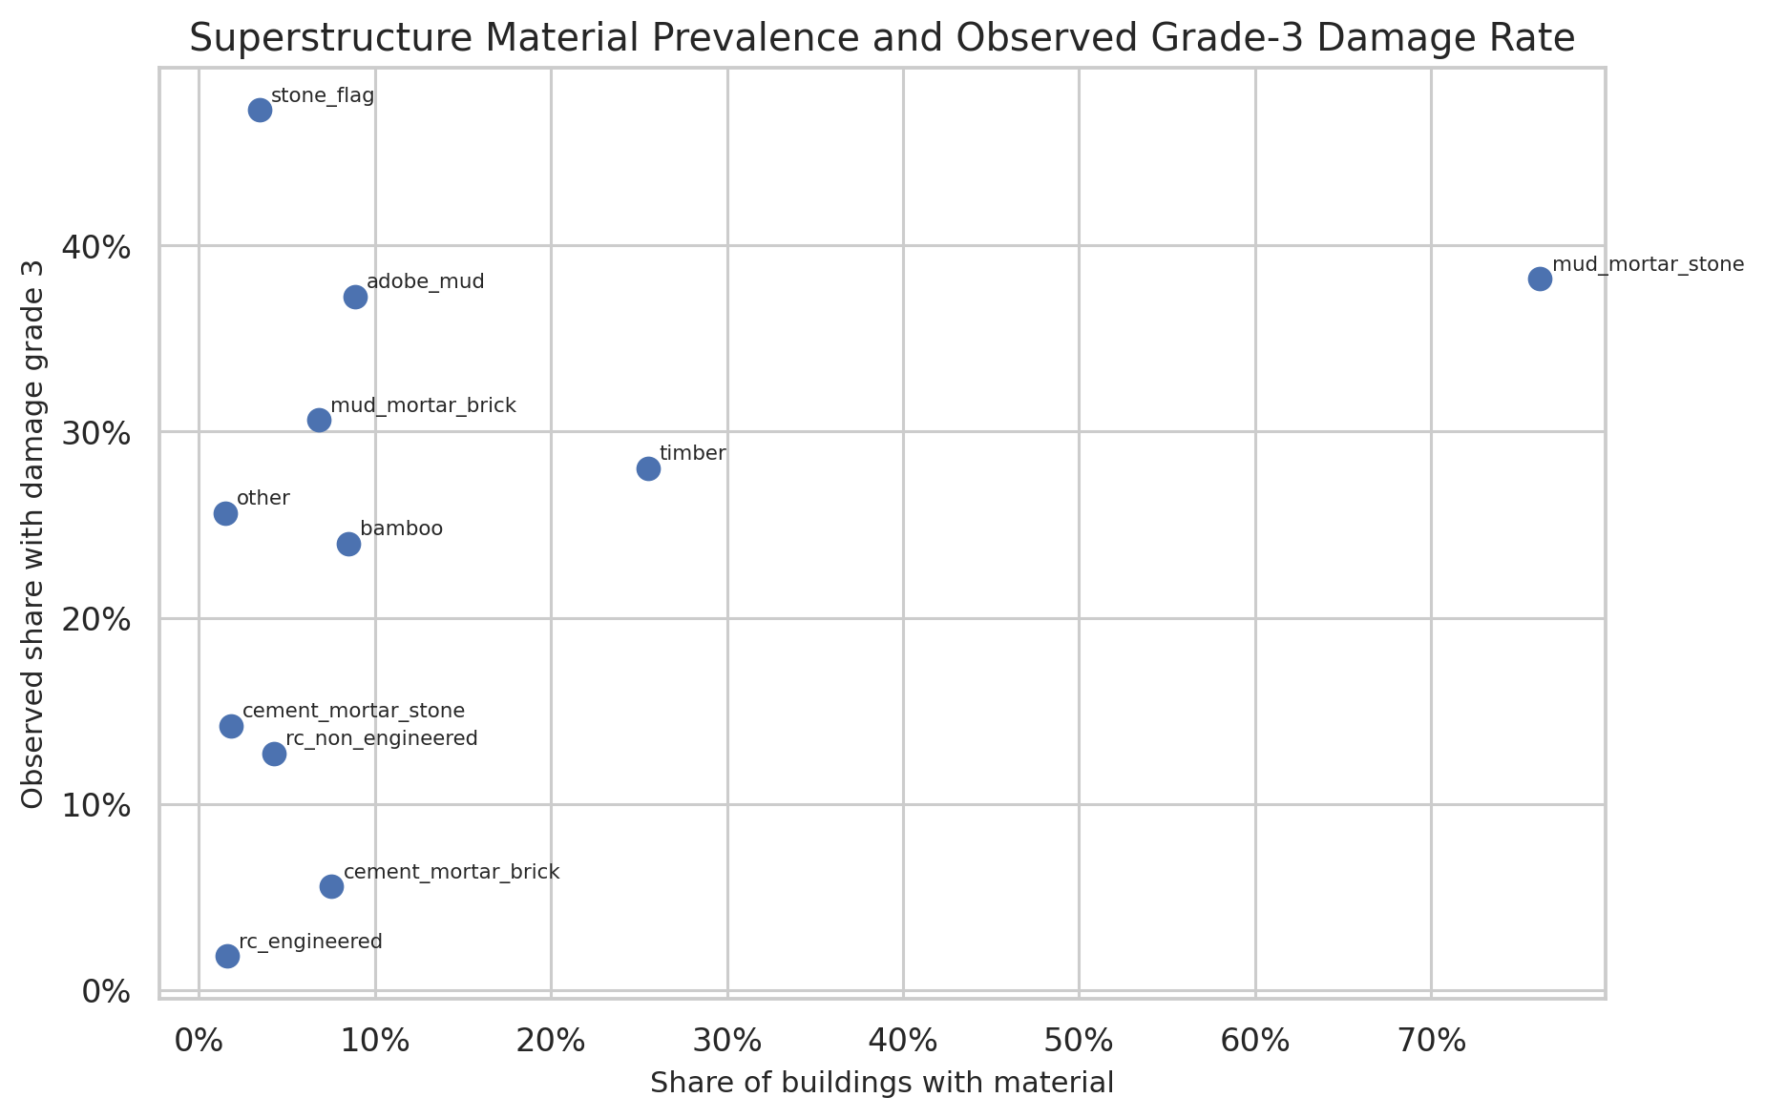
Figure 12. Material prevalence versus observed Grade-3 damage rate.
Material | Prevalence | Grade-3 rate
stone_flag | 3.4% | 47.3%
mud_mortar_stone | 76.2% | 38.2%
adobe_mud | 8.9% | 37.2%
mud_mortar_brick | 6.8% | 30.6%
timber | 25.5% | 28.0%
other | 1.5% | 25.6%
bamboo | 8.5% | 24.0%
cement_mortar_stone | 1.8% | 14.2%
rc_non_engineered | 4.3% | 12.7%
cement_mortar_brick | 7.5% | 5.6%
rc_engineered | 1.6% | 1.8%

The largest observed Grade-3 rate occurs for stone_flag (47.29%), followed by mud_mortar_stone (38.20%) and adobe_mud (37.25%). At the opposite end, engineered reinforced concrete has a Grade-3 rate of only 1.81%, and cement_mortar_brick is also relatively low at 5.55%.
The broad has_reinforced_concrete feature captures an important direction, while rc_category preserves the substantial difference between engineered and non-engineered RC. Material_count alone cannot represent these qualitative differences because the identity of the material matters more than the number of material flags.
Key finding: Construction material is one of the most interpretable damage signals in the dataset, and engineered RC is associated with far lower observed severe-damage rates than mud- or stone-based structures.

5.11 Number of Floors
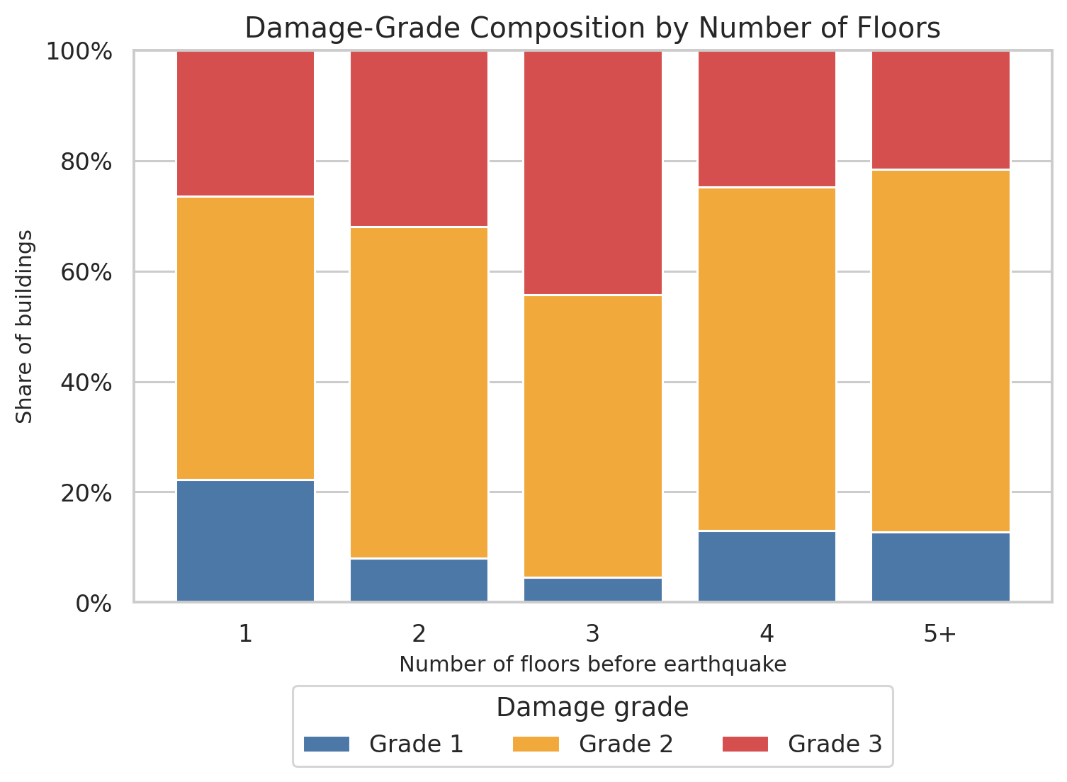
Figure 13. Damage-grade composition by number of floors before the earthquake.
The relationship is clearly non-monotonic. Three-floor buildings have the highest observed Grade-3 rate at 44.23%, compared with 26.39% for one-floor buildings, 31.96% for two-floor buildings, 24.76% for four-floor buildings, and 21.55% for buildings with five or more floors.
This pattern is a strong warning against assuming a simple linear effect of floor count. The risk associated with floors likely depends on foundation, material, height, and geography.
Key finding: Floor count has a nonlinear relationship with damage, supporting interaction-capable models such as Random Forest, XGBoost, LightGBM, or CatBoost.

5.12 Height per Floor
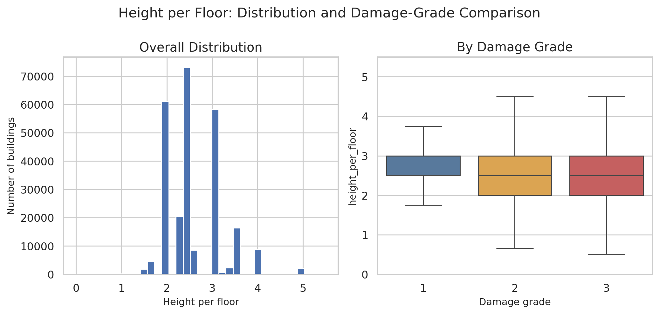
Figure 14. Distribution of height_per_floor and comparison across damage grades.
Mean height_per_floor declines from 2.843 for Grade 1 to 2.613 for Grade 2 and 2.565 for Grade 3. The median is 3.0 for Grade 1 and 2.5 for Grades 2 and 3. The distributions still overlap substantially, so this feature should be treated as a modest structural proxy rather than a standalone discriminator.
Key finding: height_per_floor adds a normalized structural view, though its class separation is moderate compared with foundation, material, or geography.

5.13 Families per Floor
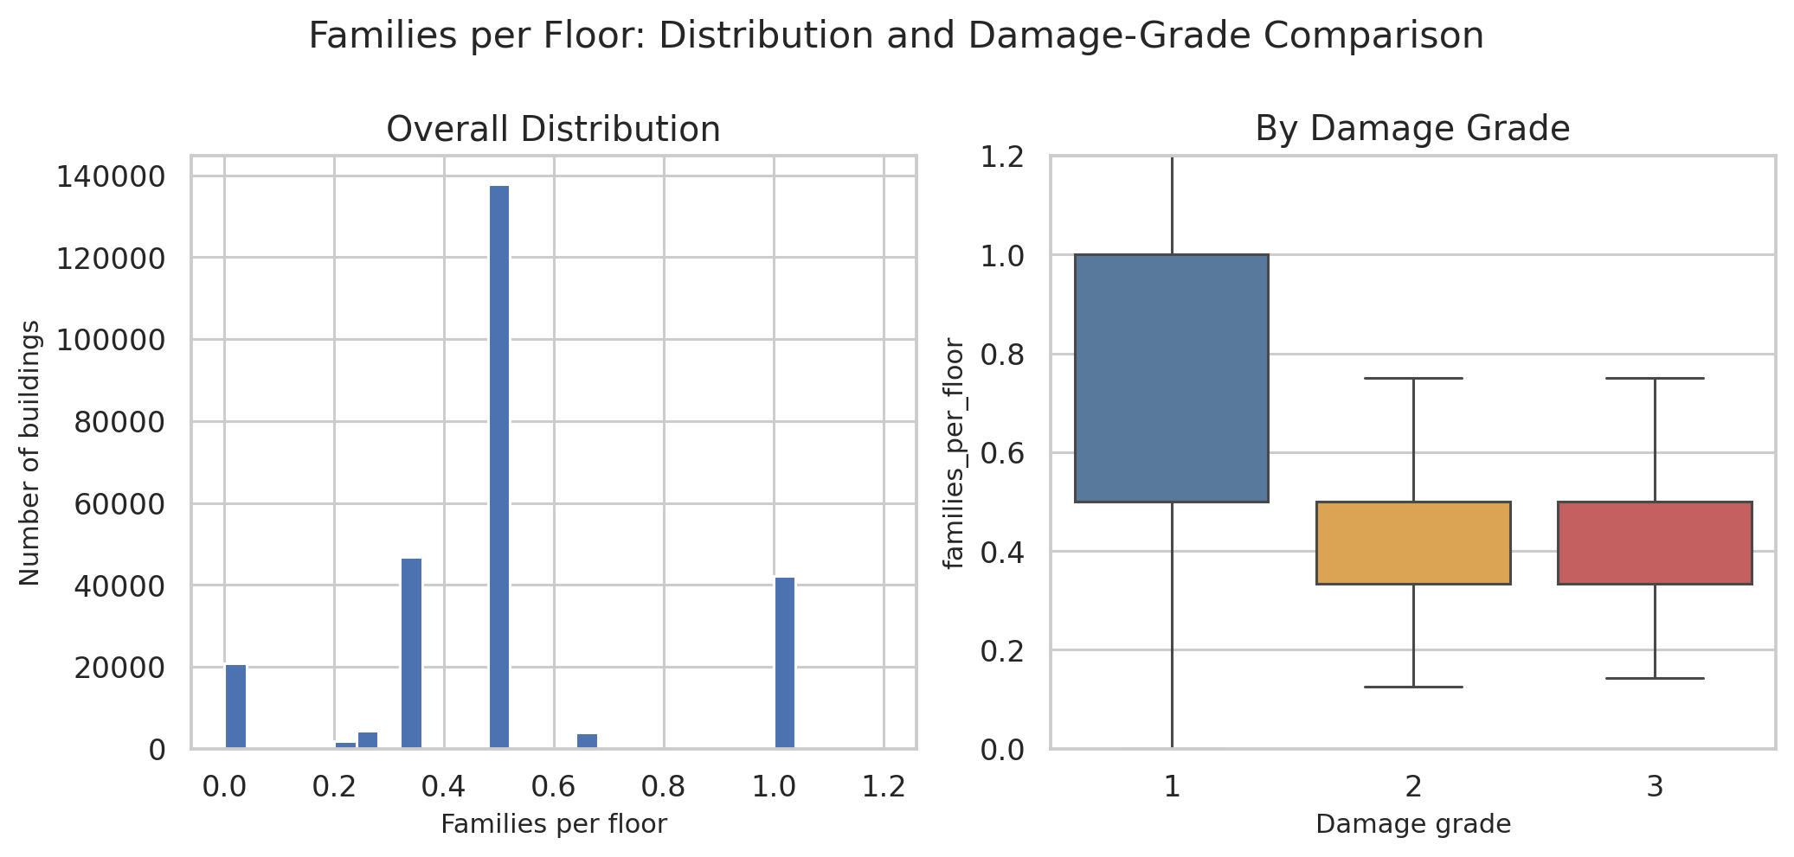
Figure 15. Distribution of families_per_floor and comparison across damage grades.
Mean families_per_floor is 0.591 for Grade 1, 0.515 for Grade 2, and 0.504 for Grade 3. The medians are all close to 0.5, so the signal is relatively weak in isolation. Its main value is as a compact occupancy-density proxy that may interact with building size and floor count.
Key finding: families_per_floor is a candidate interaction feature rather than a dominant standalone predictor.

5.14 Geographic Heterogeneity
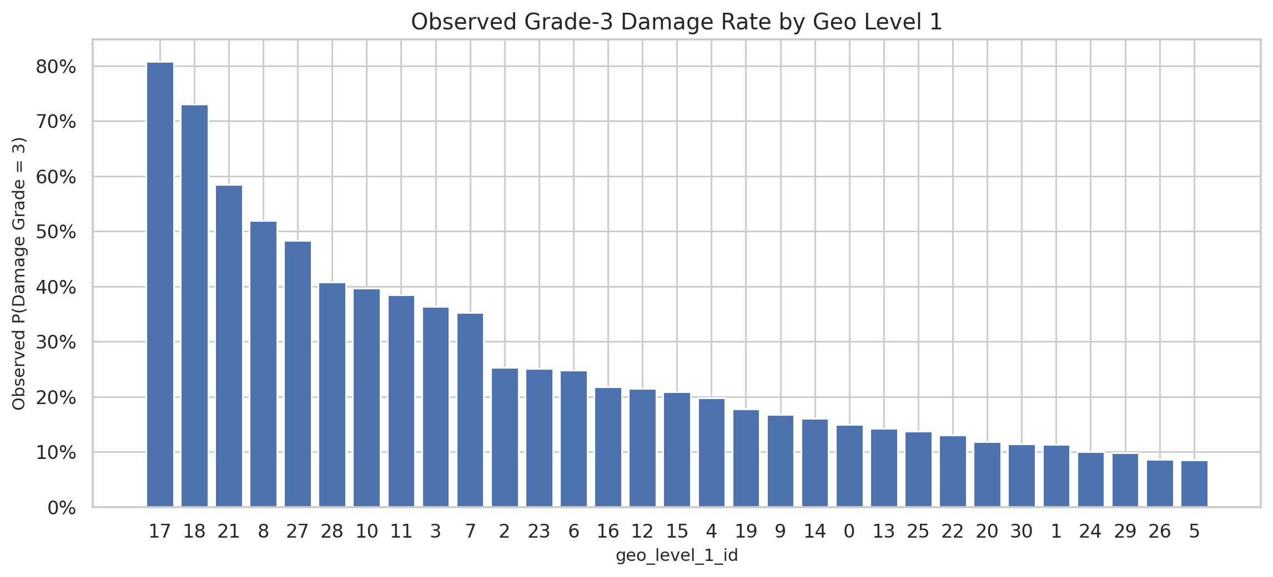
Figure 16. Observed Grade-3 damage rate by Geo Level 1. These target-based rates are used only for EDA.
Geo Level 1 | N | Grade-3 rate
17 | 21,813 | 80.75%
18 | 3,189 | 73.10%
21 | 14,889 | 58.50%
8 | 19,080 | 51.95%
27 | 12,532 | 48.36%
5 | 2,690 | 8.55%
26 | 22,615 | 8.59%
29 | 396 | 9.85%
24 | 1,310 | 10.08%
1 | 2,701 | 11.29%

Geography is the strongest heterogeneity signal observed in the preprocessing stage. Across the 31 Geo Level-1 categories, the Grade-3 rate ranges from 8.55% to 80.75%. Geo Level 1 = 17 has 80.75% Grade-3 damage across 21,813 buildings, while Geo Level 1 = 5 has only 8.55% across 2,690 buildings.
Geographic field | Unique categories | Median buildings/category | Categories <20 buildings | Categories <5 buildings
geo_level_1_id | 31 | 4332.0 | 0 | 0
geo_level_2_id | 1,414 | 120.5 | 278 | 80
geo_level_3_id | 11,595 | 14.0 | 6,974 | 2,783

The finer geographic levels are high-cardinality and sparse: Geo Level 3 has 11,595 observed categories, a median of only 14 buildings per category, and thousands of very small groups. Direct one-hot encoding is therefore expensive and potentially brittle. CatBoost or carefully regularized/fold-safe encodings are better candidates for these fields.
Because geography is so predictive, random validation can overstate how well a model transfers to completely unseen regions. A geographic holdout or GroupKFold experiment should be included later to measure true geographic generalization.
Key finding: Location carries extremely strong predictive information. The modeling stage should separate geographic memorization from transferable structural vulnerability.

6. Consolidated Conclusions from Preprocessing and EDA
- The dataset is clean and internally consistent. No missing-value repair or row deletion is required at the preprocessing stage. The main work is correct variable representation, feature engineering, and leakage prevention.
- The target is imbalanced. Grade 2 dominates the sample, so macro F1 and per-class metrics are necessary alongside the official micro F1.
- Damage patterns are strongly nonlinear. Floor count, age, and structural variables do not follow simple monotonic relationships. Interaction-capable tree ensembles are therefore well motivated.
- Foundation, roof, and material are high-value structural predictors. The observed severe-damage rates differ sharply across these categories, with especially strong contrast between mud/stone structures and engineered RC.
- Age contains both genuine signal and a special code. Ordinary age bands show increasing severe damage, while age = 995 must be isolated so that it does not distort the high-age tail.
- Geography is a dominant source of heterogeneity. Geo Level-1 severe-damage rates range from 8.55% to 80.75%. This motivates geography-aware validation and feature ablation.
- The supplementary features improve representation. secondary_use_count, area_per_family, rc_category, and age_group retain distinctions that are compressed in the original variables and are ready for ablation testing during modeling.

7. Handoff to Modeling
The preprocessing stage now produces a consolidated modeling table while preserving the original raw files and the original processed outputs. The recommended modeling workflow is:
- Use building_id only as an identifier and remove it from X immediately before model fitting.
- Use the fixed stratified 80/20 split for a common benchmark, with all learned preprocessing fit on X_train only.
- Start with a majority-class baseline and a simple linear or tree baseline, then compare Random Forest and gradient-boosting models.
- For high-cardinality categorical geography, prioritize CatBoost or another method that handles categories safely.
- Report micro F1, macro F1, per-class precision/recall/F1, and a confusion matrix. Grade-3 recall is especially useful for severe-damage detection.
- Run an ablation comparing the original preprocessing feature set against the supplemented feature set to measure whether the additional engineering contributes predictive value.
- Run Geography Only, Structure Only, and Full Model experiments to quantify where predictive power comes from.
- Compare ordinary random validation with a geographic holdout or GroupKFold setup to test transfer to unseen regions.
Key finding: The core modeling question should extend beyond leaderboard performance: how much of earthquake-damage predictability comes from location, and how much comes from structural vulnerability that transfers across regions?

8. Interpretation Limits
- All EDA relationships are observational associations. They do not establish causal effects of construction choices, secondary use, or geography on damage.
- Geographic damage rates are computed from the target and must remain outside the feature matrix unless a leakage-safe out-of-fold encoding is designed.
- The meaning of age = 995 is not established by the supplied project files. The current pipeline preserves and flags it rather than assuming a specific semantic interpretation.
- Rare categories at Geo Level 2 and especially Geo Level 3 can produce unstable raw group-level rates. Sparse-group summaries should be interpreted cautiously.
- Any claim that an engineered feature improves prediction must be supported later by held-out or cross-validated model results.

Appendix A. Processing Outputs
Output | Purpose
processed_data/ | Original engineered data, fixed train/validation split, metadata, and preserved labels.
supplementary_processed_data/ | Consolidated feature tables, schema, and the supplementary split mapping.
supplementary_outputs/figures/ | Additional geography visualization.
supplementary_outputs/tables/ | Geo Level 1/2/3 damage summary tables for EDA and presentation use.

The consolidated supplementary training table contains 260,601 rows and 49 columns including building_id. Removing building_id leaves 48 model features before any model-specific encoding.

Part II · Modeling, Evaluation and Experimental Analysis

9. Modeling Inputs and Validation Design
The modeling stage consumes the consolidated feature tables produced by the preprocessing pipeline. The final training table contains 260,601 labeled buildings and 49 columns including building_id. Because building_id is used only for alignment and submission, 48 features enter model-specific preprocessing. The common benchmark uses the fixed 80/20 stratified split created earlier: 208,480 training observations and 52,121 validation observations.
The target is ordinal. Grade 1 indicates low damage, Grade 2 medium damage, and Grade 3 severe or near-complete destruction. The DrivenData metric is Micro F1. In a single-label multiclass setting, Micro F1 is numerically equal to accuracy, so the analysis also reports Macro F1, Grade-3 Recall, ordinal MAE, Quadratic Weighted Kappa, and Catastrophic Error Rate.
Metric | Role in evaluation
Micro F1 | Official competition metric; equals overall accuracy in this task.
Macro F1 | Weights all three classes equally and exposes minority-class weakness.
Grade-3 Recall | Measures detection of the most severely damaged buildings.
Ordinal MAE | Uses the natural 1 < 2 < 3 ordering; a two-grade miss is worse than a one-grade miss.
QWK | Ordinal agreement metric with stronger penalty for larger disagreement.
CER | Catastrophic Error Rate: fraction of direct Grade-1 ↔ Grade-3 mistakes.

10. Model Benchmark and Selection
Model | Micro F1 | Macro F1 | G3 Recall | MAE | QWK | CER
LightGBM + One-Hot | 0.7474 | 0.6937 | 0.6222 | 0.2557 | 0.6142 | 0.0031
LightGBM, compact encoding | 0.7387 | 0.6816 | 0.6079 | 0.2639 | 0.5993 | 0.0026
Linear Logistic Baseline | 0.7359 | 0.6835 | 0.5488 | 0.2692 | 0.5922 | 0.0051
XGBoost + One-Hot | 0.7331 | 0.6700 | 0.5792 | 0.2692 | 0.5838 | 0.0023
Random Forest | 0.7172 | 0.6446 | 0.5340 | 0.2848 | 0.5495 | 0.0020
Decision Tree | 0.7087 | 0.6529 | 0.6069 | 0.2975 | 0.5609 | 0.0062
Majority Baseline | 0.5689 | 0.2417 | 0.0000 | 0.4311 | 0.0000 | 0.0000
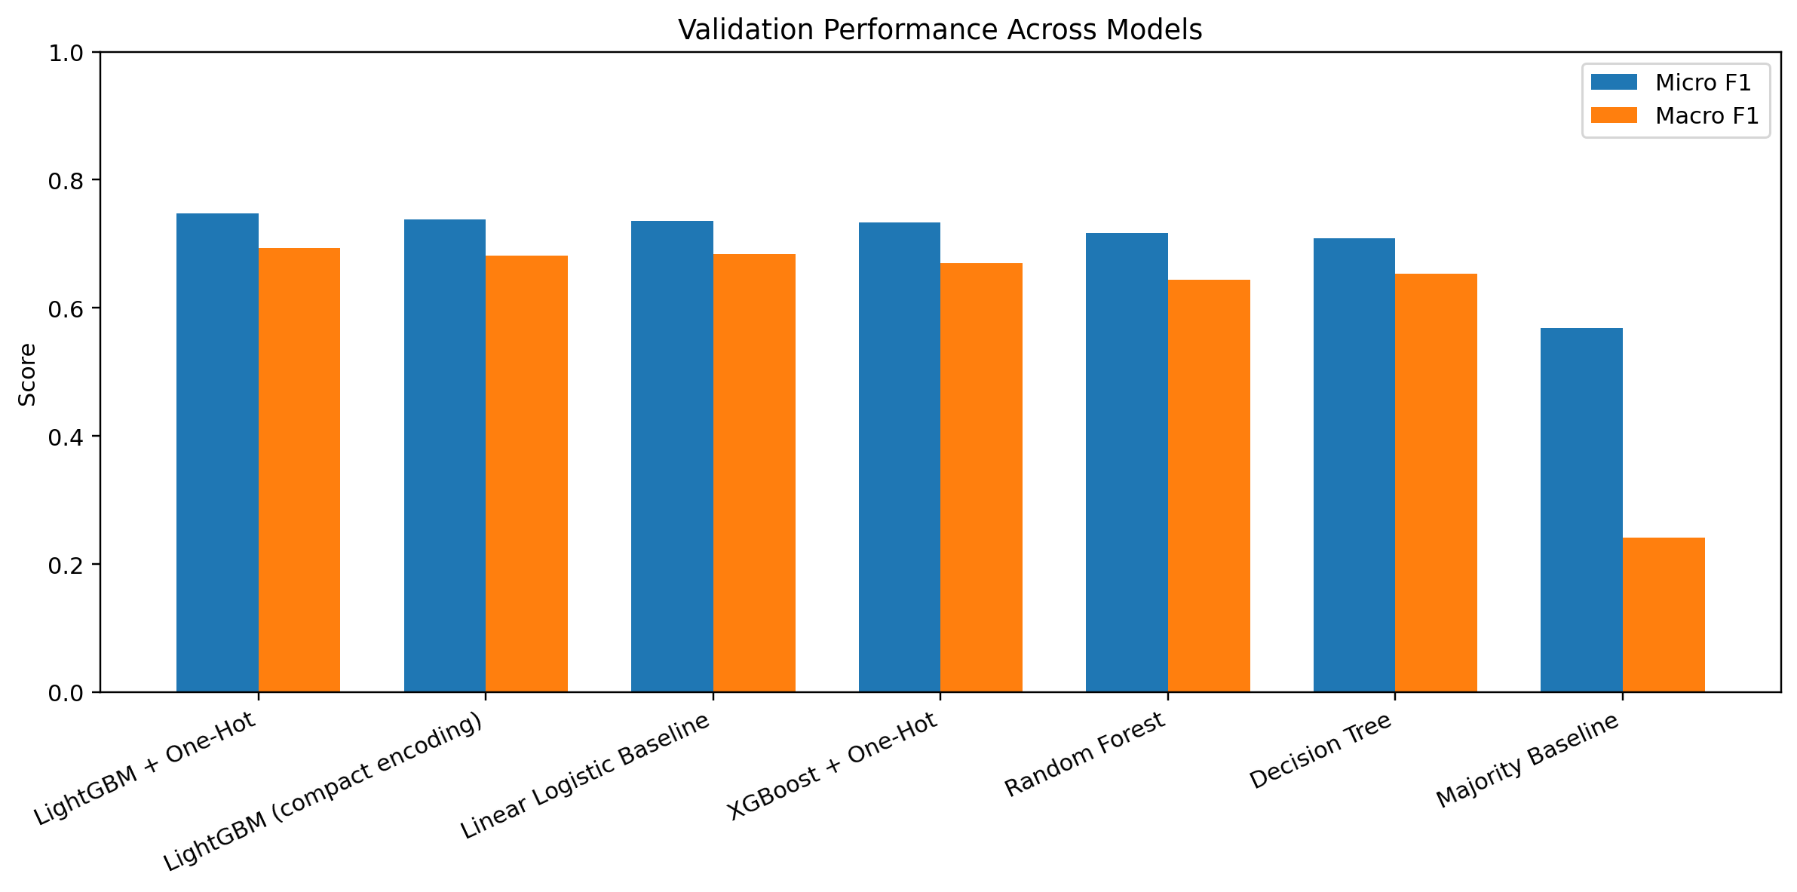
Figure 17. Validation performance across the main candidate models.
LightGBM with one-hot encoded categorical variables is the strongest model on the fixed validation set. Its Micro F1 of 0.7474 is 17.85 percentage points above the majority baseline. The linear logistic baseline is surprisingly competitive at 0.7359, suggesting that much of the signal is additive, while the additional LightGBM gain shows that nonlinearities and interactions remain useful.
Key finding: LightGBM + One-Hot is the strongest tested course-project model on the common random validation split.

11. Best-Model Class-Level Error Analysis
Class | Precision | Recall | F1 | Support
Grade 1 | 0.6932 | 0.5202 | 0.5944 | 5,025
Grade 2 | 0.7425 | 0.8595 | 0.7967 | 29,652
Grade 3 | 0.7740 | 0.6222 | 0.6899 | 17,444
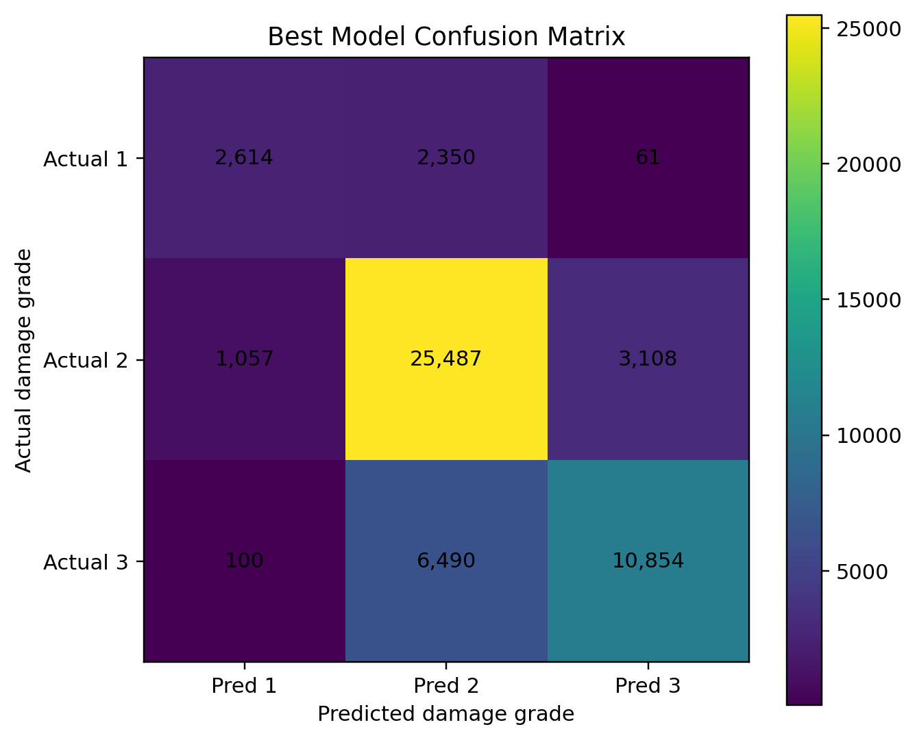
Figure 18. Confusion matrix for the best LightGBM + One-Hot validation model.
Grade 2 is the easiest class, with recall close to 0.86. Grade 1 is the hardest minority class, with recall around 0.52. Grade 3 achieves precision around 0.77 and recall around 0.62. Only 161 of the 52,121 validation observations are misclassified across the full two-grade distance between Grade 1 and Grade 3, producing a catastrophic error rate of about 0.31%.
Key finding: The best model avoids extreme Grade-1 ↔ Grade-3 mistakes, yet minority Grade 1 remains the main class-level weakness.

12. Did the Supplementary Features Improve Prediction?
Feature set | Micro F1 | Macro F1 | Grade-3 Recall
Notebook 01 features | 0.7398 | 0.6823 | 0.6084
Notebook 01 + 02 features | 0.7387 | 0.6816 | 0.6079
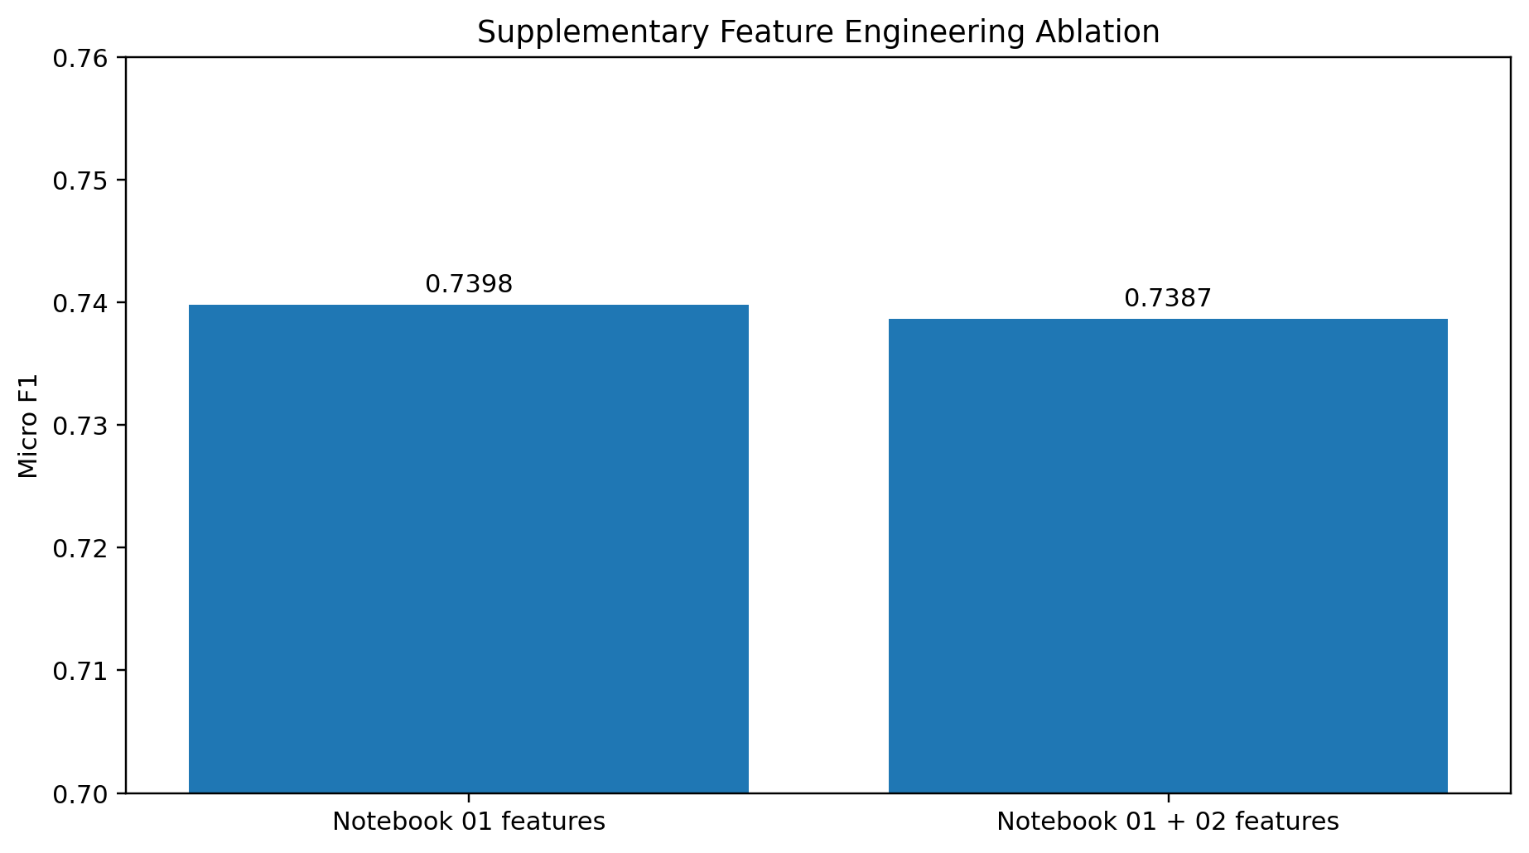
Figure 19. Controlled feature-engineering ablation.
Under the same compact LightGBM configuration, the four additional features from Notebook 02 change Micro F1 by approximately -0.0011. This is a small negative difference. The experiment does not support a claim that the supplementary engineered features improve predictive accuracy for this model. Their value is primarily richer representation and interpretability.
Key finding: Feature engineering claims are kept evidence-based: the supplementary features are interpretable, but they do not improve this held-out benchmark.

13. Geography versus Structural Vulnerability
Feature set | Micro F1 | Macro F1 | Grade-3 Recall
Geography only | 0.7166 | 0.6150 | 0.5901
Structure only | 0.6201 | 0.5310 | 0.3081
Full compact model | 0.7387 | 0.6816 | 0.6079
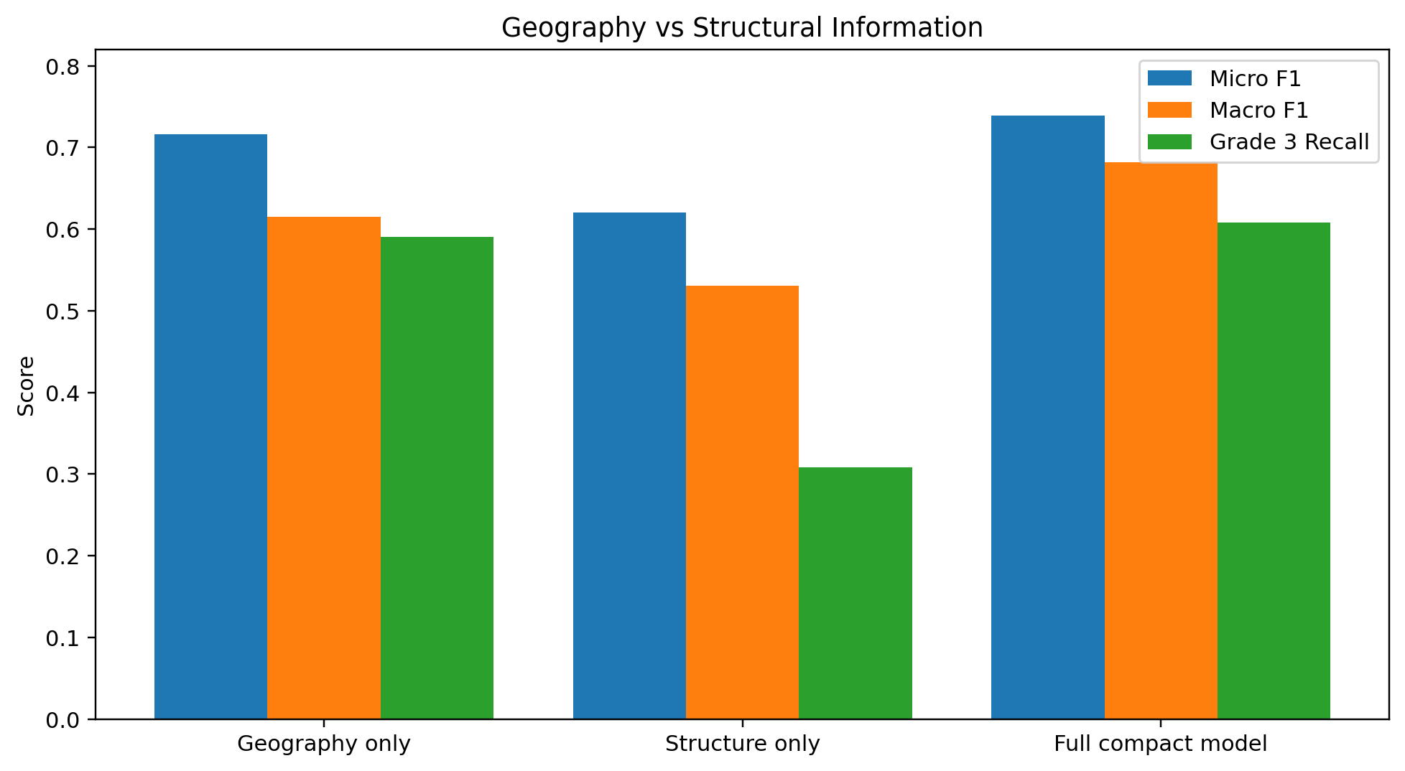
Figure 20. Predictive contribution of geography and structural information.
Geography alone substantially outperforms the structure-only feature set. The full model still improves by about 2.2 Micro-F1 points over geography alone, so structural features carry incremental predictive value beyond location. The result is a predictive ablation, not a causal decomposition: geographic IDs can proxy shaking intensity, local construction practice, topography, and other unobserved factors.
Key finding: Geography is the dominant source of signal under random validation, while structure provides measurable incremental information.

14. Geographic Holdout and Distribution Shift
Validation design | Micro F1 | Macro F1 | QWK
Random stratified holdout | 0.7387 | 0.6816 | 0.5993
Unseen Geo-Level-1 holdout | 0.5109 | 0.4335 | 0.2638
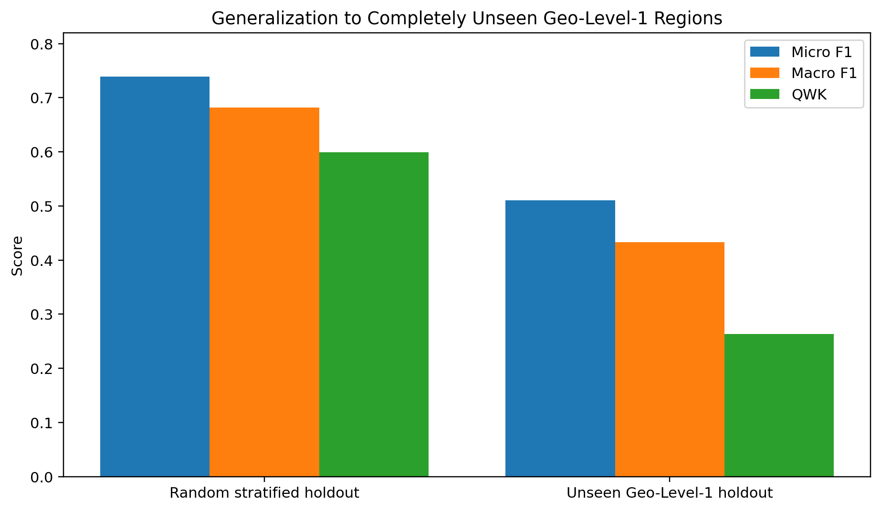
Figure 21. Random validation versus completely unseen Geo-Level-1 regions.
The geographic holdout trains on 24 Geo-Level-1 groups and evaluates on seven completely different groups. Micro F1 falls to about 0.5109 and QWK to about 0.2638. The held-out regions also have a materially different target distribution, with Grade 3 around 45% versus roughly 28% in the geographic-holdout training subset. The drop therefore reflects a combined unseen-geography and target-distribution shift.
Key finding: Strong same-distribution performance does not imply equivalent transfer to new regions; geographic generalization is the project’s main robustness limitation.

15. Explainability: What the Model Is Learning
Feature | Mean |SHAP|
geo_level_1_id | 0.5340
geo_level_2_id | 0.1503
age | 0.1392
foundation_type | 0.1343
has_superstructure_mud_mortar_stone | 0.1080
other_floor_type | 0.0660
ground_floor_type | 0.0616
geo_level_3_id | 0.0523
roof_type | 0.0458
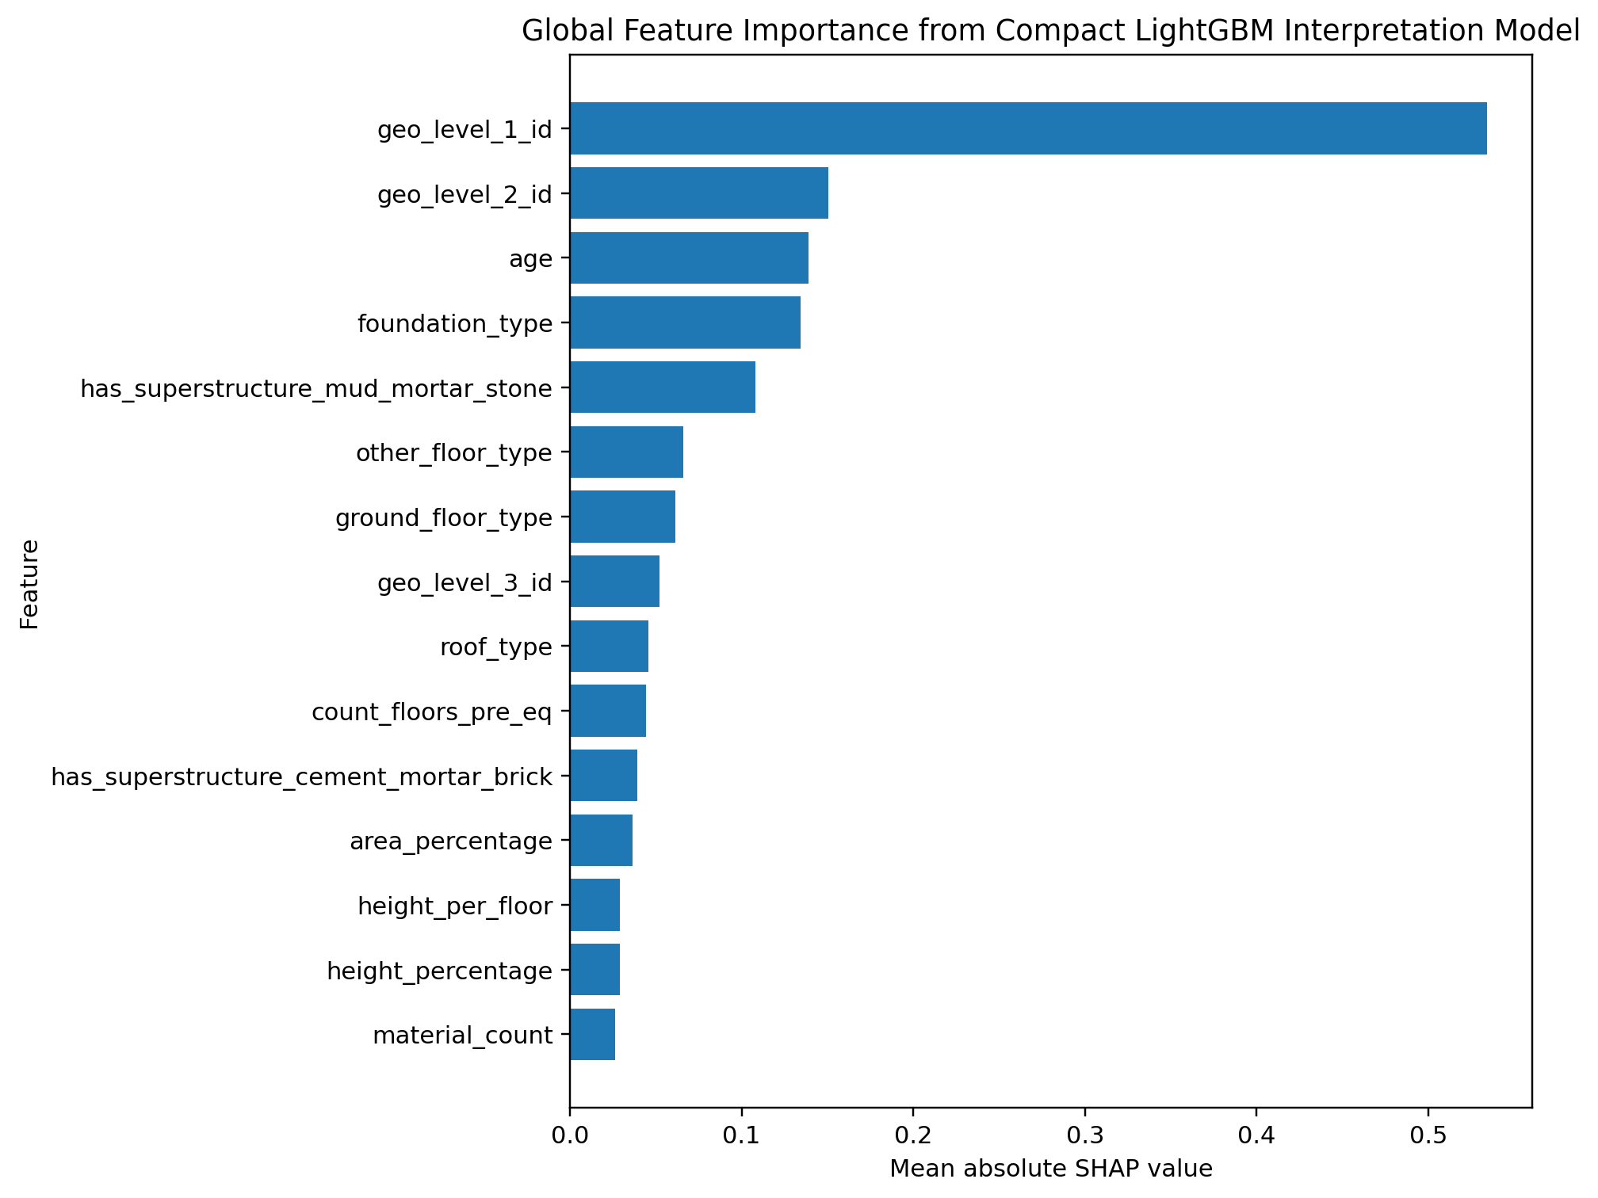
Figure 22. Global SHAP importance from the compact LightGBM interpretation model.
The SHAP ranking is consistent with the exploratory analysis. Geo Level 1 is the dominant feature by a large margin; finer geography, age, foundation, mud-mortar-stone construction, floor type, roof type, and floor count also contribute. These values quantify predictive association and should not be read as causal safety effects.
Key finding: The model-level evidence reinforces the EDA story: location dominates, followed by age and structural-system variables.

16. Post-Earthquake Inspection Prioritization
Inspection budget | Buildings selected | Precision@K | Recall@K | Lift@K
5% | 2,606 | 0.9662 | 0.1443 | 2.8870
10% | 5,212 | 0.9390 | 0.2806 | 2.8056
20% | 10,424 | 0.8408 | 0.5025 | 2.5124
30% | 15,636 | 0.7438 | 0.6667 | 2.2224
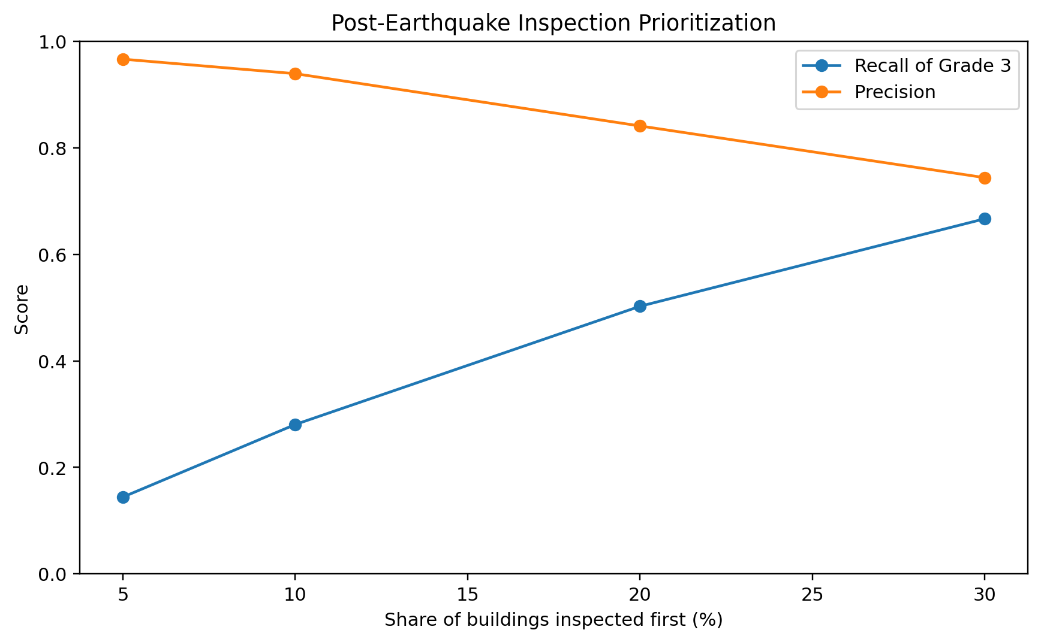
Figure 23. Grade-3 precision and recall at different inspection budgets.
The best model’s Grade-3 probability can be used as a ranking score. If inspectors can examine only the highest-risk 10% of validation buildings, approximately 93.9% of those selected are truly Grade 3 and the selected group contains about 28.1% of all Grade-3 buildings. At a 20% budget, recall rises to about 50.2% while precision remains about 84.1%.
Key finding: Within the random-validation distribution, predicted risk is useful for concentrating scarce inspection resources on severely damaged buildings.

Part III · Public Leaderboard Optimization

17. External Competition Validation
The first DrivenData submission from the main LightGBM pipeline scored 0.7440, close to the internal best validation score of 0.7474. This small gap supports the usefulness of the fixed random split for same-distribution competition performance, while the geographic holdout remains the more demanding test of regional transfer.
Version | Method | Actual Public Micro F1
Original | LightGBM + One-Hot, lighter full-data fit | 0.7440
A | LightGBM + One-Hot, 400 trees | 0.7451
B | 80% LightGBM + 20% Logistic blend | 0.7456
C | Blend + mild class-score adjustment | 0.7460
D | Native CatBoost | 0.7486
E | LightGBM + CatBoost + Logistic blend | 0.7494
F | Tuned CatBoost + tuned LightGBM probability ensemble | 0.7515
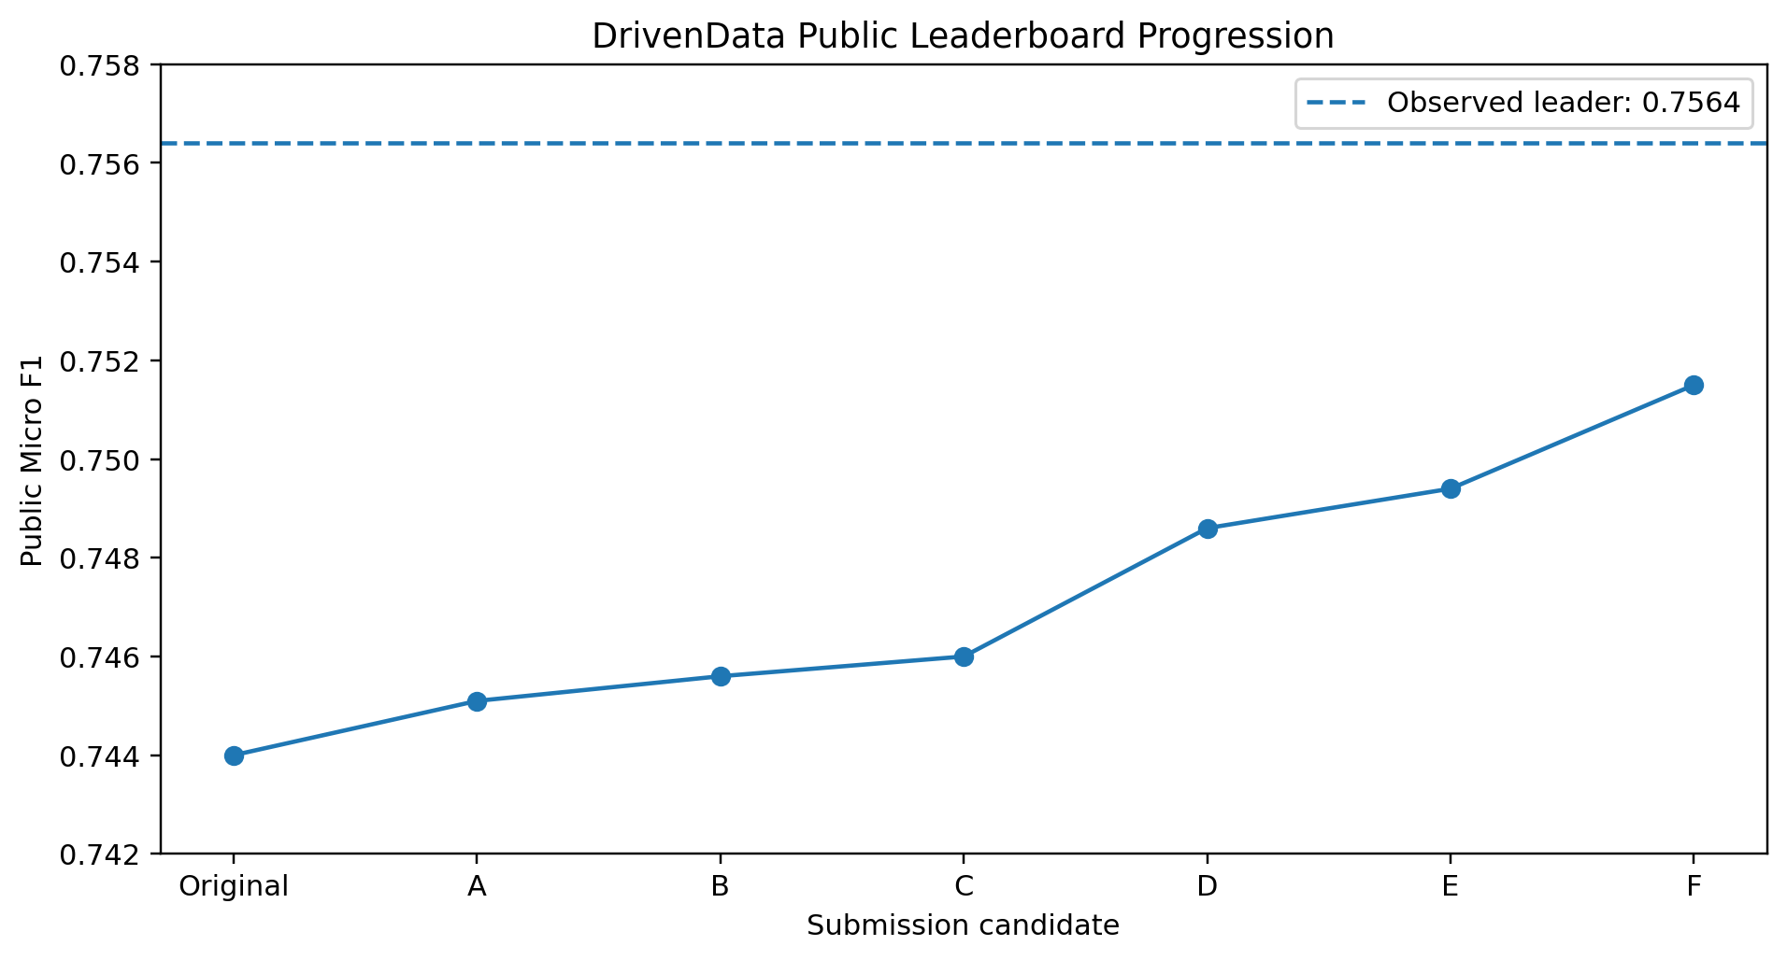
Figure 24. Actual public-score progression across submitted leaderboard candidates.
The public score improved monotonically from 0.7440 to 0.7515. Small LightGBM configuration changes and score adjustments yielded incremental gains. The larger improvements came from adding a genuinely different model family, CatBoost, and then tuning the LightGBM and CatBoost base models before probability ensembling.
At the time of the latest recorded submission, the observed leaderboard leader scored 0.7564. The project’s best score of 0.7515 ranked 252nd out of 2,761 competitors, approximately the top 9.1% of the public leaderboard, and was 0.0049 below the observed leader.
Key finding: The highest public result is achieved by tuned CatBoost + tuned LightGBM probability ensembling, reaching 0.7515 and a top-9.1% recorded position.

18. Final Leaderboard Implementation
The final leaderboard notebook is 04_CatBoost_LightGBM_Tuning_Ensemble.ipynb. It uses the same fixed validation split and final Notebook-02 features as the main modeling pipeline, then performs controlled candidate searches for both LightGBM and CatBoost. LightGBM candidates vary tree complexity, learning rate, child-size constraints, feature subsampling, and regularization. CatBoost candidates vary depth, learning rate, L2 regularization, random strength, and bagging temperature. Early stopping determines the effective iteration count for each candidate.
After selecting the strongest individual LightGBM and CatBoost configurations on validation data, the notebook searches a transparent probability-blend weight. The selected architecture is then refit on all labeled observations and applied once to the official test set. This procedure separates model selection from final test prediction and keeps the leaderboard stage reproducible.
Model family | Candidate design
LightGBM | Balanced 63-leaf configuration; deeper 127-leaf configuration; stronger-regularization 63-leaf configuration, all with early stopping.
CatBoost | Depth-8, depth-9, and more strongly regularized depth-8 configurations with native categorical handling and early stopping.
Final ensemble | Weighted average of the selected CatBoost and LightGBM class probabilities; blend adopted only when validation evidence supports it.

Part IV · Final Conclusions, Limitations and Reproducibility

19. Complete Project Conclusions
- The official dataset is clean and internally consistent, so representation, feature engineering, and leakage prevention matter more than missing-value repair.
- The target is imbalanced, making Macro F1 and class-level metrics necessary alongside the official Micro F1.
- EDA and SHAP consistently identify geography, foundation, roof, material, age, and floor-related variables as important predictive signals.
- The strongest course-project validation model is LightGBM + One-Hot with Micro F1 = 0.7474.
- The four supplementary engineered features do not improve the controlled compact-LightGBM validation result, so the project does not overclaim their predictive value.
- Geography is the dominant predictive source under random validation, while structural variables still add incremental information.
- A completely unseen Geo-Level-1 holdout causes a large performance drop, demonstrating a serious transferability limitation under regional distribution shift.
- Risk probabilities can support inspection prioritization within the familiar validation distribution.
- Leaderboard optimization benefits more from stronger model diversity and tuned ensembling than from small tree-count or score-threshold adjustments.
- The final tuned CatBoost + tuned LightGBM ensemble reaches an actual public Micro F1 of 0.7515, recorded at rank 252 of 2,761 competitors (top 9.1%).

20. Interpretation Limits and Deployment Cautions
- All EDA, feature importance, and SHAP findings are observational and predictive; they do not establish causal effects of construction choices or geography.
- Geographic damage-rate summaries use the target and therefore remain outside the model feature matrix unless a leakage-safe out-of-fold encoding is explicitly designed.
- The geographic holdout changes both geographic composition and class distribution, so its performance drop is a combined domain-shift effect rather than a pure memorization estimate.
- The dataset contains geographic identifiers but not direct shaking intensity, soil condition, or precise spatial coordinates, limiting physical interpretation.
- The public leaderboard is useful external evidence, but repeated leaderboard tuning can overfit the public test subset; the fixed validation experiments remain the primary academic evidence.
- Inspection-prioritization results are validated under the random-split distribution and require separate calibration before operational use in unseen regions.

21. Reproducibility and Project Workflow
The coding pipeline is intentionally modular and should be run in sequence:
Stage | Notebook | Main outputs
01 | 01_Preprocessing_EDA.ipynb | Raw-data audit, core EDA, six engineered features, fixed train/validation split.
02 | 02_Supplementary_Preprocessing_Geography_EDA.ipynb | Four supplementary features, geographic EDA, final 48-feature modeling table and schema.
03 | 03_Model_Training_Evaluation.ipynb | Benchmarks, ablations, geographic holdout, SHAP, inspection prioritization, main submission.
04 | 04_CatBoost_LightGBM_Tuning_Ensemble.ipynb | Leaderboard-focused LightGBM/CatBoost tuning, probability blend, final 0.7515 public model.
The official test data are isolated from model selection. Learned encoders and model transformations are fitted on training data before validation transformation, and the public test set is used only after architecture selection. building_id remains an identifier for alignment and submission and is excluded from model fitting.

22. Final Deliverables
- Preprocess & EDA/01_Preprocessing_EDA.ipynb
- Preprocess & EDA/02_Supplementary_Preprocessing_Geography_EDA.ipynb
- Modeling/03_Model_Training_Evaluation.ipynb
- Modeling/04_CatBoost_LightGBM_Tuning_Ensemble.ipynb
- Modeling/figures/ and Modeling/results/ for the course-project modeling stage
- Modeling/figures_04_tuning/ and Modeling/results_04_tuning/ for the leaderboard-optimization stage
- This complete technical report and the root project README

