Nepal Earthquake Damage Prediction
Modeling, Evaluation and Experimental Analysis Report
Course Project · Coding Stage 03
This report documents the complete modeling stage built on the verified outputs of Notebook 01 (preprocessing and core feature engineering) and Notebook 02 (supplementary features and geographic EDA). All reported validation metrics below come from executed models using the fixed 80/20 stratified split preserved by the preprocessing pipeline.

Executive Summary
The strongest validated model was LightGBM trained on a sparse one-hot encoded feature matrix. It achieved Micro F1 = 0.7474, Macro F1 = 0.6937, Grade-3 Recall = 0.6222, and QWK = 0.6142. The results show that geographic variables are the dominant predictive signal, while structural features add additional value. Model performance deteriorates substantially when complete Geo-Level-1 regions are held out, indicating that random-split performance does not fully transfer to new regions. The model is also useful as a ranking system: inspecting the highest-risk 20% of validation buildings would capture about half of all Grade-3 buildings while maintaining about 84% precision.

1. Modeling Inputs and Validation Design
The modeling input contains 260,601 labeled buildings and 48 usable predictors after removing building_id from the feature matrix. The fixed validation design contains 208,480 training rows and 52,121 validation rows. The validation split is stratified by damage_grade and is inherited from preprocessing; the modeling notebook does not generate a new random split.
The target is ordinal: Grade 1 indicates low damage, Grade 2 medium damage, and Grade 3 almost complete destruction. Because the official competition uses Micro F1 and the task is single-label multiclass classification, Micro F1 is numerically equal to accuracy. We therefore supplement it with Macro F1, Grade-3 Recall, ordinal MAE, Quadratic Weighted Kappa, and Catastrophic Error Rate.

2. Metrics
Metric | Interpretation
Micro F1 | Official competition metric and overall fraction of correct predictions in this setting.
Macro F1 | Averages F1 equally across the three classes and therefore exposes minority-class weakness.
Grade-3 Recall | Measures the fraction of severely damaged buildings correctly identified.
Ordinal MAE | Uses the natural 1 < 2 < 3 ordering, so a two-grade miss is worse than a one-grade miss.
Quadratic Weighted Kappa | Measures ordinal agreement and penalizes larger disagreements more strongly.
Catastrophic Error Rate | Fraction of Grade-1 ↔ Grade-3 errors, i.e. |true - predicted| = 2.

3. Model Benchmark and Model Selection
Model | Micro F1 | Macro F1 | Grade 3 Recall | Ordinal MAE | QWK | CER
LightGBM + One-Hot | 0.7474 | 0.6937 | 0.6222 | 0.2557 | 0.6142 | 0.0031
LightGBM (compact encoding) | 0.7387 | 0.6816 | 0.6079 | 0.2639 | 0.5993 | 0.0026
Linear Logistic Baseline | 0.7359 | 0.6835 | 0.5488 | 0.2692 | 0.5922 | 0.0051
XGBoost + One-Hot | 0.7331 | 0.6700 | 0.5792 | 0.2692 | 0.5838 | 0.0023
Random Forest | 0.7172 | 0.6446 | 0.5340 | 0.2848 | 0.5495 | 0.0020
Decision Tree | 0.7087 | 0.6529 | 0.6069 | 0.2975 | 0.5609 | 0.0062
Majority Baseline | 0.5689 | 0.2417 | 0.0000 | 0.4311 | 0.0000 | 0.0000
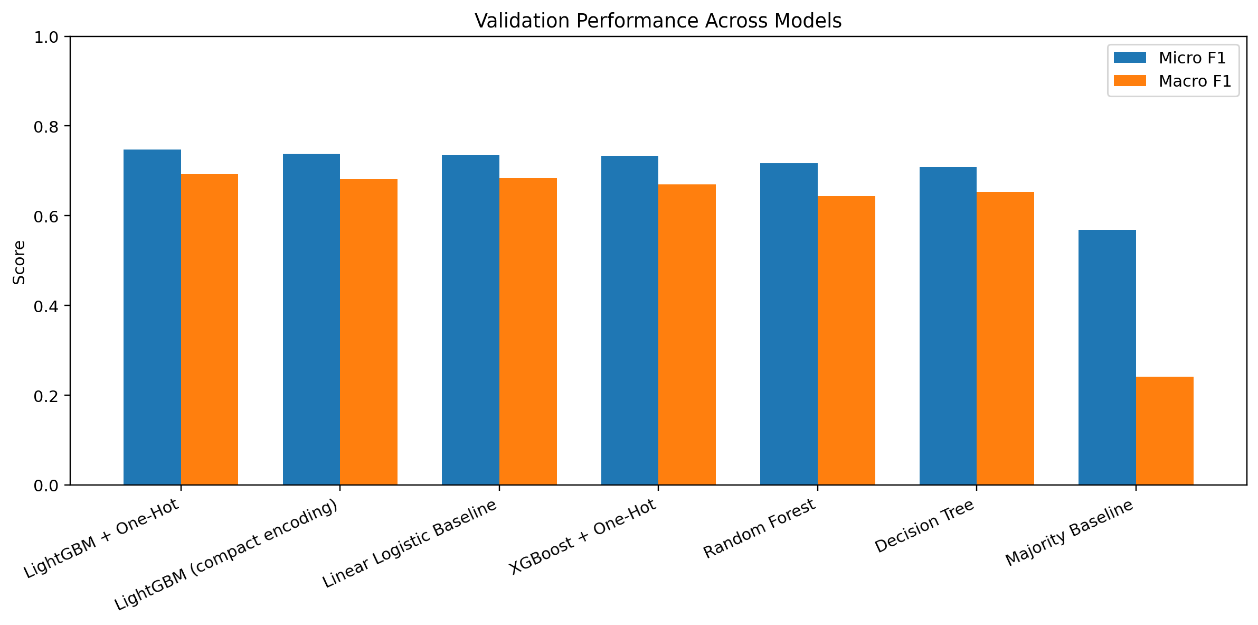
Figure 1. Validation performance across candidate models.
LightGBM with one-hot encoded categorical variables produced the strongest overall validation result. Its Micro F1 of 0.7474 is about 17.85 percentage points above the majority baseline. The linear logistic baseline was already strong at 0.7359, which indicates that a substantial share of the signal is approximately additive. LightGBM still improves Micro F1 by about 1.15 percentage points and Grade-3 Recall by about 7.34 percentage points relative to the linear baseline, showing that nonlinear interactions remain valuable.
The Decision Tree attained relatively high Grade-3 Recall but weaker overall performance. Random Forest reduced catastrophic errors but also lost Grade-3 recall. XGBoost with the same one-hot representation was competitive but remained below LightGBM. The majority classifier has CER = 0 because it always predicts the middle class; this demonstrates why CER must be interpreted alongside overall and class-specific metrics.

4. Best Model: Class-Level Error Analysis
Class | Precision | Recall | F1 | Support
Grade 1 | 0.6932 | 0.5202 | 0.5944 | 5025
Grade 2 | 0.7425 | 0.8595 | 0.7967 | 29652
Grade 3 | 0.7740 | 0.6222 | 0.6899 | 17444
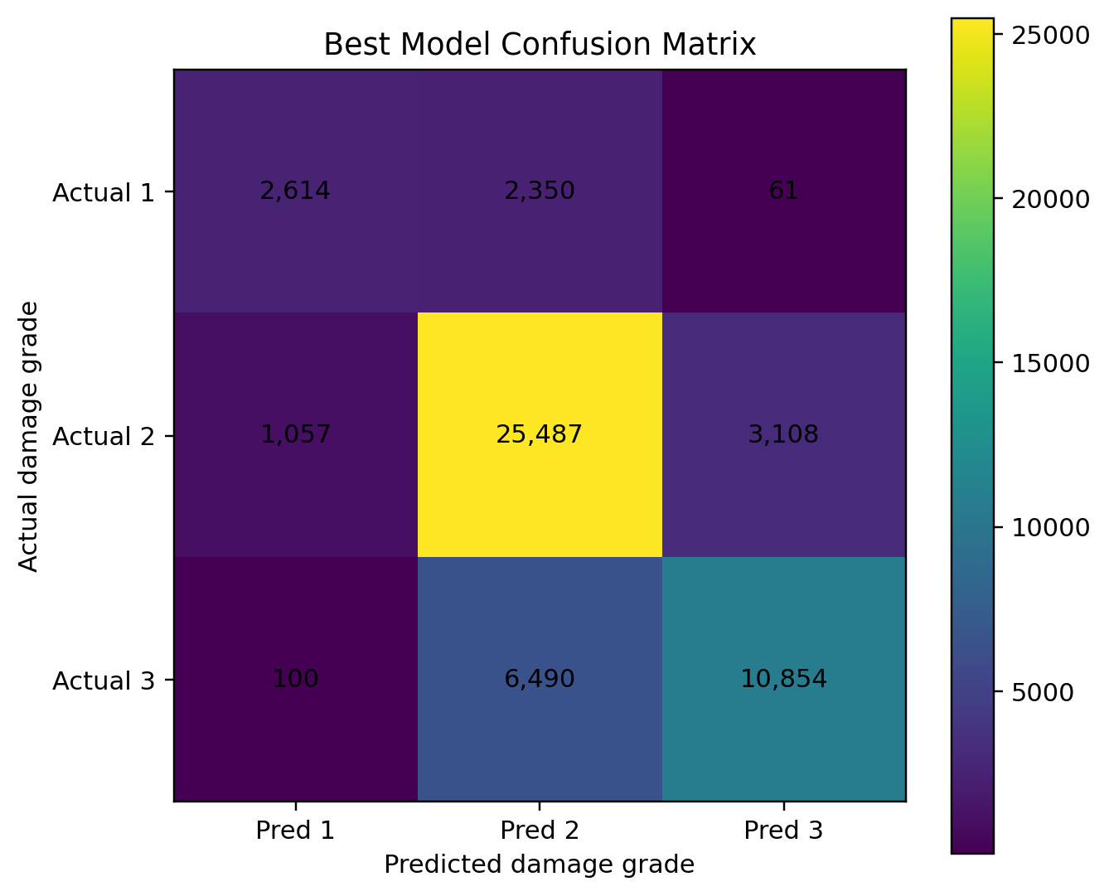
Figure 2. Confusion matrix for the best LightGBM + one-hot model.
Grade 2 is the easiest class: recall is approximately 0.860 and F1 is approximately 0.797. Grade 1 is the hardest minority class, with recall around 0.520. Grade 3 achieves precision around 0.774 and recall around 0.622. The model therefore identifies a majority of severely damaged buildings while keeping false severe-damage predictions relatively controlled.
Only 161 of 52,121 validation observations were misclassified across the full two-grade distance between Grade 1 and Grade 3. This corresponds to a catastrophic error rate of about 0.31%.

5. Did Supplementary Feature Engineering Help?
Feature Set | Micro F1 | Macro F1 | Grade 3 Recall
Notebook 01 features | 0.7398 | 0.6823 | 0.6084
Notebook 01 + 02 features | 0.7387 | 0.6816 | 0.6079
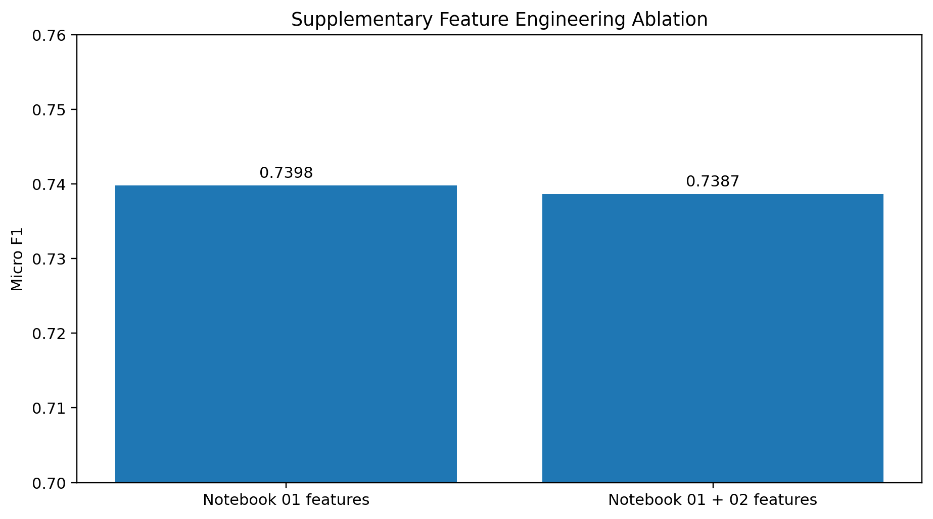
Figure 3. Controlled ablation of the Notebook-02 supplementary features.
Under the same compact LightGBM configuration, adding secondary_use_count, area_per_family, rc_category, and age_group changed Micro F1 by -0.0011. This is a very small negative difference. The experiment does not provide evidence that these four engineered features improve LightGBM predictive accuracy on the fixed random validation set.
This is still a useful result. Feature engineering should be retained only when empirical evidence supports it. The supplementary notebook remains valuable for clearer structural representation, geographic analysis, and downstream interpretability, but the final report should not claim a predictive gain that is not observed.

6. Geography versus Structural Vulnerability
Feature Set | Micro F1 | Macro F1 | Grade 3 Recall
Geography only | 0.7166 | 0.6150 | 0.5901
Structure only | 0.6201 | 0.5310 | 0.3081
Full compact model | 0.7387 | 0.6816 | 0.6079
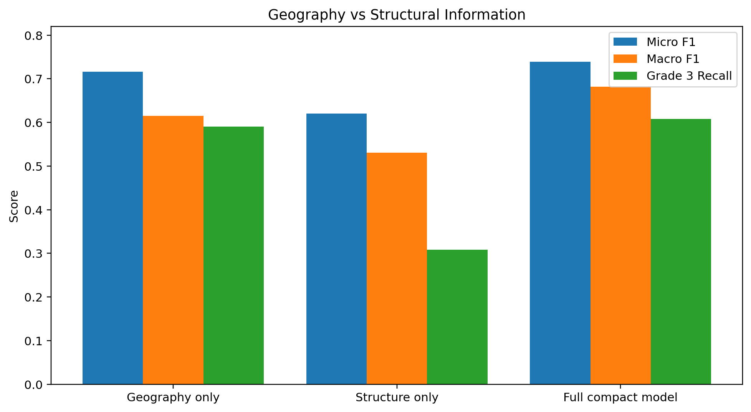
Figure 4. Predictive contribution of geography and structural features.
Geography alone reaches Micro F1 = 0.7166, whereas the structure-only model reaches approximately 0.6201. The full compact model reaches approximately 0.7387. This makes geography the dominant information source under the random split. At the same time, the full model improves by about 2.21 Micro-F1 points over geography alone, so structural characteristics contain additional predictive information beyond location.
These results should be interpreted as predictive ablation, not causal decomposition. The data do not show how much damage would change if a specific building feature were experimentally altered, and geographic IDs can proxy many unobserved factors such as shaking intensity, local construction practices, topography, and exposure.

7. Geographic Holdout and Distribution Shift
Validation | Micro F1 | Macro F1 | QWK
Random stratified holdout | 0.7387 | 0.6816 | 0.5993
Unseen Geo-Level-1 holdout | 0.5109 | 0.4335 | 0.2638
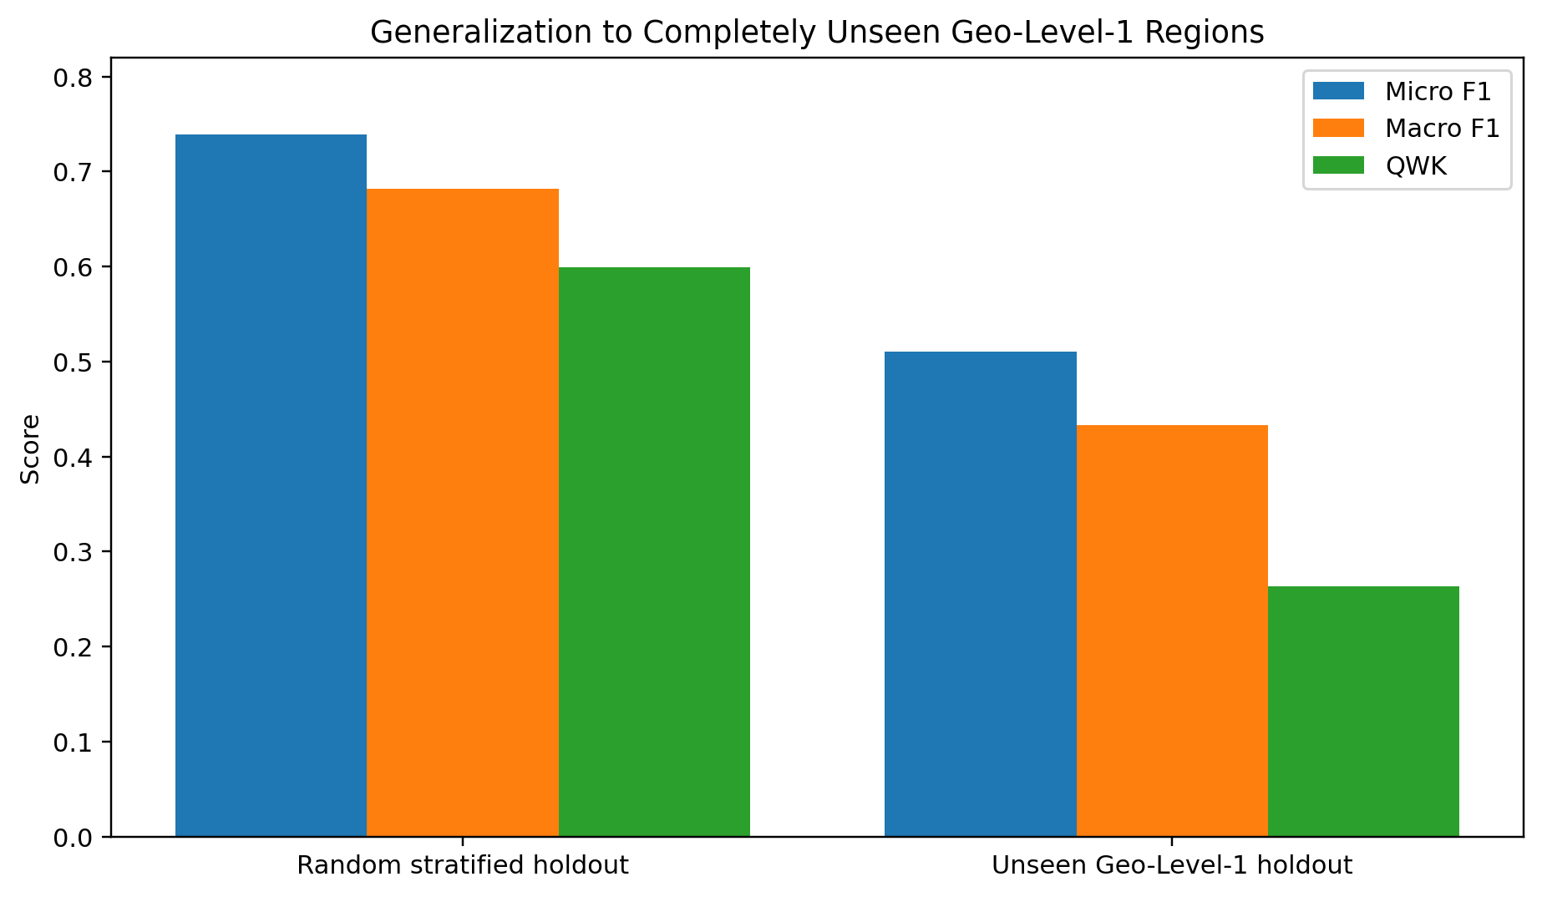
Figure 5. Random validation versus completely unseen Geo-Level-1 regions.
The geographic holdout uses 24 Geo-Level-1 groups for training and seven completely different groups for validation, with zero overlap. Micro F1 falls from about 0.7387 on the random holdout to about 0.5109, while QWK falls from about 0.5993 to about 0.2638. This is a major generalization gap.
The holdout is also a strong distribution-shift test. Grade 3 represents about 27.9% of the geographic-holdout training subset but 45.1% of the held-out regions. Therefore the score drop cannot be attributed entirely to geographic memorization. It reflects both unseen location categories and a meaningfully different damage distribution.
The full geographic-holdout model has unusually high Grade-3 Recall (0.918) while overall and Macro F1 are poor. This indicates that high severe-damage recall alone can be misleading under distribution shift. A structure-only model on the same geographic holdout achieves Micro F1 0.514, confirming that structural variables by themselves do not fully solve the regional transfer problem.

8. Explainability: What the Model Is Learning
feature | mean_abs_shap
geo_level_1_id | 0.5340
geo_level_2_id | 0.1503
age | 0.1392
foundation_type | 0.1343
has_superstructure_mud_mortar_stone | 0.1080
other_floor_type | 0.0660
ground_floor_type | 0.0616
geo_level_3_id | 0.0523
roof_type | 0.0458
count_floors_pre_eq | 0.0442
has_superstructure_cement_mortar_brick | 0.0394
area_percentage | 0.0366
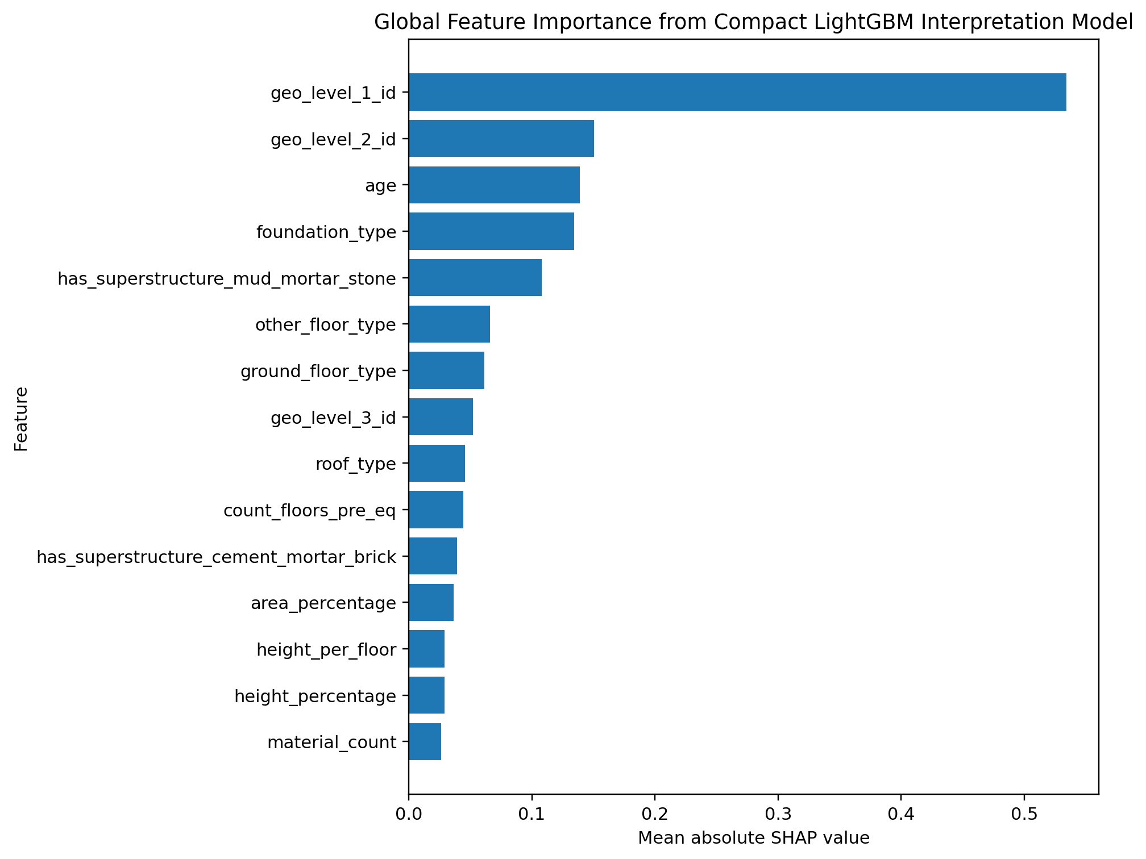
Figure 6. Global SHAP importance from the compact LightGBM interpretation model.
The most influential feature is geo_level_1_id by a large margin. geo_level_2_id and geo_level_3_id also appear among the leading features. The most important non-geographic predictors include building age, foundation type, mud-mortar-stone superstructure, floor type, roof type, floor count, and area percentage.
This ranking aligns with the EDA stage: older buildings and different foundations, roofs, and structural materials showed visibly different damage distributions. SHAP confirms that these variables remain important after the model accounts for other features. These are predictive associations and must not be interpreted as causal effects.

9. Post-Earthquake Inspection Prioritization
Top Fraction | Buildings Selected | Precision@K | Recall@K | Lift@K
0.0500 | 2606.0 | 0.9662 | 0.1443 | 2.8870
0.1000 | 5212.0 | 0.9390 | 0.2806 | 2.8056
0.2000 | 10424.0 | 0.8408 | 0.5025 | 2.5124
0.3000 | 15636.0 | 0.7438 | 0.6667 | 2.2224
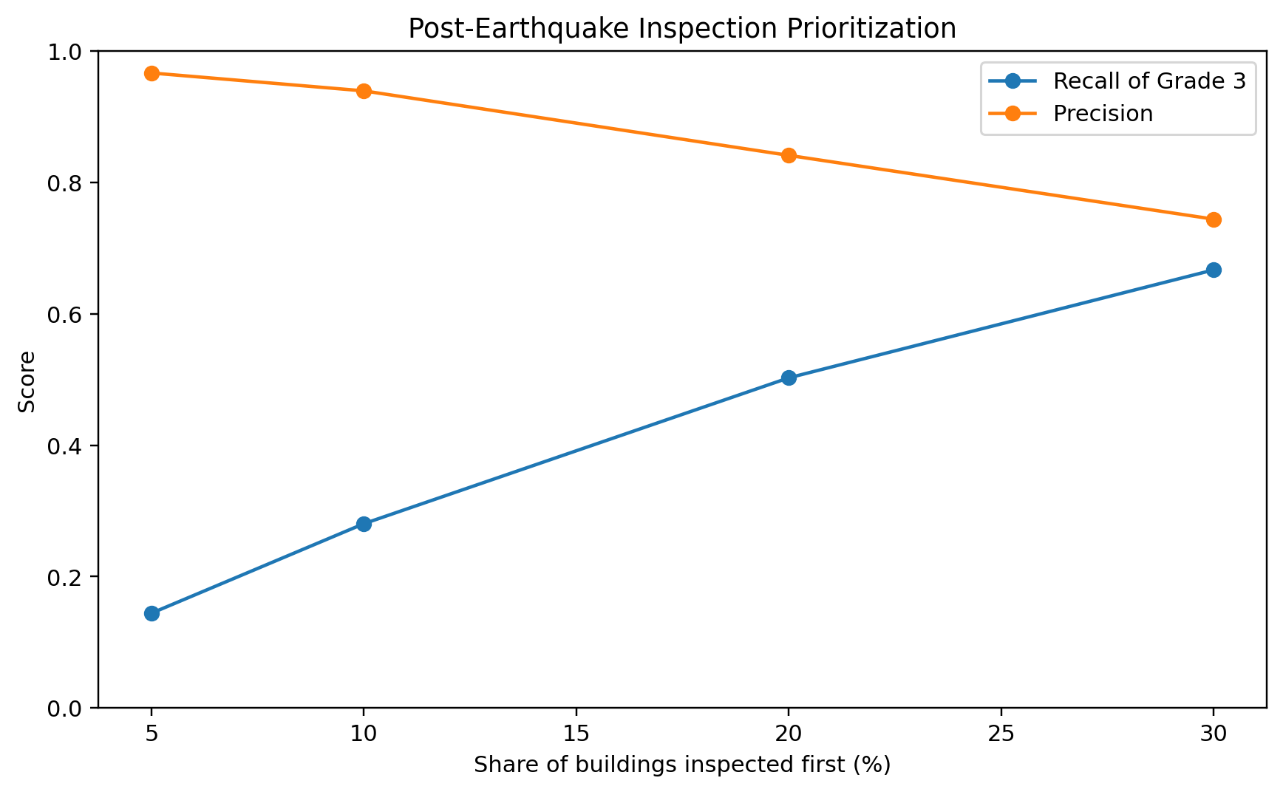
Figure 7. Precision and Grade-3 recall at different inspection budgets.
The probability output can be used as a ranking score rather than only as a hard class label. With a 10% inspection budget, the highest-risk 10% of validation buildings have approximately 93.9% Grade-3 precision and contain about 28.1% of all Grade-3 buildings, giving a lift of about 2.81 relative to random inspection.
With a 20% inspection budget, the system captures about 50.2% of all Grade-3 buildings while maintaining about 84.1% precision. At 30%, recall rises to roughly 66.7%. This demonstrates a potentially useful prioritization role for disaster response when inspection resources are constrained.
These allocation results are measured on the same-distribution random validation set. The geographic-holdout result shows that deployment to unseen regions would require additional validation, geographic or seismic covariates, and possibly recalibration before operational use.

10. Final Training and Submission
A DrivenData-format submission file is included in the Modeling/results folder. It was generated by retraining the LightGBM + one-hot architecture on all labeled data and predicting the official test set. The included artifact uses a 250-estimator full-data fit to keep execution time practical. The notebook exposes the estimator count as a parameter; if local compute permits, it can be increased to 400 to match the strongest validation configuration.

11. Limitations
- The official random validation split shares geographic distributions between train and validation and therefore overstates transfer to completely new regions.
- The geographic holdout changes both location and target distribution, so its performance drop is a combined domain-shift effect.
- The supplementary engineered features did not demonstrate measurable validation gain under the controlled LightGBM ablation.
- Feature importance and SHAP quantify predictive association, not causal structural safety effects.
- The dataset contains geographic IDs rather than direct physical shaking intensity, soil condition, or precise spatial coordinates.
- Hyperparameter search was intentionally limited to preserve a clean, interpretable course-project workflow rather than optimize leaderboard score aggressively.

12. Recommended Final Project Claims
- LightGBM with one-hot categorical encoding is the strongest tested model on the fixed random validation set.
- Geography is the dominant predictive signal, but structural features add measurable incremental information.
- The four supplementary engineered features improve interpretability and representation but do not improve compact-LightGBM validation accuracy.
- Performance is substantially weaker on unseen broad geographic regions, demonstrating a transferability limitation.
- Risk probabilities can meaningfully prioritize severe-damage inspections within the validation distribution.

Appendix A. Main Hyperparameters
Model | Configuration
Linear Logistic Baseline | One-hot, min_frequency=10; SGD log-loss; alpha=1e-5; max_iter=1000
Decision Tree | max_depth=18; min_samples_leaf=8
Random Forest | 80 trees; max_depth=24; min_samples_leaf=2; max_features=sqrt
Compact LightGBM | 400 trees; learning_rate=0.06; num_leaves=63; subsample=0.9; colsample_bytree=0.9
XGBoost + One-Hot | 300 trees; max_depth=8; learning_rate=0.08; subsample=0.9; colsample_bytree=0.9
Best LightGBM + One-Hot | 400 trees; learning_rate=0.06; num_leaves=63; subsample=0.9; colsample_bytree=0.9

Appendix B. Deliverables
- 03_Model_Training_Evaluation.ipynb
- results/model_comparison.csv
- results/feature_engineering_ablation.csv
- results/geography_vs_structure.csv
- results/random_vs_geographic_holdout.csv
- results/inspection_prioritization.csv
- results/submission_lightgbm_ohe.csv
- figures/01_model_comparison.png through figures/07_inspection_prioritization.png

Appendix C. Optional Leaderboard Optimization
The core course-project analysis is complete before this appendix. This extension uses the public leaderboard only as an external prediction benchmark and does not change the main research conclusions.

C.1 Current external benchmark
The first official DrivenData submission achieved a public Micro F1 score of 0.7440. The strongest internal random-holdout result was 0.7474, a difference of only 0.0034. This close agreement supports the usefulness of the fixed validation split for same-distribution competition performance. At the time of checking, the observed public leaderboard leader had a score of 0.7564, leaving a gap of 0.0124.
Candidate | Method | Validation Micro F1 | Official Score | Recommendation
Existing | LightGBM + One-Hot, 250-tree full-data fit | 0.7474 model family | 0.7440 | Already submitted
A | LightGBM + One-Hot, exact 400-tree validation configuration | 0.7474 | Pending | Safest next submission
B | 80% LightGBM + 20% linear-logistic probability blend | 0.7490 | Pending | Best conservative experiment
C | Candidate B plus mild class-score adjustment | 0.7496 | Pending | Most experimental

C.2 Why blending is tested
The linear logistic model is weaker than LightGBM when evaluated alone, but it makes a different set of errors. On the fixed validation set, an 80% LightGBM and 20% logistic probability blend increased Micro F1 from 0.7474 to approximately 0.7490 and Macro F1 to approximately 0.6957. This makes the blend a reasonable low-complexity ensemble rather than an arbitrary leaderboard tweak.

C.3 Experimental class-score adjustment
A mild post-processing rule was also tested on the validation probabilities. Multiplying the Grade-1 score by 0.95 and the Grade-3 score by 1.07 increased validation Micro F1 to approximately 0.7496. Because these multipliers were chosen directly on the same validation split, this candidate has a higher risk of validation overfitting and should be treated as an exploratory leaderboard experiment.

C.4 Recommended submission order
- Candidate A first: isolates the effect of matching the exact 400-tree validation configuration.
- Candidate B second: tests the validation-supported probability ensemble.
- Candidate C third only if desired: highest fixed-validation score, but the least conservative.

C.5 Reporting rule
Leaderboard tuning should remain a short optional extension in the final presentation. The main project evidence remains the model comparison, feature ablation, geography-versus-structure analysis, geographic holdout, SHAP interpretation, and inspection-prioritization experiment.

