Lab 1: NVMeVirt with ZNS vs. Traditional FTL
- two namespaces running (conventional vs. ZNS) and their Identify info
- conventional
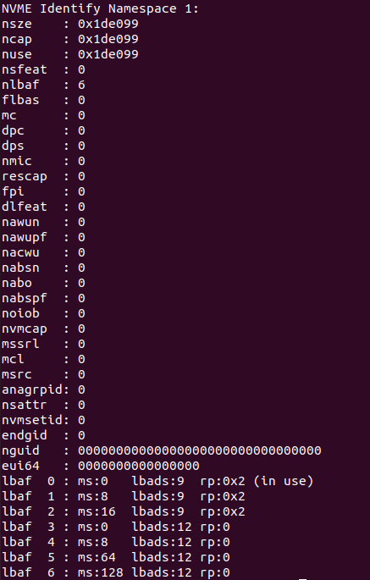
- ZNS
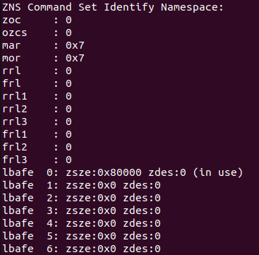

- benchmark runs on both namespaces.
- FTL + F2FS
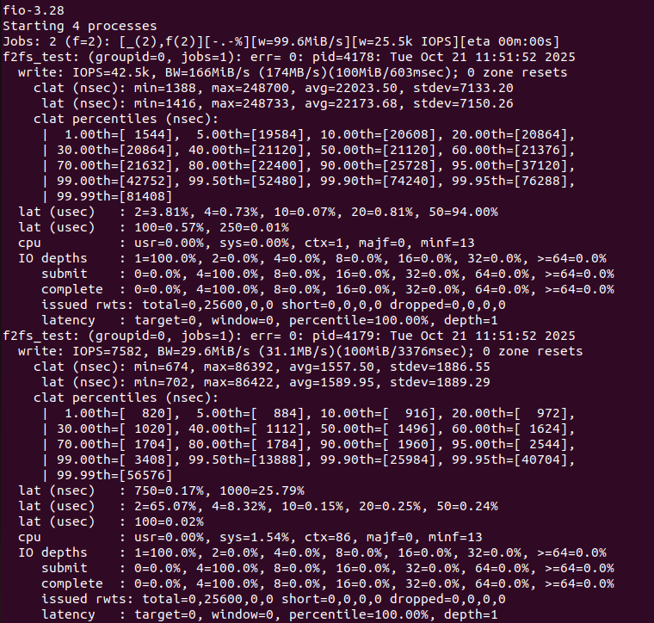
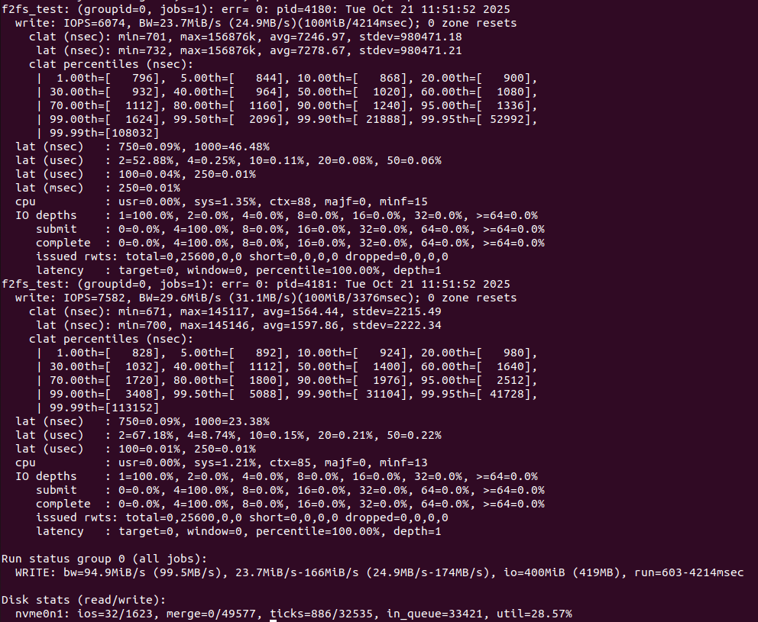
- ZNS + ZoneFS
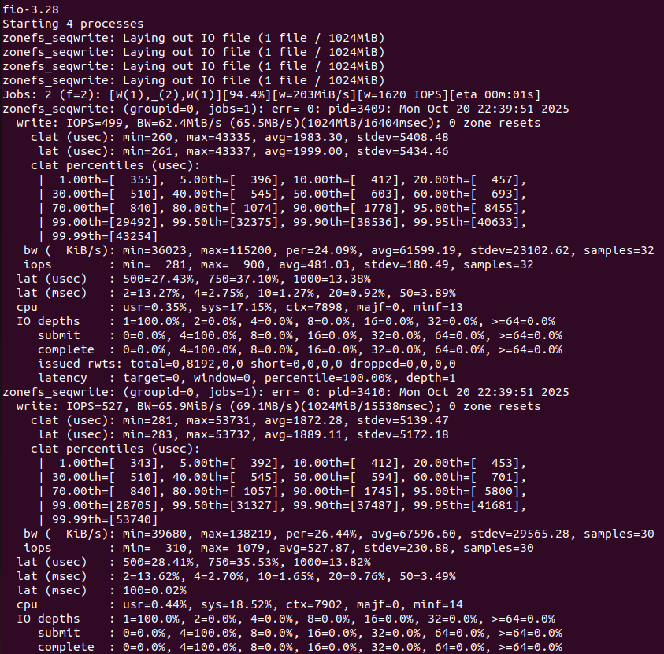
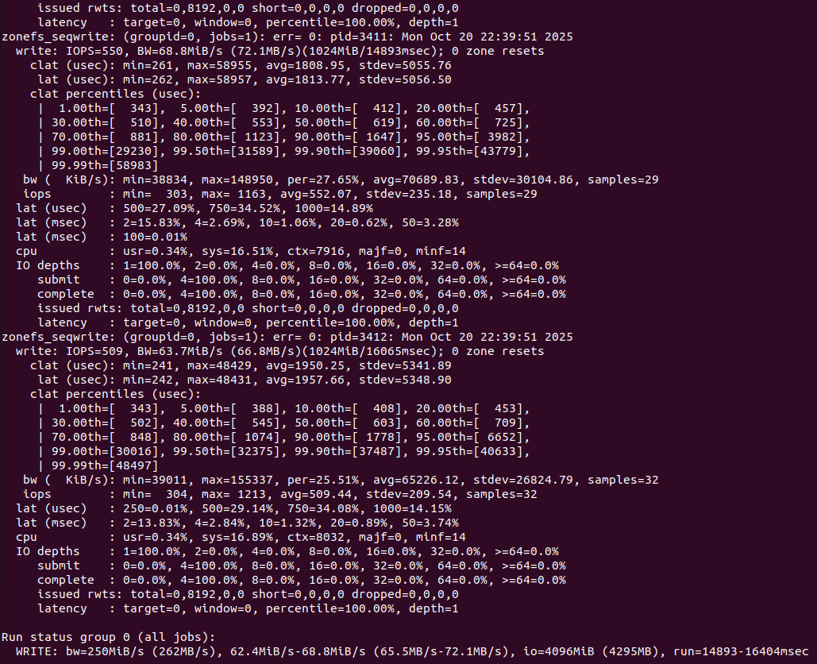
- short write-up comparing NVMeVirt code paths.

項目 | FTL | ZNS
核心檔案 | conv_ftl.c, ssd.c | zns.c, nvme_zns.c
寫入方式 | 由 FTL 轉換 LBA 到 PBA ，可任意寫 | 必須順序寫入各 zone
管理 | 隱藏式 FTL 控制 | Host 負責 zone 開啟/重設
API | read, write, flush | 加入 zone_append, zone_reset
資料 | FTL 動態映射表 | Zone 內循序配置

- modified NVMeVirt printing/logging parallelism stats.
- 修改的程式碼:
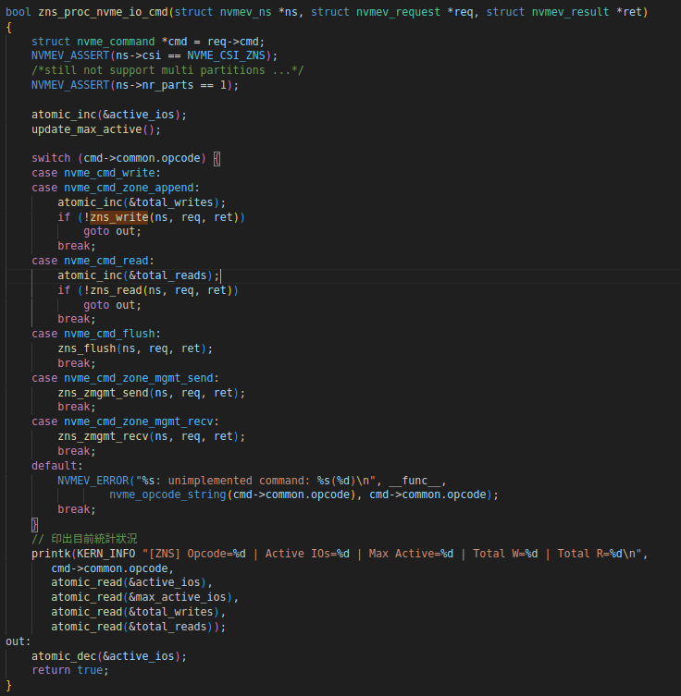

- Parallelism Stats
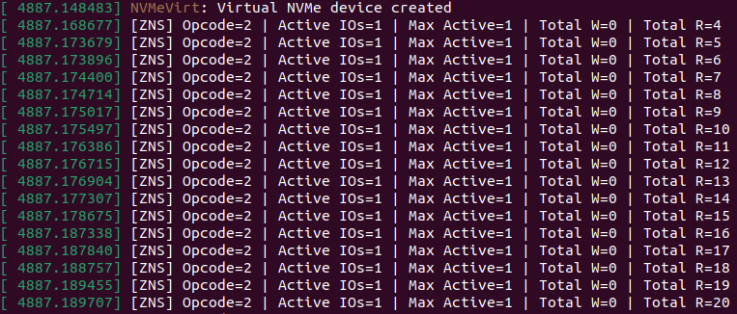
- Compare — Parallelism utilization between ZoneFS and F2FS

Filesystem | Avg Active IO  (from dmesg) | Max Active | 備註
F2FS (FTL) | 1 | 1 | 受限於 FTL 隱藏層
ZoneFS (ZNS) | 3–4 | 4 | 多 zone 同時活躍

